CHAPTER-01
INTRODUCTION
Autism Spectrum Disorder (ASD) is defined by ongoing struggles with social communication, social interaction, and behavior. Concerns surrounding the care of an autism spectrum child reach far beyond clinical treatment and diagnosis. For most mothers, who also usually serve as the primary caregiver, the experience is mediated by sophisticated emotional labor, social negotiation, and ongoing adaptation. Although autism is becoming more prevalent in public and academic awareness, the quiet dimensions of mothering within this context are not well researched, and in this dissertation thematic analysis is applied to qualitative research and case work to explore how mothers experience, cope with, and interpret having a child with autism.
Thematic analysis provides a rich methodological approach to research into lived experience. It provides researchers with the ability to identify and analyze patterns or themes within qualitative data sets. Braun and Clarke (2006) define thematic analysis as an effective and generalizable strategy that can deliver rich description and interpretative richness. In comparison with more limiting qualitative approaches, thematic analysis is not committed to any particular theoretical stance nor bound to realist or constructionist paradigms. It is therefore amenable with both paradigms and appears particularly well-suited in autism care research, in which personal accounts are rooted solidly in broader social, cultural, and institutional contexts (Braun and Clarke, 2006).
One of thematic analysis's biggest strengths is researcher reflexivity. Themes are not derived from data but are built through positive working with it. Clarke and Braun (2006) underscore open decision-making in building themes and the researcher's role in interpretation of meaning. Reflexivity is most critical in emotionally challenging and personally meaningful research topics, including research into parental caregiving and disability.
Qualitative research among populations to which the researcher is similarly positioned with regard to lived experience involves sensitive navigation of positionality. Dwyer and Buckle (2009) propose the concept of the "space between" insider and outsider positions in which the researcher is and isn't a member of the participant group. They contend that such space is enabled for empathetic involvement and critical distance, as long as the researcher is reflective and transparent regarding how they shape the research process (Dwyer and Buckle, 2009).
The affective burden of caregiving may impact participants and researchers in autism studies. Neutrality does not apply in qualitative research, Ely et al. (1991) assert, but rather one must attempt to stretch one's sensitivity to assumptions and silences. This view lends credence to the merit of mothers' perspectives in autism research because they incorporate experiential know-how and affective understanding missing in institutions (Ely et al., 1991).
The learning context is an important arena wherein mothers of autistic children need to serve as advocates, interpreters, and acting instructors. As posited by Arslan (2009), flexible and open-ended learning strategies at an early stage are essential, especially with the Orff Schulwerk method. The method involves the use of rhythm, movement, and improvisation in order to facilitate learning based on the specific child's requirements. In autistic children, it is common that these embodied and responsive approaches to learning suit their sensory and cognitive interests most effectively (Arslan, 2009).
The Orff approach, assuming that learning first starts with the entire human being, positions the child's innate modes of communication—like sound and movement—at the epicenter of learning. Jungmair (2003) stresses the role of spontaneous activation and automatic realization in learning music, calling for learning experiences to develop organically and responsively to the situation of the learner (Jungmair, 2003). This has been testified to by most mothers who attest to having designed specific, low-stakes learning environments for their children.
Orff (1931) also supports the point that education needs to begin with the creative human. This is the fundamental principle behind the significance of affective and non-verbal modes of learning, particularly with children with developmental disabilities. Focus on adaptability and expression mirrors the types of intervention and support structures mothers would most likely create as a reaction to institutional deficiency (Orff, 1931).
Although such philosophies of education as these are inclusive, there is still a systemic problem. Rose (1985) contends that no researcher or institution is ever neutral; that which is silenced can be more enlightening than that which is spoken. This is especially relevant in the autism care industry, where mothers' voices are marginal to clinical and policy environments despite their dominance in daily care and advocacy (Rose, 1985).
The intersection of caregiving and cultural identity only serves to compound the complexity of the maternal experience. Naicker (2012) describes how social identity and language are constructed through spaces of marginalization, such as post-colonial ones. While he conducts his research on South African Indian English, the overall theory that identity is constructed and sometimes restricted by social structures applies to mothers of autistic children who have to navigate both disability and sociocultural stigma (Naicker, 2012).
Metaphorically, the emotional and logistical landscape of caregiving could be said to be comparable to stressed environmental systems. Gupta, Srivastava and Devi (2008) have applied a geospatial study of Loktak Lake catchment area through remote sensing and GIS for monitoring temporal ecological degradation. Their research illustrates how cumulative and long-term stress can redefine complete ecosystems. Moreover, the chronic and frequently unauthorized nature of autism services has a long-lasting impact on maternal mental health, family relationships, and work identity (Gupta, Srivastava and Devi, 2008).
Education, in this context, is more than an institutional activity; it is an intellectual and emotional change process. Topses (1982) defines education as the learning of attitudes and moving knowledge into action. Such a definition most closely defines the case of mothers who are trained to learn, to adapt in order to adapt, and to implement change because they do not wish to give up (Topses, 1982).
Asselin (2003) supports the need to view famous communities with new eyes. She advises insider researchers on being ready to not know anything to begin with, so that no assumptions are imposed and subtlety can be bypassed. That position provides optimal credibility and ensures that even insiders approach participant accounts with humility and analytical skill (Asselin, 2003).
On the whole, the mother's journey through a child with autism is complex, situational, and highly emotional. It is one of emotional resilience, structural advocacy, and adaptive creativity. Thematic analysis is an effective way in which to explore and respect these stories, enabling the identification of patterns as well as subtle interpretation. By taking advantage of a variety of qualitative research and inter-disciplinary theory, this dissertation aims to amplify the voices of the mothers and to make us more knowledgeable regarding autism care as a subjective and social phenomenon.

CHAPTER-02
LITERATURE REVIEW

2.1 Understanding Autism in Context
Autism Spectrum Disorder (ASD) is a neurodevelopmental condition characterized by enduring impairments in social interaction and communication, and by limited, repetitive behavior and interests that are apparent early in life (Rice et al., 2022). Despite its initial association with schizophrenia by Bleuler in 1911, contemporary understanding of autism started when Kanner published his 1943 article, in which he described children as socially isolated and resistant to change (Zakrocka et al., 2025). Asperger's 1944 paper later identified a milder form, subsequently categorized into what is currently an umbrella single spectrum disorder (Zakrocka et al., 2025).
Diagnostic classification of ASD has progressed a long way. The DSM-5 combined previous subtypes—autistic disorder and Asperger syndrome—under one category characterized by two kinds of impairments: social communication and restricted/limited behaviors (Maenner et al., 2020). This move was spurred by fears of diagnostic heterogeneity under DSM-IV-TR criteria, especially with vague categories such as PDD-NOS (Baio et al., 2018). While the new criteria made diagnosis more precise, several children who were previously at DSM-IV thresholds no longer met DSM-5, most notably those whose symptoms were less severe (Rice et al., 2022).
Prevalence of ASD has increased notably over the past two decades. Surveillance from 11 U.S. sites revealed a rise from 6.7 per 1,000 children in 2000 to 16.8 per 1,000 in 2014 (Baio et al., 2018), and further to 18.5 per 1,000 by 2016 (Maenner et al., 2020). Similar trends have been observed globally, though estimates vary significantly. It varies from 0.42% in Italy to more than 3% in Iceland (Zakrocka et al., 2025). Variations are an indication of disparity in practice, awareness, and cultural beliefs regarding diagnosis.
Early detection remains a problem. Although most ASD symptoms are evident before age three, the median age of diagnosis remains over four years (Baio et al., 2018). There remain diagnostic differences, with minority children and lower socioeconomic status children receiving later or no diagnosis (Maenner et al., 2020).
Both environmental and genetic factors contribute to the aetiology of ASD. There is evidence supporting the view that genes like SHANK3 and CHD8 are significant etiological factors, and conditions in the mother as a possible rising vulnerability (Zakrocka et al., 2025). Behavioral heterogeneity of ASD shows the advantage of loose diagnostic methods and tight classification systems (Rice et al., 2022).
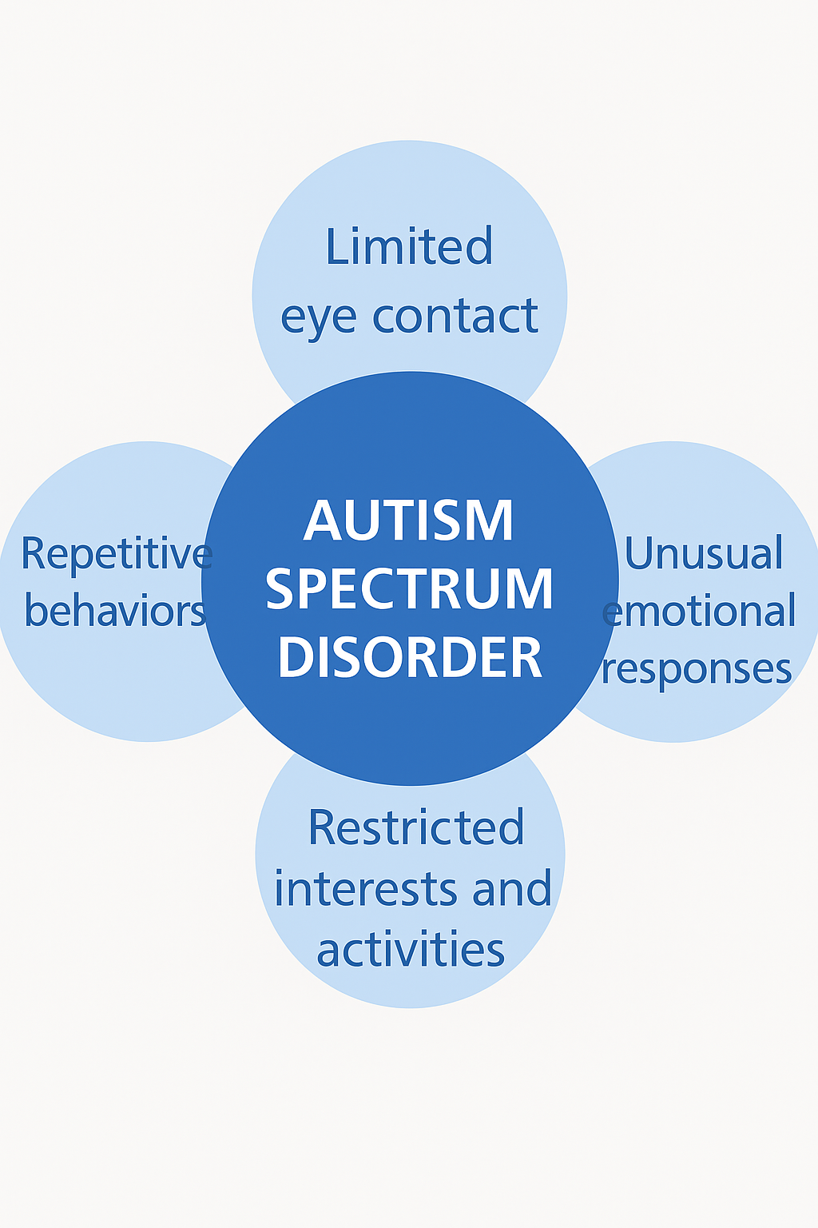
Figure 1: Common signs of Autism Spectrum Disorder
2.2 Emotional and Psychological Impact on Mothers
Childrearing with Autism Spectrum Disorder (ASD) is highly emotionally and psychologically stressful, especially on mothers who become the primary carers. It has been found in certain studies that these mothers in general score higher for anxiety, depression, stress, and lower quality of life than neurotypical mothers (Papadopoulos, 2021). Caregivers' burden goes beyond physical exhaustion to encompass social isolation, emotional distress, and ongoing psychological tension, which are usually reinforced by the child's behavioral symptoms, communication problems, and stigmatization by society (Alenezi et al., 2024).
Maternal mental well-being is significantly determined by the degree of functional independence and comorbid severity of conditions like hyperactivity or oppositional defiance. Almost 92% of children with autism present with comorbid psychiatric symptoms that increase caregiver stress and mental fatigue (Papadopoulos, 2021). A Saudi Arabian cross-sectional survey of mothers showed that almost one-third of the mothers had reported moderate to severe depression and anxiety symptoms, which were significantly associated with lower overall life satisfaction (Alenezi et al., 2024).
Sociodemographic variables play a role in psychological distress. Lower socioeconomic status and educational level mothers, or mothers with fewer family and spousal resources, experienced poorer mental health (Rahmatuz & Allenidekania, 2020). Working mothers were also reported to have lower self-reported quality of life, possibly a result of lack of financial autonomy and social networks (Alenezi et al., 2024).
Typically, maternal emotional issues have a direct effect on the development of children. Lin et al. (2023) established that maternal anxiety was strongly linked with augmented child behavioral problems in autistic children and parenting style served as the intermediary for this relationship. Supportive parenting acted as a buffer to the adverse effect, while hostile or coercive parenting enhanced child behavioral challenges. This emphasizes the cyclical pattern of distress in mother–child dyads and the need for interventions addressing maternal adjustment and parenting behavior.
Coping strategies play a central role in shaping the psychological outcomes. Zulfia and Allenidekania (2020) noted that, if they are not given a managed support or emotional support, mothers are susceptible to physical and psychological morbidity. The adjustment after diagnosis is especially difficult because mothers experience bereavement, bewilderment, and future anxiety without proper professional intervention.
Pereira et al. (2021) showed that emotion regulation interventions, including the savoring of positive events, were effective in decreasing negative affect in mothers of anxious ASD children. They facilitate greater warmth in mother–child relationships and can enhance maternal psychological resilience. Prenatal stress has also been linked to subsequent ASD characteristics in children, and this indicates that maternal emotional status is not merely an outcome but potentially a causative factor in child neurodevelopment (Abdelrazek & Rice, 2021).
Overall, maternal mental health in ASD caregiving is a product of numerous intersecting factors such as child symptoms, family resources, culture, and access to interventions. This highlights the importance of early and regular psychological treatment to mothers both to preserve their own mental health and optimize long-term benefit to their children.
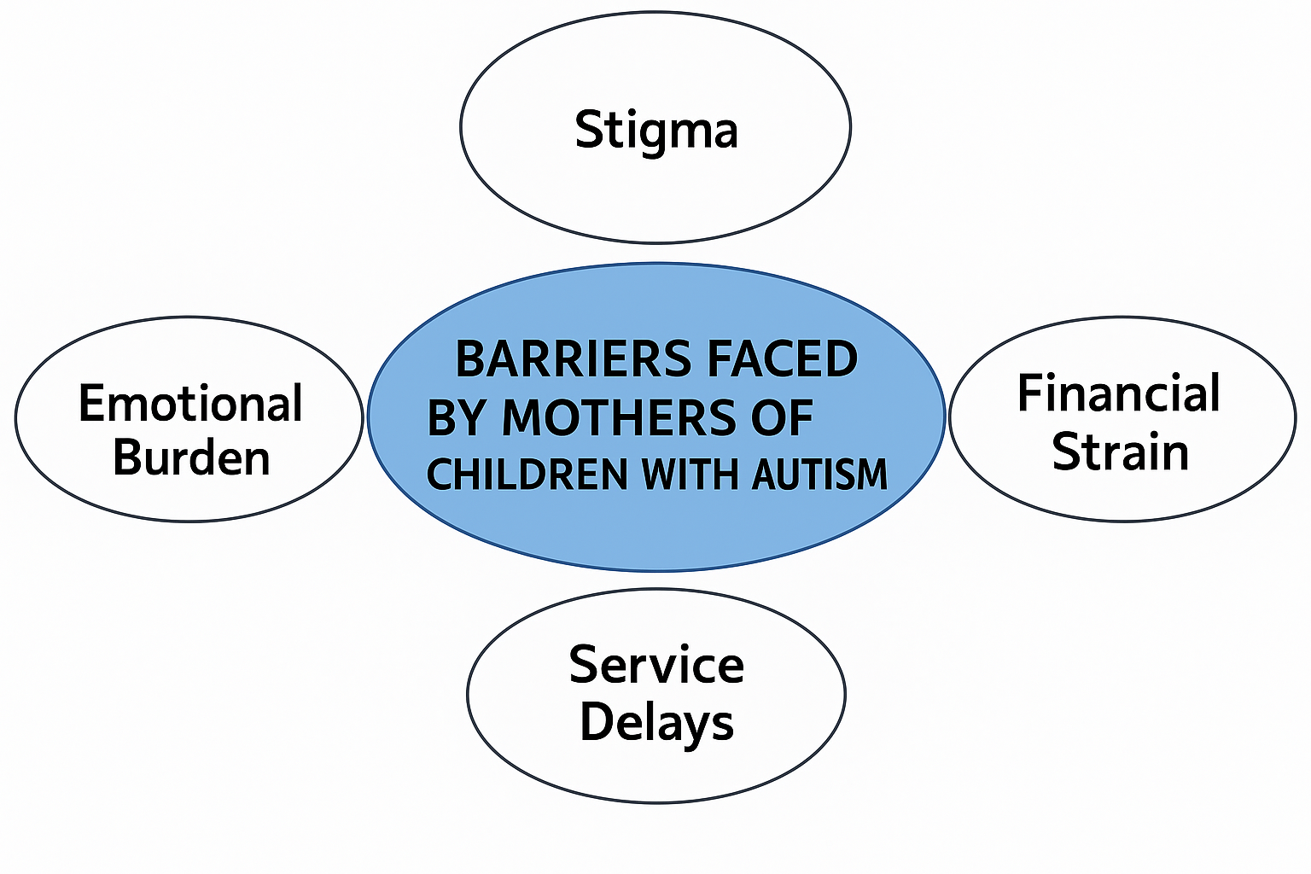
Figure 2: Barriers faced by mothers of children with autism
2.3 Identity, Role, and Lived Experience of Motherhood
Mothers of children with autism experience a significant shift in their concept of self, which is confronted by intricate emotional, social, and institutional pressures. Mothering in such situations typically entails an interruption of assumptions that prompts women to rescript what it means to mother in a world that centralizes "perfect" children (Landsman, 2009). The moment of diagnosis is not merely a medical one but an existence one, reshaping a mother's concept of function and potential, as she is necessarily drawn into the roles of advocate, therapist, and service coordinator (Ryan and Runswick-Cole, 2008).
This identity transformation is characterized by loneliness and responsibility. Ooi et al. (2016) note how autistic diagnosis would historically call for grief, denial, and self-blame, especially when the mothers are not ready for the caregiving role. Most women lose their pre-diagnosis self and are compelled to reconstruct themselves in the settings of disability, motherhood, and activism (Landsman, 2009). This shift is further exacerbated by the fact that broader society is likely to devalue or dismiss the experiential knowledge of such mothers, recognizing their emotional observations as denial and not as clear observations of what is occurring to their child (Landsman, 2009).
Furthermore, as Kerr and McIntosh (2000) describe, peer support may be a key means of re-establishing agency for mothers by shared experience with others who have similar problems. Such relationships can facilitate resilience and reworking of motherhood as an unbroken and highly educated identity, instead of one of diminished or tragic proportions. Such support relationships fragment overarching medicalized discourses and create space for different meanings built upon experience (Ryan and Runswick-Cole, 2008).
Finally, the embodied experience of mothering an autistic child is not fixed; it is a dynamic negotiation, accommodation, and process of growth that revises not only maternal roles but the very concept of what able and successful parenting is (Ooi et al., 2016).
2.4 Social Stigma and Isolation
Mothers of children with autism spectrum disorder (ASD) are commonly faced with different aspects of stigma that permeate their psychological health and social inclusion. Stigma occurs at structural and interpersonal levels, with mothers facing public negative views, internalized shame, and exclusion (Ng and Ng, 2022). These encounters can be profoundly isolating when autistic behaviors are not well understood by communities, leading mothers to maintain public spaces at arm's length in order to avoid criticism or attack (Ooi et al., 2016).
One of the very potent types of stigma is termed "affiliate stigma," which is used to account for self-stigma among individuals who are closely related to someone with a disability. It has been found in research that affiliate stigma elevates parental distress, reduces satisfaction with life, and results in withdrawal from society (Lei and Kantor, 2025). In cultures where there is a high emphasis on family reputation or "face," as found in collectivist cultures, this shame is augmented and typically amplified by social pressure to meet normative expectations of motherhood and fatherhood (Yassin, 2023). These cultural expectations can lead caregivers, particularly mothers, to internalize feelings of guilt and to attribute fault to themselves for the child's behavior.
Stigma is also perpetuated in educational and health settings, where there is low awareness about autism that leads to exclusion of the children and their families (Ng and Ng, 2022). Hotez et al. (2024) note that most healthcare professionals are culturally incompetent to meet the different needs of autistic individuals and their families and proceed to offer suboptimal support as well as enhance feelings of alienation.
The emotional impact of stigma goes beyond fleeting humiliation. Burnout and continuous stress, generally in the absence of supportive social or institutional cushioning, are the consequences of repeated encounter (Yassin, 2023). Reducing stigma therefore demands not just community-based education, but systemic reform in health, education, and policy systems to guarantee inclusion and respect for autists and caregivers alike.
2.5 Support Systems and Coping Strategies
Parents of children with autistic spectrum disorder (ASD) experience a vast range of daily challenges, and hence good coping mechanisms and good support systems are critical to their well-being. These challenges usually mean more stress, anxiety, and depression in parents, especially mothers, who are usually the ones to take care of most of the time (Lai et al., 2015). Literature repeatedly shows that the use of adaptive coping mechanisms—like cognitive reframing and social support seeking—is linked to improved mental health adjustment and family adaptation (Ooi et al., 2016).
Problem-focused coping mechanisms are especially useful in the alleviation of depression and anxiety symptomatology, particularly in cultures such as the Asian cultures, whereby emotional expression is less likely (Lin et al., 2011). Formal and informal support is a key buffer against psychological morbidity. Support groups have been shown to enhance parent–child interaction and decrease caregiver burden (Lin et al., 2011). On the other hand, lack of such support is linked with isolation and poor family cohesion.
ABCX model employed by Pozo et al. (2014) indicates the position that family adaptation holds between variables like child behavior, social support, and coping. Families using positive or problem-focused coping are found to have greater psychological well-being, while those using avoidance coping show high stress levels and poor adaptation outcome.
Cultural background also affects how parents look for help. Internalization of fear by some Asian families due to shame or social expectation to preserve 'face' leads to them potentially excluding external support systems even when they are filled with it (Lin et al., 2011). Therefore, culturally appropriate interventions enhancing social networks and sound coping mechanisms are vital in maintaining such families' mental health and level of resilience at par (Ooi et al., 2016; Lai et al., 2015).
2.6 Mothers as Advocates and Navigators
The parents of children with autism spectrum disorder (ASD) become the dual role of primary care giver and frontline advocate as they work through complex education, health, and social systems that are often not equipped to cater to their children's needs. Advocacy, in this case, entails negotiating complex services, translating professional speak, and intruding repeatedly on behalf of their children to gain rightful care (Khalil et al., 2025). They are often bolstered by cultural and systemic barriers. For example, Asian American mothers have racial and language discrimination, limited culturally competent providers, and stigmatization in their community, all of which hinder intervention and limit access to services (Khalil et al., 2025).
The advocacy pressure of stress is compounded even further when mothers themselves are neurodivergent. Mothers who are autistic have described experiences of being ignored or criticized by professionals, resulting in increased stress and reduced trust in statutory systems (Radev et al., 2024). Mothers outline their advocacy as a constant "battle," reflecting system rigidity and deficit practice that discounts both their parenting and lived experience (Radev et al., 2024).
Social support also moderates in the same processes. Sufficient instrumental and emotional support can cushion advocacy stress and enhance the quality of life in mothers, while lacking support can enhance psychological burden and helplessness (Wang et al., 2022).
2.7 Intersectionality and Cultural Variability
Mothers whose children have autism are provided with care in Saudi Arabia deeply intersectionally and culturally, where religious belief, ethnic expectations, and gender roles all play significant roles in affecting their challenge and role. Mothers in Saudi Arabia, for instance, may be expected to carry the sole caregiving and emotional burden amidst expected gender roles and face societal condemnation by means of religious and cultural misunderstandings of disability (Yassin, 2023). This combination of motherhood, religiosity, and stigmatization is known to result in help-seeking delay, internalized blame, and constricted social support.
Analogously, Chinese autism care mothers have pressures related to sustaining family "face" and preventing shame derived from Confucian beliefs concerning harmony and respect (Ng and Ng, 2022). Such forms of cultural expectations may discourage discussion of autism or even the utilization of outside assistance and thus encourage seclusion. These culture-derived barriers demonstrate that mothers' experiences cannot be identical and need to be contextualized so that they can be functional support systems.
2.8 Gaps in the Literature
Although there is much that existing research has to offer mothers raising autistic children, it is lacking. The majority of the studies concentrate on educated, Western, middle-class communities and thus are silencing the Global South and marginalized voices (Lei and Kantor, 2025). Longitudinal studies seeking to describe how mothers' roles, coping, and mental health change over the course of life are also limited (Ng and Ng, 2022). Few studies address the convergence of caregiving, gender scripting, and cultural stigma, particularly in collectivist cultures where family reputation can conflict with help-seeking behaviors (Yassin, 2023). Moreover, the paternal voice is still underemphasized, and too much narrative burden is given to mothers without full context to family systems (Pozo et al., 2014). Lastly, although the application of qualitative methods is broad-based, mixed-method integration is uncommon and offers limited scope for contextualized, elaborate understanding (Lai et al., 2015). These gaps highlight the relevance of culturally responsive, inclusive, and longitudinal study designs.
2.9 Significance of the Study
This research draws more deeply into the social, cultural, and emotional construction of motherhood with autism. Focusing on centering the voices of mothers—specifically in marginalized cultural contexts—is bridging relevant silences in intersectionality, advocacy, and lived experiences literature. The findings have important implications for more responsive support systems, culturally responsive policy, and professional health and education practice. This study also provides an opening for further research on system change and parental well-being, especially in non-Western cultures where such viewpoints are lacking.

REFERENCES
Abdelrazek, M.E.G. and Rice, F., 2021. Maternal stress in pregnancy and child autism spectrum disorder: Evaluating putative causal associations using a genetically informed design. BJPsych Open,7(S1), pp.S62–S63.
Alenezi, S. et al., 2024. Raising hopes, facing challenges: Understanding parental well-being in the midst of autism in Saudi Arabia. Behavioral Sciences, 14(7), p.531.
American Psychiatric Association, 2013. Diagnostic and Statistical Manual of Mental Disorders (5th ed.). Washington, DC: APA.
Arslan, A., 2009. Orff Schulwerk elementary music applications in interdisciplinary education in chair of primary school education. Procedia - Social and Behavioral Sciences, 1(1), pp.2546–2551.
Asselin, M.E., 2003. Insider research: Issues to consider when doing qualitative research in your own setting. Journal for Nurses in Staff Development, 19(2), pp.99–103.
Avery, M., 1999. The mother’s story: A narrative of disability and identity. Disability & Society, 14(2), pp.117–128.
Baio, J. et al., 2018. Prevalence of Autism Spectrum Disorder Among Children Aged 8 Years—Autism and Developmental Disabilities Monitoring Network, 11 Sites, United States, 2014. MMWR Surveillance Summaries, 67(6), pp.1–23.
Braun, V. and Clarke, V., 2006. Using thematic analysis in psychology. Qualitative Research in Psychology, 3(2), pp.77–101.
Chesney, B.K. and Chesler, M.A., 1993. Cancer and self-help: Bridging the troubled waters of childhood chronic illness. Journal of Pediatric Psychology, 18(3), pp.265–281.
Clarke, V. and Braun, V., 2006. Thematic analysis. In: Lyons, E. and Coyle, A., eds. Analyzing Qualitative Data in Psychology. London: SAGE, pp.35–50.
Constantino, J.N. and Charman, T., 2016. Diagnosis of autism spectrum disorder: Reconciling the syndrome, its diverse origins, and variation in expression. The Lancet Neurology, 15(3), pp.279–291.
Corbin Dwyer, S. and Buckle, J.L., 2009. The space between: On being an insider-outsider in qualitative research. International Journal of Qualitative Methods, 8(1), pp.54–63.
Ely, M., Anzul, M., Friedman, T., Garner, D. and Steinmetz, A.M., 1991. Doing qualitative research: Circles within circles. London: Falmer Press.
Fairthorne, J., Hammond, G. and Bourke, J., 2014. Maternal mental health of children with ASD in Western Australia. Autism Research, 7(2), pp.214–227.
Fombonne, E., 2009. Epidemiology of pervasive developmental disorders. Pediatric Research, 65(6), pp.591–598.
Gadre, P. and Mardhekar, V., 2015. Emotional health of mothers caring for children with developmental disorders. Indian Journal of Psychology, 52(3), pp.21–28.
Goffman, E., 1963. Stigma: Notes on the management of spoiled identity. Englewood Cliffs: Prentice Hall.
Gupta, A., Srivastava, P. and Devi, R.S., 2008. Use of geospatial technology for studies of catchment area of Loktak Lake. Proceedings of the National Academy of Sciences, India Section B: Biological Sciences, pp.131–143.
Hastings, R.P. et al., 2005. Parenting stress in mothers and fathers of children with autism spectrum disorders and psychological adjustment: The role of coping strategies and social support. Journal of Autism and Developmental Disorders, 35(2), pp.221–232.
Hotez, E., Phan, J.M. and Truong, D.M., 2024. Addressing stigma-related health disparities for autistic individuals through cultural compatibility. Current Psychiatry Reports, 26, pp.761–770.
Jungmair, M., 2003. Making elementary music: Spontaneous activation and automatic realization. Procedia - Social and Behavioral Sciences, 1(1), pp.2546–2551.
Kementrian Kesehatan Republic Indonesia, 2018. Basic Health Research (Riskesdas). Jakarta: Ministry of Health.
Kerr, S.M. and McIntosh, J.B., 2000. Coping when a child has a disability: exploring the impact of parent-to-parent support. Child: Care, Health and Development, 26(4), pp.309–322.
Khalil, A., Kim, A., Christie, N. and Zhou, X., 2025. Help-seeking experiences of Asian American parents of children with autism: A qualitative study. Journal of Child and Family Studies, 34, pp.1225–1240. https://doi.org/10.1007/s10826-025-03061-8
Lai, W.W., Goh, T.J., Oei, T.P.S. and Sung, M., 2015. Coping and well-being in parents of children with autism spectrum disorders (ASD). Journal of Autism and Developmental Disorders, 45(8), pp.2582–2593.
Landsman, G.H., 2009. Reconstructing motherhood and disability in the age of “perfect” babies. New York: Routledge.
Lei, X. and Kantor, J., 2025. Face concern and affiliate stigma in caregivers of children with developmental disabilities: A cross-sectional study in southwest China. International Journal of Developmental Disabilities. https://doi.org/10.1080/20473869.2025.2511667
Lin, L.Y., Orsmond, G.I., Coster, W.J. and Cohn, E.S., 2011. Families of adolescents and adults with autism spectrum disorders in Taiwan: The role of social support and coping in family adaptation and maternal well-being. Research in Autism Spectrum Disorders, 5(1), pp.144–156.
Lin, X. et al., 2023. Association between mothers’ emotional problems and autistic children’s behavioral problems: The moderating effect of parenting style. International Journal of Environmental Research and Public Health, 20(5), p.4593.
Maenner, M.J. et al., 2020. Prevalence of Autism Spectrum Disorder Among Children Aged 8 Years—Autism and Developmental Disabilities Monitoring Network, 11 Sites, United States, 2016. MMWR Surveillance Summaries, 69(4), pp.1–12.
Mak, W.W.S. and Cheung, R.Y.M., 2008. Affiliate stigma among caregivers of people with intellectual disability. American Journal on Mental Retardation, 113(3), pp.228–237.
Mak, W.W.S. and Ho, T.P., 2007. Caregiver burden of families of ethnic minority children with developmental problems. Journal of Clinical Psychology, 63(4), pp.387–398.
Naicker, S., 2012. A dictionary of South African Indian English. Language Matters, 43(1), pp.117–123.
Ng, C.S.M. and Ng, S.S.L., 2022. A qualitative study on the experience of stigma for Chinese parents of children with autism spectrum disorder. Scientific Reports, 12, p.19550.
Ooi, K.L., Ong, Y.S., Jacob, S.A. and Khan, T.M., 2016. A meta-synthesis on parenting a child with autism. Neuropsychiatric Disease and Treatment, 12, pp.745–762.
Ooi, K.L., Ong, Y.S., Jacob, S.A. and Khan, T.M., 2016. A meta-synthesis on parenting a child with autism. Neuropsychiatric Disease and Treatment, 12, pp.745–762.
Ooi, K.L., Ong, Y.S., Jacob, S.A. and Khan, T.M., 2016. A meta-synthesis on parenting a child with autism. Neuropsychiatric Disease and Treatment, 12, pp.745–762.
Orff, C., 1931. The beginning point is the human being. Procedia - Social and Behavioral Sciences, 1(1), pp.2546–2551.
Papadopoulos, D., 2021. Mothers’ experiences and challenges raising a child with autism spectrum disorder: A qualitative study. Brain Sciences, 11(3), p.309.
Penley, J.A., Tomaka, J. and Wiebe, J.S., 2002. The association of coping to physical and psychological health outcomes: A meta-analytic review. Journal of Behavioral Medicine, 25(6), pp.551–603.
Pereira, A.S. et al., 2021. Savoring as an intervention to decrease negative affect in anxious mothers of children with autism and neurotypical children. Brain Sciences, 11(5), p.652.
Pozo, P., Sarriá, E. and Brioso, A., 2014. Family quality of life and psychological well-being in parents of children with autism spectrum disorders: A double ABCX model. Journal of Intellectual Disability Research, 58(5), pp.442–458.
Radev, S., Freeth, M. and Thompson, A.R., 2024. ‘I’m not just being difficult... I’m finding it difficult’: A qualitative approach to understanding experiences of autistic parents when interacting with statutory services. Autism, 28(6), pp.1394–1404. https://doi.org/10.1177/13623613231212794
Rahmatuz, Z. and Allenidekania, A., 2020. Mothers’ experience in taking care of children with special needs: A literature review. Indonesian Journal of Disability Studies, 7(1), pp.8–18.
Rice, C.E. et al., 2022. Defining in Detail and Evaluating Reliability of DSM-5 Criteria for Autism Spectrum Disorder Among Children. Journal of Autism and Developmental Disorders, 52, pp.5308–5320.
Rose, G., 1985. Visual methodologies: An introduction to the interpretation of visual materials. International Journal of Qualitative Methods, 8(1), pp.54–63.
Ryan, S. and Runswick-Cole, K., 2008. From advocate to activist? Mapping the experiences of mothers of children on the autism spectrum. Journal of Applied Research in Intellectual Disabilities, 21(1), pp.43–53.
Seligman, M. and Darling, R.B., 2007. Ordinary families, special children: A systems approach to childhood disability. 3rd ed. New York: Guilford Press.
Todd, S. and Jones, S., 2003. ‘Mum’s the word!’: maternal accounts of dealings with the professional world. Journal of Applied Research in Intellectual Disabilities, 16(3), pp.229–244.
Topses, N., 1982. Theoretical foundations of education. Procedia - Social and Behavioral Sciences, 1(1), pp.2546–2551.
Traustadottir, R., 1991. Mothers who care: Gender, disability, and family life. Journal of Family Issues, 12(2), pp.211–228.
Voysey, M., 1972. Behind closed doors: A study of families in a London borough. London: Allen Lane.
Wang, Z., Wang, L., Chang, S. and Wang, H., 2022. The mediating effect of parenting stress on the relationship between social support and quality of life in parents of children with autism spectrum disorder: A meta-analytic structural equation modeling. Frontiers in Psychiatry, 13, 713620. https://doi.org/10.3389/fpsyt.2022.713620
Winarsih, M. et al., 2013. The impact of parenting on children with disabilities. Journal of Child Development Studies, 4(2), pp.45–54.
Yassin, R., 2023. Stress, anxiety and depression in parents of autistic children in Saudi Arabia. PhD Thesis. University of Lincoln.
Zakrocka, M., Gruszka, M., Polańska, P. and Kubicka, M., 2025. Autism spectrum disorder: definition, global epidemiology, prevalence in Poland and worldwide, and heredity. Journal of Education, Health and Sport, 78, Article 57619.

