Component 2: Written Report

A Critical Analysis of SDG 3 (Good Health and Wellbeing) and SDG 13 (Climate Action)

Student Name: Patrisha Devollaj
Student ID: 2223485
BMHP6030 - Health, Wellbeing and Sustainable Development

Table of Contents
1. Introduction 3
2. Section 1 – SDG 3: Good Health and Wellbeing 3
2.1 Overview of SDG 3 3
2.2 Critical Evaluation of Global Policies and Initiatives 4
2.3 Critical Evaluation of National and Local Examples 5
2.4 Use of Theories 6
2.5 Recommendation 6
3. Section 2 – SDG 13: Climate Action 6
3.1 Overview of SDG 13 6
3.2 Critical Evaluation of Global Policies and Initiatives 7
3.3 Critical Evaluation of National and Local Examples 8
3.4 Use of Theories and Models 8
3.5 Recommendation 9
4. Conclusion 9
References 10

Introduction
Wellbeing and good health are integrally connected with the process of sustainable development because the wellbeing of people depends on their access to healthcare services, inequality in society, economy, and environmental conditions. The present report is grounded on SDG 3: Good Health and Wellbeing and SDG 13: Climate Action. SDG 3 is devoted to the provision of healthy living conditions and the promotion of well-being for everybody regardless of gender, race, or income level. Universal health care coverage and prevention of avoidable deaths are the aims of SDG 3 (Martin, 2023). SDG 13 is also important due to the influence of climate change on health as a result of heat waves, floods, air pollution, food shortages, and infectious diseases. WHO claims that there will be 250,000 additional deaths per year due to climate change from 2030 to 2050 (WHO, 2023).

Section 1 - SDG 3: Good Health and Wellbeing

Overview of SDG 3
Goal 3 of the Sustainable Development Goals is the attainment of healthy lifestyles through improved well-being of all individuals across all ages. This goal seeks to address the issue of reduction in maternal and child mortality, ending the epidemic, reducing the number of premature deaths associated with non-communicable diseases, improving mental health and substance abuse, and ensuring universal health coverage among other issues, including safe and affordable drugs (Brymer et al, 2022). Even though the SDGs have achieved certain goals concerning health issues, there are inequalities in the outcomes of such measures. For example, it was reported that in 2023, 133 countries met the SDG targets of under-five mortality, and AIDS deaths were reduced by 50% due to increased access to medication (United Nations, 2025). However, healthcare alone cannot achieve SDG 3. Factors like poverty, housing, and employment also play crucial roles. Education, environment, and social inequalities are some of the other factors influencing the outcome of people’s health (Chelak et al., 2023).
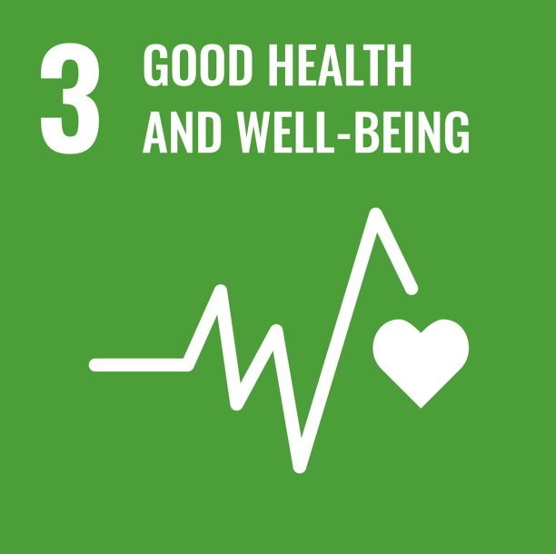

Figure 1: Sustainable Development Goal 3
Source: Good Health and Wellbeing (United Nations, 2025)

Critical Evaluation of Global Policies and Initiatives
One of the important global policy frameworks for SDG 3 includes the concept of Universal Health Coverage (UHC). It aims at providing individuals with access to high-quality health care without facing any financial difficulties (WHO, 2023). However, its implementation remains insufficient in terms of coverage all over the world. The World Bank reveals that there are still around 4.6 billion individuals without access to essential health care services and 2 billion people face serious financial difficulties related to health care expenses (World Bank, 2025). This proves that UHC is a key policy objective, but its implementation is limited by the presence of poverty, an ineffective health care system, and a shortage of human resources in high-income countries.
Other organizations such as the WHO, the UN, the World Bank, NGOs, and governments also play an important role in global health governance. The WHO sets up international health standards, conducts emergency responses and technical support, while the World Bank supports health systems and poverty reduction. NGOs provide primary health care in disaster and deprived areas (Rezaei, 2024). However, political instability and donor dependency, as well as the imbalance of power among countries, might negatively impact global policies. Therefore, global health policies may set up very high hopes, but only the ability of the nations can achieve the desired results (Kickbusch et al., 2022).

Critical Evaluation of National and Local Examples
The core20PLUS5 strategy and the NHS long-term plan are important strategies for addressing health inequalities in England. Core20PLUS5 targets the 20% most deprived population group and the five priority areas that have to be addressed urgently (NHS England, 2024). The NHS is a universal healthcare system; however, this does not mean that all people can use it. Income deprivation, poor housing conditions, lack of health literacy, transportation problems, and limited access to preventive services are the main barriers for the population in deprived regions. As a result of this, the diagnoses are often made too late and the outcome is poor. Core20PLUS5 is the beginning of targeted actions, but it still needs proper funding and staffing (Norris et al., 2025).
The NHS Health Check Program is aimed at identifying the early symptoms of heart disease, diabetes, kidney disease and dementia in adults between 40-74 years old to prevent them from progressing (NHS, 2023). Nonetheless, there is inconsistency in terms of uptake and referral pathways, while services have been affected by the COVID-19 pandemic as well (Gadsby et al., 2023). It means that provision of health care services alone is not sufficient, as deprived areas require tailored approaches to overcome the social barriers.
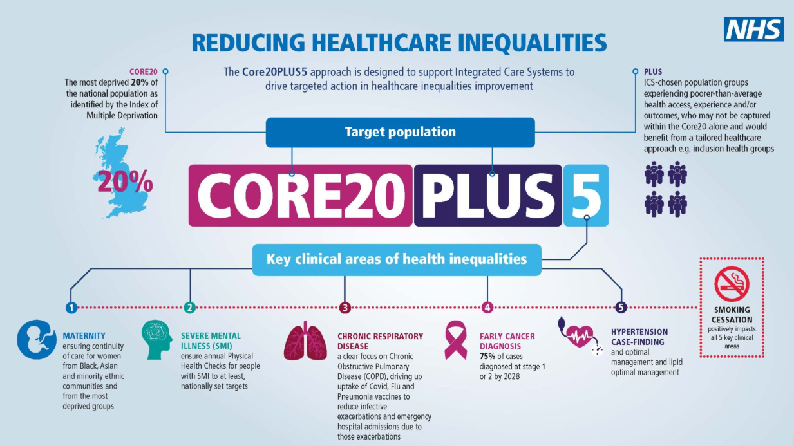
Figure 2 : Core20 Plus 5 (NHS England, 2025)

Use of Theories
The Health Belief Model can help in evaluating the NHS Health Check as it will enable one to comprehend the reasons for which certain individuals may or may not practice preventive measures. The likelihood of participation increases when an individual perceives themselves to be at risk, the severity of the disease, the benefits, and perceived self-efficacy (Alyafei et al., 2024). However, low health literacy, work-related problems, inadequate transportation facilities, lack of access to digital resources, and distrust may be among the barriers to participation. A logic model is another tool that can facilitate the evaluation of this programme through the linkage of inputs, activities, outputs, and outcomes. Poor participation among deprived individuals may lead to the failure to reduce health inequalities (Voss et al., 2025).

Recommendation
There must be a push for NHS Health Checks to target deprived communities, ethnic minorities, and people with low health literacy. The outreach program must take place in community centers, workplaces, religious institutions, and pharmacies rather than with general practitioners. While technology-driven health checks will increase accessibility, they cannot serve as an alternative to face-to-face service delivery since the digital divide could make health inequalities even worse (NHS England, 2024). In addition, there must be increased local accountability, transparent data, and ring-fenced funding for deprived areas, with Core20PLUS5 also considered. Finally, behavior change guidance needs to go hand-in-hand with the practical help in the form of affordable physical activity programs, smoking cessation, healthy food, and social prescribing. In case those measures do not get implemented, SDG 3 policies will end up being responsible for individualizing the problem of poor health conditions (United Nations, 2025).

Section 2 – SDG 13: Climate Action

Overview of SDG 13
Goal 13 draws attention to the importance of taking actions on climate change through resilience building, climate consideration in policy making, and development of adaptation capacity (United Nations, 2025). It is directly connected to SDG 3 since the effects of climate change have implications for the death rate, respiratory diseases, heart conditions, mental health, and health disparities. Heat waves, flooding, fires, storms, and the shift in diseases have been identified as health risks by the WHO. SDG 13 assumes that currently there are 3.6 billion people who live in extremely vulnerable places, and by 2030-2050, there will be 250,000 people dying each year due to malnutrition, malaria, diarrhea, and heat stress (WHO, 2023).

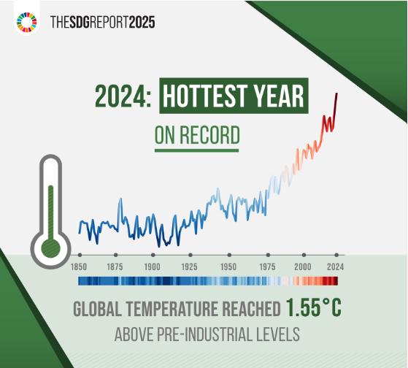
Figure 3: SDG 13 Climate Change (Martin, 2023a)

Critical Evaluation of Global Policies and Initiatives
The Paris Agreement is the key international instrument for SDG 13. The Agreement will oblige countries to curb the rise in temperature and take measures for mitigation, adaptation, and financing related to climate (Filho et al, 2023). It works internationally, and that is its biggest advantage. However, progress will require political will, financing, and national capacities. It is very significant in terms of SDG 3 because vulnerable groups will be more exposed to the consequences of climate change impacts on their health, and they usually lack a well-developed health-care system. Indeed, climate change has been described as “a health-risk multiplier” (World Bank, 2025) and may push 44 million people into extreme poverty by 2030.

Critical Evaluation of National and Local Examples
Climate change is seen as a health issue in the UK. According to UKHSA, climate change is increasing extreme weather occurrences, including heatwaves (UKHSA, 2024). The health risks associated with it relate to SDG 3, as the vulnerable groups include older adults, children, chronically ill individuals, and individuals who live in poor-quality housing conditions and have a higher vulnerability to heat, breathing issues, and disruptions of services. Flooding has a negative impact on mental wellbeing. According to Dodd et al. (2024), the populations in the UK that were affected by floods were experiencing distress, fear, and anxiety about future floods.

NHS Net Zero is important for the whole nation since carbon emissions occur during the provision of care. By 2040, NHS England plans to achieve net-zero emissions in its areas of control and, by 2045, also achieve net-zero emissions in areas that it could influence, such as supply chain and service delivery Greener NHS, 2022). This would help achieve SDG 13 while protecting SDG 3. However, this cannot be achieved owing to the difficulties presented by aging buildings, lack of finances, procurement, and the need for safe treatment.

Progress on this front has been uneven owing to the Birmingham Clean Air Zone. According to Liu et al. (2023), there has been a reduction in roadside NO2 and NOx emissions; however, there has been no significant reduction in PM2.5 emissions. This limits the benefits of SDG 3 as PM2.5 has strong links with health problems. The policy may be unfair as it imposes costs on low-income earners, taxi drivers, and small firms.

Use of Theories and Models
Climate and health issues are interconnected. For example, air pollution is related to transportation, housing, poverty, respiratory diseases, and economic development. One such issue in Birmingham is the Clean Air Zone, which helps in reducing the level of nitrogen dioxide, while having little impact on the reduction of PM2.5; therefore, it requires additional actions regarding public transport, industry, urban design, and human behaviour (South et al., 2025). This example shows the connection between SDG 13 and SDG 3, proving that health effects cannot be achieved without clinical intervention alone.
The Triple Bottom Line model assesses impacts on people, planet, and economics. The “planet” part is provided by NHS Net Zero and Clean Air Zone, which contribute to the decrease in emissions and air pollution (Tapa et al., 2025). However, the “people” aspect is underdeveloped if poor inhabitants or small firms have to face the extra expenses. The better environment should not become a cause for social injustice.

Recommendation
Recommendations should be made about upstream determinants of health. National-level policy would need to link emissions reductions with adaptations like heatwave planning, flood-resistant housing, tree planting and protection in cities, and protection of people who have chronic conditions. Funding of buildings, energy, procurement, and low-carbon care pathways is necessary for NHS Net Zero (Tapa et al., 2025). Grants, cheap public transport, taxi assistance, and exemptions for vulnerable people should be included in Clean Air Zones. Health impact assessment of local authorities would help determine the impact of benefits on deprived communities (South et al., 2025). In general, SDG 13 needs to be connected with SDG 3 because clean air, housing, and climate resilience are necessary for good health.

Conclusion
From the above discussion, it is evident that SDG 3 and SDG 13 have a correlation because access to healthcare, social inequality, environment, and climate have an impact on the health and well-being of people. SDG 3 initiatives such as Universal Health Coverage, Core20PLUS5, and NHS Health Check contribute to preventing and promoting health inequalities; however, their effectiveness depends on whether deprived areas can gain access to them. Positive progress has been made regarding SDG 13 initiatives like the Paris Agreement, NHS Net Zero and Birmingham's Clean Air Zone; however, there are challenges in terms of equity.

References

Alyafei, A. and Easton-Carr, R., 2024. The health belief model of behavior change. StatPearls.
Brymer, E. and Lacaze, A.M., 2022. An overview of Sustainable Development Goal 3. The Routledge handbook of sport and sustainable development, pp.69-81.
Chelak, K. and Chakole, S. (2023) “The role of social determinants of health in promoting health equality: a narrative review,” Cureus, 15(1). Available at: https://doi.org/10.7759/cureus.33425.
Dodd, S. et al. (2024) “Health Impacts of Climate Change in the UK: A Qualitative Synthesis Detailing the Conjuncture of Social Structure, Extreme Weather, and Mental Health,” SSM - Qualitative Research in Health, 6(45), pp. 100475–100475. Available at: https://doi.org/10.1016/j.ssmqr.2024.100475.
England, N. (2024) NHS England » Core20PLUS5 (adults) – an approach to reducing healthcare inequalities, England.nhs.uk. Available at: https://www.england.nhs.uk/about/equality/equality-hub/national-healthcare-inequalities-improvement-programme/core20plus5/?utm_source=chatgpt.com.
Filho, W.L., Wall, T., Salvia, A.L., Dinis, M.A.P. and Mifsud, M., 2023. The central role of climate action in achieving the United Nations' Sustainable Development Goals. Scientific Reports, 13(1), p.20582.
Greener NHS (2022) Greener NHS » Delivering a net zero NHS, England.nhs.uk. Available at: https://www.england.nhs.uk/greenernhs/a-net-zero-nhs/?utm_source=chatgpt.com.
Kickbusch, I. and Liu, A. (2022) “Global Health Diplomacy—reconstructing Power and Governance,” The Lancet, 399(10341). Available at: https://doi.org/10.1016/s0140-6736(22)00583-9.
Liu, B. et al. (2023) “Assessing the Impacts of Birmingham’s Clean Air Zone on Air Quality: Estimates from a Machine Learning and Synthetic Control Approach,” Environmental and Resource Economics, 86(77). Available at: https://doi.org/10.1007/s10640-023-00794-2.
Martin (2023a) Climate Change - United Nations Sustainable Development, United Nations Sustainable Development. Available at: https://www.un.org/sustainabledevelopment/climate-change/?utm_source=chatgpt.com.
Martin (2023b) Health - United Nations Sustainable Development, United Nations Sustainable Development. Available at: https://www.un.org/sustainabledevelopment/health/?utm_source=chatgpt.com.
Norris, K.L., Melton, M., Lopez, K., Rotellini, D. and Valentino, L.A., 2025. From Vision to Action: National Bleeding Disorders Foundation’s Roadmap for Achieving Health Equity, Diversity, and Inclusion. Health Equity, 9(1), pp.heq-2024.
Rezaei, N. ed., 2024. Integrated science for sustainable development goal 3: empowering global wellness initiatives (Vol. 25). Springer Nature.
South, D.W. and Alpay, S., 2025. Analyzing global progress on United Nations Sustainable Development Goals 7 and 13—clean energy and climate action. Climate and Energy, 41(9), pp.23-32.
Tapa, I.G.F.S., Ramadhan, S., Arafat and Sitio, N.M., 2025, November. Community-based Pyrolysis Technology for Plastic-to-Fuel Innovation in East Java: Integrating the Triple Bottom Line and Business Model Canvas for Climate Resilience and SDG Achievement. In IOP Conference Series: Earth and Environmental Science (Vol. 1563, No. 1, p. 012012). IOP Publishing.
UK Health Security Agency (2024) Health Effects of Climate Change (HECC) report, GOV.UK. Available at: https://www.gov.uk/guidance/health-effects-of-climate-change-hecc-report?utm_source=chatgpt.com.
United Nations (2022) Goal 3 | Department of Economic and Social Affairs, Un.org. Available at: https://sdgs.un.org/goals/goal3?utm_source=chatgpt.com.
United Nations (2025) — SDG Indicators, Un.org. Available at: https://unstats.un.org/sdgs/report/2025/Goal-03/?utm_source=chatgpt.com.
World Bank (2025) Climate Change | World Bank Group, Worldbank.org. Available at: https://www.worldbank.org/ext/en/topic/climate-change.
World Bank (2025) Universal Health Coverage | World Bank Group, Worldbank.org. Available at: https://www.worldbank.org/ext/en/topic/health/universal-health-coverage?utm_source=chatgpt.com.
World Health Organization (2023) Climate change, Who.int. World Health Organization: WHO. Available at: https://www.who.int/news-room/fact-sheets/detail/climate-change-and-health?utm_source=chatgpt.com.
World Health Organization and The World Bank (2023) Tracking universal health coverage. World Health Organization.

