UNIVERSITY OF WALES TRINITY SAINT DAVID
London campus
Assignment 1
Software Solutions for Business

Module Name: Software Solutions for Business

Module Code: ACCA4026

Student Name: Raymark Karl Limson
Student ID: 2538132
Group: 1

Lecturer’s Name: Rajeev Nath

Table of Contents
Introduction 1
Task 1. e-Commerce Website builders/software solutions 1
1.1 Wix 1
1.2 Shopify 1
Task 2. Mind-map of contemporary software applications 1
2.1 Describe mind mapping and explain the benefits of using mind mapping 1
2.2 Create a mind map of contemporary software applications 2
Task 3. Office Applications 2
3.1 Four office software solutions for business operations 2
Ms Word 2
Ms Excel 2
Ms PowerPoint 2
Ms Access 2
3.2 Test any two features 2
Mail Merge 2
IF Statement 3
Task 4. Communication and Collaboration applications 3
4.1 One contemporary Communication and one Online Collaboration 3
Gmail 3
Zoom 3
4.2 Test one feature of a freely available Communication (1) and one feature of a Collaboration (1) application 3
Gmail 3
Zoom 3
Conclusion 4
References 4

Introduction
E-commerce has become one of the fastest-growing industries, allowing businesses to sell products and services online to customers worldwide. To build an online store, businesses use e-commerce website builders that provide tools for designing websites, managing products, processing payments, and handling customer orders. Choosing the right e-commerce platform is important because it affects the store's functionality, ease of use, cost, and ability to grow. This report compares two popular e-commerce website builders: Wix and Shopify.

Task 1. e-Commerce Website builders/software solutions

1.1 Wix

Wix offers a wide range of features that make it easy for users to build and manage an online store. Its drag-and-drop editor allows users to design websites without any coding knowledge, while its large collection of professional templates helps create attractive websites quickly. Wix also provides secure online payment options, inventory management, order tracking, and marketing tools such as email campaigns and search engine optimisation (SEO). In addition, users can install extra features through the Wix App Market to improve the functionality of their websites.
One of the biggest advantages of Wix is its ease of use, making it ideal for beginners and small business owners who have little or no web development experience. It offers affordable pricing plans, attractive templates, and reliable website hosting. Wix also includes built-in SEO tools, mobile-friendly website designs, and customer support to help users manage and grow their online businesses. Its all-in-one platform allows users to build, manage, and update their websites from a single dashboard.
Although Wix is a powerful website builder, it has some limitations. It is not as scalable as other e-commerce platforms, making it less suitable for large businesses with thousands of products. Once a website has been published, changing to a different template can be difficult without rebuilding the site. Some advanced features are only available through paid apps or higher-priced subscription plans, which can increase the overall cost.
Wix is best suited for small businesses, start-ups, freelancers, local shops, and individuals who want to create a professional online presence quickly and easily. It is an excellent choice for businesses that require a simple and affordable e-commerce solution without needing advanced technical skills.


Figure 1: Wix Official Homepage
The Wix homepage is where users begin creating their websites. It provides information about Wix's services, pricing plans, templates, and website-building tools. New users can sign up for an account, choose a website template, or use Wix's AI-powered website creator to build a website quickly.
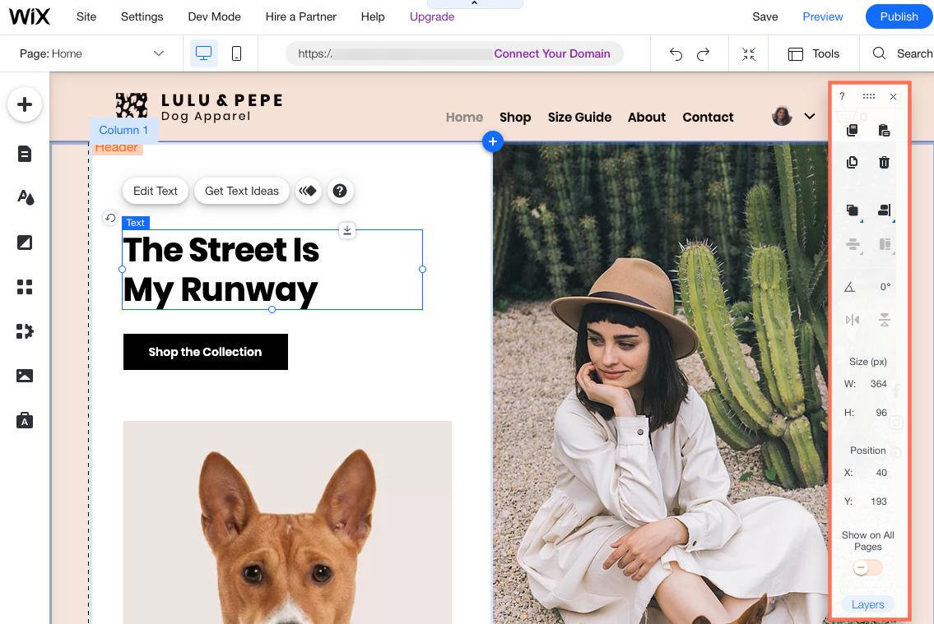
Figure 2: Wix Website Editor
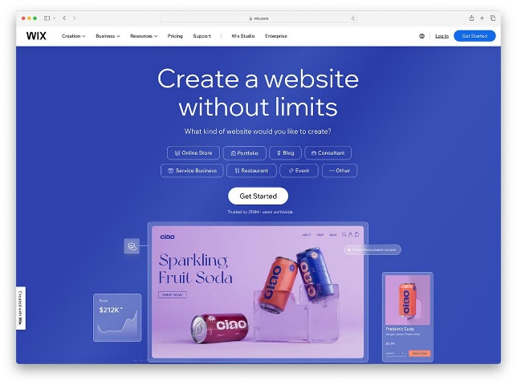
The Wix editor is one of its most important features. It allows users to drag and drop text, images, videos, buttons, and other website elements onto a page without writing any code. Users can customise colours, fonts, layouts, and menus while seeing changes in real time. This makes website creation simple for beginners and small business owners.
Figure 3: Wix E-commerce Store
This figure shows an example of an online store created using Wix. Products are displayed with images, descriptions, prices, and an "Add to Cart" button. Customers can browse products, make secure payments, and complete purchases online. This demonstrates how Wix supports businesses that want to sell products through an attractive and user-friendly website.

1.2 Shopify

Shopify is designed specifically for e-commerce and provides everything needed to run an online business. It includes tools for creating an online store, managing products, processing secure payments, tracking inventory, and handling customer orders. Shopify also offers detailed sales reports, shipping management, and support for selling through multiple channels such as Facebook, Instagram, Amazon, and TikTok. Thousands of apps and themes are available to customise stores and add extra functionality as business needs grow.
Shopify is highly reliable and offers powerful e-commerce features that help businesses manage their online stores efficiently. It provides excellent security, fast website performance, and a user-friendly interface. Businesses can easily manage products, process payments, and monitor sales using built-in analytics. Shopify is also highly scalable, allowing businesses to expand their product range and customer base without changing platforms. Its large app marketplace gives users access to many additional business tools.
Despite its many strengths, Shopify has some disadvantages. The monthly subscription plans are generally more expensive than many other website builders, and additional costs may be required for premium themes, apps, or advanced features. While basic customisation is simple, more advanced design changes often require knowledge of Shopify's Liquid programming language. Some payment methods may also include extra transaction fees if Shopify Payments is not used.
Shopify is most suitable for businesses that focus on online selling and expect to grow over time. It is ideal for medium-sized and large businesses, retailers with extensive product catalogues, and companies selling internationally. Businesses that require advanced inventory management, multi-channel selling, and professional e-commerce tools will benefit most from using Shopify.

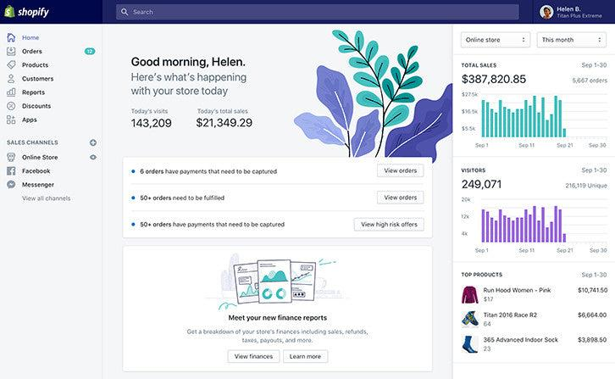
Figure 1: Shopify Admin Dashboard
The Shopify Admin Dashboard is the central control panel for managing an online business. Users can add products, monitor customer orders, update inventory, process payments, view sales reports, and manage shipping. The dashboard provides real-time business information, helping owners make informed decisions and efficiently run their stores.

Figure 2: Shopify Official Homepage the Shopify homepage introduces users to the platform and explains its e-commerce services. It allows businesses to start a free trial, explore features, compare pricing plans, and learn how to build and manage an online store. The homepage also highlights Shopify's ability to support businesses of all sizes.
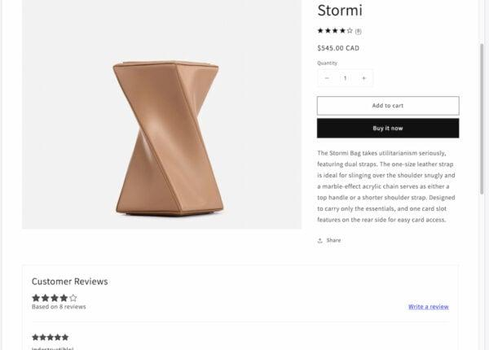
Figure 3: Shopify Online Store Product Page This figure shows a product page created with Shopify. Customers can view product images, descriptions, prices, available sizes or colours, and add items to their shopping cart. Shopify also supports customer reviews, secure checkout, and multiple payment methods, providing a professional online shopping experience.

Task 2. Mind-map of contemporary software applications

2.1 Describe mind mapping and explain the benefits of using mind mapping

Mind mapping is a visual method of organising information, ideas and thoughts around a central subject. Instead of presenting information in long paragraphs or a simple list, a mind map starts with one main topic in the centre and then uses branches to connect it to related ideas. Each main branch can then be divided into smaller branches containing more detailed information. Keywords, short phrases, colours, symbols, pictures and diagrams can also be included to make the information easier to understand. For example, if the central topic was "Contemporary Software Applications", the main branches could include office software, communication software, security software, cloud applications and creative software.
One important benefit of mind mapping is that it makes complicated information easier to organise. A large subject can contain many different areas, which can sometimes become confusing when presented as a long piece of writing. A mind map separates the information into categories, allowing the user to understand the main points before looking at the smaller details. This can be particularly useful when planning assignments, business projects or presentations.
Another benefit is that mind mapping can improve understanding and memory. People can often remember visual information more easily than large amounts of written text. Using different branches, colours, keywords and images can make important information stand out. The user can also see connections between different ideas. For example, Microsoft Teams could be connected to communication and collaboration, while Microsoft Word could be connected to office productivity.
Mind mapping is also useful for brainstorming. During brainstorming, a person or a group may have many ideas at the same time. A mind map allows these ideas to be recorded quickly without needing to decide immediately what order they should appear in. Additional branches can be added when new ideas are suggested. This makes mind mapping flexible and encourages people to think creatively.
Businesses can use mind maps when planning projects, meetings and new products or services. For example, when planning a business project, the central topic could be the project name. Separate branches could then represent costs, employees, deadlines, software, customers and marketing. Managers and employees can therefore see the different parts of the project and understand how they relate to one another.
Mind maps can be created by hand or by using digital software. Digital mind-mapping applications make it easier to move information, change colours, add images and share the finished mind map with other people. They can also support collaboration when several employees are working on the same project.
Overall, mind mapping is an effective method of presenting and organising information. It can improve planning, encourage creativity, simplify complicated subjects and help people remember important information. This makes it useful for students as well as businesses and other organisations.

2.2 Create a mind map of contemporary software applications;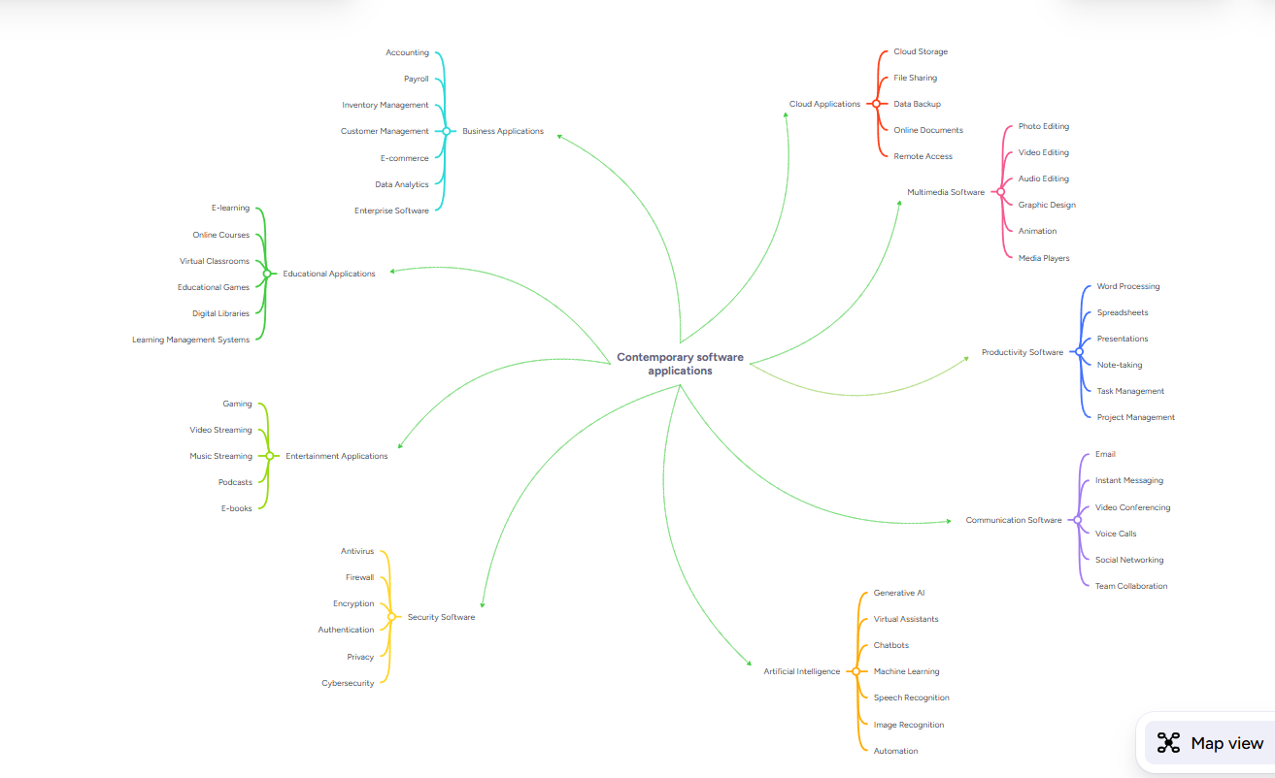

Task 3. Office Applications

3.1 Four office software solutions for business operations

Ms Word
Microsoft Word is a word-processing application that is commonly used by businesses to create, edit, format, store and print written documents. Word can be used by organisations of different sizes because almost every business needs to produce professional written information. Examples of documents that can be created using Word include business letters, reports, meeting minutes, policies, contracts, newsletters, forms, invoices, instructions and employee documents.
One important business use of Microsoft Word is producing professional correspondence. Businesses regularly communicate with customers, employees, suppliers and other organisations. Word allows employees to create letters using professional layouts containing the company's name, logo, contact information and other branding. Templates can also be created so that employees do not need to design a document from the beginning each time. This saves time and helps ensure that documents produced by different employees have a consistent appearance.
Word provides many formatting tools. Users can change fonts, text sizes, headings, paragraph alignment and spacing. Tables, pictures, shapes and charts can also be inserted into documents. Headers, footers and page numbers can be added to longer documents. These features are useful when producing professional reports because information can be organised into clear sections that are easier for the reader to understand.
Another important feature is spelling and grammar checking. Written communication containing spelling or grammatical mistakes can make an organisation appear unprofessional. Word can identify many possible mistakes and suggest corrections. However, employees should still proofread important documents because automated checking cannot identify every possible error.
Microsoft Word also supports collaboration. Employees can add comments to documents and use Track Changes to show modifications. This can be useful when several employees are working on the same report. For example, one employee could write the first version of a report, and a manager could review it, suggest changes and add comments. The original employee could then see exactly what needs to be changed.
Another useful feature for businesses is mail merge. Mail merge allows information from a data source, such as a list of customer names and addresses, to be combined with a standard document. A business could therefore create hundreds of personalised letters without manually typing each customer's information. This can save a considerable amount of time.
Documents can also be saved electronically and shared with other people. Businesses can convert Word documents into PDF files when they want to distribute a document while preserving its layout.
Overall, Microsoft Word is an important business application because it allows organisations to create professional written documents efficiently. Its formatting, templates, proofreading, collaboration and mail-merge features can improve productivity and communication while helping businesses maintain a professional image.

Ms Excel
Microsoft Excel is spreadsheet software used by businesses to record, organise, calculate and analyse information. A spreadsheet consists of rows and columns that create individual cells. These cells can contain text, numbers, dates and formulas. Excel is particularly useful when businesses work with numerical information because calculations can be performed automatically.
One common use of Excel is financial management. Businesses can create spreadsheets containing income, expenditure, budgets and other financial information. Formulas can automatically add or subtract figures, meaning employees do not have to perform every calculation manually. For example, the SUM function can calculate the total value of a group of cells. Other functions can calculate averages, percentages, maximum values and minimum values.
Businesses can also use Excel for budgeting and forecasting. Managers can record expected income and expenditure and compare these figures with actual results. This can help identify whether a department or project is spending more money than expected. Businesses can then use this information when making financial decisions.
Another use is stock and inventory management. A company could create a spreadsheet containing product names, product numbers, prices, quantities and supplier details. Employees could update the spreadsheet when products are purchased or sold. This allows the business to monitor how much stock it has available and identify when additional products may need to be ordered.
Excel is also useful for analysing data. Large amounts of information can be sorted and filtered so that users can concentrate on records. For example, a business with hundreds of sales records could filter the spreadsheet to display sales from a particular month, employee or product category.
Charts and graphs can be produced from spreadsheet information. A table containing monthly sales could be converted into a bar chart or line graph. Visual information can make trends easier to recognise and can be particularly useful when information needs to be presented to managers.
PivotTables are another useful Excel feature. They allow users to summarise and analyse large datasets quickly. For example, a company could use a PivotTable to compare sales between different locations or calculate the total sales produced by different employees.
Excel can also be used for staff rotas, timesheets, attendance records, project budgets, customer information and performance monitoring. Conditional formatting can highlight cells that meet conditions, such as sales figures below a target.
However, businesses need to ensure that spreadsheet information is entered accurately. Incorrect data or formulas can produce incorrect results and potentially lead to poor decisions. Important spreadsheets should therefore be checked carefully.
Overall, Microsoft Excel is valuable for business operations because it can perform calculations, organise information and support data analysis. Its formulas, functions, charts, filters and PivotTables can save employees time while providing managers with useful information for decision-making.

Ms PowerPoint
Microsoft PowerPoint is presentation software that allows users to organise and communicate information through a series of slides. It is widely used in businesses because presentations can communicate information to employees, managers, customers and other stakeholders in a clear and visually interesting format.
One common business use of PowerPoint is delivering presentations during meetings. Instead of giving employees a large written document, a manager can summarise the most important information on slides. For example, a monthly business meeting could include slides showing sales performance, expenditure, customer feedback and future targets. This allows employees to concentrate on the key information while the presenter provides additional explanations.
PowerPoint is also useful for sales and marketing. Businesses can create presentations explaining their products or services to potential customers. Slides can contain photographs, product descriptions, prices, statistics and other information. A well-designed presentation can help the business communicate the benefits of its products professionally.
Another important use is employee training. Organisations regularly need to train staff about procedures, health and safety, customer service, new technology or company policies. A PowerPoint presentation can divide training information into manageable sections. Images, diagrams, screenshots and videos can be included to demonstrate procedures.
PowerPoint provides different tools that can improve the appearance of a presentation. Users can choose themes and layouts to maintain a consistent design. Text boxes, photographs, shapes, tables, SmartArt and charts can be added. Information from Microsoft Excel can also be displayed as charts in a PowerPoint presentation. This is useful when businesses need to communicate numerical information.
Animations and transitions can also be used. Transitions control how one slide changes to another, while animations control how objects appear on an individual slide. These features can make presentations more engaging when used appropriately. However, excessive animations may distract the audience, so professional business presentations normally use them carefully.
Another advantage is that presentations can be edited easily. If business information changes, employees can update the relevant slides instead of producing an entirely new presentation. Presentations can also be reused for different audiences after making small changes.
PowerPoint supports speaker notes, allowing the presenter to include additional information that does not need to appear directly on the slide. Presenter View can display these notes to the presenter while the audience sees only the presentation.
Businesses can also share PowerPoint files electronically or export presentations into other formats. Employees can collaborate on presentations when files are stored using compatible cloud services.
Overall, Microsoft PowerPoint is useful because it allows businesses to communicate information visually and professionally. It can support meetings, staff training, sales presentations and project updates. When slides are designed clearly and contain appropriate information, PowerPoint can make complicated subjects easier for an audience to understand.
Another benefit of Microsoft PowerPoint is that presentations can help businesses communicate complex information in a simple and understandable way. Employees can use diagrams, charts and images to explain information that may be difficult to understand through text alone. Presentations can also be shared with colleagues after meetings, allowing employees to review important information later. Businesses can create standard presentation templates containing company colours and logos, helping maintain consistent branding and a professional appearance across different departments and business presentations.

Ms Access
Microsoft Access is a database management application that businesses can use to store, organise, manage and retrieve large amounts of structured information. It is part of the Microsoft Office suite and is particularly useful when a business has information that needs to be organised into different categories. Unlike Microsoft Excel, which mainly uses spreadsheets, Access uses databases containing tables, queries, forms and reports. These features allow businesses to manage information efficiently and reduce unnecessary duplication of data.
One of the main features of Microsoft Access is tables. Tables are used to store information in rows and columns. Each row normally represents one individual record, while the columns represent different pieces of information about that record. For example, a business could create a customer table containing a customer ID, name, address, telephone number and email address. A separate table could contain information about customer orders. This allows the business to keep its information organised rather than storing everything in one large document.
Access also allows businesses to create relationships between tables. This is particularly useful because different pieces of information can be connected without repeatedly entering the same details. For example, a customer could be given a unique customer ID. Their orders could then be linked to that ID. This means the business does not need to type the customer's full personal information every time they make a new order. Reducing duplicated information can save storage space and make the database easier to maintain.
Another important feature is queries. Queries allow users to search a database and display only the information that meets conditions. For example, a manager could create a query to find all customers located in a certain area or all products with low stock levels. Queries can therefore make it much quicker to find useful information within a large database.
Businesses can also create forms in Microsoft Access. Forms provide a user-friendly way of entering, viewing and editing information. Instead of employees working directly inside database tables, a form can contain clearly labelled boxes where information can be entered. For example, a customer registration form could contain fields for the customer's name, address, telephone number and email address. This can make data entry easier and reduce mistakes.
Another useful feature is reports. Reports allow information stored in the database to be presented in a professional and organised format. A business could produce reports showing customer orders, stock levels, sales information or employee details. These reports could then be viewed on screen, printed or shared with managers.
Microsoft Access can be used for many different business operations, including customer databases, stock management, employee records, supplier information, bookings and order management. However, businesses must make sure that confidential information is protected by appropriate security measures and that only authorised employees can access sensitive data.
Overall, Microsoft Access is useful because it allows businesses to store large amounts of related information in an organised database. Its tables, relationships, queries, forms and reports make information easier to enter, search, update and analyse. This can improve efficiency, reduce duplicated information and help businesses make better use of their data.
Another advantage of Microsoft Access is that it can help businesses save time when managing information. Employees can quickly update records and find specific data without searching through large amounts of paperwork. Access can also reduce human errors by using validation rules for data entry. This helps businesses maintain accurate, reliable and organised records for everyday business operations and decisions.

3.2 Test any two features

Mail Merge
For my first practical test, I tested the Mail Merge feature in Microsoft Word. Mail Merge is useful because it allows a user to create multiple personalised documents from one main document. For example, a business could create the same letter for many customers while automatically changing information such as the customer's name, address or other personal details. 
Firugre 1: Demonstration of starting the Mail Merge process in Microsoft Word.
To test this feature, I opened Microsoft Word and selected the Mailings tab. I then started a Mail Merge and created a recipient list containing example customer information. After creating the list, I inserted a merge field into my document where I wanted the customer's name to appear. I then used the preview option to check how the document would look for different recipients. 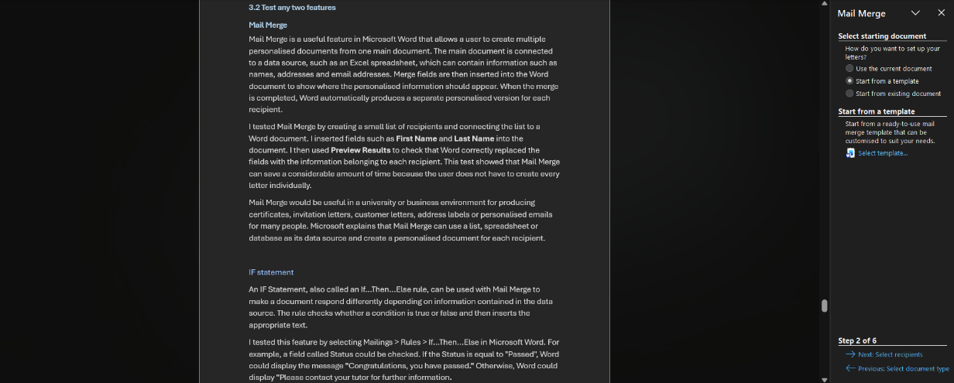
Figure 2: Demonstration of creating and selecting a recipient list containing names and project review dates.
The test showed that Word could automatically replace the merge fields with information belonging to each recipient. This would be useful in a business that needs to send large numbers of letters, invitations, notices or other documents. Instead of manually producing each document, Mail Merge can automate much of the process. This saves employees time and can reduce mistakes caused by repeatedly entering the same type of information. 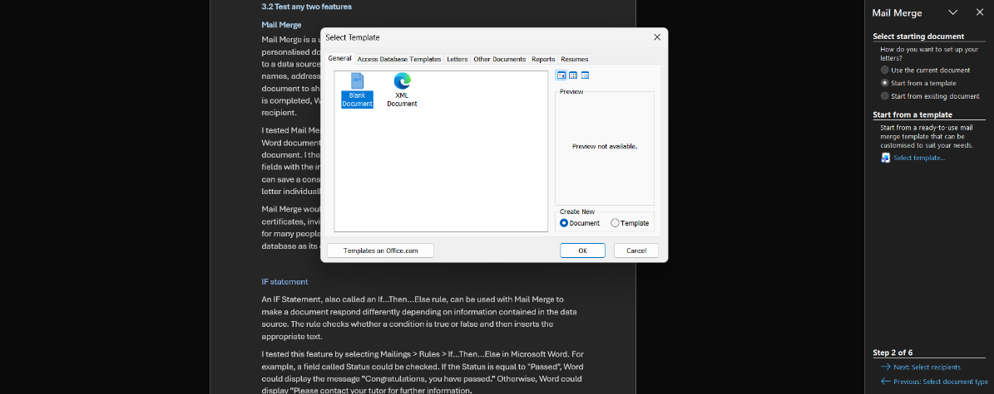
Figure 3: Demonstration of inserting Mail Merge fields such as First Name, Last Name and Review Date into the main document.
Practical demonstration screenshot Insert a screenshot showing your Word document with the Mailings tab and Preview Results/merge fields visible. Make sure no real personal information is shown.

I

IF Statement
For my second practical test, I tested the IF function in Microsoft Excel. The IF function performs a logical test and returns one result when a condition is true and another result when it is false. Microsoft gives the syntax as IF (logical test, valedictories, [value if false]).
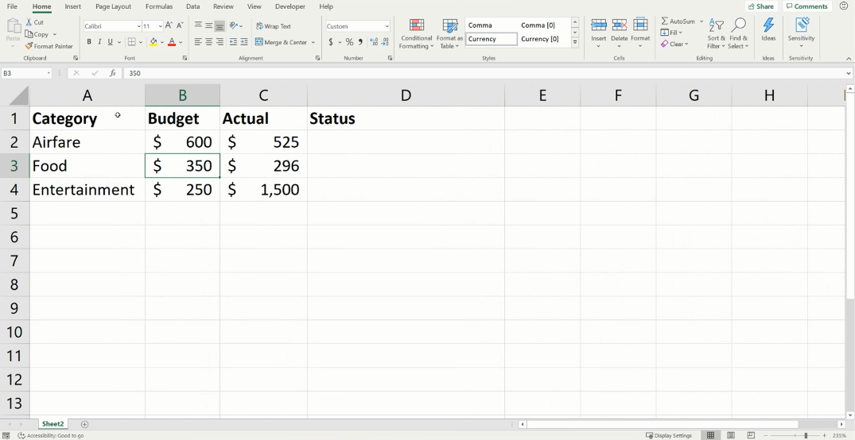
Figure 1: Demonstration of student names and assessment marks entered into Microsoft Excel.
For my test, I created a simple spreadsheet containing employee names and their sales results. I then created a column called Target Result. I entered a formula such as =IF(B2>=1000,"Target Met”, “Target Not Met"). This formula checks whether the value in cell B2 is at least 1000. If it is, Excel displays "Target Met". If it is below 1000, Excel displays "Target Not Met".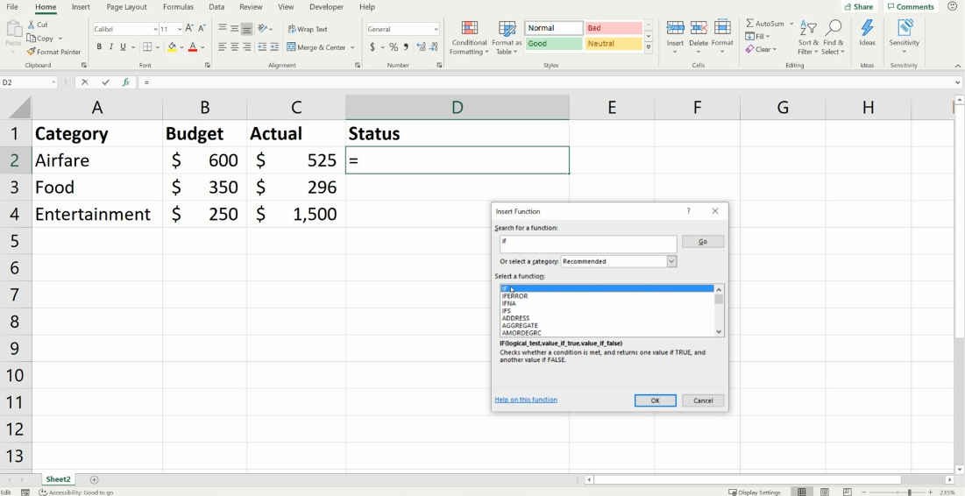
Figure 2: Demonstration of entering an IF Statement into the Result column in Microsoft Excel.

I tested the formula using different values and confirmed that the result changed depending on the value entered. This demonstrates how businesses could use IF statements to automatically categorise information. For example, they could identify employees who have achieved sales targets, determine whether stock needs to be reordered or show whether a payment is overdue. 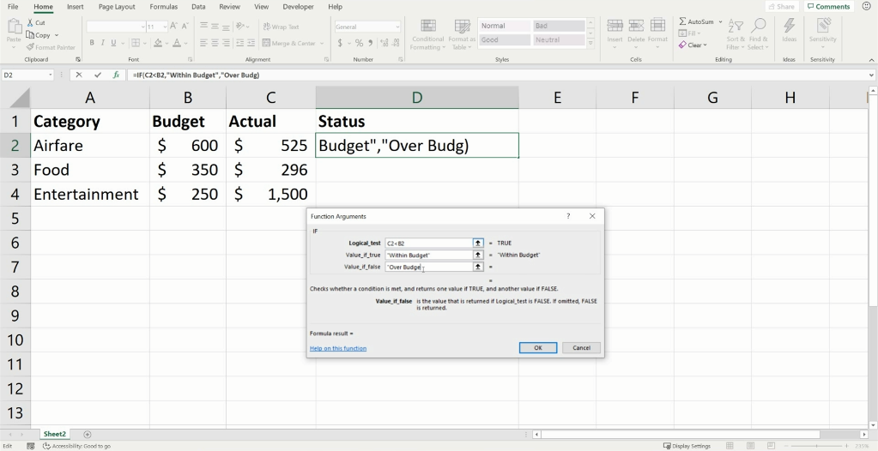x
Figure 3: Demonstration of the IF Statement returning "Pass" when the condition is TRUE.
The test demonstrated that IF statements can reduce the need for employees to manually check every record. This can improve efficiency when working with large spreadsheets.
Practical demonstration screenshot:
Create a small Excel table with Name, Sales and Target Result. Enter the IF formula and take a screenshot showing the table, result and formula bar.

Task 4. Communication and Collaboration applications

4.1 One contemporary Communication and one Online Collaboration

Gmail

Gmail is a contemporary communication application provided by Google. Its main purpose is to allow users to send and receive electronic messages over the internet. Gmail can be accessed through a web browser and supported mobile applications, which makes it suitable for communication from different locations and devices. Google describes Gmail as an email service designed for personal and workplace communication.
One important Gmail feature is the ability to compose and send emails. A user can enter the recipient's email address, add a subject and write a message. Files can also be attached to an email, allowing documents and other information to be shared with another person.
This can be useful in business because employees regularly need to communicate with colleagues, customers and suppliers. Email provides a written record of communication that can be viewed again when required.
Gmail also helps users organise communication. Messages can be searched and organised, while drafts allow users to prepare messages before sending them. Google states that Gmail automatically saves composed messages as drafts, which helps prevent unfinished work from being lost.
Gmail can therefore improve communication because messages can be sent quickly without both people being available at the same time. This is particularly helpful when employees work different hours or from different locations.

Zoom

Zoom is an online communication and collaboration platform that can be used for virtual meetings. It allows people in different locations to communicate without having to meet physically. This makes it useful for businesses with remote employees, different offices or customers located elsewhere.
A major feature of Zoom is video conferencing. Participants can join an online meeting and communicate using video and audio. This provides a more interactive form of communication than email because participants can discuss information in real time.
Zoom can support collaboration because employees can hold team meetings, training sessions, presentations and discussions online. Employees working from home can therefore continue communicating with colleagues. Online meetings can also reduce the need to travel to another location simply to attend a meeting.
Another useful capability in online collaboration is sharing information during meetings. This allows participants to discuss work while viewing relevant material together. Businesses can use virtual meetings for project discussions, customer meetings and staff training.
Overall, Gmail and Zoom provide different forms of communication. Gmail mainly supports asynchronous written communication, meaning recipients can respond later. Zoom is particularly useful for synchronous communication because participants can communicate with each other in real time. Using both types of application can provide a business with flexible ways of communicating and collaborating.

4.2 Test one feature of a freely available Communication (1) and one feature of a Collaboration (1) application

Gmail
For my communication application, I tested the Compose feature in Gmail. This feature allows a user to create an email by entering a recipient, subject and message.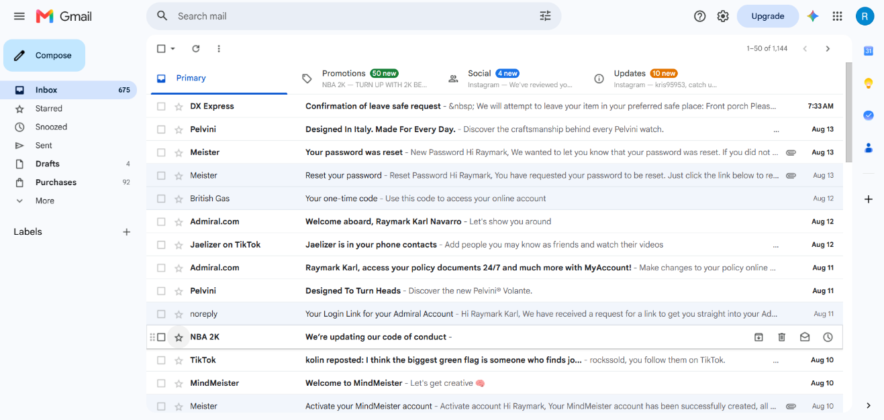
Figure 1: Demonstration of opening Gmail and selecting Compose to create a new email.
I opened Gmail and selected Compose. A new message window appeared containing fields for the recipient and subject, as well as an area for writing the email. I entered example information into these fields and created a short test message. I also examined the attachment option, which can be used to add a file to an email.

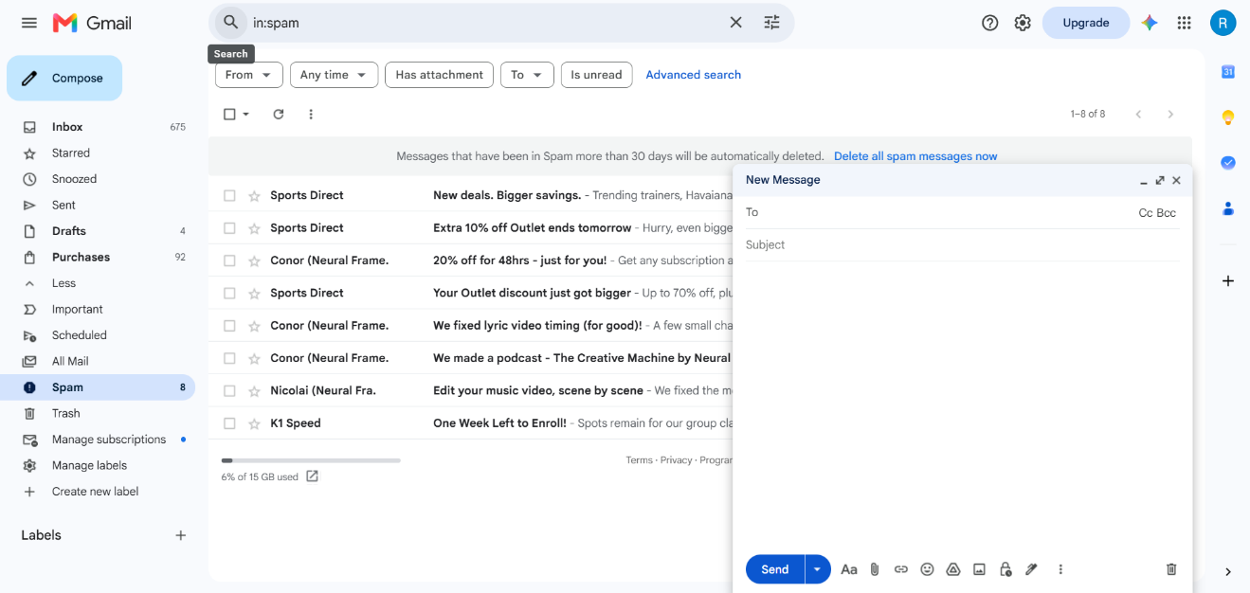
Figure 2: Demonstration of entering the recipient, subject and message and using the Attach files feature to add a document.
The test demonstrated that Gmail provides a straightforward way of creating electronic messages. This would be useful in a business because an employee could use it to contact customers, communicate with colleagues or send information to suppliers. Gmail also saves unfinished messages as drafts, allowing the user to return to them later. 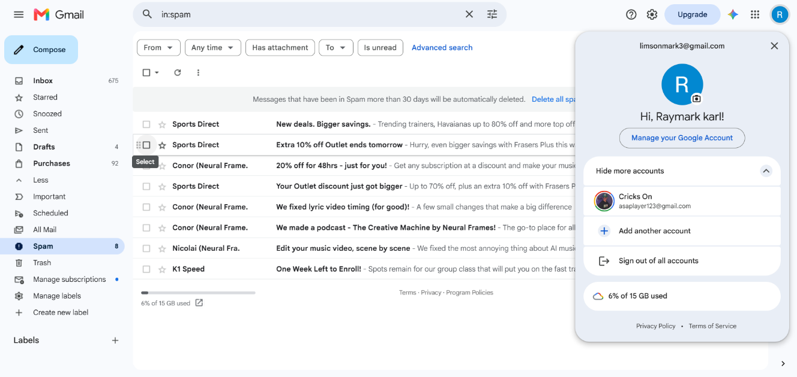
Figure 3: Demonstration of the completed Gmail message showing the successfully attached document ready to be sent.

Zoom
For my collaboration application, I tested a Zoom meeting feature. I opened Zoom and started or joined a test meeting. This allowed me to view the controls available during an online meeting. 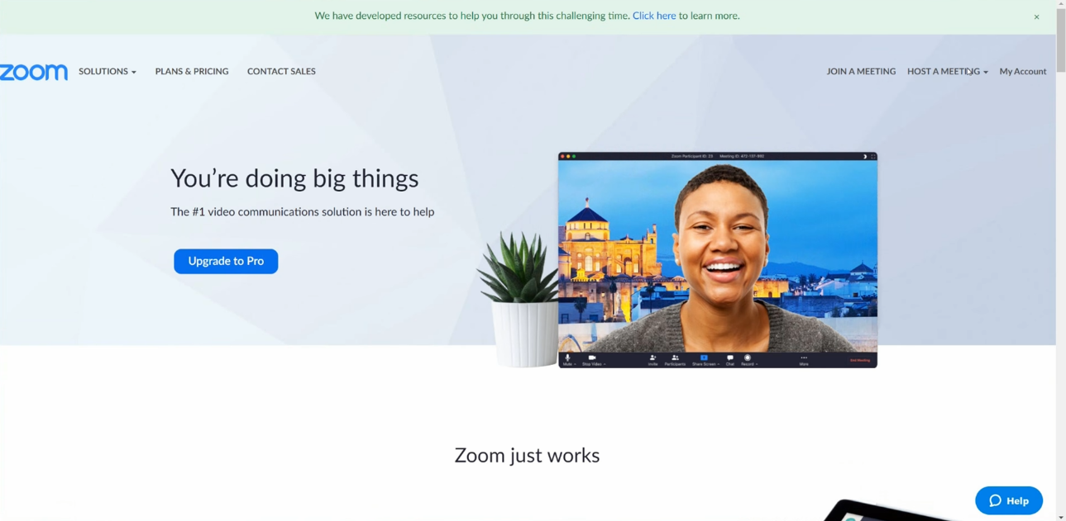
Figure 1: Demonstration of opening the Whiteboard feature in Zoom and creating a new whiteboard.
The feature demonstrates how Zoom can support online collaboration. Employees in different locations can participate in the same meeting and communicate in real time. This can be particularly useful for remote working, staff meetings, project discussions and online training.
During the test, I checked the meeting interface and demonstrated one collaboration feature, such as screen sharing. Screen sharing allows information displayed on one participant's computer to be shown to other meeting participants. For example, an employee could share a PowerPoint presentation, spreadsheet or document while explaining it to colleagues.

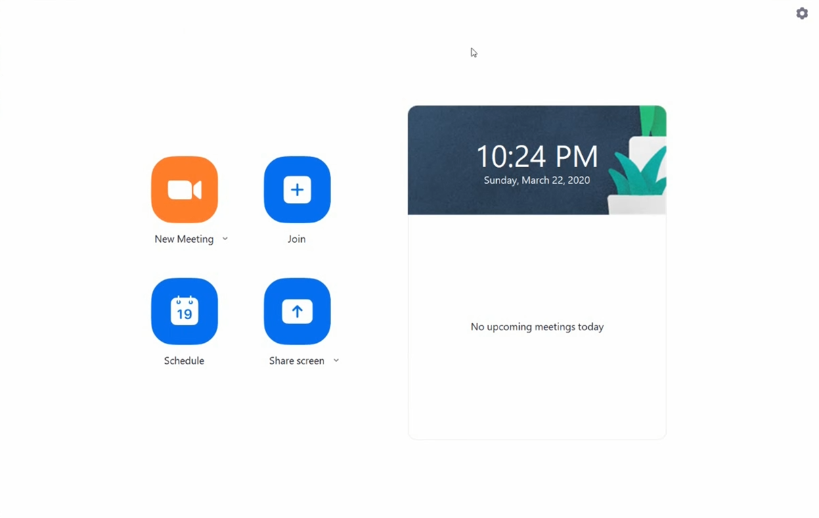
Figure 2: Demonstration of using Zoom Whiteboard tools such as text, sticky notes, shapes and connectors to create an E-commerce Website Project plan.
This can make collaboration more effective because everyone can view the same information while discussing it. It can also reduce the need for employees to travel to the same physical location.

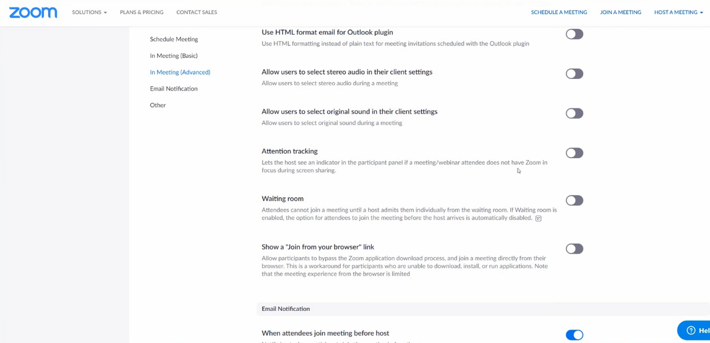
Figure 3: Demonstration of the completed Zoom Whiteboard containing project ideas.
Practical demonstration screenshot. Start a Zoom test meeting and click Share Screen. Take a screenshot showing the Zoom meeting controls and the Share Screen option. You do not need another person in the meeting.

Conclusion
In conclusion, contemporary software applications are important for modern business operations because they allow organisations to create documents, manage information, analyse data and communicate effectively. Microsoft Word provides tools for professional documents and features such as Mail Merge. Microsoft Excel allows businesses to perform calculations and make logical decisions using features such as the IF function. Microsoft PowerPoint can be used to communicate information visually, while Microsoft Access allows structured business information to be stored and managed in databases.
Communication and collaboration applications are also important. Gmail allows employees to exchange written messages and files, while Zoom allows people in different locations to participate in virtual meetings and collaborate in real time. The practical tests demonstrate that these applications can improve productivity and make common business activities more efficient.
Overall, businesses can benefit from selecting software according to the task that needs to be completed. Using appropriate office, communication and collaboration applications can save time, improve organisation, support teamwork and help employees communicate information effectively.

References
Formatting...
References
[1] Wix.com Ltd. "Online Store Builder – Create an Online Store." [Online]. Available: https://www.wix.com/ecommerce/online-store?utm_source
[2] Shopify Inc. "Shopify: Your Commerce Platform to Sell Online & In Person." [Online]. Available: https://www.shopify.com/uk[
[3] Microsoft Corporation. "Use Mail Merge for Bulk Email, Letters, Labels, and Envelopes." [Online]. Available: https://support.microsoft.com/en-US/Word/use-mail-merge-for-bulk-email-letters-labels-and-envelopes
[4] Microsoft Corporation. "IF Function." [Online]. Available: https://support.microsoft.com/en-us/excel/functions/if-function
[5] Google LLC. "Write & Send Email." [Online]. Available: https://support.google.com/

