Rhys Davies (1708879)

Research and Development Methods
Different Types of Battery Technology


Title: Battery Technology

Author: Rhys Davies

Course: BEng Electrical Engineering

Faculty: Gareth Jones

Submission Date: 14th December 2017

Declaration:

The work of this report completed under the supervision of Gareth Jones. I declare that this report is the product of my own work and is not being submitted for any other degree etc.

Sign the declaration – R.Davies

Abstract
With the rapid development of electrical technology, batteries are in their greatest demand. Due to global environmental issues, rechargeable and long lasting batteries are top priority for research and development. This paper reports on the use of batteries used in many different electronic devices, ranging from industrial equipment, household technology and electric vehicles. Also discussed is the impact batteries have on the environment and what can be done to minimise the waste.

Contents
Title: Battery Technology 1
Author: Rhys Davies 1
Course: BEng Electrical Engineering 1
Faculty: Gareth Jones 1
Submission Date: 14th December 2017 1
Declaration: 1
Abstract 2
Introduction 2
Alessandro Volta 3
Non Rechargeable Batteries 4
Rechargeable Batteries 5
Industrial Batteries 6
Vehicle Batteries 7
Conclusion 8
Bibliography 8

Introduction
Batteries are one of the greatest inventions ever made so who constructed the first ever battery? How did he do it? This report describes how rechargeable, non-rechargeable, batteries of industry and automotive batteries on how they work in detail and why they are used for specific applications? What are the advantages and disadvantages? With recycling always needed to be increased, the question is asked what happens to batteries when they are not needed anymore and what measure are in place to tackle the task.

Alessandro Volta
The first ever battery to be invented was by an Italian scientist called Alessandro Volta. In 1791 Alessandro Volta’s friend Luigi Galvani discovered that if two different metals came in contact across each other with the muscle of a frog would result in the making of an electric current. He began experimenting in 1792 with only metals. Volta soon discovered that animal tissue was not needed to produce an electrical current and therefore Volta gave a public announcement of the first electric battery in 1800. [1]

In 1800 Volta after a serious amount of experimentation, Volta developed the voltaic pile. The voltaic pile consisted of zinc and silver plates and between the plates were squares of cardboard that had been absorbed in salt water. A wire connecting the bottom zinc plate to the top silver plate kept on producing electrical sparks. After experimenting with 60 different elements Volta discovered that depending on the number of zinc and silver plates that the intensity of the electric shock would have increased also depending on the number of elements used on the pile. The pain of the electric shock was significantly greater when more than twenty elements were used. The first piles built by Volta were using the elements zinc and copper. Each plate was separated by a piece of card dampened in an acid solution. Three vertical glass rods were used in a triangle position to support the column. [2]

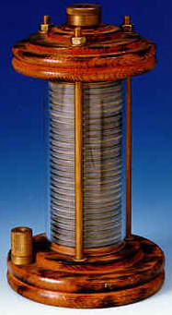

Figure 5 1 – Alessandro Volta
Figure 6 1 - Volta's development of the voltaic pile

Non Rechargeable Batteries
- Alkaline & Carbon Zinc
- Lithium
- Mercury

- Alkaline & Carbon Zinc – Both types are dry cell batteries. The only difference between a carbon battery and alkaline battery is the internal material. A carbon battery is composed of carbon rod and a zinc shell. Both elements are not good for environment protection, but because they are so cheap they are very popular on the current sales market. Alkaline batteries are environmentally friendly and are good example of future dry battery development. Alkaline battery capacity is 4-5 times greater than carbon batteries whereas its price is 2 times the price of a carbon battery. Carbon batteries are suitable for low current applications, such as clocks, remote controls, radios. Alkaline batteries are suitable for higher current discharge devices such as, CD players, electric tooth brushes and children’s toys. [3]

- Recycling non rechargeable batteries has recently become a major contributing factor in battery recycling. In California a battery solution vendor sells recycling containers that people can fill with all their old batteries. The vendor accepts all different type of batteries including AA, AAA, C and D, they also accept mobile phones and any other electronic battery device. One the containers are full, the containers must be sent back to the vendor so they can recycle the batteries. Placing one of these containers in all supermarkets and places of work would really encourage the public to not send their batteries to land fill and to be recycled. [4]
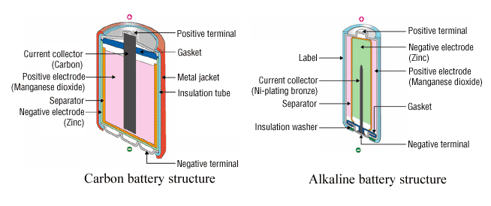
Figure 1 1 - Carbon & Alkaline Battery Structure

Rechargeable Batteries
- Lead Acid Gel
- Lithium ion
- Nickel Cadmium
- Nickel Metal Hydride

- Lithium ion – These batteries are commonly used in a wide range of devices such as home electronics, power tools and now new electric motor vehicles. They are one of the most popular types of rechargeable batteries due to them having a high energy density. If the battery cell is charged too quickly, it has the potential to cause a short circuit which would lead into an explosion. Lithium ion batteries contain a flammable electrolyte which is a safety concern to the public, as a safety feature the battery cell is kept pressurized to prevent an explosion from occurring. Due to the potential risks of an explosion happening research for lithium ion batteries are in great demand, a lot of research is being done on life extension, storage density and to reduce the production cost of the battery. Lithium ion batteries cause not a great amount of pollution when disposed but must be recycled. “All battery types must be recycled, and may not be disposed of as solid waste” [5]. Even though it’s overall plus points, lithium ion cells has its drawbacks. The batteries are fragile and require a protection circuit to maintain safe operation. Also built into each pack, the protection circuit limits the peak voltage of each cell during charge and prevents the cell voltage from dropping too low on discharge. In addition, the cell temperature is monitored to prevent the temperature for overshooting. [3]

- In California all batteries are hazardous waste and must be recycled, written in the book ‘Green IT for Dummies’ it states that’s “The Rechargeable Battery Recycling Corporation (RBRC) have set up a non-profitable organization created by the rechargeable power industry collects and recycles rechargeable batteries.” [4]
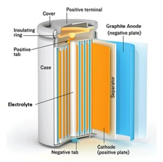

Figure 2 1 - Inside a Lithium Ion Battery

Industrial Batteries
- Absolyte
- Large Flooded
- Nickel Iron
- Un-interruptible Power Supply (UPS)
- Wet Nickel Cadmium
- Steel Case

- Un-interruptible Power Supply (UPS) – These form of batteries are very popular and are used in a range of places such as households and industry. Within industry UPS is used among the high end companies that may have safety critical loops that require power if all power fails. Companies such as BP (British Petroleum), BOC Gases and Chevron will all have UPS appliances. UPS is a power supply that provides continuous power. They are commonly used as battery backup. Although there are many other uses for UPS such as voltage regulators, speed governors, starting mechanisms, fuel systems, engine cooling systems, room ventilation, exhaust systems and control safety systems [6]. The advantages are mostly respective to keeping electronic systems in running mode. Also it prevents machines and circuitry from power surging. Disadvantages of uninterrupted power supplies are the purchasing cost of the equipment, another high cost comes from the operation and maintenance. Depending on the type of UPS some companies would have to have a service contract with the manufacturer. This would be a very expensive. On the other hand UPS power supplies can be bought for household computers which are considerably cheaper compared to the Industry equipment. A key disadvantage of UPS batteries is that they require prime temperatures to operate to its full potential. Kerry Ann Adamson describes the disadvantage stating “with batteries is their sensitivity to temperature, According to the British firm UPS systems, VRLA batteries are designed to operate at an optimal temperature of 25°C.”. [7]

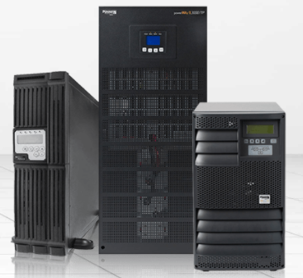
Recycling electronic equipment is one of the fastest growing waste surges in the world of industry due to the ever increasing use of electronic products. A US company called APC have constructed a collection and recycling scheme to make sure that discarded equipment does not engulf landfill sites.
- Option 1: People can trade in their old UPS’s regardless of the condition of it or if it even works. This will then give customers new UPS, with a full 2 year warranty and up to a 25% discount off the next purchase.
- Option 2: Replacement Battery Cartridges. If the Ups is 3 years or older the UPS may need to be recharged. An option is to trade in and replace the old UPS batteries with like for like APC replacement Battery Cartridges (RBCs), free return shipping will then be carried out and also free eco- friendly disposal. [8]
Figure 3 1 - Uninterruptible Power Supply

Vehicle Batteries
- Hybrid Automotive
- Lead Acid
- Valve regulated lead acid (VRLA)

- Hybrid Automotive – Hybrid Automotive batteries are the newest type of battery to be released and is considered to be exceptionally more environmentally friendly than the old lead acid battery and are now very popular amongst the manufacturing of new motor vehicles such as hybrid cars and E bikes. Hybrid car batteries consist of nickel metal hydride and lithium ion batteries. Hybrid car batteries are under lot of speculation because people are unsure with the operations of a hybrid car so questions like, are they polluting more than petrol and diesel? Will the batteries needed to be changed more frequently? A hybrid car uses a combination of an internal petrol engine and electric motor. The petrol provides fuel for the engine that is stored in a fuel tank and the electric motor gets its power from the battery packs that store and supply the energy to power the hybrid car electric motor. A disadvantage of the battery packs is that they don't provide enough power, and therefore hybrid cars are slow to which some people power is a purchasing factor, aswell as the batteries being too heavy. Both those drawbacks supposedly contradict a hybrid car exceptional fuel economy and its very low environmental impact, even the materials used to make the batteries are made from lead are harmful to the environment [9]. When purchasing a car people focus on the fundamental price of the vehicle more than the running and maintenance costs so by buying a hybrid vehicle you get the advantages in fuel economy, fuel cost and the reduced need in sustainment. [10] The price of electricity to running hybrid vehicles is a small percentage of the cost of liquid fuel vehicles needed to produce the same amount of energy. The cost of replacing the batteries is the main disadvantage. [11]
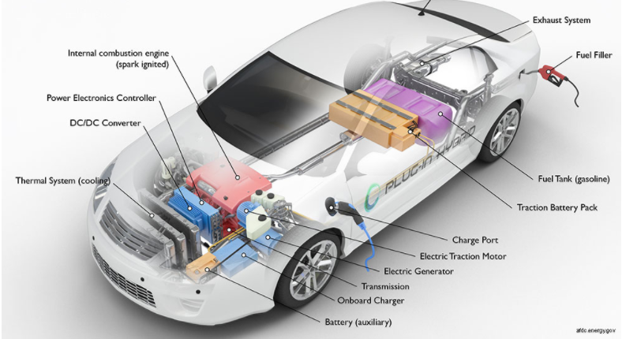

Figure 4 1 - Hybrid Automotive Battery Layout

Conclusion
With the demand of batteries only ever increasing it is important that research is constantly being carried out to help the world improve battery technology in areas such as storage density, battery life expectancy and battery safety. The four types of batteries discussed were the Alkaline & Carbon non rechargeable battery, Lithium Ion rechargeable battery, Hybrid Automotive batteries used in electric motor vehicles and Un-interruptible Power Supply (UPS) commonly found in heavy industry like steelworks and car manufacturing. As hybrid cars are slowly being introduced onto the roads, more and more hybrid vehicles are being used each day so there are many advantages and disadvantages compared to a standard petrol engine car. Even though a hybrid vehicle should have the better fuel economy, the energy needed to fully charge the vehicle is exceptional. Whilst discussing all these different types of batteries the environmental impact they have would be huge if not disposed of the correctly, that’s why governments and private companies around the world have created battery recycling schemes to help reduce the amount of toxic materials entering landfill sites.

Bibliography

[1] | G. Pancaldi, Volta - Science adn Culture in the Age of Enlightenment, Princenton, New Jersey: Princenton University, 2003.
[2] | “Battery Facts,” Curtis Wood Group, [Online]. Available: http://www.batteryfacts.co.uk/BatteryHistory/Volta.html.
[3] | Large Battery, “Differences between Carbon and Alkaline Battery,” Large, 2011. [Online]. Available: http://www.large-battery.com/differences-between-carbon-and-alkaline-battery.html.
[4] | Dummies, “Recycling Batteries,” in Green IT for Dummies, Indiana, Wiley Publishing, 2009, p. 258.
[5] | C. Mikolajczak, Lithium-Ion Batteries Hazard and Use Assessment, New York: Springer, 2011.
[6] | A. K. /. A. King, Uninterruptible Power Supplies, New York: McGraw Hill, 2003.
[7] | K. A. Adamson, Stationary Fuel Cells, Amsterdam: Elsevier, 2007.
[8] | Scbneider Electric, “Recycling Options,” APC, 2017. [Online]. Available: http://www.apc.com/us/en/who-we-are/sustainability/recycling-options.jsp. [Accessed 2017].
[9] | A. Emadi, Handbook of Automotive Power Electronics and Motor Drives, Chicago: Taylor & Francis, 2005.
[10] | Advanced automotive technology : visions of a super-efficient family car., DIANE Publishing, 1995.
[11] | Wikipedia, Electric vehicles battery, Wikipedia.

