++
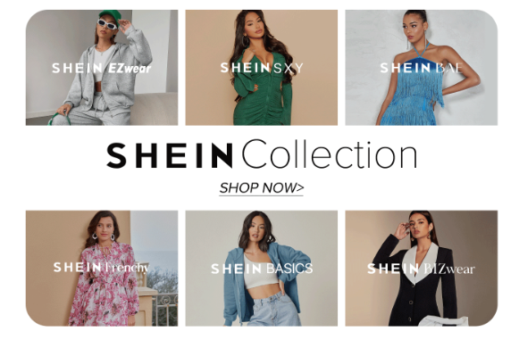  BMSP7003: Essay: Critical reflection Embedding Sustainability Within Organisations  Dr Roisin Mullins | Shein: Critical reflection  Natalie Emma Male 1702161

Introduction

By its very nature of operations Ultra-fast fashion is a difficult area to promote or support as a sustainable business model. “The rising popularity of this industry is not positive for our worldwide community, as it represents one of the main contributors to pollution, environmental harm, and workers’ exploitation” (Vittoria, 2022). It is difficult to find empirical evidence of any organisation that has managed to make a substantial and sustained environmental impact without moving away from this model in entirety. And therein lies the issue with the proposed sustainability plan for Shein. Furthermore, ultra-fast fashion supports a linear model and given the environmental issues identified it is difficult to envisage how it could ever be truly circular. “ Critics assert that fast fashion apparel cannot be sustainable by its very nature. The poor quality of the material makes it hard to recycle, even if the brands commit to recycling a certain percentage of used or unsold products”. (Kaplan, 2023) However, if all organisations made a series of changes this could add up to a combined reduction in the use of natural capital.
Although analysis on sustainability exists for organisations this does not extend to the fast fashion industry, their response to the issue or sustainable strategies. (Wells , 2021). The sustainability plan focused on HR, Marketing, Supply chain and the current business model. Shein’s existing operations appear to support Friedmans profit maximisation model, there is no evidence of natural capital accounting, though there is an emphasis on profit over ethics. To support this theory evidence can be found in elements such as the promotion of sales at all costs with banners that cover the sustainability and CSR policy. Coupled with algorithms that show a high level of dark marketing which push buyers into mass consumerism, planned obsolescence and damaging environmental waste. With a high economic turnover and no accountability, it will be difficult to convince current stakeholders to consider the value of sustainability. Furthermore, legislation is lacking, the popularity of fast fashion is appearing to increase given the current economic climate. However, the consumers bare some of the responsibility who are attracted by the low cost.
One of the most challenging aspects of developing the sustainability plan is the lack of transparency within the organisation, which is very secretive. It is difficult to follow the environmental impact of logistics, supply chain and sourcing of materials that go into creating the garments. This makes it impossible to measure impacts or success as there is no baseline. For this to be collaboratively addressed individual organisations must be honest about their sustainable practices and address that this is a work in progress. In turn this will put pressure on the industry as a whole (Allon, 2022). The following critical reflection recognises and addresses some of the shortcomings of the report, with areas for further consideration and development strategies.

Although the plan explored the current business model, suggestions were not recommended on how to change the existing model to increase sustainability and methods of reporting. Image 1. (Cuofano, 2024) displays the current plan that has been modified with areas of concern highlighted in red. The topics are discussed in depth throughout this critical analysis with suggestions to improve sustainable business operations in the future,

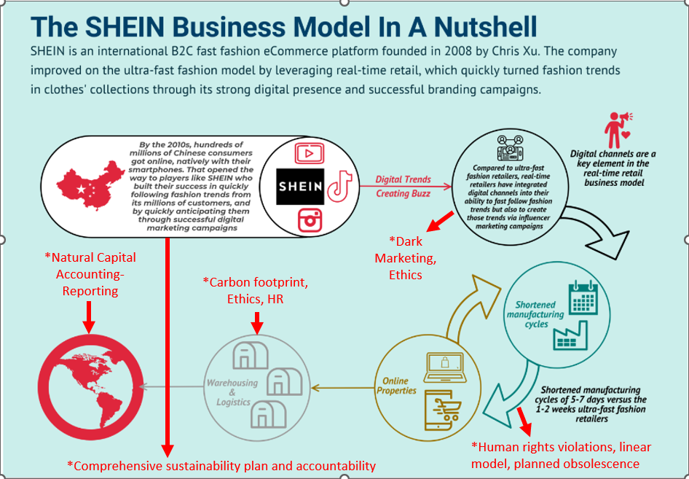
Image 1 (Cuofano, 2024)

Stakeholder benefits

The plan did not go far enough in assessing or valuing natural capital and the benefits to all stakeholders, although it did focus on some key areas that could reduce the overall impact of the organisation’s operations. Without a complete change of model or accurate reporting, it would be difficult to reach a high degree of sustainability. Disclosing ESG (social and environmental governance) goes beyond sustainability ideals and looks at the implementation and action plan utilised to reached an acquired target. (Anderson, 2023) Perhaps this also demonstrates the further need to consider nature as a stakeholder or capital asset within the business, potentially leading to increased profitability. Other global businesses have proved this can be achieved . Carpet manufacture was once considered a similar take, make, waste model to fast fashion. Interface enacted sustainable change in an industry that it was considered to be almost impossible. “Limited understanding of the types and magnitude of resources available from carpet disposals has limited exploration into their contributions to the circular economy” (Cunningham & Miller, 2022). After operating unsustainably for 21 years in an industry that excessively relied on fossil fuels in both production and transportation. Owner Ray Anderson reached a crossroads and in 1994 began to look closely at the impact of the organisation’s operations. They introduced a seven-step sustainable plan that consisted of the following areas:
Eliminate waste, Benign emissions, renewable energy, close the loop, efficient transport, and sensitising stakeholder. Part of the success is that all stakeholders promote and understand the 7 fonts. Though many organisations believe that sustainability will affect the bottom line, this has not been the case for Interface who saved $450 million from avoiding the costs of waste disposal (Case Study Interface, 2020) The environmental benefits are displayed in Image 2.

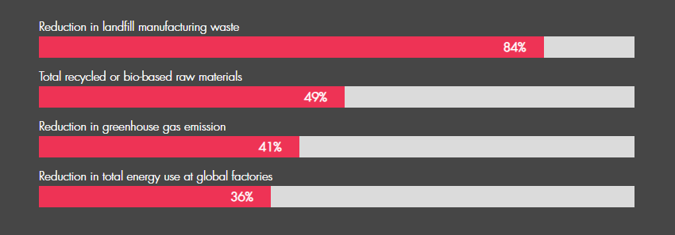
Image 2 (Case Study Interface, 2020)

Interface produced a hundred percent recycled carpet called Biosfera. The backing and fibres from old carpets are combined with discarded fishnets. In 2012 the organisation started working in collaboration with the Zoological Society of London and introduced Net-Works. An initiative to recycle ghost fishing nets as a carpet material. Using this discarded resource not only means that fish are also prevented from being killed by discarded nets, there are ecological, environmental, and social benefits. Accounting for 10% of global marine litter , the nets are recycled into nylon yarn. Some of the poorest communities along coastal regions in turn benefit. With declining fish stock, fisherman are incentivised to collect the nets bringing them in to the global supply chain. They are in turn compensated for their time and provided access to community banks (Ellis, 2017) Image 3 shows Interface’s comprehensive sustainable business model, A stark contrast to Shein’s take, make, waste business model.

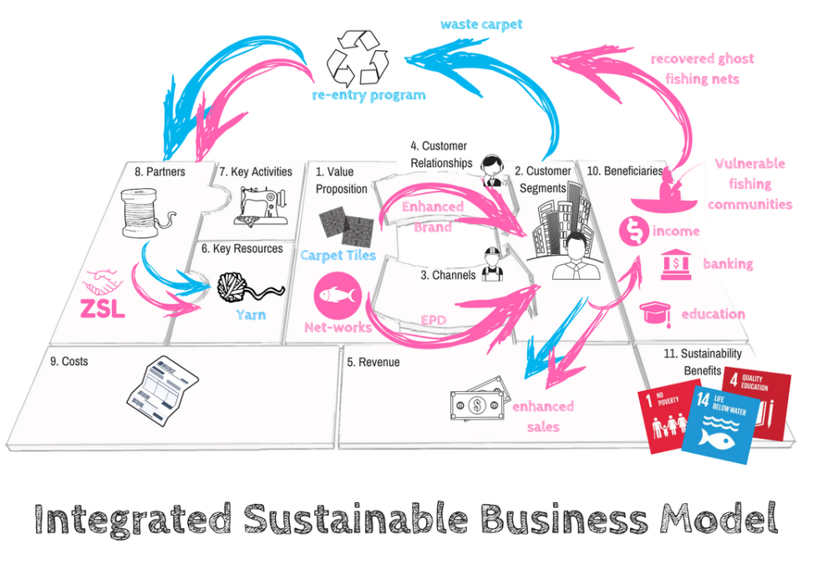
Image 3 (Greggor, 2024)

Shein still has a long way to go in terms of sustainability. “The brand’s consumption of virgin polyester and oil releases the same amount of CO2 as approximately 180 coal-fired power plants, according to Synthetics Anonymous 2.0, a report published on fashion sustainability” (Petter, 2023). Shein could show a similar move away from the mass use of synthetic fabrics by “creating a portfolio of alternate fibres with low-resource intensity and potentially rich cultural traditions .The manufacture of both cotton and polyester fibres is detrimental to the environment, albeit in different ways” (Pena & Joy , 2017). This would go a long way to addressing the level of waste produced and propel the organisation towards a circular business model. The organisation could possibly be a market leader in an industry if it chooses to close the loop. Revenue in 2022 was around $22.7 billion, giving the organisation the scope to invest heavily in its sustainability initiatives (Shukla, 2023).
Shein’s corporate site states that there is a drive to full textile circularity by 2050, this only currently covers the introduction of some ‘more responsible’ fibres into the current processes, although they have stated they will be guided by the textile exchange (Goals and Commitments, 2023). There is no information on their current environmental impact in the use of raw materials, how the progress will be measured and if the information will be shared with all stakeholders. The fashion transparency index 2022 reviews around two hundred and fifty fashion brands to discover how transparent organisations are about their supply chains, impacts and practices and environmental and social policies. One of the key findings of materials and sustainable sourcing “Almost half of all major brands (46%) publish targets on sustainable materials yet only (37%) provide information on what constitutes a sustainable material (About the fashion transparency index , 2022)

Although the report touched on the value of Natural Capital it did not offer suggestions or tools the organisation could make effective use of. Information could not be found on any current natural capital accounting or research. The Natural Capital Protocol offers a framework in an area that is already confusing with multiple initiatives. The protocol sets out to assist organisations to value, identify and measure dependencies and impacts on Natural Capital (Jones & Comfort, 2019). Mark Gough Executive Director of the Natural Capital Coalition states that “ Until now, natural capital has for the most part been excluded from decisions and, when included, has been largely inconsistent, open to interpretation, or limited by moral arguments” (Natural Capital Protocol, 2016)

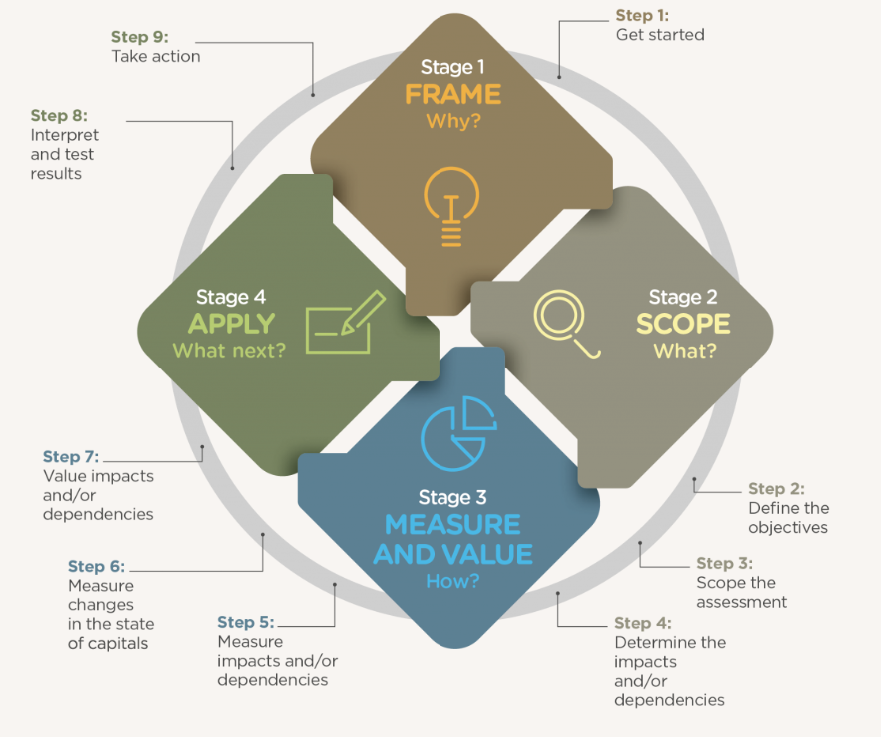

Image 4.(Natural Capital Protocol, 2016)
The above image displays the framework’s four stages.
Frame–(Why?):
Risks and opportunities are Identified for the organisation and its stakeholders. How is this relevant for decision making in the future.
Scope-(What ?):
What is the objective of the assessment, conduct a materiality assessment to discover dependencies and impacts for the organisation and stakeholders.
Measure and Value- (How ?):
What are the benefits from measuring and valuing dependency on natural capital and material impacts.
Apply ( What Next ?)
For effective decision making, verify, interpret, and validate assessment methods to integrate within the organisation and guide future processes.

Human resources and the role of the CSO
Another issue that was recognised in research is that it is difficult to establish Shein’s organisational structure and their effectiveness. Current information on the website shows some information as displayed in image 5 (Shein, 2023)

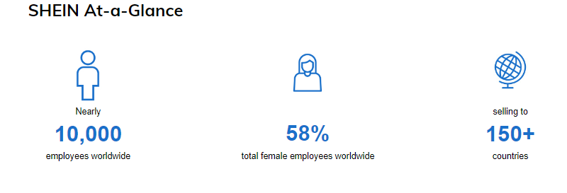
Image 5. (Shein, 2023)
Although the plan identified the current HR issues, including long working hours and dangerous conditions within the organisation, it did not emphasise on effective solutions or strategic planning. The sustainability plan touched briefly on organisational culture but did not stress the importance of cultural differences. For some cultures Human resource management is a difficult concept to understand. This could be mainly due to an economic stance that human beings are a resource, a notion that does not always translate well to all cultures (Hampden-Turner & Trompenaars, 2020). Shein should investigate ways to ensure all workers understand their value within the organisation.
Shein’s operations are extremely secretive. According to the financial times CEO Sky Xu is an elusive character, whos’ picture does not appear on Shein’s website and employees joke that they would not recognise him if he was in the office (Olcott, 2023). An interesting aspect to note, (Walker , 2023) suggests that the reason is cultural and political with secrecy thriving in China, with reliance on surveillance and control within the Chinese government who suppress information sharing. This may explain some of the past operational secrecy within the organisation and its operations. As Shein operates within global markets it may be beneficial to show more transparency moving forward
Shein has a current comprehensive HR department that claims they are committed to change. LinkedIn displayed a number of HR managers across the organisation. The head of HR is stated to be Michael Arkins displayed in Image 6 (LinkedIn, 2023)

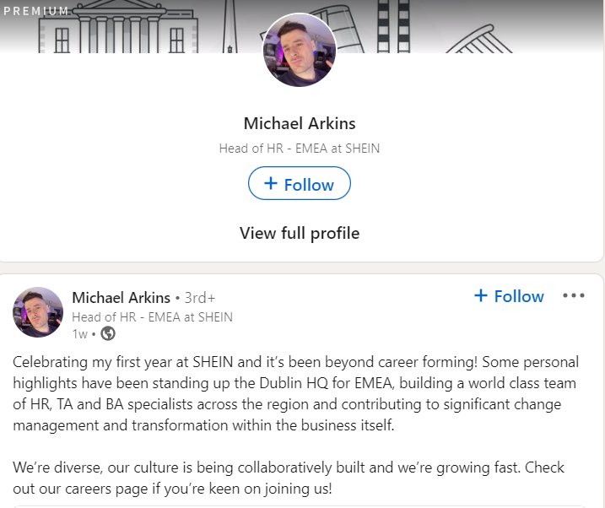
Image 6 (LinkedIn, 2023)
He stated that there is a diverse culture, and the team are contributing to significant change management (LinkedIn, 2023). This evidence only links to the management structure and not within the supply chain. An article in the Guardian stated that Shein has admitted to breeches in employees working hours and have pledged twelve million to improve their sites. However, this was in response to the Channel four exposé and not findings within the organisation itself. This evidence supports that a comprehensive reporting system is not being utilised within the organisation. Had this been the case the organisation would have been aware of working practices within the supply chain. Enabling swift action and investigation.
Shein responded with the head of ESG (environmental, social and governance) Adam Whinston stating “We have been working diligently with our contracted partners to improve welfare and working conditions. We are now looking to double our investment in the SRS programme to improve supplier management further.” (Shein admits working hour breaches and pledges £12m to improve sites, 2022) Furthermore, there is little evidence since 2023 to confirm or deny that practices have improved for the workers that produce the clothing items. It would assist Shein’s reputation further if the organisation was forthcoming with this information and reported the progress of HRM and SRS ( Shein’s responsible sourcing) in an annual report. The two areas have a strong relationship and greatly impact each other. This information could be made available in the CSR report where at the moment this information is lacking, and the organisation has been accused of greenwashing. Below is the LinkedIn profile of the head of Shein’s ESG (Whinston, 2024)

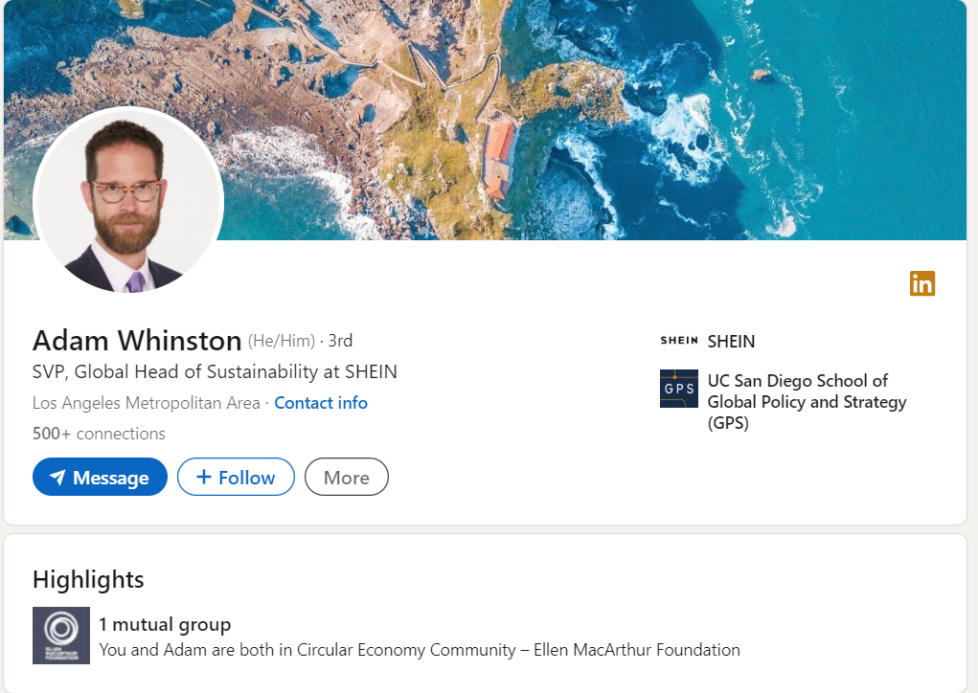

It

Image 7 (Whinston, 2024) shows Adam Whinston Head of Global Sustainability LinkedIn account, Interesting to note that he is a member of the circular economy community-The Ellen MacArthur Foundation. Perhaps this is a positive move to changing existing business operations and a move to more sustainable practices. It will be interesting to see the progress made by Mr Whiston and the methods of future sustainability reporting.
Social and Human capital accounting has not been explored as a tool to quantify the impacts of operations on individuals and society. Indeed, many businesses are beginning to acknowledge human resources as a competitive and sustainable advantage (Okeke, 2016). The World Economic Forum has published a framework the organisation can use to reshape human capital accounting, to see how investment in employees is returned, assessed and monitored. Historically frameworks in this area have been lacking. In line with the SDG goals, organisations are becoming under pressure to report sustainable practises to show a greater transparency (An Accounting Framework to Reset the Value of Talent in the New World of Work, 2020)

Supply chain management

One of the most popular methods of keeping costs to a minimum is outsourcing work. Currently in the United States it is cheaper to send work to other countries, Outsourcing does not require approvals, licences or permits, with international contracts allowing businesses to be governed by the laws of that country. Enabling lenient regulations and cheaper labour (Speed, 2021) Shein utilises the outsourcing method for its . (Liu, 2022) suggests that the garment and fashion industry are built around poor wages. This is largely due to the demand for fast production at the lowest price, essentially making it a race to the bottom. Shein then has no loyalty within the supply chain either to their suppliers or commitment to the workers producing goods. Shein could move to Circular supply chain management. Producing clothes that last longer and that can be ultimately recycled into new products, meaning value is created. (Wren, 2022) proposes that “ Brands can take a comprehensive approach to SSCM by focusing on two key areas: reducing indirect impact created by upstream and downstream activities, and reevaluating garment design to make current sustainability measures more effective” (Brophy, 2020) Image 8 explores the changes needed in the fashion industry, making fashion circular and looking at textile production an recycling.
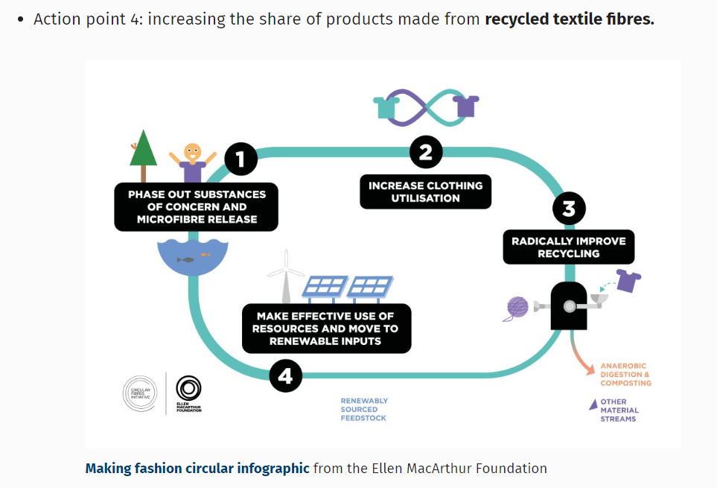
Image 8. (Brophy, 2020)

There is much to consider. within current and future operations the brand shows no sign of slowing down, in October 2023 Shein acquired the UK business Misguided, making this the first UK British brand the organisation have purchased, in one of the fastest growing markets, However although Shein would acquire the trademarks and intellectual property, former owner Frasers will retain staff and real estate (Davey, 2023) How this will impact on labour and sustainability practices has not been disclosed. Although (Croce, 2023) suggests that “It’s impossible to say how the acquisition by Shein will influence how sustainable the Missguided brand will be in the future, or how their relation to labour practices will change. But considering Shein’s track record, it’s hard to imagine it will be for the best”. How Shein will manage Missguided as part of its overall portfolio has not been disclosed. At present there are no fast fashion laws or legislation from the UK Government, although the modern slavery policy 2015 acts to end the exploitation of garment workers, long hours and poor pay can be considered as a Modern Slavery violation. (What laws has the UK Government made on fast fashion?, 2022).

Sustainable marketing and ethics
Sustainable marketing and ethics are not supported by the current business model. To move away from dark marketing will surely have an impact on Shein’s profits as the nature of the way goods are marketed drives mass consumption. However, where there were no regulations in China to monitor dark marketing, this is changing in Europe. With the recent acquisition of UK brand Missguided, the Digital Service Act (DSA) may apply when marketing the business. “The DSA specifically prohibits deceptive or nudging techniques, including dark patterns, that could distort or impair a user’s free choice or repetitively requesting or urging users to make a decision” (Cooper et al;, 2023).

In its very nature of operations, dark marketing and disposable products, empirical evidence shows that fast fashion may never be a truly sustainable business model in its current form. This has been the most difficult part of the reporting process, and a recommendation would be to move away from this model of working. Although recommendations have been made to explore many methods to reduce the impact of the current business model. Perhaps the consumer bears some responsibility. There is a lack of awareness, education and need to act coming from consumers towards the fast fashion industry. Even if it is known that workers from this industry have poor living conditions” (Gomara, 2023). There are several reasons why consumers continue to make purchases, perhaps they are not aware of the real cost of production to people and place. Secondly that if they chose to shop more ethically then one person will not really make a difference. And thirdly is cost, many cannot afford to choose other options, herein lies Shein’s ethical responsibility could they possibly be targeting this demographic, However evidence reported in the sustainability plan disputed this, as the majority of consumers were not in the low-income group,

Conclusion

Shein has often been described as a secretive organisation with a lack of transparency in its operations and organisational structure. It is hard to deny as a digital e-commerce platform model Shein is a market leader and is highly successful, Though, focus appears to be in maximising profit whilst depleting natural capital. To make any profound and lasting change, full transparency, reporting, and accountability will be required, with utilisation of every appropriate tool to analyse progress. As the organisation establishes itself in other countries focus must be drawn to legislation and cultural differences, though the organisation has faced little impact on reputation with past violations.
The sustainability plan offered suggestions though it did not point to tools that the organisation could use to analyse all areas of operations. Interface have displayed that it is possible to move away from a linear unsustainable model of production. With the proof that it can be highly profitable, ethical and creates value for shareholders, Perhaps Shein should look to these examples as a benchmark, to guide them to a more sustainable business model.
Until legislation becomes globally unified Shein may continue to practice greenwashing and outsourcing of work .Perhaps consumers should shoulder the responsibility of the depletion of natural capital, if there was no demand then there would be no supply. Perhaps consumers will become more educated and look to second hand goods, moving away from a model that supports the exploitation of people, environment, and communities.

References

About the fashion transparency index . (2022). Retrieved February 5th, 2023, from Fashion revol: https://www.fashionrevolution.org/about/transparency/
Allon, G. (2022, December 23rd). The fashion industry's dirtiest secret. Retrieved January 4th, 2023, from Insider: https://www.businessinsider.com/fast-fashion-christmas-shopping-clothes-returns-shein-zara-waste-mountain-2022-12?r=US&IR=T
Anderson, K. (2023, October 24th). What is sustainability reporting and why is it important? Retrieved January 28th, 2024, from Greenly: https://greenly.earth/en-gb/blog/company-guide/what-is-sustainability-reporting-and-why-is-it-important
Brophy, K. (2020, September 25th). Fast fashion 2 – How does the fashion industry need to change. Retrieved January 28th, 2024, from Institute for Molecular Science and Engineering: https://blogs.imperial.ac.uk/molecular-science-engineering/2020/09/25/fast-fashion-2-circular-fashion/
Case Study Interface. (2020). Retrieved January 4th, 2023, from The Natural Step: https://thenaturalstep.org/project/interface/
Cooper et al;, D. (2023, January 31st). The EU stance on Dark Patterns. Adverting & Marketting, Consumer Protection, EU data protection. Retrieved January 28th, 2024, from https://www.insideprivacy.com/eu-data-protection/the-eu-stance-on-dark-patterns/#:~:text=The%20DSA%20specifically%20prohibits%20deceptive,users%20to%20make%20a%20decision.
Croce, D. (2023, November 8th). Why Did Shein Buy UK Brand Missguided? Retrieved January 28th, 2024, from Impakter: https://impakter.com/shein-buys-missguided-following-forever-21-merger/#:~:text=Shein%20did%20buy%20the%20Missguided,maintains%20control%20over%20those%20assets.
Cunningham, P. R., & Miller, S. A. (2022, September 25th ). A material flow analysis of carpet in the United States: Where should the carpet go? Journal of Cleaner Production, 368. doi:https://doi.org/10.1016/j.jclepro.2022.133243
Cuofano, G. (2024, January 24th). How Does SHEIN Make Money? The SHEIN Business Model Analysis. Retrieved January 2024, 2024, from Four week MBA: https://fourweekmba.com/shein-business-model/
Davey, J. (2023, October 30th). Shein buys Missguided brand from Britain's Frasers. Retrieved January 28th , 2024, from Reuters: https://www.reuters.com/markets/deals/shein-buys-missguided-ip-mike-ashleys-frasers-2023-10-30/
Ellis, J. E. (2017). Interface, Inc Net Works programme Making business Mutual Case. London: University of Oxford. Retrieved January 27th, 2024, from https://www.sbs.ox.ac.uk/sites/default/files/2018-06/interface_inc._-_mutuality_case_study_16.10.17.pdf
Goals and Commitments. (2023). Retrieved January 5th, 2023, from Shein group: https://www.sheingroup.com/sustainability-and-social-impact/
Gomara, A. M. (2023). FAST FASHION AND SUSTAINABILITY. THE CASE OF SHEIN. Madrid: UPNA. Retrieved January 28th, 2024, from https://academica-e.unavarra.es/bitstream/handle/2454/45820/176891_MartinicorenaGomaraAmaia_Memoria.pdf?sequence=1&isAllowed=y
Greggor, J. M. (2024). SUSTAINABLE BUSINESS MODEL INNOVATION – PROJECT TURNS GHOST FISHING NETS INTO CARPET. Retrieved January 27th , 2024, from The Blue Tribe Company: https://bluetribe.co/sustainable-business-model-innovation-interface-case-study/
Hampden-Turner , C., & Trompenaars, F. (2020). Riding the waves of culture: Understanding diversity in global business. Uk: Hachette. Retrieved January 24th, 2024, from https://books.google.co.uk/books?hl=en&lr=&id=9boLEAAAQBAJ&oi=fnd&pg=PT3&dq=managing+cultural+differences+global+leadership+strategies&ots=ad6SGQCdy9&sig=Hu08CWi4VCaO_UdT_Mo9HT-SUz4#v=onepage&q=managing%20cultural%20differences%20global%20leadership%20str
(2020). Human Capital as an Asset: . Switzerland: World Economic Forum. Retrieved January 27th, 2024, from https://www3.weforum.org/docs/WEF_NES_HR4.0_Accounting_2020.pdf
Jones, P., & Comfort, D. (2019). The circular economy and natural capital: A case study of European clothing and fashion retailers. International Journal of Management Cases, 36-50. Retrieved January 27th, 2024, from https://scholar.google.com/scholar?hl=en&as_sdt=0%2C5&q=fast+fashion+and+natural+capital+accounting&btnG=#d=gs_cit&t=1706370702183&u=%2Fscholar%3Fq%3Dinfo%3AV8LVvAVJjckJ%3Ascholar.google.com%2F%26output%3Dcite%26scirp%3D0%26hl%3Den
Kaplan, M. (2023, February 19th). Can Fast Fashion Ever Be Sustainable? Retrieved January 28th, 2024, from Practical Ecommerce: https://www.practicalecommerce.com/can-fast-fashion-ever-be-sustainable#:~:text=Critics%20assert%20that%20fast%20fashion,of%20used%20or%20unsold%20products.
LinkedIn. (2023, January 29th). Retrieved January 5th, 2023, from LinkedIn: https://www.linkedin.com/feed/update/urn:li:activity:7023555430492565504/
Liu, J. (2022). Research on the Business Strategy and Deficiency of the Fast Fashion Industry to Enhance Development-a Case Study of Shein. nd International Conference on Economic Development and Business Culture (ICEDBC 2022). London: Atlantis Press,. Retrieved January 28th, 2024
(2016). Natural Capital Protocol. The Natural Capital Coalition. Retrieved January 27th, 2024, from https://naturalcapitalcoalition.org/wp-content/uploads/2018/05/NCC_Protocol_WEB_2016-07-12-1.pdf
Okeke, R. C. (2016). Human capital accounting: A literature review. Growing Science Accounting, 2(1), 1-10. Retrieved January 27th, 2024, from https://m.growingscience.com/ac/Vol2/ac_2015_14.pdf
Olcott, E. (2023, December 1st). Reclusive Shein founder Sky Xu prepares to enter the spotlight with IPO. Retrieved January 27th, 2024, from Finacial Times: https://www.ft.com/content/9d94c51a-ab52-49ef-8849-982da69e7dd5
Pena, C., & Joy , A. (2017). Sustainability in Fashion. Palgrave Macmillan . doi:http://dx.doi.org/10.1007/978-3-319-51253-2_3
Petter, O. (2023, October 31st). Shein is the fast fashion juggernaut that’s only getting bigger – its rise should concern us all. Retrieved January 27th, 2024, from Independant: https://www.independent.co.uk/life-style/shein-missguided-fast-fashion-b2439035.html
Shein. (2023). Retrieved January 5th, 2023, from About us: https://www.shein.co.uk/About-Us-a-117.html
Shein admits working hour breaches and pledges £12m to improve sites. (2022, December 5th). Retrieved January 27th, 2024, from The Guardian: https://www.theguardian.com/business/2022/dec/05/shein-admits-working-hour-breaches-and-pledges-12m-to-improve-sites
Shukla, A. (2023, October 19th). "Shein's Quest for Transformation: Can the Fast Fashion Giant Really Change Its Image? Retrieved January 28th, 2024, from Linkedin: https://www.linkedin.com/pulse/sheins-quest-transformation-can-fast-fashion-giant-really-shukla-pa6lf/
Speed, A. G. (2021). Impact of fast fashion and international law on workers and the environment. Oklahoma : Oklahoma State University. Retrieved January 27th, 2024, from https://shareok.org/bitstream/handle/11244/329906/oksd_speed_HT_2021.pdf?sequence=1&isAllowed=y
Vittoria, B. (2022). FAST FASHION AND CORPORATE SOCIAL RESPONSIBILITY: THE BAFFLING CASE OF SHEIN. Department of Economics and Finance. Retrieved January 4th, 2023, from http://tesi.luiss.it/33451/1/243851_BOTTINI_VITTORIA.pdf
Walker , C. (2023, July 11th). How China Exports Secrecy Beijing’s Global Assault on Transparency and Open Government. Retrieved January 28th, 2024, from Foreign Affairs: https://www.foreignaffairs.com/china/how-china-exports-secrecy
Wells , S. (2021). The Fast Fashion Industry and Sustainability: Where is the ‘fast’ now ? Radbound University. Retrieved January 4th, 2023, from https://theses.ubn.ru.nl/server/api/core/bitstreams/afafba7e-96b6-4819-b73f-44d5c61168ce/content
What laws has the UK Government made on fast fashion? (2022, October 2023). Retrieved January 28th, 2024, from Law bite: https://www.lawbite.co.uk/resources/blog/what-laws-has-the-uk-government-made-on-fast-fashion
Whinston, A. (2024). Adam Whistion. Retrieved January 28th, 2024, from Linkein: https://www.linkedin.com/in/awhinston/
Wren, B. (2022). Sustainable supply chain management in the fast fashion Industry: A comparative study of current efforts and best practices to address the climate crisis. (Elsevier, Ed.) Cleaner Logistics and Supply Chain, 4. doi:https://doi.org/10.1016/j.clscn.2022.100032

