LCBB4004 Marketing Fundamentals

Assessment 1

Student name: GINA VELICU
Student ID: 2028707


Background of the company

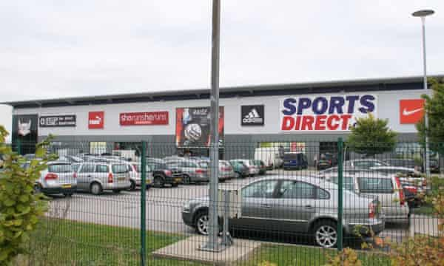
Sports Direct is the largest sports products retailer in the United Kingdom, with around 950 locations globally, including 600 in the United Kingdom (Sports direct, 2021). Mike Ashley launched the company in 1982. It has developed into a multi-retailer empire that includes House of Fraser and Flannels, as well as preppy apparel brand Jack Wills and computer game shop Game. Karrimor, Kangol, Slazenger, and Lonsdale are among the sports brands it owns. Sports Direct has established a goal for itself to become the "Selfridges of sport," with new generation stores showcasing the best products and improving customer experience.

They want to be the world's premier sports and lifestyle store, and they want to provide long-term growth for their shareholders by providing an unrivalled selection of high-quality leading brands to their customers. Sports Direct announced its rebranding to Frasers Group in November 2019. To do so, they are implementing several initiatives and collaborating with well-known organizations (Forbes, 2021).

Product strategy
A product strategy is based on the product's fundamental objective (Kotler and Armstrong, 2016). It specifies the final destination of the product. It is an integral part of putting out a product roadmap and subsequent releases. Instead of striving to be everything to everyone, product strategy allows the organization to focus on a specified target market and feature set.
Sports Direct is one of the world's largest dealers of sports gear and equipment. Sports, fitness, fashion, and leisure are among the company's product categories (Yoon et al., 2015). It has a wide range of products. They feature a large selection of products for men, women, and children. It has all of the sports equipment, footwear, clothing, and accessories under the sports category. Sports Direct sells brands such as Nike, Adidas, Umbro, Dunlop Slazenger, Lonsdale, Everlast, Antigua, Karrimor, Campral, Carlton, Donnay, Gelert, LA Gear, Lillywhites, Reebok, and others. It includes companies such as Crafted, Fabric, Firetrap, Full Circle, Golddlgga, Hot Tuna, Rock & Rags, Kangol, SoulCal, Sovlet, and others under the fashion and lifestyle category.
Many clients are pleased with Sports Direct's varied and appealing product selection. However, they have recently disappointed customers. It has been criticized for its after-sales support, product promises, and response to Covid-19. With a dissatisfaction score of 65%, it topped the list of 29 stores, with customers rating it only two stars for after-sales support and promises (Forbes, 2021). They scored two stars in a recent survey for their Covid-19 response. It's communication and customer service were unsatisfactory. Several respondents, on the other hand, praised the variety of products available at Sports Direct.
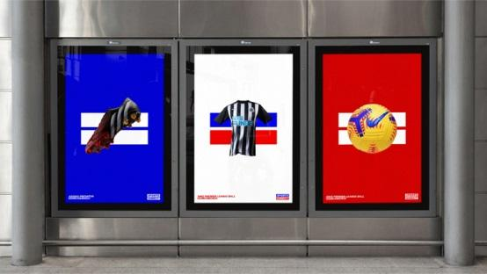
Sports Direct is aiming to rename itself in response to increasing criticism and losses, to unite the retailer's identity and stay up with industry changes (Prosser, 2021). They're working with Venturethree, a London-based brand consultant, to update their logo, name, packaging, and in-store experience. Venturethree has updated its logo by emphasizing equal signs. The sign denotes equality and can be utilized in a variety of ways across the brand, including in new advertising materials. They will also use a variety of typefaces in product packaging.

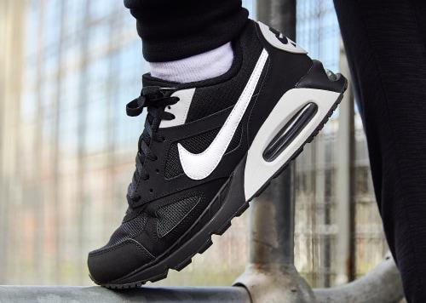
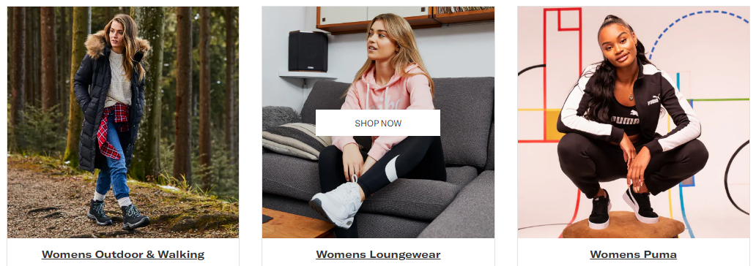
Sports: Sports Direct offers a variety of products for men and women in the sports sector (Codeluppi, 2013). It has apparel, footwear, and accessories, among other things. For extra comfort, their footwear has a cushioned insole and padded ankle collar. This category also includes several gift products comprising a variety of amazing sporting footwear, clothes, accessories, and equipment for men, women, and young athletes.

Lifestyle: For the fashion-conscious, Sports Direct offers fashionable and comfortable items. Their clothing collection caters to both sports and fashion (Wolfe et al., 2017). There are shirts, hoodies, workout gear, pants, and other items available in this category. These are made of a wonderfully soft fabric and feature a comfy hood and a relaxed fit. These unisex clothes are a great complement to any customer's casualwear collection.

Price strategy
Companies employ pricing strategy as a methodology to improve sales and optimize profits by offering their goods and services at strategic prices. It is crucial in the formation of brand perception. As per Kotler and Armstrong (2016), A strategic fit between price and quality should prevail.

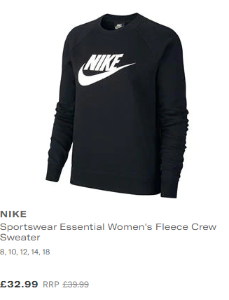
Sports Direct sells its items primarily through its retail stores and online portal at cheap prices. This is the approach that Sports Direct employs to set their prices with discounts that entice people to buy more of the company's items. Nike Sportswear Essential Women's Fleece Crew Sweater is available for £32.99. The hoodie by Adidas costs £32.00 (Sports direct, 2021). In different situations, they use different pricing methods. Their costs vary depending on whatever store you go to. The stores in the outskirts of London are less expensive than those in the city centre and other big cities. This also applies to the types of goods on display in the store
Sports Direct also uses a low-price strategy for clients who want to get the best deals when purchasing products (Sparks and Letham, 2018). Because the rivalry in this industry is expanding as new competitors enter the market with considerably higher levels of innovation and brand power. For leading brand products, they use a value-based pricing strategy. This method combines skimming and penetrating price strategies to acquire more customers without making them sensitive to price fluctuations.

Place strategy
The marketing mix place strategy refers to how a company will distribute its product or service to customers. As per Kotler and Armstrong (2016), a company must provide the goods to the customer at the proper time and place. If the organization wants to accomplish its overall marketing objectives, efficient and effective distribution is critical.
Sports Direct has partnered with several international brands to expand its portfolio and distribution network since its inception (Dugalić, 2014). They are concentrating on the development of a new generation of stores as well as improving the consumer experience across all of their channels. They collaborate with third-party brand partners to connect with customers on a variety of platforms, including online, mobile, and in-store. This technique allows their physical stores and online platform to work together to make the goods more available. Sports Direct has over 600 stores in the United Kingdom, mostly in key locations and cities. Sports Direct sells its items through these stores and its online shopping portal throughout the UK, Europe, and Asia. With thus many retailers, the per-unit cost of each product falls, and the selling price goes down as well. It leads to happy and satisfied customers. In the stores, they keep things very simple, which set them apart from the competition.
All of Sports Direct's websites and e-commerce stores are built on a single web platform. Customers can get thorough information about the products they want, learn about their features, and personalize them according to their needs and requirements. They can also get a close view of the products from different angles. They can place an order and have it delivered in 3-4 days after they've made their choice. For a strong presence in the digital market, they have built an e-commerce app. The software is tailored to the luxury Flannels brand from Sports Direct, as well as the Firetrap lifestyle brand (Tong and Su, 2014). The app runs on both Android and iOS and is powered by the group's unified online platform.

Promotion strategy
A promotion strategy is a process of establishing a brand on the market, raising awareness of the items or services it provides and demonstrating how customers can profit from choosing the brand. It is an important part of the marketing mix because it focuses on the target audience, budget, and strategy (Kotler and Armstrong, 2016).
Sports direct marketing tactics aren't enough impressive. Though they have a lot of sales and customers, it's not because of their communication, but because of their low prices. In terms of quality, impression, and reputation, they have a bad rating. They make more money by reducing the amount of money they spend on the product and promotional mix (Ascoly et al., 2012). With its present marketing strategies, Sports Direct may be viewed as a low-cost, low-quality brand where consumers go to buy stuff they couldn't afford at a more expensive retailer. This weakens its chances of remaining number one in the sports retail category.

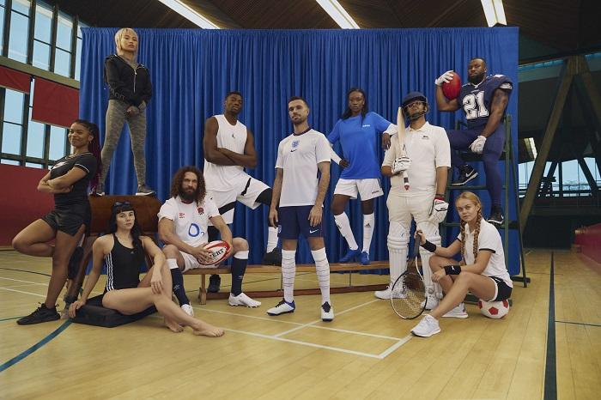
However, Sports Direct is attempting to rebrand itself and project a more powerful image. It has debuted its first-ever Christmas advertising campaign to highlight its rebranding and new positioning (The Guardian. 2021). The brand is portrayed as a high-energy, melodic celebration of sport and fitness in this commercial, which features Liverpool FC captain Jordan Henderson in a cameo appearance. They started a £6 million advertising campaign in November 2021, which included TV commercials, online commercials, social media engagement, and in-store media. These advertisements accurately reflect the retailer's new strategy and mission.

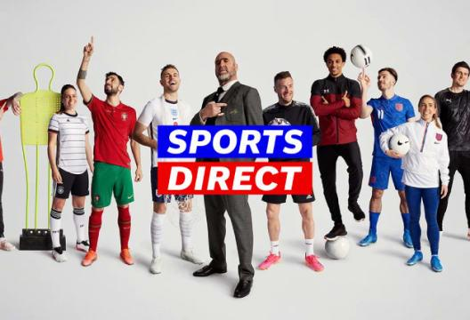
To boost sales and profit, Sports Direct employs a variety of sales marketing techniques (Pourazad et al., 2019). They provide big discounts frequently. There are three large sale areas on their website. There's a "Last Chance" part with last-minute discounts on a range of items, a "Multibuys" section with bulk discount offers, and a typical discount section with over a dozen distinct categories to pick from. Customers can save up to 70% on items in the Sale area, which is open all year. Customers can also get free standard delivery anywhere in the UK when they spend over £100.
They have good contacts with government officials, influencers, journalists, and editors in the UK and globally (. Sports Direct is rebranding the firm, so they're doing a lot of PRS to generate buzz and raise exposure. The Sports Direct International issue was covered in at least 243 articles across many media platforms, including The Daily Mail, Mail Online, Daily Mirror, Huffington Post, and Daily Express (Wang et al., 2021). Sports Direct included tempting prizes and promotional contests in their PR effort.

References
Ascoly, N., Oldenziel, J. and Zeldenrust, I., 2012. Overview of Recent Developments on Monitoring and Verification in the Garment and Sportswear Industry in Europe. Centre for Research on Multinational Corporations.
Busby, A., 2021. Is This the Beginning of The End for Mike Ashley and Sports Direct? [online] Forbes. Available at: <https://www.forbes.com/sites/andrewbusby/2019/07/26/is-this-the-beginning-of-the-end-for-mike-ashley-and-sports-direct/> [Accessed 16 November 2021].
Codeluppi, V., 2013. How value-based brands create a valuable experience: the case of sports brands. In Consuming experience (pp. 163-174). Routledge.
Dugalić, S., 2014. DISTRIBUTION OF A SPORTS PRODUCT. Sport-Science & Practice, 4(2), pp.47-56.
Frederick, H. and Patil, S., 2016. The dynamics of brand equity, co-branding and sponsorship in professional sports. International Journal of Sport Management and Marketing, 7(1-2), pp.44-57.
Kotler, P. and Armstrong, G., 2016. Principles of Marketing. Sixteenth edition, Global edition. ed. Harlow: Pearson Education.
Pourazad, N., Stocchi, L. and Pare, V., 2019. The power of brand passion in sports apparel brands. Journal of Product & Brand Management.
Prosser, D., 2021. Sports Direct Offers Another Vital Lesson in Leadership for Entrepreneurs. [online] Forbes. Available at: <https://www.forbes.com/sites/davidprosser/2017/07/12/sports-direct-offers-another-vital-lesson-in-leadership-for-entrepreneurs/> [Accessed 16 November 2021].
Sparks, L. and Letham, S., 2018. Sport and retailing. In Managing Sport Business (pp. 346-363). Routledge.
Sportsdirect.com. 2021. SportsDirect.com – The UK’s No 1 Sports Retailer. [online] Available at: <https://www.sportsdirect.com/> [Accessed 16 November 2021].
Su, J. and Tong, X., 2015. Brand personality and brand equity: evidence from the sportswear industry. Journal of Product & Brand Management.
the Guardian. 2021. Sports Direct plans to rebrand itself as Frasers Group. [online] Available at: <https://www.theguardian.com/uk-news/2019/nov/25/sports-direct-says-it-plans-to-rebrand-itself-as-frasers-group> [Accessed 16 November 2021].
Tong, X. and Su, J., 2014. Exploring the personality of sportswear brands. Sport, Business and Management: An International Journal.
Wang, R., Zhou, X. and Li, B., 2021. Pricing strategy of dual-channel supply chain with a risk-averse retailer considering consumers’ channel preferences. Annals of Operations Research, pp.1-20.
Wolfe, R.W. and Werhane, P.H., 2017. Claire Jenkins: Non-Executive Director, Sports Direct International plc: Breaking Boundaries. In Global Women Leaders. Edward Elgar Publishing.
Yoon, S.J. and Choi, Y.G., 2015. Determinants of successful sports advertisements: The effects of advertisement type, product type and sports model. Journal of Brand Management, 12(3), pp.191-205.

