

Assessment 1 – Reading Task Template
AS1 – Reading and Notes
NAME: Maria Jeni Hampu
STUDENT ID: 2611054
MODULE: NEW ACADEMIC SKILLS – LCLM4001
DEADLINE: 4TH October 2026

PART 1: PHOTO OF MIND MAP – SOCIAL MEDIA HELPS SMALL BUSINESSES GROW
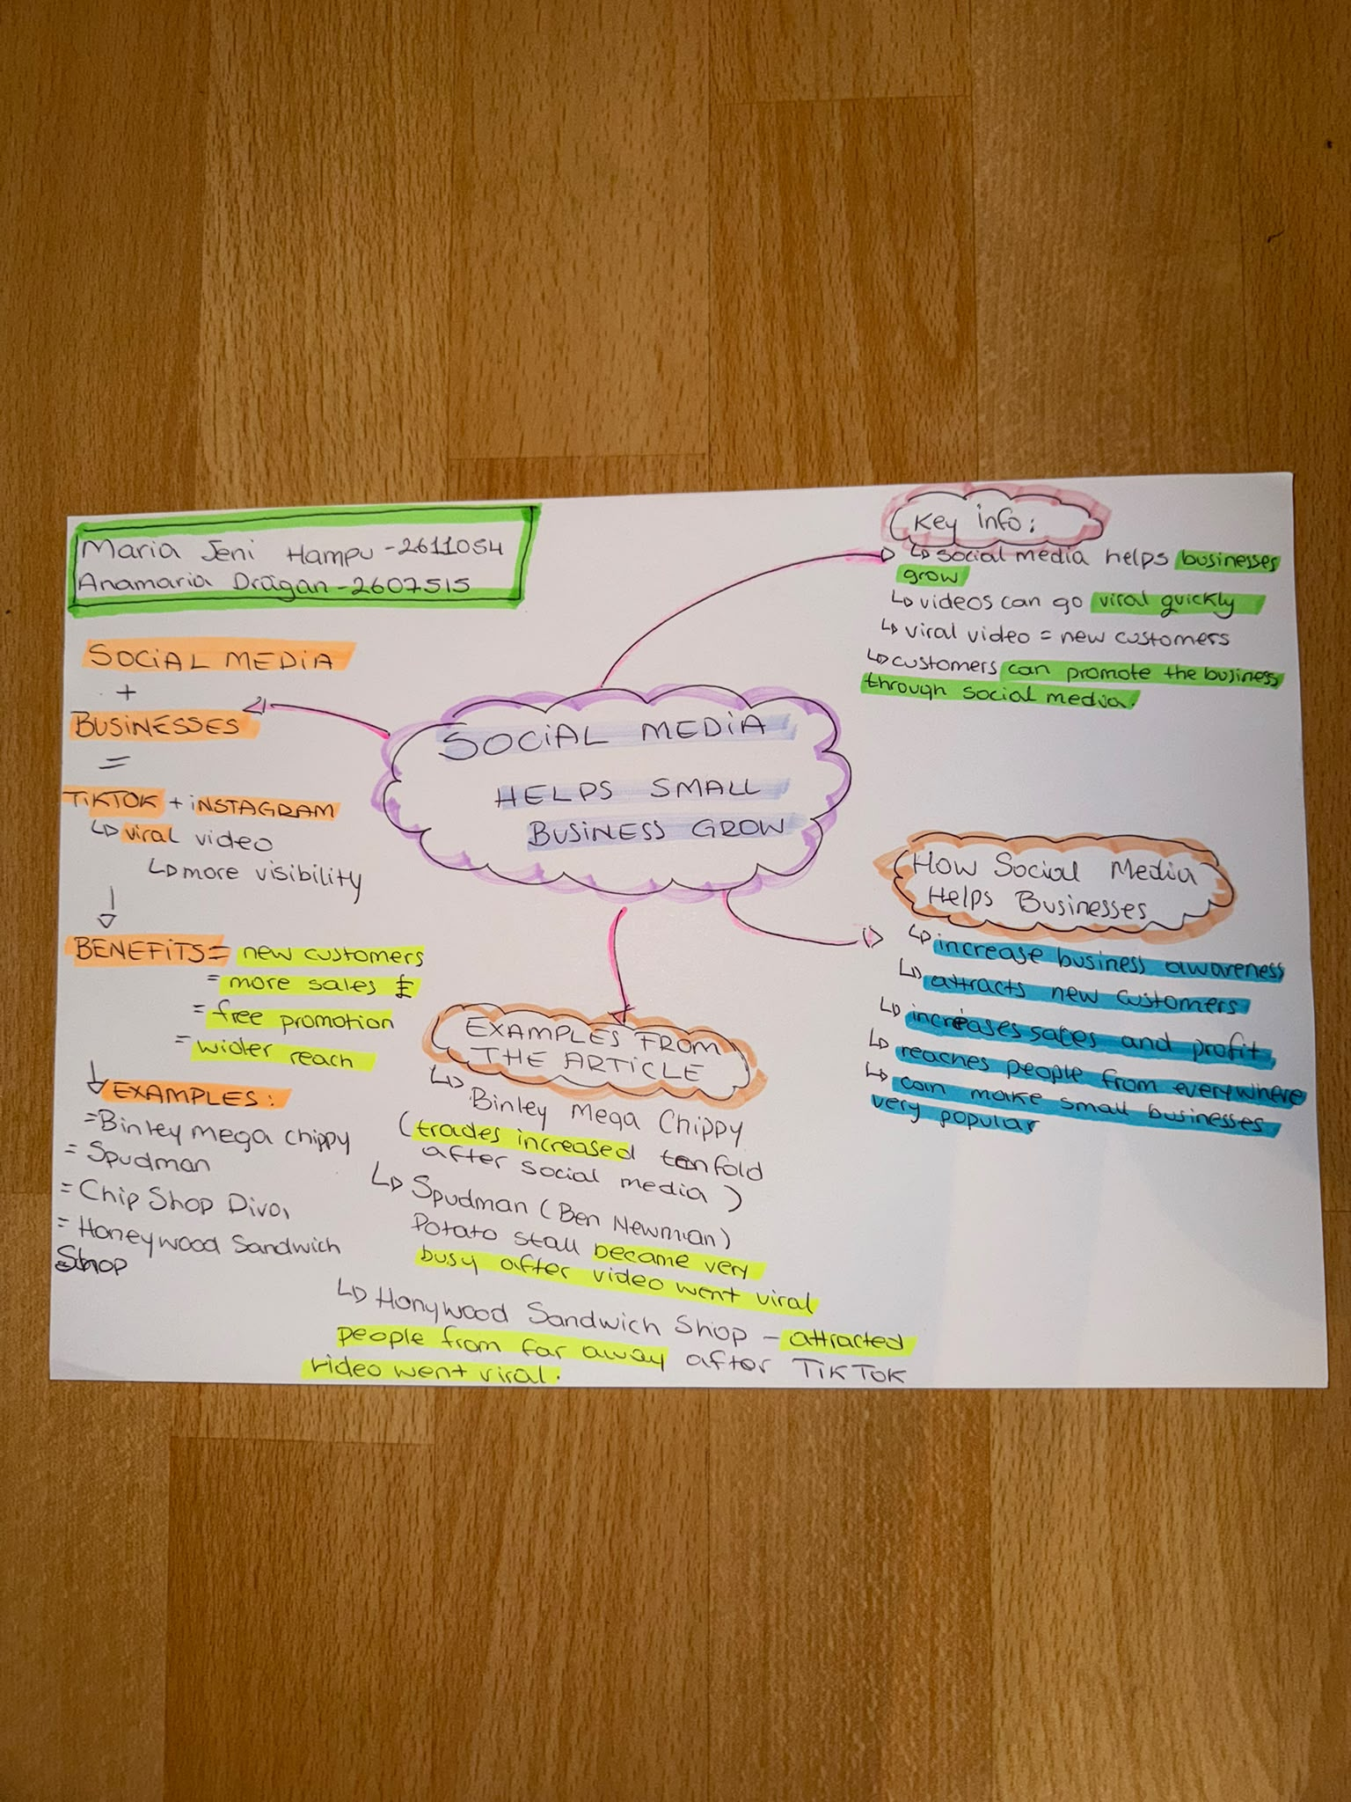

PART 2: ANSWERING QUESTIONS AND SELF REFLECTON

- What is the main idea of the whole text?
- The main point is that social media helps small businesses expand by generating more customers and enhancing sales.

- What is one key point that supports the main idea, and which specific example from the text shows this?
- The use of social media surely leads to bigger revenues. For instance, Binley Mega Chippy managed 10 times increase after posting videos on social media.

- What is a different key point that supports the main idea, and which specific example from the text shows this?
- Social media is able to draw clients from very distant places. For example, people came from three-hour distance for the chicken burger of the Honywood Sandwich Shop.

- Which part of the text do you think is most important, and why?
- The example of the Honywood Sandwich Shop is the main one, as it proves that a viral video can bring customers to a small business.

Reflection:
- What did you find difficult in this task (including in-class components), and why was it difficult?
- I had difficulties choosing the most significant information because there were plenty of examples mentioned in the article.

- What helped you with this difficulty, and how did it help you?
- Developing the mind map made the process of understanding the main ideas easier for me.

