MARKETING MANAGEMENT
Executive Summary
An effective marketing strategy is helpful to enhance a brand's performance and customer reputation in the marketplace. This report would analyze these aspects in context with Sainsbury to analyze their customer perception and reputation in the market. It would briefly analyze different aspects of marketing strategies that are effective to enhance customer reputation. It depicted the crucial role of digital marketing techniques that would enhance the performance of Sainsbury as well as its customer reputation in the marketplace. It further highlighted different theories that are relevant to the context and beneficial for enhancing the customer reputation of Sainsbury. The report presented a broad picture of marketing strategies and enhancing customer reputation.

Table of Contents
Introduction 3
Industry Overview 3
Analysis of marketing strategies to enhance customer reputation 5
Influence of Technologies on the Customer Relationship 7
Customer journey mapping 10
Conclusion 12
References 14

Introduction
Marketing strategies are an integral part of organizations that has a large influence on the performance in the market. It helps firms to enhance performance and attain a large reputation among customers. Furthermore, it enables business entities to expand their operations and achieve robust growth. This report would briefly analyze different aspects of marketing strategies that are effective to enhance customer reputation. It would further investigate brand awareness strategies that also help organisations to gain a competitive advantage in the marketplace. It would analyse these aspects in context with Sainsbury to analyse their customer perception and reputation. It is the biggest retail brand in the UK, which has a vast operation business across the world. Moreover, the report would also analyse the role of technologies to shape the customer reputation of the firm.

Industry Overview
The retail industry is one of the largest sectors that have a major contribution to the economy of the UK. It also employs people that be figured at around 3 million people. The retail industry is accountable for 8% of job generation in the country (Brc.org.uk, 2023). It shows that the retail industry is one of the most dominating industries in the UK. Sainsbury is one of the leading retail brands in the UK that has a dominating position in the market as well as a large customer base.
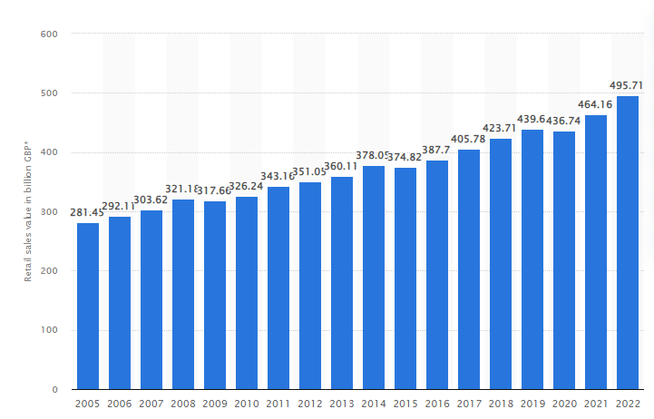
Figure 1: Retail Sales growth in the UK over the years
(Source: Statista.com, 2023)
The above figure reflects the retail sales growth in the UK over the years. It shows that in the year 2022, the retail sales growth rate was figured at around 495.71GBP which is much higher than the previous year (Statista.com, 2023). It depicts that the retail sector is highly valued in the UK and has a major contribution to the country's GDP growth. The industry also holds a higher potential for growth as well as customer reputation.
Sainsbury is the foremost retail organization that holds a significant amount of market capitalization as well as a vast customer base. It has registered a cash flow of £600 million that could provide them with further opportunities for strengthening its position in the market (Sainsbury.co.uk, 2023). The figure represents that the organization has immense financial strength that could further opportunities for its robust growth.
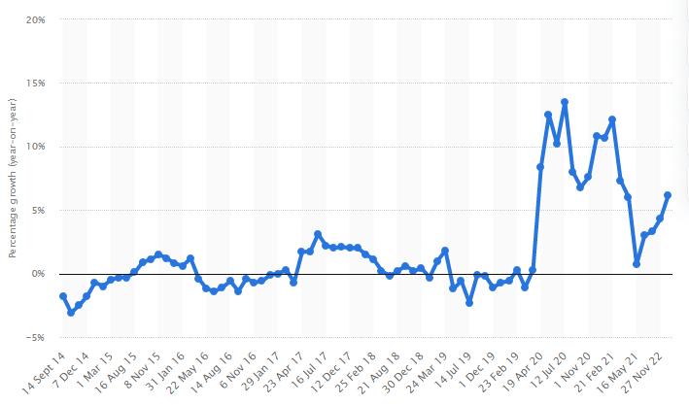
Figure 2: Sainsbury sales growth rate over the years
(Source: Statista.com, 2023)
The aforementioned figure reflects the sales growth rate of Sainsbury in the UK markets over the years. It shows that despite strict pandemic regulations, in the year 2020, Sainsbury registered 8.4% sales growth and retain their market position (Statista.com, 2023). These figures represent that Sainsbury has a dominating position in the market in terms of sales growth and revenue generation.
In the financial year 2020-21, there was around £900 million in cash flow has been registered by Sainsbury (Sainsbury.co.uk, 2022). It shows that the company has a leading position in revenue generation as well as achieving financial growth in the market. Sainsbury would be benefited from these revenue figures to bolster their market position as well as gain a competitive advantage.

Analysis of marketing strategies to enhance customer reputation
Marketing strategies play a crucial role to shape customer engagement and reputation in the market. Firms focus to formulate more customer-centric marketing strategies to expand their customer base as well as gain a good reputation. As opined by Varadarajan (2020), effective marketing strategies help firms to create an ecosystem that supports proper decision-making within the organizational barriers. The author added that it helps firms to analyze demand and supply and meet the complex demands of the market. It further helps businesses to ensure the proper utilization of resources and mitigate threats. Sainsbury could use effective marketing strategies to meet the demands of customers as well as analyze the demand-supply gap within their operational boundaries. On contrary, one of its competitors Tesco is another major retail brand that used effective marketing strategies to enhance customer reputation. It has been witnessed the company introduced the "Club Card" which changed its customer perception by 4.2% (Tesco.com, 2021). It helped the organization to achieve a broader customer reputation as well as expand its customer base.
Customer is an integral component of businesses to flourish more in the market as well as hold up an advanced position. Different strategies help firms to increase customer engagement and improve business performance. Keyser et al. (2020) stated that monitoring customer buying journeys could be an effective strategy to improve the brand’s reputation among customers. The author further stated that it helps businesses to evaluate customers’ demands and the different obstacles they faced during the buying process. Sainsbury could implement this strategy in their wide range of business operations and be able to improve their customer reputation. ASDA is a renowned retail brand that receives around 76% reputation from customers (Yorkshire.co.uk, 2020). It shows that this strategy is effective to enhance the customer reputation in the market. Sainsbury could adopt this strategy and pave way for a larger reputation among customers.
In recent times, there has been a rising trend regarding environmental concerns and sustainability among consumers. It has transformed consumer behaviour as well as forced firms to meet sustainability. As stated by Chou et al. (2020), consumer behaviour shifted to using more green products and vegan materials that ensure sustainability. The author added that the past few years showed a continuous trend to utilize more environmentally friendly products. It influences brands to introduce sustainable products as well as enhance their customer reputation in the market. Moreover, it would help the business to get an edge over its existing competitors.
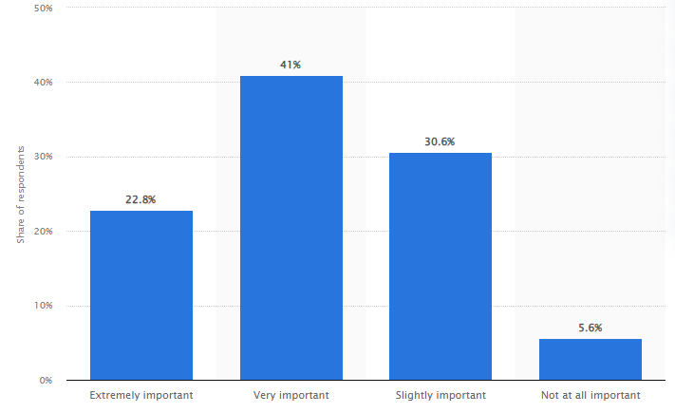
Figure 3: Consumer perception towards sustainable products
(Source: Statista.com, 2021)
The above figure represents the consumer's view towards sustainable products in the market. It shows that around 41% of people provide their opinion that they give top priority towards environment-friendly products (Statista.com, 2021). The figure shows that consumer behaviour has changed over the years and shifted to more sustainability. Sainsbury needs to implement sustainable practices within their organizational barriers to ensure a good customer reputation as well as pave way for robust growth.
Feng et al. (2022) depicted that sustainability and community programs play a pivotal role in enhancing the business performance of organizations. The author added that community programs are helpful to increase people's attachment to the brand and enhance its reputation. Sainsbury could initiate different community programs to help people and increase consumer reputation in the market. It would help them to achieve a competitive advantage and unveil further growth opportunities. As stated by Forecall et al. (2020), efficient corporate governance would be helpful for organizations to introduce community programs that enhance their brand reputation among consumers. The author added that corporate sustainability within the organizational barriers is a major contributor to creating a brand reputation and exploring growth opportunities. Sainsbury needs to take measures to implement effective corporate governance and initiate community programs to gain a good reputation among customers. The organization has been focused on lowering its water usage and achieving water neutrality by the year 2045(Sainsbury.co.uk, 2023). The company has set the goal in line with the UNSDG targets of minimizing water usage and consumption.

As opined by Freeman et al. (2021), the incorporation of stakeholder theory would help business entities to enhance stakeholder engagement and improve their reputation. The author further stated that it develops a collaborative culture that increases the participation of people and improvement of customer engagement. It would be beneficial for Sainsbury to adopt stakeholder theory in its business proceedings and gain a good reputation among customers. Vieira et al. (2019), stated that the marketing mix framework offers better opportunities for firms to examine different aspects of emerging new markets and receives more customers. Moreover, the author added that it helps to analyze the customer's needs and enables brands to identify their target customer base. Marketing mix analysis is helpful to enhance customer reputation and provide larger opportunities for firms to achieve growth. It would beneficial for businesses to retain their position in the market as well as expanding customer base.

Influence of Technologies on the Customer Relationship
Technologies have shown robust growth across the world that plays a pivotal role to shape the business performance of organizations. It’s become a crucial factor for brands to maintain customer relationships. Li et al. (2021) have opined that different digital marketplaces become a major factor in buying and maintaining customer relationships. The author added that social media platforms become a large influencer in consumer buying decisions and perceptions regarding the brand. Email marketing is also playing a crucial role to shape customer reputation as well as the performance of the brand in the marketplace.
It has played a crucial role for brands to uphold their position in the marketplace and retain their customer base. Sainsbury needs to introduce proper digital marketing strategies to expand its customer base.

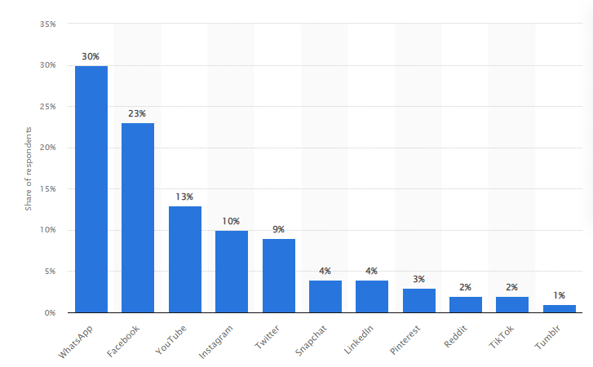
Figure 4: Internet usage in the UK among platforms
(Source: Statista.com, 2022)
The above figure represents the number of users across different social media platforms in the UK. It depicts that around 30% of users use WhatsApp as their social media platform while 23% use Facebook (Statista.com, 2022). It shows that social media becomes the key influencer of brand reputation and perception in the market and shapes the business performance of organizations.
Fiaz et al. (2019), argued that social media platforms have ensured business practices that prevent firms to do any unethical task in the market. The author further stated that negative social media mass campaigning could hamper the business performance of organizations in the marketplace. It could hamper their revenue generation as well as their customer reputation in the market. On the contrary, Khairawati (2020), argued that an effective customer loyalty program could be a major contributor to keeping customer satisfaction levels intact and making them oriented to the organization. Sainsbury could introduce several customer loyalty programs that would ensure loyalty towards its brand. It would further help them to achieve robust growth in the market as well as a larger reputation among customers.
The retail industry is facing transitional distress in the present time to shift its operations from traditional marketing to digital marketing. As stated by Zhu and Gao (2019), a precision digital marketing strategy would help firms to maintain a good relationship with customers. The author added that businesses must ensure the usage of innovative technologies in their operations to improve performance and customer reputation. Khanfar et al. (2021), stated that blockchain technologies are effective to make the supply chain more resilient and oriented to consumers. The author further stated that blockchain technologies could ensure sustainable operations within organizational boundaries and meet organizational goals.
As stated by Kwiatek et al. (2020), suppliers' preferences and inter-business relationships are effective to initiate customer loyalty programs and improve the customer reputation of the brand. The author added that these customer loyalty programs are effective to improve the relationship with customers and enable the firm to expand its customer base. Easy interaction between firms and customers helps to keep consumer-oriented in the company along with improved loyalty. Social media marketing also plays a crucial role to build up the customer loyalty of a brand. ASDA is a robust retail organization that uses software namely Salesforce to maintain a proper relationship with customers and increased engagement (Salesforce.com, 2022). It introduces easy interaction between customers and the brand helped Asda to maintain a good reputation among customers as well as achieve growth in the market.
Chaudhari et al. (2023) have opined that the “Customer Relationship Management” (CRM) method enables firms to maintain a strong relationship with customers and keep them aware of different products and services. The author added that it helps to incorporate innovative strategies and increase accountability to customers. Businesses would be able to achieve a broader reputation from customers as well as would keep them oriented to the company. In contradiction, Mahafzah et al. (2020), argued that product and service quality is a significant factor to maintain a good relationship with customers and attain a good reputation. The author added that although the theory provides a framework to maintain good relationships, however, maintaining product and service quality is equally important to keep good relations intact. Sainsbury would be able to improve its customer reputation by incorporating the CRM theory within its business operations. It would further help them to gain an advanced position in the market as well as get an edge over its existing competitors.

Customer journey mapping
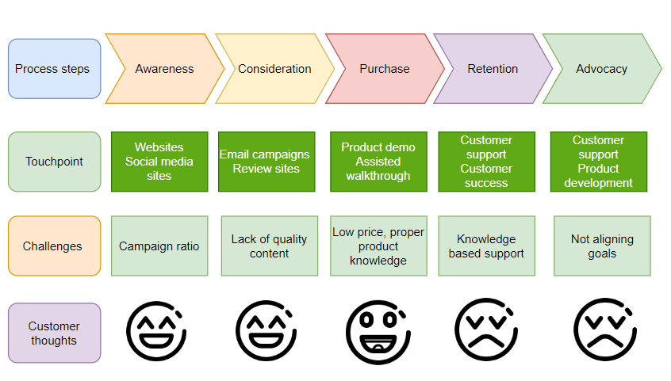
Figure 5: Customer journey mapping
(Source: Self-developed)
The above figure states the customer journey mapping of a customer in Sainsbury’s shops and it is identified that there are different processes of the customer journey including awareness, consideration, purchase, retention, and advocacy (Micheaux and Bosio, 2019). During the awareness phase, the company has been focusing on website development and social media site development. Under this phase, the consumer mainly focuses on the problem opportunities and needs. Under the consideration phase, the customers can purchase their needs and requirements and it is identified that under this, customers can determine the products that they want to buy. Furthermore, under the stage of purchase, the customer has been focusing on the purchasing of a product and they finalise a product to purchase. Under the touch point, companies mainly develop the factors related to the development of marketing collateral such as posters, stickers, flyers, display advertisements, and billboards. Customer’s thoughts, expressions, and emotions are prime factors related to the sale of products and companies need to provide customer support to increase their sales. However, while purchasing products from the different stores, the company need to eradicate the factors related to challenges that the company has been facing (Micheaux and Bosio, 2019). However, it can also be stated that the company can use different kinds of communication channels to enhance the experiences of the customer such as mobile applications, mobile smartphones, computer factors, and the use of 24*7-customer support and chat box to enhance the factors of buying behaviour.
Brand Awareness Techniques to improve customer reputation
Brand awareness strategies are helpful for companies to provide brief insights about their products and services to customers. It plays a crucial role to build relationships with customers as well as in achieving growth in the market.
Elements of marketing strategy | Description
Product | - Sainsbury is a leading retail brand in the UK that offers different kinds of grocery products, home decor items, clothing products and various other products.
Price | - “Value-based pricing strategy”
Place | - “Indirect Distribution Strategy”  - More than 600 superstores
Promotion | - “Social Media Platforms and Online marketing websites”.
Table 1: 4P’s of marketing
(Source: Self-developed)
The above table represents the 4Ps of marketing that enable a brief analysis of different Price, Place, and Promotion strategies for brands. It also provides a brief overview of Sainsbury's products. Further, in the UK Sainsbury have more than 600 superstores and more than 800 store convenience who are providing services to their consumers. As stated by Hanaysha et al. (2021), marketing mix is helpful for brands to determine the factors that influence consumer-buying decisions. The author further stated that these elements briefly analyze different strategies that are effective for a brand to gain a good reputation among customers and get an edge over its competitors.
Mason et al. (2021) stated that social media becomes a key communication channel now that influences consumer buying decisions. The author added that it is also playing a crucial role to make consumer perceptions regarding the company. It has been witnessed that social media is shaping the buying decisions of customers. Social media is widely used by consumers that figured at around 7 out of 10 people give priority to social media platforms (Forbes.com, 2022). It shows that people nowadays are highly influenced by social media platforms. As stated by Jacobson et al. (2020), social media platforms make retailers more accountable to consumers as they are forced to publish all of their data among customers.
The author added that it helps consumers to take unbiased buying decisions as well as improve their buying journey. Li et al. (2021) have opined, e-mail marketing is also showing rising demand among customers to influence their buying decisions. The author added that it serves as a prior communication channel between organizations and customers that increase brand awareness as well as influences purchasing decisions. It also helps to build up a customer perception of the brand. Furthermore, it is also observed that Sainsbury has been using above-the-line and below-the-line promotional strategies to enhance the customer’s attraction strategy. Under the “above the line” strategy the company has been using factors related to sales promotion, database management, packing and another slogan campaign. Customers are the prime factors for a company for that, Sainsbury needs to focus on the fulfilling of demand of consumers.
As opined by Hien and Nhu (2022), brand awareness theory is helpful to analyze consumer perceptions and formulate strategies to meet their perceptions. The author added that it uses real-life examples and context to evaluate consumer perception and briefly analyze that. The theory helps firms to produce a brief evaluation of consumer behaviour and draft strategies to match their demands. On the other hand, through the enhancement of packaging of products quality and other customer satisfaction services

Conclusion
Conclusively, the report analyzes different aspects of marketing strategies that play a crucial role to build up customer perception as well as the brand's reputation in the market. It highlighted different factors that are associated with the marketing strategies and the brand's customer reputation. The report analyzes all the factors in light of the Sainsbury. It is a large retail brand in the UK, which holds a dominating position in the market as well as holds a vast customer base. Moreover, it reflected the crucial role of digital marketing techniques that would enhance the performance of Sainsbury as well as its customer reputation in the marketplace. It further enlightened into different theories that are relevant to the context and beneficial for enhancing the customer reputation of Sainsbury. Thus, it can be said that the report presented a complete picture of different marketing strategies to improve customer reputation in the market.

Poster

Introduction
- Effective marketing strategies ensure the overall competitive advantage development for a brand.
- Sainsbury's is one of the well-established retail brands of the UK that successfully operated its business with effective marketing strategies
- Customer-centric marketing strategies and brand awareness of Sainsbury's helped the company to gain sustainable business growth within the industry
- High demand for retail products within the UK market ensures in development of brand positioning of Sainsbury's in an efficient manner
- The use of advanced technology such as Blockchain, delivery services, and contactless payments has ensured meeting customer demand by Sainsbury's that helped the company to enhance its brand reputation within the industry.

Industry Overview
- The retail sector of the UK has supported the economic development of the country by providing around 8% jobs (Brc.org.uk, 2023)
- In the UK retail industry, Sainsbury's has positioned itself in a dominant position through variety of products offerings and effectiveness in its marketing strategies
- The retail sector of the UK has generated around 495.71GBP retail sales in 2022 (Statista.com, 2023)
- In the UK retail industry, Sainsbury's holds its dominant financial position by possessing a cash flow of around £600 million (Sainsbury.co.uk, 2023)
- The effectiveness of marketing strategies and brand reputation helped Sainsbury's to gain around 8.4% growth in sales during 2020 (Statista.com, 2023)

Marketing strategies
- Customer-centric marketing strategies of Sainsbury's helped the company to develop a strong customer base within the UK retail industry along with attracting a wide range of new customers (Varadarajan, 2020)
- Meeting customer demand by focusing on sustainable products due to a huge demand for these products has been reported at around 41% in the UK (Statsita.com, 2021)
- Offering a variety of products and focusing on Omni channel marketing of Sainsbury's has helped the company to gain customers' attention and achieve sustainable growth
- Innovative products design and differentiation in products develop from its competitors such as Tesco, and ASDA has helped Sainsbury's to achieve competitive advantages through its marketing strategies

Technology on customer relationship
- Integrated digital marketing strategies of Sainsbury's have helped the company to expand its customers base by attracting a wide range of customers (Li et al. 2021)
- Effective social media marketing helped Sainsbury's to develop brand awareness and promote its products to a larger customer base that further ensured business growth
- Enhancement of the CRM process by evaluating "customer journey mapping" has helped the company to meet customer demand and provide customer satisfaction for business development (Chaudhari et al. 2023)
- Social media monitoring and customer insights data analysis can enhance the forecast process for the brand further ensured meets customer demand

Conclusion
- Sainsbury's digital marketing strategies and "value-based pricing" strategies ensure pricing competitive advantages within the UK retail industry
- Ensuring customer satisfaction through product differentiation and marketing strategies helped Sainsbury's to operate its business in the UK from a dominant position financially and reputation-wise
- Omni channel marketing and social media monitoring helped in customer analysis along with their buying pattern further helped in the development of effective marketing plans
- Customer journey mapping and effectiveness of digital marketing strategies can further ensure sustainable business growth of Sainsbury's in the UK retail industry

References
Brc.org.uk (2023).THE UK RETAIL INDUSTRY.Available from https://brc.org.uk/climate-roadmap/section-1-context/12-the-uk-retail-industry/#:~:text=The%20retail%20industry%20in%20the,were%20worth%20%C2%A3439%20billion. Accessed on 05.04.2023
Chaudhuri, R., Chatterjee, S., Kraus, S. and Vrontis, D., 2023. Assessing the AI-CRM technology capability for sustaining family businesses in times of crisis: the moderating role of strategic intent. Journal of Family Business Management, 13(1), pp.46-67. https://www.emerald.com/insight/content/doi/10.1108/JFBM-12-2021-0153/full/html
Chou, S.F., Horng, J.S., Liu, C.H.S. and Lin, J.Y., 2020. Identifying the critical factors of customer behavior: An integration perspective of marketing strategy and components of attitudes. Journal of retailing and consumer services, 55, p.102113. https://www.sciencedirect.com/science/article/pii/S0969698919310793
De Keyser, A., Verleye, K., Lemon, K.N., Keiningham, T.L. and Klaus, P., 2020. Moving the customer experience field forward: introducing the touchpoints, context, qualities (TCQ) nomenclature. Journal of Service Research, 23(4), pp.433-455. https://journals.sagepub.com/doi/pdf/10.1177/1094670520928390
Feng, Y., Akram, R., Hieu, V.M. and Tien, N.H., 2022. The impact of corporate social responsibility on the sustainable financial performance of Italian firms: Mediating role of firm reputation. Economic Research-Ekonomska Istraživanja, 35(1), pp.4740-4758. https://www.tandfonline.com/doi/abs/10.1080/1331677X.2021.2017318
Fiaz, M., Ikram, A., Basma, A., Tariq, Z., Jafri, S.K.A. and Khurram, W., 2019, November. Role of social media marketing activities in creating university brand image and reputation: the mediating role of customer value co-creation behavior. In 2019 8th International Conference on Information and Communication Technologies (ICICT) (pp. 135-141). IEEE. https://ieeexplore.ieee.org/abstract/document/9001927/
Forbes.com (2022).How Social Media Impacts Consumer Buying.Available from https://www.forbes.com/sites/forbesagencycouncil/2022/04/28/how-social-media-impacts-consumer-buying/?sh=63fa9e2c337d. Accessed on 05.04.2023
Forcadell, F.J., Aracil, E. and Ubeda, F., 2020. Using reputation for corporate sustainability to tackle banks digitalization challenges. Business Strategy and the Environment, 29(6), pp.2181-2193. https://onlinelibrary.wiley.com/doi/abs/10.1002/bse.2494
Freeman, R.E., Dmytriyev, S.D. and Phillips, R.A., 2021. Stakeholder theory and the resource-based view of the firm. Journal of Management, 47(7), pp.1757-1770. https://journals.sagepub.com/doi/pdf/10.1177/0149206321993576
Hanaysha, J.R., Al Shaikh, M.E. and Alzoubi, H.M., 2021. Importance of marketing mix elements in determining consumer purchase decision in the retail market. International Journal of Service Science, Management, Engineering, and Technology (IJSSMET), 12(6), pp.56-72. https://www.igi-global.com/article/importance-of-marketing-mix-elements-in-determining-consumer-purchase-decision-in-the-retail-market/289416
Hien, N.N. and Nhu, T.N.H., 2022. The effect of digital marketing transformation trends on consumers’ purchase intention in B2B businesses: The moderating role of brand awareness. Cogent Business & Management, 9(1), p.2105285. https://www.tandfonline.com/doi/abs/10.1080/23311975.2022.2105285
Jacobson, J., Gruzd, A. and Hernández-García, Á., 2020. Social media marketing: Who is watching the watchers?. Journal of retailing and consumer services, 53, p.101774. https://www.sciencedirect.com/science/article/pii/S0969698918307744
Khairawati, S., 2020. Effect of customer loyalty program on customer satisfaction and its impact on customer loyalty. International Journal of Research in Business and Social Science (2147-4478), 9(1), pp.15-23. https://ssbfnet.com/ojs/index.php/ijrbs/article/view/603
Khanfar, A.A., Iranmanesh, M., Ghobakhloo, M., Senali, M.G. and Fathi, M., 2021. Applications of blockchain technology in sustainable manufacturing and supply chain management: A systematic review. Sustainability, 13(14), p.7870. https://www.mdpi.com/1188276
Kwiatek, P., Morgan, Z. and Thanasi-Boçe, M., 2020. The role of relationship quality and loyalty programs in building customer loyalty. Journal of Business & Industrial Marketing. https://www.emerald.com/insight/content/doi/10.1108/JBIM-02-2019-0093/full/html
Li, F., Larimo, J. and Leonidou, L.C., 2021. Social media marketing strategy: definition, conceptualization, taxonomy, validation, and future agenda. Journal of the Academy of Marketing Science, 49, pp.51-70. https://link.springer.com/article/10.1007/s11747-020-00733-3
Mahafzah, A.G., Aljawarneh, N.M., Alomari, K.A.K., Altahat, S. and Alomari, Z.S., 2020. Impact of customer relationship management on food and beverage service quality: The mediating role of employees satisfaction. Humanities & Social Sciences Reviews, 8(2), pp.222-230. https://www.academia.edu/download/65453588/Humanities_Social_Sciences_Reviews.pdf
Mason, A.N., Narcum, J. and Mason, K., 2021. Social media marketing gains importance after Covid-19. Cogent Business & Management, 8(1), p.1870797. https://www.tandfonline.com/doi/abs/10.1080/23311975.2020.1870797
Micheaux, A. and Bosio, B., 2019. Customer journey mapping as a new way to teach data-driven marketing as a service. Journal of Marketing Education, 41(2), pp.127-140. https://doi.org/10.1177/0273475318812551
Sainsbury.co.uk (2022). Interim Results 2022/23. Available from https://www.about.sainsburys.co.uk/~/media/Files/S/Sainsburys/documents/reports-and-presentations/2022/Interims%202223/J%20Sainsbury%20plc%20Interim%20Results%202223%20Presentation.pdf. Accessed on 05.04.2023
Sainsbury.co.uk (2023).Minimise use of water.Available from https://www.about.sainsburys.co.uk/sustainability/better-for-the-planet/water. Accessed on 05.04.2023
Sainsbury.co.uk (2023).Third Quarter Trading Statement for the 16 weeks to 7 January 2023.Available from https://about.sainsburys.co.uk/news/latest-news/2023/11-01-23-q3-results. Accessed on 05.04.2023
Salesforce.com (2022) .Asda Redefines the Consumer Grocery Experience with Salesforce.Available from https://www.salesforce.com/news/press-releases/2022/06/09/salesforce-asda-grocery-news/. Accessed on 05.04.2023
Statista,com (2022). The most essential social media platforms in the United Kingdom (UK) 2020. Available from https://www.statista.com/statistics/1059261/social-media-usage-uk-most-important/. Accessed on 05.04.2023
Statista.com (2021).Importance of purchasing eco-friendly and sustainable products UK 2021.Available from https://www.statista.com/statistics/1257575/purchasing-eco-friendly-and-sustainable-products-uk/. Accessed on 05.04.2023
Statista.com (2023). Sainsbury's sales growth year-on-year in Great Britain 2014-2022. Available from https://www.statista.com/statistics/386729/sainsburys-sales-percentage-change-great-britain-uk/. Accessed on 05.04.2023
Statista.com (2023).Retail sales value in Great Britain 2005-2022.Available from https://www.statista.com/statistics/287912/retail-total-annual-sales-value-great-britain/. Accessed on 05.04.2023
Tesco.com (2021). How analytics helped Tesco improve its customer satisfaction amid Covid: An Economic Times Coverage. Available from tescobengaluru.com/news/how-analytics-helped-tesco-improve-its-customer-satisfaction-amid-covid-an-economic-times-coverage/. Accessed on 05.04.2023
Varadarajan, R., 2020. Customer information resources advantage, marketing strategy and business performance: A market resources based view. Industrial Marketing Management, 89, pp.89-97. https://www.sciencedirect.com/science/article/pii/S0019850120300389
Vieira, V.A., de Almeida, M.I.S., Agnihotri, R., da Silva, N.S.D.A.C. and Arunachalam, S., 2019. In pursuit of an effective B2B digital marketing strategy in an emerging market. Journal of the Academy of Marketing Science, 47, pp.1085-1108. https://link.springer.com/article/10.1007/s11747-019-00687-1
Yorkshire.co.uk (2020).Asda finishes dead last in Which? supermarket satisfaction survey - and this is why.Available from https://www.yorkshirepost.co.uk/lifestyle/asda-finishes-dead-last-which-supermarket-satisfaction-survey-and-why-1887322. Accessed on 05.04.2023
Zhu, G. and Gao, X., 2019. Precision retail marketing strategy based on digital marketing model. Science Journal of Business and Management, 7(1), pp.33-37. https://www.researchgate.net/profile/Guoan-Zhu/publication/333678454_Precision_Retail_Marketing_Strategy_Based_on_Digital_Marketing_Model/links/5cff05274585157d15a1fda4/Precision-Retail-Marketing-Strategy-Based-on-Digital-Marketing-Model.pdf

