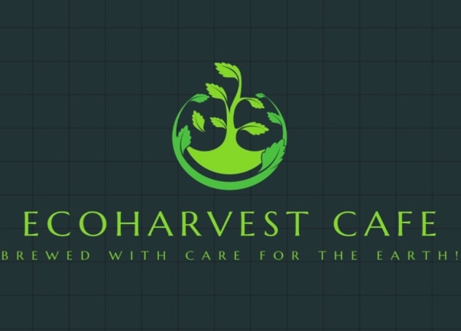
(Design.com, 2024)
Business Plan for

EcoHarvest Cafe
Produced By:

GROUP MEMBERS:
Student Name | Student No.
Adriana Mitran | 1920087
Alin-Bogdan Jeler | 2223715
Beatrice-Elia Gherasim | 2241871
Danu Mihalachi | 2022840

Dated: 15/11/2024
Module Name: Entrepreneurship
Module Code: BMIH5001
Lecturer Name: Christopher Wilkin

CONTENTS

AI Declaration: I acknowledge the use of [Logo Design] [https://www.design.com/maker/logo/eco-friendly-vegan-farm-384469?text=EcoHarvest+Cafe&isSearch=True] on [10 November 2024] to [Logo]. I used the prompt(s): 1. [Colour & Writing]
I confirm that I have not presented any AI generated text as my own work. I confirm I have copies of my drafts, notes, and other resources I used before, and after the use of AI tools which I may be asked to provide in evidence.

EXECUTIVE SUMMARY

EcoHarvest Café is a UK-based sustainable restaurant. The company offers an organic restaurant to deliver a farm-to-table experience. The café focuses on delectable food prepared from fresh organic produce cultivated in our in-house plant farm for the discerning consumer who cares about the environment. High market opportunities exist among health-conscious consumers, vegan, and vegetarian customers who are demanding healthier and more ethical choices for dining. This company will have a competitive advantage in sustainability, that is, the utilisation of recycled materials with menu nutrition and environmental predisposition.

Table of Contents
1 THE BUSINESS IDEA 5
1.1 The Product/Service 5
2 THE TEAM 6
2.1 Key Personnel (Refer to Appendix D) 6
2.2 Skills Gaps & Key Partners 6
3 MARKET RESEARCH – Beatrice-Elia Gherasim 7
3.1 Market Information, Trends, and External Factors 7
3.2 Customer Profiles 8
3.3 Competitor Profiles 8
4 MARKETING PLAN – Alin-Bogdan Jeler 10
4.1 Price 10
4.2 Product 10
4.3 Placement 10
4.4 Promotion 11
5. KEY RESOURCES (Danu Mihalachi) 11
5.1 Premises 12
5.2 Equipment 12
5.3 Key Suppliers 14
6. FINANCES AND START-UP SUPPORT - Adriana Mitran 15
7. REFERENCES 18
8. APPENDIX 25
Appendix A – SWOT Analysis 25
Appendix B – PEST Analysis 25
Appendix C Presentation/Pitch 27
Appendix D- The Team 29
Appendix E- Market research 31
Appendix F 33

THE BUSINESS IDEA

The Product/Service
Company Name: EcoHarvest Café
Location: Charlton Park Farm, Charlton Drive, Wraxall, Bristol, Somerset, BS48 1PD
Industry: Hospitality- Sustainable Restaurant and Urban Farming.
EcoHarvest Café provides sustainable bio-restaurant businesses in the hospitality sector of the UK. The facility is targeted towards environmentally considerate people looking for a better and environmentally friendly way of dining. Café serves fresh, locally grown, and organic meals prepared from within our in-house plant farm, thus reducing the traditional environmental impact associated with production and transportation.
The primary service that the EcoHarvest Café provides to customers is a farm-to-table dining place, meaning on-site harvest is directly provided within meals prepared. Secondly, cafes sell eco-products such coffee cups from used ground coffee to reduce waste and in their mission of going green.
Features and Benefits
- In-house plant farm: Fresh and organic produce grown in an environment that is pesticide-free for quality and nutritious food is guaranteed (Bozatli and Ventaka, 2021).
- Sustainable products: Eco-friendly packaging and sustainable materials such as recycled coffee grounds can help eradicate waste by making cups out of them (Hussain et al. 2024).
- Health-conscious menu: Provides numerous bio-based, organic dishes meant for vegans, vegetarians, and health-conscious customers (Versino et al. 2023).
Value Proposition:
EcoHarvest Café will offer an exclusive, eco-friendly dining experience, meeting the growing demand for sustainable, healthy food. With an in-house plant farm, it ensures freshness, transparency, and reduced environmental impact, appealing to ethically conscious consumers seeking positive lifestyle changes.

THE TEAM

Key Personnel (Refer to Appendix D)
Name and Company Position: Beatrice-Elia Gherasim – Operations Manager.
Name and Company Position: Jeler Alin-Bogdan – Head Chef
Name and Company Position: Adriana Mitran – Administrator
Name and Company Position: Danu Mihalachi – Barista

Skills Gaps & Key Partners
2.2.1 Additional Staff Requirements (Roles and Responsibilities):
Role | Responsibilities | Estimated Salary
Accountant | Financial management, budgeting, tax compliance | £100-500 Per month (Bark, 2024)
Cleaning and maintenance staff | Facility upkeep, cleanliness, minor repairs | £12-70 per hour (Bark, 2024a)
Wait staff | Customer service, order taking, serving food/drinks | £5-11.50 per hour (Brigad, 2024)
Farm staff | Managing the café’s small farm, sourcing ingredients | £12.26 per hour (Talent, 2024)

2.2.2 Training and Development:
The main aspect related to training will make all employees work toward sustainability goals and operational needs:
Sustainability Practices: External hospitality sustainability consultants would educate staff in the aspects of waste management, reducing energy consumption, and the source of supply sustainability (Green Key ,2024, The Sustainable Restaurant Association ,2024). This cost is approximated at £1,200 (Indeed UK, 2024). Other sustainable requirements include packaging suppliers, renewable energy solutions, water-saving fixtures, and local organic farmers.

2.2.3 Outsourced Support / Key Partners:
The Café will collaborate with several vital external suppliers:
Green Energy Supplier: To power the café, the Café will partner with Eco TriCity or Good Energy, ensuring our energy comes from renewable sources (Good Energy, 2023; Ecotricity, 2023). This will depend on usage but is estimated at £3,000 annually.
Marketing Agency: Digital marketing will be environmental outsourced, such as Greenhouse PR. This would give more exposure to our sustainable mission. SEO, social media management, and content creation services will be about £2,400 per year (Business Prices, 2024).

MARKET RESEARCH – Beatrice-Elia Gherasim

Market Information, Trends, and External Factors
The market share of millennials in the United Kingdom for sustainable food and non-alcoholic beverages in 2022 was 30%. The generation’s market share is expected to rise to 31% by 2027 (Statista, 2023). Notably, it is also established that 65% of UK consumers are ready to make a premium for environmentally conscious products; the market for plant-based foods is estimated to reach £1.1bn by 2026 (Mintel, 2020). Significant trends are the increasing demand for local and organic product sourcing and the popularity of vegan and vegetarian dishes, as the number of vegan and vegetarian restaurants in the UK has increased by 40% over the past 5 years (HappyCow, 2020).
PEST analysis reveals that environmental regulations on sustainability and carbon emissions will impact EcoHarvest Café. To address this, the café will recycle organic waste into compost for its in-house farm, supporting a closed-loop system. Key risks include inflation, rising costs, and supply chain issues like crop diseases, mitigated through sustainable farming and strong ties with local suppliers.

Customer Profiles
Eco-conscious Millennials (Aged 25-40) | This segment is concerned about sustainability and responsible consumption of plant-based and eco-friendly products, which aligns with EcoHarvest Café's purpose. Health-conscious, value organic food, and are willing to pay more for sustainable dining experiences (Deloitte, 2021).
Health-conscious Professionals (Aged 35-55) | Active professionals who are conscious about health. Such people will look for quick, yet healthy food options prepared from ingredients readily available in the region (Euromonitor International, 2021; Hartman Group, 2020). These customers are looking at convenience, quality of ingredients, and ethical food practices.
Families with Young Children (Aged 30-45) | Parents look for healthy food choices and family-oriented restaurants with healthy meals in an amiable environment. Seeking sustainable businesses and supporting local community. They care about their children's future. In this market, transparency in food origin and eco-friendliness are judged (Euromonitor, 2020).

Competitor Profiles

Mildreds (London) | Strengths: The restaurant has a strong brand with a loyal following. It is a well-established vegan and vegetarian restaurant famous for innovative plant-based dishes and trendy locations (Mildreds, 2024). Mildred's audience breakdown validates the restaurant drinking public, which is young, mostly women, between 25 and 34 years old (Refer to Appendix E) (Similar Web, 2024).  Weaknesses: The primary limitation is its concentration within London, needing a presence in other UK cities.  How We Compete: EcoHarvest Café will offer same quality meals however engage in community activities in other UK cities, like Bristol.
Farmacy (London) | Strength: Organic, farm-to-table restaurant that focuses on a healthy-conscious menu, and plant-based seasonal dishes (Farmacy, 2024). Farmacy London got a 48.5% traffic boost, great engagement, low bouncing rate and the visitor's duration per session is more than 3 minutes (Similarweb, 2024a) (Refer to Appendix E).  Weakness: Premium pricing may not attract price-sensitive consumers.  How We Compete: EcoHarvest Café will offer similarly organic and sustainable food at more accessible prices. To differentiate further, we will also promote our in-house farming system.
Pret A Manger | Strength: Pret A Manger has focused on fresh, ready-to-eat food and quality coffee with sustainability efforts through organic sourcing. Strong points lie in an excellent reputation for quality and speedy service (Pret A Manager,  2024). This quality, coupled with short order delivery cycle, makes Pret a Manger a trusted franchise with a consumer profile including 39.67% male visitors and 60.33% females (Similarweb, 2024b) (Refer to Appendix E).  Weakness: Its eco-practices are more general and not oriented towards the community.  How We Compete: EcoHarvest will provide engaging experiences by participating in local community events, such as farmers' markets, which Pret a Manger does not compete with.

MARKETING PLAN – Alin-Bogdan Jeler

Price
Pricing policy is one of the competitive strategies to target consumers with an awareness of environmental conservation. Making EcoHarvest Café an affordable but superior eating-place, prices will range between £5 for small dishes and £15 for large dishes. However, costs are reasonable from the perspective of sustainable supply, stressing value for the money against similar brands such as Farmacy and Mildreds (Farmacy, 2024; Mildreds, 2024). For example, a starter at Farmacy range between £6 to £7 and for mains between £19 to £22, similar prices are on Mildreds meaning that Eco Harvest Café has lower prices and great competition situating the café, in this scenario, on 1st place for lower prices.

Product
Aesthetic design consists in natural elements and earthy colours, giving a soothing look. It shall offer eco-friendly packaging, made of biodegradable materials to support its sustainable ideology. Therefore, the branding has trendy logo with green highlights symbolizing eco-friendliness (Design, 2024). The Cafe products include coffee, soft drinks, smoothies using fresh fruit and vegetables, starters, mains, desserts, vouchers through influencer partnerships and more to follow with future expansion.

Placement
Products will be sold both online (through our website and food delivery services) and offline at the café location. Delivery partnership with local services to ensure fast, eco-friendly distribution. Further, the café will focus on community pop-up events and farmers' markets to ensure local engagement.
As a strategy for expansion and use of fresh vegetables, in future when profit grows, a similar concept such as Hello Fresh will be used by delivering vegetables with customized recipes to loyal customers involved in Eco Harvest sustainable initiative at a reduced price, ensuring profitability and decrease wastage (Hello Fresh, 2024).

Promotion
Digital marketing strategies encompass social media campaigns on Instagram and Facebook, targeting the conscious consumer; influencer partnership with sustainably conscious ambassadors to build reach (Hughes, C., Swaminathan, V. and Brooks, G. 2019) and local newspapers with community boards to execute this strategy (De Vries, L., Gensler, S. and Leeflang, P.S. 2017). Loyalty programs, with discounts and other incentives to customers purchasing multiple times.
Referring to influencer partnerships, the intention is to offer reasonable discount for their meal to maintain a healthy business relationship and future vouchers that could include small % from each customer obtained through their platform. The influencers are going to use a specific code for validation and potential customers will have to complete a review at the end of their 1st visit using the code obtained from influencer’s webpage.
Eco Harvest sustainable elements will be used as Unique Selling Point (USP) as consumers today respond well to transparency and ethical branding, hence making sustainability a visible element of the brand could increase retention. In this scenario all the adverts and promotion will contain and expose the sustainable elements of the business.

5. KEY RESOURCES (Danu Mihalachi)
To maintain profitability and provide high-quality service, our restaurant to become successful must efficiently collect and handle a variety of resources.

5.1 Premises
EcoHarvest Café will use 2,826 sq. ft. profitable commercial space in an urban setting for dining, a small farm, and an office. It helps because the business is situated in city areas of Bristol; the rent will be approximately £39,996 (Burston Cook, 2024).

5.2 Equipment
For serving fast and quality food, EcoHarvest Cafe will need staple items such as high-quality ovens, stoves, grills, and other speciality equipment required for our menu. To maintain ingredients' freshness and organisation, commercial refrigerators, and freezers most of the equipment will be purchased from Amazon and Ebay platform and some of them include Catering Appliance Superstore and Nisbets, and Nisbets Catering Equipment (Nisbets, 2023). The business will opt for vintage interior decor that reflects the eco concept of the restaurant.
Items | Description | Price | Website | Screenshots
Coffee Machine | High-performance coffee machine for blending specialty drinks and smoothies, an essential to menu flexibility. Durable, easy to clean, and energy efficient. | £459.99 | (Amazon UK, 2024) | 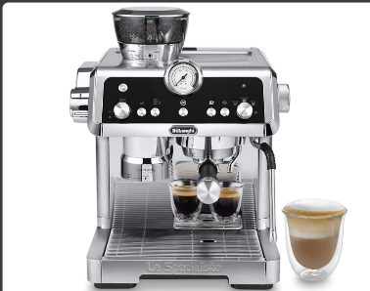
Refrigerator | Commercial-Grade Refrigerator for perishable ingredients keeping freshness and standards of food safety. | £1082 | (Amazon UK, 2024a) | 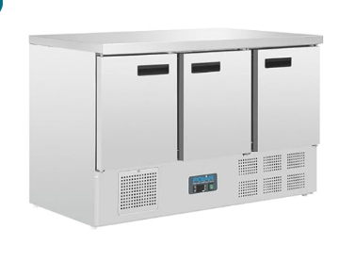
Tables and chairs | The comfortable, strong café tables and chairs made from eco-friendly materials to use in creating a cozy atmosphere. | £119 | (Amazon UK, 2024b) | 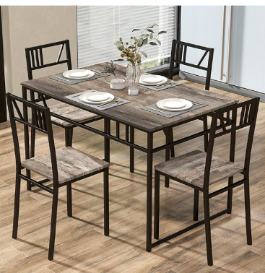
Kitchen hot plate grilled | Easy to clean  Durable stainless steel design  Accurate thermostat for temperature control  Even heat distribution for thorough cooking | £230 | (Ebay UK, 2024) | 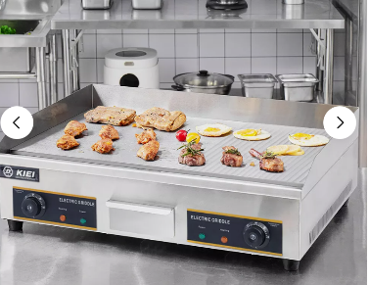
Cash Register | Modern point-of-sale system with a touch screen interface for the purpose of effective transaction and inventory managements to ensure efficient customer service. | £749 | (Amazon UK, 2024c) | 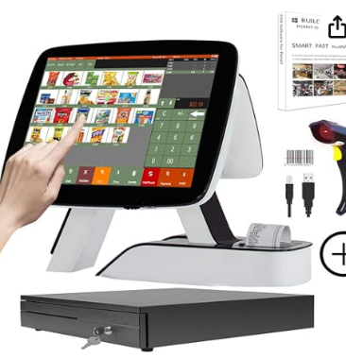

5.3 Key Suppliers
Major raw materials include organic intergalactic ingredients, packaging, and any other required material. Grocers that are local and organic, such as Riverford or Abel & Cole, can be used, based on the average calculation, it costs £1,500 – £2,000 for excellent quality food (Riverford, 2024; Abel & Cole, 2024).

6. FINANCES AND START-UP SUPPORT - Adriana Mitran

EXPENDITURE | Year 1  £
Company Registration | 71,00
Rent/Rates | 39,996
Staff Wages | 123,560
Telephone | 414,12
Broadband | 348,00
Utilities | 13,000
Marketing and materials | 2,400
Insurance | 1,267
Capital Expenditure/Equipment | 2,639.99
Training & Development | 1,200
Accounting/Legal | 720
Outside Services (Cleaning & Farm Maintenance) | 13,639.68
Stock/Materials Purchases | 40,000
Bank Charges | 300
Office Consumables | 700
Total Expenditure | £240,255.79

(Mitran, A., 2024: Finances and Start-Up Support)

0
INCOME | Year 1  £
Sales A (in-house design) | 115,000
Sales B (Takeaway and delivery) | 55,000
Sales C (event Catering) | 45,000
Capital Introduced | 15,000
Funding | 5,000
Loans/Borrowing | 25,000
Total Income | 260,000

YEAR ONE PROFIT/LOSS
Total Income | 260,000
Total Expenditure | 240,255.79
Profit/Loss | 19,744.21

(Mitran, A., 2024: Finances and Start-Up Support)

(Mitran, A., 2024: Finances and Start-Up Support)

Financial Summary

These financial calculations were made based on ongoing data collected from market information and industry averages concerning sustainable restaurants in the UK. From a similar business, it is estimated that the rent will cost £40,000 for prime urban location (Rightmove.com, 2024). The £123,560 employees’ wages are provided for hiring a team of skilled workers as described in Key Personnel (Indeed.com, 2024). Total direct cost of £2,400 are for online and community marketing as described in the Marketing Plan (Business Prices, 2024). Revenue assumptions include £115,000 from in-house dining and £55,000 from takeaway services pegged on current trend of green eating, plus £45,000 from event Catering.
An additional source of income will be the Start Up Loan provided by UK Government which may range from £500 up to £25.000. (GOV.uk, 2024)

7. REFERENCES

Abel & Cole (2024) FAQS. Available at: https://www.abelandcole.co.uk/help/faq. (Accessed: 28 October 2024).
Agriculture and Horticulture Development Board (2018) Benefits and drawbacks of vertical farming. Available at: https://horticulture.ahdb.org.uk/news/the-ups-and-downs-of-vertical-farming (Accessed: 3 November 2024).
Amazon UK (2024) De’Longhi Specialista Prestigio. Barista Pump Espresso Machine. Available at: De'Longhi Specialista Prestigio, Barista Pump Espresso Machine, Bean To Cup Coffee And Cappuccino Maker, EC9355.M, Metal - Silver : Amazon.co.uk: Home & Kitchen (Accessed: 5 November 2024)
Amazon UK (2024) Polar Refrigeration G Series 235W Tripple Door Counter Fridge 368 Litre. Available at: Polar Refrigeration G-Series 235W Triple Door Counter Fridge 368 Litre, Stainless Steel, 2°C to 5°C, 880(H)x1370(W)x700(D)mm, 3 Shelves, Energy Rating C, Usable Capacity: 308Ltr, R600a | G622 : Amazon.co.uk: Business, Industry & Science (Accessed: 5 November 2024).
Amazon UK (2024) Tangzon Dinning Table and 4 Chairs. Available at: TANGZON Dining Table and 4 Chairs, 5 Pieces Wooden Kitchen Table and Chairs Set 4 with Backrest, Metal Frame Space Saving Dining Set Furniture for Home Living Dining Room Bistro, Grey : Amazon.co.uk: Home & Kitchen (Accessed: 6 November 2024).
Amazon UK (2024) Stationery & Office Supply. Available at: ZHONGJI All in One Cash Register with Built-in Receipt Printer Point of Sale System Touch Screen Retailer POS Software SET04 : Amazon.co.uk: Stationery & Office Supplies (Accessed: 8 October 2024).
Andrews, J., (2023) 'The effect of cost of living on UK business statistics 2023', Money [blog]. 24 May. Available at: https://www.money.co.uk/cost-of-living/business-cost-of-living-statistics (Accessed: 11 November 2024).
Bark (2024) How much does an accountant cost? Available at: https://www.bark.com/en/gb/accountants/accountant-cost/ (Accessed: 5 November 2024).
Bark, (2024) Commercial and Office Cleaning Price Guide 2024. Available at https://www.bark.com/en/gb/commercial-cleaning/commercial-cleaning-price-guide/ (Accessed: 5 November 2024).
BigRentz (2021) 8 Innovative Smart Waste Management Technologies. Available at: https://www.bigrentz.com/blog/smart-waste-management (Accessed: 3 November 2024).
Bozatli, D. and Ventaka, B.K.D. (2021) Business Plan Feed Yourself Versatile Vertical Farming for Global Smart Cities. Available at: https://gbsge.com/wp-content/uploads/2023/05/bozatli-doruk-2021-feed-yourself-versatile-vertical-farming-for-global-smart-cities-mba-thesis-geneva-business-school.pdf . (Accessed: 28 October 2024).
Brigad (2024). Waiter Salary in the UK in 2024. Available at: https://www.brigad.co/en-gb/hourly-rate/waiter#:~:text=As%20per%202024%20data%2C%20the,the%20UK%20being%20%C2%A323%2C498 . (Accessed: 5 November 2024).

Burston Cook (2024) Light industrial facility to lease in Charlton Park Farm, Charlton Drive, Wraxall, Bristol, Somerset, BS48. Available at: https://www.rightmove.co.uk/properties/153558974#/?channel=COM_LET (Accessed: 26 October 2024).
Business Prices (2024) How Much Does Digital Marketing Cost? Average UK Prices Listed. Available at: https://www.businessprices.co.uk/marketing/digital-marketing-cost/ (Accessed: 5 November 2024).
Dalay, L. (2020) The impact of biophilic design elements on the atmospheric perception of the interior space. Uluslararası Peyzaj Mimarlığı Araştırmaları Dergisi (IJLAR) E-ISSN: 2602-4322, 4(2), pp.4-20.
Deloitte (2021) The conscious consumer – connecting with health and sustainability priorities. Deloitte UK. Available at: https://www.deloitte.com/uk/en/Industries/consumer/research/the-conscious-consumer-connecting-with-health-and-sustainability-priorities.html (Accessed: 29 October 2024).
Deloitte (2023) Customer expectations of sustainable products. Available at: https://www2.deloitte.com/us/en/insights/industry/retail-distribution/consumer-behavior-trends-state-of-the-consumer-tracker/sustainable-products-customer-expectations.html (Accessed: 3 November 2024).
Gov UK (2021) Net Zero Strategy: Build Back Greener. Available at: https://www.gov.uk/government/publications/net-zero-strategy (Accessed: 2 November 2024).
De Vries, L., Gensler, S. and Leeflang, P.S. (2017)’Effects of traditional advertising and social messages on brand-building metrics and customer acquisition’, Journal of Marketing, 81(5), pp.1-15. Available at: https://doi.org/10.1509/jm.15.0178
Design.com (2024) Eco-Friendly Vegan Farm Logo – EcoHarvest Café. Available at: https://www.design.com/maker/logo/eco-friendly-vegan-farm-384469?text=EcoHarvest+Cafe&isSearch=True (Accessed: 10 November 2024).
Ebay UK (2024) Stainless Steel Electric Countertop Griddle Commercial Kitchen Hot Plate Grilled. Available at: Stainless Steel Electric Countertop Griddle Commercial Kitchen Hot Plate Grilled | eBay (Accessed: 6 November 2024).
Ecotricity (2023) Our Green Electricity. Available at: https://www.ecotricity.co.uk/our-green-energy/green-electricity (Accessed: 1 November 2024).
Euromonitor International (2020) Health and Nutrition Trends: Seeking a Healthy Life. Euromonitor International. Available at: https://www.euromonitor.com/article/health-and-nutrition-trends-seeking-a-healthy-life (Accessed: 29 October 2024).
Euromonitor International (2021). Top 10 Global Consumer Trends 2021. Euromonitor International. Available at: https://www.euromonitor.com/top-10-global-consumer-trends-2021 (Accessed: 28 October 2024).
Farmacy (2024) Challenge the assumptions of modern eating. Available at: https://farmacylondon.com/. (Accessed: 28 October 2024).
Good Energy (2023) About Us. Available at: https://www.goodenergy.co.uk/about-us/ (Accessed: 1 November 2024).
Gov UK (2024) Apply for a Start-Up Loan for your business. Available at: https://www.gov.uk/apply-start-up-loan (Accessed: 11 November 2024).
Gov UK (2024) Companies House Fees. Available at: https://www.gov.uk/government/publications/companies-house-fees/companies-house-fees (Accessed:11 November 2024).
Green Key (2024) Toolbox - Environmental Management Info Material. Available at: https://www.greenkey.global/toolbox-environmental-management-info-material (Accessed: 5 November 2024).
HappyCow (2020) The Growth of Vegan Restaurants in Europe 2020. Available at: https://www.happycow.net/blog/the-growth-of-vegan-restaurants-in-europe/ (Accessed: 2 November 2024).
Hartman Group (2020) The health + Wellness 2020 Report. The Hartman Group. Available at: https://www.hartman-group.com/reports/1848694677/health-wellness-across-the-globe (Accessed: 28 October 2024).
Hello fresh (2024) Fresh Food & Meal Kit Delivery Service. Available at: https://www.hellofresh.com/ (Accessed: 11 November 2024).
HM Treasury (2021) Autumn Budget and Spending Review 2021. Available at: https://www.gov.uk/government/publications/autumn-budget-and-spending-review-2021-documents (Accessed: 2 November 2024).
House of Commons Library (2019) Brexit: Trade issues for food and agriculture. Available at: https://commonslibrary.parliament.uk/research-briefings/cbp-7974/ (Accessed: 2 November 2024).
Hughes, C., Swaminathan, V. and Brooks, G. (2019)’Driving brand engagement through online social influencers: An empirical investigation of sponsored blogging campaigns’, Journal of marketing, 83(5), pp.78-96. Available at: https://doi.org/10.1177/0022242919854374
Hussain, S., Akhter, R. and Maktedar, S.S. (2024) ‘Advancements in sustainable food packaging: from eco-friendly materials to innovative technologies’, Sustainable Food Technology, 2(5), pp.1297-1364. Available at: https://doi.org/10.1039/D4FB00084F (Accessed: 27 October 2024).
Indeed UK, (2024) Sustainability consultant salary in United Kingdom. Available at: https://uk.indeed.com/career/sustainability-consultant/salaries (Accessed: 5 November 2024).
Jain, R., Aagja, J. and Bagdare, S., (2017)’Customer experience–a review and research agenda’, Journal of service theory and practice, 27(3), pp.642-662. Available at: DOI:10.1108/JSTP-03-2015-0064
Karafs, (2023) The Rise of Sustainable Dining in the UK. Available at: https://karafs.co.uk/the-krumb/bakery-insights/the-rise-of-sustainable-dining-in-the-uk/ (Accessed 1 November 2024).
Lambin, E.F. and Thorlakson, T., (2018)’Sustainability standards: Interactions between private actors, civil society, and governments’, Annual Review of Environment and Resources, 43(1), pp.369-393.Available at: https://doi.org/10.1146/annurev-environ-102017-025931
Lloyds (2024) Rates & Charges. Available at: https://www.lloydsbank.com/business/commercial-banking/rates-and-charges.html (Accessed: 11 November 2024).
Longley, J., (2024) ‘How much energy does an average restaurant use every year?’, Utility Bidder [blog]. 12 September. Available at: https://www.utilitybidder.co.uk/compare-business-energy/how-much-energy-does-an-average-restaurant-use-every-year/ (Accessed: 11 November 2024).
McBride, A.E. and Flore, R., (2019)’The changing role of the chef: A dialogue’, International Journal of Gastronomy and Food Science, 17, p.100157. Available at: https://doi.org/10.1016/j.ijgfs.2019.100157
Mildreds (2024). Our Story. Available at: https://www.mildreds.com/ (Accessed: 28 October 2024).
Mintel, A. (2020) Plant-power: UK sales of meat-free foods shoot up 40% between 2014-19, Mintel [blog]. 17 January. Available at: https://www.mintel.com/press-centre/plant-based-push-uk-sales-of-meat-free-foods-shoot-up-40-between-2014-)19/ (Accessed: 28 October 2024).
Mintel (2023) Emerging Trends in the Plant-Based Industry. Available at: https://www.mintel.com/insights/food-and-drink/emerging-trends-in-the-plant-based-industry/ (Accessed: 2 November 2024).
Nisbets, (2023) Nisbets Catering Equipment | Free Next Day Delivery. Available at: https://www.nisbets.co.uk/. (Accessed: 28 October 2024).
Office for National Statistics (2023) Food and energy price inflation, UK: 2023. Available at: https://www.ons.gov.uk/economy/inflationandpriceindices/articles/foodandenergypriceinflationuk/2023 (Accessed: 2 November 2024).
Pasquier, M. and Villeneuve, J.P., (2018) Marketing management and communications in the public sector (p. 274). Available at: https://library.oapen.org/bitstream/id/ff6b0592-468e-4f1c-a90c-0b17e09beed7/oa-9781317222613.pdf (Accessed: 11 November 2024).
Pret A Manger (2024) Sustainability. Available at: https://www.pret.co.uk/en-GB/sustainability (Accessed: 29 October 2024).
Riverford (2024) Riverford Organic Farmers - Organic Fruit & Veg Box Delivery. Available at: https://www.riverford.co.uk/?srsltid=AfmBOopp1zsaziYFg7lkMPlxhvdto8BV2pozHQbYJE89O1Y7HfnOooQX. (Accessed: 28 October 2024).
Similar Web (2024) Mildreds Demographics. Available at: https://www.similarweb.com/website/mildreds.com/#demographics (Accessed: 28 October 2024).
Similar Web, (2024) Website Analysis for October 2024. Available at: https://www.similarweb.com/website/farmacylondon.com/#traffic (Accessed: 28 October 2024).
Similar Web (2024) Digital Suite. Available at: https://pro.similarweb.com/#/digitalsuite/websiteanalysis/audience-demographics/*/999/1m?webSource=Total&key=pret.co.uk (Accessed: 28 October 2024).
Statista (2023) Digital advertising spending in the UK 2008-2023. Available at: https://www.statista.com/statistics/265267/digital-advertising-revenue-in-the-uk/ (Accessed: 3 November 2024).
Statista (2023) Market share of generations in the sustainable food & non-alcoholic beverage market in the United Kingdom in 2022 and 2027. Available at: https://www.statista.com/statistics/1276477/uk-generational-share-of-the-sustainable-food-and-drinks-market/#:~:text=UK%3A%20Generational%20share%20of%20the,market%20in%202022%20and%202027&text=In%202022%2C%20millennials%20in%20the,to%2031%20percent%20by%202027. (Accessed: 28 October 2024).
Talent (2024) Farm Worker average salary in United Kingdom, 2024. Available at: https://uk.talent.com/salary?job=farm+worker . (Accessed: 5 November 2024).
The Sustainable Restaurant Association (2024) Framework. Available at: https://thesra.org/the-food-made-good-standard/framework/ (Accessed: 5 November 2024).
UK Organic and Organic Research Centre (2024) Consumer Insights Report 2024. Available at: https://www.ukorganicsector.org/news/2024/09/23/uk-organic-and-organic-research-centre-release-consumer-insights-report-2024/ (Accessed: 3 November 2024).
Versino, F., Ortega, F., Monroy, Y., Rivero, S., López, O.V. and García, M.A., (2023) ‘Sustainable and bio-based food packaging: A review on past and current design innovations’, Foods, 12(5), p.1057. Available at: DOI: 10.3390/foods12051057

Villena, V.H. and Gioia, D.A., (2018) ‘On the riskiness of lower-tier suppliers: Managing sustainability in supply networks’, Journal of Operations Management, 64, pp.65-87. Available at: https://doi.org/10.1016/j.jom.2018.09.004
Yurday, E., (2024) ‘Average Cost of Restaurant Insurance’, Nimblefins [blog]. 7 May. Available at: https://www.nimblefins.co.uk/business-insurance/restaurant-insurance/average-cost-restaurant-insurance (Accessed: 11 November 2024).

8. APPENDIX

Appendix A – SWOT Analysis

Strength  - Sustainable business model  - In-house plant farm for fresh produce  - Eco-friendly products | Weaknesses  - Higher operational costs  - Potential impact on pricing and affordability.
Opportunities  - Growing demand for eco-friendly dining  - Potential for partnerships with local suppliers and sustainable brands (Karafs, 2023). | Threats  - Fluctuating costs of organic supplies  - Competition in the sustainable food sector.

Appendix B – PEST Analysis

Factors | Key points
Political | - UK government policies promoting sustainability and eco-friendly business practices (Department for Business, Energy & Industrial Strategy, 2021).  - Support for green initiatives through grants and tax incentives (HM Treasury, 2021).  - Post-Brexit regulations affecting supply chains, especially in organic and food sectors (House of Commons Library, 2019).
Economic | - Rising inflation rates affecting operational costs and pricing of organic products (Office for National Statistics, 2023).  - Local sourcing to mitigate risks from global supply chain disruptions.
Social | - Increasing consumer demand for plant-based, health-conscious, and sustainable dining options (Mintel, 2023).  - Growing interest in eco-friendly products and packaging (Deloitte, 2023).  - Consumers are willing to pay more for ethically sourced, organic food (UK Organic and Organic Research Centre, 2024).
Technology | - Advancements in sustainable farming techniques, including vertical farming and low-impact energy solutions (Agriculture and Horticulture Development Board, 2018).  - Digital marketing and online platforms driving customer engagement and awareness (Statista, 2023).  - Use of technology for efficient waste management and energy monitoring (BigRentz, 2021).

Appendix C Presentation/Pitch
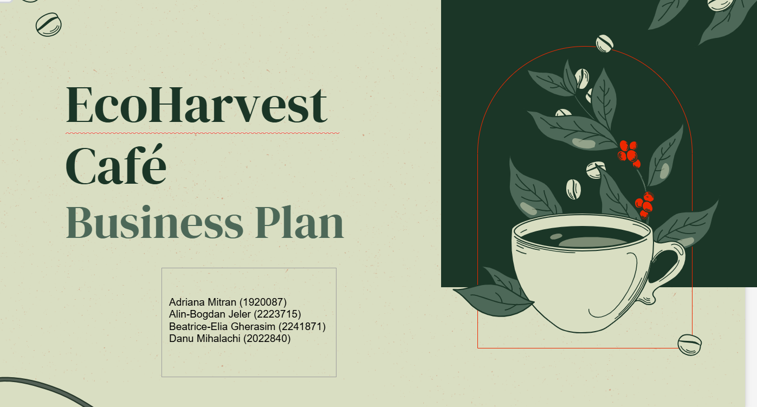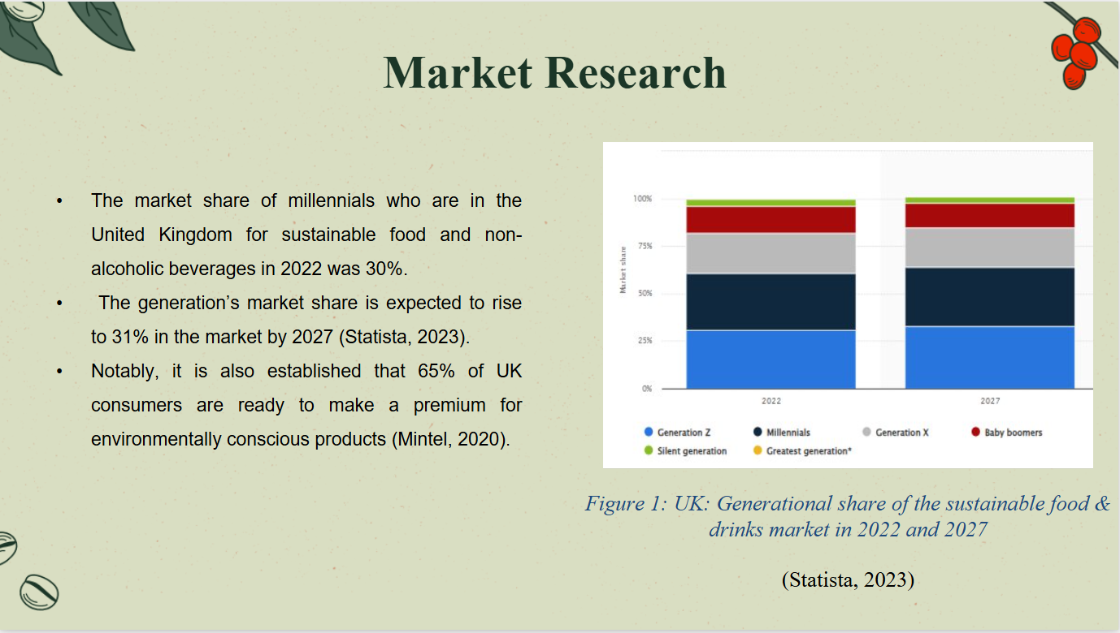
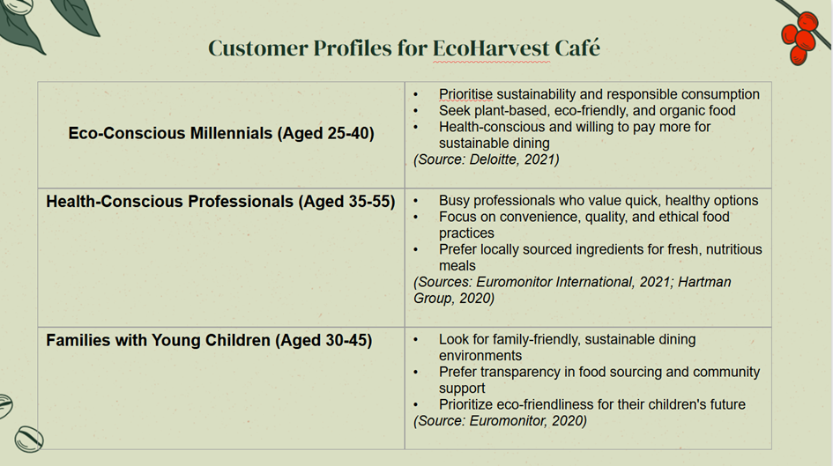

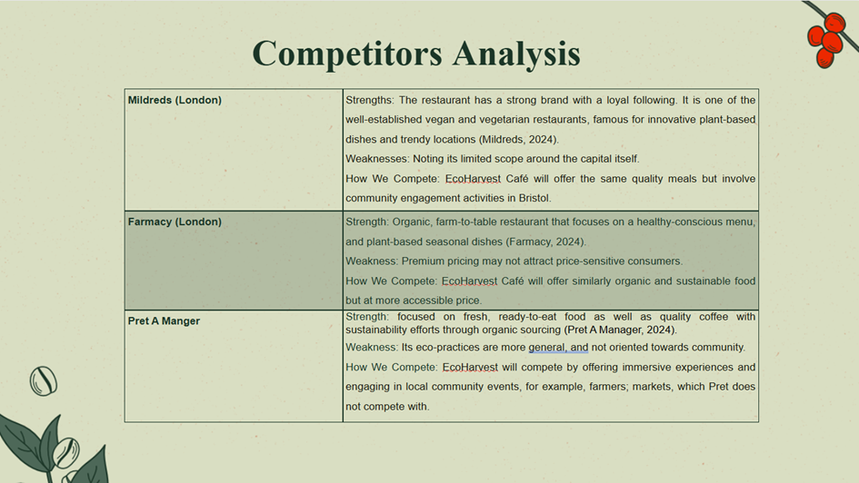
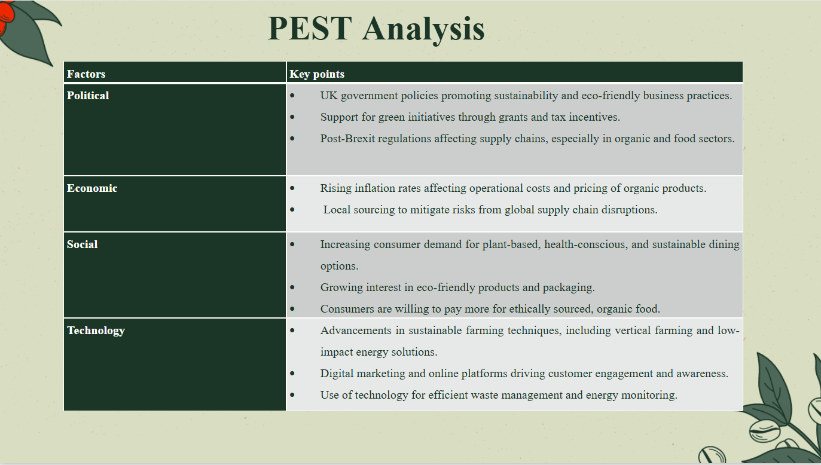

Appendix D- The Team

Name | Company Position | Skills and Experience | Role and Responsibilities
Beatrice-Elia Gherasim | Operations Manager  (£40,000 Salary) | Beatrice brings over 8 years of experience, including 5 years as a manager at Cristeli Construction in Romania and 3 years as assistant manager at London’s sustainable restaurant Spring. She has expertise in operations, customer relations, and inventory management, along with Level 3 qualifications in Mathematics, IT, Psychology (Romania), and Interior Design (UK). | As Operations Manager, Beatrice oversees EcoHarvest Café’s daily operations, manages the in-house plant farm, sources eco-friendly products, and ensures staff management, customer service, and sustainability align with the café's mission.
Alin-Bogdan Jeler | Head Chef and Culinary Director (£38,000 Salary) | Alin is a professional culinary specialist with 10 years of work experience in several high-end, farm-to-table restaurants. Previous experience includes managing Le Bistrot Pierre kitchen from Leicester with a degree as sport trainer Lever 3 meaning he is relying on health and wellbeing when creating recipes. He specializes in plant-based cuisine. Alin feels enthusiastic about involving sustainable principles in his gastronomic career. He is an experienced leader in winning sustainable kitchen teams with a valid Health and Safety Certificate, Allergen / Hygiene Certificate, Train the Trainer Certificate, Flow Hospitality Training, and numerous managerial skills gained through the experience cumulated as Head Chef. | Alin is a professional culinary specialist with 10 years of work experience in several high-end, farm-to-table restaurants. Previous experience includes managing Le Bistrot Pierre kitchen from Leicester with a degree as sport trainer Lever 3 meaning he is relying on health and wellbeing when creating recipes. He specializes in plant-based cuisine. Alin feels enthusiastic about involving sustainable principles in his gastronomic career. He is an experienced leader in winning sustainable kitchen teams with a valid Health and Safety Certificate, Allergen / Hygiene Certificate, Train the Trainer Certificate, Flow Hospitality Training, and numerous managerial skills gained through the experience cumulated as Head Chef.
Adriana Mitran | Administrator  (£23,000 Salary) | Detail-oriented with three years of administrative experience and three years within the Hospitality Industry. Proven ability to manage office operations efficiently while delivering exceptional customer service. Strong organizational and communication skills. | Office Management: Oversee daily office operations, ensuring a smooth workflow, Data Management Handle: data entry, maintain filling system, and manage company records, Financial Administration: Process and reconcile bank statements, Reporting: Prepare and present reports for management, identifying areas for improvement.
Danu Mihalachi | Barista  (£22,560 salary) | A combination of technical, interpersonal, and organisational skills. With 3 years of experience in Coffee Shops, Danu have ability in understanding to operate several types of coffee machines. Proven Communication Skills, Teamwork and Collaboration. | Providing excellent customer service, the barista’s role goes beyond simply making a coffee. Baristas are key contributors to the overall customer experience in our restaurant. It will then ensure that the service café delivers are of quality and green coffee, with expertise not found in regular specialized coffee service (Metodijeski and Andrevski, 2023).  Barista is responsible for maintaining a clean and organisational environment as well as preparing and restocking ingredients and supplies.

Appendix E- Market research
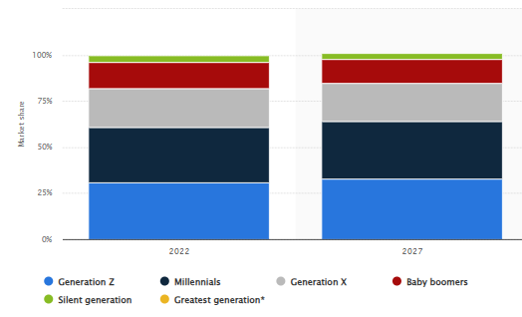
Figure 1: UK: Generational share of the sustainable food & drinks market in 2022 and 2027
(Statista, 2023)

Customer Profiles
Mildreds (London) Customer Profile
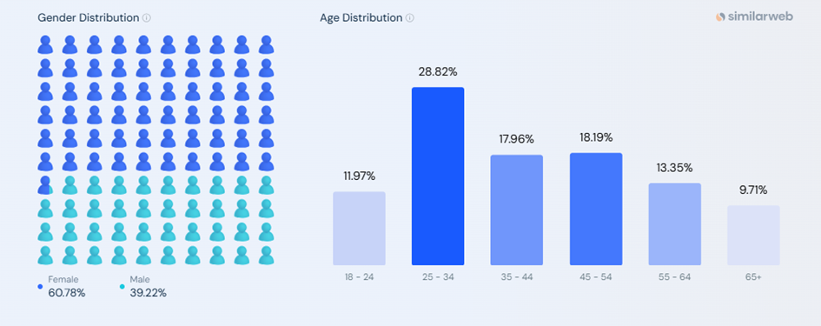(SimilarWeb, 2024)

Farmacy (London) Customer Profile
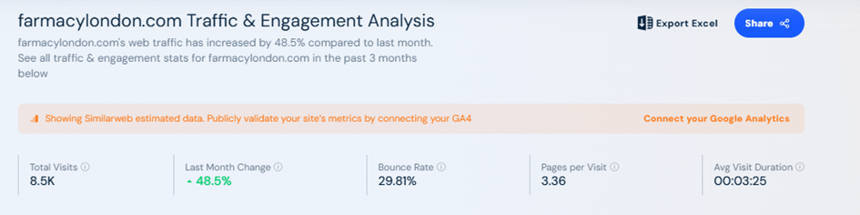 (SimilarWeb, 2024a)

Pret A Manager (Customer Profile)
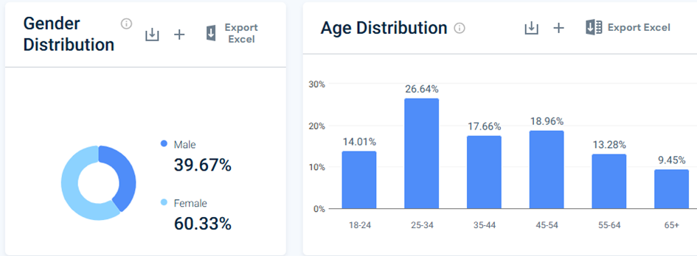(SimilarWeb, 2024b)

Appendix F



