Change Management Analysis: A Case Study of Midea Corporation

Executive Summary
The management of the digital transformation at Midea Corporation is critically examined in this paper with an emphasis on the motivating and restraining elements that support this shift. Examining internal and external elements such company culture, leadership, and digitalization strategy, it looks at how Midea prepared for the digital revolution. The paper also looks at power relationships, resistance to change, and the application of important change management approaches. The paper offers suggestions for successfully implementing digital transformation in enterprises after evaluating the performance of the change management process. Overall, this research emphasizes how crucial stakeholder participation, strategic planning, and good communication are to a successful digital transition.

Table of Contents
1.0 Introduction 1
2.0 Change Analysis: Driving Factors and Resisting Factors 1
2.1 Driving Factors 1
2.1.1 Market Dynamics and Globalization 1
2.1.2 Technological Advancements and Digitalization 2
2.1.3 Strategic Objectives and Competitive Landscape 2
2.2 Resisting Factors 3
2.2.1 Organizational Culture and Resistance to Change 3
2.2.2 Power Dynamics and Political Influences 3
2.2.3 Employee Engagement and Communication Challenges 3
3.0 Plan for Change: Internal and External Readiness 3
3.1 Internal Factors 3
3.1.1 Organizational Culture and Change Readiness 3
3.1.2 Leadership and Change Champions 4
3.1.3 Digitalization Strategy and Technological Infrastructure 4
3.2 External Factors 4
3.2.1 PESTEL Analysis 4
3.2.2 Stakeholder Analysis: Managing Stakeholder Expectations and Resistance 6
4.0 Resistance to Change: Causes and Strategies for Overcoming 7
4.1 Understanding Resistance to Change 7
4.2 Cause of Resistance 7
4.3 Strategies for Overcoming Resistance 7
5.0 Power and Politics in Change Management 8
5.1 Power Dynamics and Influence Networks 8
5.2 Political Tactics and Strategies 9
5.3 Managing Power and Politics for Successful Change Implementation 9
6.0 Implementation of Change: Key Models and Theories 9

6.1 Lewin's Change Management Model 10
6.2 Kotter's Eight-Step Change Model 10
6.3 ADKAR Model 11
6.4 Prosci's Change Management Process 12
7.0 Evaluation of Change Management Process 13
7.1 Measuring the Impact of Change 13
7.2 Assessing the Effectiveness of Change Management 13
7.3 Key Performance Indicators and Evaluation Tools 13
7.4 Examining the Alignment between Planned and Actual Outcomes 14
8.0 Conclusion 15
9.0 Recommendations 15
10.0 Reference List 17

1.0 Introduction
In the past one to five years, the well-known international corporation Midea Corporation, which specializes in HVAC systems and home appliances, has experienced a dramatic transformation known as "Digital Transformation." The goal of this transformation is to improve efficiency, innovation, and customer experiences by integrating digital technology and processes into different elements of Midea's business(Media, 2023).

The goal of this research is to conduct a critical analysis of Midea Corporation's "Digital Transformation" management. It will look at the motivations for the adoption of digital transformation initiatives as well as any potential opposition that may have arisen throughout the transition. The study will also assess the efficiency of Midea's change management procedure and offer suggestions for effectively putting digital transformation plans into practice.

2.0 Change Analysis: Driving Factors and Resisting Factors

2.1 Driving Factors

2.1.1 Market Dynamics and Globalization
The shift that Midea Corporation has done has been largely driven by market dynamics and globalization. Intense rivalry, changing consumer tastes, and shifting market trends define the competitive environment in the home appliance and HVAC systems industries. Midea understood that in order to keep its competitive edge, it would need to adjust to these market realities(Gokalp and Martinez, 2022).

By extending businesses' international reach, globalization has further heightened competitiveness. Being a worldwide firm, Midea has been under growing pressure to broaden its customer base internationally. Change has been prompted by the need to expand into new markets, forge strategic alliances, and serve a variety of clientele(Angtyan, 2019).

2.1.2 Technological Advancements and Digitalization
Change within the Midea Corporation has been largely driven by technological developments and the introduction of digitalization. Rapid technological advancements in the sector made Midea realize how critical it is to embrace innovation in order to fulfill changing client expectations and stay one step ahead of rivals.

The market for home appliances has undergone a transformation because to the integration of cutting-edge technologies like Internet of Things (IoT), artificial intelligence, and smart home automation. Midea saw how digitization might improve business operations, product functionality, and consumer experiences. In order for the business to remain relevant in the digital era, embracing digital transformation became a strategic priority(Schwarz et al., 2021).

2.1.3 Strategic Objectives and Competitive Landscape
Midea's change management methodology has been influenced by strategic goals and the competitive environment. In order to maintain its market position and experience long-term growth, Midea has created strategic goals that are in line with current market trends and client demands.

The intense competition has forced Midea to constantly innovate and set itself apart with its goods and services(Saarikko et al., 2020). Midea saw the need for strategic initiatives that would improve company skills, simplify processes, and maximize resources in order to successfully compete with both established competitors and new disruptors in the market.

Midea made the adjustment to better match its strategic goals with the shifting competitive environment in order to enhance market share, capture growth opportunities, and solidify its position as a world leader in HVAC systems and home appliances.

2.2 Resisting Factors

2.2.1 Organizational Culture and Resistance to Change
The organizational culture significantly influences how workers feel and behave about transformation projects. Certain facets of the organizational culture of Midea Corporation may have facilitated resistance to change. First off, it may be difficult to adopt new ideas and techniques because of a deeply embedded culture of conventional practices and aversion to change. Second, employees may reject the change if they believe it threatens their current power structures, jobs, and responsibilities(Mabasa and Flotman, 2022).

2.2.2 Power Dynamics and Political Influences
Within an organization, political pressures and power relationships may have a big impact on whether or not reform is accepted. If a change threatens their influence, status, or interests, powerful people or organizations may fight it. This opposition may take the form of covert sabotage, the withholding of essential resources, or the construction of obstacles to the execution of change.

2.2.3 Employee Engagement and Communication Challenges
Communication and effective staff involvement are essential for a change initiative to be successful. Resistance and misunderstanding can be brought on by poor communication and a lack of employee engagement in the change process. Employee resistance may be caused by feelings of exclusion, ignorance, or uncertainty regarding the changes' justifications.

3.0 Plan for Change: Internal and External Readiness

3.1 Internal Factors

3.1.1 Organizational Culture and Change Readiness
The preparedness of a company for change is significantly influenced by organizational culture. The organizational culture of Midea Corporation has an impact on the attitudes, convictions, and actions of the staff regarding change projects. A greater level of change readiness typically results from a culture that encourages innovation, flexibility, and continual development(Mergel et al., 2019).

It is essential to analyze the current corporate culture in order to gauge Midea's readiness for change. Surveys, interviews, and observations can be used to determine how willingly employees are willing to accept change and how they perceive it. Positive change readiness may be shown by elements like an atmosphere that fosters cooperation and learning.

3.1.2 Leadership and Change Champions
In order to promote and manage change within a company, leadership is essential. Effective leadership is crucial for Midea Corporation's ability to successfully undertake change initiatives(Lee, 2019).

3.1.3 Digitalization Strategy and Technological Infrastructure
If businesses want to remain competitive in the present digital environment, they must embrace digitalization(Graamans et al., 2020). The Midea Corporation's technological foundation and digitalization strategy have a substantial internal impact on the success of transformation initiatives. The capacity of the company to react to change, simplify processes, and take advantage of new possibilities is improved by a strong technology foundation(Taibi et al., 2022).

3.2 External Factors

3.2.1 PESTEL Analysis

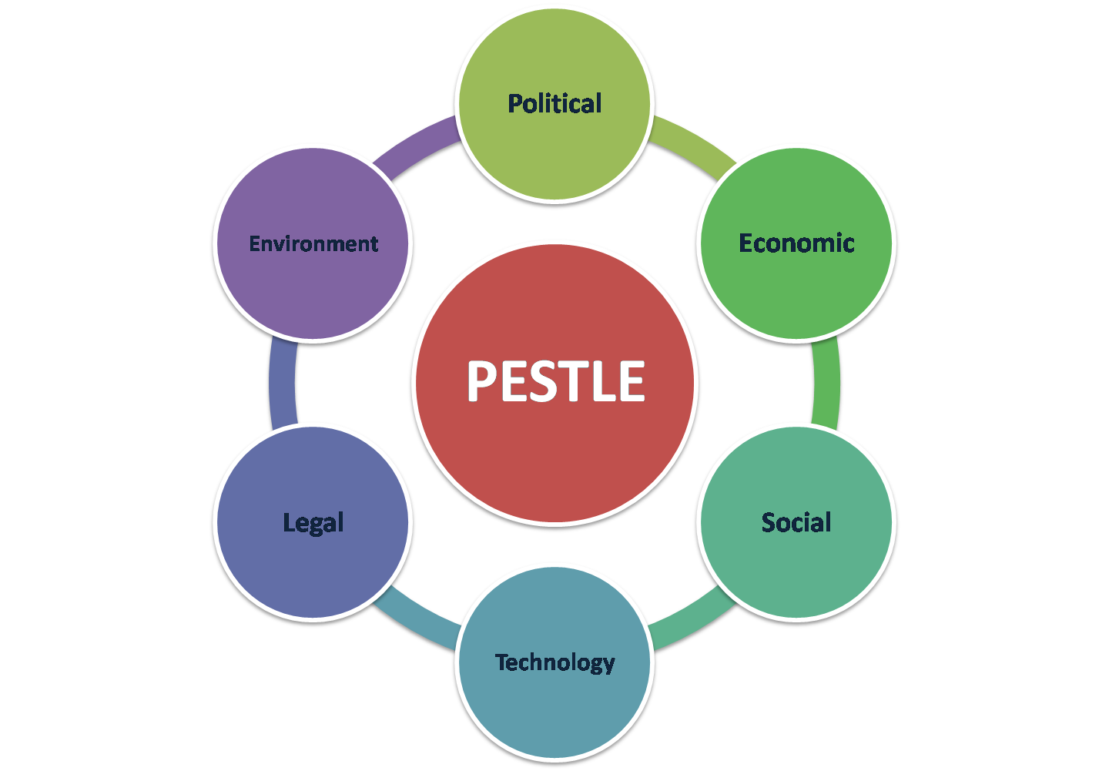

Figure 1: PESTEL (source: https://www.thebusinessplanshop.com/blog/fr/entry/analyse_pestel )

The success of change activities within businesses is highly influenced by the external environment. Understanding the effects of numerous external factors on the change process may be accomplished with the use of a PESTLE analysis(Thornton, 2019). Midea Corporation performed a thorough PESTLE analysis to evaluate the following elements:

Politics: The political environment may have a significant impact on change management. Midea assessed political stability, laws, and government policies. It took into account variables that can have an impact on how the change effort is implemented, such as trade agreements, taxes regulations, and labor laws(Vito and Sethi, 2020).

Economic factors: The viability and feasibility of change are directly impacted by the state of the economy. Indicators of the economy, such as GDP growth, inflation rates, and consumer spending trends, were examined by Midea. Understanding the economic environment allowed Midea to prepare for anticipated financial difficulties and provide enough resources for the transformation(Bican and Brem, 2020).

Social factors: Demographics and social trends have an influence on organizational transformation initiatives(Da et al., 2023). Midea looked at consumer preferences, cultural norms, and society views. Midea might match the transformation initiative with changing consumer demands and expectations by taking social aspects into account(Binci et al., 2020).

Technological Aspects: Modern change management depends heavily on technological progress. Emerging technology, digital trends, and prospects for innovation were evaluated by Midea. Midea was able to successfully utilize technology breakthroughs and incorporate digital solutions into the transformation process thanks to this study(Ventura et al., 2019).

Legal considerations: The parameters of change implementation can be shaped by legal and regulatory frameworks(Chanias et al., 2019). Midea took into account laws governing labor, intellectual property, and industry-specific rules. Midea reduced possible hazards and made sure there was a seamless transition during the transformation process by adhering to regulatory regulations.

Environmental considerations: Sustainability in the environment is a growing concern in change management(Galli, 2019). Midea looked at environmental laws, worries about climate change, and resource availability. Midea showed its dedication to sustainability and corporate social responsibility by implementing eco-friendly methods into the transformation project.

3.2.2 Stakeholder Analysis: Managing Stakeholder Expectations and Resistance
Because stakeholders have a significant impact on a change initiative's success or failure, stakeholder analysis is an essential part of change management(Memon et al., 2021). To identify the important people or groups affected by the change, as well as to comprehend their expectations and potential opposition, Midea performed a thorough stakeholder study. The following steps were taken during the analysis:

Identification: Employees, managers, shareholders, clients, suppliers, and members of the community are just a few of the key and secondary stakeholders that Midea identified. Based on their influence, enthusiasm, and potential influence on the change, each stakeholder group was assessed(Sukoco et al., 2022).

Expectations: Midea looked at what each stakeholder group needed and expected from the transformation program. To learn more about their issues and intended goals, this required conducting surveys, interviews, and focus groups(Kreutzer, 2022).

Understanding possible opposition is essential for successful change management. Midea foresaw potential points of resistance across stakeholder groups and investigated the underlying causes(Graves et al., 2023). Due of this, Midea was able to create focused tactics to deal with resistance and win over stakeholders.

4.0 Resistance to Change: Causes and Strategies for Overcoming

4.1 Understanding Resistance to Change
When organizations adopt change initiatives, they typically encounter opposition to change. It can hinder the success of the transformation process and has a number of factors(Alzubi, 2022). Understanding the underlying causes of resistance is crucial for successfully overcoming it.

4.2 Cause of Resistance
Employees may not completely understand the motivation, advantages, and ramifications of the change as a result of poor communication and information about it. Employees are more inclined to oppose change if they feel it is unjust or that they have lost control over their work processes, out of concern for unfavorable outcomes or a loss of autonomy.

4.3 Strategies for Overcoming Resistance
- Effective Communication and Engagement: Establishing open and transparent lines of communication, from the top down and from the bottom up, may assist allay employee fears and clarify the shift. A sense of engagement and ownership may be promoted by regularly including employees through town hall meetings, feedback sessions, and informational updates(Ozawa, 2020).

- Employee Empowerment and Involvement: Employee empowerment via participation in the change process might lessen opposition(Rousseau and ten Have, 2022). They may be made more open to change by being given chances for training and skill development, being encouraged to participate in decision-making, and receiving feedback.

- Change Agents and Leadership Support: Forging change requires appointing change agents inside the organization and securing solid leadership support. Change agents can act as catalysts, directing and inspiring staff members during the shift. Leadership support emphasizes the significance of change, establishes the vision, and offers the essential tools and direction(Sharma and Lowe, 2023).

5.0 Power and Politics in Change Management
Power relationships and politics have a big impact on the success or failure of any organizational reform program. The impact of politics and power on the transformation process at Midea Corporation is examined in this section along with methods for handling them successfully.

5.1 Power Dynamics and Influence Networks
The adoption and execution of change may be influenced by power relationships within Midea Corporation. Important people or organizations may possess official or informal authority that can influence the transformation process. awareness potential sources of opposition or support for the change requires an awareness of these power dynamics and influence networks(Ahmad et al., 2022). To ascertain who has the power to make decisions and who may influence others, it is crucial to map out the connections and hierarchies inside the company.

5.2 Political Tactics and Strategies
Individuals and groups use political tactics and methods to advance their own agendas, obtain control of resources, or defend their own interests. These strategies may help or hurt the process of change. Alliance building, information manipulation or withholding, coalition building, and power battles are a few frequent political strategies(Hay et al., 2021). It is critical to understand the political climate inside Midea Corporation and to pinpoint any obstacles or disputes that could develop as a result of political actions.

5.3 Managing Power and Politics for Successful Change Implementation
Effective power and political management is essential for successful change implementation. This entails establishing an open channel of communication and participation for all parties involved in the transformation process. Political strategies that might obstruct progress can be lessened by outlining persuasive justifications for the change and responding to objections or resistance from influential people or organizations(Payne et al, 2022).

A culture of cooperation and shared decision-making can also lessen power disputes and encourage alignment with the change objectives. The organizational atmosphere may be influenced by strong leadership that upholds moral principles and honesty, encouraging staff to concentrate on the group's interests rather than personal power struggles(Lee, 2021).

6.0 Implementation of Change: Key Models and Theories
Applying effective change management concepts and theories, as well as taking an organized approach, are necessary for the successful implementation of change, particularly in the context of digital transformation(Dorogaia, 2022). The essential concepts and theories that can direct the execution of change within Midea Corporation's digital transformation strategy are covered in this section.

6.1 Lewin's Change Management Model
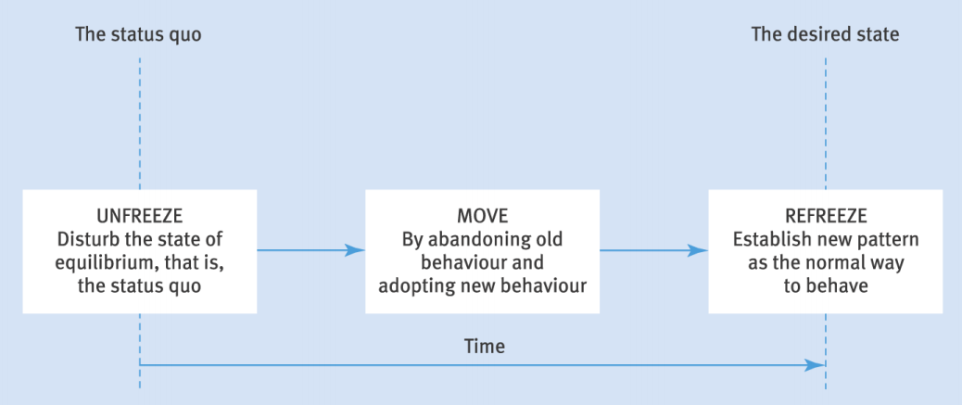
Figure 2: Liwin’s three-step change process(Source: courseware Power Point from school)

Unfreezing, altering, and refreezing are the three phases of Lewin's three-stage paradigm for managing change. The unfreezing step of Midea's digital transformation includes educating staff members about the need for change and getting them ready for the approaching shift. This was accomplished by running communication campaigns, holding training sessions, and emphasizing the advantages of digitization. In the stage of change, new digital systems, technologies, and procedures were implemented together with staff support and training(Burnes, 2020). The third step, known as "refreezing," concentrated on integrating the new digital practices into company culture in order to ensure long-term adoption and reinforce new behaviors.

6.2 Kotter's Eight-Step Change Model
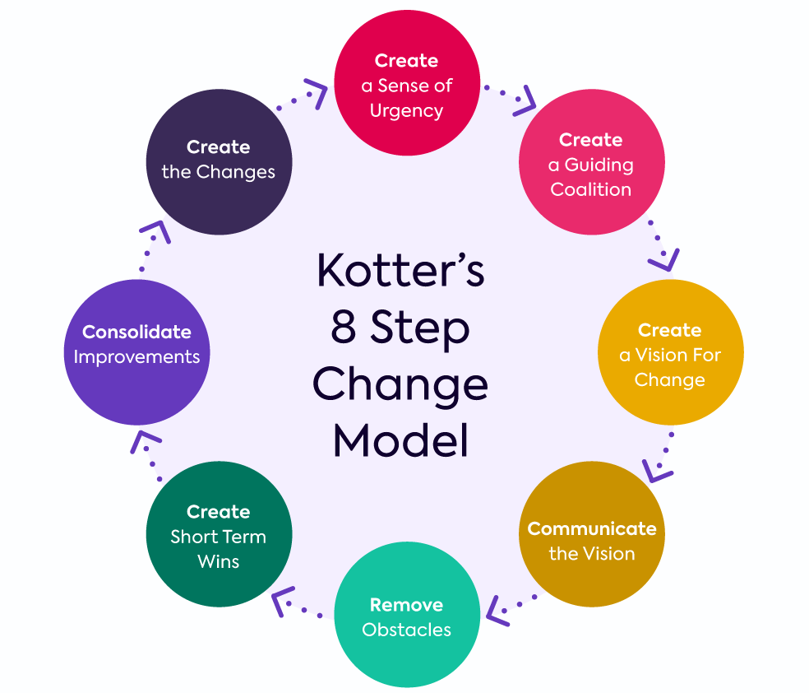
Figure 3: Kotter's Eight-Step Change Model (Source: https://giuseppemartinengo.org/change-leadership-john-kotters-8-step-model/ )

Kotter's Eight-Step Change Model offers a methodical strategy for bringing about change. In order to apply this methodology to Midea's digital transformation, the first stage involves creating a feeling of urgency by outlining the importance of digitization and the possible dangers of failing to respond to market needs. The next phase was to put up a strong steering coalition that would lead the transition by engaging significant leaders and change agents(Vial, 2019). The following steps involved formulating a precise vision and strategy for digitalization, sharing that vision with the workforce, empowering action by removing barriers and promoting experimentation, producing quick wins to build momentum, consolidating gains by enshrining changes in organizational culture, and continuously pursuing the change to ensure its long-term success.

6.3 ADKAR Model

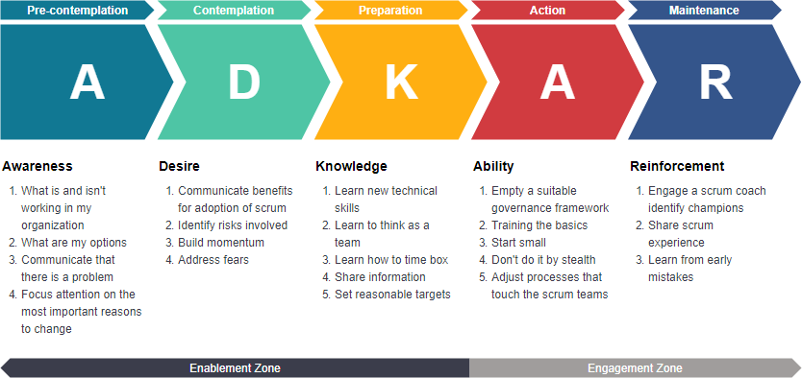

Figure 4: ADKAR Model(https://online.visual-paradigm.com/knowledge/project-management/adkar-guide-for-project-management/ )

With a focus on individual development, the ADKAR Model offers a framework for handling the human element of change. Awareness, desire, knowledge, ability, and reinforcement are its five main components(Zhang et al., 2023). The goal of Midea's digital transformation program was to increase employee motivation for change and raise knowledge of the advantages of digitization. To help staff better adapt to digital technologies and procedures, information and skills were then provided through training programs(Biswas and Akroyd, 2022). Incorporating the new behaviors into performance management systems and rewarding employees who adopted digital habits were the last steps in achieving reinforcement.

6.4 Prosci's Change Management Process
The three phases of Prosci's Change Management Process are "preparing for change," "managing change," and "reinforcing change." The preparation step for Midea's digital transformation included completing change impact assessments, creating a change management strategy, and selecting change agents who would assist staff members along the procedure(Shulga, 2021). The management phase concentrated on effective coaching, training, and communication to encourage staff members to embrace digital practices. The goal of the reinforcement phase was to keep the change going by integrating it into the organization's systems, processes, and structure as well as regularly monitoring and assessing the outcomes.

7.0 Evaluation of Change Management Process

7.1 Measuring the Impact of Change
It is critical to take into account several aspects of change while evaluating the impact of the digital transformation change program at Midea Corporation. The influence on operational effectiveness is a crucial factor. Metrics like manufacturing lead time, equipment efficiency, and overall process improvement can be used to gauge this(Evans and Britt, 2023). Additionally, customer surveys, comments, and metrics for service quality improvement should be used to assess the impact on customer satisfaction(Safraou and Guiot, 2023). Financial metrics that measure the impact of the transformation include revenue growth and cost savings brought on by digitization. Midea can acquire a thorough knowledge of the effects the digital transformation has had on the company by gathering and evaluating both quantitative and qualitative data.

7.2 Assessing the Effectiveness of Change Management
It is crucial to examine how successfully the change management strategies and interventions were executed in order to gauge the efficacy of change management during the digital transformation(Binci et al., 2020). Assessing the degree of employee participation during the transition process is one strategy. Surveys, focus groups, and interviews can be used to determine how satisfied workers are with the change projects and how they perceive them(Kanitz and Gonzalez, 2021). Assessing the degree of resistance and how it is handled may also shed light on how well change management is working. In order to assess the efficacy of the change management process, it is critical to examine the degree of alignment between the planned change management activities and the actual execution.

7.3 Key Performance Indicators and Evaluation Tools
Key performance indicators (KPIs) are useful instruments for assessing the success of the change brought about by digital transformation. Relevant KPIs include the pace at which new digital systems and technologies are adopted, the rise in productivity and efficiency brought about by digitization, the decline in mistake or defect rates, and the enhancement of customer query response times. Other KPIs, such as the retention rate, employee feedback, and training completion rates for digital skills, may concentrate on employee happiness and engagement(Galindo-Martin et al., 2019). Midea can measure the development and success of the digital transformation transition by developing and measuring these KPIs.

Benchmarking and maturity models are two evaluation approaches that might offer insightful data. The company may discover areas for development and track its progress by contrasting Midea's digital transformation activities with industry best practices and standards. Midea's digital capabilities may be evaluated using maturity models, such as the Capability Maturity Model Integration (CMMI), which also offers a development plan(Kretschmer and Khashabi, 2020). Midea can get a thorough evaluation of the change management process by combining KPIs and evaluation tools.

7.4 Examining the Alignment between Planned and Actual Outcomes
For determining if the change management process was successful, it is essential to look at how well anticipated and actual outcomes matched up. It entails contrasting the planned goals, plans, and milestones set forth in the change plan with the results actually obtained(Haas et al., 2019). Any inconsistencies or gaps may point to places where the change management approach needs to be adjusted or where it was unsuccessful. Both immediate and long-term effects should be taken into account in this analysis. The effective adoption of new digital technologies, personnel training, and preliminary process enhancements are examples of short-term benefits. The maintained operational efficiency, higher market competitiveness, and enhanced customer experiences may be the main long-term results.

8.0 Conclusion
This document provided a critical analysis of Midea Corporation's plan for digital transformation. The results show that the organization's efforts to adapt digitally have improved its operational effectiveness, competitiveness, and customer happiness. Midea has effectively adjusted to the shifting business environment through the deployment of digital technology and has seen notable improvements in manufacturing lead time and customer satisfaction.

Overall, Midea's change management strategy has been successful in accelerating the digital transition. The use of change management models, such as Kotter's Eight-Step Change Model and Lewin's Change Management Model, gave the shift a formal framework to be managed. The emphasis on instilling a feeling of urgency, motivating workers, and matching organizational culture with digitalization objectives has helped transformation initiatives succeed.

The conclusions reached from this investigation emphasize how crucial it is to aggressively embrace digital transformation in the current corporate climate. The experience of Midea highlights the need of matching organizational goals with digitalization initiatives, encouraging a creative culture, and including staff members in the transition process. The insights gained from Midea's digital transformation journey can be very helpful for other organizations starting similar initiatives, highlighting the necessity to keep an eye on the efficacy of change management, adjust to new technological developments, and take advantage of opportunities for growth and sustainability.

9.0 Recommendations
A progressive and methodical strategy must be used to guarantee the digital transformation at Midea Corporation is implemented successfully. First, create a compelling vision for the change that is in line with the strategic goals of the company. Create a thorough change management strategy that outlines detailed objectives, time frames, and resource allocation. To advance the change, enlist change advocates and establish cross-functional teams. Additionally, provide an innovative and ongoing learning environment to motivate staff to accept digital developments in a proactive manner.

Informing all workers of the rationale for the digital transformation and its possible advantages can help them be more change-ready. Give the workers plenty of opportunity for training and development to upgrade their knowledge of digital technology. Involve workers in the transformation process as well by asking for their opinions and feedback to make them feel valued and involved.

10.0 Reference List

Angtyan, H. (2019), ‘ADKAR Model in Change Management’, International review of management and business research, 8:2, pp.179-182.

Alzubi, B. M. A. (2022), “Systematic literature review for strategic change management”, Shanghai li gong da xue xue bao, 24 (11), pp.41.

Avidan, A. et al. (2020), “Difficult airway management practice changes after introduction of the GlideScope videolaryngoscope: A retrospective cohort study”, European journal of anaesthesiology, 37 (6), pp.443-450.

Ahmad, J. et al. (2022), “Quality Requirement Change Management’s Challenges: An Exploratory Study Using SLR”, IEEE access, 10, pp.127575-127588.

Burnes, B. (2020), ‘The Origins of Lewin’s Three-Step Model of Change’, The Journal of applied behavioral science, 56:1, pp.32-59.

Binci, D., Belisari, S. and Appolloni, A. (2020), ‘BPM and change management’, Business process management journal, 26:1, pp.1-23.

Biswas, S. and Akroyd, C. (2022), ‘Collaborative inter‐organisational relationships and management control change’, Accounting and finance (Parkville), 62:4, pp.4569-4586.

Bican, P. M. and Brem, A. (2020), ‘Digital Business Model, Digital Transformation, Digital Entrepreneurship: Is There A Sustainable “Digital”?’, Sustainability (Basel, Switzerland), 12:13, pp.5239.

Chanias, S., Myers, M. D. and Hess, T. (2019), ‘Digital transformation strategy making in pre-digital organizations: The case of a financial services provider’, The journal of strategic information systems, 28:1, pp.17-33.

Dorogaia, I. (2022), ‘CHANGE MANAGEMENT IN THE DIGITAL AGE: THE PERSPECTIVES OF DEVELOPMENT’, Eastern European Journal of Regional Studies, 8:1, pp.50-62.

Da, R. A., Vainieri, M. and Belle, N. (2023), ‘An Overview of Reviews: Organizational Change Management Architecture’, Journal of change management, 23:2, pp.113-142.

Evans, M. I. and Britt, D. W. (2023), ‘Resistance to Change’, Reproductive sciences (Thousand Oaks, Calif.), 30:3, pp.835-853.

Esposito, P., Ricci, P. and Sancino, A. (2021), ‘Leading for social change: Waste management in the place of social (ir)responsibility’, Corporate social-responsibility and environmental management, 28:2, pp.667-674.

Graves, L. et al. (2023), ‘Creating change: Kotter’s Change Management Model in action’, Canadian medical education journal.

Galli, B. J. (2019), “An Engineering Manager's Guide for Commonly Used Change Management Approaches-From One Practitioner's Experience”, IEEE engineering management review, 47 (3), pp.118-126.

Gokalp, E. and Martinez, V. (2022), ‘Digital transformation maturity assessment: development of the digital transformation capability maturity model’, International journal of production research, 60:20, pp.6282-6302.

Galindo-Martin, M. A., Castano-Martinez, M. S. and Mendez, M. T. (2019), ‘Digital transformation, digital dividends and entrepreneurship: A quantitative analysis’, Journal of business research, 101, pp.522-527.

Haas, M. R. C. et al. (2019), ‘DidacticsRevolution: Applying Kotter's 8-Step Change Management Model to Residency Didactics’, The western journal of emergency medicine, 21:1, pp.65-70.

Hay, G. J., Parker, S. K. and Lukstye, A. (2021), ‘Making sense of organisational change failure: An identity lens’, Human relations (New York), 74:2, pp.180-207.

Hayne, C. (2022), ‘The Effect of Discontinuous and Unpredictable Environmental Change on Management Accounting During Organizational Crisis: A Field Study’, Contemporary accounting research, 39:3, pp.1758-1796.

Holten, A. L., Hancock, G. R. and Bollingtoft, A. (2020), ‘Studying the importance of change leadership and change management in layoffs, mergers, and closures’, Management decision, 58:3, pp.393-409.

Ik, M. and Azeez, A. A. (2020), “ORGANISATIONAL GREEN BEHAVIOURAL CHANGE: THE ROLE OF CHANGE MANAGEMENT: Ik, M. & Azeez, A. A. (2020). Organisational green behavioural change: The role of Change Management. International Journal of Entrepreneurial Knowledge, 8(1), 34-48. doi: 10.37335/ijek.v8i2.98”, International journal of entrepreneurial knowledge, 8 (1), pp.34-48.

Kanitz, R. and Gonzalez, K. (2021), ‘Are we stuck in the predigital age? Embracing Technology-Mediated Change Management in Organizational Change Research’, The Journal of applied behavioral science, 57:4, pp.447-458.

Kreutzer, R. T. (2022), ‘Change Management: Shaping Change Processes Successfully’, Toolbox Digital Business.

Kretschmer, T. and Khashabi, P. (2020), ‘Digital Transformation and Organization Design: An Integrated Approach’, California management review, 62:4, pp.86-104.

Lee, S. P. (2021), “Ready for Business: An Anthropology Graduate as Change Management Consultant”, Journal of business anthropology, 10 (1), pp.161-181.

Lano, Y. et al. (2022), ‘Change Management in a Brazilian Family-Owned Business in the Window and Door Frames: A Case Study’, Proceedings of the 7th Brazilian Technology Symposium (BTSym'21), 207.

Lee, M. (2019), “The Push for Change/Change Management”, Forensic science international. Synergy, 1, pp.S5.

Midea. (2023) ‘Make yourself at home’ [Online] Available at: https://www.midea.com/us , Accessed at: 3th July, 2023.

Mergel, I., Edelmann, N. and Haug, N. (2019), ‘Defining digital transformation: Results from expert interviews’, Government information quarterly, 36:4, pp.101385.

Mabasa, T. D. and Flotman, A. P. (2022), ‘Employees’ experiences of change management in the implementation of a performance management system’, SA Journal of Industrial Psychology, 48:1, pp.e1-e12.

Memon, F. A., Shah, S. and Khoso, I. U. (2021), ‘Improving Employee's Engagement in Change: Reassessing Kurt Lewin's Model’, City University Research Journal, 11:1, pp.144-164.

Ozawa, K. (2020), ‘The influence of managers' successful change experience on organisational change: performance crisis and managers' tenure’, Knowledge management research & practice, 18:4, pp.367-379.

Payne, D., Trumbach, C. and Soharu, R. (2022), ‘The Values Change Management Cycle: Ethical Change Management’, Journal of business ethics.

Rousseau, D. M. and ten Have, S. (2022), ‘Evidence-based change management’, Organizational dynamics, 51:3, pp.100899.

Salgado, M. et al. (2022), ‘Driving organisational change in SMEs using service design’, Journal of service theory and practice, 32:5, pp.701-736.

Safraou, I. and Guiot, D. (2023), “The influence of need for cognition and need for emotion on elderly responses to advertising: an exploratory study and implications for change in management”, Journal of organizational change management, 36 (2), pp.217-232.

Sharma, U. and Lowe, A. (2023), ‘Change agents’ enactment of management control systems: shaping strategic change in a telecommunications organisation’, Qualitative research in accounting and management, 20:2, pp.229-256.

Sung, W. and Kim, C. (2021), ‘A Study on the Effect of Change Management on Organizational Innovation: Focusing on the Mediating Effect of Members’ Innovative Behavior’, Sustainability (Basel, Switzerland), 13:4, pp.2079.

Sukoco, B. M. et al. (2022), ‘Organisational change capacity and performance: the moderating effect of coercive pressure Organisational change capacity and performance: the moderating effect of coercive pressure’, Asia-Pacific journal of business administration, 14:1, pp.27-49.

Saarikko, T., Westegren, U. H. and Blomquist, T. (2020), ‘Digital transformation: Five recommendations for the digitally conscious firm’, Business horizons, 63:6, pp.825-839.

Sadeghi, J. K., Struckell, E., Ojha, D. and Nowicki, D. (2021), ‘Absorptive capacity and disaster immunity: the mediating role of information quality and change management capability’, Journal of knowledge management, 25:4, pp.714-742.

Schwarz, G. M., Bouckenooghe, D. and Vakola, M. (2021), ‘Organizational change failure: Framing the process of failing’, Human relations (New York), 74:2, pp.159-179.

Thornton, B., Usinger, J. and Sanchez, J. (2019), ‘Leading Effective Building Level Change’, Education (Chula Vista), 139:3, pp.131-138.

Taibi, D. et al. (2022), ‘Change Management in Cloud-Based Offshore Software Development: A Researchers Perspective’, Product-Focused Software Process Improvement, 13709, pp.243-251.

Ventura, H. O., Stewart, M. H. and Lavie, C. J. (2019), ‘New Guidelines, Increasing Hypertension Numbers, Resistance and Resistance to Change?’, Mayo Clinic proceedings, 94:5, pp.745-747.

Vial, G. (2019), ‘Understanding digital transformation: A review and a research agenda’, The journal of strategic information systems, 28:2, pp.118-144.

Vito, R. and Sethi, B. (2020), ‘Managing change: role of leadership and diversity management’, Journal of organizational change management, 33:7, pp.1471-1483.

Zhang, X., Xu, Y. Y. and Ma, L. (2023), ‘Information technology investment and digital transformation: the roles of digital transformation strategy and top management’, Business process management journal, 29:2, pp.528-549.

