Project Management for Sustainability (BMSP5008)
Glenn Behenna
Report
Joaquim Anthony Fernandes (1805865)

Executive Summary

This summary is to show my critical understanding of the key aspects of project management and to critically evaluate a range of approaches that are available to project managers.

Contents

Introduction

Definitions of Project Management

Approaches to Project Management

The stages to managing a project

Stakeholders

Why a project may succeed or fail

Conclusion

References

Introduction

The purpose of this report is to provide a critical assessment of the key aspects towards project management and this is going to be done by discussing, analysing and compare three definitions of project management. Also, the purpose of this report is to critically evaluate three approaches to project management, and they are PRINCE2, Waterfall and PERT. Also, another target that is to be met for the purpose of this report is to discuss the stages to manage a project, the stakeholders that are involved in the project internal and external and the reasons why projects succeed or fail.

Definitions of Project Management

The first definition that is going to discussed is by a theorist called Peter Drucker. Peter Drucker was born in Vienna, Austria on November 19, 1909. He was a consultant, educator and an author and his findings interjected to the theoretical and practical fundamentals of the modern business corporation. In addition to this he was also a frontrunner for the development of management and education, he created the notion of management by objectives and self-control and he has been known as the creator of modern management (Drucker Institute, 2019). Peter Drucker theory was that management is a multi-purpose organ that manages business and manages managers and manages workers and work. This can be implemented by doing five basic steps which are that managers and team members should set their organisational targets together, the team members to make the organisational targets into individual targets, managers and team members to observe the progress of the individual and shared targets that need to be achieved, manager and team members to calculate their performance based on what they have achieved so far and for the team member to receive feedback and be rewarded for the progress that has been done (Alderton, 2019).

The advantages to Peter Drucker’s theory towards project management are is that each manager has a clear understanding of their specific tasks and the essential standards that are needed, better contribution might develop morale and communication, it keeps everybody knowledgeable about the organisational goal and being rewarded for their participation gives them an incentive to work even harder (Chand, 2018). The disadvantages to Peter Drucker’s theory is that it may become time consuming trying to perfect this theory of management, employees might be under a lot of pressure to get their work done on time as the set times for the work to be completed by can be unrealistic, some of the managers may not be as skilled as others within interacting well with their team and the finances and funding could be quite bad which means due to a low budget their materials and equipment may not be as high standard as they would like them to be (Kukreja, 2019).

The second definition that is going to be discussed is a bit more structured and planned out and this definition is by Henri Fayol. Henri Fayol was a French coal mine engineer, director of mines and modern management theoretician. He is the creator of the fourteen principles of management and the five functions of management (Vliet, 2010). Henri Fayol’s theory suggests that to manage is to forecast and to plan, organise, to command, to coordinate and to control which then creates the five functions of management which is planning, organising, commanding, coordinating and controlling.

The advantages to Henri Fayol’s theory is that it enables an organisable structure within management, encourages the team working notion, gives the employees an influence to work better through fair compensation and this theory suggests it is a good structured theory so that people will have a good knowledge understanding of their targets they need to achieve and finish them on time (Chron, 2019). The disadvantages to Henri Fayol’s theory is that it is based on his own experiences and not anyone else’s experiences or research, this theory is not giving any thought towards the customer’s needs and wants also this theory is now outdated due to the present time where it now concentrates more on inspiring creativity, innovation and problem solving within a team (Expert Program Management, 2018).

The third and final definition that is going to be discussed is that project management is knowing the precise goals that you are going to achieve, how you are going to achieve your goals, what tools and resources you are going to need and how long it will take for you to achieve the specific goals that you need to achieve. For example, one of the project management goals that must be achieved is making sure that everyone gets involved and that everyone is well aware of the principle of the project (Paymo Academy, 2018).

The advantages to this theory is that the employees will be very knowledgeable of their specific tasks that need to be done, know the specific time limit that the task has to be done by and having the correct tools and resources is good as it will make the problem solving easier for achieving your goals with the team (Naybour, 2013). The disadvantages to this theory is that you may not understand the specific tasks that have been given to you, the project may not be completed by the deadline it is due in by and you might have the wrong tools and resources to complete your project (Project Management Lerning, 2019).

In my opinion, I think that Henri Fayol’s theory and the third theory are very similar to each other as they both discuss their knowledge and understanding towards the goals they have to achieve, and they are also structured similarly as well. However, I do prefer Peter Drucker’s theory as this theory is used in present time unlike the other two that would have been used in the past.

Approaches to Project Management

The first approach that is going to be discussed is PRINCE2 which means PRojects IN Controlled Environments. This type of approach towards project management is the world’s most broad type of project management approach used by people and organisations from extensive industries and sectors. The PRINCE2 approach can consist of four stages which are principles, themes, processes and project environment. The principle stage consists of seven PRINCE2 principles and they are continued business justification, learn from experience, defined roles and responsibilities, manage by stages, manage by exception, focus on products and tailor to suit the project environment. The themes stage consists of seven themes and they are the purpose of the project, roles and responsibilities, quality, planning, risk, amendments and progress. The seven PRINCE2 processes is commencing the project, directing a project, beginning the project, controlling a stage, managing product delivery, managing stage boundaries and closing the project for the final process (AXELOS, 2017).

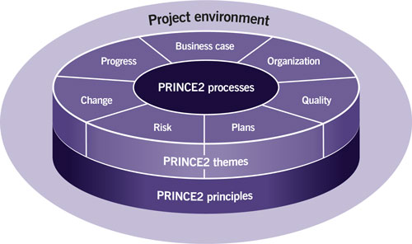
https://www.axelos.com/best-practice-solutions/prince2/what-is-prince2

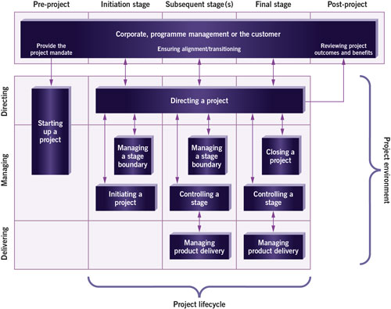
Use of the PRINCE2 processes through the project lifecycle:
https://www.axelos.com/best-practice-solutions/prince2/what-is-prince2
The advantages towards the PRINCE2 approach is that it provides a stage to stage process which guides the managers and employees on what goals they need to achieve, as it is a very common and well recognised approach it improves communication between stakeholders which conserves energy and time, this type of approach clearly defines each other’s roles and responsibilities and it also provides a firm structure which sets clear precise lines of authority, delegation, accountability and improves the standards of communication (Willis, 2017). The disadvantages towards the PRINCE2 approach is that it is not in known in Canada or the United States of America, it affects budgeting and cost management and it has a very similar approach that contrasts with PRINCE2 and it is called the Agile approach (project management informed solutions, 2018).

The second approach that is going to be discussed is the Waterfall approach. The Waterfall approach was first introduced by Winston Royce in 1970. The waterfall approach is a direct approach to software development. In this approach consists of five stages and they are idea engineering, system design, implementation, testing and valuation and maintenance. The advantages for this approach is that it uses a clear structure so this makes planning and designing easy, progress can easily be monitored and through the development stage everyone can be involved in the development of the project. The disadvantages to the Waterfall approach is that when you make amendments this could cause problems, it cannot be tested until all of the stages are at one hundred percent completion, this approach has a high amount of risk and uncertainty and it is not suitable for complex projects (Web Applications & Data Integration Company, 2019).

The third and final approach that is going to be discussed is PERT. This means Programme Evaluation Review Technique and it was first introduced in 1957. This type of approach is favourited to manufacturing companies as it takes its time to complete a task. This type of approach is most commonly used for conducting the final review of a project and it characterises an important step in the making of managerial science. The advantages to PERT is that it locates applications in planning and control of a complex set of tasks, functions and relationships, it is a very resourceful tool for planning the time and resources and it spots the potentially troublesome areas that could disrupt the development of the project it is also helpful in the decision making (Business Management Ideas, 2019). The disadvantage to PERT is that it is an approach where the time is a high priority so it is important that the task is completed within its deadline, the prediction and the decisions for this type of approach towards project management can be quite inaccurate and this approach can be very expensive due to the methods, time and resources that are being used (The Engineering Community, 2018).

The Stages to Managing a Project

The stages to managing a project consists of a beginning, a middle and an end. This can be measured by analysing the project lifecycle which consist of four different stages the project start up stage, the project planning and organisation stage, the project implementation with monitoring stage and completion and evaluation stage. The main aims for the project start up is to understand the objectives, priorities, deadlines and the risks of the project. The main aims for the planning and organisation of a project include summarising the tasks and defining the timeline that is required to implement on the project. The main aims for implementing the project with monitoring includes executing the plan into action whilst monitoring the projects progress. For the final stage, the main aims for the completion and the evaluation of the project consists of analysing the results, identifying key learning and to plan for the next steps ahead (Nediger, 2019).

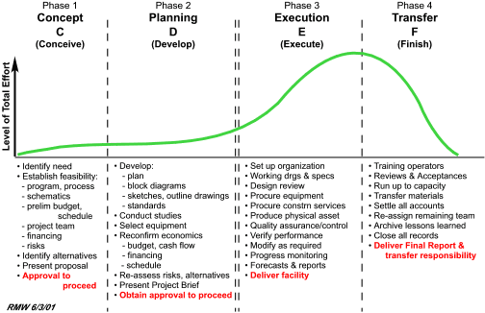
http://www.maxwideman.com/papers/projenviron/dimensions.htm

Stakeholders

A stakeholder is anyone who is interested in the project and are positively and negatively affected by the different variables within the project. A stakeholder is involved in the projects by helping out with the analysis, planning and management of the project (Landau, 2017). There are two sectors of a stakeholder and they are internal and external stakeholders. An internal stakeholder is someone who makes decision for the projects on behalf of the company who are already within the organisation. For example, internal stakeholders include of employees, managers, board members, company owners and volunteers (Habas, 2018). An external stakeholder is someone where the financial wellbeing of the company can have an effect on, who are not directly appointed within the business. For example, an external stakeholder includes of suppliers, shareholders, customers, government, members of the communities and other organisations (Spacey, 2017).

You can prioritise your stakeholders by using a technique used to identify the main people that have to be won over by identifying the stakeholders, prioritising the stakeholders and understanding the key stakeholders and this can be done by measuring if they have high power or low interest or vice versa, by doing a power and interest chart where you split the stakeholder into four sections and they are keep satisfied, mange closely, monitor and to keep informed (Bright Hub Project Management, 2019).
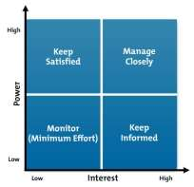
https://www.ukessays.com/essays/management/characteristics-change-management-5643.php
The benefits of having stakeholders is that you can decide upon the different views from the most high power stakeholders to be able to plan the projects at an early stage, which means that the stakeholders will be able to support the team so that they can input their views to improve on the quality of the project, having good communication early and during the project makes sure that they fully understand in what their purpose is for and fully understand the benefits of the project. Another benefit would be that due to the good communication between the stakeholders this can also improve the company’s reputation (Hall, 2019).

Why a Project may Succeed or Fail

Within project management there aspects that help make the project work and the main aspects are cost, quality, time, good relationships, communication, planning and control. To make a project successful the main requirements will be to have well defined distinct objectives, good communication, good planning and control method, having a project manager that is very knowledgeable in what they are doing, enough time and resources, good project organisation and structure and commitment by all (egeland, 2019) The aspects for which a project may fail is where there would be unclear project objectives, very poor communication, no risk management, lack of team planning sessions and poor monitoring control (Mimic, 2016).

Conclusion

The purpose of this report has been met as the report critically assesses Peter Drucker’s theory which is management by objectives, Henri Fayol’s theory which is to manage is to forecast and to plan, organise, to command, to coordinate and to control which then creates the five functions of management which is planning, organising, commanding, coordinating and controlling. The last definition is where that project management is knowing the precise goals that you are going to achieve, how you are going to achieve your goals, what tools and resources you are going to need and how long it will take for you to achieve the specific goals that you need to achieve. The purpose of this report has also been met as it critically evaluates PRINCE2 approach, the Waterfall approach and PERT approach towards project management. Another purpose has been met as it describes the stages to managing a project, critically evaluates what stakeholders are and how they can be identified and the benefits of stakeholders. Lastly it is clearly evaluated how a project may succeed or fail.

References
Alderton, M. (2019). How to apply Peter Drucker's management theory. Retrieved from https://www.business.com: https://www.business.com/articles/management-theory-of-peter-drucker/
AXELOS. (2017). What is PRINCE2. Retrieved from https://www.axelos.com: https://www.axelos.com/best-practice-solutions/prince2/what-is-prince2
Bright Hub Project Management. (2019). Power/Interest Grid. Retrieved from https://www.brighthubpm.com: https://www.brighthubpm.com/resource-management/80523-what-is-the-powerinterest-grid/
Business Management Ideas. (2019). PERT: Meanaing and Steps. Retrieved from https://www.businessmanagementideas.com: https://www.businessmanagementideas.com/project-management/pert-meaning-and-steps-network-analysis-project-management/9785
Chand, S. (2018). Management by Objectives. Retrieved from www.yourarticlelibrary.com: http://www.yourarticlelibrary.com/management/management-by-objectives-mbo-advantages-and-disadvantages/35358
Chron. (2019). The Advantages of Fayol's Principles of Management. Retrieved from https://smallbusiness.chron.com: https://smallbusiness.chron.com/advantages-fayols-principles-management-78162.html
Drucker Institute. (2019). About Peter Drucker. Retrieved from https://www.drucker.institute: https://www.drucker.institute/perspective/about-peter-drucker/
egeland, B. (2019). 5 reasons why projects succeed. Retrieved from https://www.projecttimes.com: https://www.projecttimes.com/articles/5-key-reasons-why-some-projects-succeed-and-some-don-t.html
Expert Program Management. (2018). 14 Principles of Management . Retrieved from https://expertprogrammanagement.com: https://expertprogrammanagement.com/2017/11/14-principles-of-management/
Habas, C. (2018, October 25). What is an internal stakeholder. Retrieved from https://bizfluent.com: https://bizfluent.com/info-12073429-internal-stakeholder.html
Hall, H. (2019). Nine Awesome Benefits in the World of Stakeholder Management. Retrieved from https://projectriskcoach.com: https://projectriskcoach.com/benefits-of-stakeholder-management/
Kukreja, S. (2019). Advantages and Disadvantages of Management by Objectives. Retrieved from https://www.managementstudyhq.com: https://www.managementstudyhq.com/advantages-and-disadvantages-of-mbo.html
Landau, P. (2017, June 13). What is a stakeholder. Retrieved from https://www.projectmanager.com: https://www.projectmanager.com/blog/what-is-a-stakeholder
Mimic, V. (2016, December 16). Why projects fail. Retrieved from https://project-management.com: https://project-management.com/why-projects-fail/
Naybour, P. (2013, July 14). Top ten benefits of good project management. Retrieved from www.projectaccelerator.co.uk: http://www.projectaccelerator.co.uk/ten-benefits-of-good-project-management/
Nediger, M. (2019, May 02). The 4 stages of a project lifecycle. Retrieved from https://venngage.com: https://venngage.com/blog/project-life-cycle/
Paymo Academy. (2018, March 13). What is Project Management. Retrieved from https://www.paymoapp.com: https://www.paymoapp.com/academy/what-is-project-management/
project management informed solutions. (2018). 10 major reasons why PRINCE2 is not the best practice. Retrieved from https://www.pmis-consulting.com: https://www.pmis-consulting.com/10-reasons-why-prince2-is-not-even-close-to-best-practice/
Project Management Lerning. (2019). What are the disadvantage of project management. Retrieved from https://projectmanagementlearning.com: https://projectmanagementlearning.com/what-are-the-disadvantages-of-project-management.html
Spacey, J. (2017, August 21). 7 examples of External Stakeholders. Retrieved from https://simplicable.com: https://simplicable.com/new/external-stakeholders
The Engineering Community. (2018). The Pros and Cons of PERT. Retrieved from https://www.theengineeringcommunity.org: https://www.theengineeringcommunity.org/the-pros-cons-of-pert-analysis-technique/
Vliet, V. V. (2010). Henri Fayol Biography. Retrieved from https://www.toolshero.com: https://www.toolshero.com/toolsheroes/henri-fayol/
Web Applications & Data Integration Company. (2019). 6 Advantages and Disadvantages of the Waterfall Model. Retrieved from https://wadic.net: https://wadic.net/waterfall-model-advantages-disadvantages/
Willis, R. (2017, September 7). 7 advantages of usinf PRINCE2 methadology in project management. Retrieved from https://yourprojectmanager.com.au: https://yourprojectmanager.com.au/7-advantages-prince2-methodology-project-management/

