Principles of Learning and Teaching
Module Code: ECIE4004
Lecturer: Sue Ainsworth
Student: Yvonne Blachford

Contents
Blog 1 – John Dewey – Is he still relevant today
Blog 2 – Introducing Lev Vygotsky
Blog 3 – Influencers if their time
Blog 4 – ALN in Wales
Reference list

(Pedagogy 4 Change)

John Dewey – Is he still relevant today?

Bruner, Dewey, Skinner, Piaget, Vygotsky and Froebel?

Four weeks ago, these names meant very little to me, and I felt choosing who I would research and discuss would be, in all honesty a long and tedious activity. How would I relate to any of these? Would ideas and thoughts from another era really still be relevant not only in education but in our ever changing, fast paced society?

How wrong was I? Step up Mr John Dewey, who it is claimed is “one of the most prominent American scholars” (Currell, 2020) and his pedagogical philosophies on learning by doing, was sought after in many countries. (Pedagogy 4 Change).

Had I found a new hero?

I soon learned that Dewey believed in the child centred approach (Beckett, 2017) , he was of the opinion that children were naturally inquisitive and wanted to explore both independently and cooperatively. Dewey was critical of the traditional teaching methods, believing them to be irrelevant and disconnected from young learners. (Williams, 2017). Dewey considered that we learn best through a hands-on approach, that we need to interact with our environment to grow and learn, firmly placing him as a founder of the educational philosophy of pragmatists. (Gounlock, 2022).
Education is not preparation for life: education is life itself: John Dewey
What is the pragmatism philosophy in education you may ask

Dewey believed that education should not be just learning, but about growth and life. That children should be discovering skills that will not only help them in life but encourage them to be better people. (Boyd, n.d).

Some Important principles
of Dewey’s Theory of Education

- Learning by doing
Rather than children being told the information or them reading facts from a book, knowledge is retained more if we learn while actually doing the activity. You would not teach piano without the student having the experience of actually playing. Children should take part in active learning and investigation.

- Discussions and interactions
Through debates and communications they will learn to formulate their own ideas, maybe to influence others or to consider the views and experiences of others.

- Critical thinking
For children to think for themselves, challenge ideas, look at other opinions.

- Diversity
The importance of recognising and embracing our differences would allow children to have a better understanding and a more diverse way of thinking.

- Engagement
Getting children’s interest in an activity or topic is key to stimulating their interests and eagerness to learn. Making things more fun or practical activities to allow them to take part.
Not everyone is a fan:

While many of Dewey’s principles are practiced by educators today, he was viewed with suspicion. Some believed that his views would result in children not grasping the basic academic skills, while others worried that teachers would lose all authority and classrooms would become disorderly. (Oiedra, 2018).
The Atlantic Newspaper in 1953, wrote an article of the critics of John Dewey, who viewed his changes in education as godless, held him accountable for the increase in juvenile delinquency and Dewey was a danger to education. (Ernst, 1953). In an earlier article in the same newspaper, it was noted that parents did not want progressive education and if they examined Dewey’s beliefs they would believe “really understand what evil influences are at work in our modern classrooms”. (Lynd, Who Wants Progressive Education?, 1953)

Although some viewed John Dewey with contempt and did not agree with his ideas on education, many of his principles are still being used in classrooms today. With the new Additional Learning Needs and Educational Tribunal (Wales) Act (Welsh Goverment), a pupil centred approach is very much considered a big step forward in education and how children with additional learning needs are having their needs met.

Introducing Lev Vygotsky
“What a child is able to do in collaboration today, he will be able to do independently tomorrow” Lev Vygotsky

While Vygotsky is considered as one of our cognitivism theorists, who believed that how we learn, and gain knowledge is very much dependent on social interaction with family, friends, peers and teachers. (Bates, 2019). He rejected the opinions of other cognitivists such as Perry and Piaget, that you can separate learning from social context. (Graduate Teacher Instructor, n.d). Vygotsky was a firm supporter that culture affects cognitive development. (Currirculum Management soloutions, 2017)

How is he relevant today?

Vygotsky argues that in order to learn children needed to play, (Vygotsky, 1930), he believed that the encouragement to play enhanced a child’s imagination and conceptual ability, which would in turn lead to better development and progress. This is a concept that is adopted by many early year settings in Swansea, which allow the children to follow a child led play structure.

Vygotsky felt that a student benefited from learning with help of a more informed individual (teacher), this is a method that we call scaffolding today. The main principles of scaffolding are:

- Break tasks in to smaller, more manageable chunks.
- Encourage interest in the task and engage with them
- Use people with more knowledge or skill to offer support
- Keep focused on the smaller task, but not losing sight of the main task
- Model answers or completed activity. Show them how the completed task should look (Bates, Learning Theories Simplified, 2019)

Zone of Proximal Development (ZPD)

Vygotsky developed this concept, to show what a child could achieve without support, compared to what they can do with it. He believed that a child would begin by following an adult’s lead and then will gradually develop and learn the skills to complete the task independently. (Mockingjay, N.D)

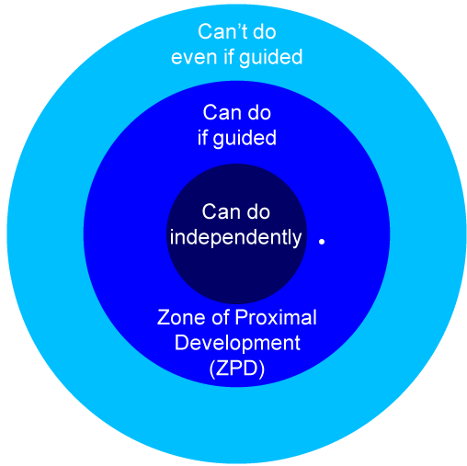

A study was conducted to test this theory, where children were requested to put furniture in a dolls house. Several of the children were first allowed to play a similar game with their mothers before they began the task, while the rest completed the activity independently. It was discovered that those who had worked with their mothers beforehand showed the most understanding and made the greatest improvement. Proving that guided learning resulted in better understanding, that working alone. (Freund, 1990).

Most Knowledgeable Others

Vygotsky called the people that we learn from most knowledgeable others or MKOs. This may well be your teacher or mentor, who through instructions, demonstrations or modelling will pass on their skills to you, Vygotsky referred to this as collaborative or cooperative dialogue. (McLeod, 2019). MKOs are not always teachers or adults, it can be anyone who has the most knowledge, an adolescent showing their parent how to create a TikTok, a child explaining to their gran how to use their mobile phone. In fact, we have even moved on to computer programmes providing training and knowledge in the work place.

So, what’s the downside?

We have examined the positives of Vygotsky and how it is beneficial in our classrooms, but does everyone agree? Apparently not.

- It is noted that Vygotsky died young, leaving many of his theories and idea’s incomplete. There is a lack of experimental tests, he relied on observations to demonstrate his findings.
- That his theories did not fully explain how changes in “socioemotional capabilities contribute to cognitive development” (Estes, 2013).
- That a MKO would become too helpful, especially if a parent, not allowing the child to take part and contribute.
- Would the learner become too reliant, or lazy, expecting help on a task they could have completed on their own?
- His theory that social interaction is vital to learning, making the assumption that all societies are the same (Kurt, 2020) and in some cultures there may be a more effective way of learning skills.
- Vygotsky does not acknowledge the emotional aspect of learning, how enjoyment of success, or the annoyance of failure can be a strong motivation for learning.

Final word
It is clear to see that Vygotsky’s ideas and theories are not only used in education, but in our everyday life. We offer our knowledge and experiences to a new member of staff; a teacher may help a child put on their shoe. It is argued that Vygotsky’s theories are the forerunner of our current educational practices. (Curran, 2013) .

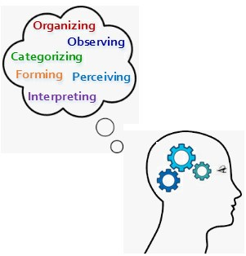
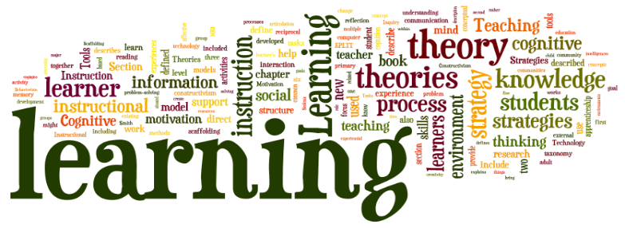
(Harapnuik, 2021)

(The Peak Performance Center, 2022)

Influencers of their time

When we hear the word influencer today, we have images of the young and cool posting vlogs and pictures to their social media, convincing us that we must have that brand of coffee, or our lives would be more content if we only had the amazing hair curlers. It will be hard to imagine that many of the thousands of self-proclaimed influencers today will have a lasting impact on us, our lives or society.

Dewey and Vlogotsky were the influencers of their time and without the help of social media. Their work and views on the learning process is still seen in education today and were advocates for change.

Both theorists are considered to be cognitivists, which is a learning theory that sees how information is obtained, retained, stored and organised by our mind. Looking “beyond observable behaviour, viewing learning as an internal mental process”. (Open Education, 2020).

Vygotsky in our classrooms

Vygotsky’s theories can certainly still be seen in education today, his idea of Zone Proximal Development for example is where we have our peer tutoring or what we call today scaffolding (Hargraves, 2021). Vygotsky’s views on how a child’s cultural influences and social interactions can impact on their development is very much still studied and evaluated in schools. With schools providing annual data to the Welsh Government with the pupil level annual school census (PLASC) detailing information on a pupil’s ethnicity, if they have additional learning needs and whether a child was in receipt of free school meals.

His ideas on inclusive pedagogy could be considered well ahead of his time, Vygotsky was quoted as saying “A child whose development is impeded by a defect is not simply a child less developed than his peers: rather than he has developed differently” he believed that a child’s disability should be identified as a strength rather than a disability. (Vik & Somby, 2018). Inclusive education is certainly more relevant and important in education than ever, with the emphasis on inclusive classrooms, the new Individual Development Plans, with the key element being a pupil centred approach and that mainstream education is accessible to all.

How is Vygotsky’s theories adopted in classrooms?

- Checklists
Breaking complex, difficult tasks into smaller more manageable chunks.
- Modelling
Give examples of how the finished task should look.
- Group work
Allow students to work collaboratively, discussing possible solutions.
- Buddy system
Pair students together so they can learn from each other.
- Evaluate
Review previous material before moving on to new tasks.
(Kurt, 2022)

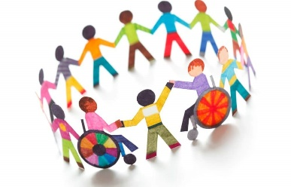
(Plester & Parasuram, 2015)
Let’s not forget about John Dewey.

While Dewey and Vygotsky shared similar ideas and views, one of the main differences is Dewey saw education as a bottom-up process, the child being central to the process, Vygotsky however viewed it as a top-bottom process, the social group being more important to the process. (Slatinsky, 2009).

Dewey was an advocate of progressive education and believed that the curriculum should focus on the interests of the children and to include active experiences while learning.

Teachers can adopt Dewey’s theories into their classrooms by using some of the following steps:

- Ask students questions that they can use their own experiences to answer
- Use a variety of practical teaching methods, such as school trips, guest speakers sharing their personal experiences.
- Critical thinking – Ask students to evaluate what may happen if things were done differently.
- Social participation – Encourage students to become volunteers in the community. Clean up local parks, arrange fund raisers.
- Respect the diversity in your classroom, do not expect students to conform to your way. (Murphy, n.d).

Dewey’s views on progressive education can still be a controversial debate, with schools effectively needing to be exam factories and graded on exam results which are published each year. Parents often pursue the settings with the best scores, pushing schools to adopt a more traditional approach, demanding a strict adherence to rules. Asking the question “are good exam results the main focus of our education system today?”

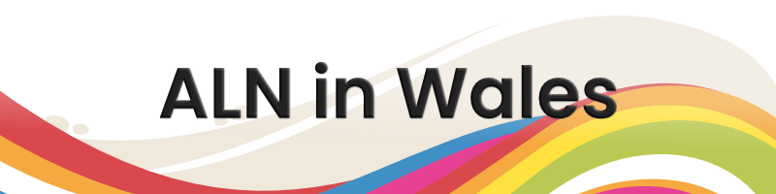

(Langley Wellington Solicitors, n.d).

Education has faced some of its biggest challenges and changes in the last few years, which has not only tested teachers, students and parents, but has forced us to evaluate and adapt previous methods. Looking at my own personal experience within my previous role in a secondary school, working with children with additional learning needs. I was able to reflect how Dewey and Vygotsky had influenced the way I worked.

I used many of Vygotsky’s theories to support and encourage students with learning needs. Part of my role was to write Individual Learning Plans for teaching staff, in collaboration with student’s on how they like to be supported in their learning. Some of the strategies I would put in place would be:

- Tasks to be broken into smaller sections, so the student would not feel overwhelmed. A smaller task feels more manageable.
- Sit the student by someone who can help and support them, someone they can ask.
- For teachers to provide model answers, showing them how an end task should look. Giving the student a clearer view of what direction they should be going.

Using Dewey’s child centred approach, the student would be involved in setting their targets, working on what they would like to achieve. An example could be:
To improve their maths skills, the student will complete maths games on the
computer for 10 minutes, 3 times per week.

This would also incorporate Dewey’s learning by doing and engagement theory.
A tool I would use to follow the child centred approach would be the one page profile, this is a snap shot of the student that would form part of their Individual development plan. Working with the child, we would discuss:

- What we like and admire about them?
- What is important to and for them?
- How they like to be supported?

Another of Dewey’s principles used was social participation; students who were struggling to manage their behaviour in class and becoming dysregulated became part of a pilot scheme to encourage empathy. Each week they would visit a local residential home for the elderly with Alzheimer’s. Within in a few weeks not only did we see an improvement in the pupil’s behaviour and engagement, but the care home reported that the residents were calmer and would often remember the children who were visiting them.

New beginnings and challenges
Incorporating my increased knowledge through studying the Inclusive Education Foundation degree and my passion for additional learning needs, I felt that I needed to do more. I was fortunate enough to be given the opportunity to move to the local authorities Additional Learning Needs and Inclusion Team to support children of all ages with severe and complex needs.

It was here I could see the importance of Vygotsky’s view of learning through social interaction. As a team, we were receiving an alarming number of referrals from the health authority, identifying young children who were presenting global development delay. Their speech was delayed, play skills were non-existent and they were showing poor social communication skills, the health visitors had nicknamed these children as “Covid babies”. It was evident, that due to enforced isolation during Covid, children had missed out on vital social interaction that had caused them a delay in their development.

Part of my role is to work with education settings, parents and children ensuring that strategies and tools are in place to fully support any child with an additional learning need. Scaffolding is a main method we incorporate in early years:

- Using visual aids to support learning, if a child is struggling to understand show them a plate to indicate snack time, or their coat to show its home time.

- Modelling, showing a child how to roll a ball, not just verbally explaining it to them
- Using suggestions – If a child is struggling with an activity, suggest how it could be made easier. If they find it hard to hold a pencil, would chalk or a crayon be easier.

Vygotsky’s learning through play is a vital part of early years:
Singing songs with actions or stacking blocks to support fine motor skills.
Messy play to build tolerance for children with sensory difficulties.
Playing games such as peek-a-boo and games that involve turn taking to support a child’s joint attention.
Using equipment such as slides, climbing frames to develop a child’s core strength to help them with their walking skills.

Last word………..

During my research for this assignment, I was automatically drawn to John Dewey and Lev Vygotsky but I didn’t know why. On reflection I can see that I shared much of their passion and views on children with additional learning needs and the importance of having inclusivity in education.

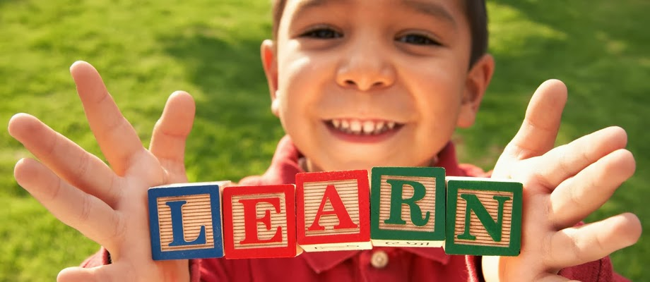
(Meagor, 2014)

References
Bates, B. (2019). Learning Theories Simplified (2nd ed.). London: Sage Publications.
Bates, B. (2019). Learning Theories Simplified (2nd ed.). London: Sage Publications Ltd.
Beckett, K. (2017, August 28). John Dewey's conception of education: Finding common groung with R.S. Peters and Paulo Freire. Educational Philosophy and Theory, 380-389. doi:https://doi.org/10.1080/00131857.2017.1365705
Boyd, N. (n.d). Pragmatism: Overview & Practical Teaching Examples. Retrieved December 10, 2022, from Study.com: https://study.com/academy/lesson/pragmatism-overview-practical-teaching-examples.html#:~:text=Pragmatism%20is%20an%20educational%20philosophy,including%20John%20Dewey%2C%20were%20pragmatists.
Curran, S. (2013). To what extent is Vygotsky's theory of education relevant to the UK contemporary education sytem? Retrieved December 19, 2022, from Grin: https://www.grin.com/document/451612
Currell, J. (2020, January 27). The lewgacy of John Dewedy. Retrieved December 1, 2022, from Maths no problem: https://mathsnoproblem.com/blog/teaching-practice/legacy-of-john-dewey/
Currirculum Management soloutions. (2017, December 4). Vygotsky vs. Piaget: A Paradigm Shift. Retrieved December 19, 2022, from Currirculum soloutions: https://curriculumsolutions.net/blog/2017/12/04/vygotsky-vs-piaget-a-paradigm-shift/#:~:text=Vygotsky%20argued%20that%20social%20learning,cognitive%20development%20varied%20across%20cultures.
Ernst, F. (1953, May). How dangerous is John Dewey? Retrieved December 14, 2022, from The Atlantic: https://www.theatlantic.com/magazine/archive/1953/05/how-dangerous-is-john-dewey/641090/
Estes, V. (2013, November 4). Piaget's *& Vygotsky's Theory of Cognitive Development. Retrieved from Prezi: https://prezi.com/on42h-4fcpse/piagets-vygotskys-theory-of-cognitive-development/
First Discoveries. (n.d). Child Development Theories: B.F. Skinner. Retrieved December 14, 2022, from First Discoveries: https://www.firstdiscoverers.co.uk/b-f-skinner-child-development-theories/
Freund, L. (1990, February). Maternal regulation of children's problem-solving behaviour and its impact on children's performance. Child Development, 61(1), 113-126.
Gounlock, J. S. (2022, December 23). John Dewey American philosopher and educator. Retrieved January 3, 2023, from Britannica: https://www.britannica.com/biography/John-Dewey
Graduate Teacher Instructor. (n.d). Socail Constructivism. Retrieved December 19, 2022, from Berkeley Graduate Division: https://gsi.berkeley.edu/gsi-guide-contents/learning-theory-research/social-constructivism/
Harapnuik, D. (2021, November 10). Four Keys to understanding learing theories. Retrieved December 20, 2022, from Its abour learning: https://www.harapnuik.org/?p=6344
Hargraves, D. V. (2021, March 17). Vygotsky's philosophy of education. Retrieved December 19, 2022, from The Education Hub: https://theeducationhub.org.nz/vygotskys-philosophy-of-education/
Kurt, D. S. (2020, July 11). Lev Vygotsky - Sociocultural Theory of Cognitive Development. Retrieved December 20, 2020, from Educational Technology: https://educationaltechnology.net/lev-vygotsky-sociocultural-theory-of-cognitive-development/
Kurt, D. S. (2022, October 22). Vygotsky's Theories and How To Incorporate Vygotsky's Theories in The Classroom. Retrieved from Theeducationlibrary: https://educationlibrary.org/vygotskys-theories-and-how-to-incorporate-vygotskys-theories-in-the-classroom/
Langley Wellington Solicitors. (n.d). SEN/ALN System in Wales. Retrieved January 2, 2023, from Education Lawyers.
Lynd, A. (1953, April). Who Wants Progressive Education? Retrieved December 14, 2022, from The Altantic: https://www.theatlantic.com/magazine/archive/1953/05/how-dangerous-is-john-dewey/641090/
Lynd, A. (1953, April). Who Wants Progressive Education? Retrieved December 14, 2022, from The Atlantic: https://www.theatlantic.com/magazine/archive/1953/05/how-dangerous-is-john-dewey/641090/
McLeod, D. S. (2019). The Zone of Proximal Development and Scaffolding. Retrieved December 20, 2022, from Simply Psychology: https://www.simplypsychology.org/Zone-of-Proximal-Development.html#:~:text=Social%20Interaction&text=Vygotsky%20refers%20to%20this%20as,or%20regulate%20their%20own%20performance.
Meagor, K. (2014, March 4). Forming a "Learner-Centred" Classroom. Retrieved January 2, 2023, from Team Two Blog: http://aasmith17.blogspot.com/2014/03/dewey-piaget-vygotsky-on-learner.html
Mockingjay. (N.D). Zone of Proximal Development. Retrieved December 19, 2022, from Socail Development Theory by Vygotsky: https://sites.google.com/site/qim501eiddmockingjay/discussion
Murphy, S. (n.d). How to apply John Dewey's Theories in the Classrom. Retrieved January 2, 2023, from Classroom: https://view.officeapps.live.com/op/view.aspx?src=https%3A%2F%2Ffgonzalezportfolio.weebly.com%2Fuploads%2F7%2F6%2F9%2F9%2F7699994%2Fcomparative_research_paper.doc&wdOrigin=BROWSELINK
Oiedra, A. M. (2018, February 1). The Tragedy of American Education: The Role of John Dewey. Retrieved December 15, 2022, from The Institute of World Politics: https://www.iwp.edu/articles/2018/02/01/the-tragedy-of-american-education-the-role-of-john-dewey/#:~:text=Some%20critics%20believed%20and%20still,the%20teacher%27s%20authority%20would%20disappear.
Open Education. (2020, November 16). Cognitivism. Retrieved December 19, 2022, from OpenLearnCreate: https://www.open.edu/openlearncreate/mod/page/view.php?id=147079
Pedagogy 4 Change. (n.d.). Greath Pedagogical Thonkers. Retrieved December 1, 2022, from https://www.pedagogy4change.org/john-dewey/
Plester, J., & Parasuram, K. (2015, February 27). Why every school should care about inclusive education. Retrieved January 2, 2023, from blogs.ibo: https://blogs.ibo.org/blog/2015/02/27/inclusive-education/
Slatinsky, D. C. (2009, January 6). Dewy & Vygotsky: A comparative look. Retrieved January 2, 2023, from Office Apps: https://view.officeapps.live.com/op/view.aspx?src=https%3A%2F%2Ffgonzalezportfolio.weebly.com%2Fuploads%2F7%2F6%2F9%2F9%2F7699994%2Fcomparative_research_paper.doc&wdOrigin=BROWSELINK
The Peak Performance Center. (2022). Cognitive Learning Theory. Retrieved December 20, 2022, from thepeakperformancecenter: https://thepeakperformancecenter.com/educational-learning/learning/theories/cognitive-learning-theory/
Vik, S., & Somby, H. (2018). Defectology and inclusion. Issues in Early Education, 3(42), 98-99. doi:https://doi.org/10.26881/pwe.2018.42.10
Vygotsky, L. (1930). Mind and Society. Harvard University Press. Retrieved December 19, 2022, from https://www.unilibre.edu.co/bogota/pdfs/2016/mc16.pdf
Welsh Goverment. (n.d.). The Additional Learning Needs and Educational Tribunal (Wales) Act 2018. Retrieved December 1, 2022, from https://www.legislation.gov.uk/anaw/2018/2/contents
Williams, M. K. (2017). John Dewey in the 21st Centuary. Journal of Inquiry & Action in Education, 9(1), 92. Retrieved December 3, 2022, from https://files.eric.ed.gov/fulltext/EJ1158258.pdf

