
USABILITY ENGINEERING
ACCB6017
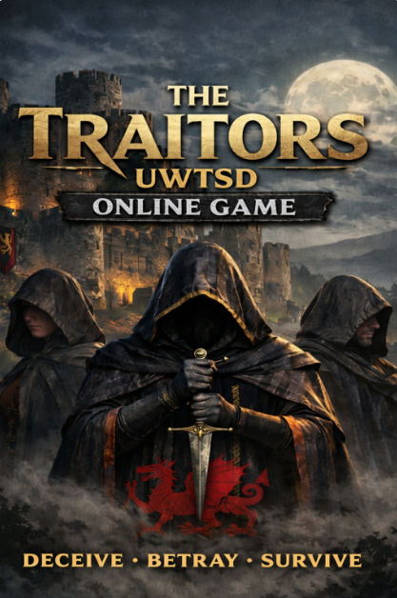
05 March 2026
SOBIA tABASSAM - 2222632
Dr Osman Elgawi

SOBIA tABASSAM - 2222632
Dr Osman Elgawi
Dr Osman Elgawi
Contents
Abstract 2
1. Introduction 3
2. User Research Methodology 4
2.1 Participants, Recruitment, and Ethical Considerations 4
2.2 Data Collection Method 4
2.3 Data Analysis and Translation into Requirements 4
2.4 Prioritisation and Traceability 5
3. Personas and Scenarios 7
4. Usability Design Rationale and Trade-offs 14
4.1 Cognitive Load and System Visibility 15
4.2 Fairness, Emotion, and Deliberate Friction 17
4.3 Accessibility as Structural Integration 19
4.4 Integrated Design Position 19
5 Storyboard Discussion 21
6. Prototype Testing and Evaluation 31
7. Conclusion 34
References 36
Appendixes 38
Appendix A – Requirements and Traceability 38
Appendix A.1 – MoSCoW Requirements 38
Appendix A.2: Traceability Matrix 40
Appendix B – Full Personas 43
Appendix C – Complete Wireframe Storyboards 50
Appendix D - Post-Prototype Evaluation Questionnaire 55
Appendix E – Task Analysis 57
HTA: Multiplayer Game Website/App Interaction Flow 58
Appendix F - Quantitative Evaluation Charts (Section 6) 63

User Requirements and Prototype
The Traitors – University Campus Edition

Abstract
This report argues that in social deduction game design, usability does not diminish suspense but relocates it, ensuring uncertainty arises from player interaction rather than system opacity. To explore this, a user-centred design process was applied to The Traitors – University Campus Edition, a multiplayer mobile social deduction game concept for the UWTSD context. Six UWTSD participants took part in semi-structured interviews; reflexive thematic analysis [11] identified four recurring themes: phase visibility anxiety, voting fairness concern, accessibility exclusion risk, and communication preference diversity. These were translated into prioritised requirements using MoSCoW [13], informing six personas and eight low-fidelity wireframes (WF1–WF8). Cognitive load theory [3], [31] guided the distinction between intrinsic gameplay complexity and extraneous interface friction, with design decisions targeting the latter while preserving the former. Task analysis using HTA and GOMS [25], [26] identified high-risk interactions, and evaluation combined moderated walkthroughs with a 5-point Likert questionnaire. Results indicated strong confidence in safeguarded voting and interface clarity, though phase transitions remained the primary usability vulnerability and were refined accordingly. Findings suggest the theoretical frameworks of CLT, Nielsen's heuristics, and procedural fairness are mutually reinforcing in this context, though each carries limitations when applied outside their original domains that future development must address.

1. Introduction
Social deduction games centre on hidden roles, incomplete information, and strategic deception [4]. On mobile platforms, weak feedback or unclear transitions can create unintended ambiguity [30]. ISO 9241-210 defines usability as achieving goals effectively, efficiently, and satisfactorily within context [32], while usability theory emphasises clarity, feedback, and error prevention [6]. Emerging perspectives in interaction design further argue that human-system interaction must account for the full context of use, including social, emotional, and environmental factors that shape how users engage with digital systems [1].
In competitive multiplayer systems, usability also protects fairness, trust, and emotional engagement [20]. Although uncertainty is essential to gameplay, cognitive load theory distinguishes intrinsic challenge from unnecessary interface complexity [3], [31]. When system states are unclear, attention shifts from strategic reasoning to interpreting the interface [3].
This project therefore adopts a clear position: uncertainty should arise from player interaction, not system opacity [6]. Usability is treated as structural protection of fairness, ensuring ambiguity stems from gameplay rather than interface design [20].
The design integrates Nielsen’s heuristics [6], [12], Norman’s design principles [5], [33], and Shneiderman’s Eight Golden Rules [7] within a user-centred design approach [14]. Insights from six participants informed prioritised requirements, personas, wireframes, and evaluation.

2. User Research Methodology
Within human-centred design, early qualitative inquiry offers contextual insight before interface commitments are made [14]. Interaction design scholarship consistently emphasises that understanding users within their real contexts of use is a prerequisite for producing systems that are both usable and meaningful [2], [14].

2.1 Participants, Recruitment, and Ethical Considerations
Six participants from the UWTSD community, including undergraduate and postgraduate students, a staff member, and a distance learner, were recruited to ensure variation in study mode, gaming experience, communication preference, and accessibility needs. Purposive sampling aligned with the characteristics represented in the project personas (Section 3; Appendix B). Although small, the sample is appropriate for early-stage exploratory HCI research focused on identifying recurring usability tensions rather than producing statistically generalisable findings [14]. Participation was voluntary and based on informed consent [10].

2.2 Data Collection Method
Semi-structured interviews were used to balance consistency with flexibility [14]. Core topics were explored across all participants while allowing individuals to describe experiences in their own words. This approach enabled less obvious concerns, such as perceptions of fairness and accessibility barriers, to emerge naturally during discussion [20].

2.3 Data Analysis and Translation into Requirements
Interview data were analysed using reflexive thematic analysis to identify recurring patterns, with themes cross-checked against transcripts to strengthen credibility [11]. Findings were translated into wireframe-level UX requirements, including clear phase indicators, transition messaging, guided onboarding, safeguarded voting, text-first communication, and embedded accessibility [6], [7], [15]. A key insight was the distinction between intended gameplay uncertainty and unintended interface ambiguity. Participant confusion about “not knowing what the game was doing” highlighted visibility-of-system-status issues, informing confirmation prompts, persistent phase indicators, and clearer phase transitions [6], [12].
Thematic analysis identified four key themes: phase visibility anxiety, where unclear Night–Day transitions caused confusion; voting fairness concern, reflecting anxiety about irreversible elimination decisions; accessibility exclusion risk, highlighting barriers such as poor contrast, forced audio, and high data requirements; and communication preference diversity, showing that players preferred different interaction styles, including text-based and gesture-based communication. These themes informed the prioritised requirements (Appendix A) and persona development (Section 3), ensuring design decisions were grounded in participant evidence rather than assumption [11], [14]. As the researcher was also the designer, reflexive awareness was maintained throughout the analysis in line with Braun and Clarke’s approach to reflexive thematic analysis [11].

2.4 Prioritisation and Traceability
Requirements were prioritised using the MoSCoW method (Appendix A.1) to address critical usability and accessibility issues first, supporting scope control and reducing high-risk problems such as accidental voting, unclear phase transitions, and inaccessible interaction [13]. Table 1 summarises the key themes and their translation into specific design requirements and wireframe decisions, maintaining traceability from user insights to design outcomes.

Table 1: Thematic Analysis Summary
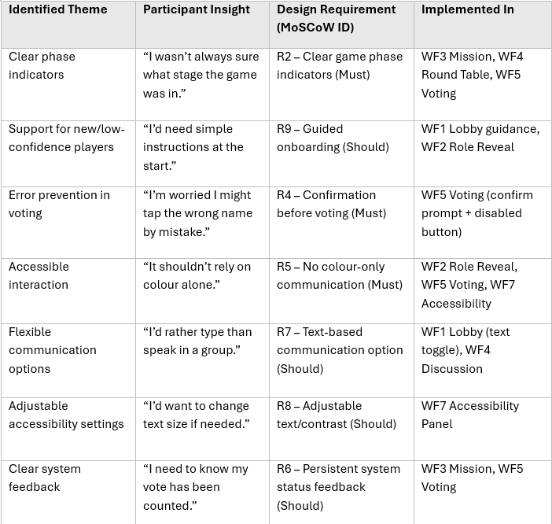

These prioritised requirements informed persona development (Section 3; Appendix B) and subsequent screen-level design decisions (Section 5), ensuring the interface remained grounded in user evidence rather than assumption[14].

3. Personas and Scenarios
Six personas derived from qualitative research (Section 2) represent potential players of the multiplayer social deduction game [14]. They reflect diverse accessibility needs, communication preferences, and levels of gaming confidence within the UWTSD community [15], [22]. Each persona links user characteristics to specific UX requirements, translating research insights into design implications [14].
Cross-persona analysis revealed three key design tensions: speed vs deliberation, immersion vs clarity, and inclusion vs social intensity. These tensions informed the usability decisions discussed in Section 4 and the prioritised requirements in Appendix A.
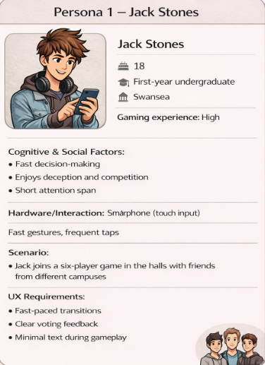
Figure 1: Persona profile – Jack Stones (fast-paced experienced gamer).

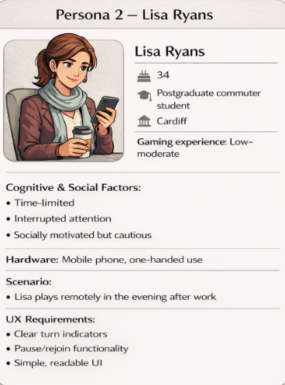
Figure 2: Persona profile – Lisa Ryans (time-limited commuter player).

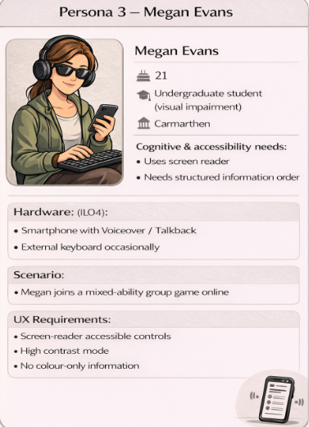
Figure 3: Persona profile – Megan Evans (visually impaired player relying on screen-reader accessibility).

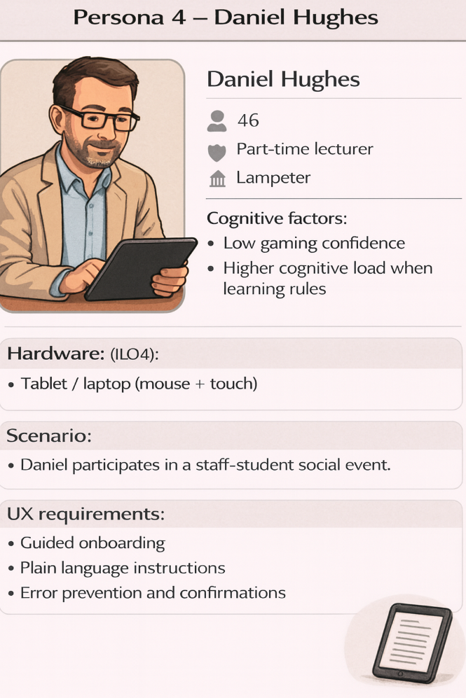
Figure 4: Persona profile – Daniel Hughes (low-confidence player requiring guided interaction and error prevention).

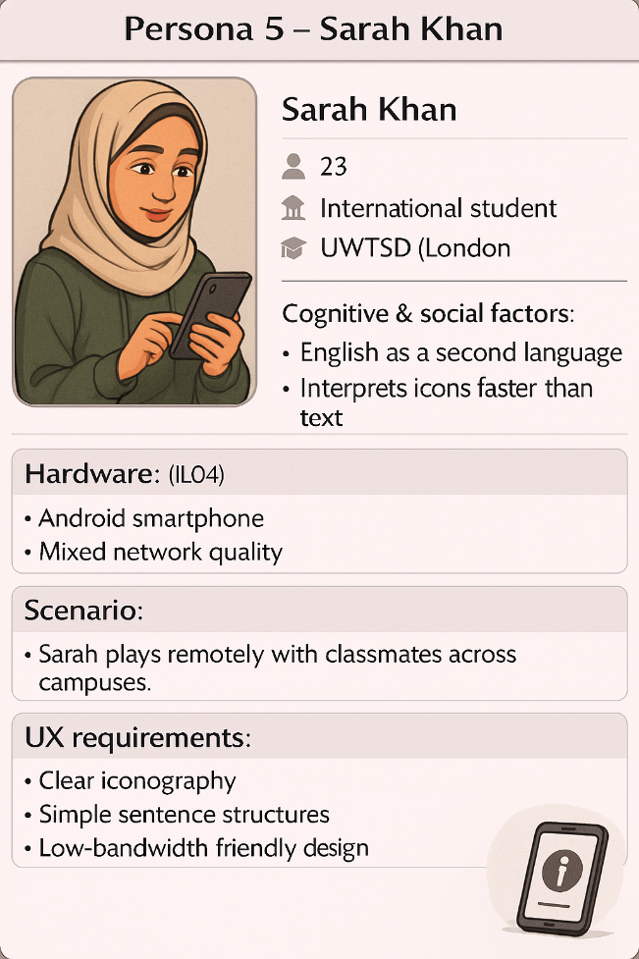
Figure 5: Persona profile – Sarah Khan (international student preferring clear language and icon-based interaction).

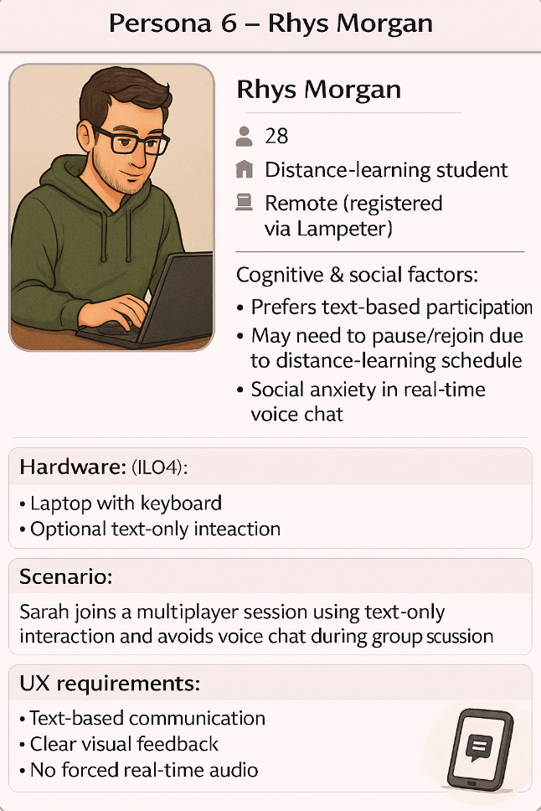
Figure 6: Persona profile – Rhys Morgan (distance-learning player preferring text-based communication).

Synthesis of Persona-Derived Design Tensions
To translate persona insights into design decisions, the personas were analysed collectively to identify shared tensions affecting interaction and interface structure. This helped ensure the design addressed overlapping and sometimes conflicting user needs rather than isolated cases [14].

Table 2: Cross-persona design tensions identified from persona analysis and their corresponding UX responses
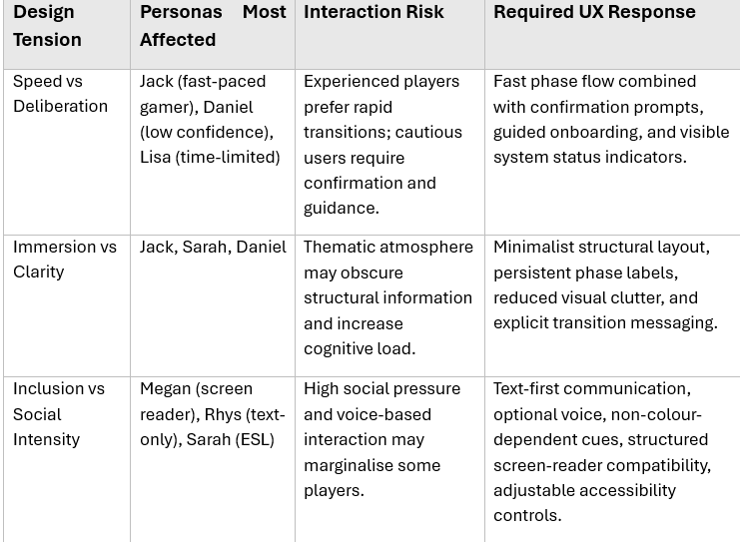

These tensions informed the usability trade-offs discussed in Section 4, shaping confirmation safeguards, clearer phase transitions, embedded accessibility features, and the principle that suspense should arise from player interaction rather than unclear system behaviour [6], [7], [20].

4. Usability Design Rationale and Trade-offs
In social deduction games, usability extends beyond efficiency; it safeguards fairness, trust, and emotional engagement in systems intentionally built around uncertainty [20]. In mobile multiplayer contexts, poor visibility of system status, unclear transitions, or weak feedback can shift tension away from player interaction toward confusion about system behaviour [6], [12]. For this reason, the central design stance of this project is explicit: uncertainty should arise from player decisions and hidden roles, not from interface opacity [4], [20].
This section integrates cognitive load theory [3], [31], usability heuristics [6], [12], procedural fairness [20], and accessibility principles [15], [22] to explain how key design tensions were resolved structurally. Figure 7 illustrates how selected Nielsen heuristics informed specific interface design decisions within the prototype.

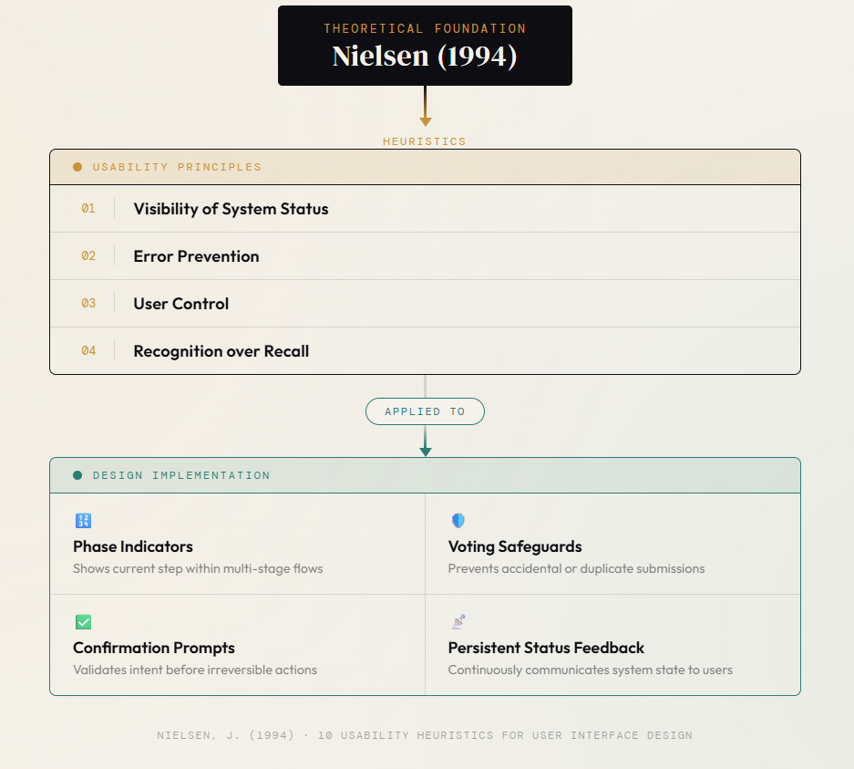
Figure 7: Application of selected Nielsen (1994) usability heuristics to prototype design decisions (author-created conceptual mapping, adapted from Nielsen [6], [12]).

4.1 Cognitive Load and System Visibility
Cognitive load refers to the mental effort required to process information and complete tasks [3], [31]. Sweller et al.’s model identifies three components: intrinsic load, the complexity of the task itself; extraneous load, caused by unclear or poorly structured information; and germane load, the effort used to understand and learn the task. Later work reframed germane load as intrinsic effort directed toward learning, but both perspectives agree that design should minimise extraneous load so users can focus on meaningful activity [3], [31].
In social deduction games, players must track hidden roles, shifting alliances, timed phases, and ongoing discussion while making strategic decisions [4]. This complexity is intentional and forms part of the gameplay. However, if phase transitions, voting states, or timers are unclear, players waste cognitive effort interpreting the interface instead of thinking strategically. The design therefore focuses on reducing extraneous load while supporting learning for new players through structured onboarding and guided role explanations. Figure 8 illustrates the relationship between these components as applied to game interface design.

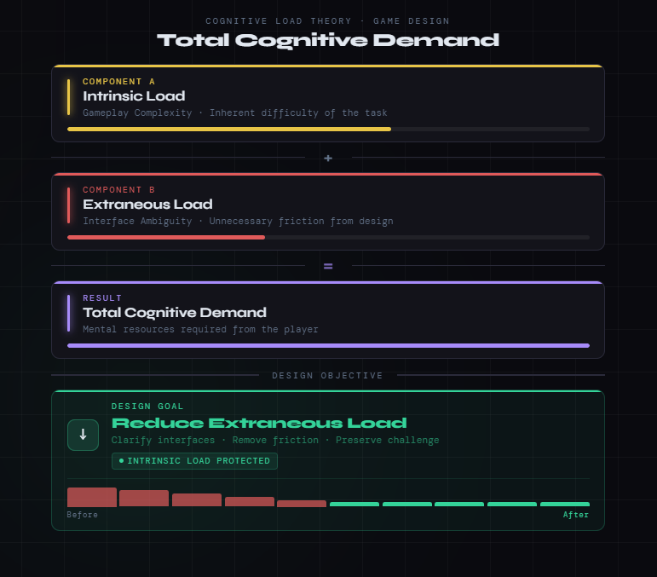
Figure 8: Author-created conceptual illustration of intrinsic and extraneous cognitive load in game interface design, adapted from Sweller, van Merriënboer and Paas [31] and Sweller [3]. Intrinsic load reflects the inherent complexity of gameplay tasks; extraneous load results from unclear or poorly structured interface design. The design objective is to minimise unnecessary cognitive effort so that players can direct available working memory toward gameplay strategy rather than system interpretation.

It is important to recognise a limitation when applying Cognitive Load Theory (CLT) in this context. The theory was originally developed for educational settings [31], so applying it to game UX involves assumptions that are not fully validated in competitive multiplayer environments. Research also suggests that motivation and emotion interact with cognitive load in ways the original framework does not fully address, particularly in social deduction games where suspicion, pressure, and social dynamics influence how players process information [17]. For this reason, CLT is used here as a structural guide rather than a strict model, complemented by game UX research [18] and procedural fairness studies [20].
To reduce unnecessary cognitive effort, the prototype maintains clear visibility of system status throughout gameplay [6], [12]. Persistent phase indicators, countdown timers, structured player lists, transition messages, and clear selection states help players understand what the system is doing at any moment. These features reflect Nielsen’s visibility of system status heuristic and Norman’s emphasis on feedback and clear conceptual models [5], [6], [12], supporting recognition rather than recall. As a result, players can focus on strategy and social interaction, ensuring gameplay tension comes from player decisions rather than interface confusion [4], [20].

4.2 Fairness, Emotion, and Deliberate Friction
Emotional engagement in multiplayer social deduction games is closely linked to perceived fairness [20]. When outcomes reflect deliberate decisions rather than interface errors, trust is maintained and suspense remains player-driven [20]. However, unclear or accidental actions under time pressure can shift tension from strategic uncertainty to frustration [6], [7].
Voting is the highest-risk interaction due to its irreversible consequences and social impact. To minimise error, the design incorporates controlled safeguards, including single-selection voting states, a disabled confirm button until a choice is made, a secondary confirmation prompt, and a visible countdown timer for transparency [6], [7]. As shown in Figure 9, this safeguarded process prevents irreversible errors by ensuring deliberate and validated submissions.
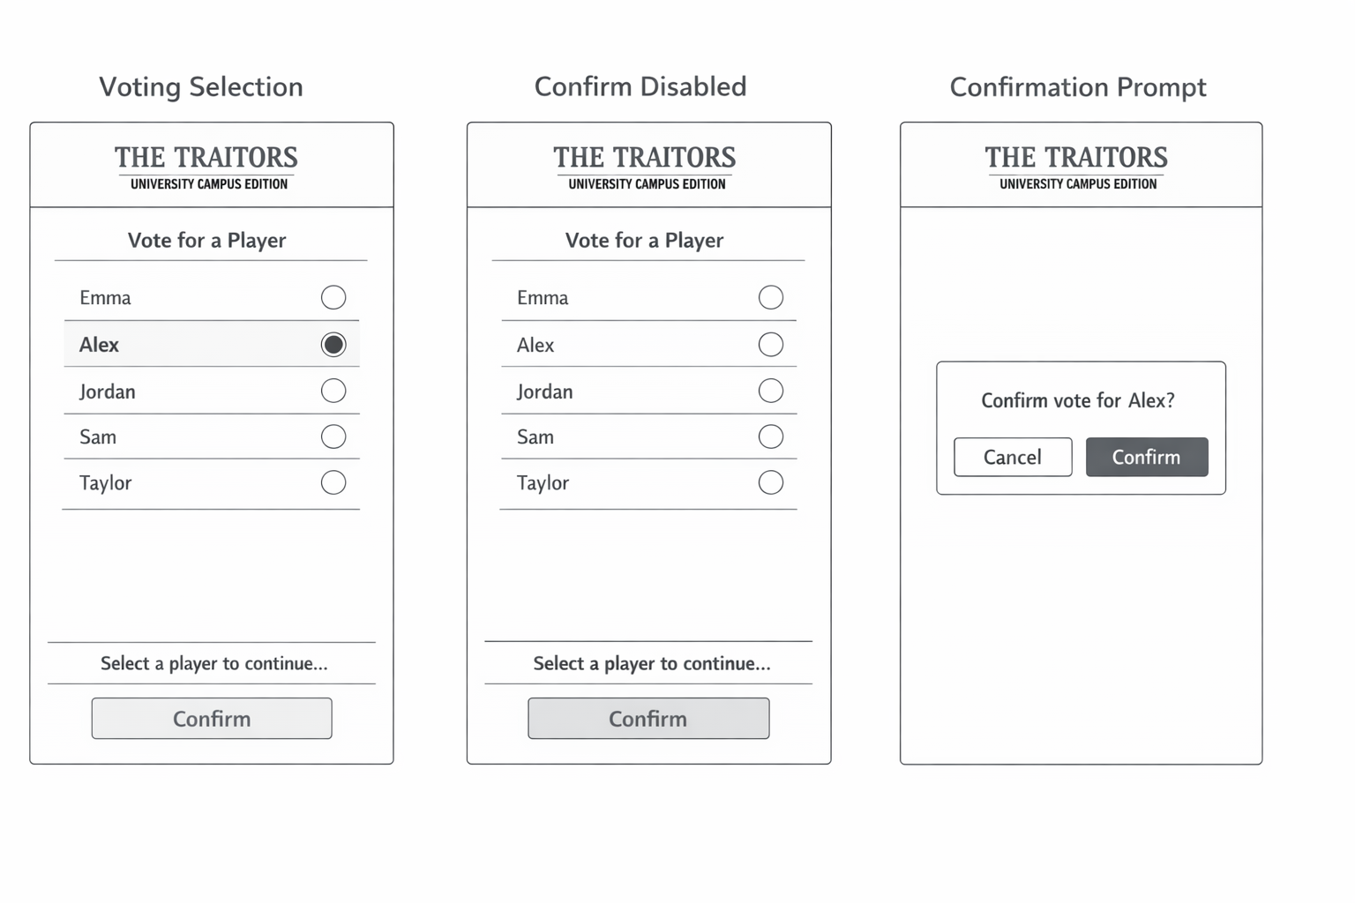
Figure 9: Voting error-prevention mechanisms in “The Traitors – University Campus Edition” prototype, showing single-selection voting, a disabled confirmation state, and a final confirmation prompt.

Although these safeguards introduce an additional step, they prioritise fairness over marginal efficiency gains, aligning with Shneiderman’s principles of error prevention and user control [7] and Nielsen’s emphasis on avoiding high-cost errors [6]. By ensuring actions are deliberate and acknowledged, the system reinforces trust and procedural legitimacy [20].
It is important not to overstate the simplicity of this solution. The trade-off between confirmation safeguards and interaction speed remains real, and the design ultimately prioritises one over the other. Extra confirmation steps can slow gameplay and may frustrate experienced players such as Jack (Section 3), who value fast-paced interaction. As Shneiderman and Plaisant note, error-prevention measures should consider user expertise and task frequency [7]. However, in multiplayer social systems the consequences of an accidental irreversible action, such as wrongly eliminating a player, can seriously damage trust and perceived fairness [20]. For this reason, the design accepts a small efficiency cost in order to protect the game’s social integrity. Future high-fidelity versions could explore adaptive confirmation mechanisms that reduce prompts for experienced users while maintaining safeguards for less confident players.
This resolves the tension between speed and safety: while rapid interaction may benefit experienced players, competitive multiplayer systems require reliable and transparent outcomes [20]. Usability therefore stabilises suspense by ensuring tension arises from player strategy rather than system ambiguity [4], [20].

4.3 Accessibility as Structural Integration
Accessibility is embedded as a core part of the system architecture rather than added retrospectively [15], [22]. The interface incorporates non-colour cues and clearly labelled states, a screen-reader-compatible structure, adjustable text size and contrast, reduced motion options, and text-based communication alternatives [15], [22].
These features align with established accessibility and inclusive design guidance [15], [22] and reflect evidence from WCAG-based accessibility analyses [21], [23]. By integrating accessibility at the wireframe stage, inclusion becomes part of the interaction logic rather than an afterthought [15].
This approach also resolves the tension between immersion and accessibility. While strong visual themes can enhance atmosphere, excessive visual complexity may increase cognitive load and exclude some users [3], [15]. In this design, immersion emerges from structured interaction flow and social gameplay rather than visual intensity [4]. Accessibility therefore strengthens engagement by enabling broader participation without compromising clarity [15], [22].

4.4 Integrated Design Position
Across cognitive clarity, fairness safeguards, and inclusive design, the system follows one core principle: preserve gameplay ambiguity while eliminating system ambiguity [6], [20]. Nielsen’s heuristics emphasise visibility and error prevention [6], [12], cognitive load theory explains how unclear transitions increase mental effort [3], [31], and game UX research highlights transparency as essential for maintaining player trust [20]. Together, these perspectives support a design where emotional tension emerges from player interaction while the interface remains clear and predictable [4], [20].
However, these frameworks do not always align. Nielsen’s heuristics were developed primarily for productivity systems prioritising efficiency and minimalism [6], which can conflict with game design goals such as immersion and deliberate pacing [18]. In this prototype, that tension appears in the accessibility panel (WF8) and voting confirmation flow (WF6), where additional steps prioritise clarity and inclusion over speed. Following Norman’s principle that design should support users’ real goals rather than simply maximise efficiency [33], this trade-off was intentionally accepted.
A related tension exists between cognitive load reduction and procedural fairness [20]. While simplifying information can reduce mental effort, it may remove details players need for fair decisions, such as visibility of player activity during voting. The design therefore distinguishes between information necessary for fair gameplay and unnecessary complexity, preserving the former while reducing the latter.
To operationalise this approach, structured task analysis (Appendix E), supported by HTA and a lightweight GOMS breakdown [25], [26], identified potential breakdown points including joining sessions, interpreting roles, making timed decisions, voting, and adjusting accessibility settings. These insights informed the wireframe refinements in Section 5, embedding usability principles directly within the interaction structure rather than applying them retrospectively [6], [7]. Usability therefore supports, rather than reduces, suspense by ensuring tension arises from player behaviour rather than system confusion [4], [20].

5 Storyboard Discussion
The storyboard wireframes present the initial interface structure for the Traitors – UWTSD Edition mobile game. Consistent with early-stage user-centred design practice, the prototypes were developed as low-fidelity wireframes using simple shapes and text without colour [14]. This approach prioritises interaction structure, navigation logic, and accessibility over visual styling, allowing usability risks to be evaluated before high-fidelity design decisions are introduced [18].
Low-fidelity paper prototyping was chosen because it encourages feedback on usability and interaction rather than appearance, keeps early design iteration quick and low-cost, and avoids creating a misleading sense of completeness that higher-fidelity prototypes can produce [14], [18].
A mobile-first design strategy was adopted to reflect smartphone dominance in university social gaming, with wireframes designed for readable text and touch-friendly controls [30]. Clear navigation paths and minimal visual clutter support learnability and reduce cognitive load during time-pressured gameplay [3], [30]. Accessibility was embedded from the wireframe stage through structured layouts, clear textual labels, large touch targets, and compatibility with assistive technologies [15], [22].
The storyboard sequence represents the full gameplay interaction flow:
Front Cover → Game Lobby → Role Reveal → Mission → Discussion → Voting → Game End.
If the game continues, the system cycles between the Mission, Discussion, and Voting phases until a win condition is reached. An Accessibility Panel remains available throughout the interaction as a persistent overlay, enabling players to adjust contrast, motion settings, text size, and assistive options without disrupting gameplay [15].
These screens operationalise prioritised user requirements identified through research (Section 2) and persona analysis (Section 3). Key design priorities include clear phase visibility, error-resistant voting, structured communication, and embedded accessibility [6], [7], [15].

Entry and Setup
The Home Screen (WF1) provides two primary actions: Start Game and Join Game. Secondary options remain visible but visually subordinate, supporting recognition over recall while reducing decision complexity.
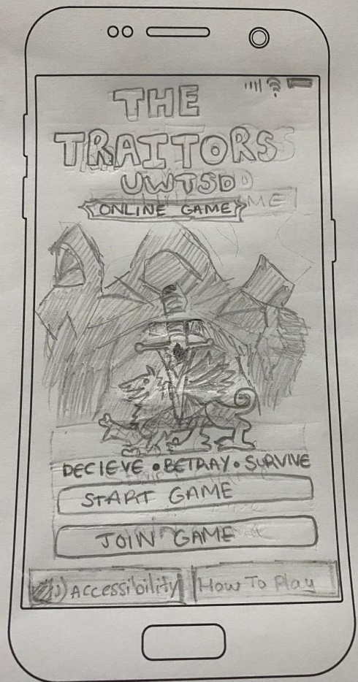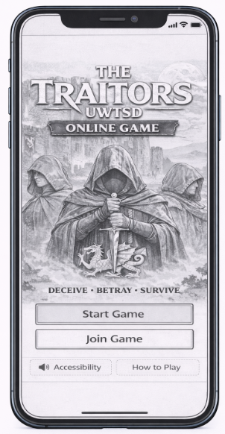
Figure 10: Low-fidelity paper prototype (left) and mid-fidelity prototype (right) of Wireframe 1 (Landing Page).

The Game Lobby (WF2) supports session setup through a structured layout displaying the room code, player list, and game controls. Sequential input fields guide users through joining or creating a session while preventing the game from starting before the required number of players is reached, maintaining clear system status and reducing onboarding confusion.

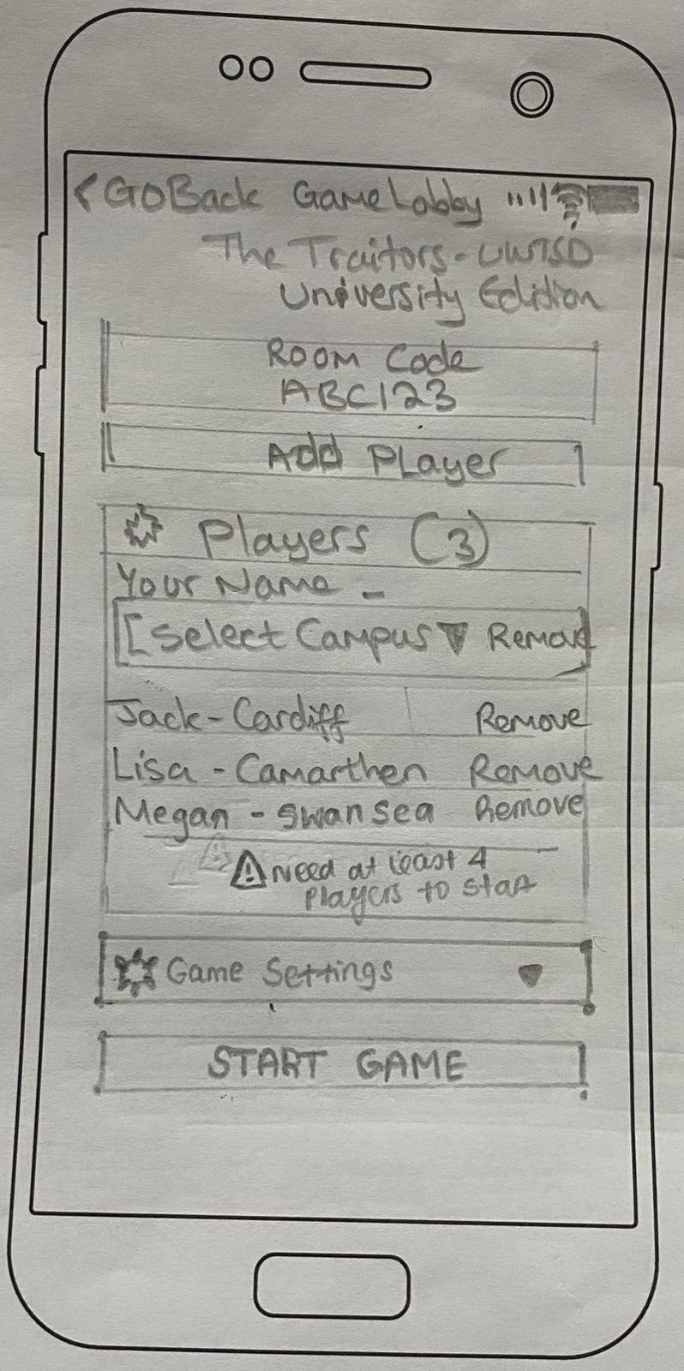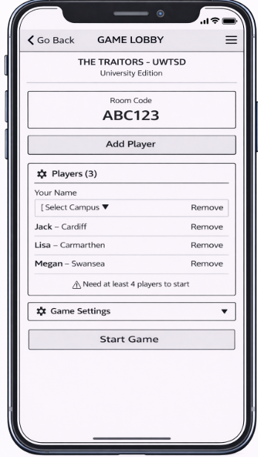
Figure 11: Low-fidelity paper prototype (left) and mid-fidelity prototype (right) of Wireframe 2 (Game Lobby).

Gameplay Interaction
The Role Reveal screen (WF3) presents private role information using a clear visual hierarchy and minimal text. This moment is socially significant in social deduction games, so the design prioritises clarity and privacy while ensuring players understand their role before continuing.
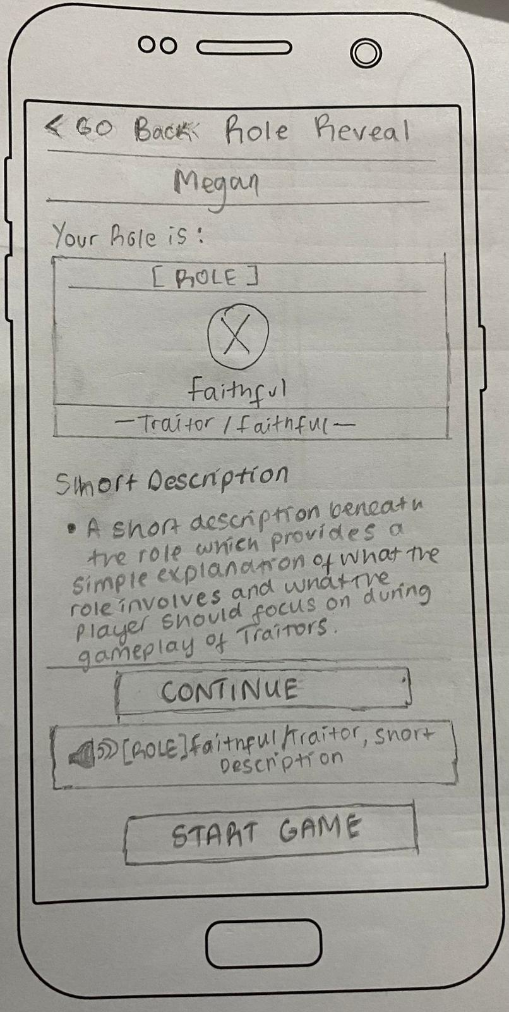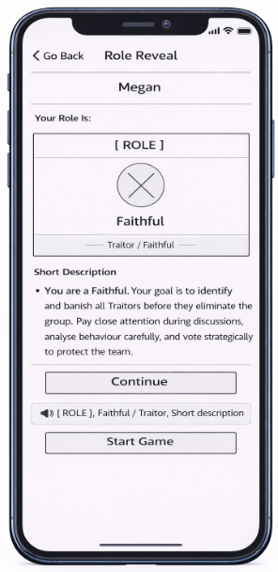
Figure 12: Low-fidelity paper prototype (left) and mid-fidelity prototype (right) of Wireframe 3 (Private Screen).

The Mission Phase (WF4) supports decision-making under time pressure through a visible countdown timer, mission brief, and structured action buttons. Large touch targets minimise interaction errors during mobile gameplay.

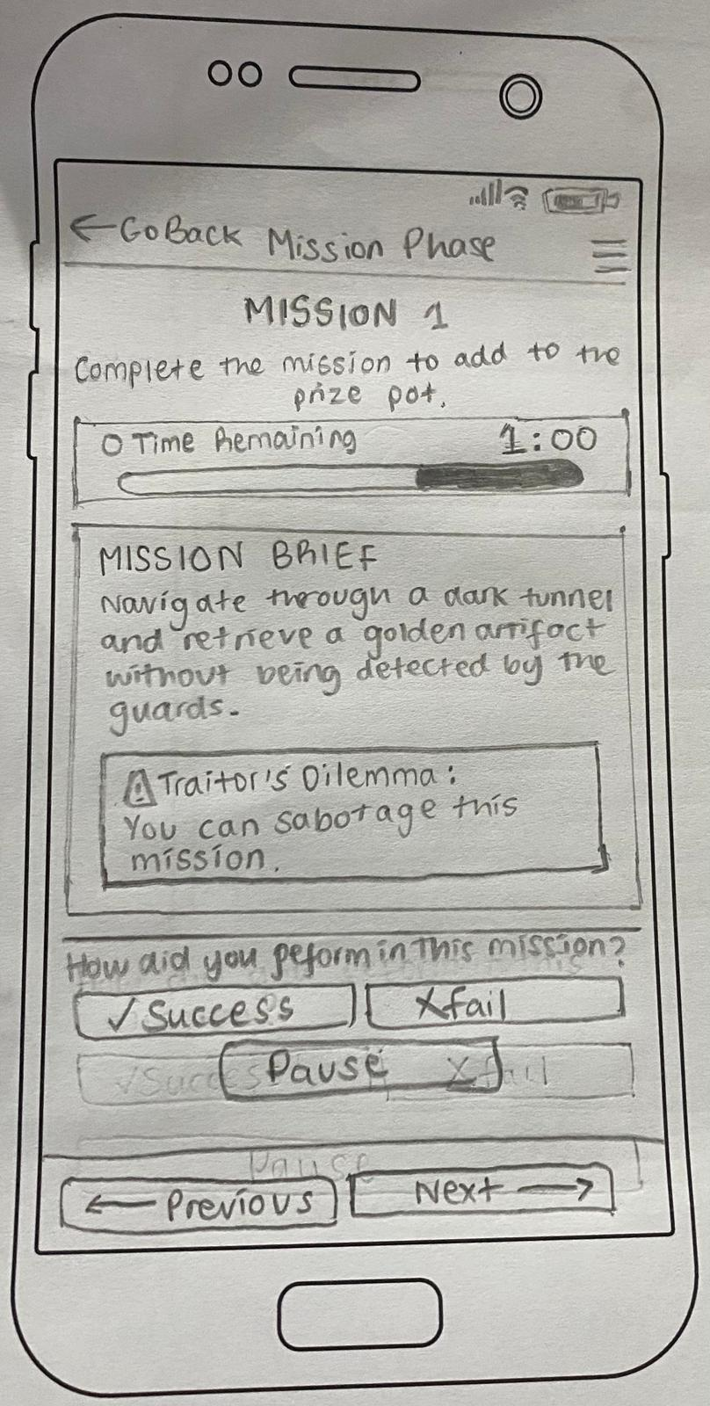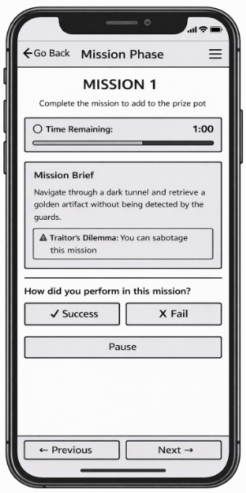
Figure 13: Low-fidelity paper prototype (left) and mid-fidelity prototype (right) of Wireframe 4 (Mission Phase).

The Discussion Phase (WF5) structures communication through a text-based chat interface supported by a visible timer and phase indicator. Separating player identity from message content improves readability and supports rapid social reasoning.
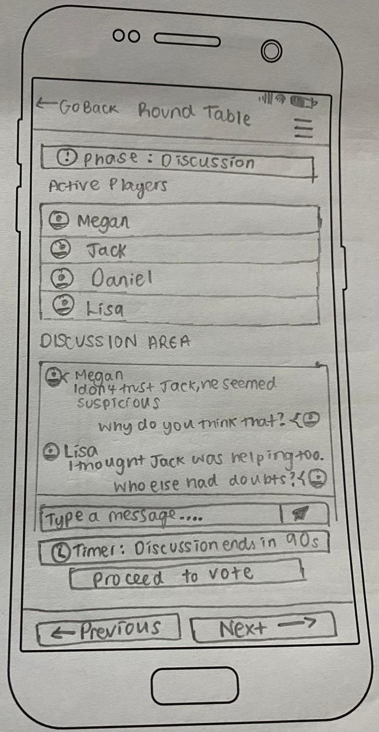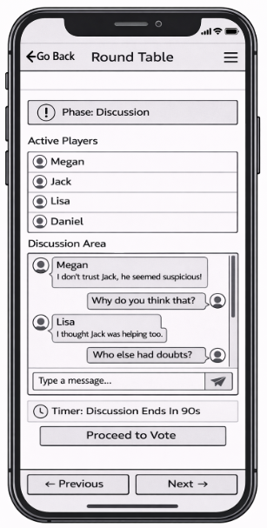
Figure 14: Low-fidelity paper prototype (left) and mid-fidelity prototype (right) of Wireframe 5 (Discussion Phase).

The Voting Phase (WF6) is the highest-risk interaction because decisions are irreversible. Single-selection voting and a confirmation step prevent accidental eliminations while reinforcing fairness and transparency.
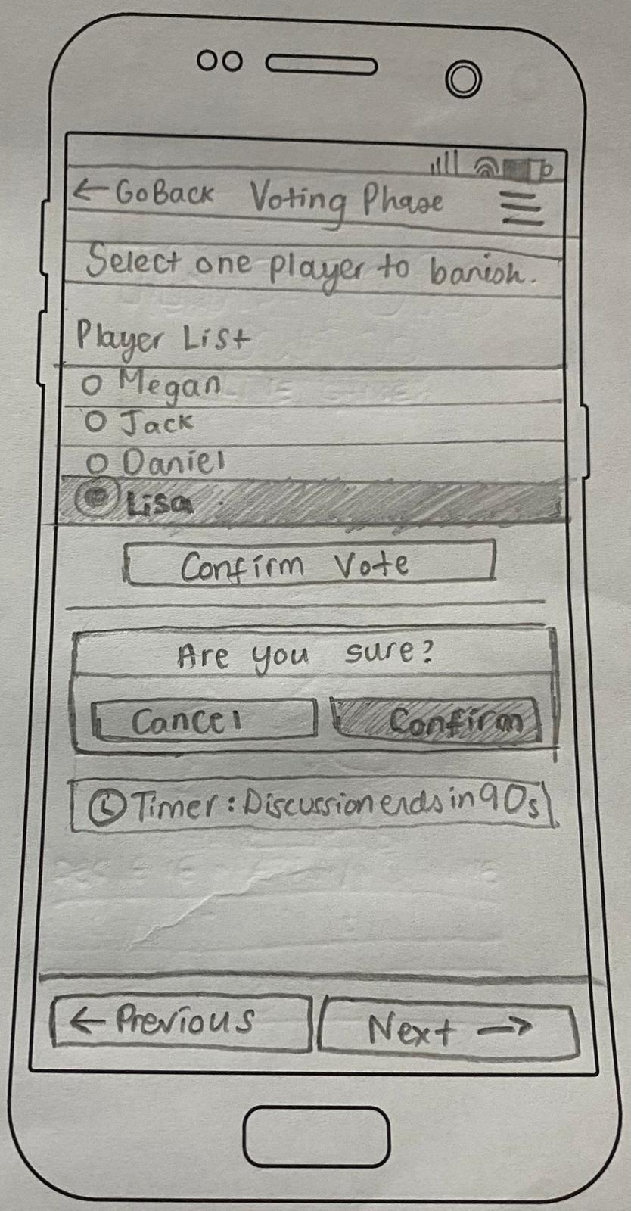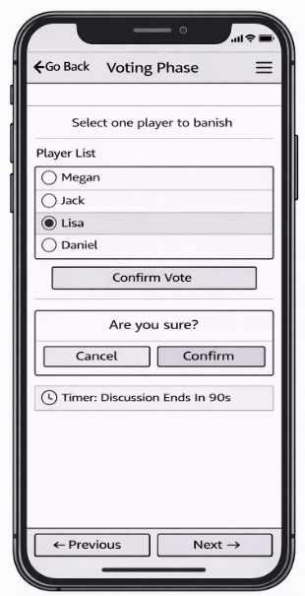
Figure 15: Low-fidelity paper prototype (left) and mid-fidelity prototype (right) of Wireframe 6 (Voting Phase).

Resolution and Accessibility
The Game End screen (WF7) provides closure by announcing the winning side and revealing player roles. Minimal text and clear outcome messaging allow players to reflect on the result before choosing whether to replay or return to the lobby.

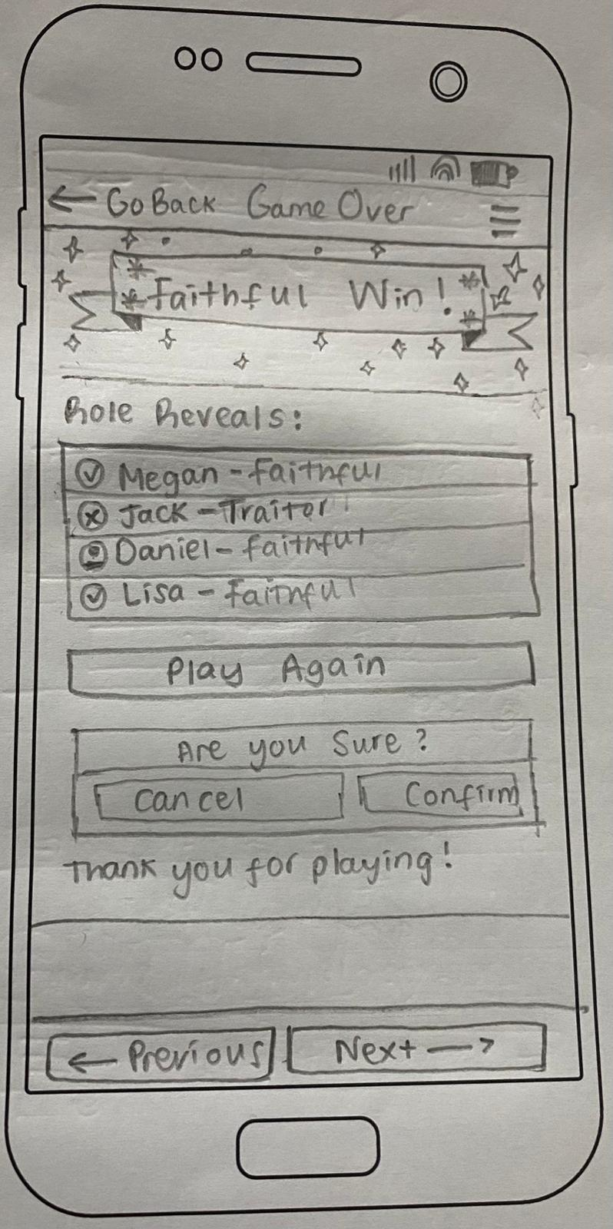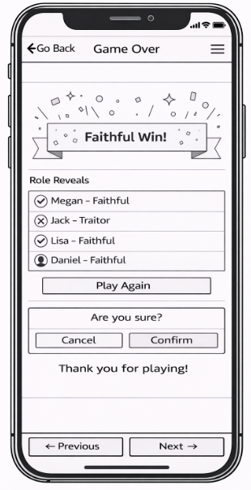
Figure 16: Low-fidelity paper prototype (left) and mid-fidelity prototype (right) of Wireframe 7 (Game End).

The Accessibility Panel (WF8) functions as a persistent overlay accessible throughout gameplay. Features such as contrast control, reduced motion, screen-reader support, simplified language, and adjustable text size allow players to personalise the interface without interrupting progression, ensuring accessibility is embedded rather than optional.
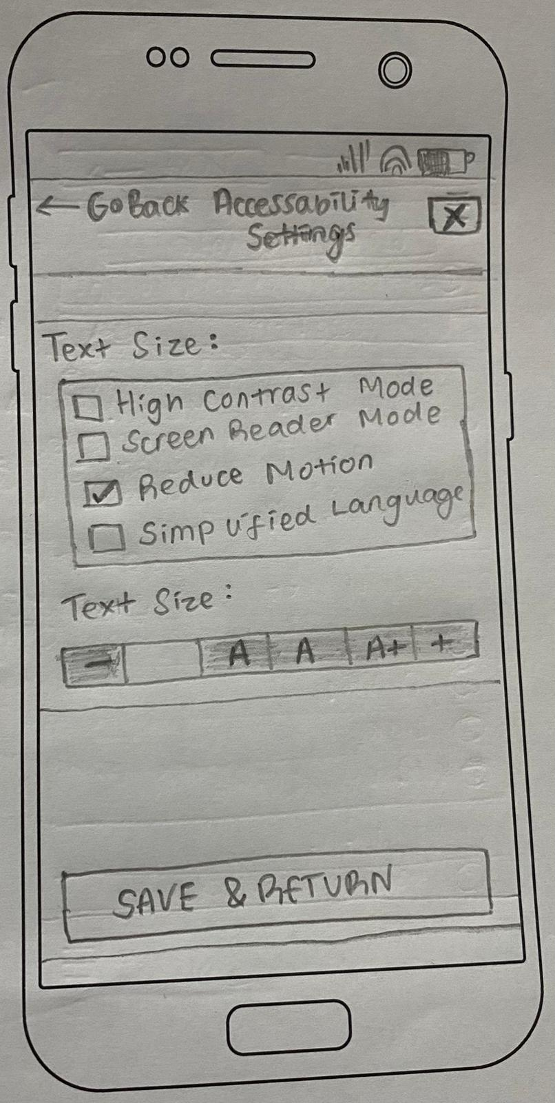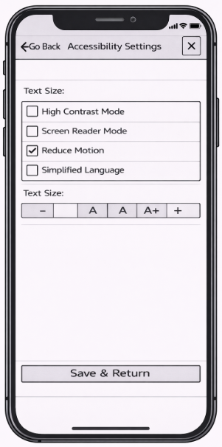
Figure 17: Low-fidelity paper prototype (left) and mid-fidelity prototype (right) of Wireframe 8 (Accessibility Panel).
Overall, the storyboard demonstrates how user research insights were translated into structured interaction design decisions. Across all screens, the interface prioritises clear system status, controlled decision-making, and inclusive participation, ensuring that gameplay tension arises from social interaction rather than interface confusion.

6. Prototype Testing and Evaluation
Prototype evaluation assessed whether the wireframes supported usability, accessibility, fairness, and the intended emotional experience of social deduction gameplay [18]. Because testing used low-fidelity prototypes, the focus was on interaction clarity rather than visual design or technical performance, particularly system state visibility, phase transitions, voting confidence, and perceived fairness [6], [20]. A central aim was to distinguish intended gameplay uncertainty from interface-induced confusion [4], [20].
Six participants were purposively selected to reflect the diversity of the six personas (Section 3), ensuring variation in gaming experience, accessibility needs, communication preferences, and study mode. Participants completed moderated online walkthroughs performing tasks across WF2–WF8, including joining the lobby, interpreting roles, making mission decisions, participating in discussion, voting, and adjusting accessibility settings. Moderation allowed participants to verbalise uncertainty, helping identify usability breakdowns during realistic task flow [18]. Afterwards, participants completed a structured 5-point Likert questionnaire (Appendix D) covering usability clarity, cognitive load, accessibility, emotional experience, and perceived fairness [18]. Quantitative responses were analysed alongside open-ended feedback to support triangulation.
Responses clustered in the Agree and Strongly Agree categories, indicating positive perceptions of clarity, interaction safety, and inclusive design. Voting safeguards received the strongest agreement, suggesting confirmation prompts and visible selection states increased confidence and perceived procedural fairness [6], [7], [20]. Minor variation appeared around phase transitions, where one participant reported uncertainty about system progression, reinforcing qualitative observations that transition signalling was the primary usability vulnerability [6]. Overview charts are provided in Appendix F.
Several methodological limitations should be acknowledged. The same six participants whose interviews informed the requirements also conducted the evaluation, creating a feedback loop that may inflate positive responses; future studies should use a separate participant group to strengthen internal validity [18]. Moderated walkthroughs may also introduce acquiescence bias, particularly when the researcher is the designer [18]. In addition, the researcher-designed Likert instrument may have favoured confirmatory responses; future iterations could adopt validated measures such as the System Usability Scale (SUS) [34] or established game UX frameworks [18] for benchmarking. Despite these limitations, consistency between qualitative and quantitative findings, particularly regarding phase transitions and voting confidence, provides useful triangulation supporting the credibility of the conclusions [11]. Table 3 summarises participant profiles and their closest persona alignment during testing.

Table 3 Participant Profiles and Persona Coverage (author-created).
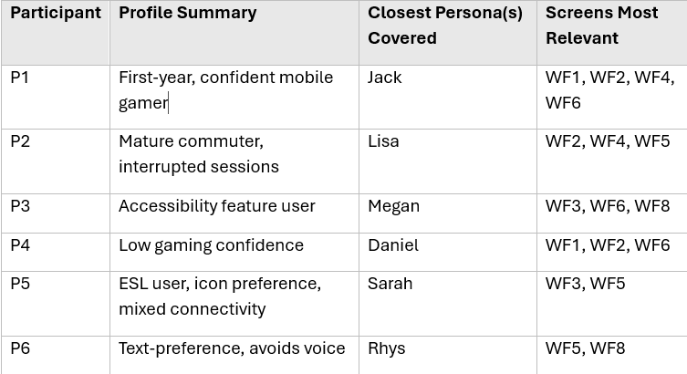

Overall, participants described the interface as clear and easy to use, particularly during discussion and voting. Confirmation safeguards reduced anxiety around irreversible decisions and strengthened perceptions of fairness [7], [20]. Some uncertainty occurred during Night–Day phase transitions, which participants attributed to interface signalling rather than gameplay mechanics. Table 4 summarises the usability issues identified and the design refinements made in response, which focused on improving transition visibility, reinforcing phase indicators, and clarifying system status labels [6].

Table 4: Summary of Identified Usability Issues and Design Refinements across evaluated wireframes (author-created)
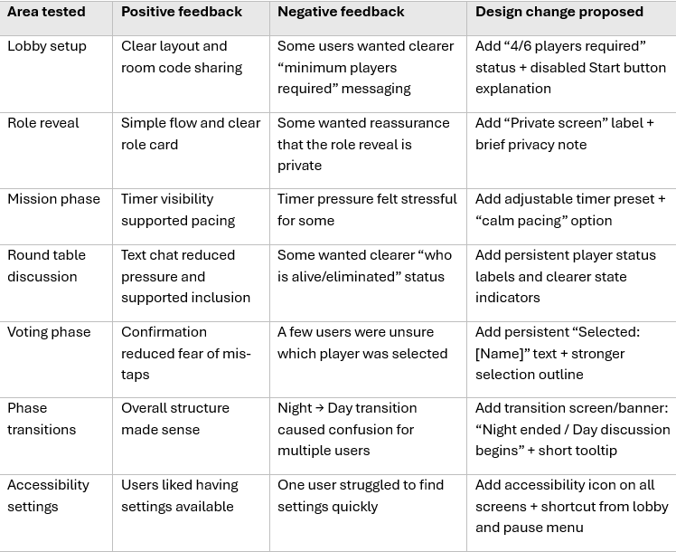

These refinements improve transparency without reducing gameplay tension, reinforcing the central design principle: preserve gameplay uncertainty while eliminating system ambiguity [4], [6], [20]. Taken together, the evaluation findings demonstrate that the wireframe designs largely achieved their intended usability objectives at this stage of development, while identifying specific interaction points, particularly phase transitions and selection state visibility, that require further attention in future high-fidelity iterations [18].

7. Conclusion
This project demonstrates how a structured user-centred design process can translate qualitative research into a clear and inclusive multiplayer mobile interface [14], [18]. Interview insights were prioritised using MoSCoW (Appendix A) [13] and developed through personas (Appendix B) [14], task analysis (Appendix E) [25], [26], and wireframe design (WF1–WF8), producing a complete gameplay cycle with embedded accessibility and consistent interaction logic [15]. Core HCI principles, system visibility, cognitive load management, error prevention, and inclusive design, were treated as design foundations rather than optional features [3], [6], [7], [15]. Evaluation results, supported by Likert-scale data (Appendix F), showed strong confidence in voting safeguards and overall interface clarity, while phase transitions emerged as the main usability vulnerability and were refined accordingly [6], [18].
A key insight is that usability in social deduction games does not remove uncertainty; it relocates it [4], [20]. By separating gameplay ambiguity from system behaviour, tension becomes intentional rather than accidental, supporting fairness, trust, and emotional engagement [20]. This challenges the assumption that usability and immersion conflict, showing instead that they are mutually dependent: players cannot engage fully with social gameplay while managing interface confusion. In this sense, usability acts as a structural enabler of meaningful play rather than a constraint on game design [4], [18], [20].
Several limitations should be acknowledged. The small university-based sample (n = 6) limits generalisability, and using the same participants for research and evaluation may have inflated positive findings [18]. Moderated walkthroughs could not replicate real multiplayer social dynamics, and accessibility features were not formally validated through assistive technology testing or a WCAG audit [21], [23]. Additionally, frameworks such as cognitive load theory and Nielsen’s heuristics were developed outside game contexts and require further validation in competitive multiplayer environments [3], [6], [17].
Future work should include high-fidelity prototyping with both the previous and a new evaluation group, live multiplayer testing to assess behaviour under real social conditions, and a formal WCAG 2.1 accessibility audit [23]. The adaptive confirmation mechanism proposed in Section 4.2, where safeguard intensity adjusts based on user behaviour, offers a promising way to balance efficiency for experienced players with protection for novices. Overall, the project provides an evidence-led design foundation and argues that in multiplayer social systems, strong usability is not opposed to engaging gameplay, it is what enables it [4], [6], [20].

References
[1] S. Rafael, E. Santiago, F. Rebelo, P. Noriega, and E. Vilar, “Bio-centred interaction design: A new paradigm for human-system interaction,” in Design, User Experience, and Usability: Design Thinking and Practice in Contemporary and Emerging Technologies, M. M. Soares, E. Rosenzweig, and A. Marcus, Eds., Lecture Notes in Computer Science, vol. 13323. Cham, Switzerland: Springer, 2022. doi: 10.1007/978-3-031-05906-3_6.
[2] S. Kurniawan, “Interaction design: Beyond human–computer interaction by Preece, Sharp and Rogers (2001), ISBN 0471492787,” Universal Access in the Information Society, vol. 3, p. 289, 2004. doi: 10.1007/s10209-004-0102-1.
[3] J. Sweller, “Cognitive load theory and educational technology,” Educational Technology Research and Development, vol. 68, pp. 1–16, 2020. doi: 10.1007/s11423-019-09701-3.
[4] D. Haqq et al., "Toward a design theory of game-mediated social experiences: A study of Among Us," in Proc. Extended Abstracts of the Annual Symposium on Computer-Human Interaction in Play (CHI PLAY EA), 2021.
[5] E. Tenner, “Review of The Design of Everyday Things, by D. Norman,” Technology and Culture, vol. 56, no. 3, pp. 785–787, 2015. doi: 10.1353/tech.2015.0104.
[6] J. Nielsen, Usability Engineering. San Diego, CA, USA: Academic Press, 1994.
[7] B. Shneiderman and C. Plaisant, Designing the User Interface: Strategies for Effective Human-Computer Interaction, 5th ed. Boston, MA, USA: Addison-Wesley, 2010.
[8] Z. Liu and Y. Yang, "Fundamental usability evaluation in visualization: Integrating Nielsen's principles and the analytic hierarchy process," International Journal of Human–Computer Interaction, vol. 41, no. 20, pp. 13012–13040, 2025, doi: 10.1080/10447318.2025.2467455.
[9] D. Lamas and V. Tomberg, “HCI design perspectives, trends and approaches,” in Foundations and Fundamentals in Human-Computer Interaction, C. Stephanidis and G. Salvendy, Eds. Boca Raton, FL, USA: CRC Press/Taylor & Francis, 2024, pp. 307–355, doi: 10.1201/9781003495109-11.
[10] V. Schwind et al., "A scoping review of informed consent practices in human–computer interaction research," ACM Transactions on Computer-Human Interaction, vol. 32, no. 4, pp. 1–60, 2025.
[11] V. Braun and V. Clarke, "Reflecting on reflexive thematic analysis," Qualitative Research in Sport, Exercise and Health, vol. 13, no. 6, pp. 1–16, 2021.
[12] J. Nielsen, “Enhancing the explanatory power of usability heuristics,” in Proceedings of the SIGCHI Conference on Human Factors in Computing Systems (CHI ’94), Apr. 1994, pp. 152–158.
[13] K. E. Wiegers and J. Beatty, Software Requirements, 3rd ed. Redmond, WA, USA: Microsoft Press, 2013.
[14] J. Preece, Y. Rogers, and H. Sharp, Interaction Design: Beyond Human-Computer Interaction. New York, NY, USA: John Wiley & Sons, 2002. [Online]. Available: https://search.catalog.loc.gov/instances/81f2d81b-f1fb-5c16-b06d-b2fe9c79bbfa
[15] K. Yuan, E. Folmer, and F. Harris, "Game accessibility: A survey," Universal Access in the Information Society, vol. 20, no. 1, pp. 1–18, 2021.
[16] K. Isbister, How Games Move Us: Emotion by Design. Cambridge, MA, USA: MIT Press, 2016.
[17] P. Evans, M. Vansteenkiste, P. Parker, A. Kingsford-Smith, and S. Zhou, "Cognitive load theory and its relationships with motivation: A self-determination theory perspective," Educational Psychology Review, vol. 36, no. 7, 2024, doi: 10.1007/s10648-023-09841-2.
[18] R. Bernhaupt, Ed., Game User Experience Evaluation. Cham, Switzerland: Springer, 2015.
[19] W.-L. Chang, L.-M. Chen, and Y.-H. Hsieh, "Online to offline social interaction on gaming motivations," Kybernetes, vol. 51, no. 12, pp. 3508–3525, 2022.
[20] R. Ma et al., "Transparency, fairness, and coping: How players experience moderation in multiplayer online games," in Proc. 2023 CHI Conf. Human Factors in Computing Systems (CHI '23), 2023, doi: 10.1145/3544548.3581097.
[21] U. Singh, J. D. Venkatesh, A. Muraleedharan, K. S. Saluja, A. J. H., and P. Biswas, “Accessibility analysis of educational websites using WCAG 2.0,” Digital Government: Research and Practice, vol. 5, no. 3, Art. no. 32, Oct. 2024, doi: 10.1145/3696318
[22] A. Horowitz, “Accessibility by numbers: A critical review of game accessibility guidelines,” in Disability and Video Games: Practices of En-/Disabling Modes of Digital Gaming, M. Spöhrer and B. Ochsner, Eds. Cham, Switzerland: Palgrave Macmillan, 2023, pp. 259–294, doi: 10.1007/978-3-031-34374-2_10.
[23] S. Paul, "Accessibility analysis using WCAG 2.1: Evidence from Indian e-government websites," Universal Access in the Information Society, vol. 22, no. 2, pp. 663–669, 2023, doi: 10.1007/s10209-021-00861-9.
[24] S. K. Card, T. P. Moran, and A. Newell, The Psychology of Human-Computer Interaction. Hillsdale, NJ, USA: Lawrence Erlbaum Associates, 1983.
[25] B. E. John and D. E. Kieras, "The GOMS family of user interface analysis techniques: Comparison and contrast," ACM Transactions on Computer-Human Interaction, vol. 3, no. 4, pp. 320–351, 1996.
[26] N. A. Stanton, P. M. Salmon, G. H. Walker, C. Baber, and D. P. Jenkins, Human Factors Methods: A Practical Guide for Engineering and Design, 2nd ed. Farnham, UK: Ashgate, 2013.
[27] G. Lu, S. Qu, and Y. Chen, "Understanding user experience for mobile applications: A systematic literature review," Discover Applied Sciences, vol. 7, p. 587, 2025, doi: 10.1007/s42452-025-07170-3.
[28] A. D. A. Oliveira and M. M. Eler, "Analyzing accessibility, usability, and user experience in mobile apps through user reviews: An extended systematic literature review," Journal on Interactive Systems, vol. 16, no. 1, 2025.
[29] P. Weichbroth, "Factors influencing the perceived usability of mobile applications," arXiv preprint arXiv:2502.11069, Feb. 01. 2025. [Online]. Available: https://arxiv.org/abs/2502.11069
[30] M. Umar, I. Hussain, T. Mahmood, and H. T. Mirza, "Design strategies to minimize mobile usability issues in navigation design patterns," Information, vol. 15, no. 11, p. 732, 2024, doi: 10.3390/info15110732.
[31] J. Sweller, J. J. G. van Merriënboer, and F. Paas, “Cognitive architecture and instructional design,” Educational Psychology Review, vol. 10, no. 3, pp. 251–296, 1998.
[32] International Organization for Standardization, ISO 9241-210:2019 Ergonomics of Human-system interaction — Part 210: Human-centred design for interactive systems. Geneva, Switzerland: ISO, 2019.
[33] D. A. Norman, The Design of Everyday Things, Revised and Expanded ed. New York, NY, USA: Basic Books, 2013.
[34] J. Brooke, "SUS: A quick and dirty usability scale," in Usability Evaluation in Industry, P. W. Jordan, B. Thomas, B. A. Weerdmeester, and I. L. McClelland, Eds. London, UK: Taylor & Francis, 1996, pp. 189–194.

Appendixes

Appendix A – Requirements and Traceability
This appendix presents the prioritised requirements derived from thematic analysis (Section 2) and demonstrates traceability between persona needs (Appendix B), wireframe implementation (Appendix C), and evaluation findings (Section 6). Together, these tables provide evidence of methodological continuity across the user-centred design process.

Appendix A.1 – MoSCoW Requirements
Each requirement is traceable to specific personas and to the wireframe screens in which it is implemented.

ID | Requirement | Description | Primary Persona(s) | MoSCoW
R1 | Join the game via code | Users must be able to join a game quickly using a simple code or invitation | Jack, Lisa, Sarah, Rhys | Must
R2 | Clear game phase indicators | The interface must clearly show the current phase (Day, Night, Voting) | All personas | Must
R3 | Screen-reader compatible controls | All interactive elements must be accessible via screen readers | Megan | Must
R4 | Error prevention in voting | Voting actions must include confirmation prompts to prevent accidental selection | Daniel, Megan | Must
R5 | No colour-only communication | Information must not rely on colour alone to convey meaning | Megan, Sarah | Must
R6 | Persistent system status feedback | The system should display player status and remaining players throughout gameplay | Jack, Daniel | Should
R7 | Text-based communication option | Users should be able to participate without voice chat | Rhys, Megan | Should
R8 | Adjustable text size and contrast | Users should be able to modify text size and contrast settings | Megan, Lisa | Should
R9 | Guided onboarding | New or low-confidence players should receive step-by-step guidance | Daniel, Lisa | Should
R10 | One-handed usability | Core interactions should be usable with one hand on mobile devices | Lisa, Sarah | Should
R11 | Low-bandwidth tolerance | The system should function on unstable or slow network connections | Sarah, Rhys | Could
R12 | Optional animations | Animations could be used to enhance emotional engagement without affecting clarity | Jack | Could
R13 | Custom avatars | Players could personalise avatars for identity and immersion | Jack | Could
R14 | Asynchronous play mode | Full asynchronous gameplay is out of scope for this prototype | Rhys | Won’t
R15 | Full voice chat integration | Real-time voice chat is not included in the current prototype | Rhys | Won’t

Appendix A.2: Traceability Matrix
The traceability matrix functions as an audit trail linking qualitative findings to design implementation. In usability engineering and requirements management, such matrices are used to ensure that system features remain grounded in documented user needs rather than designer assumption.

A.2.1 Persona-to-Requirement Traceability
Persona | Key needs (from persona sheets) | MoSCoW Requirement IDs
Jack (fast-paced, confident gamer) | Quick setup, minimal friction, fast phase transitions, clear action feedback | R1, R2, R6, R12, R13
Lisa (time-limited commuter, one-handed use) | Rejoin support, clear turn/phase cues, readable layout, one-handed usability | R1, R2, R8, R9, R10
Megan (visual impairment, screen reader) | Screen reader compatibility, high contrast, no colour-only communication, safe voting | R2, R3, R4, R5, R7, R8
Daniel (low gaming confidence) | Guided onboarding, plain language, confirmation before critical actions | R2, R4, R6, R9
Sarah (ESL, icons, mixed connectivity) | Icon-supported navigation, short text, readable UI, low-bandwidth tolerance | R1, R2, R5, R10, R11
Rhys (text-only preference, avoids voice) | Text-only participation, no forced voice, clear feedback, remote participation | R1, R2, R7, R11, R14, R15

A.2.2 Requirement-to-Wireframe Traceability (WF1 – WF2)
MoSCoW ID | Requirement Summary | Primary Persona(s) | Implemented in Wireframes (Appendix C)
R1 | Join game via code | Jack, Lisa, Sarah, Rhys | WF2 – Game Lobby (room code entry + join flow)
R2 | Clear game phase indicators | All personas | WF4 – Mission, WF5 – Round Table, WF6 – Voting (phase labels + transition banners across flow)
R3 | Screen-reader compatible controls | Megan | WF2 – Lobby, WF3 – Role Reveal, WF6 – Voting, WF8 – Accessibility Panel
R4 | Error prevention in voting | Daniel, Megan | WF6 – Voting Phase (disabled confirm until selection + confirmation prompt)
R5 | No colour-only communication | Megan, Sarah | WF3 – Role Reveal (text + icons), WF6 – Voting (selection shown by label + outline), WF8 – Accessibility
R6 | Persistent system status feedback | Jack, Daniel | WF4 – Mission (banner + timer), WF5 – Round Table (player status list), WF6 – Voting (clear state/selection indicator)
R7 | Text-based communication option | Rhys, Megan | WF5 – Round Table (text chat), WF2 – Lobby (text toggle), WF8 – Accessibility Panel
R8 | Adjustable text size and contrast | Megan, Lisa | WF8 – Accessibility Panel (text size/contrast; applies across all screens)
R9 | Guided onboarding | Daniel, Lisa | WF1 – Front Cover (clear entry structure), WF2 – Lobby (start guidance prompts), WF3 – Role Reveal (plain language instructions)
R10 | One-handed usability | Lisa, Sarah | WF4 – Mission (large buttons), WF6 – Voting (single-choice list), WF2 – Lobby (large tap targets)
R11 | Low-bandwidth tolerance | Sarah, Rhys | WF2 – Lobby (lightweight setup), WF5 – Round Table (text chat prioritised over voice)
R12 | Optional animations | Jack | Not implemented in low-fidelity wireframes; proposed for future high-fidelity iteration
R13 | Custom avatars | Jack | Not implemented in low-fidelity wireframes; optional enhancement
R14 | Asynchronous play mode (out of scope) | Rhys | Explicitly excluded from current prototype scope
R15 | Full voice chat integration (out of scope) | Rhys | WF2 – Lobby (voice optional/toggle only; no full integration)

A.2.3 Summary
The traceability matrix demonstrates that all high-priority (“Must”) requirements are embedded within core gameplay screens (WF2–WF6). “Should” requirements are primarily implemented through structural feedback and accessibility features, while “Could” and “Won’t” items are clearly documented to maintain scope control. This structure evidences continuity from qualitative research (Section 2) to persona development (Section 3), interface design (Section 5), and evaluation (Section 6).

Appendix B – Full Personas
Persona 1: Jack Stones
Demographic: 18, single, undergraduate student, Swansea.
One-line description: Jack is a first-year undergraduate who enjoys fast-paced competitive multiplayer games.
Background & Context
Jack lives in student accommodation and regularly plays fast-paced multiplayer games with friends. He is confident with digital interfaces and enjoys competitive and deceptive gameplay.
Goals
- Jump into games quickly with minimal setup
- Maintain fast pacing and momentum
- Win through social deduction and strategy
- Experience smooth, responsive gameplay
- Compete confidently with friends
Pain
- Slow transitions between phases
- Too much text during gameplay
- Unclear voting confirmation
- Delays caused by system lag
- Overcomplicated menus
Media & device preferences
- Uses an iPhone daily
- Plays primarily on mobile
- Comfortable with fast touch interaction
- Rarely uses the desktop for gaming
- Prefers minimal text-heavy screens
Role & responsibilities
- First-year undergraduate student
- Lives in shared accommodation
- Active in student social groups
- Often organises multiplayer games
- Balances study with social life
Tasks
- Create or join game sessions
- Share room codes with friends
- Vote quickly during timed phases
- Track progress and player roles
- Respond to countdown timers

Persona 2: Lisa Ryans
Demographic: 34, married, working professional, postgraduate commuter, Cardiff.
One-line description: Lisa is a part-time postgraduate student balancing study with full-time work.
Goals
- Understand game state at a glance
- Rejoin games easily after interruptions
- Participate without long learning time
- Avoid losing progress
- Play efficiently in short sessions
Pain
- Losing progress due to pauses
- Unclear phase indicators
- Cluttered interfaces
- Small unreadable text
- Confusion when rejoining games
Media & device preferences
- Uses smartphone throughout the day
- Often plays in short evening sessions
- Prefers clear text and spacing
- Occasionally uses tablet
- Needs one-handed mobile usability

Role & responsibilities
- Full-time employee
- Part-time postgraduate student
- Manages work–study balance
- Often multitasks during gameplay
- Limited uninterrupted free time
Tasks
- Join active games remotely
- Pause and resume gameplay
- Check current phase quick
- Cast votes confidently
- Reconnect after interruption

Persona 3: Megan Evans
Demographic: 21, undergraduate student, Carmarthen.
One-line description: Megan is a visually impaired student who relies on assistive technology for digital interaction.
Goals
- Access all game information independently
- Participate equally without disadvantage
- Avoid relying on colour-only cues
- Use assistive technology seamlessly
- Enjoy social gameplay confidently
Pain
- Interfaces that break screen reader flow
- Missing text alternatives
- Poor keyboard navigation
- Low-contrast visuals
- Unclear content structure
Media & device preferences
- Uses screen reader (VoiceOver)
- Adjusts text size and contrast
- Uses keyboard navigation when needed
- Plays on accessible mobile device
- Requires logical content order
Role & responsibilities
- Undergraduate student
- Advocates for accessibility
- Participates in inclusive activities
- Engages in social digital spaces
- Manages coursework independently
Tasks
- Navigate game menus with screen reader
- Listen to role descriptions
- Vote using accessible controls
- Adjust accessibility settings
- Participate in discussion via text

Persona 4: Daniel Hughes
Demographic: 46, part-time lecturer at Lampeter University Campus and has limited gaming experience
One-line description: Daniel is a lecturer who enjoys social games but lacks confidence with complex digital systems.
Goals
- Understand rules clearly
- Avoid irreversible mistakes
- Feel confident before acting
- Receive guidance during gameplay
- Participate socially without embarrassment
Pain
- Complex or unexplained mechanics
- Accidental irreversible actions
- Lack of confirmation prompts
- Unclear instructions
- Overwhelming interfaces
Media & device preferences
- Uses tablet for casual browsing
- Limited gaming experience
- Prefers large buttons and clear text
- Needs simple navigation
- Values structured layouts
Role & responsibilities
- Part-time lecturer
- Balances teaching and admin
- Participates in staff–student events
- Not digitally adventurous
- Values clarity and reassurance
Tasks
- Learn how to play quickly
- Follow guided onboarding
- Vote with confirmation prompts
- Review clear instructions
- Avoid accidental actions

Persona 5: Sarah Khan
Demographic: 23, international postgraduate student, London
One-line description: Sarah is a confident tech user who prefers simple language and visual cues in fast-paced settings.
Goals
- Understand game state quickly
- Communicate effectively with peers
- Avoid complex language
- Play smoothly despite connectivity issues
- Participate confidently in discussions
Pain
- Long text-heavy instructions
- Complex vocabulary
- High data usage
- Unstable connections
- Fast discussions without visual cues
Media & device preferences
- Uses Android smartphone
- Plays remotely across campuses
- Prefers icon-based navigation
- Needs low-bandwidth tolerance
- Relies on visual clarity
Role & responsibilities
- Postgraduate student
- Studies away from home country
- Collaborates with diverse peers
- Balances coursework and social life
- Often joins games remotely
Tasks
- Join games via room code
- Read simplified role descriptions
- Communicate using text
- Vote clearly during banishment
- Reconnect if connection drops

Persona 6: Rhys Morgan
Demographic: 28, distance-learning student, Lampeter.
One-line description: Rhys is a remote learner who prefers text-based communication due to social anxiety.
Goals
- Participate without voice chat
- Maintain control over pacing
- Avoid social pressure
- Engage comfortably from home
- Feel included in group play
Pain
- Forced audio interaction
- Time-pressured communication
- Lack of text alternatives
- Overstimulating interfaces
- Unclear feedback
Media & device preferences
- Uses laptop and mobile
- Prefers keyboard input
- Avoids voice-based platforms
- Engages in text-based forums
- Needs clear visual feedback
Role & responsibilities
- Distance-learning student
- Studies independently
- Manages own schedule
- Participates remotely
- Values low-pressure interaction
Tasks
- Join games without audio
- Communicate via text chat
- Vote using keyboard controls
- Adjust settings for comfort
- Follow game progress visually

Table B.1 Summary of Six Personas
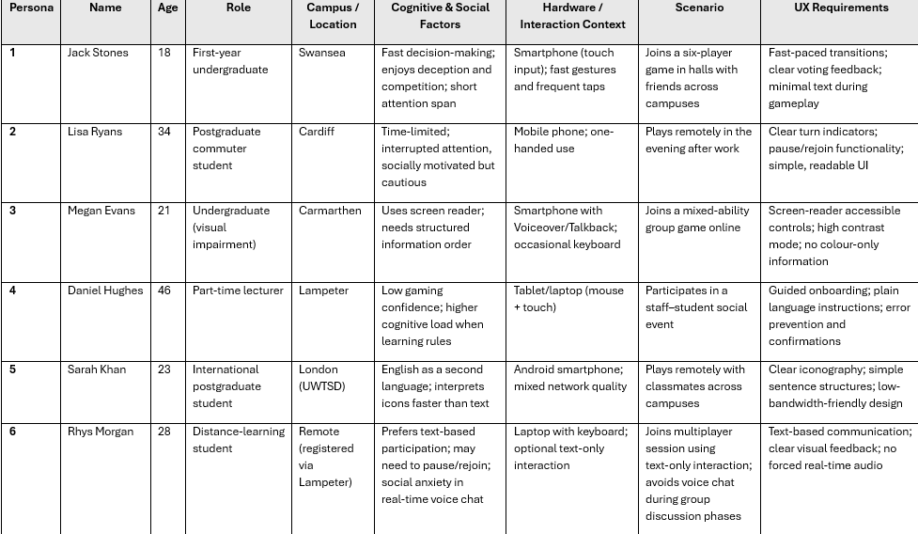

Appendix C – Complete Wireframe Storyboards
This appendix presents the complete set of eight low-fidelity and mid-fidelity wireframes developed for The Traitors – UWTSD Edition. The wireframes reflect the revised interface designs, including the addition of a Front Cover screen, and demonstrate the full gameplay journey from entry to conclusion. The purpose of this appendix is to present the entire storyboard sequence, while Section 5 discusses key usability design decisions and their theoretical justifications in analytical detail.
The wireframes implement the prioritised requirements derived from the interview themes (Table 1) and persona needs (Appendix B), demonstrating a clear and traceable progression from research findings to interface design decisions. Each screen supports a specific stage of interaction, and together they form a structured, repeatable gameplay loop.

Overall Interaction Sequence
The primary user journey follows a linear yet cyclical progression:
Front Cover → Game Lobby → Role Reveal → Mission Phase → Round Table Discussion → Voting Phase → Game End
If the game continues after voting, the system returns from the Voting Phase to the Mission Phase, repeating the cycle until a final outcome is reached. The Accessibility Panel remains accessible at every stage and does not interrupt gameplay progression.
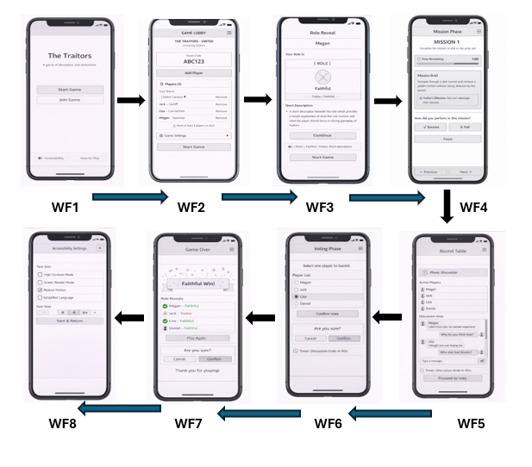

WF1 - Home Screen (Landing Page)
The landing screen presents two primary actions — Start Game and Join Game — with secondary options visually subordinate. This supports recognition over recall [6] and reduces decision complexity at the point of entry, ensuring low-confidence users such as Daniel encounter a clear, low-pressure starting point while allowing experienced players like Jack to move quickly into gameplay. Accessibility and How to Play options are available without progressing into the game, and the Accessibility Panel returns users to this screen on saving, preserving context [15].
This screen establishes the beginning of the interaction flow and directs all primary gameplay actions toward the Lobby.

WF2 – Game Lobby
The Lobby manages session coordination through a structured layout showing the room code, player list, and game controls. Preventing the game from starting before the minimum player count is reached embeds an error prevention mechanism [6], [7] that removes a class of setup failures before they occur. Large input fields and clearly labelled controls address one-handed usability for Lisa and quick entry for Jack, satisfying requirements R1 and R10 simultaneously.

WF3 – Role Reveal (Private Screen)
The Role Reveal screen presents each player's assigned role privately using minimal text and a single continue action. This deliberately reduces on-screen information at the highest cognitive risk moment before gameplay begins, preventing working memory overload before strategic reasoning is required [3], [31]. The single-column structure ensures screen reader compatibility for Megan [15], [22], and the plain language hierarchy operationalises Norman's visibility principle [33]. The Private Screen label and privacy note, added following evaluation, confirm to players that their role information is confidential, addressing the system feedback principle [6].

WF4 – Mission Phase
The Mission Phase presents time-constrained decision-making through a visible countdown timer, mission brief, and structured action buttons. Players must process the brief, make a strategic choice, and monitor time simultaneously — a high intrinsic load moment where extraneous interface friction would be most damaging [31]. The confirm button remains disabled until a selection is made, implementing Norman's constraints principle [33] to prevent accidental submission under pressure. Large touch targets support one-handed mobile use for Lisa and Sarah [30], and the adjustable timer preset identified in Table 4 acknowledges that timer pressure becomes extraneous load rather than gameplay tension for some users [17].

WF5 – Round Table (Discussion Phase)
The Discussion Phase structures social reasoning through a text-based chat interface with a persistent timer and phase indicator. Separating player identity labels from message content reduces the cognitive effort of tracking who said what, supporting recognition over recall [6]. Text-based communication ensures full participation for Rhys and Sarah regardless of voice preference or language background, addressing the communication preference diversity theme from Section 2.3 [15], [22]. The refinement of persistent alive/eliminated player labels, identified in Table 4, directly resolves the system visibility gap that evaluation found was shifting cognitive effort from strategy to interface interpretation [4], [20].

WF6 – Voting Phase (Banishment)
Voting is the highest-risk interaction due to its irreversible social consequences. Single-selection voting, a disabled confirm button until selection, and a secondary confirmation prompt together ensure elimination decisions are always deliberate [6], [7]. The clear selection highlight and persistent Selected: [Name] indicator added following evaluation address the visibility gap identified during testing, where users were uncertain which player they had chosen. This three-stage submission process operationalises Shneiderman's error prevention principles [7] and reinforces procedural fairness by ensuring outcomes always reflect intentional player decisions rather than interface errors [20].

WF7 – Game End
The Game End screen announces the winning side and reveals all player roles, providing the social closure and transparency that multiplayer social deduction games require to maintain trust across repeated sessions [20]. Full role disclosure at resolution ensures eliminated players can understand the complete game picture, reinforcing perceived fairness [20]. The two clear exit options, Play Again and Exit, implement Schneiderman’s clearly marked exits principle [7], and the minimal text layout reduces cognitive demand at a moment when players are processing emotional responses to the outcome [3]. For less experienced players such as Daniel, role reveal at game end also supports schema formation by connecting hidden information to the final result, building the mental models needed for more confident future play [31].

WF8 – Accessibility Panel (Accessible Throughout)
The Accessibility Panel operates as a persistent overlay accessible from every screen, offering contrast control, reduced motion, screen reader support, simplified language, and adjustable text size. Implementing accessibility as an overlay rather than a separate page preserves gameplay context — navigating away would impose an unnecessary interruption cost, particularly for Megan whose assistive technology interaction depends on consistent screen structure [3], [15]. Save and Return logic restores users to their exact prior state, and settings persist across all gameplay stages, embedding inclusion as an architectural feature rather than an optional addition [15], [22]. The accessibility shortcut added to all screens following evaluation directly responds to the finding that one participant struggled to locate settings quickly, closing the final visibility gap identified in Table 4.

Interaction Structure Summary
The full gameplay cycle follows a linear but repeating structure:
Front Cover → Lobby → Role Reveal → Mission → Discussion → Voting → Game End, with the Mission–Discussion–Voting loop repeating until a win condition is reached. The Accessibility Panel operates as a persistent layer throughout without interrupting progression. This structured flow maintains consistent visibility of system status at every stage [6], [12], ensuring players always know where they are in the game and what action is available to them, keeping cognitive effort directed toward strategy rather than system interpretation [3], [4].

Appendix D - Post-Prototype Evaluation Questionnaire
A 5-point Likert scale was used to capture participants’ views on usability, clarity, accessibility, emotional tension, and fairness. This type of scale makes it easy for participants to express how strongly they agree or disagree with each statement, while also allowing responses to be compared consistently across the group. It provides enough range to show differences in experience without making the questionnaire overly complex. By combining scaled questions with open-ended responses, the evaluation captures both measurable trends and more detailed personal feedback, creating a balanced and meaningful assessment of the prototype.

Appendix D – Post-Prototype Evaluation Questionnaire
The Traitors – UWTSD Edition (Wireframe Evaluation)

Thank you for taking part in this prototype evaluation.
Please answer the following questions based on your experience using the low-fidelity wireframe version of the game.

For Questions 1–12, please indicate your level of agreement:
1 = Strongly Disagree
2 = Disagree
3 = Neutral
4 = Agree
5 = Strongly Agree

Section A – Usability and Interface Clarity
- I understood what was happening at each stage of the game.
1 ☐ 2 ☐ 3 ☐ 4 ☐ 5 ☐
- The current game phase (e.g., Mission, Discussion, Voting) was clearly indicated.
1 ☐ 2 ☐ 3 ☐ 4 ☐ 5 ☐
- The screen layouts were clear and easy to navigate.
1 ☐ 2 ☐ 3 ☐ 4 ☐ 5 ☐
- I felt confident that the system correctly registered my actions (e.g., voting).
1 ☐ 2 ☐ 3 ☐ 4 ☐ 5 ☐

Section B – Cognitive Load and Pacing
- The amount of information on screen was manageable.
1 ☐ 2 ☐ 3 ☐ 4 ☐ 5 ☐
- The timer supported gameplay tension without confusion.
1 ☐ 2 ☐ 3 ☐ 4 ☐ 5 ☐

Section C – Accessibility and Inclusion
- The interface appeared usable for players with different abilities.
1 ☐ 2 ☐ 3 ☐ 4 ☐ 5 ☐
- The game felt playable without requiring voice communication.
1 ☐ 2 ☐ 3 ☐ 4 ☐ 5 ☐
- Accessibility settings were easy to locate and understand.
1 ☐ 2 ☐ 3 ☐ 4 ☐ 5 ☐

Section D – Emotional Experience and Fairness
- The sense of tension came from gameplay rather than interface confusion.
1 ☐ 2 ☐ 3 ☐ 4 ☐ 5 ☐
- The voting process felt fair and secure.
1 ☐ 2 ☐ 3 ☐ 4 ☐ 5 ☐

Section E – Overall Experience
- Overall, the interface felt intuitive and suitable for a university-based multiplayer game.
1 ☐ 2 ☐ 3 ☐ 4 ☐ 5 ☐

Open-Ended Questions

- Which part of the interface worked particularly well?

- Where, if anywhere, did you feel confused or uncertain?

- What is the most important improvement you would suggest?

Appendix E – Task Analysis
Task analysis was undertaken to examine the interaction structure of the prototype and to identify usability risks within core gameplay flows. This method decomposes user goals into steps, highlights potential cognitive or interaction failures, and links design mitigations directly to established usability principles.
A lightweight GOMS (Goals, Operators, Methods, Selection rules) perspective was also applied to key tasks to check step efficiency and identify where safeguards (e.g., confirmation prompts) were necessary.
The analysis focuses on tasks identified as high-risk during interviews and evaluation, particularly those involving decision pressure, accessibility requirements, and phase transitions.
Table E1 summarises the core gameplay task analysis, outlining each user goal, the key interaction steps involved, associated usability risk points, and the corresponding wireframe mitigations. The table demonstrates clear traceability between identified risks and implemented design safeguards.

Table E1. Core Gameplay Task Analysis
Task | User Goal | Key Steps | Primary Risk Points | Wireframe Mitigation (WF Ref.)
Join Game via Code | Enter session quickly and confidently | Select Join (WF1) → Enter code (WF2) → Confirm | Incorrect entry; unclear confirmation; small tap targets | Large input field; visible confirmation; structured layout (WF2)
Interpret Role Reveal | Understand assigned role privately | View role (WF3) → Read description → Continue | Cognitive overload; screen reader disruption | Minimal text; clear hierarchy; non-colour cues; screen-reader structure (WF3)
Complete Mission Decision | Submit decision under time pressure | Review brief (WF4) → Select option → Confirm | Mis-tap; unclear timer meaning | Disabled confirm until selection; visible countdown; separated pause control (WF4)
Participate in Discussion | Engage socially without exclusion | Read chat (WF5) → Respond → Monitor timer | Text overload; unclear speaker attribution | Structured chat layout; labelled player list; visible timer (WF5)
Cast Banishment Vote | Make deliberate, fair decision | Select player (WF6) → Review highlight → Confirm | Accidental vote; perceived unfairness | Disabled confirm; clear selection state; secondary confirmation prompt (WF6)
Adjust Accessibility Settings | Modify interface without losing state | Open panel (WF8) → Toggle → Save & Return | Loss of context; unclear persistence | Overlay model; return-to-context logic; persistent settings (WF8)
The analysis confirms that the highest usability risks occur during phase transitions and irreversible decisions, particularly voting. In response, the wireframe design prioritises visibility of system status, confirmation safeguards, structured information hierarchy, and persistent accessibility integration. This demonstrates that usability principles were embedded systematically within interaction logic rather than applied retrospectively.

HTA: Multiplayer Game Website/App Interaction Flow
Hierarchical Task Analysis (HTA) breaks big user goals into smaller, clear steps. This makes it easier to see where users might get confused, feel pressured, or make mistakes.
In this project, HTA is important because the game has timed phases and irreversible actions like voting. By mapping each step, it becomes easier to identify risks such as mis-taps, unclear feedback, or accessibility issues.

0. Join and Participate in Game Session
1. Join Game via Code
Goal: Enter the session quickly and confidently
Plan 1: Do 1.1 → 1.2 → 1.3 in sequence.
1.1 Select “Join” on the landing screen (WF1)
1.2 Enter session code (WF2)
1.2.1 Tap code input field
1.2.2 Enter alphanumeric code
1.2.3 Review entered code
1.3 Confirm entry
Primary Risk Points:
- Incorrect code entry
- Unclear confirmation state
- Small tap targets
Wireframe Mitigation (WF2):
- Large input field
- Structured layout
- Clear visual confirmation feedback

2. Interpret Role Reveal
Goal: Understand the assigned role privately
Plan 2: Do 2.1 → 2.2 → 2.3.
2.1 View assigned role (WF3)
2.2 Read role description
2.2.1 Scan role title
2.2.2 Review abilities/objectives
2.3 Continue to the next phase
Primary Risk Points:
- Cognitive overload
- Screen reader disruption
- Reliance on colour cues
Wireframe Mitigation (WF3):
- Minimal text
- Clear information hierarchy
- Non-colour cues
- Screen-reader structured layout

3. Complete Mission Decision
Goal: Submit a decision under time pressure
Plan 3: Do 3.1 → 3.2 → 3.3 before timer expires.
3.1 Review mission brief (WF4)
3.2 Select decision option
3.2.1 Tap the chosen option
3.2.2 Verify selection state
3.3 Confirm decision
Primary Risk Points:
- Mis-taps under pressure
- Ambiguous timer meaning
- Accidental submission
Wireframe Mitigation (WF4):
- Confirm button is disabled until selection
- Visible countdown timer
- Separate pause control

4. Participate in Discussion
Goal: Engage socially without exclusion
Plan 4: Loop 4.1 ↔ 4.2 while monitoring 4.3 until the timer ends.
4.1 Read chat messages (WF5)
4.1.1 Identify speaker
4.1.2 Interpret message content
4.2 Respond to discussion
4.2.1 Enter text
4.2.2 Send message
4.3 Monitor discussion timer
Primary Risk Points:
- Text overload
- Unclear speaker attribution
- Losing track of time
Wireframe Mitigation (WF5):
- Structured chat layout
- Clearly labelled player list
- Persistent visible timer

5. Cast Banishment Vote
Goal: Make deliberate, fair decisions
Plan 5: Do 5.1 → 5.2 → 5.3.
5.1 Select player (WF6)
5.1.1 Tap player name/avatar
5.2 Review highlight state
5.2.1 Confirm visual selection indicator
5.3 Confirm vote
Primary Risk Points:
- Accidental vote
- Perceived unfairness
- Lack of clarity in the selection state
Wireframe Mitigation (WF6):
- Disabled confirm until selection
- Clear selection highlight
- Secondary confirmation prompt

6. Adjust Accessibility Settings
Goal: Modify the interface without losing session context
Plan 6: Do 6.1 → 6.2 → 6.3 → Return to prior state.
6.1 Open accessibility panel (WF8)
6.2 Toggle desired settings
6.2.1 Adjust text size
6.2.2 Toggle colour contrast
6.2.3 Enable assistive options
6.3 Save and return
Primary Risk Points:
- Loss of gameplay context
- Unclear persistence of settings
- Disorientation
Wireframe Mitigation (WF8):
- Overlay model (no navigation away)
- Return-to-context logic
- Persistent settings across session

Overall HTA Plan Structure
Plan 0:
1 → 2 → 3 → 4 → 5 (repeat 3–5 loop per round) → 6 (optional at any time)
This HTA demonstrates:
- Clear hierarchical decomposition (Goal → Tasks → Subtasks → Operations)
- Identification of usability risk points
- Direct traceability to wireframe mitigations
- Integration of accessibility within core gameplay rather than as an afterthought

The analysis shows a clear goal-to-step structure, highlights key risk points, links directly to wireframe solutions (WF1–WF8), and keeps accessibility part of the main interaction flow. It confirms that the biggest risks happen during phase changes and final decisions, which is why confirmation prompts, visible timers, and clear layouts were included.

Appendix F - Quantitative Evaluation Charts (Section 6)
The following charts present the quantitative findings referenced in Section 6.3. Responses were collected using a 5-point Likert scale (1 = Strongly Disagree, 5 = Strongly Agree) during moderated prototype testing (n = 6). As this represents early-stage exploratory usability evaluation, results are interpreted as indicative patterns rather than statistically generalisable findings.

Figure F1: Distribution of Likert-scale responses across evaluation statements (n = 6).
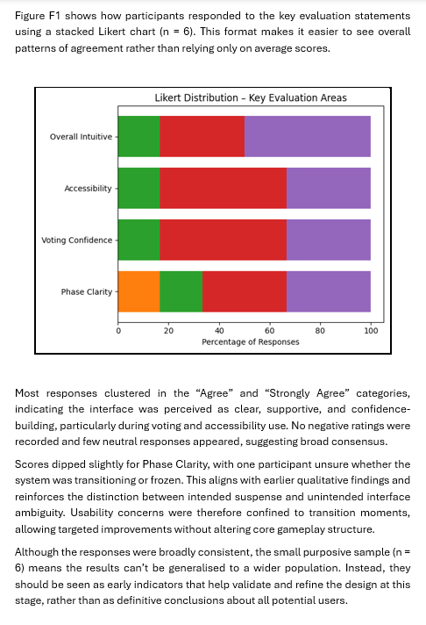

Figure F2: Mean scores by evaluation category (5-point scale, n = 6).
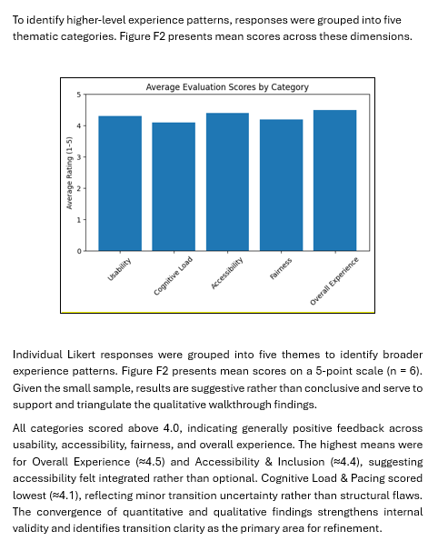

Figure F3: Participant preference for interface visual style (n = 6).

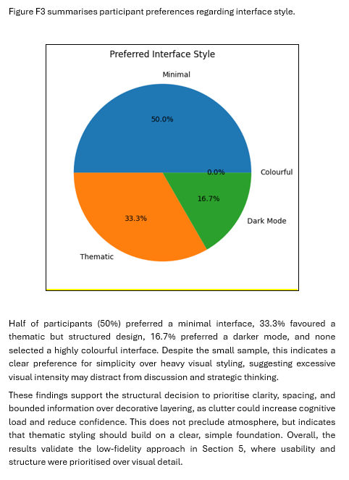

Figure F4 – F9: Individual pie chart distributions for selected core evaluation questions (n = 6).
These pie charts show the percentage breakdown for key areas such as phase clarity, voting fairness, accessibility, cognitive load, and emotional tension. They help illustrate the patterns discussed in Section 6.3, highlighting strong agreement around safeguarded voting and inclusive design, while also showing some minor variation in how clearly transitions were understood.

Figure F4: Understanding of game stages (n = 6)
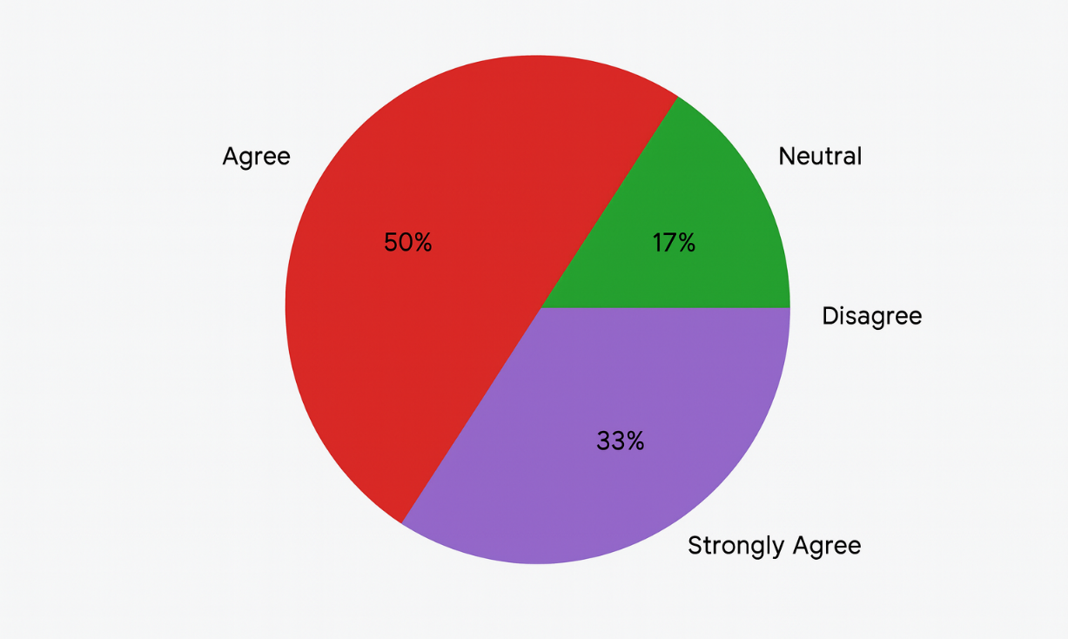

Figure F5: Clarity of phase indicators (n = 6)
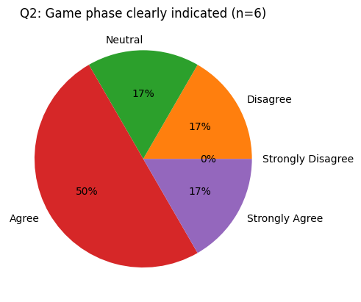

Figure F6: Perceived fairness and security of voting (n = 6)
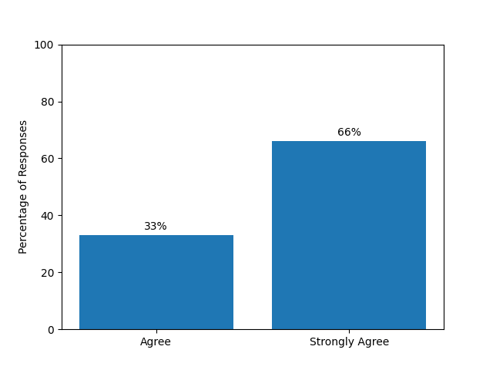

Figure F7: Manageability of interface and cognitive load (n = 6)
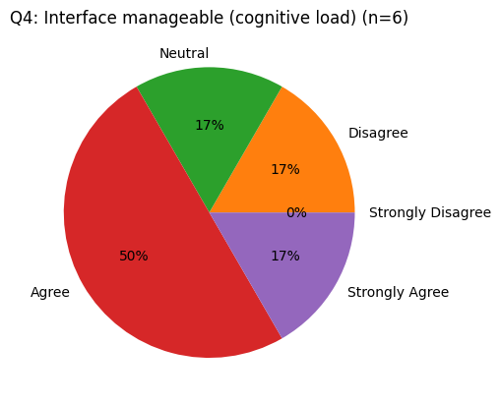

Figure F8: Accessibility settings usability (n = 6)
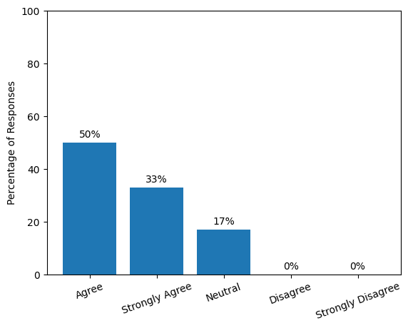

Figure F9: Source of tension (gameplay vs confusion) (n = 6)


