Reflective Report
Oliver Duane - P151457
1st Year Motorsport Engineering BEng
Module Code: M4X02063 & M4X00384
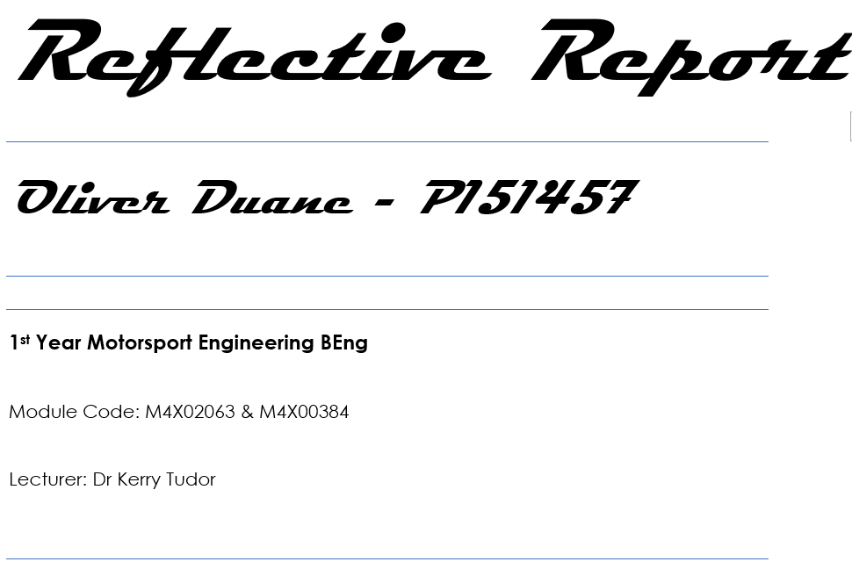
Lecturer: Dr Kerry Tudor

Contents
Contents 2
1 Introduction 3
2 Coursework for reflection 3
2.1 Demonstration of Simple Harmonic Motion, Marks: 40% 3
2.1.1 Coursework Brief 3
2.1.2 Feedback received 3
2.1.3 Reflections on feedback for Demonstration of SHM 6
2.1.4 Improvements I can make for the future 6
2.2 Technical poster, Marks: 46% 7
2.2.1 Coursework brief 7
2.2.2 Feedback received 8
2.2.3 Reflections on feedback for Technical poster 9
2.2.4 Improvements for the future 9
3 What did I learn? 9
4 Strengths and weaknesses after foundation year 10
5 Changes to be made 10
6 Changes already made 10
7 Conclusion 10

Figure 1: “Technical poster”.....................................................................................................1

Introduction
In this reflective report, two of my lowest marked assignments from last year are looked at to Identify weaknesses in my work. Solutions can then be found, improving chances of better results in the future.

Coursework for reflection

Demonstration of Simple Harmonic Motion, Marks: 40%
This assignment involved performing a group experiment with a pendulum and writing a 1500-word report analysing it.

Coursework Brief
- Carry out the experiment using the Simple Harmonic Motion Kit
- Write up experiment and report on your findings.
- Use photographs
- Use research to justify the validity of your experiment, calculations and results.

Feedback received
Below are the key points of feedback on the marking criteria and student feedback form:
Research informed literature
Mark: 3 / 20
Good points: None
Bad points:
- Inclusion of external information [1/8 marks] - Little or no evidence of reading. Quality of references [1/4 marks] Much more needed
- Views and findings unsupported and non-authoritative - justify better.
- Referencing conventions largely ignored - Use the Harvard system to cite your reading in the body of the report.

Knowledge and Understanding of Subject
Mark: 9.6 / 20
Good points:
- Evidence of basic knowledge and understanding of the relevant concepts and underlying principles.
- Most basis are covered.
Bad points:
- 'Conclusion' is very weak, you need to summarise the good things (*What are “good things”?) and point out the relationships you have found, giving citations to external reading in- order to back up these findings adequately.
- No 'Evaluation' present, this is where you discuss possible errors and what you did to minimise them.
- You need a 'Further work' chapter (as requested in the brief), this is where you could have put in your 'possible improvements' and then given some images or citations to enhance the reading.

Analysis
Mark: 13 / 30
Good points:
- logical, analytical thinking and attempts to synthesise;
- Relevant conclusions and recommendations, where relevant.
Bad points:
- …some logical, analytical thinking and some attempts to synthesise, albeit with some weaknesses.
- Some evidence to support findings/ views, but evidence not consistently interpreted.
- Quality of Excel tables [5/10 marks] Ok, table is a little small, and includes more than just the raw data. Some units missing from columns.
- Quality of Graphical data [5/10 marks] Nice data, a little small.
- You needed to back up your findings with research into what others have done, using citations.
- Calculation of the gradient [3/10 marks] This is not present on the graph but found in the tables. Units of 'g' missing.
- You need to give citations when justifying why your answer for 'g' is not what you were expecting.

Practical Application and Deployment
Mark: 7.2 / 15
Good points:
- An adequate awareness and mostly appropriate application of well-established methods, materials, tools and/or techniques.
- Basic appreciation of the context of the application.
- Nice, simple explanation of the experimental procedure. A step by step procedure, list of apparatus and better use of your images would enhance this.
Bad points: None

Skills for Professional Practice
Mark: 7.2 / 15
Good points:
- Can communicate in a suitable format;
- Can work as part of a team.
Bad points:
- limited involvement in group activities;
- Can communicate in a suitable format but with some room for improvement;
- Work lacks coherence in places and could be better structured;
- Chapter number starts with the 'Introduction';
- Justify the text both sides of the page;
- No need to give aims and objectives sub-headings;
- 'Purpose' is not a chapter heading for a technical report;
- Generally, you have a lot of headings and sub-chapters, try and stick to the report writing guidelines;
- Tables of data should go into a 'Results' chapter;
- Calculations and data manipulation (such as graphs) go in the 'Analysis' chapter;
- All images or graphical data needs to be labelled 'Figure 1: Title (ref, date)' underneath the object and referred to accordingly in the body of the text;
- Tables of data should be labelled 'Table 1: Title (ref, date)' underneath the object.

Reflections on feedback for Demonstration of SHM
- The feedback contains some useful advice on the importance of references and basics of report writing;
- Some of the feedback seems wrong, such as “Tables of data should go into a 'Results' chapter”, when they already are, or “limited involvement in group activities” when I was one of the two people who were actually performing the experiment. These inaccuracies cast doubt in my mind over the quality of the marking.
- Unless full-marks are achieved, specific criticism would be useful;

Improvements I can make for the future
- Implement clear, constructive advice;
- Clarify unclear advice such as: “Can communicate in a suitable format but with some room for improvement” and “Work lacks coherence in places and could be better structured”
- Analyse feedback sooner and raise any questions nearer the time;
- Read more about the subject - this will provide a bigger source of references and improve understanding;
- Use more references – Improves credibility and demonstrates understanding;
- Pay closer attention to brief.

Technical poster, Marks: 46%

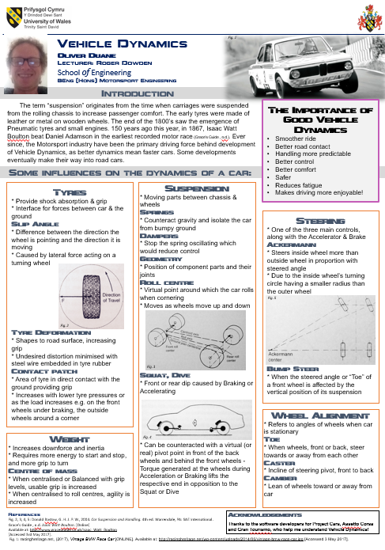
Coursework brief
- Produce a technical poster which provides an overview based on one of the Introduction to Automotive Engineering lectures practical sessions that complements your chosen lecture topic;
- Provide a short technical review on them, giving an overview of the topic and its importance in the Automotive/Motorsport/Motorcycle Industry;
- Try to link the lecture and the practical session;
- Include some background research on the topics. This will need to be referenced on your poster;
Figure 1 - Technical poster
- Include pictures or tables;
- Be concise;
- Research topic;
- Use quality sources and apply the Harvard Referencing conventions.

Feedback received
Below are the key points of feedback on the marking criteria and student feedback form:
Research informed literature 5.5 / 10
Good points:
- Inclusion of a range of research-informed literature, including sources retrieved independently.
- Referencing conventions mostly consistently applied.
- You have used a selection of suitable sources for the poster.
Bad points:
- Reference list is not in the alphabetical order as it should be for Harvard.
- You have used in-text citations in some places but not in others.
Knowledge and Understanding of Subject 19.2 / 40
Good points:
- Evidence of basic knowledge and understanding of the relevant concepts and underlying principles
- The poster is gives a really good overview of vehicle dynamics from the sessions that you did with Roger.
- Good understanding of the different elements on a vehicle that can affect it's handling and drive.
Bad points:
- No information relating to one of the practical sessions
Analysis 14.4 / 30
Good points:
- Evidence of logical, analytical thinking and attempts to synthesise
- Some relevant conclusions and recommendations, where relevant
- Your introduction clearly shows how the motorsport industry has developed vehicle dynamics.
- I like the box at the top which clearly states that importance of good vehicle dynamics
Bad points:
- ...some weaknesses
- Some evidence to support findings / views, but not consistently interpreted
Skills for Professional Practice 7 / 20
Good points: None
Bad points:
- Media is poorly designed and/or not suitable for the audience.
- Poor independent initiative.
- Work lacks structure, organisation, and/or coherence
- The brief asked you to talk about one of the lectures (which you have done) and one of the practical sessions (dampers, simulator etc.).

Reflections on feedback for Technical poster
I wanted a poster that was clearly informative and visually attractive. I think I achieved this, but that I:
- mis-interpreted parts of brief;
- didn’t follow the outline of the brief closely enough;
- tried to include too many aspects of vehicle dynamics;
- didn’t include specific information from class sessions;
- referenced pictures but not topics;
- don’t understand some feedback – some criticism seems vague and difficult to use constructively.

Improvements for the future
- Ask for more clarification beforehand;
- Ask for more specific examples in feedback - I find it easier to understand a criticism when specific examples are given.

What did I learn?
It is easy for two people to interpret a brief differently, and for them to attach different values to aspects of it.
Conveying a message clearly, with the recipient comprehending adequately is of great importance in many situations.
It is therefore beneficial to make every effort from the very start of an assignment to ensure that misunderstandings are minimised.

Strengths and weaknesses after foundation year
Strengths:
- Desire to improve;
- Increasing confidence in an academic environment.
Weaknesses:
- Less time available for study due to work;
- Lazy using citations and referencing conventions.

Changes to be made
- My time management and efficiency can be improved by better discipline with scheduling;
- Make more effort to fully comprehend the task outlines.

Changes already made
- I regularly attend assignment support with David Toft.
- I have taken up jogging as physical health can improve mental ability;
- Healthy diet;
- Minimal leisure time.

Conclusion
Often, feedback seems disproportional or even unrelated to the marks awarded. There also seems to be some inconsistency in the amount of useful feedback received.
I think that the lower the awarded mark is, the more detailed feedback (with examples) is required for the student to improve.
The student then needs to apply this feedback, otherwise the quality of work has less chance of improvement.

