Simon Oglesby P108944



BSc (H) Business Information Technology
(Part Time)

Major Project
M3X8645
Supervisor: Dr. N. Whitehead

Systems upgrade to reduce natural gas consumption at Basic Oxygen Steelmaking Plant

Declaration
I Simon Oglesby declare that I am the sole author of this project; that all references have been consulted; that I have conducted all work of which this is a record, and that the finished work lies within the prescribed works limits.

This work has not been previously been accepted as part of any other degree submission

Signed: ………………………………………………..
Date: …………………………………………………….

I Simon Oglesby hereby consent that my project, submitted in candidature for the BSc (H) Business Information Technology Degree, if successful may be made available for inter-library loan or photocopying(subject to the law of copyright), and that the title and abstract may be made available to outside organisations.

Signed: ………………………………………………..
Date: …………………………………………………….

Table of Contents
Abstract 6
Acknowledgements 7
Chapter 1 - Introduction 8
Tata Steel Port Talbot Works 8
Basic Oxygen Steelmaking Plant 9
Project Aims and Objectives 11
Project Budget and Plans 11
Existing Equipment Status and Scope of Works 12
Chapter 2 – Research & Review of Literature 16
BSEN 746-2:2010 17
BSEN 61508-1:2010 19
Dangerous Substances & Explosive Atmosphere Regulations 2002 20
BSEN 298:2012 21
BSEN 60079-10-2-2:2015 21
Interface Usability 22
Chapter 3 – Design and Implementation 29
Management of Change 29
Hazard Study 29
Functional Specification 30
Factory Acceptance Testing 33
Installation 46
Commissioning 50
Safeguard Verification 50
Handover and Training 51
Chapter 4 – Conclusions and Recommendations 52
Conclusions 52
Recommendations 54
Chapter 5 – Reflection 56
References 58
Appendices 60
Appendix A HAZRES Explosion Protection Document 60
Appendix B Functional Design Specification 60
Appendix C Quotes 60
Appendix D HAZOP 60

Table of Figures
Figure 1 Tata Steel Port Talbot Process Flow (1) 8
Figure 2 Finished Coils, ready for despatch 8
Figure 3 Tata Steel UK Sales Spread (2) 9
Figure 4 Port Talbot Site Lay-out (1) 10
Figure 5 Ladle Inspection & Maintenance 10
Figure 6 Pre Upgrade Flare Control Station 13
Figure 7 Close Up of Flare Controllers 14
Figure 8 Pre Upgrade Flare Panel Internals 14
Figure 9 Flare station, Ladle In Place & Lid Lowered 15
Figure 10 Spark Igniter Transformer, Pre Upgrade 15
Figure 11 L71 Safety Processor Installed 17
Figure 12 Section of Valve Proving Ladder Logic 18
Figure 13 Natural & Coke Oven Gas Trains 19
Figure 14 Fireye Self Checking Flame Scanner 20
Figure 15 Fireye Flame Scanner ATEX Approvals (10) 20
Figure 16 Hazardous Area Classification Zones 22
Figure 17 New Control Panel Installation 25
Figure 18 Final System Overview Mimic 25
Figure 19 Approved Management of Change 27
Figure 20 Processor Showing Dual Network Cards Installed 29
Figure 21 Safe Torque Off Card - Powerflex Drive 30
Figure 22 Factory Acceptance Test Sheet 32
Figure 23 Alarm Definition & Check Sheet 33
Figure 24 Burner Management Panel at Fives USA Testing 34
Figure 25 Combustion Air Fan Panel at Fives USA Testing 34
Figure 26 USA Factory Acceptance Test Page 1 36
Figure 27 USA Factory Acceptance Test Page 2 37
Figure 28 USA Factory Acceptance Test Page 3 38
Figure 29 Main System Overview Page 39
Figure 30 Dual Screen Coke Oven & Natural Gas 40
Figure 31 Screen Showing Burner Popup Detail 40
Figure 32 Screen Showing Air Fan Popup 41
Figure 33 Admin Screen for Setup & Configuration 42
Figure 34 Controller Input / Output Diagnostic Screen 42
Figure 35 Recipe Screen 43
Figure 36 Screen Showing Signal Error Warning 44
Figure 37 Hot Metal Flare P&ID Drawing 45
Figure 38 Site Installation Air Fan 46
Figure 39 Site Installation Flowmeters & Motor Controls 46
Figure 40 Site Installation New Control Station 47
Figure 41 Overview of Network Link & Panel Layout 47
Figure 42 Site Installation Safeguard Sign Off Sheet 49
Figure 43 Before & After Natural Gas Usage 50
Table of Tables
Table 1 Advantages and Disadvantages of Pre Upgraded System ………………………………………………… 23
Table 2 Step 1 Cognitive Walkthrough Output …………………………. ………………………………………………… 23
Table 3 Advantages and Disadvantages of Planned Upgraded System ……………………………………..…. 26

Abstract
The Basic Oxygen Steelmaking (BOS) facility located at Tata Steel Strip Products UKs Port Talbot Works utilises a Hot Metal Flare which is employed to cure refractory lining and or drive off moisture from steel plant vessels used in the steel making process. This flare was installed during initial build of the BOS facility in the 1980s, and was commissioned to operate on a dual fuel system. This allowed the flare to operate on indigenous site gas made as part of the coke making process and imported natural gas. Initially anecdotal evidence from the maintenance and operations team at the BOS plant shows that the flares did operate on Coke Oven gas, however numerous issues and failures over the years resulted on an increasing reliance on clean Natural Gas which is relatively problem free. This project is a combination of project management tools and techniques and Business Information technology subjects such as usability, which are discussed further in the body of this report.
This project was commissioned to reduce the operating cost of the ladle drying facility and were possible to provide a more sustainable operation. This involved identifying and resolving the issues associated with reinstating the Coke Oven gas, as well as assisting to deliver an improved financial result for a company that is struggling to compete, against such a difficult economic background, money that can be better spent on other plant or process improvements. The modern safety requirements for combustion control systems as well as improved operator interface and diagnostics were considered when determining what our upgrade path would look like.
The solution was to retain the physical asset as is and provide an upgraded burner management facility with variable speed air fan to reduce electricity consumption, the project was initiated at a budget cost of £215, 074.00. The project has been delivered on time and under budget, providing a reliable, safe, and sustainable service to the BOS plant team, reducing the import of natural gas, reducing electricity consumption, increasing the use of onsite indigenous gases and reducing the CO² emissions for the site. The project has saved over £400,000.00 since installation.

Acknowledgements
I should very much like to place on record my grateful thanks to the following non-exhaustive list of people whom without their help, support and encouragement, I would not have got to the end of this degree neither would I have completed my major project.
Beverly Holland -UWTSD
Dr Nik Whitehead -UWTSD
Sue Maw -UWTSD
Richard Charlton – TATA
Gareth Freeguard – TATA
The author has been delighted to be able to escort Dr Whitehead and Sue Maw on site at Tata recently to give a them both a detailed tour and inspection of the facility that has been improved as a result of this project activity. They were able to see first-hand, the work that has been carried out and the improvements that have resulted from that work.
My heartfelt thanks go to my family for supporting me and putting up with me through “assignment times”.
Lastly and by no means least my employer Tata Steel UK, who’s support and dedication to my professional and academic development has been first class.
I am indeed indebted to you all so very much.

Chapter 1 - Introduction

Tata Steel Port Talbot Works
Integrated steel making started at Port Talbot works in 1905. Currently the site makes close to 5 million tonnes of steel coil per annum and employs 4000 direct employees and around 3000 contract and supply chain employees, making it the largest private employer in South Wales. The site produces hot and cold rolled steel coils from the base raw materials which are globally sourced and delivered to the site via road, rail and sea. The main stages of the steelmaking process are depicted in figure 1 below.
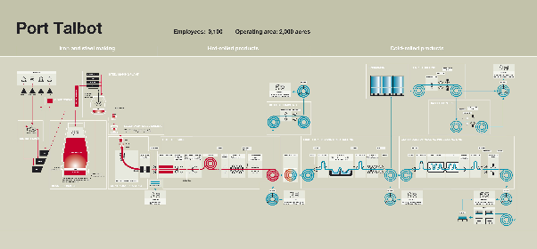
Figure 1 Tata Steel Port Talbot Process Flow (1)
This process results in hot and cold rolled coils which are used in various further downstream businesses or sold to end customers.
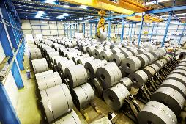
Figure 2 Finished Coils, ready for despatch
These coils are then used many different market segments such as building, construction, automotive, packaging, aerospace and energy. 60 percent of the steel produced in the United Kingdom is sold or consumed by United Kingdom manufacturers or distributors with the remaining 40 percent exported to other countries,
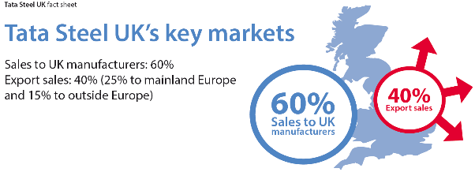
Figure 3 Tata Steel UK Sales Spread (2)

Basic Oxygen Steelmaking Plant
The BOS facility located at Port Talbot utilises two vessels which are charged with Iron delivered by train from the onsite Blast Furnaces and other ferrous metals as scrap recycling. The vessel then has a hood lowered onto it to collect fume and gasses, whilst oxygen is blown into the contents of the vessel. The iron is delivered to, and the steel despatched from the vessels in ladles. These ladles are made of steel and lined with special refractory material to withstand the high temperature of liquid steel and iron.
Figure 4 shows the location of these facilities in relation to the whole Port Talbot site.
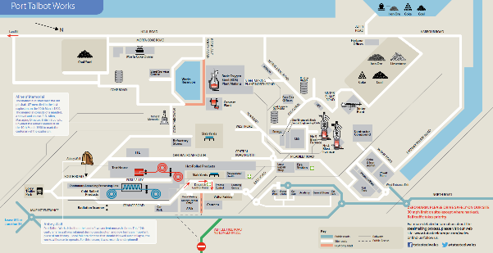
Figure 4 Port Talbot Site Lay-out (1)
These ladles require specific care and attention to avoid a breakout of liquid metal which can result in significant damage to equipment, delays to our customers as well as significant injuries or fatalities dependant on how or when a failure occurs. Figure 5 below shows one of the fleet of ladles undergoing periodic planned maintenance and inspections, using a crane mounted inspection platform, lowered inside the ladle.
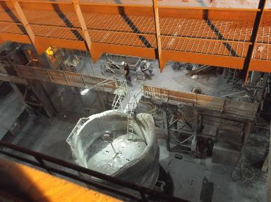
Figure 5 Ladle Inspection & Maintenance
The Hot Metal or Scrap Bay Flare is used to pre-heat the ladles prior to them going into service, so that they do not suffer thermal shock when molten metal is poured into them. This increases the life of the ladle, prevents refractory damage and limits the heat loss when pouring molten metal. The flare can also be used to dry cure a ladle that has had refractory repairs or relining before re-joining the ladle fleet. As the flare is the only one in the department it must have a high degree of reliability and availability, there is no backup to maintain operations if the flare becomes unavailable.

Project Aims and Objectives
This project aims to deliver a flare operation that is reliable, has the lowest cost of operation as possible in terms of natural gas use and is compliant in all aspects with modern day safety legislation. The project objectives are as follows;
- Review existing installation and propose an upgrade solution
- Record and manage the progress of the project
- Design and arrange Implementations of a new user interface for the system
- Implement the upgrade and monitor progress against the stated project aims.
In order to measure the overall success of the project, the natural gas consumption for the flare will be trended and it is expected to show a sharp decrease in demand post project works. This will be reflected in the weekly cost of running the flare and will be monitored against the availability of the Coke Oven has system, which one upgraded will be the main source of fuel for this flare, utilising the spare works arising gas which would otherwise be burnt at the works flare stacks.

Project Budget and Plans
As part of wider capital investment’s planned by Tata Steel to improve the cost effectiveness of operations at the Port Talbot site, a capital expenditure request (CAPEX) application was submitted to the board for consideration to provide funding of £3.2 Million to undertake a range of projects across the site aimed at reducing the important of natural gas and maximising the utilisation of indigenous works arising gases. The hot metal flare element of this applications comprised a budget of circa £225,000.00, from a pot of £770,000.00 allocated to Steel Plant gas reduction activities. This project was initially identified back in 2014 for work to be completed in 2015. However a lack of capital investment money and the precarious state of the UK steel industry meant that higher priority projects were allocated funding first. Again I raised this in 2015 application rounds, and we got the funding approved to proceed in 2016 funding round. This scheme was approved with a proviso that the payback period cannot be longer than 2 years before we see a return on our investment, initial calculations indicated that this could be achieved.
As has been previously stated the flare is a single unit which is critical to steel plant operations, so any proposed upgrades would have to reflect this status and minimise any down time of the flare to the absolute minimum. From the outset the plan was always to manufacture as much as possible of the upgrades offline and have a short outage to remove the old and fit the new equipment as quickly and efficiently as possible.

Existing Equipment Status and Scope of Works
Prior to submitting a bid for capital money, I undertook several visits to the BOS plant area to view the flare in operation, and it was abundantly clear that the criticality of the flare was not reflected in its maintenance and operation. It was in a very poor state and practically devoid of the care and attention it deserved, it was however highly reliable which meant it was often overlooked in maintenance priorities. Initial reviews of the natural gas flows indicated that the flare was consuming an average of £38,263.68 per week of operation. The combustion air fan was constantly on and running at full speed and the burner had one fire setting with no low fire mode when the lid was raised and lowered from the top of the ladle. The electrical panels were in a very poor state of repair, and there was no evidence of any modifications or upgrades having been made since the original installation. The project scope included:
- Instrumentation and control system
- Burner management system
- Operator user interface
- All associated cabling and pipework
- Mechanical and Civil works as required
As you can see from figure 1.6 overleaf, the current user interface is very lacking. It is not intuitive in any way, does not depict the process and is particularly difficult to understand what each item actually does. Additionally there is no diagnostic systems or remote monitoring, so if the flame goes out nobody knows so, until someone walks past and visually inspects the burner, which can sometimes lead to unplanned downtime due to ladles not being ready in time.

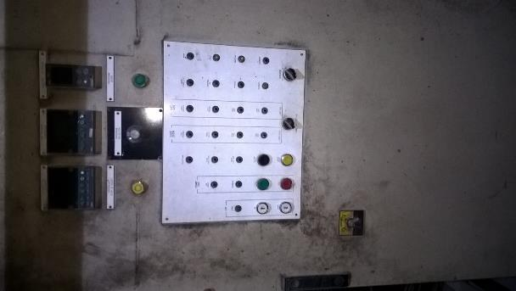
Figure 6 Pre Upgrade Flare Control Station
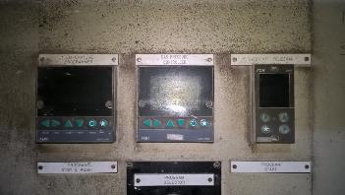
Figure 7 Close Up of Flare Controllers
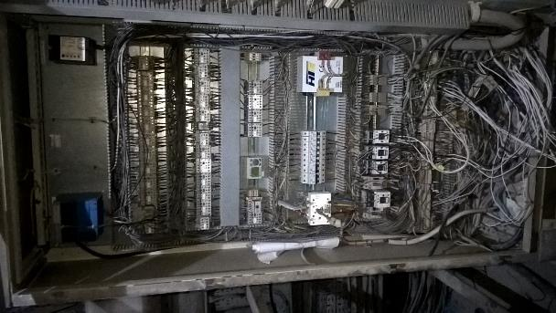
Figure 8 Pre Upgrade Flare Panel Internals

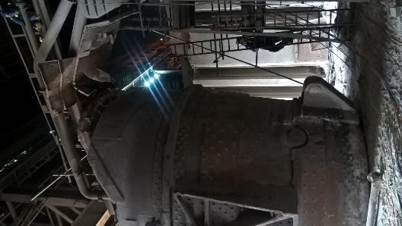
Figure 9 Flare station, Ladle In Place & Lid Lowered
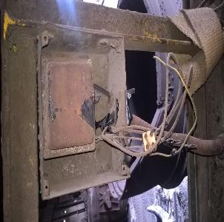
Figure 10 Spark Igniter Transformer, Pre Upgrade

Chapter 2 – Research & Review of Literature
Before undertaking any upgrades It was made clear to all involved that we were about to alter a system that controls air, gas and a source of ignition in this case a spark plug, all of which if handled incorrectly equals a recipe for serious fires, explosions and significant damage and or injuries. This fact was not taken lightly by anyone associated with the project. Without the necessary design experience and system controls being in place the above event would be a certainty. Experience from across Tata was employed to ensure the works being planned were up to standard and in keeping with company engineering standards. Through past experience and previous works, Tata had engaged Fives North American Ltd as the burner specialist on this project. Fives are a world renowned company and experts in the field of burner design, manufacture along with the design and implementation of the associated control systems.
As part and parcel of their occupation the author is required to be familiar with standards and regulations that are related to their field of employment. However as one of the aims is to deliver an upgrade that is compliant in all aspects with modern day safety legislation, my day job not being routinely involved with burner control and management systems, I have been required to acquaint myself with the contents and requirements of additional pieces of legislation pertaining to the upgrade path. The main regulations I have had to consider are;
- BSEN 746-2 2010 (3)
- BSEN 61508-1 2010 (4)
- Dangerous Substances & Explosive Atmosphere Regulations 2002 (5)
- BSEN 298 2012 (6)
- BSEN 12067-2 2004 (7)
- BSEN 60079-10-2 2015 (8)
Each of these documents have been studied in fine detail to ascertain what legislative requirements are place upon us, and what actions we need to undertake in order to ensure compliance with said legislative implements. This has not been done in isolation, it has been undertaken using the skills and expertise available within Tata Steel and from the selected automation vendor using subject matter experts from Fives North American.
Additionally I have reviewed internal Tata Engineering Standards to ensure that compliance is achieved in relation to our internal standards which should ensure compliance with or exceed the requirements placed on us by legislation.

BSEN 746-2:2010
This standard requires that “all functions which lead to immediate hazard in case of failure (e.g. flame detector device, ration monitoring) performed by components for which no relevant product standards are existing shall comply with at least SIL3 Ple” Safety Integrity Levels (SIL) are defined in BS EN 61508-1:2010, as we were using flame scanners and the ratio control of gas and air was planned to be undertaken in the new logic controller, the system had to comply with SIL 3, as such the controller itself had to be SIL 3 rated in order that it was able to carry out the required safety actions and monitor the essential devices such as the flame scanner. In order to achieve compliance with this requirement an Allen Bradley 1756L71S safety rated processor coupled with a safety partner was selected. Figure 11 below shows the selected processor installed in the new panel.
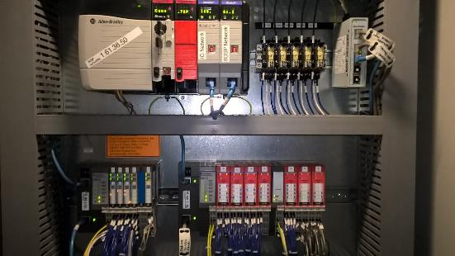
Figure 11 L71 Safety Processor Installed
This processor is certified to perform the requirements demanded by SIL 3 or performance level e and it is also one of the preferred brands of automation controllers used across the site (9).
As we are controlling a capacity in excess of 200kW this standard also requires that a valve proving system is present and that a leak test must be undertaken before every operation. This type of function is common across the many valve systems that we have across the site, normally this would involve purchase of a local valve proving unit and additional field wiring to cable the units signals back to the control panel. However on this occasion there was the opportunity to provide a more elegant and sophisticated solution, reducing the need for extra cabling and to automate function within the logic code written in the SIL 3 safety rated controller. However in order to undertake this additional legislation had to be consulted to ensure compliance with BSEN1643:200 in relation to valve proving systems, having checked this, the code was included into the design scope. Figure 12 below shows a section of controller ladder logic code that was written to automate the valve leak test upon start-up. The remaining code is attached at appendix XXX
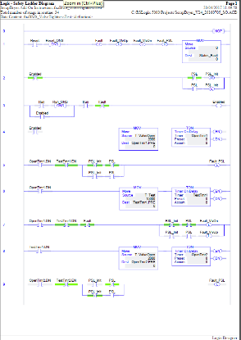
Figure 12 Section of Valve Proving Ladder Logic
There are some distinct advantages of having this function automated. From safety perspective, you no longer have to have people working in close proximity to vales containing dangerous gasses, especially when fault finding. Also there was the ability to provide a whole system diagnostic via the user interface. When a traditional wired system is used, you just get an alarm that states leak test failed. With the automated version written for this project, there is a whole raft of diagnostics that can be made available to the user, via the interface to aid in diagnosing the fault and reducing the time to repair and returning to service.
Figure 13 shows the valve train with the two isolation valves in place and pressure transmitters to measure for any drop in pressure within the set time period.
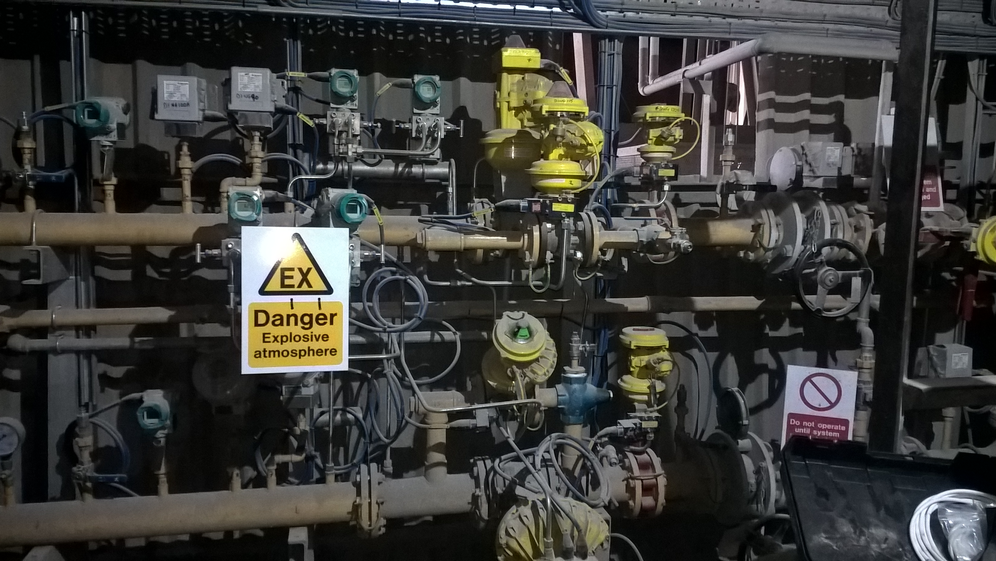
Figure 13 Natural & Coke Oven Gas Trains

BSEN 61508-1:2010
This is the standard pertaining to the functional safety requirements of electronic or programmable electronic devices that perform safety functions. Due to the fact that this project sought to remove all the old manual fixed gas to air ratio equipment and upgrade this with electronic equivalents BSEN 61508 became applicable. The flame scanner and logic controller are both programmable and have a huge effect on the overall safety of the system and as such they have to comply with the requirements of BSEN61508, as mentioned previously the logic controller selected was a SIL 3 rated 1756-L71S Allen Bradley controller the flame scanner selected was a Fireye 85UVF/IRF 1QD integrated flame scanner with internal flame relay. This device as shown in figure 14 below is a self-checking device.
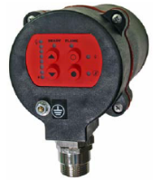
Figure 14 Fireye Self Checking Flame Scanner
Figure 15 below details the certifications for the fireye flame scanner.
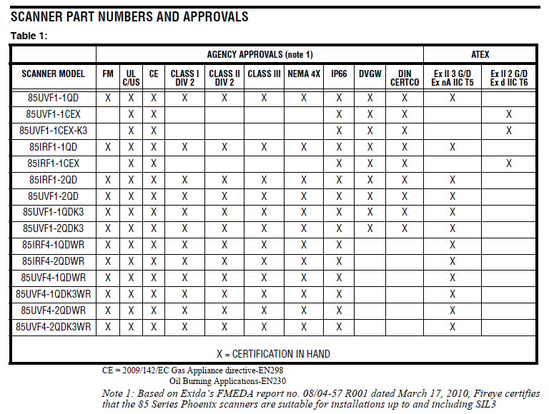
Figure 15 Fireye Flame Scanner ATEX Approvals (10)

Dangerous Substances & Explosive Atmosphere Regulations 2002
The Dangerous Substances and Explosive Atmospheres Regulations 2002 (DSEAR) place duties on employers to eliminate or control the risks from explosive atmospheres in the workplace (11).
As from June 2015, this standard was expanded to cover substances corrosive to metals and gasses under pressure, therefore it has an effect on the design of this projects upgrade solution. In order to meet the requirements of these regulations, a DSEAR survey was conducted by an external third party company called Hazard Research & Risk Consultants (HasRes), who in turn produce an Explosion Protection Document(EPD) (12). This document details all of the zonal areas where equipment if installed in these areas must meet certain prescribed standards to ensure that its operation cannot give rise to a source of ignition. The document is attached at Appendix A
This report documents the extent of the classified zones, which extend between 0.5 and 1.5m from valves and instruments installed into the mechanical pipework. It was designated as zone 2 group IIA for natural gas and IIC for Coke Oven Gas in accordance with the requirements of BSEN60079-10. This review identified some issues with the current installation such as light fittings not EX rated and the new controller and variable speed drive panels had to be located outside of the zones areas, unlike the existing panel which was housed next to the gas pipe trains. The solve this issue the light fittings were upgraded to LED and moved outside of the specified zones and the control cabinets were located in a nearby by contactor room, thus removing them from the zones and affording them better degree of protection from the ingress of dust and dirt.

BSEN 298:2012
This standard covers the automatic burner control system for burners and appliances burning gaseous or liquid fuels. As the control of the flare burner was designed to be undertaken by the safety controller already discussed compliance with this standard also became a requirement. This standard make many reference to BSEN 61508 as well as placing specific requirement on the use of controller memory to store safety lockout status. This was not required in this instance so there was no requirement to store lockout statuses.

BSEN 60079-10-2-2:2015
This standard details the requirements for area classifications dependant on the nature of the substances used and the equipment installed. In order to demonstrate compliance with this regulation, the HazRes explosion protection document was commissioned to calculate the zone extents and classifications of equipment which can be installed within the zones. Figure 16 below demonstrates the plan view elevation of the area classification zones. Ideally all equipment should be installed outside of these zones, thus avoiding the need to purchase specialist equipment and have specialist trained and competent people to maintain the equipment. If however the installation of equipment outside of the zone is not possible, then equipment rated for the zone and gas group must be used.
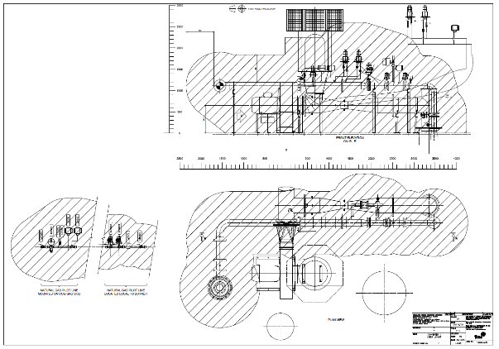
Figure 16 Hazardous Area Classification Zones

Interface Usability
As shown in figure 6 the current system user interface is rather poor, it is located within a dark room, adjacent to the process and the controls are poorly labelled and spread across different heights, requiring the user to concentrate across the whole panel area just to start the process. Once the process is running, the only diagnostics available to the user in the event of failure is the illumination of a lamp on the panel. Prior to deciding how to improve the interface, the author undertook a walk through with the plant operations team to fully understand what the main issues are associated with the current operation. The main points are listed as advantages and disadvantages of the current location and system as show below in Table 1.
Comment | Advantage | Disadvantage
Simple system, wires and relays, basic technology | X
Relatively simple to maintain/replace | X
Reliance of Lamps for indication (maintenance required) |  | X
Located next to process, in gas pipe shed |  | X
Diagnostic System / Current status of the system at a glance |  | X
Ease of user training |  | X
Ease of understanding of the process being controlled |  | X
Difficult to keep the dirt and dust out of the panels in the process area of the plant, increased maintenance required |  | X
Operation requires the user to operate several different controls |  | X
Table 1 – Advantages & Disadvantage of current system/location
Human factors (13) play a large part in this part of the review, currently the integrity of the system is reliant on the users undertaking a set of activities in a set order to achieve the desired outcome, however it is natural for users to identify and often adopt “short cuts” which over the passage of time become the new operating standard. Shortcuts can be referred to as automatic cognition in time and motion theory, and are not explicit always rules, however they are often learned from experience and as such they are sometimes called Cognitive rules of thumb (14). It is clear from this project that it was the custom to leave the air fan running all the time, even when the flare was offline. This saved the time delay associated with starting the fan and progressing through the air fan safety checks.
As a significant part of this project was associated with the development of a new user interface via touch screen panel, the author reviewed previous modules on usability engineering and what that could bring to the project in terms of user interface design and standards. As this is to be a user interface and it is controlling lots of pieces of equipment, metaphor is very important. Items on the screen must represent the actual equipment installed on site in order to allow the user to easily identify the functions associated with the controls (15) Interface design and task analysis were undertaken as part of the design reviews. Ordinarily the author would proceed from the task analysis to a paper prototype version of how the user interface might look. This would then be reviewed with the operations team and the vendor to discuss changes or options available. However in this case the vendor was able to supply example screens from previous jobs as a basis of good practice from similar flare installation around the world. There were used as our paper prototypes and reviewed to determine their suitability and marked up with changes as required for this project, these screen were then used to complete a system cognitive walk through using the task analysis (16) to ensure that the operator was able to undertake the required actions without too much screen changing. The following table shows the output of the cognitive walkthrough in order to get the pre upgrade system interlocks clear and a system ready to start signal.
Step | Action
1 | Check panel to see if any fault LEDs are illuminated.
 | Reset any interlocks that are not in healthy state, clear the faults.
 | Set the level of combustion air in the gas to air ratio via the controller.
 | Start the combustion air fan by pressing the start button on the panel.
 | Allow air fan to get up to speed and check that air flow exceeds the minimum air flow threshold.
 | Press button start a leak test on the main gas line,
 | If leak test passes, user is now ready to move to step 2, lighting the burner
Table 2 – Step 1 of Cognitive Walkthrough – Pre start up interlocks
The poor location of the existing control posed a significant difficulty for the team. If the new controls were to be installed into the existing location then they would not be compliant with the requirement of the dangerous substances and explosive atmosphere regulations, and there would still be the issues associated with lighting and ingress of dust and dirt. These issues necessitated a new location if we were to achieve an improvement for the users and compliance with the regulations.
After reviewing possible new locations, the team decided to install a new touch screen control panel on the exterior wall of the gas pipe shed, which afforded the user eye level access to the panel, a flat a level floor surface and a well illuminated environment. There is still the issue of dust and dirt ingress, therefore to provide an additional layer of protection the author decided to install an additional screen to cover the user touch screen control as shown in figure 17 below
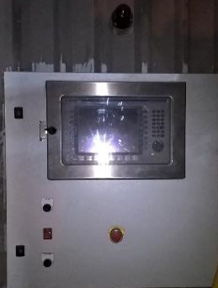
Figure 17 New Control Panel Installation
Mounted above the panel was a red flashing and audible beacon to attract attention from users in area in the event of a high priority or shut down alarm. The new system will remain unmanned as is the case for the existing installation.
Figure 18 below shows the final production version of system overview page. This is as a result of several reviews and the insistence of the author that increased affordance was built into the interface.
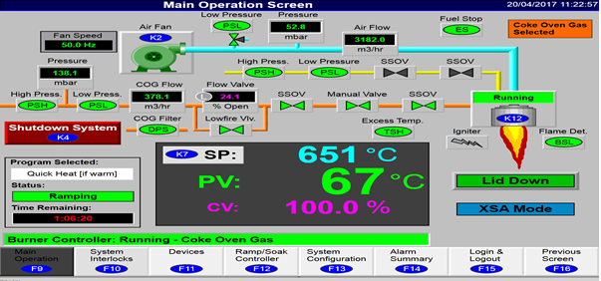
Figure 18 Final System Overview Mimic
As can be seen in figure 18, affordance has been heavily used on the interface, where an object is displayed in a way that it is easily recognisable what the control does, such as pointers and scroll bars. The screen displayed above shows raised controls on some items indicating to the user that the item is clickable or selectable to reveal another layer of control or information (17). This allows the screen to be information rich without cluttering up the whole screen area and overpowering the user’s senses. This enables the user to have all the relevant measure points displayed in a single screen view without having to click on other menus or buttons (18)
Metaphor has also been employed heavily in this design. The overview mimic represent the layout of the physical installation, and detail such as the pipe colours are matching the colour used on the plant all assist the user in identifying the equipment and undertaking the correct action. This will also make user training far simpler.
Table 3 shows a comparison of the advantages and disadvantages of the new system located at the new location based on the same criteria as the pre upgraded system was reviewed against.
Comment | Advantage | Disadvantage
Safety Rated Controller, minimises field wiring | X
Relatively simple to maintain/replace, all system is now in the controller | X
Lamps replaced with a touch screen | X
Located fairly close to process, clear location well illuminated and flat level ground, panel mounted at average eye level | X
Diagnostic System / Current status of the system at a glance. | X
Ease of user training | X
Ease of understanding of the process being controlled | X
Difficult to keep the dirt and dust out of the panels in the process area of the plant, increased maintenance required |  | X
Single view and single button to start/stop system | X
Table 3 – Advantages & Disadvantage of proposed system/location
Clearly a huge improvement in terms of interface design, ergonomics, usability and human factors. This design is now suitable to go forward for formal design and implementation. In order to remove the human factors issues in relation to pre-requisites for starting the system, the new screen now provides a solution with a single start and stop button. Once start or stop routines are selected, then the controller takes over and carries out all the other actions on behalf of the user.
This project followed the Tata Steel project department project methodology as defined in the Tata project manual (19). This methodology is based upon the Association of Project Management Professionals (APMP) (20) project life cycle, which defines the following steps are required for safe and successful project implementation;
- Defining the reason for the project
- Capturing project requirements, quality, deliverable, timescales, resources
- Business case and justification
- Corporate agreement and funding
- Developing the management plan
- Leading and motivating the project team
- Managing the risk
- Managing the budget
- Third party vendor management
- Project closure in a controlled fashion

Tata Management of change procedures require that all changes projects have undergone a rigorous change evaluation, which consider the risks to the plant, people, process and environment. Each and every change is subject to a 3 step risk assessment process as defined by the Health and Safety Executive (21).

Chapter 3 – Design and Implementation

Management of Change
In accordance with established Tata project procedures (19), before any change that involves a non like for like part is undertaken on any equipment, a thorough management of change assessment is to be undertaken to assess any potential impacts that the change may have both intended and unintended. Figure 18 below shows a screen shot of the change document that was raised and approved prior to proceeding with this project.
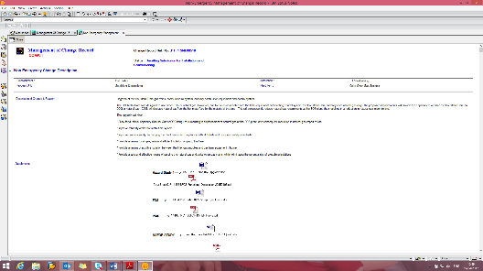
Figure 19 Approved Management of Change
This process allows the team to review the whole operation before any changes are made to ensure that any proposed changes will have the desired effect and will not compromise the operation in any way. It also gives the opportunity for additional control measures to be identified especially when new methods of working or new technologies are being adopted. This will also include the need for documentation additions, spares holding and training requirements.

Hazard Study
As we are dealing with a gas which is not controlled correctly, has the potential to cause a major fire and or explosion, a full Hazard study assessment was undertaken in line with Tata project procedures. As part of Tata procedures hazard studies one through to six are required for the whole life cycle of a project which covers initial inception through to completition and handover and acceptance by the works area management team. Hazard study 6 is carried out many months after the project has been delivered and handed over to ensure that the system is still operating as planned and that no new issues have arisen through continuous operation over a prolonged period of time. In addition to the hazard studies a full Hazard Operation study was undertaken to identify all of the scenarios that could lead to an unwanted condition resulting in undesired consequences such as loss of containment, fire or explosion. Each scenario is detailed out and control measure highlighted to ensure that the condition cannot arise. Once each control measure is agreed it is then placed on the safeguard register for use when we are commissioning the system to check the integrity of the safeguards and prove that the controls do indeed perform to the desired standards. The Hazard Operation study is attached at Appendix D.

Functional Specification
Before proceeding to the commercial tendering stage, a full functional design specification document was produced. This document detailed all our requirements in terms of what the system must do and how it is intended to operate. Additionally it covered environmental and safety factors as well as what legislation should be covered and to what standards the proposed solution should comply with. This was an iterative process and required several sessions with a team of people from all disciplines to review and refine the specifications as the project matured. This specification was then sent out to selected contractors to bid for the work, producing a budget estimate against the requirements laid down in our functional design specification. The Functional Design specification is listed at Appendix B to this report.
After an agreed period of time the prices are returned and reviewed to determine which one best meets the requirements of the specification, has a proven track record of safe and effective delivery in this field of work, is the most cost effective and is able to deliver the works within the chosen time frame of the project window. This upgrade was sent to two vendors to quote, both quotes are detailed at Appendix C. Fives North American were the winning bidder, not only on cost but previous experience on site and a proven ability to deliver.
Once a vendor is selected the functional design specification is once again review to have the input of the system designer, to ensure that there are no major equipment or design issues or any items that we may have overlooked in our initial drafts of the specifications.
At the time of working through this review of the functional design specification, the Iran nuclear power plant Stuxnet virus infection was a prominent feature in the media, and it highlighted the vulnerability of the plant safety critical systems which are connected to the internet (22). Whilst our initial design did have a safety controller on the corporate network, it was protected by MacAfee Intrusion Detection Shields and the corporate firewalls. However we took the decision to add a layer of separation and added an additional network interface card in the safety controller PLC, this changed then shifted all of the critical safety functions onto an internal only safety based network, which could not be accesses for any other networks unless you are physically plugged into that safety network. The existing network connection was left then for plant historian communications and non-critical SCADA links only. If this connection was compromised, it could no longer have any effect on the safety functions controlled by the controller. Figure 20 bellows shows the new logic controller layout with the two network cards in place, which allows all of the devices to communicate via the TCP/IP Protocol.
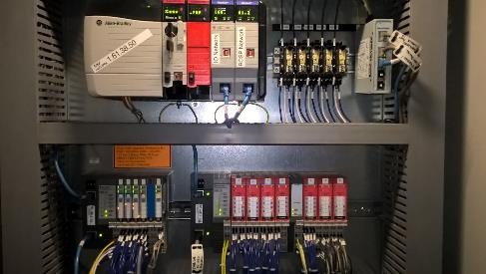
Figure 20 Processor Showing Dual Network Cards Installed
Once this work had been completed and both parties are satisfied as to what is expected and where the project responsibilities lay, the functional design specification is frozen and issues as fit for production, in order that the vendor can commence works as required.
In order to help deliver on the aim of lowest cost of operation, the current system employs an air fan which is started direct on line and runs at full speed at all times, this can lead to inefficient combustion and does not give any scope to vary the flame. It was decided to move the air fan over to a variable speed drive which could vary the speed according to the demand placed on the system, thus saving energy by running the motor slower when the demand allows for it. In order to do this compliance was required with BSEN 746 to be able to shut off the air system in the event of a safety failure, to achieve this and Allen Bradley Powerflex 753 drive was selected with a 20-750-S safe torque off option card fitted to maintain SIL 3 compliance (23). Figure 20 below shows the safe torque off card installed in the Powerflex drive.
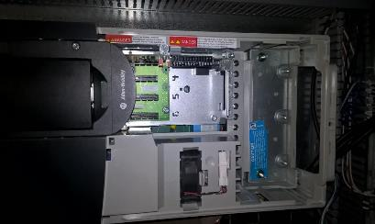
Figure 21 Safe Torque Off Card - Powerflex Drive

Factory Acceptance Testing
Once the design was frozen the vendor commended manufacturing for the panels and associated pipelines and valve trains. The panels were constructed at the Fives North American facility in Ohio, United States of American and the pipework’s at various mechanical contractors within the UK. Regular progress meetings were held to ensure that work was on track to be delivered to site as per the plan. However a key milestone in the plan was user acceptance testing to ensure that the system as built met the design requirements as specified before it was shipped for installation on site. This process ensures that no surprises arise when the equipment is scheduled to be installed on site. Modifications and designing on the run as it were are not consistent with a safe and successful project outcome, therefore we had to travel to Ohio to undertake full system testing at Fives North American facilities in order to prove that the systems delivered against the requirements of the design specification. This was the first time to view the user interface mimics on the actual screens, and these formed a significant part of the testing procedure. The factory acceptance document consisted of a 44 page list of check that had to be made to ensure each item operated as designed and was correctly linked to the corresponding screen mimics. Figure 21 below shows a screen shot of one of the acceptance test pages.
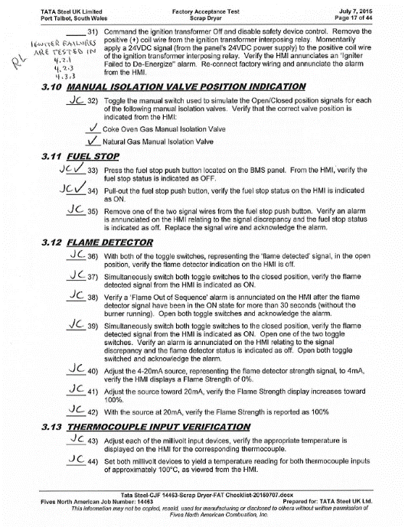
Figure 22 Factory Acceptance Test Sheet
Additionally this presented an opportunity to review and error check all of the alarms that were configured on the system. A 24 page check sheet was followed to test the scenarios that would create an alarm activation as well as ensuring the alarm contained the correct text and had been assigned the correct priority level. Figure 22 below details a screen shot of one of the test pages.
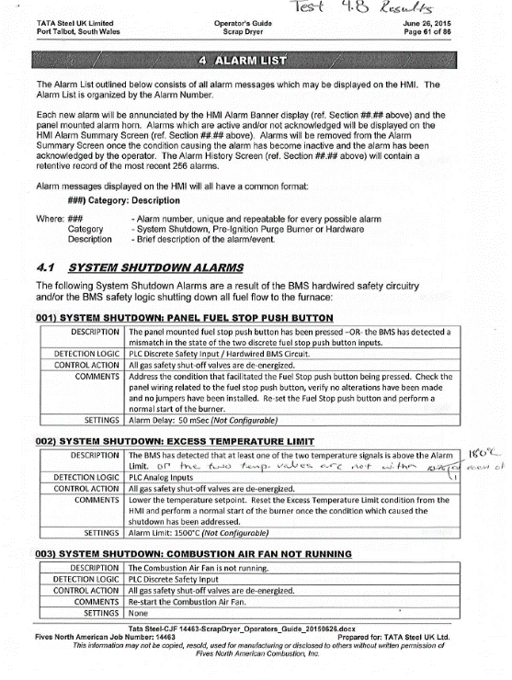
Figure 23 Alarm Definition & Check Sheet

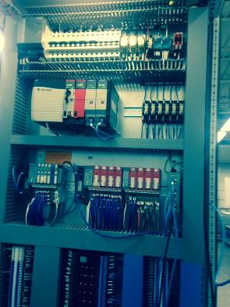
Figure 24 Burner Management Panel at Fives USA Testing

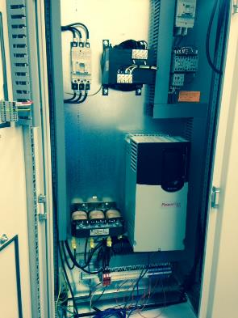
Figure 25 Combustion Air Fan Panel at Fives USA Testing
As part of the factory acceptance process a number of issues were identified. The most serious of these was the fact that the vendor had wired the panel and intended to supply Namur type resistance limit switches on all of the valves. This was not commensurate with the standard employed at the Port Talbot site, and would have contributed to significant delays as the maintenance team would not be expecting Namur signals when fault finding. Namur switches use resistance to define an open or closed state varying the resistance accordingly. Poor connections or cable damage can cause issues with such a system, resulting in possible undesired indication. It was decided at the visit to instruct the vendor to change all of the switches and associated wiring to traditional logic switches. A number of other issues were also highlighted such as alarm history deleting every time the panel was power cycled, the processor memory card was formatted to a different firmware version than that currently deployed in the safety processor and many more minor snags.
Whilst testing each of the screen mimics it was highlighted that there was no indication to depict the status of the flares lid in either the raised or lowered position. Upon questioning the vendor it transpired that this requirement has been passed to the UK branch of the vendor, however it had not been transmitted to the US branch who were building the panels, and as such no provision was made for this on the mimic or the associated input cards and controller logic. This necessitated a hasty design change and instruction to the vendor to correct. The flare lid was existing equipment and had been included in the functional design specification for re-integration into the new system. The vendor accepted that the error was theirs and agreed to integrate the flare lid, this work was undertaken during the duration of our visit.
A three page list of issues was created for the vendor to address prior to the equipment being shipped to the UK for installation on site. Figures 26, 27 and 28 overleaf details the finding of the factory acceptance visit.
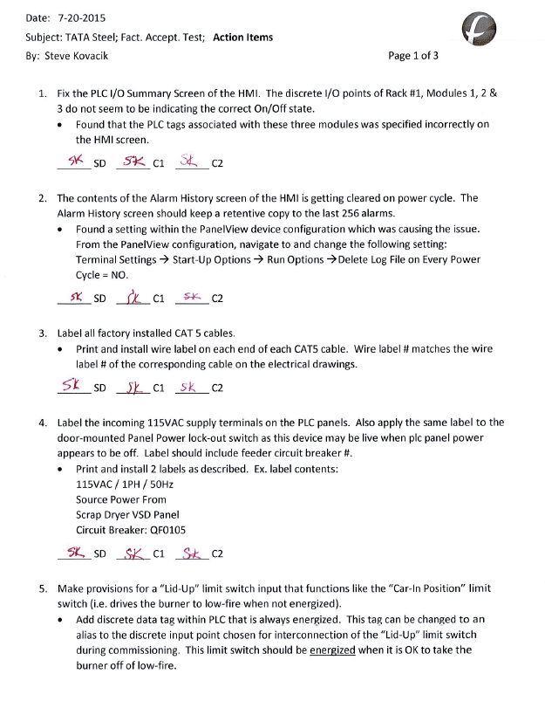
Figure 26 USA Factory Acceptance Test Page 1
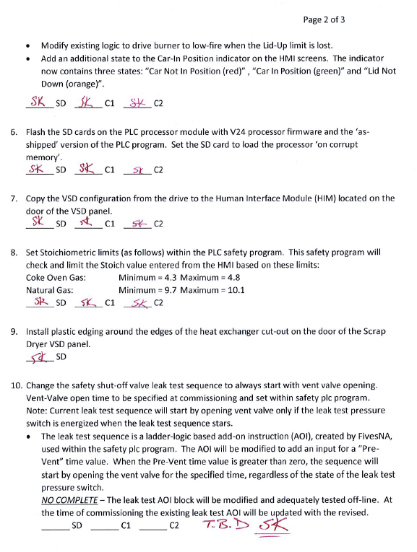
Figure 27 USA Factory Acceptance Test Page 2
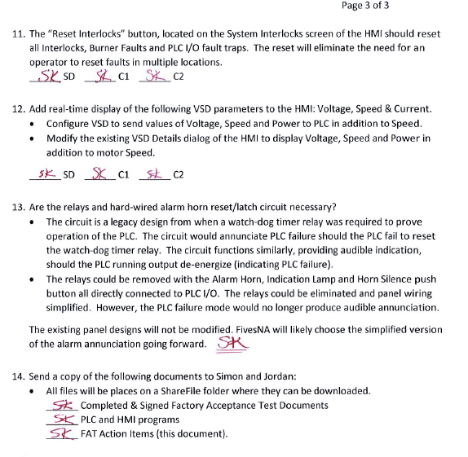
Figure 28 USA Factory Acceptance Test Page 3
During this activity the screens as discussed from the literature review were now seen for the first time as live actual screens, running on the touch panels. These were reviewed for consistency and appearance as well as functionality as previously described. Each screen was reviewed to confirm that it addressed the concerns raised in the system walk through of the old system. It was discovered that this upgrade would solve all of the issues, except the ingress of dust and dirt. In order to mitigate against that an additional cover was installed to protect the touch screen. Each and every data point listed on the controller was checked against the list to ensure it was displayed on the panel correctly, that it had the correct alarm priority level set and that it displayed the correct meaningful alarm text when the conditions for alarm were simulated, once confirmed each point was signed off on the test sheets. Each screen in turn was tested point by point and every control operated to ensure uniformity of look and feel of the interface, again this was recorded on the test sheets. Every pop up screen was operated to ensure it displayed the correct level of information and control. During this period we requested the change of pipe colours to conform to Tata steel Pipework standard colours as defined in our Mandatory Engineering Standard 003 (24).
Figure 29 details the layout of the main system overview when Coke Oven gas is selected. The same view is present when natural gas is selected, however pipe colours change to yellow to depict a natural gas pipe.
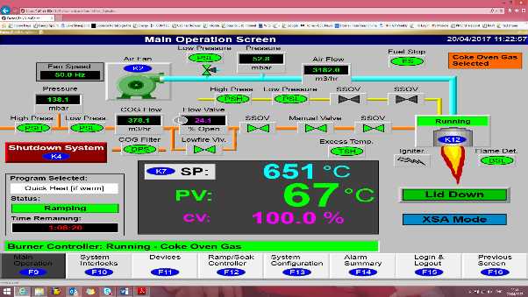
Figure 29 Main System Overview Page
Figure 30 overleaf shows the diagnostic screen for both systems, this affords the user an overview of both systems in order to decide which is able to be used at a single glance.
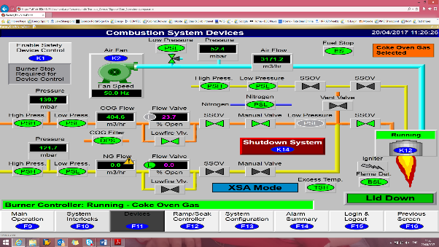
Figure 30 Dual Screen Coke Oven & Natural Gas
Figure 31 below shows the overview screen with the burner control popup activated. From here the user is able to access all of the controls and readings that are associated with the burner.
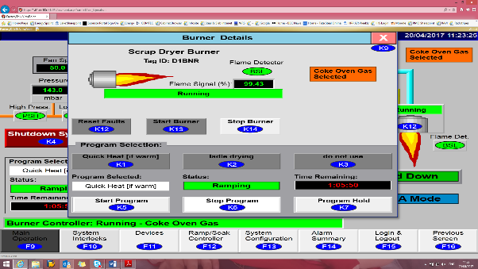
Figure 31 Screen Showing Burner Popup Detail

Figure 32 below shows the overview screen with the air fan control popup activated. From here the user is able to access all of the controls and readings that are associated with the burner.
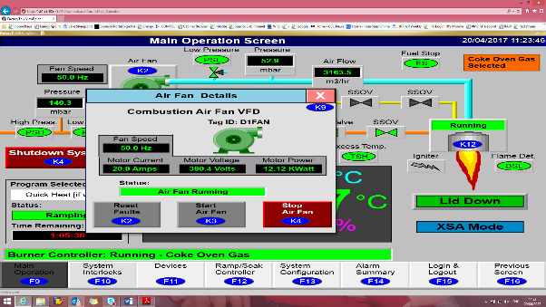
Figure 32 Screen Showing Air Fan Popup
Previously all of the settings for the various instrument loops would have been set via switches and pots in the hard wired panel. Now that everything is integrated into the safety controller there is an admin and configuration screen which if logged in with the correct level permissions allows the user to modify the system parameters with the need to log onto the controller via a laptop. None of the major safety features can be accessed via this method, in order to preserve the integrity of the safety system. Figure 33 overleaf shows the admin and configuration page.
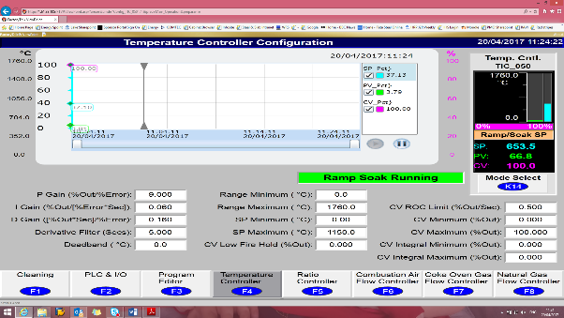
Figure 33 Admin Screen for Setup & Configuration
In order to improve the diagnostic’s available to the maintenance teams a full IO page was developed to answer the issue from the walk through in relation to poor diagnostics. The page at figure 34 shows every single channel on the controller, each channel can be drilled into to see the signals on the channel and their current status, meaning that maintenance team can diagnose faults quickly and efficiently without the need to connect up a laptop.
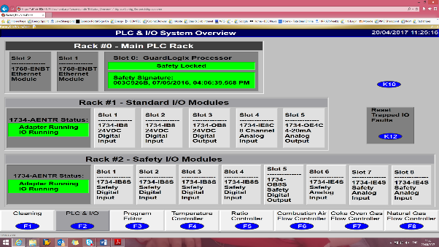
Figure 34 Controller Input / Output Diagnostic Screen
Previously the flare was manually controlled and the duration that a lade spent under the flare was down to personal preference of the operations teams and was not always uniform across the fleet of ladle. Therefore a recipe screen was created so that the user could select from a range of programs to select, then the controller will take care of everything else and ensure that going forward every ladle on the program was treated exactly the same, and allowed for controlled temperature change over a period of time, ending the previous process of full heat all the time, the new system will now bring the ladle gradually up to temperature before soaking at the higher temperature for the desired period of time.
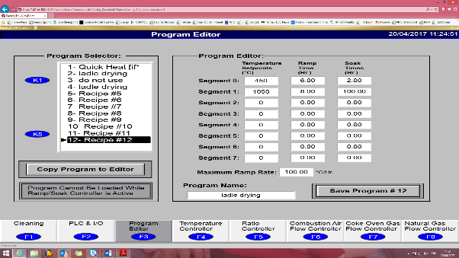
Figure 35 Recipe Screen
Figure 36 overleaf detailed some of the more advanced features of the user interface. A warning text is displayed when the controller detects that the system is operational, however on of its parameters it outside of its operational zone. In this case all as well as the flare is running on coke oven gas, and the mimic chosen has looked at the natural gas flow in order to demonstrate the error handling capabilities of the system.
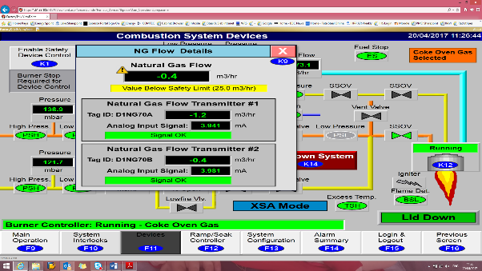
Figure 36 Screen Showing Signal Error Warning

Installation
As per the project plan the equipment was delivered to site well in advance of the planned installation date to ensure that there were no hold ups related to equipment. As previously stated the flare is a critical unit and its downtime must be carefully planned and coordinated with steel making operations. The first few days of the outage are concerned with isolating the gaseous and electrical services and issuing permits to enable wrecking or removal of the old and now redundant equipment, prior to installation of the new equipment. Figure 37 overleaf shows the Pipe and Instrumentation Diagram (P&ID) for the flare upgrade.
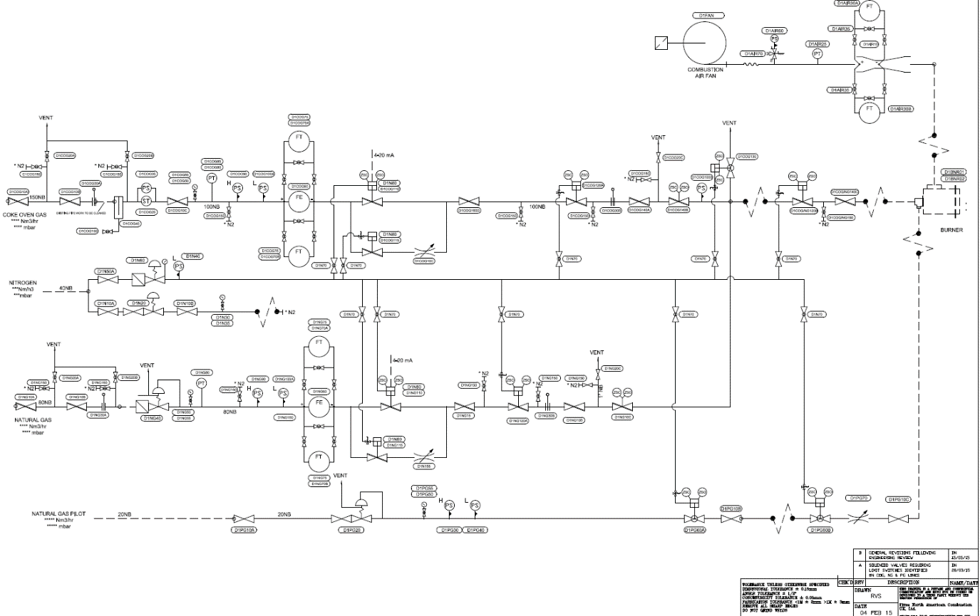
Figure 37 Hot Metal Flare P&ID Drawing
The challenges of installing new equipment around an operational steel plant are not simple, and there were often delays to works due to steelmaking activities and or overhead crane movements. This lead to increased working hours to catch up the time lost due to non-productive periods. As the electrical and automations systems progressed it was also time to install the networked services to the area which would provide the capability to remotely view and control the flare, a first for this area since it was initially installed. The piped services and electrical services continued installation during the day and night shifts in order to minimise downtime. The control cabinets were installed into the adjacent contactor room and connections were made between the panels and the field devices. Once installed and thanks to the high speed networking links, anyone with a company iPad or laptop is able to log onto the works Wi-Fi and view the operation of the flare, something that has never before been possible in this area. The web browser built into the touch screen has now been configured in order that the operations team in the main control pulpit for steel making can remotely observe the operation of the upgraded flare.
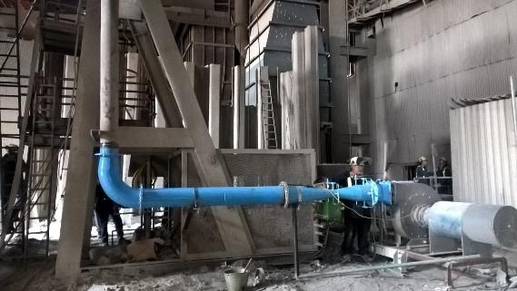
Figure 38 Site Installation Air Fan

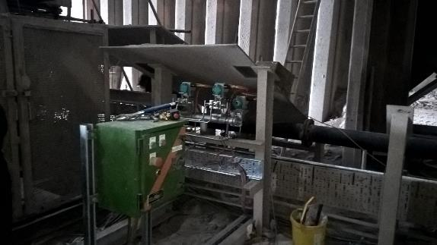
Figure 39 Site Installation Flowmeters & Motor Controls

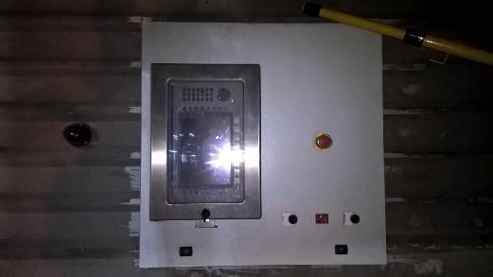
Figure 40 Site Installation New Control Station

Figure 41 Overview of Network Link & Panel Layout

Commissioning
Once all of the physical installation was completed and all the pipework and cabling fully tested and checked out the electrical power was restored to the drive and controller cubicles one by one and the control system brought to life. At this stage the gas systems are still isolated and the mechanical integrity has been proven by using compressed air and nitrogen. Each of the circuits are brought to life one by one and the instruments attached to each circuit are powered up, checked and calibrated using known tested calibrated test equipment, as each loop is signed off the control system as a whole begins to come to life. This activity involved testing of SIL rated and non SIL rated signals, for the SIL rated signals the intrinsically safe barriers installed were secured with a password once they had been confirmed as being correctly wired and configured. As we could be assured that the system does operate according to its design intent due to the work carried out previously during the factory acceptance testing, commissioning is made somewhat easier save for errors that are made during the installation activities. The commissioning activity culminates in the process of testing the systems safeguards to ensure that they are correctly connected and will operate as designed before any gasses are allowed to pass through the system. The commission process facilitates the progress of the hazard study 4 and 5 documents, which were signed off by all members of the team and the works management team before any activity was permitted in relation to using the gasses as a combustion medium.

Safeguard Verification
Once the system had been fully commissioned, it was necessary to refer back to the hazardous operations study and consult the safeguard check list in order to prove the integrity of the system as commissioned. For some of the tests involved it was first necessary to engineer the environment to undertake the test such as high pressure or low flows. Each and every safeguard detailed in the hazardous operations study was individually tested and signed off by the project team present. Ensuring that the design intent was satisfied and that the control measure specified worked and would protect the system from serious incident. The safeguard check sheets are attached at Appendix E.
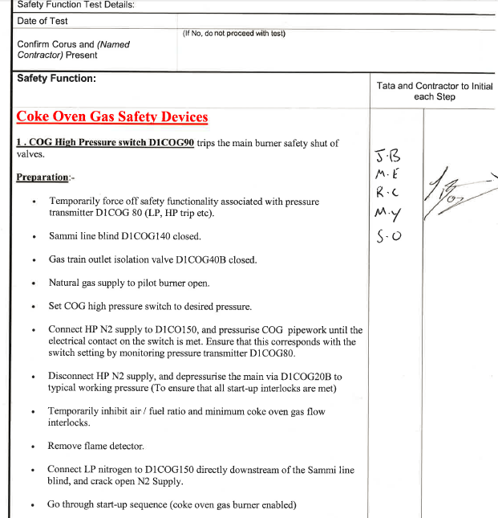
Figure 42 Site Installation Safeguard Sign Off Sheet

Handover and Training
As part of the design process I specifically selected controllers, instruments and sensors where possible that were already in use with the steelmaking area. This was an intentional act to reduce the training effort required in order to get the maintenance teams competent to maintain the equipment, as well as having a benefit of reducing the volume of spare required to be held in the site general stores to support a three hundred and sixty five day a year operation. Where new and unfamiliar equipment was installed the vendor provided training sessions to dedicated people within the steelmaking area who in turn trained the remaining people within the teams.

Chapter 4 – Conclusions and Recommendations

Conclusions
The aim of this project was s to deliver a flare operation that is reliable, has the lowest cost of operation as possible in terms of natural gas use and is compliant in all aspects with modern day safety legislation. The final solution as installed and commissioned at the steel plant has delivered in all aspects of this aim. Figure 43 below details the trend of natural gas usage at the hot metal flare prior to and after the upgrade.
Figure 43 Before & After Natural Gas Usage
As can be seen from figure 43, the gas usage has been reduced on average by 307Nm³/Hr. there is one large spike on the graph, this coincided with a plant maintenance period at the Coke Ovens gas cleaning plant. Therefore natural gas had to be consumed in order to maintain operations and not compromise them in attempting to burn coke oven gas that had not been properly cleaned.
The savings are calculated as follows.
Energy Use = Differential Nm3/Hr x Burner rating MJ/m3 = GJ/Hr
1000

Energy Use = GJ/Hr x 168 hrs in a week = GJ/Wk
Energy Use = 307 Nm3/Hr x 36.5 MJ/m3 = 11.20 GJ/Hr
1000

Energy Use = 11.20GJ/Hr x 168 = 1882.52 GJ/Wk
Gas cost = GJ/Wk x Unit Cost
Natural gas costs £5.20/GJ (Natural gas cost provided by Tata accounts department)
Therefore
Gas cost = 1882.52GJ/Wk x £5.20/GJ = £9789.12 per week.
Assuming an operational rate of 48 weeks per year allowing for maintenance and outage periods that delivers a saving to the business of £469,877.00 per year, in natural gas alone. Achieving payback in a little over 6 months. Indeed as can be seen from the graph the system has already paid for itself since it commenced operations in June 2016. In addition to these saving and helping to deliver the sustainability section of the project aim this project has delivered a reduction in CO² emissions as a result of burning natural gas. On average the reduction in gas consumption is 1882.52 GJ/Wk converted to CO² 1882.52 x 0.056 = 105.42 tonnes of CO²
Using the government’s 2016 EUETS price cap of £18/T (25), that equates to 105.42 T x £18 = £1897.58 saving in emissions per week or £91,083.84 per 48 week operational year. This is almost half of the project costs alone. Tata does not pay £18/tonne as it joined the carbon trading scheme since its inception and has a price to reflect its membership of the scheme. This price is highly confidential and as such cannot be revealed in this report. The financial savings for CO² emissions are therefore purely illustrative.
As mentioned in the literature review in relation to safety systems the air to gas ratio control was intended to be performed in the safety controller. Indeed this was the case and it proved to be a very successful and has performed as expected even given the demands of the steel works environment. Two more upgrades have been completed at the works since and both of them have integrated the ratio control into the safety controller, this may well become the new site standard. The project was delivered to time and budget without any accidents or injuries which is indeed a credit to all involved in such high tempo activities in a tight area the potential for things to go wrong is always present.

Recommendations
1: Once the system had been handed over and returned to service, there was a period of poor reliability in relation to the automated control valves which are air operated. This was traced back to a defective dryer on the general compressed air compressor. The compressor was not supplying dry air and as such the vales actuator solenoids were sticking from time to time. The recommendation would be to replace the general purpose air actuation line with a nitrogen line in the future to remove the reliance on the compressed air dryer and compressor.

2: In order to improve the accuracy of the savings achieved an electric meter should be fitted to accurately record the quantity of electricity consumed by operating the system. It can be calculated for the periods prior to the upgrade as the loading was constant. Whilst it is abundantly clear that savings are being achieved in this area, they cannot currently be quantified.

3: Now that the system has been delivered and proven to deliver in operation. The connectivity is present for remote access and control, this also opens up the possibility of connecting the controller to the site sequel servers. This connection could be used to gather data from the controller in relation to usage and operational availability, enabling further data mining or dashboard creation. One such dashboard would be to show how often the flare is on Coke Oven gas, as this it when we are saving the most money. This information can then be used to help decision making and drive a culture that strives to run the flare as soften as possible using Coke Oven gas, avoiding the import of expensive natural gas.
4: As the project is complete, there is an opportunity to consider drafting a set of company guidelines or works standard be established and adopted to manage the design and development of all suture user interfaces as the Port Talbot site. This will ensure that the good work that went into the design of the user interface on this project will live on in all future projects, ensure that those future designs are consistent throughout the company and fit for purpose.

Chapter 5 – Reflection
Written in first person.
I think it is fair to say, that had I not been searching for a project to undertake that was relevant to my degree, this project might not have been done ever. I am particularly pleased to be able to undertake it and that it was such was a good fit for both myself and my employer. I have been very pleased and indeed proud to have played my part in delivering a solution which has met and in some cases surpassed the aims and objectives set out at the project inception.
I particularly liked the period of time spent reviewing the regulations and rules, as this gave me an opportunity to explore different ways of achieving compliance other than the ways which might have normally been selected, the Ethernet emergency stops being a good example of ground breaking technology implementation of the site.
Implementation is always the most exciting and challenging time, have lots of opportunity to get involved and see the paper based creation come to life in front of you. There is also something special about bringing new technology to life, and showing that it can indeed do what it says it can.
I can feel rightly proud that I have delivered on all fronts and have achieved significant financial savings for my employer as well as delivering a state of the art control system, which is setting the standard for the art of the possible in rough and hazardous conditions for the site going forward.
Undertaking this degree allowed me to do this, the modules taught throughout the different years of the degree such as systems analysis and design, research methodology and usability engineering in particular have been key areas of learning which have enabled me to build a foundation, from which I have been able to produce this final major project, I have no doubt that this underpinning knowledge has enhanced the overall success and quality of the final result, which I feel is the pinnacle of my achievements in terms of my educational journey to date. I know that I have delivered a safe and sustainable solution as part of this project, and as a result my employer is flaring less works arising gas, purchasing and burning less natural gas, consuming less electricity to run the combustion air fan and emitting less CO² into the atmosphere, delivering on our corporate vision to create a sustainable steel industry in South Wales.

References
1. Tata Steel internal Communications Department. Tata Steel Visitors Briefing Booklet. s.l. : Tata Steel, 2016.
2. Tata Steel Sales and Marketing. Corporate News. Tata Steel Europe. [Online] [Cited: 01 03 2017.] https://www.tatasteeleurope.com/static_files/Downloads/Corporate/News/tsukfactsheet.pdf.
3. British Standards Institue. BSEN 746-2:2010 Industrial thermoprocessing equipment. Safety requirements for combustion and fuel handling systems . UK : British Standards Institue, 2010. ISBN 978 0 580 54597 9.
4. British Standards Institute. BSEN 61508-1 2010 Functional safety of electrical/electronic/ programmable electronic safety-related systems. General requirements . UK : British Standards Institute, 2010. ISBN 978 0 580 56233 4.
5. Health & Safety Executive. The Dangerous Substances and Explosive Atmospheres Regulations 2002. Legislation.gov.uk. [Online] 2002. [Cited: 01 04 2017.] http://www.legislation.gov.uk/uksi/2002/2776/contents/made. ISBN 978 0 7176 6616 4.
6. British Standards Institute. BSEN 298:2012 Automatic burner control systems for burners and appliances burning gaseous or liquid fuels . UK : British Standards Institute, 2012. ISBN 978 0 580 70697 4.
7. —. BSEN 12067-2:2004 Gas/air ratio controls for gas burners and gas burning appliances. Electronic types . UK : British Standards Institute, 2004. ISBN 0 580 43627 6.
8. —. BS EN 60079-10-2:2015 Explosive atmospheres. Classification of areas. Explosive dust atmospheres . UK : British Standards Institute, 2015. ISBN 978 0 580 80696 4.
9. Rockwell Automation. 1756 Guardlogix Integrated Safety Controller Datasheet. Rockwell Automation. [Online] 2014. [Cited: 14 03 2017.] http://literature.rockwellautomation.com/idc/groups/literature/documents/pp/1756-pp009_-en-p.pdf.
10. Fireye. UVF Scanner Datasheet. Fireye. [Online] 8 02 2017. [Cited: 03 04 2017.] http://www.fireye.com/Documents/CU-114.pdf.
11. Health & Safety Executive. ATEX and explosive atmospheres. hse.gov.uk. [Online] [Cited: 04 03 2017.] http://www.hse.gov.uk/fireandexplosion/atex.htm.
12. Hazard Research & Risk Consultants (HAZRES). Explosion Protection Document. 2014.
13. Human Factors and Ergonomics in Manufacturing & Service Industries. New York : Wiley, 2015. 1520-6564.
14. Mitchell, Patrick. Human Factors In Healthecare Course Handbook. UK : Swan & Horn, 2013. 978-1-909675-01-8.
15. Neilsen, Jakob. Usability engineering. United States of America : Morgan Kaufmann, 1993. 978-0125184069.
16. Usability.gov. Task Analysis. Usability.gov. [Online] 2 10 2016. [Cited: 19 04 2017.] http://www.usability.gov/how-to-and-tools/methods/task-analysis.html.
17. Carroll, Mary Beth Rosson & John M. Usability Engineering, Scenario based development of Human-Computer Interfaces. United States of America : Morgan Kaufmann, 2002. 1-55860-712-9.
18. Bringing usability to industrial control systems. Reul, Marcus. Boston : CHI EA 09 Confrenece, 2009. 978-1-60558-247-4 .
19. Tata Steel Project Department. WBS V3 Project Manual. Tata Steel Europe Sharepoint. [Online] 1 8 2013. [Cited: 19 03 2017.] http://sharepoint.eu.tatasteel.com/sites/cspuk/design/PM/Menus/WBS_V3_Issue_A.aspx.
20. Assocaitaion of Project Managers. Resources. Association of Project Managers. [Online] [Cited: 20 04 2017.] https://www.apm.org.uk/body-of-knowledge/context/governance/project-management/.
21. Health & Safety Executive. Revised guidance for operators of top tier COMAH establishments. Health & Safety Executive. [Online] 11 2009. [Cited: 20 04 2017.] http://www.hse.gov.uk/humanfactors/topics/specific3.pdf.
22. Iran nuclear facilities 'Thunderstruck' by AC/DC malware. New Scientist. [Online] 24 07 2012. [Cited: 03 04 2017.] https://www.newscientist.com/blogs/onepercent/2012/07/iranian-nuclear-facilities-thu.html.
23. Rockwell Automation. Powerflex 750 Safe Torque Off Datasheet. Rockwell Auotmation. [Online] [Cited: 19 03 2017.] https://www.rockwellautomation.com/resources/downloads/rockwellautomation/pdf/certification/safety/pdf/750-UM002C-EN-P.pdf.
24. Tata Steel Europe. Engineering Standards & Codes of Practice Platform. Tata Steel Intranet. [Online] 12 10 2013. [Cited: 07 04 2017.] http://intranet.eu.tatasteel.com/irj/go/km/docs/corporatedocuments/News/corporate/en/corus/e0a80574-e243-3110-c29d-ae9cdc7e6fe5.xml. MES 003.
25. UK Government. Carbon price floor: reform. Gov.uk. [Online] 19 03 2014. [Cited: 12 04 2017.] https://www.gov.uk/government/publications/carbon-price-floor-reform.

Appendices

Appendix A HAZRES Explosion Protection Document
Document in the physical hand in copy only due to its size

Appendix B Functional Design Specification
Document in the physical hand in copy only due to its size

Appendix C Quotes
Document in the physical hand in copy only due to its size

Appendix D HAZOP
Document in the physical hand in copy only due to its size

