  LOCATION Swansea | LLEOLIAD abertawe
LEVEL 6 | LEFEL 6
EXAMINATION PERIOD | CYFNOD ARHOLIADAU
May 2016 | Mai 2016

MODULE CODE: M3X8529
Embedded Microcontrollers

Marking Scheme

ANSWER ALL QUESTIONS

QUESTION ONE (35 marks total)
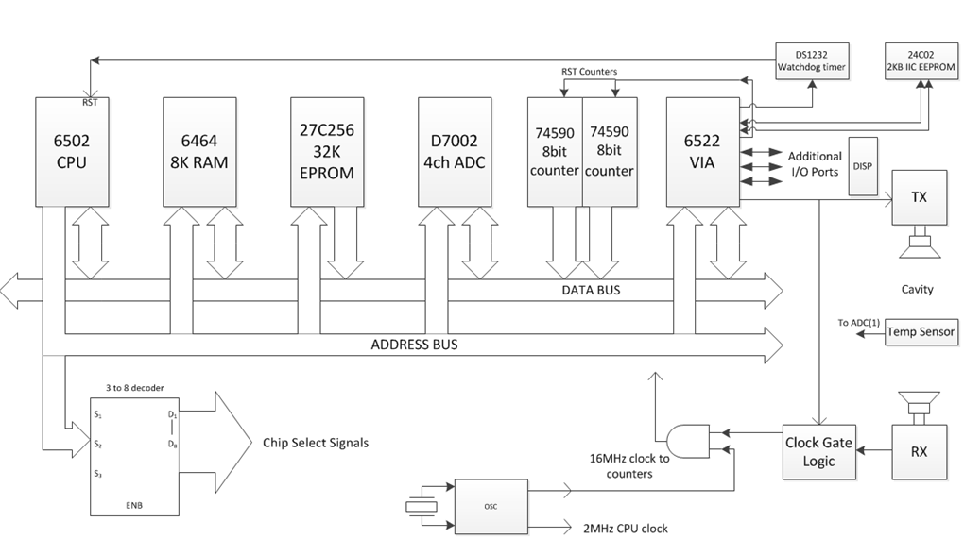

The system diagram above is of one of the case studies covered during the course of the term. It illustrates the design of a microprocessor controlled device that calculates the concentration of Carbon Dioxide in the air, based on time of flight information of an ultrasonic pulse sent through an air cavity but also utilising a compensation value from a temperature sensor.

- Identify and explain the purpose and general function of each of the blocks in the above diagram. (15 marks)

There are 15 discrete areas. One mark for each area..
CPU
RAM
EPROM
DAC
8 bit counters
VIA
Watchdog
IIC EEPROM
3-8 decoder
Clock & crystal
Clock gate
AND gate for clock
RX & TX
Temp Sensor
Display

You are now given the task of updating the design to try and reduce the overall component count and base as much as possible around an embedded microcontroller instead of a discrete microprocessor and associated peripheral/support circuitry.

- Sketch a rough circuit/system diagram using a typical PIC microcontroller. You do not have to specify an exact model, but you should explain the basic functionality of the device type chosen and indicate the function of any pins used in your diagram.
(10 marks)

Diagram should be able to be functionally accurate, showing the appropriate power lines, digital and analogue I/O pins, clocking circuitry plus any additional components that are not capable of being included internally in the chip, such as a high speed counter if the speed of the PIC is not sufficient. (10 marks)

- Explain why you have chosen that device type, detailing what features does it have that replace the original discrete ‘blocks’, and any other issues that factored into your choice. Are there any items of the original design that might not be able to be directly replicated within your choice of PIC? If this is the case, what would be your design solution? (10 marks)

Answer should be sensible, identify a suitable family such as the 16 series. Able to specify the correct number of I/O pins and type needed. Inclusion of built in watchdog timer and a small amount of EEPROM for calibration purposes.
The accuracy of the in built timer might not be sufficient for this particular application, therefore the discrete 16 bit timer might have to be separate, thus sufficient additional I/O pins will be required. (10 marks)

QUESTION TWO (15 marks total)

What is JTAG? Explain its original purpose and give examples of how its standards have been extended to provide additional functionality.

Answer to include the following core areas. Sections of notes are included here as a guide.

History
In the 1980s, multi-layer circuit boards and non-lead-frame integrated circuits (ICs) were becoming standard and connections were being made between ICs that were not available to probes. The majority of manufacturing and field faults in circuit boards were due to poor solder joints on the boards, imperfections in board connections, or the bonds and bond wires from IC pads to pin lead frames. The Joint Test Action Group (JTAG) was formed in 1985 to provide a pins-out view from one IC pad to another so these faults could be discovered.
Debugging
Although JTAG's early applications targeted board level testing, the JTAG standard was designed to assist with device, board, and system testing, diagnosis, and fault isolation. Today JTAG is used as the primary means of accessing sub-blocks of integrated circuits, making it an essential mechanism for debugging embedded systems which may not have any other debug-capable communications channel.

Storing firmware
JTAG allows device programmer hardware to transfer data into internal non-volatile device memory (e.g. CPLDs). Some device programmers serve a double purpose for programming as well as debugging the device. In the case of FPGAs, volatile memory devices can also be programmed via the JTAG port, normally during development work. In addition, internal monitoring capabilities (temperature, voltage and current) may be accessible via the JTAG port.

JTAG programmers are also used to write software and data into flash memory.

Boundary scan testing
JTAG boundary scan technology provides access to many logic signals of a complex integrated circuit, including the device pins. The signals are represented in the boundary scan register (BSR) accessible via the TAP. This permits testing as well as controlling the states of the signals for testing and debugging. Therefore, both software and hardware (manufacturing) faults may be located and an operating device may be monitored.

QUESTION THREE (30 marks total)

Sometimes, the design of an embedded system involves significant complexity that would be better realised by utilising more sophisticated hardware and software than a simple microcontroller can easily provide. The PC104 standard is one such platform.

- Produce a brief report explaining what it is and highlighting its general features.
(10 marks)

PC/104 (or PC104) is a family of embedded computer standards which define both form factors and computer buses. PC/104 is intended for specialized environments where a small, rugged computer system is required. The standard is modular, and allows consumers to stack together boards from a variety of COTS manufacturers to produce a customized embedded system
PC/104 is sometimes referred to as a "stackable PC", as most of the architecture derives from the desktop PC. The majority of PC/104 CPU boards are x86 compatible and include standard PC interfaces such as Serial Ports, USB, Ethernet, and VGA
Available with a range of PC compatible processors, from low power Atom type, up to full core i7 variants. Full range of I/O capability as per a normal PC.

- What types of operating systems typically run on such devices? (3 marks)

A x86 PC/104 system is usually capable of standard PC operating system such as DOS, Windows, or Linux. However, it is also quite common to use a real-time operating system, such as VxWorks.

- Why do many such embedded systems require a specialised RTOS (Real Time Operating System)? (5 marks)

Need to ensure a guaranteed maximum latency time while still providing a powerfull, multitasking environment, complete with the typical high level features and connectivity such as interrupt servicing etc that would be found on a more traditional OS.
an RTOS an operating system must:
Have response time predictability.
Be deterministic.

- Explain what is meant by:
A Non Real Time System
A Soft Real Time System
A Hard Real Time System
(12 marks – 4 marks each)

Non Real Time systems
A non real time system is a system where there are no deadlines involved. Non-RT systems could be described as follows:
“A non real time system is a system where the programmed reaction to an event will certainly happen sometime in the future”. (4 marks)

Soft Real Time systems
A Soft real time system is a system where not meeting a deadline can have undesirable but not catastrophic effects, a performance degradation for example. SRTs could be described as follows:
“A soft real time system is a system where the programmed reaction to an event is almost always completed within a known finite time”. (4 marks)

Hard Real Time systems
An Hard Real Time (HRT) system is a system where not meeting a deadline can have catastrophic effects. HRT systems require a much more strict definition and could be described as follows:
“An hard real time system is a system where the programmed reaction to an event must be guaranteed to be completed within a known finite time”. (4 marks)
QUESTION FOUR (20 marks total)

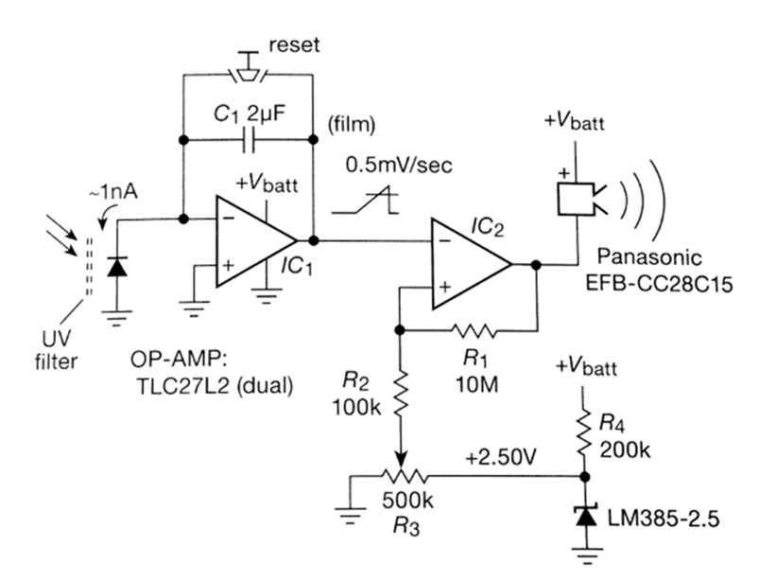

The Circuit above shows a purely analogue implementation of a simple ‘suntan timer’ where the light falling on a photodiode causes the sounder to operate after a time period that can be adjusted by the 500K potentiometer.
The circuit below is an alternative implementation based around an ATmega microcontroller.
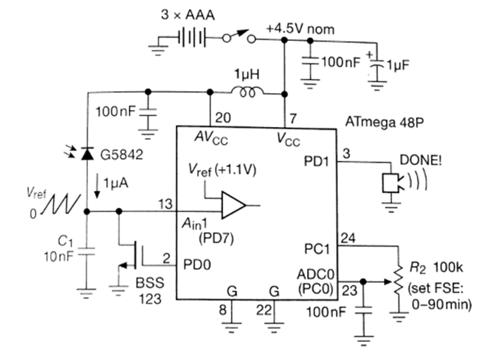

Explain the principle of operation of:
- the analogue version (5 marks)

Student should be able to explain:
Photodiode allows reverse leakage current to pass depending on light
IC1 with C1 is configured as an integrator which builds up a voltage proportional to time
The voltage is presented to IC2 which is configured as a comparator.
The charge is reset by shorting out the capacitor via the switch
When the comparator input crosses a threshold set by the reference voltage produced by the precision voltage reference (and made variable by the pot R3 which forms a potential divider), the output switches and drives the buzzer.
Typically 1 mark for each of the 5 sections.

- the microcontroller version, detailing the function of each component and every pin of the micro. (15 marks)

Student should be able to describe the following salient areas:

Use of the decoupling capacitors – 100nf for the HF side, the 1uF as the main smoothing cap.
The 1uH choke to separate the analogue and digital power rails of pins 20 and 7 resp. to avoid HF feedthrough from the micro’s clocking operations.
The reverse charge through the photodiode used to ramp a charge on C1
The chip having an on board comparator on pin13 driven with an internal precision reference of 1.1v
Pin 2 driving a FET to discharge the ramp capacitor.
Pin24 being a switchable logic output used to provide power to the potential divider/pot R2 (to save power once the pot is used – its switched off)
Pin23 is an analogue in to read the pot value with the capacitor to smooth the DC and remove HF noise.
Pin 3 configured as a digital output with enough drive current to operate the buzzer module directly.
Approximatley 2 marks would be allocated for each correct section. 15 marks total.

