Proposal for Improving Information Systems at Maldiva Ltd.
Component 2 – Individual Report: Information Systems Improvements

Student Name | Mohammed shah Nawaz Afzal
Student ID Number | 2424009

Table of Contents
1. Introduction 2
2. Evaluation of Existing Systems 2
3. Recommended Solution 4
4. Implementation Plan 7
5. Conclusion 9
References 11

1. Introduction

Maldiva Ltd. is a rapidly expanding retailer of consumer electronics with 30 stores and ecommerce. As this business case demonstrates, the sales growth has not been matched by similarly developed information systems. The business continues to manage stock and record the details of customers with manual methods, disjointed customer records, spreadsheets for reporting, and the lack of access control and departmental applications. The weaknesses are not just administrative matters anymore, but customer satisfaction, cost control, legal compliance and management decision making issues. In the Omnichannel world, the same product can be looked up online, bought at a store, returned on another channel, and used as a basis for a new service call. So, information needs to be passed on correctly through inventory, sales, finance, marketing and customer support. The modern information system is considered to be a business improvement, rather than an IT replacement. Cloud-based enterprise resource planning (ERP) is appropriate because it makes it easier to integrate key enterprise functions and provide scaling for growing businesses (Ahn and Ahn, 2020). The value of ERP is best established when it is tied to a specific benefit to the business and the redesign of processes, and not just software installation (Anaya et al., 2023). The current gaps in the system in Maldiva Ltd. are assessed, and a cloud ERP solution, including CRM, inventory management, business intelligence (BI), e-commerce integration and security measures aligned with GDPR regulations is recommended, along with tangible implementation steps and performance indicators. The goal is to increase efficiency, reduce stock inaccuracies, enhance customer service, facilitate data management and real-time decision making, and remain within the scope of a developing retail business.

2. Evaluation of Existing Systems

The biggest deficiency in Maldiva Ltd. is its current inventory process. With handwritten stock keeping, you are likely to have mismatch between the stock in store and the availability of the product on the website, which leads to order placement by customers of product that you don't have. This translates into a loss of trust, a loss of sales and complaints. Data integration is a critical component of modern supply chains as it enhances visibility, forecasting, and responsiveness, which can lead to better decision-making and efficiency (Atieh et al., 2025). The current inventory approach also allows for overstocking and understocking as there isn't a view of the product movement across the channels. This is particularly harmful to a company that sells consumer electronics, as it can be easily outdated and items like popular products can sell out before restocking is initiated.
The same applies to the CRM issue. The company has a fragmented customer data spread across different and disconnected systems and can't create a single customer view. This restricts personalised marketing, hampers complaint handling procedures and hinders the analysis of repeat purchases. As customer interactions within a CRM system can be analyzed to understand the customer's needs, this capability is associated with customer engagement and innovation performance.Customer engagement and innovation performance are closely linked to the CRM capability of learning from customer interactions (Binsaeed et al., 2023). Recent studies on CRM also indicate that digital relationship management can enhance customer satisfaction and market effectiveness by organizing and leveraging customer information (Elshaer et al., 2025). Retail-based CRM is most effective if retailers and central management share the customer insight and not act as holding separate local records (García-Nieto, Ramón-Jerónimo and Flórez-López, 2025). Without a connected CRM, marketing and support teams at Maldiva Ltd. have to deal with incomplete evidence.
The management reporting is also out of date. Manually created spreadsheets are slow and prone to errors, making it hard for managers to respond rapidly to changes in demand and understand regional sales trends and fulfilment issues. The BI systems are essential to increase the competitiveness of organizations by converting operational information into decision-making-ready information (Jiménez-Partearroyo and Medina-López, 2024). Moreover, retail analytics can aid in customer segmentation, decision-making regarding product planning and promotion (Alqhatani et al., 2022). BI is a part of firm performance when it is integrated in big data analytics and is understandable and used by the managers (Pancić, Ćućić and Serdarušić, 2023). Last but not least, lack of appropriate access control leads to GDPR and cyber security risk. According to GDPR, personal data must be processed lawfully, securely and transparently (Labadie and Legner, 2023). A disjointed system thus leaves Maldiva Ltd vulnerable to operational, legal and reputational risk. In summary, the current approach is not satisfactory enough to serve as a single source of truth for the omnichannel retail business. Data from each department can be assumed to be accurate, but no department can trust the data being used by other departments because there is no integration.
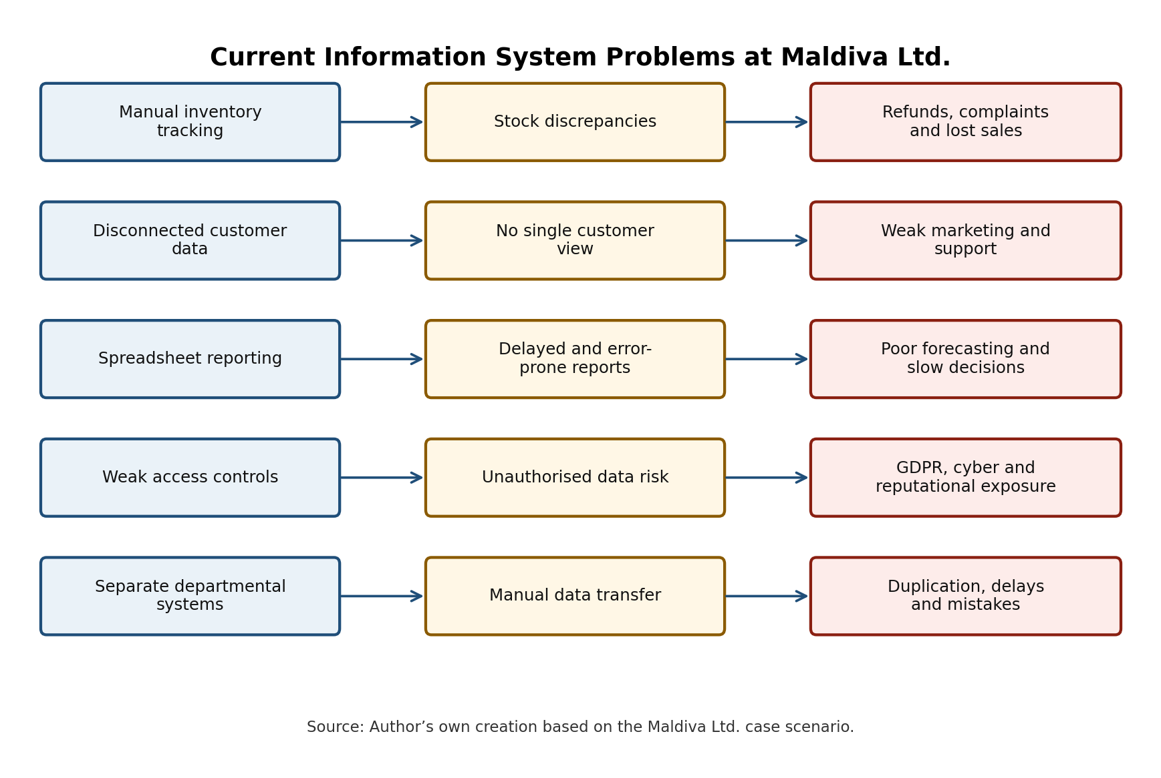
Figure 1: Current information system problems at Maldiva Ltd. Source: Author’s own creation.

3. Recommended Solution

A suggested solution is an Integrated ERP system running on the cloud with five modules connected: Inventory Management, CRM, e-commerce integration, finance/sales integration and BI dashboards. A scalable, modular solution like Microsoft Dynamics 365 (with Dynamics 365 Sales/Customer Insights) and Oracle NetSuite or SAP Business One would all be viable choices, but the report suggests that as a growing retailer that wants a cloud solution, Microsoft Dynamics 365 might be considered. According to the research undertaken on cloud ERP, relative advantage, organisational culture, regulation and employee capability are the factors that affect the successful acceptance of the ERP system (Ahn and Ahn, 2020). With modern architecture and managed service capability, a cloud ERP platform offers resilience and agility (Lee, Kim and Lee, 2024).
The first benefit is inventory visibility. A central stock database should be able to synchronize online orders, track sales, transfers, returns and replenishment. This will minimize false online availability, boost fulfilment accuracy and enable managers to determine which products are moving slowly or quickly. Logistics management can be supported by ERP, providing integration of inventory, purchasing and operational data that can minimise duplication of manual tasks and enhance coordination (Canon et al., 2025). The system should have low stock alerts, automatic overstock, stockout, order cycle time and refund alerts and dashboards. This would enable management to determine if the stock should be moved from one store to another, if the product needs to be replenished from suppliers or if the product should be adjusted in the online system before the customers.
The second advantage is CRM enhancement. Customer profiles, purchase history, service requests and marketing permissions will be stored in a single, secure platform in a central CRM. This will make it possible for Marketing to create targeted promotions and for support to be able to solve complaints quicker. In researching sustainable CRM (SR), it is important to focus on the value of forging long-term relationships with customers, not only short-term selling (Li, Lin and Zhang, 2023). In addition, Data-driven CRM can be used to drive innovation by understanding what customers are looking for and the frequency of their purchases (Lin and Chen, 2025). At the Maldiva Ltd., this translates to communicating in a more accurate way, whilst still respecting consent and privacy rules. The CRM should also include information about complaint types, the reasons for the product to be returned, and warranty problems that will allow customer service information to be useful for buying and quality decisions.
The third benefit is improved management information. BI dashboards should provide daily sales, product profitability, store performance, online conversion, complaint trends, stock accuracy and should forecast demand. The implementation of BI should correspond to strategy, system function, and the cost of license and the maturity of the IT infrastructure (Fu et al., 2022). BI tools can also help in marketing planning by linking data analysis and marketing decision making (Kongthanasuwan et al., 2023). Managers would be able to make action decisions on real-time trends, rather than waiting for spreadsheet reports. For instance, a product might be selling well on the Internet while having an excess of product in some stores – this system can bring up the option of a product transfer or a product promotion.
The alternative solutions are not as strong as this solution. While a BI dashboard will enhance reporting, it will not eliminate manual processes that cause inaccuracies to the report in the first place. Likewise, a standalone CRM would help with marketing, but not with customer support and stock and order information. The solution is due to efficiency, cost and scalability in accordance with business needs. Having one standalone inventory app would address only one operational concern and a standalone CRM would not resolve the inventory concerns or reporting delays. If you consider the long-term value of an integrated cloud ERP, it will far outweigh the upfront cost it'll take to implement because it eliminates duplicate work, decreases refunds, streamlines reporting and supports future store growth. The deployment in cloud also eliminates the investment in maintaining and constructing local servers. The system should have role-based access control, encryption, audit trail, multi-factor authentication, backup and data retention features. An approach to cyber risk as outlined in the NIST Cybersecurity Framework is governance, identification, protection, detection, response, and recovery (NIST, 2024). Data protection should be incorporated into processes, responsibilities and information governance and not be an "afterthought" (Labadie and Legner, 2023).
Table 1: Comparison of information system options for Maldiva Ltd.
Option | Main benefit | Limitation and suitability
Standalone inventory system | Improves stock recording and reorder visibility. | Does not solve CRM, finance integration or management reporting problems; medium suitability.
Standalone CRM system | Improves customer records, marketing and support service. | Does not fix stock discrepancies or spreadsheet reporting; medium suitability.
BI dashboard only | Improves reporting speed and visibility of trends. | Depends on accurate source data and does not automate operational processes; low to medium suitability.
Integrated cloud ERP + CRM + BI | Connects stores, e-commerce, inventory, finance, CRM and dashboards in one secure platform. | Higher implementation cost and change-management need, but best overall fit for Maldiva Ltd.; high suitability.

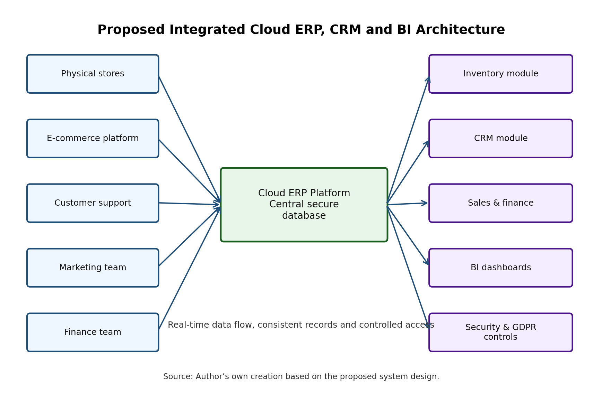
Figure 2: Proposed integrated cloud ERP, CRM and BI architecture. Source: Author’s own creation.

4. Implementation Plan

Transition should be phased to minimize any disruption and maintain trading continuity. The first phase includes requirements and process audit of inventory, sales, finance, marketing, customer support and e-commerce. This will determine if data is duplicated, report requirements, access and integration points. The second step in vendor selection is based on factors like functionality, scalability, licensing fees, implementation assistance, GDPR capabilities, and user-friendliness. Technical fit and business process fit are important criteria for ERP selection; if they do not fit, then the implementation risk goes up (Svensson and Thoss, 2021).
The third phase is data cleaning and data transfer. Any customer data, product codes, supplier data, stock balances and previous sales should be cleaned prior to uploading. The lack of quality data would simply take all the errors that were there with the old platform and put them into the new platform. Phase four: System Configuration, inventory rules, CRM fields, finance workflows, BI dashboards and security permissions. Phase five involves a pilot of stock synchronisation, order fulfilment, refunds and dashboard accuracy in a limited number of stores and the e-commerce channel. During the pilot, the pilot process should be placed side by side with existing controls to allow for the comparison of old and new data in order to examine differences prior to rollout.
Phase six is "Training and Change Management. Store managers should be trained on inventory dashboards, marketing staff should be trained on CRM, finance staff trained on reporting and customer support staff should have access to customer history. This is probably due to staff using spreadsheets they are familiar with, and manual processes. Therefore, implementing it should involve the user champions, short training videos, helpdesk support, feedback sessions. Training not only needs to teach button clicking it needs to teach why good data entry is important to customer satisfaction, compliance and management decisions. In addition, the message of change should be made clear to managers: the system is not designed to be a tool for monitoring staff but rather to lessen repetition of administration and enhance the quality of service. The next phase of the work is full rollout, where monitoring against key performance indicators (KPIs) including stock discrepancy rate, refund volume, order fulfilment time, complaint resolution time, report preparation time, customer satisfaction and GDPR incident records will take place. Value of ERP realization research indicates the need to monitor the benefits of ERP in a continuous manner after the go-live point, not just at the installation time (Anaya et al., 2023).
Table 2: Implementation plan and timeline for Maldiva Ltd.
Phase | Weeks | Key activities and outputs
1 | 1–2 | Requirements audit, process mapping and data-risk review.
2 | 3–4 | Vendor selection, cost review, contract and implementation planning.
3 | 5–7 | Clean product, stock, customer, supplier and sales data before migration.
4 | 7–9 | Configure ERP, CRM, BI dashboards, workflows and access controls.
5 | 10–11 | Pilot selected stores and e-commerce integration; compare old and new records.
6 | 11–14 | Train users, provide helpdesk support and appoint user champions.
7 | 14–15 | Full rollout across 30 stores and online sales channel.
8 | 16–18 | Monitor KPIs, resolve defects and optimise dashboards/processes.

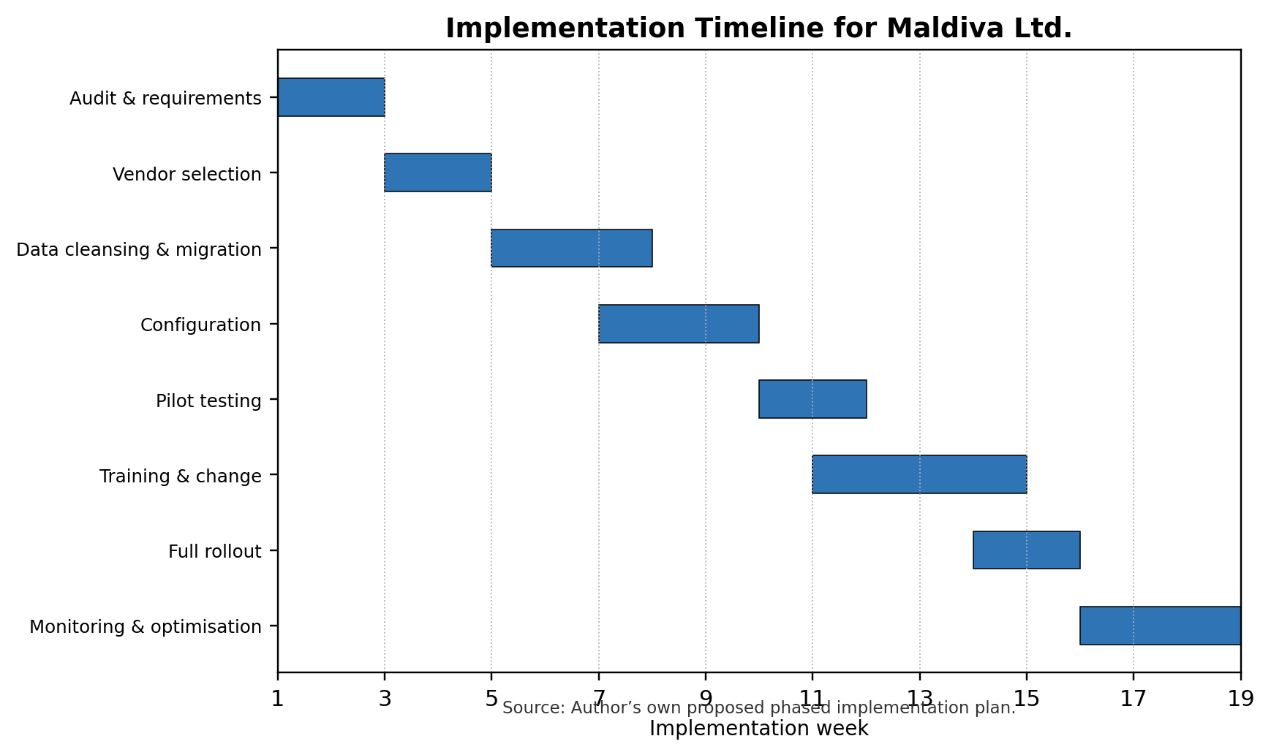
Figure 3: Implementation timeline/Gantt chart. Source: Author’s own creation.

5. Conclusion

Maldiva Ltd has found that its existing information systems are inadequate for a retailer going through a phase of expansion and operating in both the physical and digital world. Errors in inventory, lack of personalized service due to disconnected CRM, delayed decision-making due to spreadsheet reporting and chronic GDPR and cyber security issues due to weak access control are all common issues with manual inventory tracking. The best fit is the right cloud ERP solution integrated with the CRM, inventory, BI, e-commerce and security modules; which addresses the root problem: Lack of information across departments. The solution will enhance the visibility of inventory in real-time, centralize customer data, automate reporting, integrate sales and finance and ensure adherence to regulations and facilitate future expansion. Rollout, data cleansing, staff training, integration testing and post-implementation monitoring will be key to a successful implementation. With proper management, the system should help to minimize human mistakes, enhance customer satisfaction, and provide accurate information to the senior management for quick and well-informed decision-making. This will set up Maldiva Ltd. for measured expansion, as the growth will be based on correct data, processes and good governance, and not on delicate manual solutions.

References
Ahn, B. and Ahn, H. (2020) ‘Factors affecting intention to adopt cloud-based ERP from a comprehensive approach’, Sustainability, 12(16), p.6426.
Alqhatani, A., Ashraf, M.S., Ferzund, J., Shaf, A., Abosaq, H.A., Rahman, S., Irfan, M. and Alqhtani, S.M. (2022) ‘360° retail business analytics by adopting hybrid machine learning and a business intelligence approach’, Sustainability, 14(19), p.11942.
Anaya, L., Flak, L. and Abushakra, A. (2023) ‘Realizing sustainable value from ERP systems implementation’, Sustainability, 15(7), p.5783.
Atieh, A.A., Abu Hussein, A., Al-Jaghoub, S., Alheet, A.F. and Attiany, M. (2025) ‘The impact of digital technology, automation, and data integration on supply chain performance: exploring the moderating role of digital transformation’, Logistics, 9(1), p.11.
Binsaeed, R.H., Yousaf, Z., Grigorescu, A., Chitescu, R.I., Nassani, A.A. and Samoila, A. (2023) ‘Customer engagement and customer relationship management capabilities’ effects on innovation performance and customer distrust’s moderating role’, Sustainability, 15(12), p.9475.
Canon, J.G.F., dos Santos, R.J.R., de Carvalho, V.D.H., Monte, M.B.S. and de Barros, T.L. (2025) ‘Integrated logistics management through ERP system: a case study in an emerging regional market’, Logistics, 9(2), p.59.
Elshaer, I.A., Azazz, A.M.S., Fayyad, S., Mohamed, S.A., Fouad, A.M. and Fathy, E.A. (2025) ‘From data to delight: leveraging social customer relationship management to elevate customer satisfaction and market effectiveness’, Information, 16(1), p.9.
Fu, H.P., Chang, T.H., Teng, Y.H., Liu, C.H. and Chuang, H.C. (2022) ‘Critical factors considered by companies to introduce business intelligence systems’, Axioms, 11(7), p.338.
García-Nieto, M., Ramón-Jerónimo, J.M. and Flórez-López, R. (2025) ‘Effectiveness of customer relationship management in shopping malls: mall–retailer collaboration empirics’, Administrative Sciences, 15(1), p.31.
Jiménez-Partearroyo, M. and Medina-López, A. (2024) ‘Leveraging business intelligence systems for enhanced corporate competitiveness: strategy and evolution’, Systems, 12(3), p.94.
Kongthanasuwan, T., Sriwiboon, N., Horbanluekit, B., Laesanklang, W. and Krityakierne, T. (2023) ‘Market analysis with business intelligence system for marketing planning’, Information, 14(2), p.116.
Labadie, C. and Legner, C. (2023) ‘Building data management capabilities to address data protection regulations: learnings from EU-GDPR’, Journal of Information Technology, 38(1), pp.16–44.
Lee, C., Kim, H.F. and Lee, B.G. (2024) ‘A systematic literature review on the strategic shift to cloud ERP: leveraging microservice architecture and MSPs for resilience and agility’, Electronics, 13(14), p.2885.
Li, J., Lin, Z. and Zhang, X. (2023) ‘The study on the effectiveness of sustainable customer relationship management: evidence from the online shopping industry’, Sustainability, 15(7), p.5911.
Lin, J.Y. and Chen, C.C. (2025) ‘Driving innovation through customer relationship management—a data-driven approach’, Sustainability, 17(8), p.3663.
National Institute of Standards and Technology (2024) The NIST Cybersecurity Framework (CSF) 2.0. NIST CSWP 29.
Pancić, M., Ćućić, D. and Serdarušić, H. (2023) ‘Business intelligence (BI) in firm performance: role of big data analytics and blockchain technology’, Economies, 11(3), p.99.
Svensson, A. and Thoss, A. (2021) ‘Risk factors when implementing ERP systems in small companies’, Information, 12(11), p.478.

