Rebecca Aldron 1804494

National Health Service Wales Report

Teacher: Dr Jayne Griffith parry

This report will look into the current structure of NHS wales it will look into the seven health boards and how they are governed, looking at aspects like the trusts situated in the health boards, where the funding comes from and how is it divided, and will provide recommendations for improvements.

Contents page

Introduction page 4

How the trusts work page 5

How management structures generally work within each Health Board page 6-8

The pros and cons of the current structure page 9-10

Recommendations page 11

Reference list page 12

Introduction

National health service Wales (NHS) was established in 1948, by Aneurin Bevan. The national health service is a publicly funded health service that delivers care to three million people that live in Wales. The NHS will give free health care to anyone that needs it regardless of their wealth status (National Health Service 2020).
The NHS Wales is governed by seven health boards

- Aneurin Bevan Health Board, delivers healthcare a population of around 600,000 people, this covers the areas of Blaenau Gwent, Caerphilly, Monmouthshire, Newport, Torfaen and South Powys (NHS Wales 2020).
- Betsi Cadwaladr University Health Board, deliver care to 676,000 people across North Wales: Bangor, Bodelwyddan and Wrexham are where the main hospitals a located.
- Cardiff & Vale University Health Board, delivers healthcare to approx. 472,400 individuals in Cardiff and the Vale of Glamorgan
- Cwm Taf Morgannwg Health Board, covers Merthyr Tydfil, Rhondda Cynon Taf and Bridgend county borough
- Hywel Dda Health Board, delivers healthcare to 372,320 individuals throughout Carmarthenshire, Ceredigion and Pembrokeshire.
- Powys Teaching Health Board, delivers healthcare to 133,000 individuals throughout Powys
- Swansea Bay University Health Board delivers healthcare to 390,000 invidouals in the surrounding areas of Swansea and Neath Port Talbot.
(NHS 2020).

How the trust works?

A major change was made in 2009, in order to deliver better healthcare to the growing population of Wales. The seven health boards deliver healthcare services to their areas.
There are four NHS trusts in wales, they deliver care to a population approximately of 3 million, covering an area 20,640 kilometres

- Welsh Ambulance Service, they are in place to help service users in an emergency with unplanned clinical care, they attend to more than 250,000 calls, over 50,000 critical call outs and deal with 1.3million non-emergency call outs every year
- Velindre, specialist Services: cancer care, national support services and public health Wales, they deliver this service through south and mid wales
- Public health Wales, purpose is to protect and improve health and wellbeing, protecting the public from infections. (Health in Wales 2020)
- Health Education and Improvement Wales (HEIW) Established on 1 October 2018 this trust looks at the educational side, to see if students are getting enough education before going into a workplace HEIW is there to check and regulate students and employees
(NHS Wales, 2020)

The NHS Wales is a Shared Services Partnership (NWSSP) is an impartial company, owned and directed by NHS Wales. NWSSP aids NHS Wales through the provision of a comprehensive range of high quality, service user centred support functions and services (NHS Wales, 2020).

How management structures generally work within each Health Board.

The health board chosen is a very busy health board, that works well, this one has been chosen to show an example of how health boards are generally run. Cardiff and vale of Glamorgan employ around 14,500 staff members, they spend roughly 1.4 billion pounds every year, on providing healthcare and wellbeing services to the population of Cardiff and the vale of Glamorgan this is approximately 472,400 people. They also deal with the population in south and mid wales, for a variety of specialties. Their structure involves their 14,500 staff that deliver magnificent care services to all their patients. The organisation itself is designed into eight clinical boards which cover the four trusts, the eight clinical board was first established in June 2013, it has been very successful in giving strong leadership in clinical areas, this has been great for the outcomes of patients and an improvement on care. The boards are held to account through the exclusive directors and they deal with the inspection based on the monthly performance, this is a robust authorisation process.
NHS Wales in 2009 when though a structure change, welsh labour government changed a system that had mixed market levers along with bureaucratic in NHS Wales, welsh labour brought in a new system that removed almost all market levers. The purpose of this reform was an attempt to focus solely on patient care, and therefore create a structure that would provide a simpler and more efficient way of delivering care to the patients. (GP-one, 2019)

NHS Wales is funded by the United kingdom’s (UK) tax payers, so it firstly comes from the UK Government, then it gets passed to the UK treasury then it is divided between England, Northern Ireland, Scotland and Wales (NHS Wales Informatics Service, 2020). Once the National Assembly for Wales receive their share it is passed to the Welsh Government that allocates the amount to the seven health boards. (Doheny, 2015).
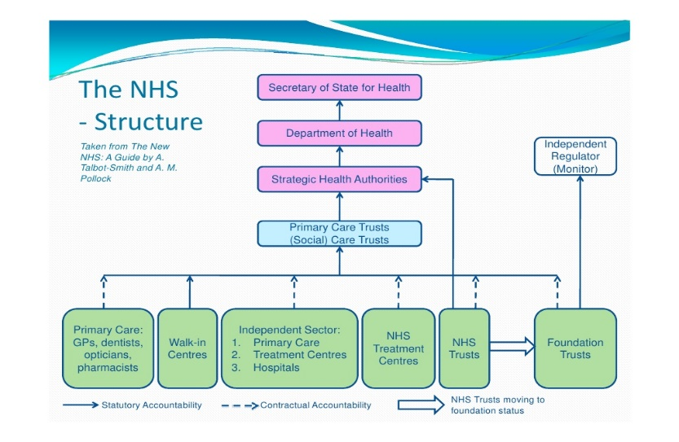

NHS wales manages within the seven integrated health boards. Unlike England, it makes not much use if any of the private sector. The devolved welsh government has used the abilities to set distinct priorities and has made goals to make healthcare better for the people in Wales. It has highlighted prevention and public health more than England, as England have privatised their services more than Wales. Wales targets for waiting times for planned hospital entries, A&E, and ambulance response times has declined considerably. (Nuffield Trust, 2020)
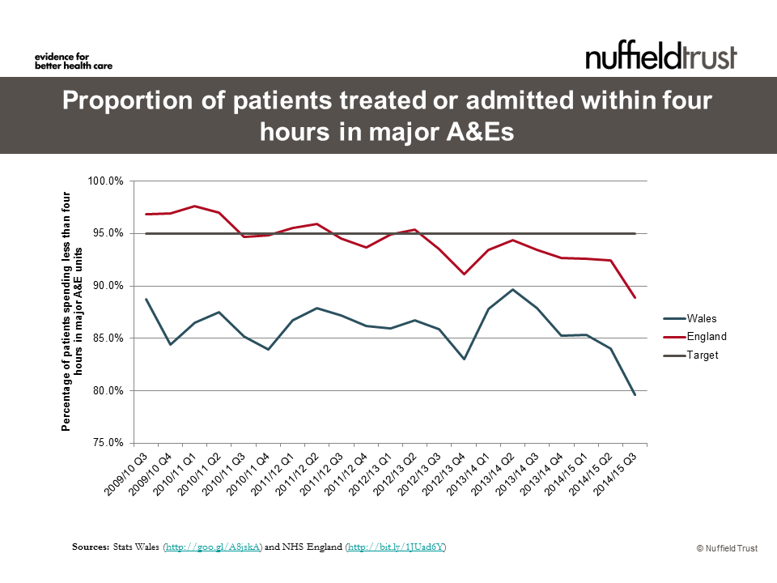

Sources: Stats Wales

The pros and cons of the current structure
Even though wales as a form of independence, and runs a successful health service to many people across wales, since the whole Brexit worry has been about there has been troublesome thoughts as to what will happen to our Welsh NHS, according to BBC News (2017) there has been a decrease in EU nurses applying for jobs with the NHS since the idea of Brexit. Now that we know that Brexit will commence on the 31st of January 2020, people of Wales need security to know that their NHS is not going to be sold off, or to know that it is to enable them to prepare for the future of their healthcare needs.

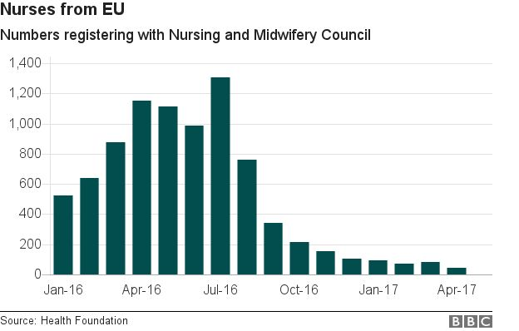

These are the worrying conditions; wales need to gain clarity over what is going to happen to their NHS in wales or will there even be doctors and nurses in the future applying for this role as NHS wales is deemed not a stable job.
In winter 2020, has seen its worst waiting times they have ever been, the target was aimed to see 95% of patients, however they did not meet this target.
One of the recommendations is if they privatised some of their facilities, like the ambulance service to private firms they would be able to get people the critical care they need, The Welsh Ambulance Service have missed its target for responding critical life threating calls for a second month
Even though the way the NHS wales is structured well, there are over stretched and understaffed (BBC Wales 2020).

This report looked in-depth NHS wales. it went on to discuss the seven health boards and how they are current structured, it highlighted that there are four trusts within the seven health boards. It found that Brexit will impact the NHS significantly, Recommendations are to follow.

Recommendations for future improvement for NHS Wales even though NHS wales is structured well, and showing better results than England, according to BBC Wales (2018) there is a funding problem in 2018 the welsh health boards owed over 163 million pound, this was just for the one financial year. This was a 40% increase from 2017. Possibly if the NHS found a new way to gain more funding, such as raising national insurance, they would gain more money for better equipment, extra staff members and hopefully that would lead to shorter waiting times. Another recommendation is that they could access the patients more to dedicate their time on the people that need the most important care would be seen to first, it would be the upmost importance to get critically ill patients seen to first to minimise the risk of death and minimise the risk of infection and disease.

Reference list

BBC News (2018). Health boards' deficit reaches £163m. [online] BBC News. Available at: https://www.bbc.co.uk/news/uk-wales-43543145 [Accessed 23 Jan. 2020].
BBC Wales (2017). Huge drop in EU nurses since Brexit vote. [online] BBC News. Available at: https://www.bbc.co.uk/news/health-40248366 [Accessed 23 Jan. 2020].
BBC Wales (2020). Welsh A&E waiting times hit worst ever level. [online] BBC News. Available at: https://www.bbc.co.uk/news/uk-wales-51209403 [Accessed 23 Jan. 2020]
Doheny, D. (2015). The organisation of the NHS in the UK: comparing structures in the four countries. [PDF] Cardiff, Wales: National Assembly for Wales, p.04. Available at: https://www.assembly.wales/research%20documents/15-020%20-%20the%20organisation%20of%20the%20nhs%20in%20the%20uk%20comparing%20structures%20in%20the%20four%20countries/15-020.pdf [Accessed 16 Jan. 2020].
.GP-one (2019). Structure. [online] Gpone.wales.nhs.uk. Available at: http://www.gpone.wales.nhs.uk/nhs-wales-structure [Accessed 16 Jan. 2020].
NHS Wales (2020). Workforce, Education and Development Services | Management. [online] Weds.wales.nhs.uk. Available at: http://www.weds.wales.nhs.uk/management [Accessed 16 Jan. 2020].
NHS Wales Informatics Service (2020). Information and Statistics - Annual PEDW Data Tables. [online] Infoandstats.wales.nhs.uk. Available at: http://www.infoandstats.wales.nhs.uk/page.cfm?pid=41010&orgid=869 [Accessed 16 Jan. 2020].
NHS Wales (2020). Organisational Structure of NHS Wales. [online] Wales.nhs.uk. Available at: http://www.wales.nhs.uk/governance-emanual/organisational-structure [Accessed 16 Jan. 2020].
NHS. (2020). Health boards. Available: http://www.wales.nhs.uk/nhswalesaboutus/structure. Last accessed 5th January 2020.
National Health Service. (2020). NHS Wales - About Us. Available: https://www.wales.nhs.uk/nhswalesaboutus. Last accessed 11/01/2020.
Health in Wales. (2020). Structure. Available: http://www.wales.nhs.uk/nhswalesaboutus/structure. Last accessed 5th January 2020.
NHS Wales. (2020). Aneurin Bevan University Health Board. Available: http://www.wales.nhs.uk/sitesplus/866/home. Last accessed 11/01/2020.
NHS Wales (2020). Home - HEIW. [online] Heiw.nhs.wales. Available at: https://heiw.nhs.wales/ [Accessed 22 Jan. 2020].
Nuffield Trust (2020). The challenge of change in the NHS in Wales. [online] The Nuffield Trust. Available at: https://www.nuffieldtrust.org.uk/resource/the-challenge-of-change-in-the-nhs-in-wales#what-does-it-mean-for-patients [Accessed 23 Jan. 2020].
Stats Wales (http://goo.gl/A8jskA) and NHS England (http://bit.ly/1JUad6Y)

