
Skills for the Workplace
Module Assignment Submission
Student Name: | Caroline Smitham
Student Number: | 2011711
Module No: | BMSK4002
Module Title: | Effective Team Working and Communication  Part 2

Statement of Confirmation of Authenticity
By the act of making this submission, the student declares that this is the work of the student named above. The work has not, in whole or in part, been knowingly presented elsewhere for assessment, or where assessment has been built on a previous assessment, this has been identified. Where materials have been used from other sources it has been properly acknowledged. If this statement is untrue, the student acknowledges that an assessment offence has been committed.
Attention is drawn to the plagiarism and unfair practice policies of both the University and of ILM.

Table of Contents
Part 2 Communication 2
1.0 4
Communication Cycle 4
2.0 4
Assessing Own Communication Skills 5
Gap Analysis 5
PDP 6
References 6
Appendix A 7
Skills You Need Communication Quiz 8
Mind Tools Communication Quiz 8

Part 2 Communication

Having effective communication with your team can help avoid misunderstandings and sometimes negative conflict, having effective communication can also create a happy and healthy workplace. Having an open and efficient communication with colleagues will get the job done quicker and with care.
After researching various websites on the web (4 Different Types of Workplace Communication and How to Improve in Each Area2018) I have come across 4 main types of communication in the workplace, they are Verbal (in-person) communication, body language and facial expressions, written communication, and phone conversations. Communicating verbally (face-to-face) can cut any misunderstandings that may occur as people are able to read facial expressions and body language. As mentioned previously body language and facial expressions play an important part in how you portray your communication with others. Team members will hear what you say more positively if you are positive in your body language and facial expressions. Using gestures when talking can enhance what you are saying and make others be more interested when communicating with them. Several types of written communication are uses in the workplace, these can include employee manuals, job descriptions, and bulletins. The most common type of written communication is email is especially if working in a large organization as employees could be in various times zones or have different working patterns. Employees are spending a lot more time on their phones than they do on their computers, employees can communicate via platforms such as what's app, Facebook, and the most popular platform in the workplace is Microsoft teams. These platforms can alert you with notifications, so you are likely to be able to communicate immediately. The advantages of communicating over the phone are queries can be answered quicker than waiting for replies via written communication, it also offers a more delicate touch when talking over the phone and the message could be understood quicker.
It is important to have the ability to communicate both verbally and nonverbally. (What Is Non-Verbal Communication, And Why Does It Matter? | BetterHelp) Verbal communication is a term used that involves words, whether it be written, spoken or signs. Non-verbal communication is equally important in the workplace, it involves body language and posture, face expressions, eye contact and the distance between yourself and others. There are many reasons why both types of communication are equally important in the workplace, when a new person joins the team, they are not able to form relationships with co-workers without conversing with them. Effective verbal communication removes barriers between managers and employees which can increase job satisfaction. Nonverbal communication is a way of expressing yourself without using words non-verbal communication can help support relationships both professionally and personally, for example if someone enters the room your facial expressions such as a smile can have a positive reflection in the other person, having good posture and body language can portray how you are as a person. When standing upright, keeping head straight and supporting eye contact with you colleagues shows that you have confidence even while sitting straight with your knees and arms straight Infront of you can portray your confidence and how you are as a person.
According to an article by (Philip Yaffe, 2011) it has been mentioned that Professor Albert Mehrabian published a book called silent messages (1971) in which he talks about his research on verbal and nonverbal communication. Albert Mehrabian Concluded that only 7% of communication is verbal and 93% is nonverbal but after looking more into the ‘7% rule’ I have found that this false information and that 7% is verbal (spoken words), 38% voice and tone and 55% is body language. (Appendix B).
Within my workplace, a variety of written and verbal communication is used. The most common platform that is used is Microsoft teams. Microsoft teams is a cloud-based platform that can be used anywhere at any time on any device. At work if a visitor approaches reception or a parcel is delivered, I use the instant chat function, when wanting to have a conversation with my colleagues I mainly use the video chat feature as I can get a clear message across to them clear as they are able to see my body language and facial expressions and I can see theirs.

1.0

Communication Cycle

I have researched many cycles of communication which include Linear Mode of communication, Shannon Weaver module and Berlos S-M-C-R module, the modules that I have mentioned are mainly one way communication modules this mean that the message goes directly from the sender to the receiver. The first stage of communication modules are when a person starts putting thoughts into words and decides how they are going to deliver, this then turns into encoding when a message has been created, then the sender has to decide how to deliver that message whether it be written or verbal this is called the channel, the message then reaches the receiver and they then have to understand what the sender is trying to say and respond accordingly.
The disadvantages of a Linear Mode of communication are there is no form of feedback and people need to be on the same level for communication to occur.

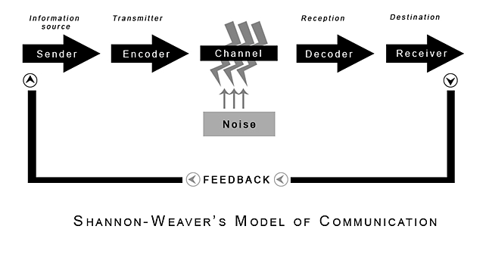(Shannon and Weaver, 1949)

2.0

Assessing Own Communication Skills

In my workplace I have good communication skills face to face, I interact well with colleagues and students when talking to them I always listen well when they are talking to me. To avoid distractions, I would direct the students or my colleagues away from noisy areas so I can listen effectively. For example, a student came to reception at a busy time distressed as she had work to complete by a deadline and wanted a certain article from the library that she couldn’t find, I asked her to take a seat in the quiet area of reception for a few minutes and that when I have answered other students non urgent queries I would come and sit with the student in a quiet place and help the best I could. I am a lot more confident interacting with people face to face then I am in group interaction, I find when I am in a group, I lose a bit of confidence and if more than one person is talking I find it hard to process information. I need to improve on group interaction and not be afraid to interrupt and ask group members to speak in turn and not over each other, another way I could improve interacting with groups is asking questions to communicate better.
My non-verbal communication skills could be improved when I am communicating face to face my body language can sometimes show that I am not really listening even though I try to show I am interested in the conversation, this is more when I am sitting at my desk, and I don’t realised I am slumped over. To improve this, I try to stand when having a conversation face to face. In both types of interaction (face to face and group interaction) I sometimes struggle to maintain eye contact, I think if I build more confidence, I will be kept eye contact with colleagues and students. I have good facial expressions as I always try to make sure I am smiling when I greet people and I always stay calm and focused which I personally think is quite an important communicating skill to have.
After presenting my PowerPoint to my feedback I received from the group was

Gap Analysis

Objective | Current Position | Deficiency | Action
What do I want to do? | What can I already do? | What am I lacking? | How do I fix this?
To be able to present and talk in front of a larger group of people | I can already communicate in front of a small group | Confidence | Increasing size of groups, I talk in front
Applying for a higher-grade job role | I already have the experience | qualifications | Complete courses relevant to role I want  Learn new skills
Improve communication skills | Already have effective communication skills | confidence | Regular voice and face to face contact.

PDP

Objectives | Tasks | Success Criteria | Time Frame | Resources
List your Goals | What do you need to do to achieve these goals? | How will you identify your success? | When do they need to be done by? | Who or what do you need to help you?
To complete level 4 skills for workplace | Research  Attend lectures | By applying for jobs | December 2022 | Attend lectures regularly
Better Time management | Set Goals and Targets |  | December 2022 | Time Trackers

References

- Blenkinsop, P. (2010) The Communication Cycle. [online] Available at: http://manyana-education.blogspot.com/2010/10/communication-cycle.html Accessed: 15.05.19
MindTools (2019) How good are your communication skills? [online] Available at: https://www.mindtools.com/pages/article/newCS_99.htm Accessed: 15.05.19
- Shannon, C. and Weaver, W. (1949) The Mathematical Theory of Communication. Urbana: University of Illinois Press.
- Skills You Need (2019) Interpersonal Skills Self-Assessment. [online] Available at: https://www.skillsyouneed.com/ls/index.php/343479 Accessed: 15.05.19
- , Why mobile is essential in employee communications-10-19T02:13:52+00:00, 2021-last update. Available: https://firstup.io/blog/mobile-essential-employee-communications/ [Mar 7, 2022].
- , 4 Different Types of Workplace Communication and How to Improve in Each Area-10-18T18:10:00+00:00, 2018-last update. Available: https://www.sandler.com/blog/4-different-types-workplace-communication-and-how-improve-each-area/ [Mar 3, 2022].
- , The Communication Cycle: 6 Stages of Michael Argyle's Theory Free Essay Example-03-05T18:19:39+00:00, 2016-last update. Available: https://studymoose.com/the-communication-cycle-6-stages-of-michael-argyles-theory-essay [Mar 6, 2022].
- , 7 Ways to Communicate Effectively at Work. Available: https://uk.indeed.com/career-advice/career-development/ways-to-communicate-effectively [Mar 3, 2022].
- , Effective communication in the workplace. Available: money-business/effective-communication-the-workplace [Mar 7, 2022].
- , The Importance of Verbal & Non-Verbal Communication. Available: https://oureverydaylife.com/the-importance-of-verbal-non-verbal-communication-5162572.html [Mar 8, 2022].
- , Ubiquity: The 7% rule. Available: https://ubiquity.acm.org/article.cfm?id=2043156 [Mar 8, 2022].
- , What Is Non Verbal Communication, And Why Does It Matter? | BetterHelp. Available: https://www.betterhelp.com [Mar 8, 2022].
- 52, VALENTINE BELONWU IN MANAGEMENT, -11-19T19:00:32+00:00, 2013-last update, 20 Ways to Communicate Effectively With Your Team. Available: https://smallbiztrends.com/2013/11/20-ways-to-communicate-effectively-in-the-workplace.html [Mar 3, 2022].
- REDDY, K., 2015. Why is Verbal and Nonverbal Communication Important at Workplace? .

Appendix A

https://www.communicationtheory.org/shannon-and-weaver-model-of-communication/

Appendix B
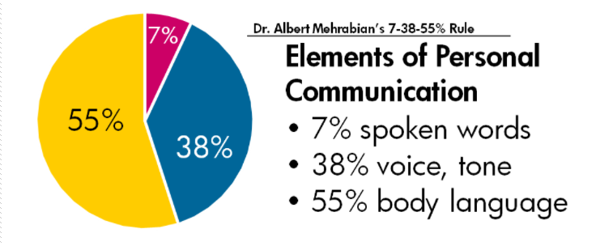

Appendix C

Presentation Feedback form
Directions: Complete the following review sheet for your designated partner. Circle the appropriate numbers and provide two pieces of feedback at the bottom of the page.
5 – Excellent
4 – Good
3 – Sufficient
2 – Poor
1 – Very Poor

Posture and Body Language
-Does the speaker stand upright and exude confidence?
5 | 4 | 3 | 2 | 1

Ideas
-Does the speaker share key ideas or elements relevant to his/her topic?
5 | 4 | 3 | 2 | 1

Clarity
-Does the speaker communicate in a clear and concise manner?
5 | 4 | 3 | 2 | 1

Eye Contact
-Does the speaker make the audience feel as part of his/her presentation?
5 | 4 | 3 | 2 | 1

Reviewers Comments
*One area I truly enjoyed about your presentation was . . .
………………………………………………………………………………………………………………………………………………………………………………………………………………………………
*One possible area of improvement to consider is . . .
………………………………………………………………………………………………………………………………………………………………………………………………………………………………

Skills You Need Communication Quiz

Mind Tools Communication Quiz

