Module: Learners, Schools & communities: Where am I teaching?

Module Code: ECAD7003

How a school develops one aspect of its SDP: a report that critically reflects on the actions, impact, and evidence base.

Shannon Jones

Student number - 1801341

Table of contents

Introduction 2
Literature Review 2
Developing An Action Point 5
Reflection And Evaluation 7
Conclusion 8
Appendices 10
Reference List 11

Introduction
The overview of this report is to critically examine a specific aspect of a School Development Plan (SDP). This research will demonstrate the purpose of an SDP and how a school develops the actions and impact. The key purpose of school improvement is to provide schools with the best learning experiences for all children no matter the background the child (Welsh Government, 2022). The Curriculum for Wales, (2020) highlights that fundamentally schools need to support all learners to ensure they are contributing to the Four Purposes of the curriculum. School development planning is an ongoing process that helps schools challenge and enhance the quality to manage change (DES, 1999, p. 9).
To adhere to the British Educational Research Association guidelines (BERA, 2018) schools and individuals will be kept confidential throughout research to ensure safeguarding is pivotal. The research investigated will be justifiable and informative to limit any risk or consequence to the school, individuals, and stakeholders involved.
This school is an English medium primary school based in the centre of Rhondda Cynon Taf. The school currently has 292 pupils attending with 10 classes and 5 mixed age classes. At present there are 8.2% of pupils who are having free school meals (FMS). According to Estyn (2021) this is well below the national average of 21%.

Literature review
School improvement is conceptualised as a process in which uses data to play an important role on implementing action evaluations. School improvements are built on clearly defined, specific and measurable goals (Hamilton 2006: Schildkamp and Poortman 2015). Welsh Government (2014) state that school improvement is underpinned by short- and long-term planning, which links to challenging targets. Schools’ work on a cycle where they reflect on the priorities identified for improvement and create action plans to review the development. Strands for development in these plans are often resulted from deliberation and negotiation between stakeholders involved in the process (Penuel and Shepard 2016). Stakeholders in the goal setting process are those school leaders, they have input from other stakeholders which incorporate the vision and ethos of the school.
The school leader’s priority is to ensure school improvement actions are being implemented and evaluated accordingly (Tulowitzki, 2016). The Welsh governments expectations for school improvement is evaluated using a variety of evidence and information from the school. The information gathered ensures that school activity and learner progress and well-being is measured to create an effective starting point which should result in planning that is based around the Curriculum for Wales framework, (2020).
Welsh Government, (2014) declares SDPs are considered as live documents which needed to be monitored and revised at least annually. Kruse, (2001) explains how quality SDPs are associated with improved student outcomes linking to high levels of achievement in students, which is further demonstrated in Fernandez (2011) research of evaluation on school improvement plans (SIP).
In contrast critics argue that SDPs are believed as a waste of time and resources. It is further established that heightened pressure is put on educators for further social problems (Bell 2002: White and Noble 2020). Wang (2021b) emphasises how poor decision-making processes contributes to implementing proficient development plans in schools.
Monitoring the school development improves the function of the school, which incorporates development of the curriculum, planning and professional development of school staff (Schildkamp and Kuiper 2010). SDPs / SIPs are collectively worked on to develop better improvements in the school which indicate failings previously. When the SDP is reviewed, the data determines how the school has progressed towards the goals set out. New goals are then aligned with actions and strategies with targets implemented to monitor progress (Meyers and VanGronigen, 2019).
The term outdoor learning is achieved with experiences that occur outside the classroom such as, the school grounds and the community and other natural environments where learning can follow (Dillion et al., (2006). Maposhah- Kandemiri, Higgins and Mclaughin (2009) state indoor learning needs to be ‘put in practise’ outside. Applying outdoor learning provides a starting point for meaningful learning which when sustained, builds individuals with experiences of meeting new people and venturing to new places.
Integrating outdoor learning to the curriculum is embedded in the Four Core Purposes, stating the benefits provides individuals with better mental and emotional well-being, by developing their confidence (Curriculum for Wales, 2022). Underpinning the challenges found in outdoor learning state teachers lack familiarity of incorporating learning outdoors and being unable to manage the class (Dyment, 2005). Though research from Beames, Higgins and Nicol, (2012) expresses that the best way to support teachers propose greater professional development and increased resources to support teachers in outdoor learning curricula.
Key findings from Waite (2011) recognises that being outdoors was once used for students to “let off steam”. Waite further concludes that outdoor learning is an approach that teaches should use to enrich the curriculum for improved learning. Being outdoors in natural areas with wildlife creates an educational environment for ecological learning (Comber, 2016). Which embraces opportunities for children to create ideas about spaces children want to learn in (Green 2013; Parnell and Pastsarika 2011; Sahrakhiz, Harring, and Witte, 2017).
Rea and Waite (2009) research outlines that outdoor and experiential learning are significant to development. Outdoor experience and learning are recognised to be exceedingly important and moreover, widely influential on the physical, emotion and intellectual development of children (Sandster, 2009). Further literature from Munoz (2009) explains well-being in primary schools extols the outdoors as a play and learning space. Rickinson et al., (2004) indicates the amount of evidence on classroom learning emphasises the positive effects it has on child development.
Piaget, (1972) has massively influenced the study of child development implying that knowledge must be invented or constructed by each learner and their actions. Piaget stated that children learn through repeated actions, implicating that new experiences accommodate new knowledge and thinking that create constructive and cognitive improvements.
Increasing the accessibility to outdoor experiences provide children with greater creativity and encourages lifelong learning (Waite, Davis, and Brown (2006) which is also stated in the curriculum for Wales, (2022) guidance framework. Balls, (2008, p. 2) supports Waite et al., (2006) findings by asserting that encouraging creativity and inspiration motivates lifelong learning.

Developing an Action Point
In compliance with the Curriculum for Wales, (2022) the school embeds the Four Purposes into their vision of the school that states ‘all pupils develop a love of learning for life’.
The area of focus in this SDP is to successfully develop a Diocesan Vision, by taking account of development and knowledge to improve social and emotional well-being of both pupils and staff through a Christian based curriculum which is based on nurturing all. Welsh Government, (2021, p.5) state health and well-being have lifelong benefits which promotes learners to develop positive informed behaviours that encourages individuals to respect and care for themselves and others.
The target in the SDP is set out to give children an additional 30 minutes a day outside the classroom every day. The foundation for this was built upon a ‘Active Outdoors Project’ (appendix 1) created from the school improvement group (SIG).
The school decided to run this to support emotional and physical health and well-being after the significant impact of COVID-19. This project aimed to support individuals’ challenges to concentrate, increase engagement and increase physical activity outdoors. Much older literature found that being outdoor was portrayed as negatively, being associated with diseases (Beyer et al., 2018). Though much more recent findings show evidence of being outdoors increases well-being and reduces depressive symptoms (Belanger et al. 2019).
To find the focus of this scheme, all children from year 5 and 6 were given a strength and difficulty questionnaire (SDQ) to be completed by their parents. (Appendix 2). The teachers from both classes also carried out an SDQ, from the combined results from the parents and teachers’ questionnaires, the SIG identified a sample of 5 pupils that would benefit from this project. The project run with 12 other clusters schools located in the area who ran the same project for a 7-week timeframe at the end of July 2020. The pupils were evaluated at the end of the course to understand the effects of the project. Finenes et al, (2015) explains research data and evidence of outdoor initiatives encourages development and use of good practise in outdoor learning. This statement clarifies the value of the project signifying the benefits.
With the pupils identified the SIG agreed to an additional 2 hours per week where they participate in outdoor activities. The results from this initiative after the 7-week project revealed that the children selected were noticeably calmer, focused and settled in school. With the results from the SDQ, data highlighted a 100% decrease in the ‘hyperactivity’ strand (appendix 3.) Taylor and Kuo (2009) found that time spent outdoors can reduce the feelings of hyperactivity which is commonly found in symptoms of Attention-deficit hyperactivity disorder (ADHD).
As the impact of the project conveyed an increase in child attainment, behaviour and well-being, the school implemented a 30 minutes per day for well-being session into the SDP. By being included into the SDP this certified that staff and pupil well-being became a priority in the school. This was particularly important to incorporate as research suggests that in more recent years children’s health and well-being is declining. Conversely, Becker (2017) stresses how regular physical activity and outdoor engagement improves mental health and education outcomes. The Curriculum for Wales, (2014) SDP planning cycle is going to be used to further evaluate the school’s priority with further research.
The new initiative has now been implemented into all classes in the school, making it accessible to all learners in comparison to the ‘Active outdoor Project’ where only limited students were selected. The school’s reflection on their performance provides a sustainable improvement into planning, being able to identify strengths and weaknesses correlates with a plan that highlights the need for improvement and the actions monitored (Estyn, (2014).
To fulfil this target, the school used strategic planning in use to receive funding from the local government, with the funds the school invited an outdoor learning expert into the school for a term. The expert worked with all classes and teachers to model good quality teaching and learning outdoors. As previously cited, this refers back to Dyment’s (2005) statement displaying that teachers lack familiarity with outdoor learning. In view of this aspect, this limits the factor of teachers feeling unprepared and apprehensive when being outdoors. Outside partners coming into school further provides teacher with continuous professional development for staff to gain greater confidence when delivering.
Working with partners in the community to develop outdoor learning provides the school and learners to enhance their provision by being able to foster and develop strategies. Current results from pupils and staff state that the children really enjoy the outdoor learning, and the teachers recognise a much calmer atmosphere in the classroom. The success thus far highlights satisfaction from pupils and staff.
Welsh government, (2014) state stakeholders involved in developing targets are expected to contribute to the SDP, those such as the Welsh government, local authority, and central south consortia. External providers are expected to contribute to determine assessment of progress and implement of aspects that are considered critical to see success (Welsh Government, 2019).

Reflection and Evaluation
Reflection is used to understand strengths and weaknesses whilst being able to act critically to recognise learning difficulties (Hilzensauer, 2008). To reflect efficiently on this report the use of Driscoll’s What Model, (1994) will be used to analyse the development of this target.
The first step of Driscoll’s model is the ‘What’?, to give a clear idea of context this is the 30 minutes per day outdoors initiative being introduced in all classes in the school. The structure of this initiative was to boost the health and well-being for learners, coming from the previous project “Active Outdoor Project”. The new initiative has releveled a general impact on the children’s’ well-being in school. Kirkby et al. (2019, p.264) advocates development of practises and repertoires are supported by new approaches whilst emphasising the need for systematic and sustainable change in education.
Yet, this target is not assessed regularly and only monitored by the class teacher. As this is newly implemented in the school there is no physical evidence to show how this is operating in the school. Monitoring projects ensures the operation is working at the predetermined standard (Scheerens et al., 1998). The school aims to review and evaluate the success of the target at the end of the summer term.
Introducing the next step of Driscoll’s model, the ‘So What?’ this looks at analysing the experiences from the development, examining this aim highlights a few limitations in developing the target. One of the biggest issues that has emerged is the lack of funding to have regular sessions with the outdoor learning expert. This further restricts teachers in continuous development to encourage this target. Day et al. (2016) sates the importance of contribution to teacher development improves a school environment increasing sustainability in education.
Another finding suggests that with no regular observation of this target, this is not being fulfilled daily as stated in the SDP. These findings challenge the notion that this target is not running as successfully as expected, further work is needed to develop a reliable analytical method that will assess the target. Estyn (2017) corresponds to areas for improvement in outdoor learning, implicating it’s not maintained. This could be stemmed from activities being unsuitable for outdoors and the weather, schools are required to assess the risks of outdoor learning. This may indicate a further area to research contingencies for bad weather to still implement this target everyday (Welsh Government, 2009).
Commencing the final step of Driscoll’s model is ‘Now what? This process anticipates future practises based on the findings, where new learning can be applied. This target has identified how an improvement is needed to better this in school, a suggestion arising from this would be to ensure that every day the pupils are outdoors for 30 minutes. Building on this, there needs to be thought around whether this is beneficial every day to the pupil’s education. Reiterating the effectiveness of this, there is no evidence to suggest that children are learning, or weather well-being has or is improving (Estyn, 2011).

Conclusion
The present study was set out to investigate how a school develops an aspect in their SDP, the chosen target was investigating into 30 minutes of outdoor learning everyday lead by the SIG, formed from the schools ‘Active Outdoors Project’. This study has identified the benefits of outdoor learning and why it should be applied in schools, outdoor learning is of paramount importance to children's education. Ouvry and Furtado (2019) stated “The best classroom and the richest cupboard are roofed only by the sky”, further emphasising the advantages.
Whilst the study did not confirm physical evidence of this target, it did substantiate how the well-being is a priority within the school after the COVID-19 pandemic. Which is contributing to increased student learning and achievement (Schildkamo 2016; Van Geel et al. 2016). The Welsh Government (2013) commit to developing physical literacy explaining it is equally essential as improving literacy and numeracy skills. They further understand the outdoor learning is a systematic advance to improving health and education in Wales.
To enhance the researcher a future recommendation is observe this target in action, this permits to recognising additional strengths or limitations in-practice that enhance the development of this target subsequently.

Word count - 2574

Appendices

Appendix 1
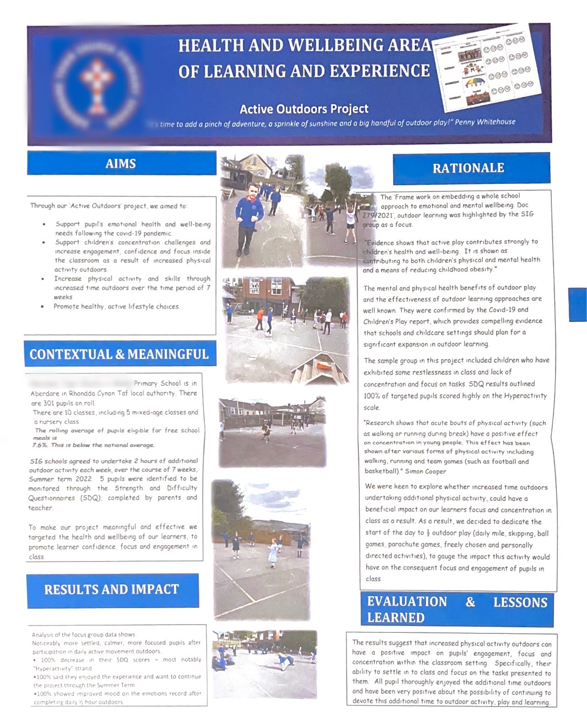

Appendix 2
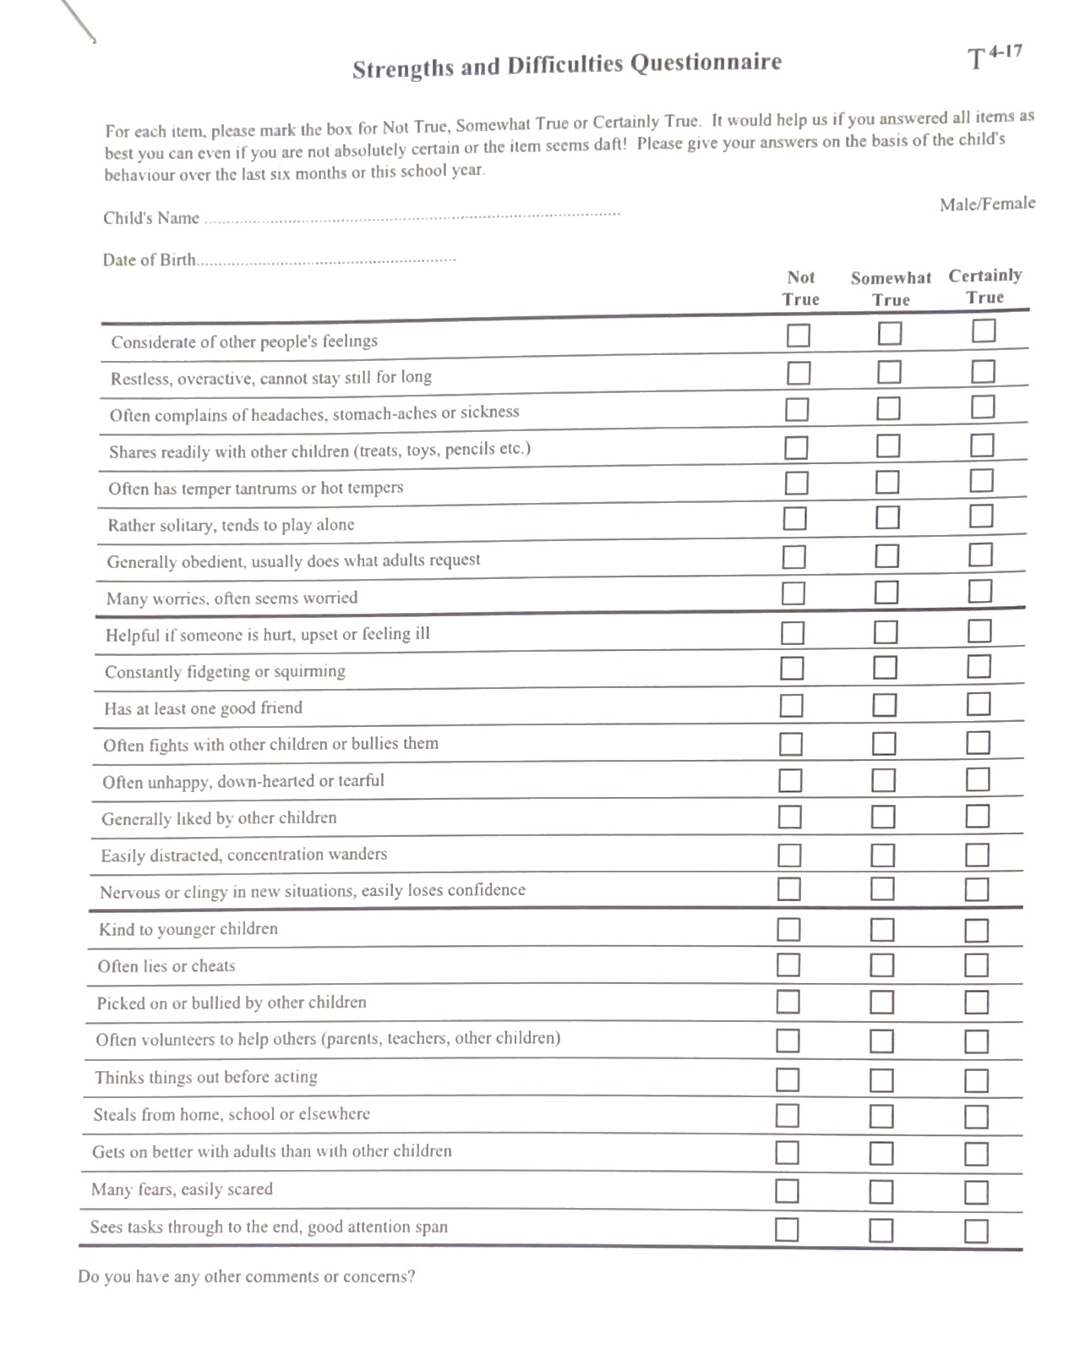

Appendix 3

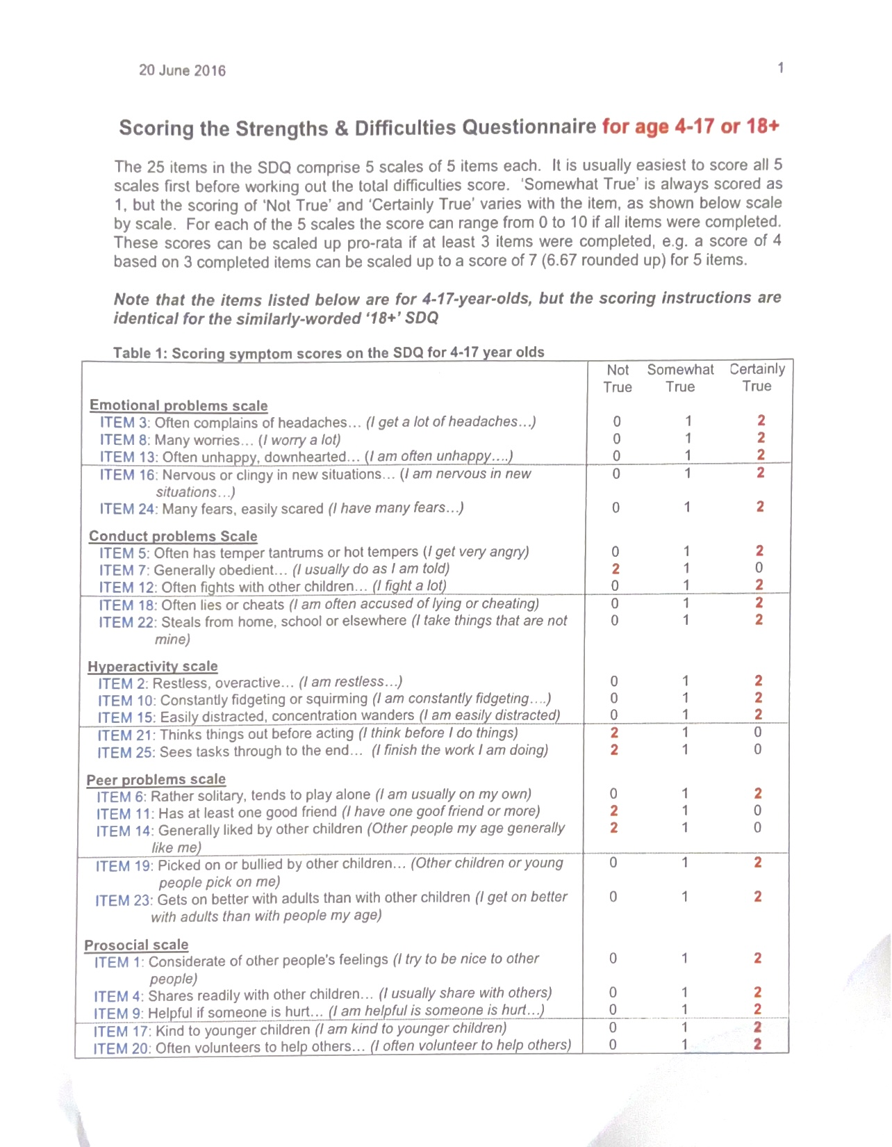

Reference List

Alves, R., Lopes, T. and Precioso, J. (2020) “Teachers' well-being in times of covid-19 pandemic: Factors that explain professional well-being,” IJERI: International Journal of Educational Research and Innovation, (15), pp. 203–217. Available at: https://doi.org/10.46661/ijeri.5120. (Accessed: 10 April 2023).
Beames, S., P., Higgins, and R., Nicol. (2012) Learning Outside the Classroom: Theory and Guidelines for Practice. New York: Routledge. Available at: https://www.taylorfrancis.com/books/mono/10.4324/9780203816011/learning-outside-classroom-pete-higgins-simon-beames-robbie-nicol (Accessed 3 April 2023).
Belanger M, Gallant F, Dore I, O'Loughlin JL, Sylvestre MP, Abi Nader P, Larouche R, Gunnell K, Sabiston CM. 2019. Physical activity mediates the relationship between outdoor time and mental health. Prev Med Rep. 16:101006.
BERA (2018) Research ethics case studies. Available at: https://www.bera.ac.uk/publication-series/research-ethics-case-studies (Accessed: 13 April 2023).
Beyer KMM, Szabo A, Hoormann K, Stolley M. (2018) Time spent outdoors, activity levels, and chronic disease among American adults. J Behav Med. 41(4):494–503.
Boulton., P. and Thomas., A. (2022) How does play in the outdoors afford opportunities for schema development in young children? International Journal of Play, 11:2, 184-201, DOI: 10.1080/21594937.2022.2069348

Brown., J and Devecchi., C. (2013) The impact of training on teaching assistants’ professional development: opportunities and future strategy, Professional Development in Education, 39:3, 369-386, DOI: 10.1080/19415257.2012.762720

Day, C., Guo, Q., and Sammons, P. (2016) The impact of leadership on student outcomes: how successful school leaders use transformational and instructional strategies to make a difference. Educational administration quarterly 52(2): 221–258. DOI: 10.1177/0013161X15616863
Dillon, J. Rickinson, K. Teamey, M. Morris, M. Choi, D. Sanders, and P. Benefield. (2006). “The Value of Outdoor Learning: Evidence from Research in the UK and Elsewhere.” School Science Review 87: 107–111.
Dyment, J. (2005) Gaining Ground: The Power and Potential of Green School Grounds in the Toronto District School Board. Toronto: Evergreen. Available at: https://www.evergreen.ca/en/lg/lg-resources.html. (Accessed 5 April 2023).
Estyn. (2011) Outdoor Learning: an evaluation of learning in the outdoors for children under five in the Foundation Phase. Available at: www.estyn.gov.uk
Estyn (2021) Appendix 3, Estyn. Available at: https://www.estyn.gov.wales/document-page/20673/appendices/appendix-3 (Accessed: April 13, 2023).
Fiennes, C., Oliver, E., Dickson, K., Escobar, D., Romans, A., & Oliver, S. (2015) The existing evidence base about the effectiveness of outdoor learning. London: Giving Evidence; University College London. Available at: https://www.sapoe.org.uk/wp-content/uploads/2017/08/outdoor-learning-giving-evidence-revised-final-report-nov-2015-etc-v21.pdf (Accessed 8 April 2023).
Green, M. (2011) Place Matters: Pedagogies of Food, Ecology and Design. Unpublished PhD, Monash University Churchill Victoria. Available at: https://www.tandfonline.com/doi/full/10.1080/13504622.2012.697546 (Accessed 5 April 2023).
Green, M. (2013) “Transformational Design Literacies: Children as Active Place-Makers.” Children's Geographies 11 (4): 1–16.
Heather E. Prince (2019) Changes in outdoor learning in primary schools in England, 1995 and 2017: lessons for good practice, Journal of Adventure Education and Outdoor Learning, 19:4, 329-342, DOI: 10.1080/14729679.2018.1548363
Kernandez, K. (2001) Evaluating school improvement plans and their affect on academic performance. Education Policy 25 (20; 388-67. DOI: 10.1177/0895904809351693.
Kirkby, J., Walsh, L., and Keary, A. (2019) A case study of the generation and benefits of a community of practice and its impact on the professional identity of early childhood teachers. Professional Development in Education, 45 (2), 264–275. DOI: https://doi.org/10.1080/19415257.2018.1449003
Kruse, S. (2001) Creating communities of reform: Continuous improvement planning teams. Journal of Education Administration. DOI: 10.1108/EUM0000000005496.
Kühn, S. et al. (2021) ‘Spend time outdoors for your brain – an in-depth longitudinal MRI study’ The World Journal of Biological Psychiatry, 23(3), pp. 201–207. Available at: https://doi.org/10.1080/15622975.2021.1938670.

Maposhah- Kandemiri, M., Higgins. P., and Mclaughin., P (2009). Outdoor learning: curriculum imperatives and community relevance in a rural setting. Education 3–13, 37:1, 15-28, DOI: 10.1080/03004270802291756.
Matthews, D.E. and Wang, Y.Y. (2023) ‘How can principals lead in the School Improvement Planning Process? reducing biases in shared decision making’ The Clearing House: A Journal of Educational Strategies, Issues, and Ideas, 96(2), pp. 43–51. Available at: https://doi.org/10.1080/00098655.2022.2163971.
Meyers, C. and VanGronigen, B. (2019) ‘A lack of authentic School improvement plan Development’. Evidence of principal satisficing behaviour. Journal or Education Administration 57(3);261-78. DOI: 10.1108/JEA-09-2018-0154.
Ozturk., Y and Ozer., Z. (2022) Outdoor play activities and outdoor environment of early childhood education in Turkey: a qualitative meta-synthesis, Early Child Development and Care, 192:11, 1752-1767, DOI: 10.1080/03004430.2021.1932865

Piaget, J. (1970) Science of education and the psychology of the child. London: Longman. Available at: https://psycnet.apa.org/record/1970-19308-000 (Accessed 4 April 2023).

Prince, H.E. (2018) ‘Changes in outdoor learning in primary schools in England, 1995 and 2017: Lessons for good practice.’ Journal of Adventure Education and Outdoor Learning, 19(4), pp. 329–342. Available at: https://doi.org/10.1080/14729679.2018.1548363.

Rea, T. and Waite, S. (2009) International perspectives on outdoor and experiential learning, editorial. Education 3–13, 37(no. 1): 1–4. Available at: https://www.tandfonline.com/doi/abs/10.1080/03004270802291699 (Accessed: 4 April 2023).
Sahrakhiz, S., M. Harring, and D. Witte. (2017) ‘Learning Opportunities in the Outdoor School–Empirical Findings on Outdoor School in Germany from the Children’s Perspective.’ Journal of Adventure Education and Outdoor Learning 18 (3): 214–226.
Sandseter, E. (2009) Characteristics of risky play. Journal of Adventure Education and Outdoor Learning, 9(no. 1): 322. Available at: https://www.tandfonline.com/doi/full/10.1080/14729670802702762 (Accessed 6 April 2023).

Schildkamp, K. (2019) Data-based decision-making for school improvement: Research insights and gaps, Educational Research, 61:3, 257-273, DOI: 10.1080/00131881.2019.1625716

Slepcevic-Zach., P and Stock., M. (2018) ePortfolio as a tool for reflection and self-reflection, Reflective Practice,19:3, 291-307, DOI: 10.1080/14623943.2018.1437399
Waite, S. (2011) Teaching and Learning Outside the Classroom: Personal Values, Alternative Pedagogies and Standards.” Education 3-13 39 (1): 65–82. DOI: https://doi.org/10.1080/03004270903206141.
Wang, Y. (2021b) Something went wrong: 52 biases that undermine your leadership decision making. Available at: https://orcid.org/0000-0002-9005-9641 (Accessed: 8 April 2023).
Welsh Government (2009) Outdoor Learning Handbook. Available at: https://hwb.gov.wales/storage/fcb8539c-9be7-4883-8542-35d7b54b56f2/foundation-phase-outdoor-learning-handbook.pdf (Accessed 12 April 2023).

Welsh Government (2013) Physical Literacy – an all-Wales approach to increasing levels of physical activity for children and young people. Available at: https://www.gov.wales/sites/default/files/publications/2018-02/physical-literacy-an-all-wales-approach-to-increasing-levels-of-physical-activity-for-children-and-young-people-schools-and-physical-activity-ask-and-finish-group.pdf (Accessed 14 April 2023).
Welsh Government (2014) School Development Plans. Available at: https://www.gov.wales/sites/default/files/publications/2018-03/school-development-plans.pdf (Accessed 9 April 2023).
Welsh Government (2019) Terms of reference: Education Strategic Stakeholder Group. Available at: https://www.gov.wales/strategic-stakeholder-group/terms-of-reference (Accessed 12 April 2023).
Welsh Government (2021) The curriculum for Wales; Statements of What Matters Code. Available at: https://www.gov.wales/sites/default/files/publications/2021-11/curriculum-for-wales-statements-of-what-matters-code.pdf (Accessed 9 April 2023).
Welsh Government (2022) School improvement guidance: impact assessment. Available at: https://www.gov.wales/school-improvement-guidance-impact-assessment-html (Accessed: 9 April 2023)
Welsh Government (2022) School improvement guidance: Framework for evaluation, improvement, and accountability. Available at: https://hwb.gov.wales/evaluation-improvement-and-accountability/school-improvement-guidance-framework-for-evaluation. (Accessed: April 6, 2023).

