

LCMB7000- Human resource management

NAME: SONA VADAKKEKARA
ID: 2212235
WORD COUNT: 2700
Table of content
Introduction 3
Current state of the labour market in the UK 4
Emerging changes in Human Resourcing Strategies in the post Covid, post Brexit external environment 8
Conclusion 11
References 12

Introduction
A labour market is a place where employer as well as staff interact and communicate with one another hand. In the labour market, employers struggle to recruit the best and the staff compete for the superior satisfying job. The report provides a discussion of the current situation of the labour market within the UK and evolving changes in human resourcing techniques within the global pandemic, post-Brexit external ecosystem.

The current state of the labour market in the UK
The labour market involves labour supply by households and labour demand by organisations. Wages represent the labour price that offers an income to the household and represents the cost to the organisations. A labour market is a place where staff and workers interact with each other. In the labour market, employers struggle to recruit the best and the staff compete for a pleasing job. Employers need labour as employees are a vital part of the process of production. The employees adopt equipment to convert inputs to output (Devine and Powell, 2022). Without staff, the employer could not manufacture products and services and gain profits. The labour market refers to the demand for as well as supply of labours, in which staff offer the supply and employers offer the demand. It is a key element of the economy and is related to markets for products, services, and capital. In addition to this, the employment rate in the UK for the year 2022 was approximately 75.5%, 0.3% points less than the last quarter which has a high rate of employment than other periods.
The total number of jobs in the workforce within the UK in the year 2022 increased by 290,000 to 35.8 million and for the first time go beyond the pre-corona virus of December 2019. The openings of jobs have steadily enhanced since the year January 2020, while the unemployment rate has slowly decreased (Sumption, 2022). In the year 2021, the employers ended up adding an exceptional 3.8 million jobs. But simultaneously, several individuals left the workforce before the global pandemic.
In the year 2022, the number of individuals aged 16+ within employment was approximately 32.77 million and the rate of employment for individuals aged 16-64 was 75.6% increased from 75.4 in the last quarter (Leaker, 2022). The level of employment enhanced within the last quarter, but still 211,000 below their pre-pandemic level. The unemployment rate of the UK was approximately 3.7% as well as 1.25 million individuals aged 16+ were unemployed. The levels of unemployment have increased within the last quarter but dropped over the last year and 128,000 below their pre-pandemic levels (NHS Employers, 2022). Further, 8.94 million individuals aged 16-64 were efficiently inactive and the rate of inactivity was 21.5% (Trading Economics, 2022). The rate of unemployment in the year 2022 enhanced by 0.1% to 3.7%. In the three-month period, the number of individuals unemployed for up to 6 months enhanced and this increment was identified across overall age groups. Worsening labour market circumstances are impacted both by creating employment and the quality of jobs (Hanushek, et al., 2017). The inequalities labour market is likely to increase contribution towards continued divergence among developed as well as developing economies.
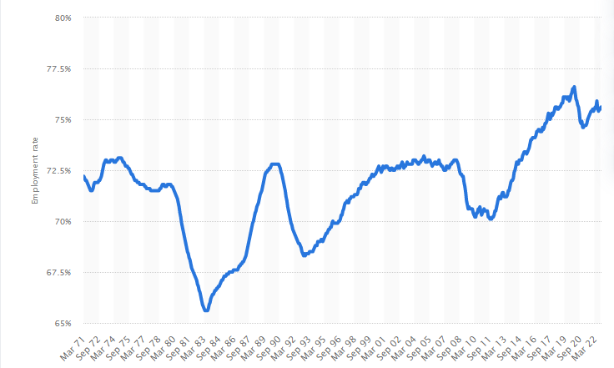
Figure 1: Rate of employment within the UK
Source: (Clark, 2022)
In the three months to October 2022, the rate of employment within the UK was 75.6% in comparison with 75.4% for a similar period in the year 2021. After decreasing by 70% in the year 2011, the rate of unemployment within the UK increased in the year 2020 (Clark, 2022). The rate of employment has decreased in recent months, due to the global pandemic and lockdowns. In addition to this, about 17% of the individual employed within the UK in the year 2018 were born abroad. Among the male, migrants are more likely to be used than the UK born (83% vs 79% in the year 2018), but among women, migrants are less likely to be in work (66% vs 72%). In the month of August-October, there were approximately 1.25 million unemployed individuals within the UK with the level increasing from the last quarter but decreasing over the years. Before the global pandemic, the rate of unemployment was at a historically low level. The unemployment rate increased as an outcome of the global pandemic to a high of 5.2% in late 2022, however, it was less than the unemployment rates that were anticipated at the beginning of the global pandemic. Compared, the unemployment rate reached a post-recession high of 8.5% in the year 2011 following the 2008 economic crisis.
The rate of unemployment in the year 2022 enhanced by 0.1% points to 3.7%. In the period of 3 months, the number of individuals unemployed for up to 6 months enhanced and this increase was identified across all age groups (Caligiuri, et al., 2020). The global pandemic has had an unbalanced influence on several industries of the labour market. The hospitality, retail as well as leisure industries have been hard bit, with several organisations pushed to close and decrease their operations because of the lockdown measures. It has led to a high number of losses of jobs in these industries. The shortage of labour in the UK may cost the economy £30 billion a year. The rate of unemployment within the UK averaged 6.76% from the year 1971-2022 reaching an all-time high of 11.90% in the year 1984 and a record low of approximately 3.40% in the year 1973 (Przytuła, et al., 2020). There is a small enhancement in the number of young individuals not in education, and employment with the current projected to be 724,000. Hiring from outside the UK to improve UK-based training and hiring and training from within the local societies remains an option for various roles in the sector (Contractor, 2022). The recent job market presents both opportunities and issues for the staff and organisations. For job seekers, the unclear economic atmosphere may make it complex to identify workers and secure a new job. On the other hand, the availability of the support of the government involves furlough schemes, as well as unemployment benefits, which may offer several economic stabilities throughout this time.
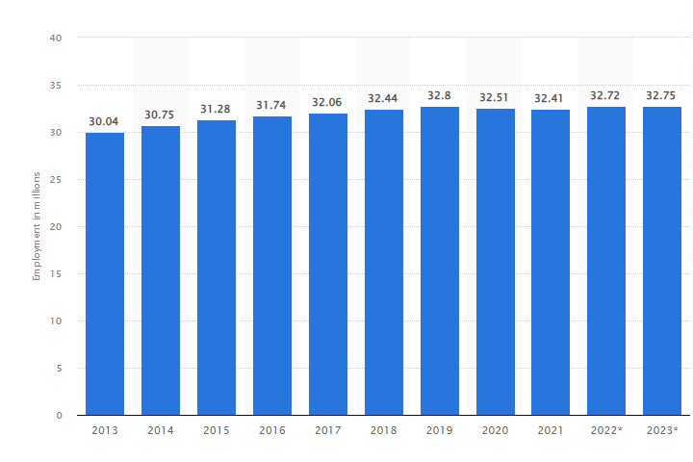
Figure 2: Employment in the UK
Source: (Statista, 2022)
Based on the diagram, it is observed that the number of employed people in the UK was anticipated to regularly enhance in 2022 as well as 2023 by 0.03 million individuals. The number is anticipated to be approximately 32.75% million individuals in the year 2023 (Statista, 2022). For the organisation, the labour market may present issues in the context of analysing and retaining skilled staff and navigating the changing regulations as well as market circumstances. On the other hand, it may present opportunities and chances to adapt in response to changing demands of the consumers and to take the benefit of available support of the government (Sindakis and Aggarwal, 2022). The labour market of the UK is confronting issues because of the global pandemic, but it remains strong as well as resilient. The organisations and government will require to perform work together to address the effect of the pandemic and provide support to the recovery of the labour market in the coming years.

Challenges confronting the labour market
The labour market of the UK is confronting various issues such as a shortage of skills, digital transformation, Brexit and inequality at the current time involving:
- Shortages of skills: Some sectors are confronting shortages of competent staff, which can make it complex for the organisation to identify the employee they require. It can be due to a lack of competent staff in several areas or a mismatch between the competence of available staff and the requirement of employers (Wright, et al., 2018).
- Digital transformation: The increasing usage of technology in the organisation is changing the nature of several jobs and generating new ones. It may lead to the obsolescence of several skills and the requirement for staff to learn new ones to remain competitive.
- Inequality: There are vital disparities in the context of employment as well as pay among several groups within the UK which involves women, ethnic minorities as well with disabilities. Addressing these disparities is a key issue for the labour market.
- Brexit: The UK's withdrawal from the European Union (Brexit) has generated uncertainty for organisations and staff, specifically in the industries that are based on cross-border trade and movement of the individual. It may impact the availability as well as labour cost and regulations that the organisation must comply with.

Emerging changes in Human Resourcing Strategies in the post-Covid, post-Brexit external environment
Remote working, advanced technology, as well as competitive labour markets, have made it complex for managers to maintain the human capital of the company. The problems of retention of employees, talent acquisition as well as employee well-being have enhanced the issues of human resource management. The organisational leader considers productivity measures suited to remote working (Sindakis and Aggarwal, 2022). Collaboration, favourable work-life behaviour as well as communication might be better performance indicators. The global pandemic forced several changes to arise in the companies, which is important to put the continuance of the operations of the company. Shaping as well as putting the performance of the jobs during the global pandemic is an issue for the companies due to its adverse effect on staff, causing their stress and lack of sense of safety.
There is an increasing role of HRM professionals in effectively shaping HRM techniques that can favourably shape job-related attitudes resulting in increasing performance of jo throughout difficult times. The role of globally oriented HRM techniques in influencing the performance of jobs through job-related attitudes which involve work motivation, the fulfilment of the job as well as an organisational commitment during the crisis arising in the company due to the global pandemic. The global pandemic has altered the work experience for most of the staff. It forced companies across the world to adapt how work is managed and how jobs are intended (Ridgway, 2019). The HR manager has been at the centre of the quick response of the company towards the crisis and played a key role in putting the staff involved, productive as well as resilient. The HR manager converts their attention towards the recovery stage, to ensure their companies are prepared to thrive. It will need exceptional focus as well as coordination, during what may be a prolonged period. Human resource makes use of several technologies to automate procedures and enhance communication. Several ways such as remote working, employee personalisation and talent acquisition in which the global pandemic has impacted HRM within the UK involve:
- Remote working: Several organisations have executed remote working policies during a global pandemic, requiring HRM to adapt to the changes as well as opportunities to manage a remote workforce. It has included developing innovative policies for remoting work and offering the technology and providing support to allow staff to work from home.
- Employee personalisation: The uncertainty of the global pandemic has had a direct impact on the well-being of several staff as well as the HR department's emphasis on providing support to the well-being of the staff. It has involved offering resources which include mental health support as well as flexible working arrangements to assist staff cope with the issues of the global pandemic. The organisation provides personalised benefits as well as online tools. Instead of providing one benefits package, the staff are casting a broad net with niche alternatives such as reimbursement and insurance.
- Talent acquisition and retention: The global pandemic has resulted in changes within the market of job, with several sectors enhancing the need for staff while other individuals have struggled. The human resource department adopts its hiring and retention techniques in providing a response to the changes, involving using digital techniques to attract as well as retain talent.
Managing HR in the post-Brexit business environment in the UK
The UK's exit from the European Union, commonly referred to as Brexit, has created a new business landscape in the country, with implications for HR departments and the management of human resources. One of the main challenges of Brexit for HR is the potential impact on the availability of talent (Schilbach, et al., 2022). Some businesses may struggle to recruit and retain EU workers due to changes in immigration policies and the possibility of increased barriers to movement. This could pose a problem for organisations that have traditionally relied on a diverse and international workforce. In order to address these challenges, HR departments may need to rethink their recruitment and retention strategies and consider alternative approaches, such as focusing on domestic talent or seeking out other sources of labour.
In addition to the potential impact on the availability of talent, Brexit may also affect employment law and regulation in the UK. This could include changes to areas such as working hours, holidays, and discrimination. It will be important for HR professionals to stay informed about any updates or changes to these laws and ensure that their policies and practices remain compliant (Collings, et al., 2021). The uncertainty surrounding Brexit may also have an impact on the well-being of employees, particularly those who are directly or indirectly affected by the changes. HR departments can play a crucial role in supporting the mental health and overall well-being of their workforce by providing resources such as mental health support and flexible working arrangements.
For businesses that rely on cross-border trade or the movement of people, managing the challenges and opportunities presented by Brexit will require a proactive approach (Nasir, 2017). This could involve adapting to new regulations and procedures, as well as exploring alternative business models. HR professionals will need to be adaptable and proactive in order to successfully navigate the changing business environment in the post-Brexit UK.
On the other hand, the issues such as frequent changing in the requirements of the organisation and enhancing the usage of technology within the workplace result in shifting the skills as well as training required by workers. HR departments emphasise reskilling as well as upskilling staff to ensure that they possess the required competencies to meet the changing requirement of the organisation. The demand of the modern workplace to meet the changing requirement on the well-being of the staff, the HR sector must emphasise on provide support to the mental health and well-being of staff by offering resources which involve mental health support, promoting a favourable work culture as well as flexible working arrangements. Further, inequality is a vital issue within the UK with disparities in the context of employment as well as pay among several groups such as ethnic minorities and disabilities.
To remain competitive as well as meet the requirement of their staff and users, organisations adapt their human resources techniques. The organisation must provide a flexible work atmosphere to meet the requirement of the employees (Gigauri, 2020). It may include providing flexible hours, and usage of technology to allow collaboration as well as communication. In addition to this, technology continues to advance, the organisation stays up to date with the techniques to remain competitive. It may include investment in innovative software, training staff on innovative technologies and executing automation to streamline procedures.

Conclusion
Based on the above-given information, it can be concluded that the employment rate in the UK for the year 2022 was approximately 75.5%, 0.3% points less than the last quarter which has a high rate of employment than other periods. The labour market of the UK is confronting various issues such as a shortage of skills, digital transformation, Brexit and inequality in the labour market. Several ways such as remote working, employee personalisation and talent acquisition in which the global pandemic has impacted HRM within the UK. On the other hand, the issues such as frequent changing in the requirements of the organisation and enhancing the usage of technology within the workplace result in shifting the skills as well as training required by workers. To remain competitive as well as meet the requirement of their staff and users, the organisation must provide a flexible work atmosphere to meet the requirement of the employees. Some businesses may struggle to recruit and retain EU workers due to changes in immigration policies and the possibility of increased barriers to movement.

References
Caligiuri, P., De Cieri, H., Minbaeva, D., Verbeke, A. and Zimmermann, A., 2020. International HRM insights for navigating the COVID-19 pandemic: Implications for future research and practice. Journal of international business studies, 51(5), pp.697-713.
Clark. D., 2022. Employment rate in the United Kingdom from March 1971 to October 2022 [Online]. Available at: https://www.statista.com/statistics/281992/employment-rate-in-the-united-kingdom/ [Accessed on: 2nd January 2023].
Collings, D.G., McMackin, J., Nyberg, A.J. and Wright, P.M., 2021. Strategic human resource management and COVID‐19: Emerging challenges and research opportunities. Journal of Management Studies.
Contractor, F.J., 2022. The world economy will need even more globalization in the post-pandemic 2021 decade. Journal of International Business Studies, 53(1), pp.156-171.
Devine. F. B., and Powell. A., 2022. UK Labour Market Statistics [Online]. Available at: https://commonslibrary.parliament.uk/research-briefings/cbp-9366/ [Accessed on: 2nd January 2023].
Gigauri, I., 2020. Organizational support to HRM in times of the COVID-19 pandemic crisis. European Journal of Marketing and Economics, 3(3), pp.36-48.
Hanushek, E.A., Schwerdt, G., Woessmann, L. and Zhang, L., 2017. General education, vocational education, and labor-market outcomes over the lifecycle. Journal of human resources, 52(1), pp.48-87.
Leaker. D., 2022. Labour market overview, UK: October 2022 [Online]. Available at: https://www.ons.gov.uk/employmentandlabourmarket/peopleinwork/employmentandemployeetypes/bulletins/uklabourmarket/october2022 [Accessed on: 2nd January 2023].
Nasir, S.Z., 2017. Emerging challenges of HRM in 21st century: A theoretical analysis. International Journal of Academic Research in Business and Social Sciences, 7(3), pp.216-223.
NHS Employers, 2022. Labour Market Trends 2022 [Online]. Available at: https://tradingeconomics.com/united-kingdom/labour-costs [Accessed on: 2nd January 2023].
Przytuła, S., Strzelec, G. and Krysińska-Kościańska, K., 2020. Re-vision of future trends in human resource management (HRM) after COVID-19. Journal of Intercultural Management, 12(4), pp.70-90.
Ridgway, M., 2019. Brexit: human resourcing implications. Employee Relations: The International Journal.
Schilbach, M., Selenko, E., Baethge, A. and Rigotti, T., 2022. Work in times of Brexit: explanatory mechanisms linking macropolitical events with employee well-being. European Journal of Work and Organizational Psychology, pp.1-12.
Sindakis, S. and Aggarwal, S., 2022. The Implications of Brexit for Small Businesses in the UK. In Small Business Management and Control of the Uncertain External Environment. Emerald Publishing Limited.
Sindakis, S. and Aggarwal, S., 2022. The Implications of Brexit for Small Businesses in the UK. In Small Business Management and Control of the Uncertain External Environment. Emerald Publishing Limited.
Statista., 2022. Employment rate in the United Kingdom from March 1971 to October 2022 [Online]. Available at: https://www.statista.com/statistics/275311/employment-in-the-united-kingdom/ [Accessed on: 2nd January 2023].
Sumption. M., 2022. Migrants in the UK labour market: An overview [Online]. Available at: https://www.trustforlondon.org.uk/publications/migrants-uk-labour-market-overview/?gclid=CjwKCAiA-8SdBhBGEiwAWdgtcJPEjsgPcuVQc_PEm_P9W2MNGyUDF2mz2qzw4Dgrv2c9mtrmo_iZVhoCdgcQAvD_BwE [Accessed on: 2nd January 2023].
Trading Economics, 2022. United Kingdom Labour Costs [Online]. Available at: https://tradingeconomics.com/united-kingdom/labour-costs [Accessed on: 2nd January 2023].
Wright, M., Tartari, V., Huang, K.G., Di Lorenzo, F. and Bercovitz, J., 2018. Knowledge worker mobility in context: Pushing the boundaries of theory and methods. Journal of Management Studies, 55(1), pp.1-26.

