Name: Florentina Babache
Student ID: 2240975
Assignment Title: Business report: Comparison of two hospitality organizations - Shangri La & Premier Inn.
Module: BMIH5007
Tutor- Tristan Hawkins

AI ACKNOWLEDGEMENT: I confirm that I have not used any AI tools in the research and creation of this assignment. I confirm that I have not presented any AI-generated materials as my work. I confirm I have copies of my drafts, notes, and other resources I used, which I may be asked to provide in evidence.

Table of Contents
Summary: 3
Total Revenues: 3
Shangri La Hotel: 3
Premier Inn Hotel: 4
Sources of Revenue: 5
Shangri-La Hotel: 5
Premier Inn: 6
Factors Affecting Revenue Growth and Decline: 6
Revenue Growth for Shangri-La: 6
Revenue Decline of Shangri-La 7
Revenue Growth of Premier Inn: 7
Revenue Decline of Premier Inn Hotel: 7
Market Positioning: 7
Shangri-La Hotel: 7
Premier Inn Hotel: 8
Growth Potential: 9
Expansion strategies: 9
Shangri-La Hotel: 9
Premier Inn Hotel 10
Market Opportunity 10
Shangri-La Hotel: 10
Premier Inn Hotel: 10
Potential growth barriers: 11
Shangri-La Hotel: 11
Premier Inn Hotel: 11
Financial Investment in CSR 11
Shangri-La Hotel 11
Premier Inn Hotel: 12
Conclusion: 12
Recommendations 13
References 14
References: 16

Summary:
The report will comprehensively analyse Shangri-La Hotels and Premier Inn Hotels, two of the most recognisable brands in hospitality. The details of their financial strategy will form the base of the paper on which key factors affecting their performance such as revenue, growth opportunities, market positioning and the CSR activities of both the hotels will be covered. This report will analyse the financial performance of the last few years and the present through the departments they have expanded in, which have shown decline and critically assess the reasons for this. Shangri-La's commitment towards offering unmatched luxury and innovation will be subjected to the same examination as Premier Inn, which can ensure a high degree of efficiency and affordability based on a cost-leadership model.

Total Revenues:

Shangri La Hotel:
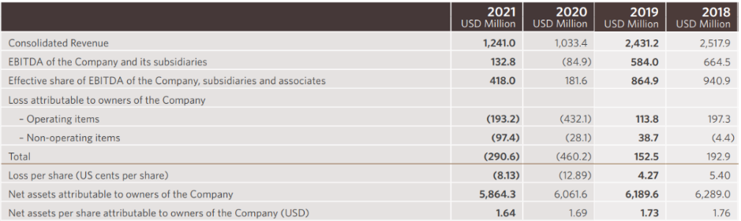
Revenue by Years (Shangri-La, 2021)
The chart for Shangri-La Hotel shows a 20.1% revenue increase to USD 1.241 billion in 2021. This growth mainly came from hotel operations, with USD 205.4 million in additional revenues as domestic demand in Mainland China and Hong Kong surged, the latter being supported by quarantine-related business. Rental properties added USD 4.0 million in revenue, primarily from assets in Mainland China and Sri Lanka. However, property development revenue decreased by USD 2.6 million because of fewer units available for handover. Strategic cost controls and market focus mitigated the losses despite trade tensions and political unrest (Shangri-La, 2021).

Premier Inn Hotel:
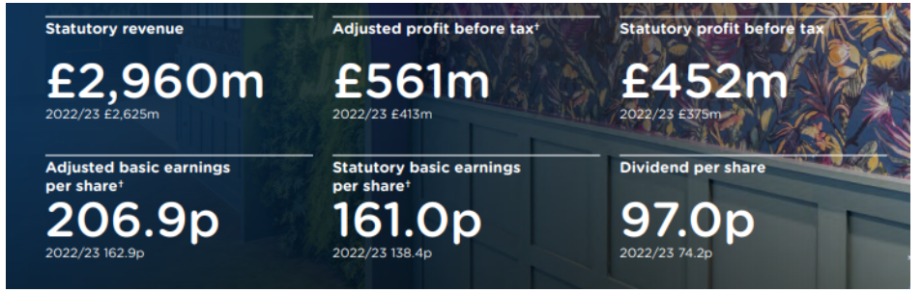
Total revenue (Whitbread, 2024)
Premier Inn's financial statements depict a forward growth pattern in revenues- its statutory revenue rose to £2,960 million compared with £2,625 million that the previous year logged. It may therefore be business performance improvement due to increased occupation or rates. Adjusted profit before tax was also at a high of £561 million from £413 million, reflecting operating efficiency and good cost control. Dividend per share also improved from 74.2p to 97.0p, thus indicating that the enterprise is committed to rewarding shareholders, which helps to increase investor confidence (Whitbread, 2024).

Sources of Revenue:

Shangri-La Hotel:
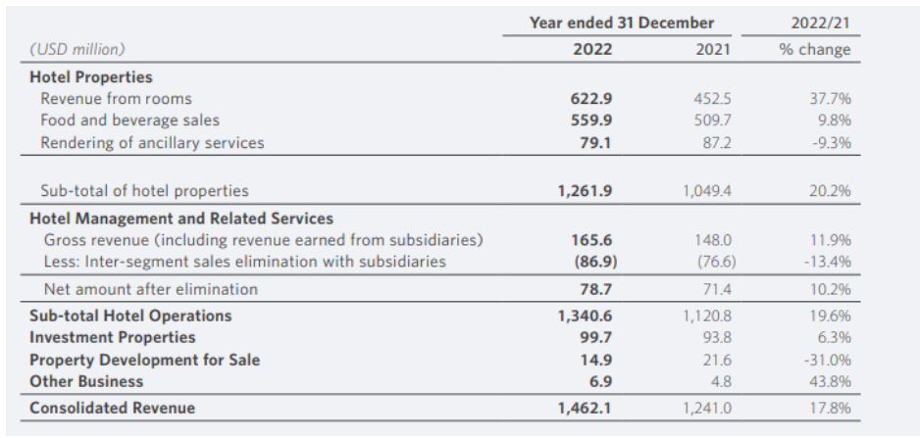
Financial Data of Shangri La Hotel (Shangri La, 2021)
Shangri-La Hotels reported an increase in dollar revenues to USD 1,462.1 million for 2022, which was up 17.8% from the previous period. This growth was largely due to a USD 219.8 million rise in hotel operations, driven primarily by improved conditions for business as travel and gathering restrictions eased. However, sporadic restrictions on COVID-19 measures in Mainland China offset growth somewhat. There was an increase of USD 5.9 million in revenue from investment properties, which was largely due to contributions from Mongolia, Singapore, and Mainland China. Revenue came down, on the other hand, by USD 6.7 million concerning property development due to less unit handover in One Galle Face in Sri Lanka compared to the previous year (Shangri-La, 2021).

Premier Inn:
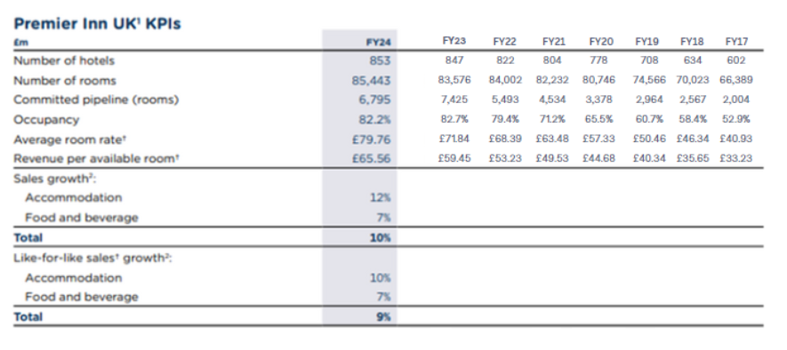
Sources of revenue (Whitbread, 2024)
KPIs from FY17 to FY24 reflected continuous growth and recovery since the number of hotels grew from 602 in FY17 to 853 in FY24, implying an aggressive expansion strategy. Occupancy was volatile, peaking at 82.7% in FY23 but declined marginally to 82.2% in FY24. Such a decline could be a sign of market saturation or due to other macroeconomic factors affecting demand. The average room rate, on the other hand, is indicated in positive upward momentum reaching £79.76 in FY24 from FY17's £53.23-which is a positive signal of price discrimination despite the decline in occupancy. Revenue per available room (RevPAR) also increased, from £33.23 in FY17 to £65.56 in FY24: doubling during the period and improving profitability per room (Whitbread, 2024).

Factors Affecting Revenue Growth and Decline:

Revenue Growth for Shangri-La:
- New hotel and resort openings in growth geographies are likely to drive revenue growth as they expand the scope of the market for Shangri-La.
- Luxury apartments and One Galle Face Mall increased revenue further (Sunday Times, 2020).

Revenue Decline of Shangri-La
- Shangri-La Hotel announced that this was due to higher operating costs and a reduction in non-operating income. Earnings before interest, tax, depreciation, and amortisation (EBITDA) for the hotel fell by 3.8% to US$381.5 million (Simply Wall, 2024).
- COVID-19 massively influenced travel and hospitality worldwide. Shangri-La suffered losses owing to low occupancy rates, event cancellations, and long-time lockdowns.

Revenue Growth of Premier Inn:
- Airline, travel website, and high-end brands alliance to help derive more league in attracting more customers into the chain.
- The hotels in the UK recovered from COVID-19 with an average occupancy of 75% compared to other favourable Western markets (Ben, 2022).

Revenue Decline of Premier Inn Hotel:
- The high cost of real estate and property in core markets also impacts revenue.
- Political unrest, terrorism threats, or changes in regulatory conditions across some regions; for example visa and travel restrictions policies may be deterrents for international visitors.

Market Positioning:

Shangri-La Hotel:
The hotel lies in the Differentiation strategy of the Bowman’s Clock because Shangri-La places a focus on geographically expanding into emerging markets in Asia, Africa, and the Middle East. The report highlights that with the differentiation of service, the company makes it altogether special. However, some aspect of the differentiated product makes the value proposition to be higher (Mithun, 2021). In focusing its product on affluent travellers targeting luxury accommodations in under-served, high-growth regions, Shangri-La emphasises exclusivity and premium services that reinforce its luxury positioning on the strategy clock.
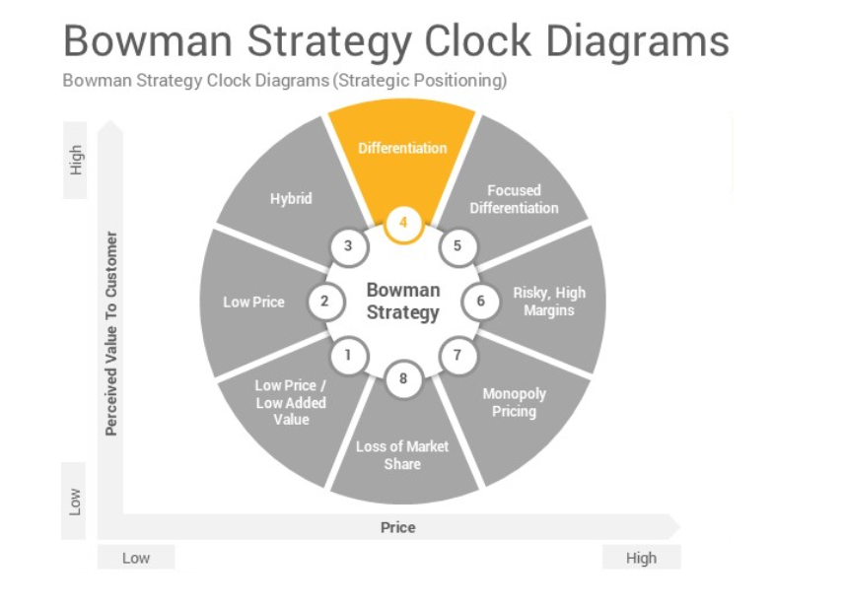
Bowman Strategy Clock (Slide Salad, 2023)

Premier Inn Hotel:
Premier Inn lies in the Hybrid Strategy on Bowman's clock. The hybrid strategy bonds low pricing and product differentiation to customers to unique features offered at competitive rates (Vaia, 2023). It assures buyers of low price, good quality, and reasonable price, balancing between being affordable and distinctive in the market. The chain kept its prices low whilst adding services to be differentiated in guest experiences, particularly for business travellers. This balance between affordability and value-added services helps Premier Inn penetrate a larger market, providing value while still sustaining the cost leadership positioning. The hybrid approach enables it to be competitive while increasing service offerings.
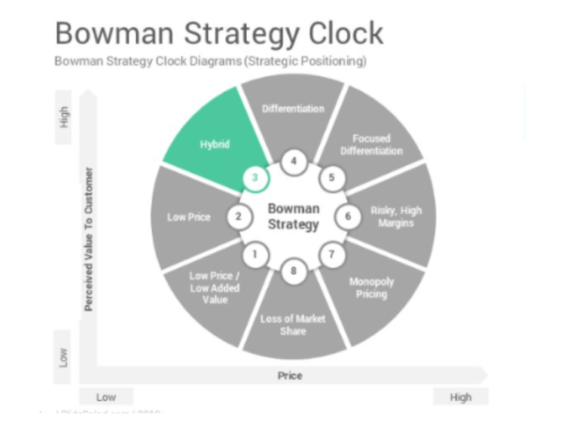
Bowman Strategy Clock (Slide Salad, 2023)

Growth Potential:

Expansion strategies:

Shangri-La Hotel:
Shangri-La Hotels has growth prospects with its Shangri-La Shougang Park, Beijing, viewed from innovative perspectives. Opened in conjunction with the 2022 Beijing Winter Olympics, this hotel combines industrial heritage with modern luxury, catering to business as well as leisure travellers. Its proximity to the major Olympic venues helps it gain visibility and attract international guests. The amenities and sustainability focus of the hotel set it apart in the luxury space. Unfurling further expansion and urban transformation along with increasing domestic and international demand in cooperation with recoveries in China's tourism sector will benefit Shangri-La. Further urban transformation projects and partnerships will enhance its brand visibility and revenue growth in key markets (Shangri-La, 2021).

Premier Inn Hotel
Premier Inn is scaling up aggressively in Germany, adding 1,464 rooms in FY24, taking the total rooms to over 10,500 with a further 6,000 in the pipeline. Improved performance, though early challenges reared their heads, speaks for the rising brand presence. New payment processes, OTA partnerships, and a locality CEO team are resulting in driving revenue and awareness. Although the brand is still in a post-pandemic growth phase, existing hotels alone will make a profit, with £9m profit in FY24. With improved performance and rising occupancy, Premier Inn is on track to capture the top position as a hotel brand in Germany as it expands further into the market with a well-established UK model (Whitbread, 2024).

Market Opportunity

Shangri-La Hotel:
Shangri-La makes use of the trend of luxury experiential consumption to control costs. The "Find Your Shangri-La" campaign has strengthened brand appeal, driving engagement through property-level events. The company focuses on cash flow management and navigating risks from inflation, interest rates, and geopolitical turmoil. With a ~60% interest rate hedge ratio, Shangri-La aims to stabilise financing costs while diversifying funding channels and currencies into more cost-effective spreads. It has a debt reduction plan in place to improve the status of its finances. The strategies will put Shangri-La in a prime position to gain market share, rack up profits, and retain its place in luxury hospitality. (Shangri-La, 2023).

Premier Inn Hotel:
With more than 85,000 rooms open and 7,000 additional rooms in development, Premier Inn has a huge growth potential of as many as 125,000 rooms in the UK and Ireland (Whitbread, 2019). Their in-house acquisition team, extensive freehold portfolio, and adaptable property ownership strategy uniquely equip us to seize the substantial market opportunity and expand our offerings through new sites and extensions.

Potential growth barriers:

Shangri-La Hotel:
Various barriers to the worldwide expansion of Shangri-La, especially in the regions of Europe and North America, could include increased wages and a shortage of trained hospitality staff. Other challenges include cultural differences in that the values considered hospitality within Asia would not be understood by the Western markets (BusinessEssay, 2022). The degree of authority decision-making in different regions by first-line employees would vary and thus require accommodation. Then there are challenges posed by spiking labour costs in the Western countries that keep increasing operational costs, thus affecting room pricing. Shangri-La attempted to address that challenge through massive recruitment and training programs to ensure consistency of service. Maintaining its corporate culture while bending in response to the local labour conditions is, however, a big challenge for global expansion.

Premier Inn Hotel:
Premier Inn is facing a labour shortage, which results in rising wages and retention bonuses to attract and keep staff. Supply chain challenges in recent times are also impacting operational and cost issues. The uncertain timing of business travel's recovery and any resurgence of Covid-19 might still affect occupancy. The challenge is expanding in Germany while retaining a competitive advantage in the UK. Balancing cost efficiency with service quality is crucial since rising costs may come under pressure on margins. Even as it seeks to grow, it has to find its path through labour constraints, economic mores, and changing consumer behaviours to return to superior profitability levels quickly attained before the onset of COVID-19 (The Guardian, 2022).

Financial Investment in CSR

Shangri-La Hotel
Shangri-La Hotels and Resorts is committed to corporate social responsibility (CSR), with a particular emphasis on education, environmental conservation, and community development. In this regard, Shangri-La Xi'an has supported Dan Yang School under the Care for People program by providing essential educational materials, infrastructure improvements, and offering extracurricular opportunities for underprivileged children. The hotel established a library within the school, renovated classrooms, and donated computers to improve the students' digital literacy. The Care for Nature project works with endangered species like pandas and golden monkeys. Shangri-La Xi'an helps nature reserves through upgrading patrol facilities, donation of equipment, and awareness of sustainable livelihoods. Local communities are encouraged to cultivate medicinal plants to mitigate environmental impact (Shangri-La, 2024). Shangri-La fosters long-lasting good change by fostering education combined with sustainability. Its CSR initiatives show a deep commitment to social impact, conservation, and responsible business practice through balancing hospitality against environmental stewardship.

Premier Inn Hotel:
Premier Inn incorporates CSR into its business plan through its sustainability programme labelled as Force for Good. The three pillars that govern the programme are opportunity, community, and responsibility. These aspects create a good input on society while supporting the growth of the business.
Premier Inn is not slack in staff development, especially through an apprenticeship scheme tailored to equip novice workers with skills and career prospects. This would build the responsible and engaging workforce desired. Besides that, the company had made well beyond adequate progress in reducing its carbon footprint and water footprint at operations by demonstrating its commitment to an environmentally sustainable future. At the community outreach level, Premier Inn is planning to collect £20 million by 2027 for Great Ormond Street Hospital Children's Charity (Premier Inn, 2024). Beyond this, the company responded to humanitarian crises by providing over 50,000 pieces of bedding and 2,000 mattresses to people in Ukraine who were affected by the conflict (Whitbread, 2024).

Conclusion:
Premier Inn anchors more strongly on affordability with value-added services through cost leadership for business travellers, whereas Shangri-La focuses more on delivering luxurious experiences with technology in emerging markets (Marketing-interactive, 2024). Both Shangri-La and Premier Inn are major hospitality brands with their difference in strategy and approach towards sustainability, market positioning, and growth. Although both hotels have shown resilience in terms of finances, they are yet to be exposed to the following threats: economic conditions, change over to sustainability, and loss of employees.

Recommendations
Shangri-La should continue investing in premium markets but diversify into eco-luxury offerings to address the needs of environmentally conscious affluent travellers.
Premier Inn should more frequently enhance its efforts toward sustainability, especially in such areas as diminishing its carbon footprints. Then, it would be maintained the much-revered angle that focuses on cost efficiency.
Improvement of employee engagement at both hotels through onboarding, training, and retention strategies can help in reducing turnover rates (Bauer, 2010).

References
Bauer, T.N. (2010) 'Onboarding New Employees: Maximizing Success.'. SHRM Foundation. Available at: https://penedulearning.com/wp-content/uploads/2019/05/Onboarding-New-Employees_Maximizing-Success.pdf (Accessed: 12 February 2025).
Ben, W. (2022) Revenue growth helps offset operating costs at UK hotels Available at: https://www.hospitalityinvestor.com/strategy/how-revenue-growth-helps-offsets-operating-costs-uk-hotels (Accessed: 11 February 2025).
BusinessEssay (2022) Challenges Facing Shangri-La Expanding Its Operations Available at: https://business-essay.com/challenges-facing-shangri-la-expanding-its-operations/ (Accessed: 14 February 2025).
Marketing-interactive (2024) Shangri-La Circle pioneers the future of hospitality with innovative technology Available at: https://www.marketing-interactive.com/shangri-la-circle-pioneers-the-future-of-hospitality-with-innovative-technology (Accessed: 18 February 2025).
Mithun, A.S. (2021) Bowman's Strategic Clock Available at: https://thinkinsights.net/strategy/bowmans-strategic-clock (Accessed: 14 February 2025).
Premier Inn (2024) Supporting Great Ormond Street Hospital Children’s Charity Available at: https://www.premierinn.com/gb/en/why/gosh-childrens-charity.html (Accessed: 16 February 2025).
Shangri-La (2021) Annual Report 2021 Available at: https://sitecore-cd.shangri-la.com/-/media/Project/Shangri-La-Group/Investor/Files/Public-Disclosures/Latest-Top-Publications/2021_Annual-Report_E.pdf (Accessed: 18 February 2025).
Shangri-La (2021) Shangri-La Shougang Park, Beijing, Officially Opens Ahead of 2022 Beijing Winter Olympics Available at: https://www.shangri-la.com/group/media/media_post?post=Dec28_Shangri-La_Shougang_Opening (Accessed: 13 February 2025).
Shangri-La (2023) Shangri-La Asia Ltd 2023 Interim Results Available at: https://sitecore-cd.shangri-la.com/-/media/Project/Shangri-La-Group/Investor/Files/Public-Disclosures/Corporate-Presentation/2023InterimResultsPresentation-E.pdf (Accessed: 14 February 2025).
Shangri-La (2024) Corporate Social Responsibility Available at: https://www.shangri-la.com/xian/shangrila/about/corporate-social-responsibility/ (Accessed: 15 February 2025).
Simply Wall, S. (2024) Are Poor Financial Prospects Dragging Down Shangri-La Hotels (Malaysia) Berhad (KLSE:SHANG Stock? Available at: https://finance.yahoo.com/news/poor-financial-prospects-dragging-down-224333005.html?guccounter=1&guce_referrer=aHR0cHM6Ly93d3cuZ29vZ2xlLmNvbS8&guce_referrer_sig=AQAAAJbbcRC4T2-Y8sfTcDOy_kJiYgDytQZAGKdTcnAeg19q1dCdmy8VEdigqlrCMJn4_l0WJazI1Dk3_TWFcurxfOQqe (Accessed: 15 February 2025).
Slide Salad (2023) Bowman Strategy Clock Google Slides Template Available at: https://www.slidesalad.com/product/bowman-strategy-clock-google-slides-template/ (Accessed: 16 February 2025).
Sunday Times (2020) Shangri-La’s Sri Lanka hotels revenue growth surpasses all its markets Available at: https://www.sundaytimes.lk/241013/news/shangri-las-sri-lanka-hotels-revenue-growth-surpasses-all-its-markets-574144.html (Accessed: 19 February 2025).
The Guardian (2022) Premier Inn warns over staff shortages as hotel bookings recover Available at: https://www.theguardian.com/business/2021/oct/26/premier-inn-staff-shortages-hotel-salaries-bonuses (Accessed: 18 February 2025).
Vaia (2023) Bowmans Strategic Clock Available at: https://www.vaia.com/en-us/explanations/business-studies/strategic-direction/bowmans-strategic-clock/ (Accessed: 16 February 2025).
Whitbread (2019) Full year Results Available at: https://cdn.whitbread.co.uk/media/2021/02/15100443/press-release-30-04-2019.pdf (Accessed: 15 February 2025).
Whitbread (2024) Annual Report and Accounts 2023/24 Available at: https://cdn.whitbread.co.uk/media/2024/05/Whitbread-PLC-Annual-Report-and-Accounts-2023_Single_pages-1.pdf (Accessed: 12 February 2025).
Whitbread (2024) Everyone deserves a good night’s sleep: Premier Inn delivers up to 2,000 mattresses to Ukraine Available at: https://www.whitbread.co.uk/everyone-deserves-a-good-nights-sleep-premier-inn-delivers-up-to-2000-mattresses-to-ukraine/ (Accessed: 15 February 2025).
Whitbread (2024) FY24 Results Available at: https://cdn.whitbread.co.uk/media/2024/04/FY24-RNS-FINAL.pdf (Accessed: 12 February 2025).

