
BMSW6102 Developing Innovation and Creativity for Business Advantage
Development of Innovative product: SmartScape Innovations
Task 1: Individual Report

Student Name: MIHAITA GHEORGHE
Student ID: 2120440
LECTURER: PIYUMIKA K. GAMAGE

Table of Contents
Introduction 3
Task 1 4
A. Unique Product or Service Proposition 4
Product/Service Description: 4
Target Customers: 4
Sales Channels: 4
Venture Name: 4
Sustainability Strategy: 5
Competitive Analysis: 5
B) eCommerce (Propose to Set Up an Online Website) 5
Using SaaS (Software as a Service) Platforms like Shopify: 5
Utilising a Marketplace such as Amazon or eBay: 6
Creating Compelling Content 6
Using Secure Payment Services: 7
C) Marketing 7
Promotional Methods 7
Target Customers 7
Social Media 7
Paid Search Engines 8
Customer Journeys 8
Email Marketing 9
Pre-launch Promotion 9
D) Privacy and Data Protection 9
GDPR/Data Protection Act 2018 9
Privacy and Electronic Communication Regulations (PECR) 10
Security and the Importance of Secure Access 10
Sensitivity about Default Access and Frequent Changes 10
Encrypting Traffic in Transit and at Rest 11
Conclusion 11
References 12

Appendix: Task 2 Presentation .....................................................................................................

Introduction
In a world where technology changes rapidly, SmartScape Innovations suggests a new solution that will change home automation (Marshall, 2022). Specialising in customisation, user experience and data security, SmartScape provides easy IoT device integration for homeowners, renters, and property managers to improve their comfort, convenience, and security. This integrated plan discusses product parameters, sales outlets, marketing tactics, and privacy steps, providing a full flood command to build a leading smart home ecosystem.

Task 1

A. Unique Product = EASY LIFE

Product Description:
I suggest developing an innovative product, a personalised residential automation system under the name of "SmartScape" that is expected to change the way people deal with their living spaces.
SmartScape enables users to customise their home environment by incorporating multiple IoT (Internet of Things) devices like bright lights, thermostats, security cameras, and entertainment systems into one seamless system. The proposed devices can be operated and automated via an easy-to-use mobile application, which delivers convenience, energy savings, and improved security.

Target Customers:
SmartScape targets homeowners, renters, and property managers who are looking to renovate their living space and improve the comfort and convenience of their daily lives (McCrary, 2023). These encompass people who are comfortable with technology, families, and professionals, who are seeking for the continuous home automation systems that make their life easier and provide a greater comfort and safety.

Sales Channels:
The main channel of distribution of SmartScape will be an e-commerce platform but supported by some strategic partnerships with home improvement retailers and smart device manufacturers (Ferguson, 2021). Mostly improving the customer shopping experience the online store will provide them with a user-friendly interface where they can choose from the product options, customize their SmartScape package, and purchase. Last but not least, we will use targeted digital marketing campaigns, social media channels, and influencers to attract potential customers and enhance traffic flow to our online shop.

Venture Name:
The business will assume a brand name “SmartScape Innovations” which demonstrates our dedication to provide market leading solutions that redefine contemporary living.

Sustainability Strategy:
In the innovative business proposal, SmartScape Innovations will focus on product development, customer satisfaction, and strategic alliances. We will devote ongoing R&D which adds value to our product portfolio by capturing the newest breakthrough in IoT technology, as well as incorporating user feedback for functionality and usability enhancements. Further, we will emphasize customer support and after-sales services that will result in easy product integration and help in troubleshooting for users. Further, partnering with smart home ecosystem’s major players, such as device manufacturers and home automation platforms, will increase our footprint and enhance product compatibility.

Competitive Analysis:
There are also the other players on the smart home automation market, but SmartScape
Innovations aims at the differentiation through customization, accessibility and user experience (Bookhart, 2023). Other competitors are Nest, Ring, and Philips Hue but their solutions might not be as flexible and integrated as SmartScape. Our system is modular, allowing users to create their unique smart home solution. This level of flexibility and scalability is not found in competing products. We aim to develop a strong competitive edge in the market by offering competitive pricing and value-added services such as personalized setup help and support and service.
Most of the competitors mainly distribute their products using online channels, retail channels, and home improvement retailer partnerships. Nevertheless, SmartScape Innovations will set itself apart by providing an all-encompassing online social network that not only sells products but also offers educational materials, tutorials, and communities designed to empower users to get the most out of their smart home ecosystem. We seek to achieve an integrated customer experience, which would lead to loyalty and long-term relationships, with the help of these initiatives.

B) eCommerce (Propose to Set Up an Online Website)
Setting up an online store for SmartScape Innovations requires taking several factors into account to create an easy and functional platform for customers to browse, buy, and engage with the products and brand.

Using SaaS (Software as a Service) Platforms like Shopify:
Acing a SaaS platform like Shopify has many advantages in terms of launching an e-commerce website. Shopify offers a friendly UI with a selection of templates that make it easy to design and set up the online store (Tsai, 2022). Shopify, with its built-in inventory management, order processing, and secure payment gateway features, makes the whole e-commerce process very efficient. Third-party app integration grants more features like marketing automation and analytics, which improve the e-store performance as a whole. Again, Shopify also respects scalability, which allows SmartScape Innovations to change and evolve when the business expands.
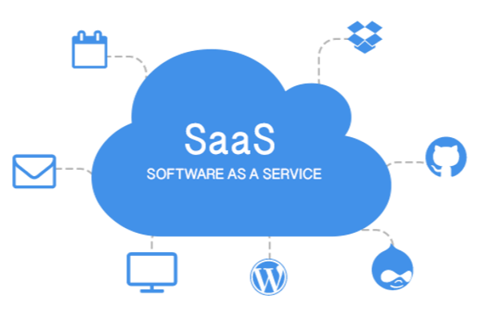
Figure 1: SaaS (Tsai, 2022)

Utilising a Marketplace such as Amazon or eBay:
Another way to reach a larger audience is to exploit existing marketplaces like Amazon or eBay. They have built-in traffic and a vast customer base, which means that SmartScape Innovations will use existing networks without the need for much marketing effort. Placing the products on Amazon and eBay, SmartScape will gain not only visibility but also credibility as these platforms are trusted by customers for their purchases. Further, the marketplace model allows for simplifying logistics and the order fulfilment process as these platforms often offer fulfilment services, warehousing, and shipping solutions, making logistic management more accessible for the business.

Creating Compelling Content
However, the role of the content is essential in attracting customers and converting them to the online store. SmartScape Innovations should spend on high-quality content that includes product descriptions, images, videos, and interactive elements that propagate the features and benefits of the SmartScape system. Product descriptions should be short and straightforward and should show the essential functions and unique selling points of the automation system, meeting customer pain points and sharing how SmartScape can enrich their everyday lives (Dickons, 2020). Images and videos demonstrating the attractive use of the products can give the users the visual experience of using the products, allowing them to see the benefits of home automation. By including interactive elements like product configurators or virtual tours, the online shopping experience becomes even more engaging, giving the customers an opportunity to personalise their SmartScape setup and see other options before purchasing.

Using Secure Payment Services:
Payment processing security is critical to establishing trust and credibility with clientele. SmartScape Innovations should use reliable payment gateways, including credit card processors and PayPal, to enhance easy and secure purchases on the online store (Alghamdi, 2020). With multiple payment options such as credit/debit cards, digital wallets, and others, SmartScape is able to fulfil various customer preferences and convenience. Nevertheless, you should keep in mind the need for PCI-DSS (Payment Card Industry Data Security Standard) compliance requirements when you are accepting card payments online. PCI-DSS standard conformity guarantees data security of sensitive cardholder details, which in turn protects both the customers and the business from possible security breaches and fraud.

C) Marketing

Promotional Methods
The marketing of SmartScape Innovations and the reaching of the target customers will require an integrated marketing mix that will include several channels including social media, search engines, email marketing, and pre-launch promotions (Elrod, 2022).

Target Customers
The homeowner, renter and property manager market have been the principal target customers of SmartScape Innovation due to the fact that they are interested in the convenience, ease and safety of the places they live. They are digital natives and want solutions that enrich their lives through automation and intelligent technologies. Our largest demographic consists of families, professionals and technology enthusiasts. In order to target them effectively, we are adopting a multichannel approach that will cater to their needs and behaviour.

Social Media
Facebook, as well as other social media platforms, will be important in our marketing campaign
(Bucher, 2020). We will use targeted advertisement campaigns to reach certain demographics by their interest, location, and online behaviour. The content includes an attractive presentation of the benefits of SmartScape, customer testimonials and a look at the product development that will be shared in order to create awareness and stimulate interest. Frequent updates and communication with our followers will help to create a community and trust that will encourage them to look at our offer further.

Figure 2: Social Media (Bucher, 2020)

Paid Search Engines
Google Ads will be used to target potential customers who are searching for smart home solutions. By using relevant keywords in the areas of home automation, IoT devices, and smart home security, we will make sure that SmartScape Innovations is found at the top of search results. Ad copy will feature critical features, benefits, and competitive advantages to attract clicks and draw visitors to our website. Continuous iterative optimisation with the help of performance metrics will ensure the high efficiency of our paid search campaigns.

Customer Journeys
Understanding the customer journey is crucial in creating individual experiences and directing prospects through the sales funnel (Addis, 2022). We will define various touch points from awareness to conversion and customise messages and content of each point to speak to the level in the journey. Such content could be educational blog articles, comparison guides, and interactive demos that would deal with specific pain points and objections while presenting the value proposition of SmartScape.

Email Marketing
Email marketing is the most essential element of our approach to lead generation and ongoing engagement with our clients. We will use targeted email lists based on user preferences, behaviour, and purchase history to provide relevant content and promotions. The personalised product recommendations, promotional offers, and educational newsletters will keep the list updated and promote repeat sales. In addition, automatic workflows set off by specific actions or milestones will facilitate communication and improve customer satisfaction.

Pre-launch Promotion
For the launch of SmartScape Innovations, our plan is to create buzz and anticipation for the launch before the day, and therefore, we will have pre-launch promotions in which we will collect email addresses and build our subscriber list (Rathore, 2021). Teaser campaigns in social media, targeted ads, and landing pages will provide early access, exclusive discounts, or some incentives for signing up. Capturing leads prior to the official launch will help us have a group of interested prospects to nurture and convert once the product becomes available. Nevertheless, compliance with rules is crucial here, e.g. with GDPR, to make sure that email marketing is legally correct and respects the user’s privacy.

D) Privacy and Data Protection

GDPR/Data Protection Act 2018
The GDPR and the Data Protection Act 2018 compliance is necessary for SmartScape
Innovations in order to ensure the ethical and legal treatment of personal information (Scott, 2020). The GDPR lays down very stringent criteria for what amounts to the collection, processing, and retention of personal data, aimed at guaranteeing the basic rights and freedoms of people within the European Union (EU) and the European Economic Area (EEA). SmartScape Innovations should adhere to all activities of data processing including customer data collection for marketing purposes to GDPR principles of lawfulness, fairness, and transparency.
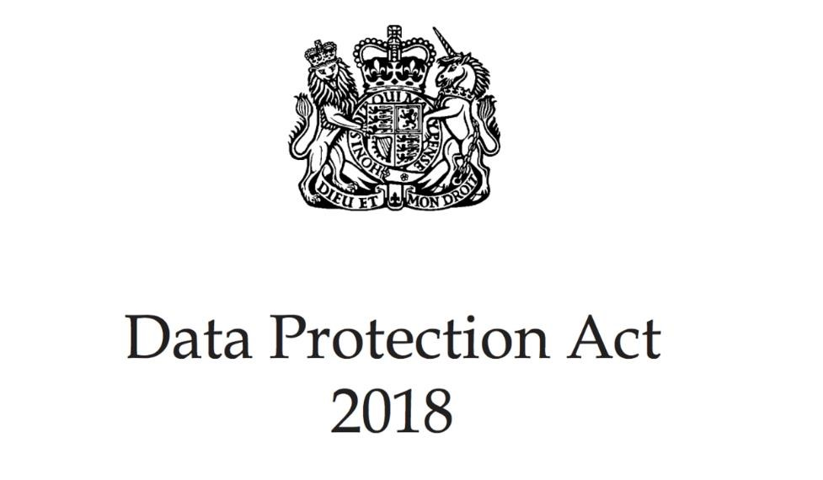
Figure 3: Data Protection Act (Scott, 2020)

Privacy and Electronic Communication Regulations (PECR)
Furthermore, in addition to the necessity to comply with GDPR, SmartScape Innovations is obliged to observe Privacy and Electronic Communication Regulations (PECR) covering electronic marketing communication (Stigler, 2022). PECR requires the obtaining of consent from individuals for sending them advertising or other promotional material through electronic media, in particular email and SMS among others. Therefore, the approach of ensuring explicit consent of the customers to be contacted with the promotional emails or short messages should be utilized by SmartScape Innovations. In addition, PECR demands the companies to offer the recipients the opt-out ability, which gives the person the ease and control of handling marketing contact.

Security and the Importance of Secure Access
The data security of its customers is an important aspect of SmartScape Innovations' concern to ensure the trust and confidence within it. Security of access to the cloud providers where the data of the customer is usually stored is necessary to prevent unauthorised access and data leakages. SmartScape Innovations uses firm authentication systems to heighten MFA and RBAC access control and guarantee that essential data is only accessed by authorised people.

Sensitivity about Default Access and Frequent Changes
Customer data access for SmartScape Innovations default should be least privilege-based. Ideally, default access permissions should be to the level that is only necessary so that employees can perform and complete their roles effectively (Gornall, 2022). Considering changes in the roles of employees or organisational structure, SmartScape Innovations also has to regularly review and renew access permissions. When access permissions are changed very frequently, the risk of unauthorised access is minimised, and employees are only provided with the data that they need at the moment.

Encrypting Traffic in Transit and at Rest
Encryption is one of the most essential elements in the protection of customers' data from unauthorised interception or access (Zaidan, 2024). Data on the SmartScape Innovations should be protected in a way that secures data while in transit and while at rest through the implementation of encryption protocols. Data in motion over networks should be encrypted using a Transport Layer Security (TLS) protocol, for example, during online transactions or communication between servers and clients. In addition, data stored in databases or on cloud servers should be encrypted employing powerful encryption algorithms so that they would likely be inaccessible in the case of a security breach or if any storage devices are stolen.

Conclusion
SmartScape Innovations is becoming the leader in the intelligent house automation field, providing an unmatched range of personalisation, accessibility, and user-centred design. SmartScape targets savvy consumers through strategic alliances, robust e-commerce platforms, and highly focused marketing offensives, all while operating under strict data protection regulations. SmartScape will lead the future of personalised home automation, where convenience, efficiency and security become the new standards of modern living through continuous innovation, customer satisfaction and compliance.

References

Addis, M. (2022). Understanding the Customer Journey to Create Excellent Customer
Experiences in Bookshops. International Journal of Marketing Studies, 8(4), p.20. doi:https://doi.org/10.5539/ijms.v8n4p20.
Ahmad, A. (2020). Architecting Software for the Internet of Thing Based Systems. Future Internet, 11(7), p.153. doi:https://doi.org/10.3390/fi11070153.
Alghamdi, T.A. (2020). Secure Service Provisioning Scheme for Lightweight IoT Devices With a Fair Payment System and an Incentive Mechanism Based on Blockchain. IEEE Access, 8(6), pp.1048–1061. doi:https://doi.org/10.1109/access.2019.2961612.
Bookhart, S.W. (2023). Benchmarking: A natural progression beyond competitive analysis. Competitive Intelligence Review, 4(1), pp.44–49. doi:https://doi.org/10.1002/cir.3880040110.
Bruggen, A. (2020). The Hidden Costs of Different Sales Channels. SSRN Electronic Journal, 6(3). doi:https://doi.org/10.2139/ssrn.2131169.
Bucher, T. (2020). Networking, or What the Social Means in Social Media. Social Media + Society, 1(1), p.205630511557813. doi:https://doi.org/10.1177/2056305115578138.
Dickons, G. (2020). How to use the knowledge of your unique selling points. Journal of Aesthetic Nursing, 8(5), pp.253–254. doi:https://doi.org/10.12968/joan.2019.8.5.253.
Dickons, G. (2024). How to indentify your unique selling points. Journal of Aesthetic Nursing, 8(4), pp.201–202. doi:https://doi.org/10.12968/joan.2019.8.4.201.
Elrod, J.K. (2022). Public relations in health and medicine: using publicity and other unpaid promotional methods to engage audiences. BMC Health Services Research, [online] 20(S1). doi:https://doi.org/10.1186/s12913-020-05602-x.
Ferguson, C. (2021). The Strategic Use of Soft Balancing: The Normative Dimensions of the Chinese–Russian ‘Strategic Partnership’. Journal of Strategic Studies, 35(2), pp.197–222. doi:https://doi.org/10.1080/01402390.2011.583153.
Ferrier, W.J. (2023). Navigating the Competitive Landscape: The Drivers and Consequences of Competitive Aggressiveness. Academy of Management Journal, 44(4), pp.858–877. doi:https://doi.org/10.5465/3069419.
Gornall, W. (2022). Customer Data Access and Fintech Entry: Early Evidence from Open Banking. SSRN Electronic Journal, 6(2). doi:https://doi.org/10.2139/ssrn.4071214.
Hassan, S.S. (2021). Determinants of Market Competitiveness in an Environmentally Sustainable
Tourism Industry. Journal of Travel Research, 38(3), pp.239–245. doi:https://doi.org/10.1177/004728750003800305.
Johnson, C.M. (2021). Compliance with data protection laws using Hippocratic Database active enforcement and auditing. IBM Systems Journal, 46(2), pp.255–264. doi:https://doi.org/10.1147/sj.462.0255.
Marshall, S. (2022). Change, technology and higher education: Are universities capable of organisational change? Australasian Journal of Educational Technology, 26(8). doi:https://doi.org/10.14742/ajet.1018.
McCrary, M. (2023). Enhanced customer targeting with multi-stage models: Predicting customer sales and profit in the retail industry. Journal of Targeting, Measurement and Analysis for Marketing, 17(4), pp.273–295. doi:https://doi.org/10.1057/jt.2009.22.
Okunishi, T. (2023). IoT (IoT Supporting our Life and Industry）. Nippon Shokuhin Kagaku Kogaku Kaishi, 64(5), pp.283–283. doi:https://doi.org/10.3136/nskkk.64.283.
Rathore, A.K. (2021). Pre- and post-launch emotions in new product development: Insights from twitter analytics of three products. International Journal of Information Management, 50(6), pp.111–127. doi:https://doi.org/10.1016/j.ijinfomgt.2019.05.015.
Schau, H.J. and Akaka, M.A. (2020). From customer journeys to consumption journeys: a consumer culture approach to investigating value creation in practice-embedded consumption. AMS Review, 3(2). doi:https://doi.org/10.1007/s13162-020-00177-6.
Scott, P.F. (2020). National Security, Data Protection, and Data Sharing after the Data Protection Act 2018. SSRN Electronic Journal, 4(3).
Spencer, A. (2022). Applying the Data Protection Act 2018 and General Data Protection Regulation principles in healthcare settings. Nursing Management, [online] 26(1), pp.34–40. doi:https://doi.org/10.7748/nm.2019.e1806.
Srinivasan, A. (2021). Entrepreneurship in digital platforms: A network-centric view. Strategic Entrepreneurship Journal, 12(1), pp.54–71. doi:https://doi.org/10.1002/sej.1272.
Stigler, G.J. (2022). An Introduction to Privacy and Electronic Communication Regulations . The Journal of Legal Studies, 9(4), pp.623–644. doi:https://doi.org/10.1086/467657.
Tsai, W.-T. (2022). Ontology patterns for service-oriented software development. Software: Practice and Experience, 43(7), pp.867–883. doi:https://doi.org/10.1002/spe.1132.
Zaidan, B.B. (2024). Enhancing Selective Encryption for H.264/AVC Using Advanced Encryption Standard. International Journal of Computer and Electrical Engineering, 2(1), pp.223–229. doi:https://doi.org/10.7763/ijcee.2010.v2.141.
Zhang, G.P. (2020). The Impact of the Online Channel on Retailers’ Performances: An Empirical
Evaluation. Decision Sciences, 41(3), pp.517–546. doi: https://doi.org/10.1111/j.15405915.2010.00279.x.



