University of Wales Trinty Saint Davids
Wales Institute of Science & Art



Title of Report: Mechanics and Dynamics
Module name (ACHA026)
Student name: Finn O’Connor
Student number:2406000
Date (1/2026)
Contents
Contents
Figures 2
1. Introduction 4
2. Experimental procedure 5
3. Results 7
3.1 Brass 7
3.2 Aluminium 7
3.3 Steel 8
4. Analysis 9
4.1 Brass analysis 9
4.2 Aluminium analysis 10
4.3 Steel analysis 11
5. Conclusion 12
6. Evaluation 12
7. Further work 13
8. References 13

Figures
Figure 1- Experiment 5
Figure 2 – Torsion of Brass rod 9
Figure 3: Torsion of Aluminium 10
Figure 4: Torsion of Steel 11

Introduction
The aim of this experiment was to investigate the torsional behaviour of circular shafts and determine the shear modules of three materials: Brass, Aluminium and Steel. This was achieved using a torsion testing apparatus by applying known loads to each specimen and measuring the resulting angle of twist.
Torsion occurs when a component is subjected to a twisting moment, causing shear deformation within the material. Understanding the torsional properties of engineering materials is important for applications such as shafts, axles and rotating components. The experimental results obtained were used to compare the torsional response of the three materials and assess their mechanical behaviour

Experimental procedure
The experiment was carried out using a torsion testing apparatus in the engineering laboratory. Three circular shaft specimens made of brass, aluminium, and steel were tested. Each specimen was secured in the torsion rig using the chuck and clamp system to prevent axial or rotational movement during testing.
The diameter of each rod was measured using a vernier calliper. The torsion apparatus was then set to its zero position before any loads were applied. A metal wire was attached to the pulley of the torsion apparatus, where known masses were applied in steps of 100g up to a maximum of 500g.
After each load was applied, one member of the team would shout out the angle that had been displayed, giving us our twist angle that was then used for further data. This process was repeated for each load increment and for each material specimen. All measurements were then recorded and later used for further calculations and analysis
Photographs were taken during the experiment to document the setup of the apparatus and the measurement process.

Figure 1- Experiment
Figure 1 shows the torsion apparatus used during the experiment
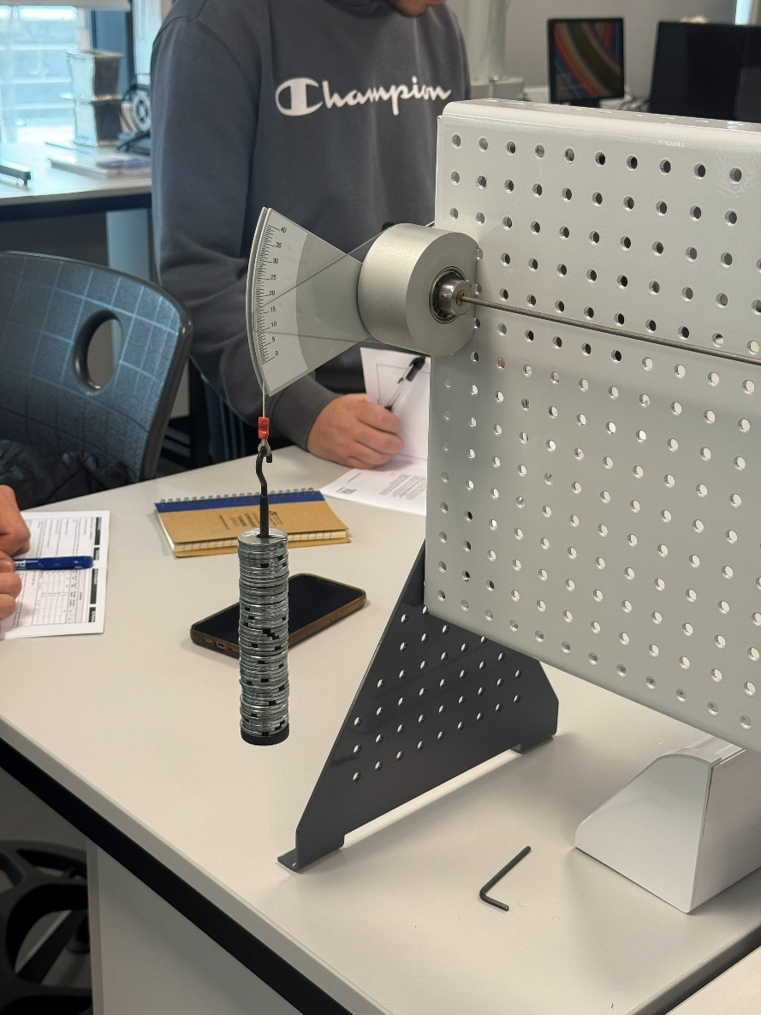

Results

3.1 Brass
Table 1 shows the processed torsion results for the brass specimen
Load (m)  (g) | Load (w)  (N) | Torque (T)  (Nm) | Twist Angle  (degrees) |  | TL
  Twist Angle
  ( ) (radians)
  $$θ$$
  J
  $$θ$$
100 | 0.98 | 0.10 | 6.5 | 0.11 | 0.033 | 1.04191E-12
200 | 1.96 | 0.20 | 13.5 | 0.24 | 0.07 | 2.16398E-12
300 | 2.94 | 0.29 | 19.5 | 0.34 | 0.10 | 3.12574E-12
400 | 3.92 | 0.39 | 25.5 | 0.45 | 0.13 | 4.08751E-12
500 | 4.91 | 0.49 | 31.5 | 0.55 | 0.17 | 5.04928E-12
Material:Brass |  | L= | 0.34m | D= 0.00311m | 9.1842E-12

3.2 Aluminium
Load (m)  (g) | Load (w)  (N) | Torque (T)  (Nm) | Twist Angle  (degrees) |  | TL
  Twist Angle
  ( ) (radians)
  $$θ$$
  J
  $$θ$$
100 | 0.98 | 0.10 | 8.5 | 0.15 | 0.03 | 1.3625E-12
200 | 1.96 | 0.20 | 16.5 | 0.29 | 0.07 | 2.6449E-12
300 | 2.94 | 0.29 | 19.5 | 0.34 | 0.10 | 3.1257E-12
400 | 3.92 | 0.39 | 25.5 | 0.45 | 0.13 | 4.0875E-12
500 | 4.91 | 0.49 | 31.5 | 0.55 | 0.17 | 5.0493E-12
Material:Aluminium |  | L=0.34m |  | D= 3.11mm | 9.1842E-12
Table 2 shows the processed torsion for the aluminium specimen

3.3 Steel
Load (m)  (g) | Load (w)  (N) | Torque (T)  (Nm) | Twist Angle  (degrees) |  | TL
  Twist Angle
  ( ) (radians)
  J
  $$θ$$
100 | 0.98 | 0.10 | 3.5 | 0.06 | 0.033 | 5.61031E-13
200 | 1.96 | 0.20 | 6 | 0.10 | 0.07 | 9.61767E-13
300 | 2.94 | 0.29 | 8 | 0.14 | 0.10 | 1.28236E-12
400 | 3.92 | 0.39 | 10.5 | 0.18 | 0.13 | 1.68309E-12
500 | 4.91 | 0.49 | 13.5 | 0.24 | 0.17 | 2.16398E-12
Material: steel |  | L= | 0.34m | D= 3.11mm | 9.1842E-12
Table 3 shows the processed torsion for the steel specimen
$$θ$$

Analysis

4.1 Brass analysis
Figure 2 – Torsion of Brass rod

Figure 1 shows a graph of TL plotted against J$θ$ for the brass specimen. The graph demonstrates a strong linear relationship between the two variables, including elastic torsional behaviour. The coefficient of determination was found to be R^2 = 0.9991, indicating excellent agreement with the torsion theory. The gradient of the graph was calculated to be approximately 3.0 × 10^10 Pa, which represents the shear modulus of brass.

4.2 Aluminium analysis
Figure 3 Torsion of Aluminium

Figure 2 shows the graph TL plotted against J$θ$ for the aluminium specimen. The graph shows an approximate linear relationship between the two variables, indicating elastic torsional behaviour over the applied load range. The coefficient of determination was found to be R^2 = 0.9863, indicating a strong correlation between TL and J$θ$. The gradient of the graph was calculated as approximately 4.0x 10^10 Pa, which represents the shear modules of aluminium

4.3 Steel analysis
Figure 4 Torsion of Steel

Figure 3 shows the graph of TL plotted against J$θ$ for the steel specimen. The graph demonstrates a strong linear relationship between the two variables, indicating elastic torsional behaviour. The coefficient of determination was found to be R^2 = 0.9953, showing excellent agreement with torsion theory. The gradient of the graph was calculated as approximately 8.0 x 10^10 pa, which represents the shear modulus of Steel.

Conclusion
The aim of this experiment was to investigate the torsional behaviour of circular shafts and determine the shear modules of brass, aluminium, and steel using a torsion testing apparatus. This was achieved by applying known torques to each specimen and measuring the resulting twist.
From the experimental result, the shear modules of brass was found to be approximately 3.0 x 10^10 Pa, aluminium approximately 4.0 x 10^10 Pa, steel approximately being 8.0 x 10^10 Pa. The graphs TL plotted against j$θ$ for all three materials showed a strong linear relationship, indicating that the specimens behaved elastically within the applied load range
Overall, the experimental values obtained were of the correct order of magnitude when compared to with published values for each material. Minor discrepancies are likely due to experimental uncertainties. The experiment therefore, successfully demonstrated the principles of torsion in circular shafts and allowed the shear modules of each material to be determined. The experimental values obtained were compared with typical published values for the shear modulus of brass, aluminium, and steel and were found to be of the same order of magnitude (The Engineering ToolBox 2019)

Evaluation
Several unexpected uncertainties may have affected the accuracy of the results obtained. The most significant source of error was the measurement of the rod diameter. Since the polar second moment of area depends on the diameter raised to the fourth power, even small measurement errors would have had a large effect on the calculated shear modules.
Additional sources of error include friction within the pulley and bearing system, which may have reduced the effective torque applied to the specimen. Small zero errors and human error when reading the angle of twist from the scale may have also contributed to inaccuracies. Efforts were made to reduce these by zeroing the apparatus before testing.

Further work
Given unlimited time and resources, the accuracy of the experiment could be improved by using a digital angle measurement system to reduce reading and parallax errors. Repeating the experiment multiple times and averaging the results would improve the reliability of the calculated shear modulus values. Testing additional materials and using shafts with different diameters would further validate torsion theory and allow comparison of torsional behaviour across a wider range of specimens

References
The Engineering ToolBox. “Engineering ToolBox.” Engineeringtoolbox.com, 2019, www.engineeringtoolbox.com/.

