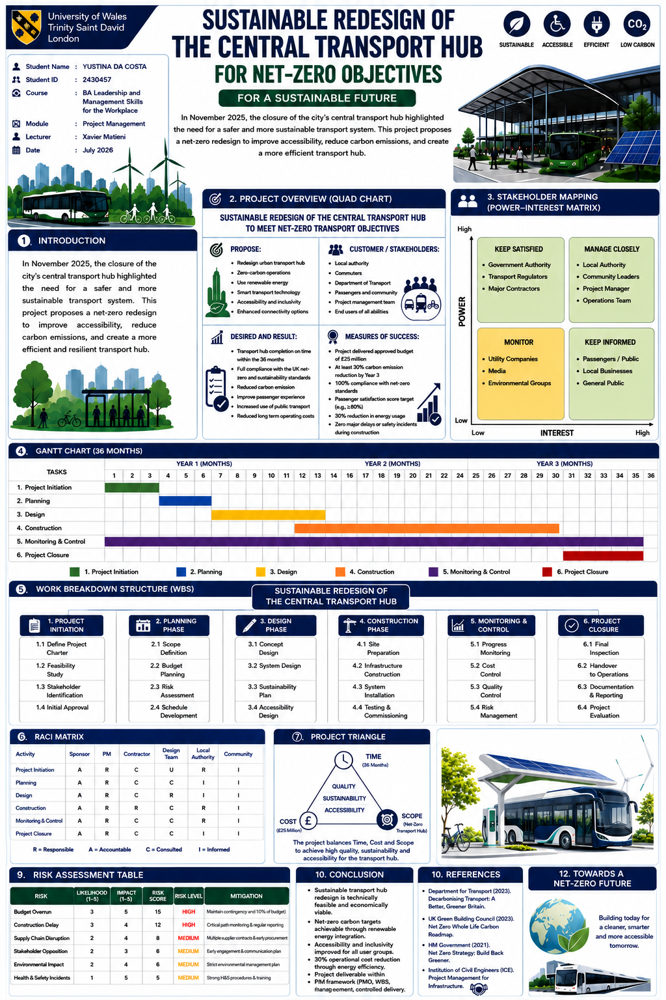

Part B: Critical Reflection Using Gibbs’ Reflective Cycle
Description
I used Gibbs’ six-stage reflective cycle to structure this reflection: description, feelings, evaluation, analysis, conclusion and action plan (University of Edinburgh, 2024). I presented my poster, “Sustainable Redesign of the Central Transport Hub for Net-Zero Objectives,” to my tutor and classmates. It included a Quad Chart, stakeholder mapping, a Gantt Chart, a Work Breakdown Structure, a RACI Matrix, a Project Triangle, and a risk assessment. The aim was to explain my project and receive feedback. Afterwards, my teacher emailed me and recommended changing the Quad Chart. A friend also told me that I forgot to say my name at the beginning. This feedback showed that the poster content was generally good, but specific improvements were needed.
Feelings
Before the presentation, I felt nervous because speaking in front of others is challenging for me. I was confident about the poster because I had prepared it carefully, but I was less confident about explaining it verbally. After receiving the feedback, I was pleased that the content was considered good. I felt disappointed about forgetting my introduction and needing to change the Quad Chart, but I accepted both comments positively.
Evaluation
A key strength was the organisation of my poster. Its purpose, stakeholders, schedule, responsibilities and risks were presented in separate sections. The images, colours and tables communicated the sustainable transport concept. The poster also demonstrated my understanding of project management tools and how they can support the delivery of a net-zero transport hub.
The main areas for improvement were the Quad Chart and my opening. My teacher’s email showed that the Quad Chart needed to communicate the project information more clearly. My friend’s comment showed that I should introduce myself before explaining the poster. I also need greater confidence and clarity because a good poster is insufficient if its main points are not explained effectively.
Analysis
This feedback helped me understand that communication is an essential project management skill. A project manager must present information clearly to sponsors, contractors, local authorities and community members. Forgetting my name may seem like a small mistake, but it made my opening less professional and weakened my connection with the audience. Unclear communication could also cause misunderstandings about objectives, schedules, costs or responsibilities.
The recommendation to change the Quad Chart showed that visual tools must be clear, accurate and consistent with the project plan. Preparation involves more than designing the poster. I must check each tool, practise how I will explain every section, manage my speaking time and answer questions. Short notes could help me remember important points without reading directly from the poster.
Conclusion
I learned that my poster demonstrated a good understanding of project management, but I must revise the Quad Chart and improve my public speaking. In future presentations, I need to introduce myself and explain the project confidently because these are important leadership and management skills.
Action Plan
For my final project plan, I will revise the Quad Chart following my teacher’s email and check that it matches the project objectives and success measures. I will prepare an opening that includes my name and presentation title. I will also make short notes, practise several times, record myself and check my voice, pace and timing. Finally, I will practise eye contact and possible questions so I can present professionally and confidently.
Reference: University of Edinburgh (2024) Gibbs’ Reflective Cycle. Available at: https://reflection.ed.ac.uk/reflectors-toolkit/reflecting-on-experience/gibbs-reflective-cycle (Accessed: 26 July 2026).


PART C | PROJECT MANAGEMENT PLAN
SUSTAINABLE REDESIGN OF THE
CENTRAL TRANSPORT HUB
For Net-Zero Objectives

Student : Yustina Da Costa
Student ID : 2430457
Course : BA Leadership and Management Skills for the Workplace
Module : Project Management
Module code :LCLM5003
Lecturer : Xavier Matieni
Submission date: 18/August/2026

Table of Contents
1. Introduction 1
2. Project Description 1
2.1 Business Need and Objectives 1-2
2.2 Delivery and Governance Approach 2
3. Scope 2
3.1 Scope Statement and Deliverables 2
3.2 Constraints, Assumptions and Control 3
4. Work Breakdown Structure (WBS) 3-4
5. Quad Chart 5
6. Gantt Chart 5-6
7. Stakeholders' Involvement 6-8
8. Allocation of Resources 8
8.1 Financial and Physical Resources 8
8.2 People, Technology and Accountability 8
9. Raci Matrix………………………………………………………………………………..9
9. Risk Analysis 9-10
10. Conclusion 11
References 12-13

List of Tables
Table 1. Scope boundaries 3
Table 2. Project Quad Chart 5
Table 3. Stakeholder involvement plan 7
Table 4. Financial resource allocation 8
Table 5. RACI responsibility matrix 9
Table 6. Prioritised risk register 10

List of Figures
Figure 1. Work breakdown structure 4
Figure 2. Thirty-six-month baseline Gantt chart 6

Executive Summary
This project management plan sets out a controlled 36-month programme for redesigning the city's central transport hub after its closure in November 2025.
The proposed investment is capped at GBP 25 million and combines safety renewal with step-free accessibility, renewable energy, smart systems, active-travel facilities and lower operational energy demand.
A mainly predictive, stage-gated approach is selected because construction, statutory approval and commissioning activities require clear sequencing; structured design reviews and stakeholder consultation provide controlled adaptation.
The plan defines scope boundaries, a six-phase work breakdown structure, a baseline Gantt schedule, a Quad Chart, stakeholder engagement, resource allocation, RACI accountability and a scored risk register, all aimed at ensuring stakeholder understanding and alignment.
Success is measured through completion within 36 months and budget, at least a 30% carbon-emission reduction by Year 3, a 30% reduction in operational energy use, full accessibility acceptance, passenger satisfaction of at least 80% and no major safety incident. Clarifying these success criteria helps the audience feel assured and motivated about the project's goals.
The plan defines scope boundaries, a six-phase work breakdown structure, a baseline Gantt schedule, a Quad Chart, stakeholder engagement, resource allocation, RACI accountability and a scored risk register. Emphasising stakeholder involvement helps the audience feel included and confident in the project's collaborative management.

Introduction
The closure of the central transport hub in November 2025 exposes material weaknesses in safety, accessibility and environmental performance. The proposed redesign responds through an integrated public-infrastructure project rather than a like-for-like repair. National policy expects transport investment to support the transition to net zero while improving the attractiveness of public and active travel (Department for Transport, 2021; HM Government, 2021). The plan therefore treats carbon, energy, inclusion and passenger experience as controlled project outcomes alongside time, cost and quality.
A project management plan translates those outcomes into governable work, decision rights, resources, controls and acceptance measures. The Project Management Institute (2025) emphasises value delivery, adaptability, accountability, stakeholders, risk and tailoring; these principles suit a transport hub whose construction, operational and community systems are interdependent. Sustainable project management also extends decisions beyond delivery to whole-life environmental, social and economic impacts (UK Green Building Council, 2021; Wu et al., 2023). Accordingly, this report applies a tailored predictive approach with controlled consultation and design iteration, supported by a WBS, Gantt schedule, Quad Chart, stakeholder analysis, resource plan and risk register.
The plan is intended for the project sponsor, local authority, delivery team, regulators, operators, and community representatives, emphasising the need for consistent communication about decisions, progress, cost, risk, and expected benefits to keep stakeholders engaged and aligned.

Project Description

Business Need and Objectives
The project redesigns the existing central interchange as a safe, resilient and inclusive gateway for bus, pedestrian and cycling movements. Core outputs comprise renewed passenger and operational areas, step-free routes, accessible facilities, renewable energy generation, electric-vehicle support, smart energy and passenger information systems, secure cycle provision, and improved pedestrian connections. Construction is planned around temporary access and service-continuity arrangements so that disruption remains proportionate.
The approved parameters are a maximum budget of GBP 25 million and completion within 36 months. Outcome targets are at least a 30% reduction in carbon emissions by Year 3, a 30% reduction in operational energy use, compliance with applicable net-zero and accessibility requirements, passenger satisfaction of at least 80%, and zero major safety incidents. Current guidance assesses success across value, benefits, sustainability, time, cost, risk, scope and quality rather than relying only on the traditional iron triangle (PeopleCert, 2023; Project Management Institute, 2025).

Delivery and Governance Approach
A predictive, stage-gated lifecycle is appropriate for feasibility, planning approval, detailed design, procurement, construction, commissioning and handover. Each gate requires sponsor approval of scope, cost, risk and readiness before further commitment. Adaptive elements operate within design packages: accessibility users, operations staff and community representatives review prototypes and layouts before design freeze. This combination preserves baseline control while allowing learning where stakeholder needs and technical interfaces are uncertain. Governance separates direction from delivery through a sponsor-led project board, a responsible project manager, specialist assurance and formal change control. This tailored structure is consistent with current guidance on project context, governance and delivery capability (International Organisation for Standardisation, 2021; Infrastructure and Projects Authority, 2022).
Governance information flows from work-package leads to the project manager and then to the project board. The board reviews the schedule, cost forecast, major risks, quality results, carbon performance and stakeholder issues each month. Decisions and actions are recorded in controlled logs with owners and completion dates. Independent assurance is used at design freeze, construction readiness and final acceptance to test whether evidence is complete. This structure supports accountability without removing the contractor's responsibility for safe and compliant delivery.

Scope

Scope Statement and Deliverables
The scope covers design and delivery inside the defined hub boundary, including enabling works, passenger areas, transport interfaces, accessibility upgrades, renewable and smart-energy systems, active-travel facilities, testing, staff training and operational handover. The product scope is expressed as measurable deliverables, while the project scope includes the management work needed to produce and accept them.
Configuration control links each deliverable to requirements, design approval, testing evidence and an accountable owner. Whole-life thinking is necessary because environmental performance during construction may differ from performance during operation (UK Green Building Council, 2021).

Table 1 clarifies what the baseline includes and excludes. The boundary prevents unapproved expansion while retaining the work needed to realise the approved benefits.
Included in baseline | Excluded from baseline
Hub building, platforms and passenger circulation | Purchase of buses or other rolling stock
Step-free access, tactile routes and accessible facilities | City-wide road works outside the hub boundary
Solar generation, charging and smart-energy controls | Long-term operating subsidy after handover
Cycle parking, pedestrian links and passenger information | Unrelated commercial property development
Commissioning, training and handover documentation | Routine maintenance after the defects period

Constraints, Assumptions and Control
Primary constraints are the GBP 25 million ceiling, 36-month deadline, statutory approvals, safe work in a constrained urban location, supply availability and continued access for surrounding users. Assumptions include sponsor funding at agreed gates, access to the site, timely utility coordination, availability of specialist suppliers and participation by regulators and user groups.
Scope change requires a documented request, impact analysis and project-board decision. Only approved changes update the scope, schedule, cost and benefit baselines. This discipline supports the Construction Playbook’s emphasis on outcomes, early planning, effective contracting, safety and better, faster and greener public-works delivery (Cabinet Office, 2022).
Quality management converts the scope into acceptance criteria. Design reviews confirm compliance with safety, accessibility, planning and sustainability requirements before construction information is released. Inspection and test plans define what is checked, who witnesses the check and what evidence is retained. Non-conforming work is recorded, corrected and verified before closure. At handover, the operations team receives training, asset information, warranties, maintenance instructions and commissioning records. These controls reduce the risk of achieving physical completion without delivering a usable and supportable transport hub.

Work Breakdown Structure (WBS)
The WBS decomposes the project into six control accounts: initiation; planning; design; construction; monitoring and control; and closure. Decomposition creates manageable packages that can be estimated, assigned, scheduled and verified. The hierarchy also strengthens traceability: the scope statement defines required outputs, the WBS defines the work, the Gantt chart defines timing, the RACI matrix defines responsibility, and the risk register defines uncertainty. The Project Management Institute (2025) treats scope, schedule, resources, stakeholders and risk as connected areas of project performance.
Figure 1 contains four work packages under each phase. Initiation confirms feasibility and authority; planning establishes the baselines; design integrates technical, sustainability and accessibility requirements; construction creates and commissions the asset; monitoring and control operate throughout delivery; and closure verifies acceptance, transfers records and evaluates performance. Work-package owners develop detailed method statements and estimates, but additions outside this hierarchy require change approval. The WBS therefore functions as both a planning model and a governance boundary.
A WBS dictionary supports the diagram by defining the description, owner, deliverables, dependencies, resources, assumptions and acceptance criteria for each package. Control-account owners estimate cost and duration at the lowest practical level and report progress against measurable completion evidence.
This prevents subjective percentage reporting and improves consolidation into the overall dashboard. Package boundaries also clarify interfaces between civil works, renewable systems, accessibility installations and operational commissioning, where unclear ownership could otherwise create delay, rework or gaps in testing.
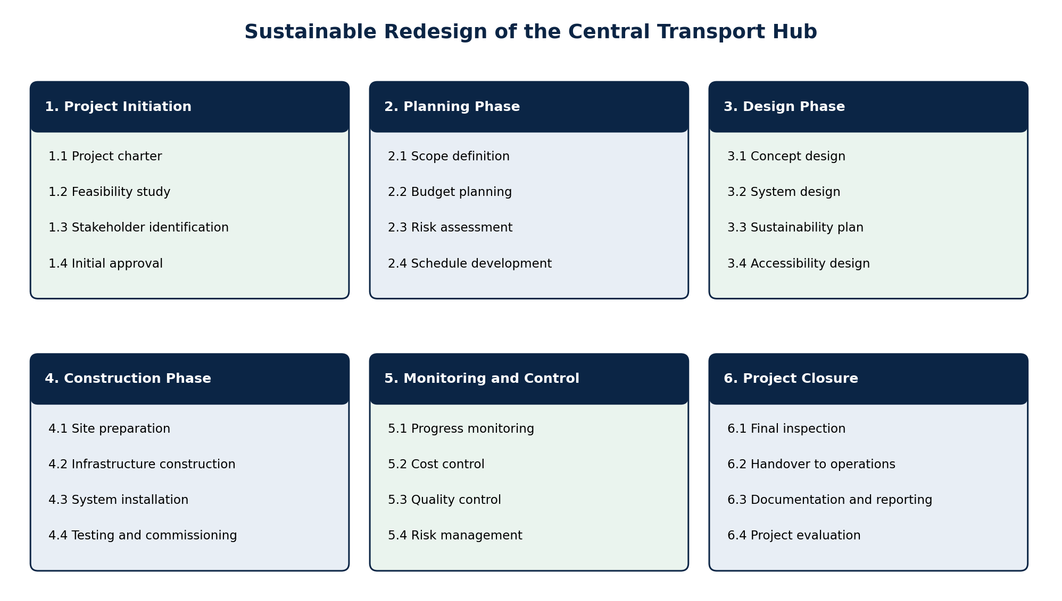

Quad Chart
The Quad Chart condenses the project's purpose, customers, intended results and success measures into one governance view. Table 2 supports rapid alignment at sponsor reviews: the upper cells explain why the investment exists and who must receive value, while the lower cells define the expected change and the evidence required for acceptance. Linking outcomes to evidence supports public-sector appraisal and stakeholder alignment (HM Treasury, 2026; Ngampravatdee et al., 2023).
Table 2. Project Quad Chart
Purpose | Customers and stakeholders
Create a safe, accessible, resilient and lower-carbon hub using renewable energy, smart systems and active-travel connections. | Sponsor; local authority; Department for Transport; regulators; operations team; passengers; community; local businesses; users of all abilities.
Desired results | Measures of success
Operational hub within 36 months; compliant net-zero and accessibility performance; improved passenger experience; lower carbon, energy use and operating cost. | Cost at or below GBP 25m; at least 30% carbon reduction by Year 3; 30% lower operational energy use; satisfaction at least 80%; no major safety incident.

Gantt Chart
The baseline schedule in Figure 2 converts the WBS into a 36-month sequence. Initiation occupies Months 1-3 and planning Months 4-6. Design runs from Months 7-13. Construction begins in Month 12 after release of approved early-work packages and continues to Month 30, creating a controlled overlap that protects the completion date without authorising unresolved design. Closure and handover occupy Months 31-36. Monitoring and control span all months because cost, quality, carbon, safety, interfaces and benefits require continuous evidence rather than an end-stage inspection.

Figure 2. Thirty-six-month baseline Gantt chart

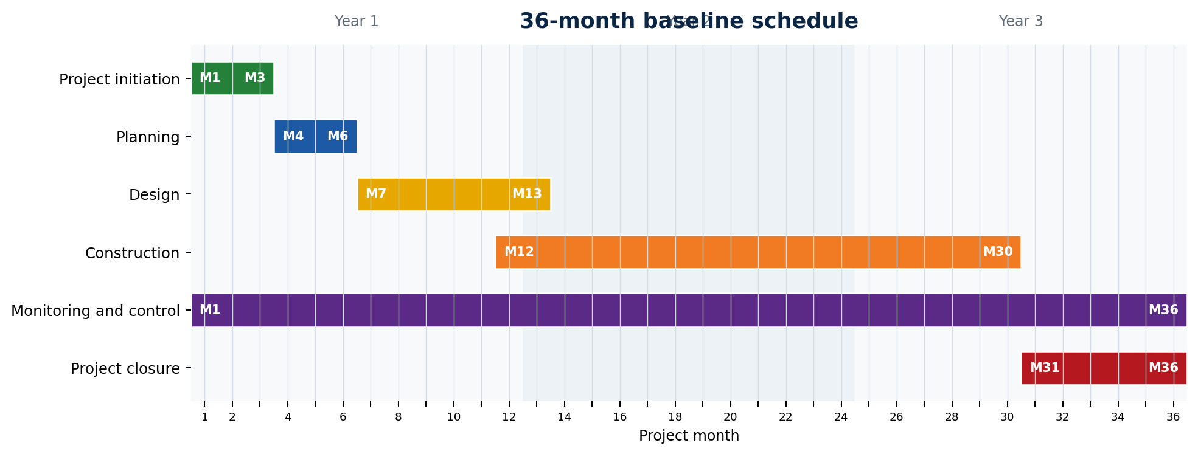
Milestone reviews occur at charter approval, baseline approval, design freeze, construction readiness, commissioning completion and final acceptance. The project manager maintains the integrated schedule and reports variance monthly.
Critical or near-critical activities receive corrective action, while proposed acceleration is assessed for cost, safety and carbon consequences. Current guidance for complex projects combines formal controls with capable governance, transparent performance information and timely decisions (Infrastructure and Projects Authority, 2022; Project Management Institute, 2025). Schedule changes affecting a gate, approved completion date or contingency require project-board approval.
Schedule control begins with clear dependencies and realistic resource assumptions. The planner updates actual starts, finishes, remaining duration and milestone forecasts using information approved by package owners. A rolling twelve-week look-ahead identifies access constraints, design information, procurement dates and approvals needed for upcoming work.
Variance analysis distinguishes isolated delay from movement on the critical path. Recovery options may include resequencing, additional resources or alternative suppliers, but every option is reviewed for cost, quality, safety, accessibility and environmental effects before approval.

Stakeholders' Involvement
Stakeholder analysis is continuous because stakeholder power, interest, needs and influence can change across the lifecycle. Research on large transport infrastructure and sustainable construction shows that structured engagement supports planning quality, sustainability and project success (Ngampravatdee et al., 2023; Wu et al., 2023). The sponsor, local authority, project manager and operations team remain closely involved because they control funding, approvals, delivery and acceptance. Government bodies, regulators and major contractors require satisfaction through assurance and timely decisions. Passengers, community groups and local businesses require accessible information and meaningful consultation. Utilities, media and environmental groups are monitored for emerging issues.
Table 3 translates the power-interest matrix into specific involvement, frequency and ownership. The approach avoids treating communication as one-way publicity; feedback is recorded, assessed and closed through the decision log. This systematic approach helps integrate stakeholder knowledge and sustainability considerations into project decisions (Ngampravatdee et al., 2023; Wu et al., 2023).
Table 3. Stakeholder involvement plan
Group and position | Involvement method | Frequency/owner
Manage closely: sponsor, local authority, PM, operations | Board decisions, design reviews, cost-risk reports and acceptance gates | Monthly and at gates / PM
Keep satisfied: government, regulators, major contractors. | Compliance submissions, assurance meetings and commercial reviews | At milestones/sponsor and PM
Keep informed: passengers, community, local businesses. | Accessible briefings, workshops, surveys, disruption notices and feedback log | Monthly; fortnightly during disruptive works/engagement lead
Monitor: utilities, media, environmental groups | Interface coordination, published updates and issue-based consultation | Quarterly or by trigger / PM

Accessibility representatives participate during concept design, detailed design, mock-up review and acceptance testing. Operations personnel confirm maintainability, safe operating procedures and training needs before handover. Recent UK evaluation evidence reinforces the importance of accessible information, staff capability and measuring disabled passengers’ confidence and experience (Department for Transport, 2025). Community feedback may refine circulation, working hours or temporary access, but any change remains subject to scope and cost control. Escalation routes are published so urgent safety, equality or service-continuity concerns reach the project manager and sponsor promptly.
The communication plan specifies the message, audience, channel, timing, owner and method for confirming understanding. Information is provided in accessible formats and plain language where public participation is required. Consultation results are summarised without disclosing personal information, and responses explain whether a proposal is accepted, rejected or referred for further study. Attendance, survey results, complaints and response times provide evidence of engagement quality. This approach helps the team identify concerns early and demonstrates that participation influences decisions rather than operating as a procedural exercise.

Allocation of Resources

Financial and Physical Resources
Resources are released by lifecycle stage and matched to WBS ownership. The GBP 25 million baseline in Table 4 reserves the largest share for construction while protecting specialist design, accessibility, renewable systems, stakeholder activity and commissioning. The sponsor holds a 10% contingency and is not treated as available working budget. Drawdown requires a quantified risk event or approved change. Cost accounts align with WBS packages, enabling monthly comparison of planned value, actual cost and forecast completion. This approach reflects current public-sector guidance to assess options through their costs, benefits and risks (HM Treasury, 2026).
Table 4. Financial resource allocation
Resource category | GBP million | %
Governance and project management | 1.50 | 6
Design, environment, accessibility and approvals | 3.00 | 12
Civil works and construction | 10.00 | 40
Renewable energy and smart systems | 4.00 | 16
Accessibility and active-travel facilities | 2.00 | 8
Testing, training and commissioning | 1.00 | 4
Stakeholder engagement and communications | 1.00 | 4
Sponsor-held contingency | 2.50 | 10
Total | 25.00 | 100

People, Technology and Accountability
The core team comprises the sponsor, project manager, cost manager, planner, design manager, sustainability and carbon lead, accessibility adviser, stakeholder lead, procurement manager, principal contractor, health and safety manager, quality manager, systems integrator and operations representative. Plant, low-carbon materials, modular components, solar equipment, charging assets, sensors and digital information systems are procured against technical and whole-life criteria. Specialist availability is secured early for design assurance, accessibility audit and commissioning. The resource strategy supports current expectations for capable teams, early supply-chain involvement and whole-life carbon management (Cabinet Office, 2022; UK Green Building Council, 2021).
Table 5 clarifies accountability using RACI: Responsible performs the work, Accountable approves the result, Consulted contributes before decisions, and Informed receives status. A single sponsor remains accountable for each phase, while the project manager coordinates delivery and escalation.
Resource control also addresses capacity and timing, not only total cost. The project manager reviews the demand for specialist people, plant and long-lead equipment against the programme so that competing requirements are visible early. Procurement packages include technical, environmental, accessibility and social-value criteria alongside price. Supplier performance is monitored through delivery reliability, quality, safety and corrective-action measures. Where forecast demand exceeds availability, the team considers resource levelling, resequencing, approved alternatives or additional capacity before the shortage affects a critical activity.
Table 5. RACI Responsibility Matrix
Activity | Sponsor | PM | Contractor | Design team | Local authority | Community
Initiation | A | R | C | I | C | I
Planning | A | R | C | C | C | I
Design | A | R | C | R | C | C
Construction | A | R | R | C | C | I
Monitoring and control | A | R | C | C | C | I
Closure | A | R | C | C | C | I

Risk Analysis
Risk management follows a repeating process of identification, analysis, response, ownership, monitoring and communication. Current project management standards integrate risk with objectives, value, and decision-making (PeopleCert, 2023; Project Management Institute, 2025). Each risk receives a likelihood and impact rating from 1 (very low or negligible) to 5 (very high or critical); multiplication produces the risk score. Scores of 1-4 are low, 5-9 medium, 10-15 high and 16-25 extreme. Ratings are reviewed monthly and before every stage gate.
Table 6 prioritises the six threats identified in the poster and adds ownership. Budget overrun is the highest current exposure because inflation, design development and interface change can affect several packages simultaneously. Construction delay is also high because approval, access and supply dependencies converge on the critical path. Responses combine avoidance, reduction, transfer and acceptance; contingency is a treatment resource, not a substitute for prevention. Current guidance also encourages teams to examine opportunities alongside threats, so the review records possible early-procurement savings, modular construction and energy-performance improvements (Project Management Institute, 2025).
Table 6. Prioritised risk register
Risk | L | I | Score/level | Response and owner
Budget overrun | 3 | 5 | 15 / High | Design-to-cost, change control and 10% contingency / PM and cost manager
Construction delay | 3 | 4 | 12 / High | Critical-path review, early approvals and recovery plans/planner and contractor
Supply-chain disruption | 2 | 4 | 8 / Medium | Early procurement, dual sourcing and approved alternatives/procurement manager
Stakeholder opposition | 2 | 3 | 6 / Medium | Early consultation, accessible evidence and issue closure/engagement lead
Environmental impact | 2 | 4 | 8 / Medium | Environmental management plan, monitoring and stop-work triggers/sustainability lead
Health and safety incident | 1 | 5 | 5 / Medium | Construction-phase plan, competence checks, briefings and audits / H&S manager

Risk owners report leading indicators as well as incidents. Cost forecast movement, design queries, approval ageing, supplier lead times, complaints, environmental exceedances and safety observations trigger reassessment. High risks appear on the project-board dashboard with trend, treatment status and residual score. Escalation occurs when exposure exceeds tolerance, threatens a success measure or requires contingency.
Sustainable control also tests whether corrective action transfers harm to another outcome; for example, schedule recovery cannot bypass accessibility assurance or increase unsafe working. This balanced approach integrates project delivery with whole-life sustainability and stakeholder value (UK Green Building Council, 2021; Wu et al., 2023).
After each response is implemented, likelihood and impact are rescored to determine residual exposure. The sponsor accepts risks that remain above tolerance only when further treatment is impractical or disproportionate. The register also records emerging risks, causes, consequences, trigger dates and response deadlines. Opportunities follow the same governance process and may improve cost, duration, carbon performance or passenger value. Lessons from incidents, audits and completed packages are reviewed throughout delivery, allowing controls to improve before similar work begins elsewhere on the project.

Conclusion
The plan converts the net-zero transport-hub proposal into an integrated and governable delivery baseline. Scope boundaries, six WBS phases, the 36-month schedule, stakeholder involvement, a GBP 25 million resource plan, RACI accountability and scored risk responses reinforce one another. Stage gates provide control for a safety-critical infrastructure project, while structured consultation and design reviews allow evidence-based adaptation. Success is assessed through time and cost performance together with carbon, energy, accessibility, passenger satisfaction, safety and operational acceptance.
These wider measures respond to the limits of the iron triangle and support durable stakeholder value. Continuous monitoring, transparent governance and whole-life sustainability remain essential from initiation through handover. Subject to sponsor approval and statutory assurance, the plan provides a credible route to a safer, inclusive, efficient and lower-carbon central transport hub.
Final acceptance therefore depends on verified completion of deliverables, approved operating documentation, trained staff, resolved defects and evidence that the hub can achieve its promised service and sustainability outcomes during normal operation. Benefits reviews continue annually after handover.

References
Cabinet Office (2022) The Construction Playbook. London: Cabinet Office. Available at: https://www.gov.uk/government/publications/the-construction-playbook (Accessed: 26 July 2026).
Department for Transport (2021) Decarbonising Transport: A Better, Greener Britain. London: Department for Transport. Available at: https://www.gov.uk/government/publications/transport-decarbonisation-plan (Accessed: 26 July 2026).
Department for Transport (2025) Inclusive Transport Strategy Evaluation: Summary Report. London: Department for Transport. Available at: https://assets.publishing.service.gov.uk/media/67bddd96b0d253f92e213c67/inclusive-transport-strategy-evaluation-summary-report.pdf (Accessed: 26 July 2026).
HM Government (2021) Net Zero Strategy: Build Back Greener. London: HM Government. Available at: https://www.gov.uk/government/publications/net-zero-strategy (Accessed: 26 July 2026).
HM Treasury (2026) The Green Book: Central Government Guidance on Appraisal and Evaluation. London: HM Treasury. Available at: https://www.gov.uk/government/publications/the-green-book-appraisal-and-evaluation-in-central-government/the-green-book-2026 (Accessed: 26 July 2026).
Infrastructure and Projects Authority (2022) Project Routemap: Handbook. London: Infrastructure and Projects Authority. Available at: https://assets.publishing.service.gov.uk/media/6297200fe90e0703a2fed794/Handbook__-_FINAL.pdf (Accessed: 26 July 2026).
International Organisation for Standardisation (2021) ISO 21500:2021 Project, Programme and Portfolio Management - Context and Concepts. Geneva: ISO. Available at: https://www.iso.org/standard/75704.html (Accessed: 26 July 2026).
Ngampravatdee, C., Gharehbaghi, K., Hosseinian-Far, A., Tee, K.F. & McManus, K. (2023). 'Strategic initiatives for large transport infrastructure planning: reinforcing sustainability in urban transportation through better stakeholder engagement', Sustainability, 15(18), 13912. doi: 10.3390/su151813912.
PeopleCert (2023) Managing Successful Projects with PRINCE2 7. London: PeopleCert International.
Project Management Institute (2025) A Guide to the Project Management Body of Knowledge (PMBOK Guide). 8th edn. Newtown Square, PA: Project Management Institute.
UK Green Building Council (2021). Net Zero Whole Life Carbon Roadmap: A Pathway to Net Zero. London: UK Green Building Council. Available at: https://ukgbc.org/wp-content/uploads/2021/11/UKGBC-Whole-Life-Carbon-Roadmap-A-Pathway-to-Net-Zero.pdf (Accessed: 26 July 2026).
Wu, S.-W., Yan, Y., Pan, J. & Wu, K.-S. (2023). 'Linking sustainable project management with construction project success: moderating influence of stakeholder engagement', Buildings, 13(10), 2634. doi: 10.3390/buildings13102634.

