Academic and Employability Skills
Student: Shemeka Williams
Student ID: 1913883
Lecturer Name: Alfred Mensah
BMSW4001 Term 1 Rework

Contents
Introduction 3
1. Employability Skills 3
1.1 Communication 3
1.2 Time Management 4
1.2.1The Importance of Time Management 4
1.3 Team Working 5
1.3.1 S.W.O.T Analysis 5
2. Academic Skills 5
2.1 Communication 6
2.2 Team Working 6
2.3 Time Menagement 6
2.4 Plagiarism 6
2.5 Personal Development Plan 6
3. Appendix 7
4. Conclusion 7
5. References 7

Introduction
Academic and employability skills is to understand the knowledge and skills to help individual to use in a workplace in an effective manner, in this assignment I would be defining skills and example of skills and why they are needed in workplace, employer needed to have several roles and responsibility skill to reach performance objectives, I will be talking about personal development plan, swot analysis, team working, time management and communication, and also my conclusion on this assignment.

1. Employability Skills
Oxford English Dictionary stated skill is the ability to do somethings well, the job require skill and an eye for details, Employability skills plays a very important role in the effective performance in a workplace, skills can be divided in a lot of different way which include communication skills, time management and team working, skills are the ability to perform and carry out your confident (Oxford University press 2020). I will be talking about hard skills- technical skills which are writing using a computer, soft skills which are skills that develop in a workplace through the academic. I need different skills to do jobs, and life skills to help through my day at work and in different stages in my life, learning more skills in life makes you improves on helping me to succeed and stand out more in life and work

1.1 Communication
In academic and employability communication must be involve, communication is sharing information between two are more individuals by speaking, writing or using some other medium, communication is important aspect of life especially in workplace it brings employee’s together, workplace communication is needed to allow employee to be productive and operate properly, failing to communicate at work could end up missing your chance of securing your job. Effective team working and communication is great for business when relation with company and client can communicate well, there are different types of communication non-verbal and verbal. There are different types of model of communication which was invented for individuals to send messages, the Shannon and Weaver model is consisted of three primary parts which are sender, channel and the receiver and as time went by more concepts added to the model which was noise, decoder and encoder it is known as the mother of all model. In 1960 Divid Berlo expand the Shannon Weaver model creating the SMCR model meaning sender-message-channel-receiver, in 1984 the next model Wilbur Schram examines the impact that message has on the target of massage with each party. (Businesstopia 2018).

1.2 Time Management
Time management is the time spend planning on doing specific activities to work smarter and harder so I can get more done in less time it will help me to aim for my short- and long-term goals, even if the time is short and pressures are high it is a juggling act upon a person work life, social life, family life and hobbies. When using effectively it give me choice on how to spend and manage time on my own, in a workplace no one manage time then a project manager when they have to handle team member and too many tasks, also it’s important to understand both structural and technical different in time management, by keeping a record of the time I send make me manage time efficiently at work, improving my time at work makes me perform and achieve my goals, failing to manage my time is poor management and can lead to stress affect a business impact on performance and lock of self-esteem etc. The benefits of good time management in my professional life can benefit me from the following, give good quality of work, less procrastination, more productivity and efficiency, less anxiety stress etc, better time management are plan, prioritize, do not multitask and cut off distraction. Time management can have good impact on my life and work for me get thing things done on time on a daily life, I need to improve my ability with better decision gain utmost control of things that are important.

1.2.1The Importance of Time Management
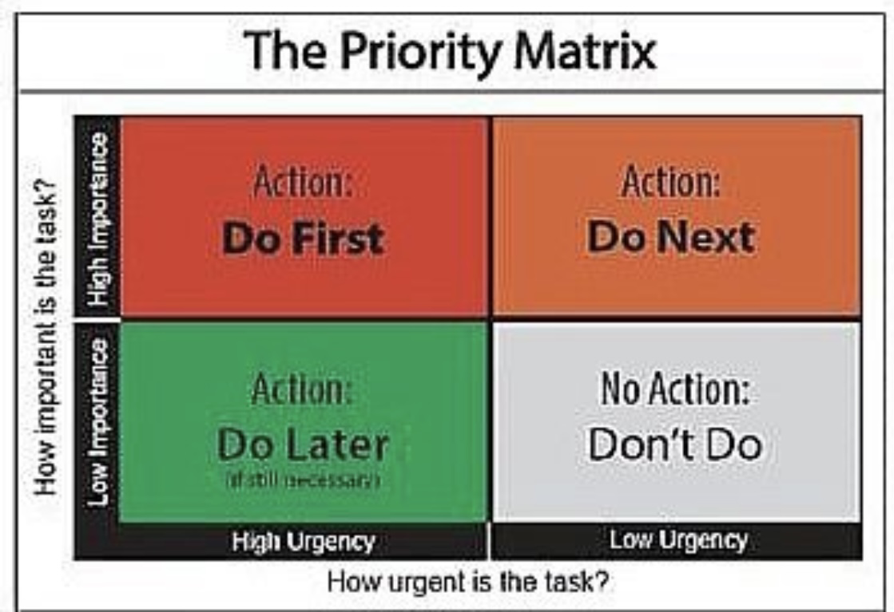
Using time productively and efficiently is important but sometimes we cannot get everything done on time, you can save time management is a combination of productively working good timing prioritising. People that are good at time management is better at prioritising by working out what is really needed for such time, there are urgent and things that important, for us to have good time management we must work out wish comes first and by doing so there is a thing call the priority matrix which can help us. (2011-2020 SkillsYouNeed)

1.3 Team Working
Team working is when a group of people comes to work towards a goal/result to gain a good atmosphere. It is also defined as a collabrative effort of group to achieve great task (Kozlowski, Bell 2003). By building each other confident to gain good team performance most work place relies on team working to accomplish their jobs, it also let me gain good friendship , loyalty and sharing, most team required a leader which sometimes share the work load so other don’t feel left out, In these days the ability to only work as an individual is not sufficient, staff are needed by menagement leader to work more collectively in order to enhance and advance development and growyh of the company, when working in a team individual going to have different’s like opinion, feeling towards things, views and approach we may come from different back ground so we have fine ways of communicate well in a team, In one of my class exrcise we done a group presentation where other from other group was giving different topic to work on we chose a leader what topic we are good at working on, this is where we found out about our swot analysis within the group and we even have a better communication then before.

1.3.1 S.W.O. T Analysis
Swot analysis use to identify strenghs, weaknees, opportunities treats towards working, It is design to make process in my life, The swat analysis was made to ask question and answers to determine competitive advantage, These are example of my swot analysis.
Strenght- I have learn how to communicate through verbal and non-verbal and active listening, I also learn about time management and was able to be better when meeting my deadlines with jods are tasks, I found myself to be stronger at communicating.
Weakness- I still struggly to on how to start are end a roport, I fine myself very weak at referncing even when trying to use the Harvard referencing, when doing a presentation I need to know what are the most important to present and how to present instead of reading stright out word for word.
Opportunities- By doing this course I have gain a lot of skills knowledge, I didn’t have to use computer offen but by doing this course I remember a lot thing that I total forgot about.
Treats- Referncing, paraphrasing and plagiarism are impotant in an report and these I belive are my biggest treats which need working on.

2. Academic Skills
Academic skills are a group of studys that use to help student to absorts lessons, some of thses tools are academic writing, analytic thinging, referencing, digital skills and time management, it is considered to be a very essentila for getting good grades. (wiseGEEK 2020)

2.1 Communication
Communication skill have many types that can help me me to learn and practice to be better at effective communicator, communication skills are important when working together which give me a great contevts when possible. Some example of communication skills are active listening, friendliness, confidence and respect etc.

2.2 Team Working
Team working is needed in a class for it to develope and grow especially in group work, by working as a team it show each individual skills regardless of their weaknesses and strenght academically. We ask in one class to do a group presentation and to be in groups of five, at first it was a bit challenging for everyone trying to be on the part but in the end it all went well we have learn a lot from each other, one of the main areas that I have learn lot from as digital skill, so in all aspest I can say been in a team show lot from individual skills.

2.3 Time Management
Time menagement is very imortant in our everyday life whatever time lose can not be giving back, so I have to set myself to accomplish certain task on time. By planing and writing my daily task dimissing all distraction I get things done ontime both social and non-social life, In my assignments we set date and time for these to be done so be understanding and using time management I complete them.

2.4 Plagiarism
Plagiarism is when you present some else ideas or work for yours without their knowledge (them knowing) and not acknowledging them so its best to avoid plagiarism, there are diferent tyoes of plagiarism like ideas ans written text contant, however by not doing plagiarism it helps to get better understanting of things done by yourself, it increase your writting, vocabulary, understanting and learning power. Plagiarism include quotations and use to paraphrase checker, (Oxford,2020).
- Paraphrasing is by using other words by speaking, writing and rewriting in your own words, always keep the original meaning so that statement remain the same, it expresses the same idea in your own words, it male explaining ideas of your wors and use information usful, there is a bit different in paraphrasing and summarising.
- Summarising is a passage that you mainly stated the main ideas in your own words, and is much shorter than the main passage and also summarising has needless details and kept shorter.

2.5 Personal Development Plan
I am aming towards good and productive plan and by looking at my SWOT analysis and priority matrix, working towards my short and long term goals to become a duty manager are a station manager and also by doing the course it one step towards achieving my goals

3. Appendix
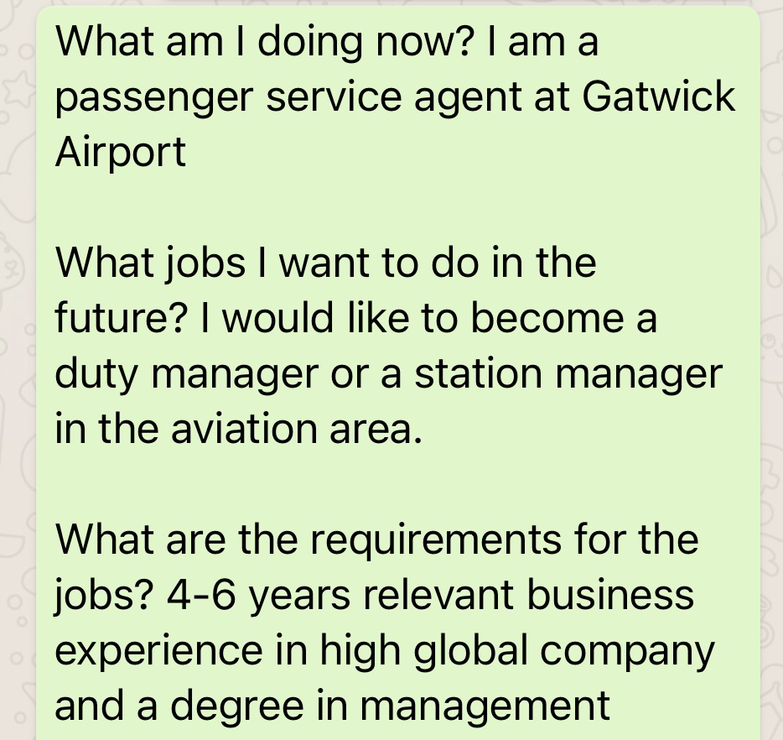
My in class exercise for my future plan

4. Conclusion
By doing this assignment and what other information I knew before I can say that academic and employability skill are need in a workp place, it aslo show me the inportances of good communication, time management, team working, plagarism and swot analysis. It also helps to fine my voice, writing and referencing skills, I can really say that by doing time management it have hepls me in both personal and work life, without academic and employability skill work can’t impove well, and I truly hope that this assignment give you a good understanding of academic and employability skills.

5. References
Oxford, (2020). [online] Available at: https://www.ox.ac.uk/students/academic/guidance/skills/plagiarism
SkillsYouNeed (2011-2020).[online] Available at:
https://www.skillsyouneed.com/ps/time-management.html
Businesstopia (2018).[online] availble at:
https://www.businesstopia.net/communication
Wikipedia, (2009). [online] Available
https://en.wikipedia.org/wiki/Study_skills

