

The School of
Architecture, Built and Natural Environments

Level 4

Module title:
Fundamentals of Construction Technology

Module code:
ACBA4001

Module Leader:
Allan Nantel
Word Count: 1,952.

Assessment Component: 1:
‘Describe the historical background of the site via a preliminary desktop study, drawing upon archival material. Your study should include plans and photographs, with full referencing of both illustrations and archival information gained.
Describe, given the historic background, your recommendations for the contents of a detailed site investigation, which is to be undertaken by others. You must advise them of which elements of the site investigation you consider being most significant and applicable to this site, given it historical background.
State the building regulations/ codes of practice from which your recommendations are derived. With the aid of sketches describe a suitable foundation detail.’

PROPOSAL for SITE INVESTIGATION REPORT
DESK STUDY AND RECOMMENDATIONS FOR AREA OF INVESTIGATION

Introduction

The purpose of this case study is to explore the appropriate site and soil investigation techniques plus identify types of substructure foundations available for typical low-rise buildings while identifying building regulation and codes of practice that govern the industry.
This case study will assume that there is to be a new two-storey structure built on land that has previously been used. This structure is to have a ground floor with a gross internal area (GIA) of 300 m² and must contain an ice-cream parlour, restaurant, café bar, kitchen, food stores, and toilet facilities. On the first-floor level, there is to be a self-contained managers apartment with a staff area.
This case study will assume that the work has been carried out by a junior construction professional, working for a local company tendering for a Design and Build contract, asked to carry out a full site investigation to observe the feasibility of the construction.

Background

This desk study is being carried out as part of a feasibility study on behalf of the contractors tendering proposal.
It is to comply with British Standards (BS) 5930:2015 Code of practice (2015) for ground investigations.
The City and Council of Swansea have agreed in conjunction with the Marriott Hotel Group to construct a new restaurant with accommodation for management above.
The following desk study is comprised of readily available information to form a preliminary report, suggesting on any further investigations to be carried out, also indicate the type of possible foundation that might be suitable for the site. Thus, informing on the relative feasibility of the proposed construction.
Site location; west of the Marriott Hotel, Swansea SA1 3SS.
Coordinates - 51º36’48’’N 3º56’43’’ W
Site area - internal area of 300m² (including walls, area coverage of 312m²)
Land use surrounding site – North – carpark, vegetation and though road
East – carpark, hotel and storage constructions
South – coast and promenade
West – carpark and vegetation
The site is currently a carpark for both adjacent buildings, with a landscaped area with vegetation and grasses in-between.
The area for consideration is on the foreshore, between the carparks of the City and County of Swansea County Hall and Swansea Marriott Hotel, (henceforth known as the ‘site’) (see Appendices A, B & C). This information was acquired to follow the procedure stated in BS EN 5930:2015,14-1-2.
Access to the site could be limited, the closure of large sections of the adjacent carparks will be needed, while consideration towards the walkway on the beachfront which may involve footpath diversions. (Countryside and Rights of Way Act 2000)
It is seen that the site is located on a pre-used landscaped area. Apart from the apparent maintenance holes, there are no other apparent obstacles to consider. (Appendix D)

Site history

Research into the history of the site using old geological maps dating from 1887-1964 and historical information from Swansea Archives, it becomes apparent that the proposed area had been heavily industrialised, with many rail lines in the area (see Appendices, E, F & G) and the south docks located nearby. After the 1960’s these lines were replaced with the Civic Centre and a hotel that exists, both owned by the client.
In conjunction, in WWII Swansea was subjected to many nights of aerial bombing, focused on the docks and industrial areas of Swansea. Speaking to Buckingham construction site located 200m away, they did not detect any UXO’s in their survey. This may still be relevant to check as the Nazi’s did locate the said area as a significant target (Appendix H). This information was collected with the guidance of section 13.1 and 13.6 in BS EN 5930:2015.

Utilities and services

In need for mapping and layout of utility and services for the supply of the construction, there will be a need to contact the following authorities for information on the relevant supplies.
Water – Dŵr Cymru Welsh Water
Gas Lines – Wales & West Utilities
Electrical supply – Western Power Distribution
BS 5930 section 5.3 states that identifying these utilities and services should be following PAS 128. (2015) During the walkthrough, there were no above-ground services identified.

General geology and ground conditions

Using existing geological mapping done by the British Geological Survey (BGS) 1: 50,000 shows that the top regolith is Blown Sand though it is unsure as to what depth, Bedrock is shown as Sand Stone, again it is in sure at what depth. (see Appendices I & J) BS 5930:2015-14.3
Due to the pre-use of the site, the ‘O’ and ‘A’ horizon of the soil will be Anthropogenic ground. A BGS borehole test proves this, SS69SE345, that was carried out directly above the site, down to the depth of 20.00m, (Appendix K), which shows that the Anthropogenic layer goes to a depth of 4.95m. As in compliance with section 13 of BS 5930:2015.

Permitted uses and restrictions

Planning is to consider the Town and Country Planning (General Permitted Development) (Amendment) (Wales) Order 2019. This will be relevant to the authority of City and County of Swansea Council.
Though there is a by-law that is to be considered that does not permit the construction to obscure public access to the foreshore: B14-23-04-1913 Regulation of the Seashore. Also, to be considered, a parking by-law, Traffic Regulation Order 2019, Civic Centre Car Park (east), Oystermouth Road, Swansea, made under the Road Traffic Regulation Act 1984 and Traffic Management Act 2004.

Though, Right of Way will need to be considered as the construction will be cutting of an existing path. Therefore, thought should be taken into diverting this footpath. This should all be in conjunction with the Rights of Light Act 1959 and Countryside and Rights of Way Act 2000.
As there are residential properties about 200m away, consideration should be taken towards disturbances like noise and traffic. Work hours will have to be confined to 08:00 till 18:00 and notices will have to be provided if drilling or pile driving is needed. This will be managed following the Control of Pollution Act 1974.
As in conjunction with BS EN 5930:2015-11-12 a desk study and field walkover has been completed, part of a preliminary investigation, giving findings that can now be acted on in a detailed investigation.

Suggestions for further investigations

Before the start of a detailed ground investigation, a risk assessment is required looking at field reconnaissance, identification and correction measures, this should then be applied throughout the investigation. If any changes in conditions occur, then a review is to be incited, as stated in BS 5930:2015-5.1.
Due to the foreseen risk of UXO’s and the previous use of the site as an industrial area and potential chemical residue, there will need to be an investigation in line with BS 10175:2011+A2:2017. This standard guide how to proceed with managing risk to contaminated or harmful materials.

As more information is obtained the primary objectives and identification shall be updated in line with the needs laid out in BS EN 1997-2
The staff of contracted company to carry out the tasks of planning, execution, sampling, measurement and supervision of the exploratory hole will need to be a qualified professional with relevant experience as is stated in BS 10175,5.2.6.1. Though the operator and lead driller of the rigs used is following BS 5930:2015,17.8.
When comprising a detailed plan for a ground investigation to look at possible contamination will need to observe the BS EN 1997-2:2007. Also, when plotting out the points of drilling locations for exploratory holes the relevant distances will need to be observed, for our construction that is 10-30m as stated in BS EN 1997-2 annexe B. Also, if and historical utilities are detected and are still in use a designated distance will have to observed, this changes if these are of cast iron construction, stated in HSG 47 and HSE A25 No8.

When the exploratory hole is being dug, it will be used for multiple tests, one being groundwater observation (2.1.4) as the proximity of the site to the coast will become relative. While investigating the soil and rock at the site to find strong enough strata to support the proposed construction, exploratory methods will have to reach a depth that is past any ‘made’ ground, as stated in BS EN 1997-2 2.4.1.2 and 2.4.1.3 of BS EN 1997-2:2007. The selection of these rigs and exploratory methods are defined by BS EN 5930:2015,19.

As seen with the borehole test (Appendix L), dense/compact ground does not occur until 4.00m deep, so the exploratory hole would have to be a minimum of 3m below this point this will then relate with the guidance of BS EN 1997-2:2007 annexe B.
When identifying and testing these samples, work will be carried out in accordance to standards stated in CEN/TC 341 and CEN/TC 288.
Giving the prior knowledge of the ground, it would be advised to explore deeper, though this would lead to an increase in costs.
As Anthropogenic ground and blown sand layers are not suitable for ‘open hole’ drilling and would need supporting as stated in BS EN 5930:2015,20.8. It would be advised to use a method of ‘open hollow stem auger’, to prevent the collapse of drilled walls. A highway rig would be relevant for this area as it has quite easy access to the adjacent tarmacked carparks on either side of a wide foot path. This is supported by BS EN 1997-2 (3.4.1 and 3.5.1). Sample drilling and properties of the strata layers detected should be identified and assessed using the parameters of EN ISO 22475-1. It would be advised in conjunction with exploratory pits; observation trenches would be the most efficient way to observe the strata and enable an informed decision.
Due to the history of the site, the test samples will need to be analysed for potentially corrosive and deteriorate elements to enable any changes needed to be implemented further down the planning stage. This would be done to counter any degenerative factors in line with section 21.2 and 21.5 in BS EN 5930:2015, though it is stated in section 16.8 and 16.9 that this should be part of any ground investigation on an industrialised site.

When drilling is completed, it must be cleaned to the guidelines of CIRIA R132.
Now, looking at the preliminary data collected in this study, consideration of the type of foundations should be in conjunction with BS 8004:2015 and conform to BS EN 1997-1.

Proposed preliminary foundations

Spread foundations alone would not be suitable to support the construction as a dense stratum does not occur till a depth of 4.95m (see Appendix M). As it is stated in section 4.1.2.1 that an adequate bearing stratum would need to be at a depth below 2m. Section 4.1.2.2 states that Spread foundations should not be placed on non-engineered fill.
Section 4.1.3.1 states that pile foundations should be used when there is a compressive stratum on top of bedrock or overlaying soils of an adequate density.

When investigating for piled foundation, not only should it conform to BS EN 1997-2, it should also observe BS EN 12699. Relevant for this site as a viable option of a Driven Pre-formed Displacement pile (Appendix N & O), as shown in BS EN 8004:2015-6.1.3.
Though it could be said that the best form of foundation for this site would be a pile-enhanced raft (Appendix P), this would minimise foundation settlement and reduce any shear forces that occur on an unsupported raft foundation, (Appendix O & P sections 4.1.5.2 and 4.1.5.3 state the recommendations of how a piled raft should be considered. Even though it would be possible to construct on this site, the cost would be far higher than the profit that is recoupable from the planned business at this site. It could be suggested to move sites or convert a pre-existing structure.

Appendix A,
An OS map showing area of proposal.

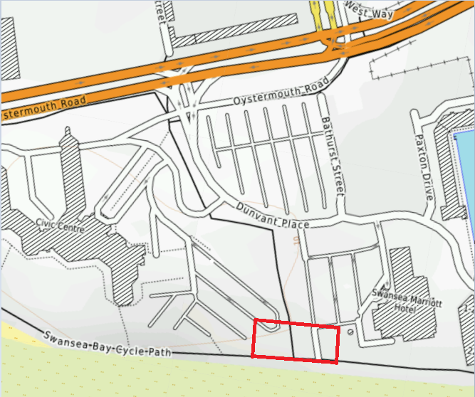

Appendix B,
Google satellite photo highlighting area.

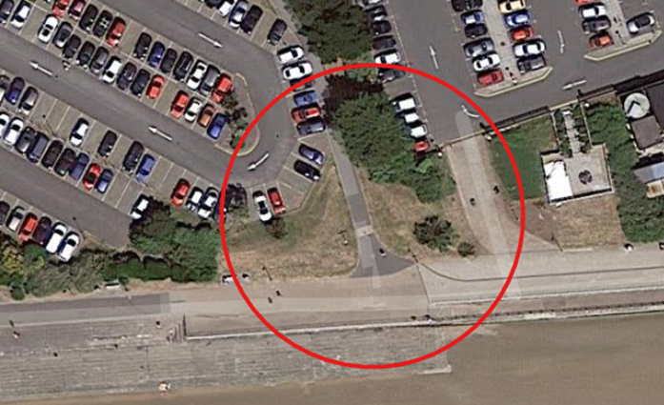

Appendix C,
Google satellite photo, the surrounding area of the site.

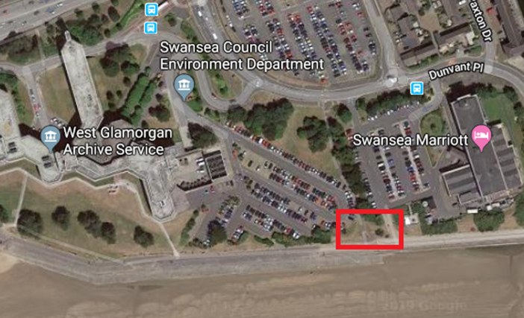

Appendix D,
An image obtained during walkthrough of site, facing north from the shore.

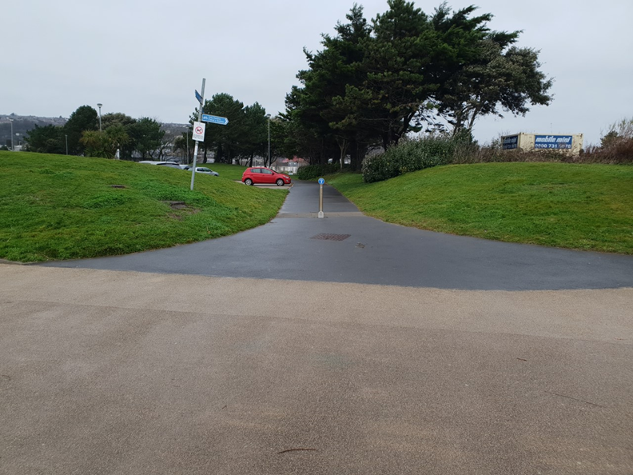

Appendix E,
1897 Geological map showing the area proposed for construction.
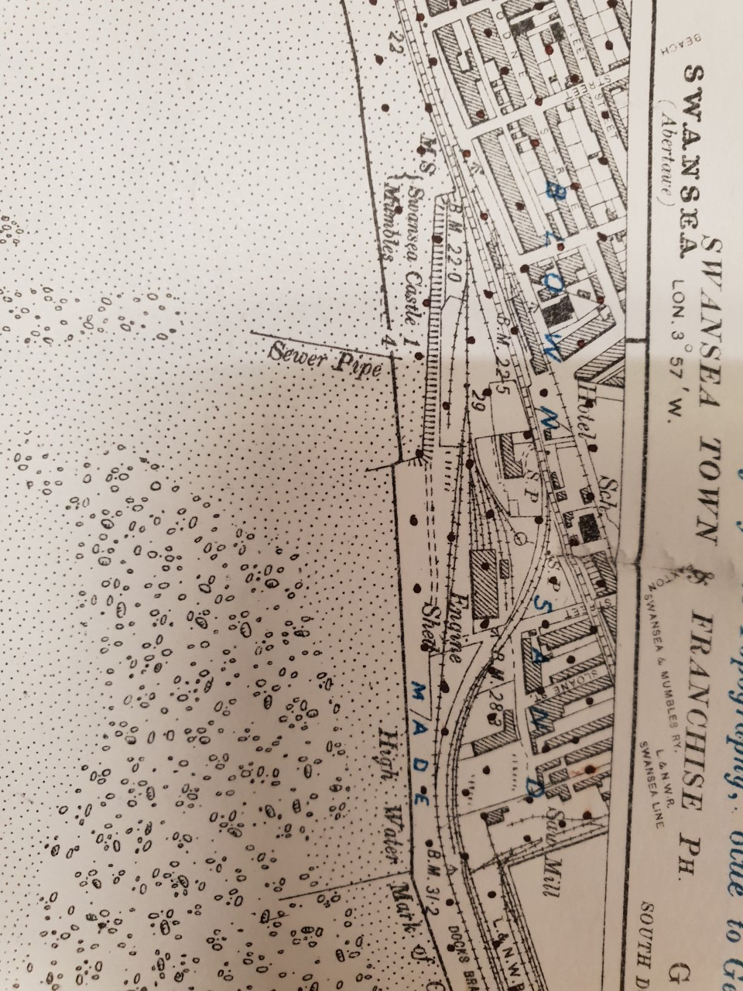

Appendix F,
Map from 1900 showing the proposed area with further development.

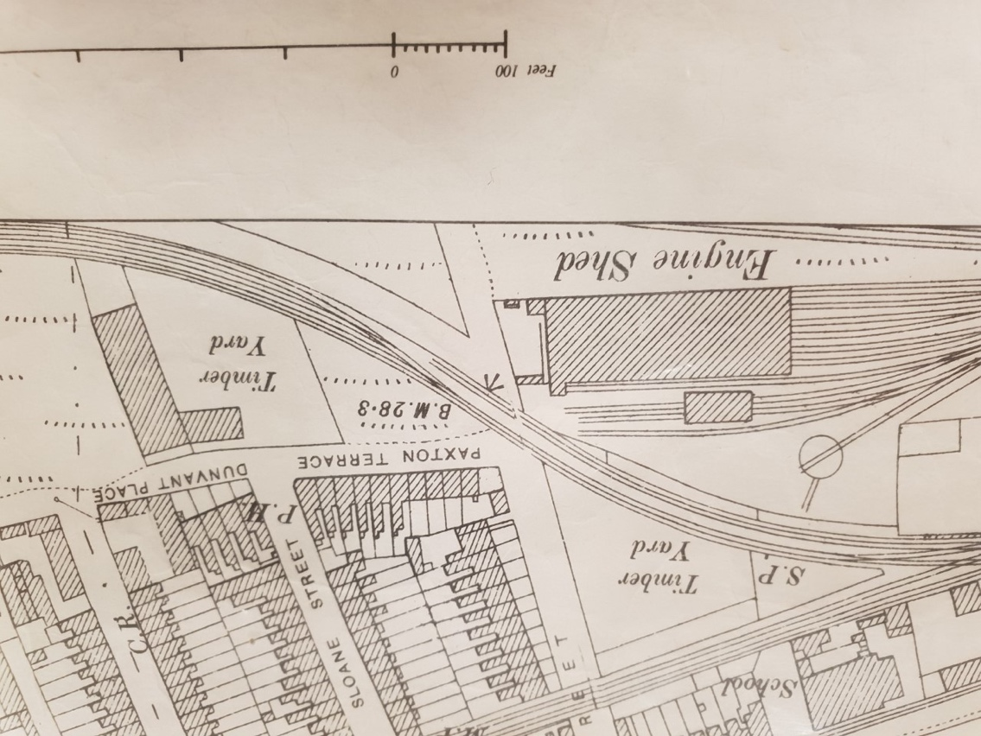

Appendix G,
Map from 1945-1946 showing area in more detail, but no new changes.
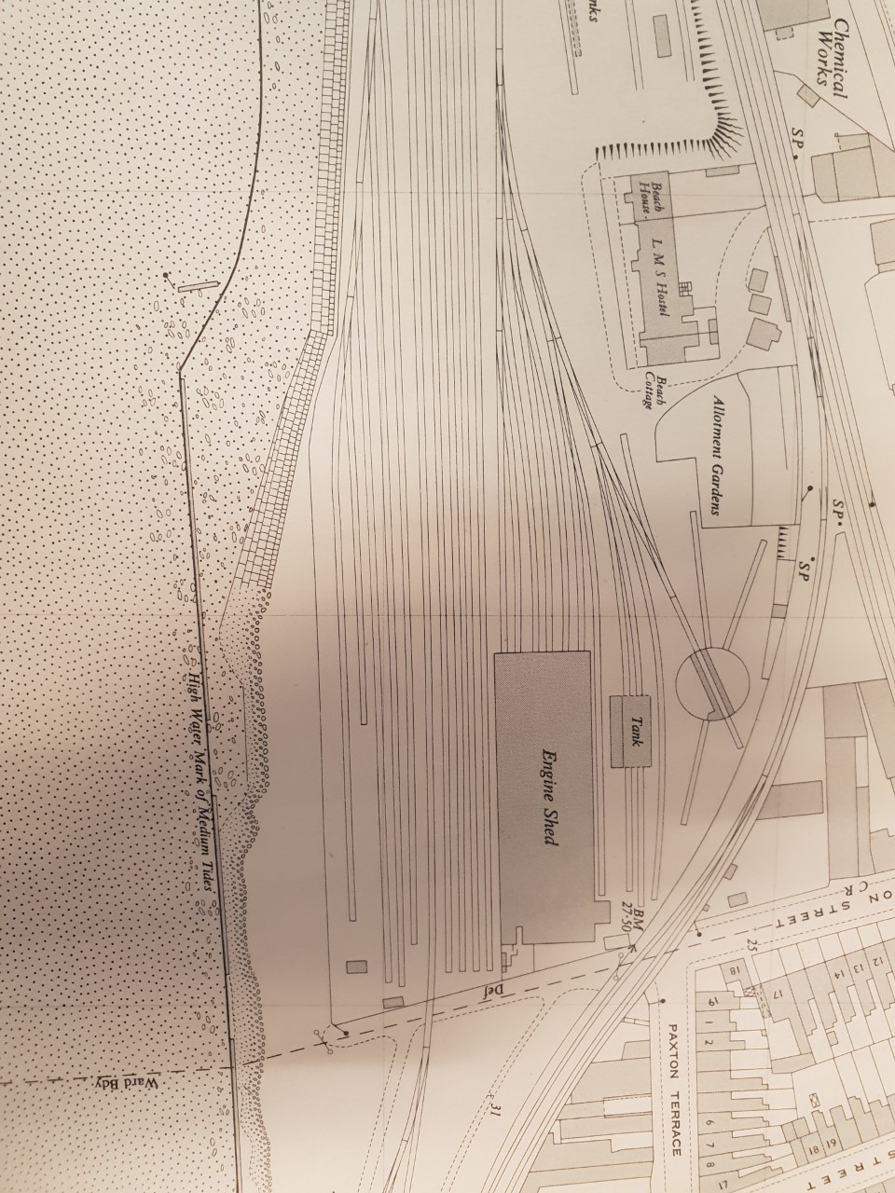

Appendix H,
German map showing highlighted area for focus of bombing raids.
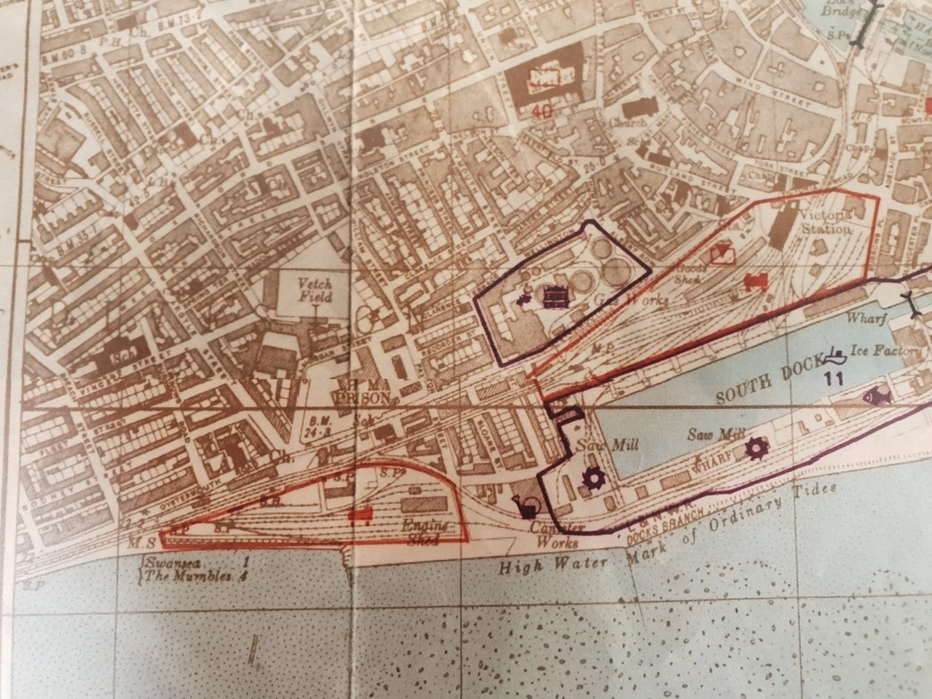

Appendix I,
Image of the soil make-up of the area done by the British Geological Society.
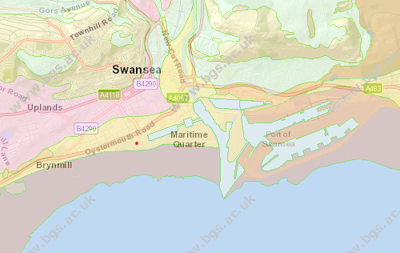

Appendix J,
Image of the bed rock located in the site area as Sand Stone, comprised by the British Geological Society.
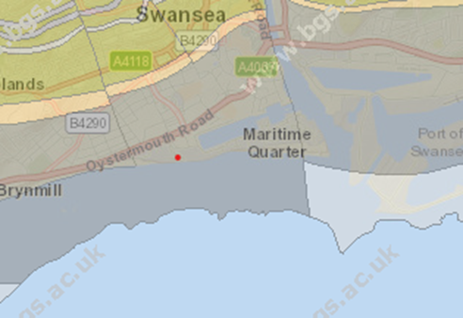

Appendix K,
Results from bore hole SS69SE345 located on the site by British Geological Society.
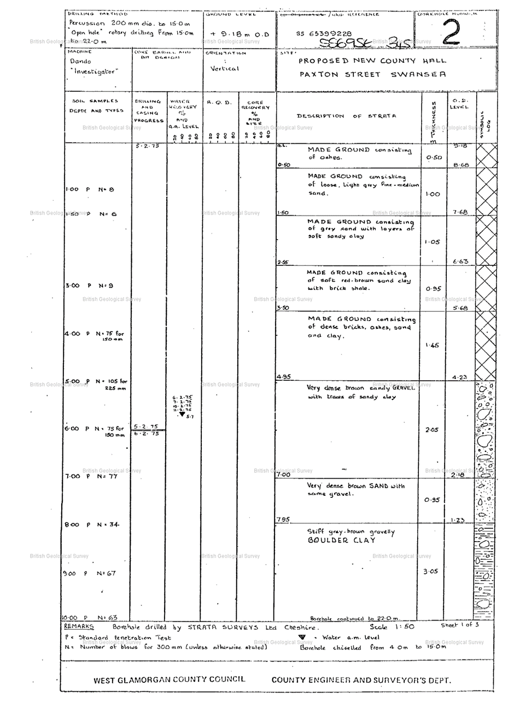
Appendix L,
Drawing of a precision driven pile, then the extraction of the metal casing and the concrete fill.
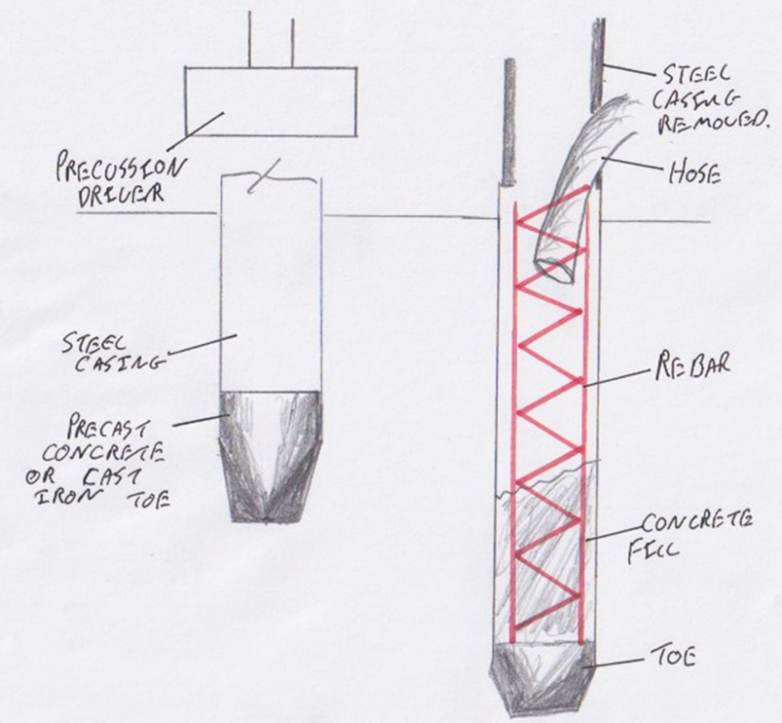

Appendix M,
Drawing of the metal casing being driven back down into the concrete to force displacement into the surrounding strata, then showing the finished pile.
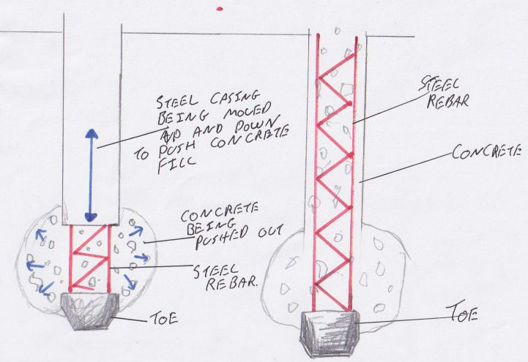

Appendix N,
Drawing showing a finished enhanced raft foundation.

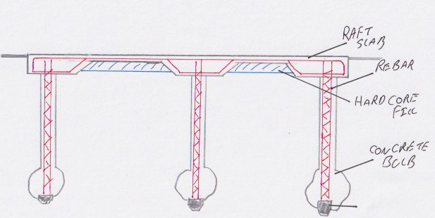

Appendix O,
Drawing showing a detailed supporting edge of a raft foundation.
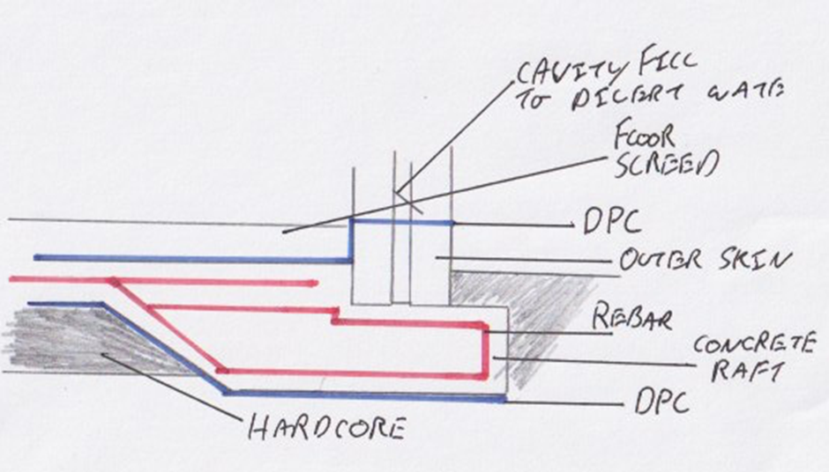

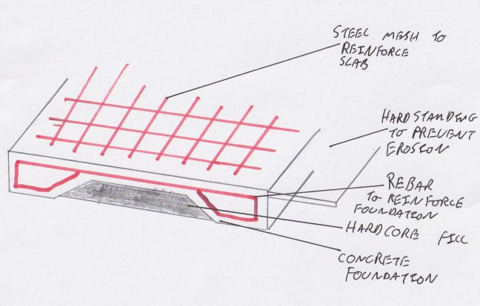
Appendix P,
Drawing showing the design of a basic raft foundation.

Reference List

European standard. 2004. Geotechnical Design. [Online]. [12 December 2019]. Available from: http://geotechnicaldesign.info/ec7p1.html
(European standard, 2004)
Code of practice for ground investigations. 2015. Geotechnical Design. [Online]. [13 December 2019]. Available from: http://geotechnicaldesign.info/bs5930-2015.html
(Code of practice for ground investigations, 2015)
Code of practice for foundations. 2015. Geotechnical Design. [Online]. [13 December 2019]. Available from: http://geotechnicaldesign.info/bs8004-2015.html
(Code of practice for foundations, 2015)
Specification for underground utility detection, verification and location. 2014. Geotechnical Design. [Online]. [13 December 2019]. Available from: http://geotechnicaldesign.info/pas128-2014.html
(Specification for underground utility detection, verification and location, 2014)
Eurocode 7 geotechnical design ground investigation and testing. 2007. Geotechnical Design. [Online]. [13 December 2019]. Available from: http://geotechnicaldesign.info/ec7p2.html
(Eurocode 7 geotechnical design ground investigation and testing, 2007)
Map data. 2019. Google Maps. [Online]. [13 December 2019]. Available from: https://www.google.co.uk/maps/@51.6133058,-3.9456899,17z?hl=en
(Map data, 2019)
Trafic managment act 2004. 2004. Legislation . [Online]. [13 December 2019]. Available from: http://www.legislation.gov.uk/ukpga/2004/18/contents
(Trafic managment act 2004, 2004)
ermanent traffic regulation orders. 2019. Swansea Council . [Online]. [13 December 2019]. Available from: https://www.swansea.gov.uk/article/4911/Permanent-Traffic-Regulation-Orders
(Permanent traffic regulation orders, 2019)
The town and country planning order . 2019. Legislation . [Online]. [13 December 2019]. Available from: http://www.legislation.gov.uk/wsi/2019/330/contents/made
(The town and country planning order , 2019)
Byelaws. 2018. Swansea Council . [Online]. [13 December 2019]. Available from: https://www.swansea.gov.uk/byelaws
(Byelaws, 2018)

