(AC 1.1)
Employee involvement
Numerous interventions have been developed and used to improve the efficient use of human resources in response to the ongoing push to improve organisational performance. Gifford, et al (2005) states that one of these is employee participation initiatives, also known as high involvement work practices, which aim to match employees' interests with those of their organisation and harness employee potential and incorporate it into the business strategy. Engagement of employees is essential to the success of an organisation. It entails giving employees the freedom to take charge of their projects and collaborating with management on important choices. Increased motivation and productivity can be the result of this direct engagement, which promotes creativity and independent thought. Organisations can establish a structure that empowers staff members to make critical decisions without needing upper management's approval by giving them training and growth opportunities. (Bin Hussain, 2024).
Employee participation
Employee participation can be a very effective way to accomplish a shared objective. It entails establishing a collaborative, community-based workplace where staff members from various job roles can collaborate to produce ideas (Bin Hussain, 2024). By encouraging a strong sense of ownership and belonging, this cooperative approach can create an atmosphere where you can maximize the ability of your employees to achieve organisational objectives. Participation from employees can have a significant and strategic influence on corporate success. Lombard (2025) states that the results from employee participation can include deeper communication, a boost in morale and making work for the employees meaningful. a decrease in turnover rate, it breeds quality and promotes productivity and innovation.
Utilising employee participation as part of this merger could keep morale high and promote inclusivity in a time of potential high stress. An example of how this could be used is by empowering members of a department (from both organisations) to come together and best plan how their department can be run, in line with the Company values.
Employee involvement v Employee participation
Through the development of effective communication and employee well-being, employee involvement and participation build relationships between staff and organisational managers. Despite their frequent interchangeability, the words "employee participation" and "employee involvement" have certain distinctions. One of the main differences between employee participation and employee involvement is that while involvement relates to how much influence employees have over the decisions they make about which company activities to engage in, participation refers to the actual business activity that employees carry out (Bin Hussain, 2024). Participation from employees encourages a team approach where a group of employees uses their varied skill sets to accomplish a project and reach a shared objective. However Employee involvement is all about the direct relationship between employees and management to promote better communication and more empowerment in the process of making decisions that impact the workplace.
Through the development of effective communication and employee well-being, employee involvement and participation will help build relationships between staff and organisational managers during this merger. Understanding the differences will be advantageous to the teams in their new roles.

(AC 1.2)
Union employee representation – Trade Unions
CIPD (2025) states that trade unions are organisations whose members are usually workers or employees. Through bargaining on issues like pay and working conditions, they can safeguard and advance the interests of their members. They accomplish this through collective bargaining, which involves consulting and negotiating agreements with employers to represent the opinions of their members. Union members elect representatives to speak on their behalf on matters of mutual interest in the working relationship, like compensation, and to offer one-on-one counsel when they are having issues at work. Members pay a membership fee.
Non-union employee representation – Employee forums
It is estimated that around half of employee representatives in the UK are non-union. Compared to their union counterparts, their function is typically far more constrained, primarily consisting of advice (ACAS, 2014). Employee forums, a type of non-union representation, enable staff members to organise and talk about significant issues, then giving management their feedback. These forums are made up of elected employee representatives that meet with management on a regular basis to discuss issues pertaining to employees. including workplace policies and health issues. Employee forums are intended to promote candid conversations and give workers a chance to air grievances outside of a trade union setting.
Similarities
Employees can voice their opinions on workplace issues through employee forums and trade unions. They seek to advance constructive organisational changes, raise employee satisfaction, and improve working conditions. Employees in both situations negotiate with management on several issues by elected or appointed representatives. Additionally, both contribute to conflict resolution and the protection of workers' rights and interests.
Differences
Trade unions and employee forums differ primarily in their authority and scope. As a manager, transferring to public sector, understanding that trade unions have a special status in law which gives them special rights that other employee groups may not have, is imperative. CIPD (2025) informs us that unions now have more legal safeguards to bargain for better wages and working conditions, as well as the right to information and consultation on workplace changes like redundancies, TUPE transfers, and health and safety issues (CIPD, 2025). Understanding the role in which trade unions take, is essential for your success as a manager in public sector. Employee forums, on the other hand, are typically run within a single organisation and are more informal. They mostly function as advisors and lack the power to engage in industrial actions or bargain for pay increases.
As both organisations are public sector and will recognise a trade-union, it is essential that any new team member that has moved from private sector understands the differences in how employee representations work. Understanding the differences is essential for new team members that are moving from the private sector to the public sector.

(AC 1.3)
Advantages of employee voice on organisational performance
The definition of employee voice can vary across different contexts (CIPD, 2025). CIPD (2025) also states that they use Dromey’s definition: "the ability of employees to express their views, opinions, concerns and suggestions, and for these to influence decisions at work." Everyone has a fundamental right to employee voice. It is essential to good work and enables workers to communicate issues that are significant to them. Employee voice is also important because it can enhance an organisation's performance and efficiency by enabling staff members to make suggestions for operational improvements. Allowing employees the opportunity to participate in decision making is important to their well-being. CIPD (2025) states that their research on voice showed that employees’ involvement in decision-making is significantly and positively linked to job satisfaction.
Employee voice can also lead to better decision-making for the organisation. Incorporating a range of viewpoints through employee voice can result in more balanced decision-making. Diverse perspectives can aid in identifying possible dangers and result in more effective choices.
Disadvantages of employee voice on organisational performance
Even though employee voice has numerous advantages, it's important to consider the difficulties it may cause. By understanding these disadvantages, organisations can prepare for and mitigate potential negative outcomes. The possibility of confrontation may be one of these disadvantages. Team dynamics may be impacted by disagreements that turn into interpersonal disputes (Wilson, 2024). To mitigate these risks, the company should consider training in communication and conflict resolution.
Another potential disadvantage could be managerial overload. Managers may become overwhelmed by the amount of employee feedback they must process and handle, especially in large firms. Burnout or the failure to provide critical feedback may result from juggling this obligation with other responsibilities. Wilson (2024) states that a consideration for this could be to assign dedicated roles or teams to manage employee feedback and implement changes efficiently.
Conclusion
Employee voice and organisational performance generally have a positive relationship, with the advantages—such as job satisfaction, higher levels of innovation, and improved well-being—outweighing the disadvantages. However, to reduce the potential for information overload and guarantee that employee input stays relevant and constructive, organisations should put in place strong processes for handling the feedback. However, understanding that with the merger comes a new team with limited experience of people management, the organisation will need to put in place strong processes for handling any feedback, to help prevent information overload and reduce the risk of scope-drift when receiving employee input.

(AC 1.4)
Better working lives
The concept of better working lives is a varied approach to creating work environments that promote employee well-being, productivity, and satisfaction (CIPD, 2024). "Good work" is a metric for job quality that is connected to working circumstances and surroundings (Young, 2024). From work-life balance and career development opportunities to job design and workplace culture, the concept of better working lives covers a wide range of elements of the work experience.
Designing Better working lives
CIPD (2025) states that the CIPD Good Work Index report is an annual benchmark of job quality in the UK and is based on a survey of 5,000 employees with questions on key aspects of good work, such as job satisfaction, pay and benefits, skills development, voice, autonomy and wellbeing. By enhancing these areas, businesses can establish objectives that, if met, result in better working circumstances for their staff. Some key strategy areas for creating better working lives are:
Prioritisation of work-life balance
Policies that support work-life balance should be implemented by businesses. Examples of these policies could include flexible working hours, hybrid or remote working flexibility and encouraging staff members to take regular breaks and use their annual leave. These policies must be reviewed regularly and updated in-line with any employment law updates.
Providing opportunities for development and growth
Improving working lives requires fostering career development. This can entail providing mentorship opportunities, training courses, and well-defined career development plans.
Ensuring fair pay and benefits
It is essential to provide competitive pay and benefits packages. This considers bonuses, pension payments, and other benefits in addition to base income. The CIPD Good Work Index 2025 has found that better reported performance, better mental health, and a higher retention level are all correlated with higher pay satisfaction.
Enhancing workplace relationships
Promoting positive relationships at work can significantly enhance the working environment. This entails encouraging collaboration, providing social gatherings, and making sure that there are efficient lines of communication. CIPD (2025) has found through the Good Work Index 2025 that employees who have a favourable opinion of their manager are more likely to believe they work well, are less likely to believe their job negatively affects their health and are less likely to plan to leave.
Conclusion
Better working lives are not designed in a one-size-fits-all manner. It necessitates a thorough approach that considers different facets of the work environment and adjusts to the particular requirements of each organisation and its workforce.
By concentrating on these crucial areas, organisations may you will be able to establish a work environment that improves employee satisfaction and well-being while also increasing productivity. In the end, better-working lives acknowledge that work plays a vital role in people's lives and ought to enhance their general standard of living. Employers You can create a win-win scenario that benefits both the employees and the our organisation by prioritising employee well-being when structuring work experiences.
(AC 2.1)
Organisational Conflict
Suff (2020) states that conflict in the workplace can arise from a variety of behaviours, ranging from minor disagreements to severe cases of bullying or harassment. Notwithstanding decades of equal rights laws, movements such as #MeToo have brought attention to the pervasiveness of sexual harassment in the workplace.
There are several key causes that could contribute to conflicts within organisations, which can often stem from competition for resources, breakdowns in communication or employee’s personal values.
An example of this could be resource scarcity. Resource scarcity could result in employees frequently have to compete for resources due to limited funding, workspace, or equipment. This circumstance frequently causes stress and raises the possibility of conflict at work.
Even though unhealthy conflict has negative impact on an organisation, some conflict can be positive. Suff (2020) explains that a healthy dose of competition to accomplish objectives or when a problem-solving technique is applied to address differing viewpoints on a project in order to arrive at an innovative solution are examples where conflict, can be positive. For instance, a work group may disagree on how to divide up the responsibilities or what approach to take. If handled well, these disputes can have positive results that could benefit the organisation and employees.
Organisational Misbehaviour
Watson (2003) describes organisational misbehaviour as workplace activities that (a) "should not happen" in accordance with the organisation's formal structure, culture, and norms, and (b) involve a challenge to the organisation's dominant ways of operation or dominant interests. Employees and organisations as a whole may suffer from misbehaviour.
Mbagwu (2021), states that misbehaviour can be broken down into three types:
- Misbehaviour that benefits self: This is a conduct that is primarily internal to the organisation and is typically meant to harm it.
- Misbehaviour that benefits members of the employing organisation: This could be actions taken by the employees that benefits themselves as employees and the organisation but are targeting external victims (e.g. customer or contractors).
- Misbehaviour that inflicts damage or destructive: This misconduct is harmful, violates the organisation's survival and causes harm both internally and externally.
Differences
Conflict and misbehaviour in organisations differ mostly in their impact and objective. When handled well, organisational conflict—a disagreement about work—can result in constructive change. However, misbehaviour refers to acts that go against organisational standards and can result in a detrimental impact on how the organisation operates.
Understanding the difference between conflict and misbehaviour will be essential when managing your new teams, as it will ensure that you address these issues, not only correctly, but lawfully. Conflict might not be purposefully detrimental and can be resolved through communication or negotiation, whereas misbehaviour is often intentionally harmful and requires a more formal action under our existing policies (e.g. disciplinary).
(AC 2.2)
Strikes are one type of industrial sanction that may emerge from labour disputes. ACAS (2024) tells us that strikes are a kind of industrial action in which workers refuse to report for duty. A trade union that complies with all legal requirements is said to be on an official strike. Holding a ballot for members to vote is part of this. When a trade union disregards the regulations or when workers take actions that are not approved by the union, a strike is considered unofficial. Data shows us that since 2022, the UK has experienced a wave of industrial disputes, resulting in approximately 661,000 workers involved in labour disputes in the first quarter of 2023 (shown in graph below) (Clark, 2025). This was an increase of 4,031% on the first quarter of 2022.
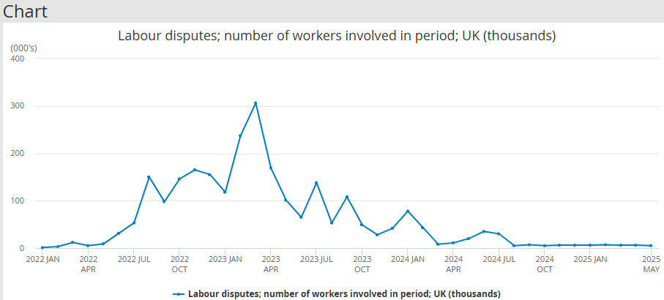
Office for National Statistics (2025)
The graph from the Office for National Statistics below, shows that between the years of 2015 and 2019, the number of working days lost due to strike action remained consistently low. Following this period, there were two years where data was not collected which was due to the COVID-19 pandemic. Following the pandemic, the UK saw a significant increase to labour disputes and subsequent working hours lost.
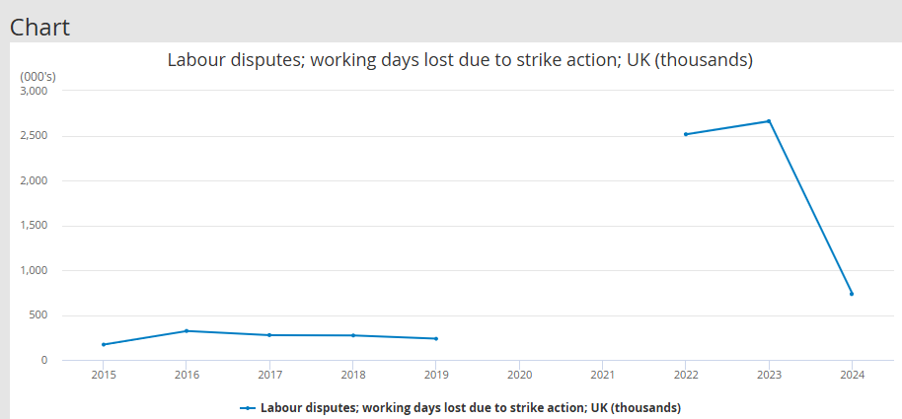
Office for National Statistics (2025)
Office for National Statistics (2023) tells us that pay disputes have been the most common cause of strikes in the years for which we have comparable data. Between 1999 and 2018, pay disputes accounted for around 75% of all working days lost because of workplace disputes. The rising cost of living since COVID-19, in the UK is a larger backdrop for recent labour issues. The real value of regular pay decreased by 2.5% from October to December 2022 after taking inflation into account.
Horne (2024) explains that it is possible to avert or lessen any kind of industrial action by constructive communication (with workers and trade union leaders). Organisations should proactively investigate the grievances that are causing the strike threat and, if practical, look into mediation or conciliation. This strategy can show a dedication to peacefully settling conflicts and could prevent disruptive labour action.
Once again, as a lot of the new team have moved from private to public sector, there will have been minimal exposure to trade unions. Horne (2024) explains that communication should be done with caution, especially when a disagreement involves a contract negotiation. Directly attempting to alter an employee's terms of employment without consulting a recognised trade union could jeopardise a collective bargaining agreement and violate the applicable law, which carries a sizable potential liability.

(AC 2.3)
Conciliation
ACAS (2024b) describes early conciliation as talks to try and make a legal agreement without going to an employment tribunal. When an employee wants to make a claim, a third-party will offer early conciliation and will talk to both the employee and employer about the dispute, giving the opportunity for an agreed outcome before it reaches the tribunal stage. Talks at this stage can take place for up to six weeks. Conciliators are impartial, independent of the dispute and are able to examine ways for both parties to settle the disagreement without resorting to a tribunal. Conciliators are also able to discuss how comparable cases have been evaluated by employment tribunals in the past.
Collective conciliation is done in the same way but ‘the claimant’ is a group of employees with the same claim, rather than just an individual.
If an agreement is reached through conciliation a conciliation agreement is written up and is legally binding.
Mediation
Gifford (2024) tells us that a neutral third person facilitates the voluntary process of mediation to settle disputes between individuals. Any work relationship may experience conflict, which is best resolved early on. By assisting parties in arriving at mutually agreeable solutions, mediation can assist in avoiding more formal and expensive approaches. Mediation is a tool used to settle conflicts or disagreements at work. It is frequently referred to as an informal or "alternative" dispute resolution (ADR) process because it is less formal than the more established employment tribunals and grievance and disciplinary procedures. It does, however, still take a methodical approach.
At any point during a dispute, mediation can be used. It Mediation is a flexible and voluntary approach but, unlike with conciliation, any agreement through this process is morally binding and not legally so. Mediators cannot force the employee or employer to accept the solution.
Arbitration
GOV.UK (2025) describes arbitration as when an independent third-party hears a case, weighs all the factors and makes a firm decision to resolve it. ACAS (2022) recommends that both sides should try and resolve the dispute themselves first or if this is not possible, use conciliation to help reach an agreement.
Arbitration is only available if the dispute is solely about flexible working or unfair dismissals and both parties agree to use this service. The decision (or ‘award’) made by the arbitrator is legally binding and will have a comparable result to appearing before an employment tribunal.
Summary
Understanding the forms of dispute resolution and when to use them will be hugely beneficial when working with your new teams. The key distinctions between conciliation, mediation and arbitration We take from the above information that key distinctions between these forms of conflict resolution are found in their timings and in the outcomes. Mediation is the least formal process of the three and can be initiated at the first point when a dispute is raised. Conciliation is offered at the point when an employee informs the third-party of the wish to make a claim regarding a workplace dispute. Arbitration is used if conciliation is not successful and in place of employment tribunals for certain types of workplace disputes. The outcomes from both conciliation and arbitration are legally binding, whereas the outcome from mediation is voluntary. With minimal exposure to working with Trade Unions, it is important to note that they can be utilised by an employee for conflict resolution, such as conciliation and arbitration.
(AC 3.1)
CIPD (2024) states that the termination of an employment contract by the employer is known as a dismissal. There are two types of dismissals: fair and unfair. Employers who want to ensure a fair dismissal must fulfil their legal requirements. Unfair dismissal is regulated under the Employment Rights Act (ERA) 1996, which provides information on the grounds and processes for a lawful dismissal as well as the rights of employees to be protected against unfair dismissal. The Employment Rights Act 1996 states that an employee has the right not to be unfairly dismissed by his employer.
A dismissal is considered unfair if it is established that there was no valid reason for it, the employer is unable to provide one of the five statutory justifications (appendix 1), the employer did not follow a fair process before the dismissal, the organisation did not follow its disciplinary or dismissal procedures, or the legal requirements of a dismissal were not met.
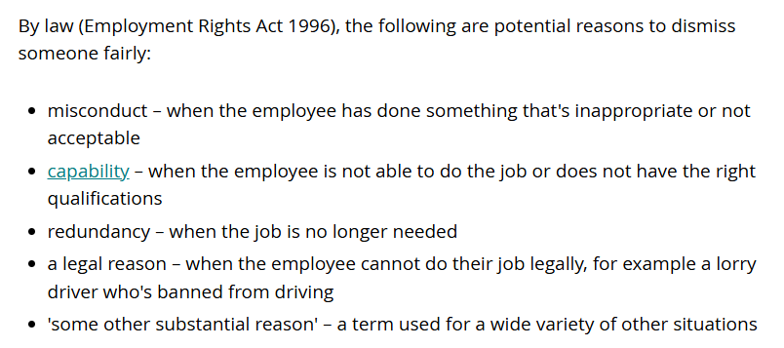
Appendix 1 – ACAS (2024c). Types of dismissal
Capability
Although having a capability management procedure is not required by law, many organisations do have one because capability is a potentially fair reason for termination. Companies can also include a capability process as a specific part of the disciplinary process.
The ability of an employee to do their duties is referred to as capability. Capability refers to problems that are out of the employee's control and cause poor performance (Morris, 2025).
Health problems or some other fundamental incapacity that the employee is powerless to change are likely to be the cause of capability challenges (CIPD, 2024).
Monmouthshire County Council v Harris (2015) emphasises how crucial it is to accurately evaluate a worker's medical condition, especially when a disability is a factor in ill-health dismissals. Employers should follow a fair and reasonable procedure where concrete proof exists that an employee's prolonged absence due to illness is negatively affecting the company and coworkers. The key components of this procedure are pictured below in appendix 2.
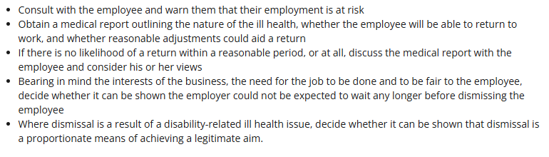
Appendix 2 – HR Inform. Monmouthshire County Council v Harris - Dismissal: Capability
When taking on a people management role, it is important to understand that capability can also refer to underperformance. Morris (2025) informs us that we should think about whether there are any steps they can take to support or address the causes of underperformance, such as offering additional training.
If the issues have not been settled through informal means or conversations, The employee would then be formally informed that they are subject to a performance management procedure, which usually include creating a performance improvement plan (PIP).
Misconduct
ACAS (2024a) describes misconduct as when an employee's inappropriate behaviour or action breaks the organisation's rules.
If an employee's conduct is a factor in their termination, it may be justified. Insubordination (disregarding reasonable directions), tardiness, unapproved absences from work, and poor attendance are a few instances of misconduct (CIPD, 2024). Example of gross misconduct, which could result in dismissal, could include more serious allegations such as theft, fraud, physical violence or harassment. Employers always need to ensure a fair process has been followed before dismissal, which includes an investigation, a disciplinary hearing where the employee can present their case (where they have the right to be accompanied), and an appeal. With limited awareness of managing employee relations in the public sector, it is important to point out that the process should, at a minimum, follow the ACAS Code of Practice, and any internal procedures. Trade Unions may also be utilised during these processes.
Fitzgerald v Bouygues Energies and services (2023), where an employer’s failure to communicate properly a reasonable management instruction, and hasty disciplinary process, resulted in an unfair dismissal for a matter that otherwise would have been within the band of reasonable responses, shows the importance of having proper, recordable processes in place are essential, both to make sure employees are aware of company changes, but also as evidence in the future should an employee deny knowing them.

(AC 3.2)
Through a grievance procedure, an employee can formally voice their concerns or grievances to their employer. If the worker feels that bringing up the matter informally has not worked, they do not want it handled informally or it is a very serious issues (such as sexual harassment) they may file a grievance.
Bullying
Any bullying or discrimination allegation should be taken seriously and should be investigated right away. Someone may be more likely to file a claim with an employment tribunal if their complaint is not handled properly. ACAS (2023) tells us that if an employee make an employment tribunal claim, the tribunal will take into account how you handled the complaint.
Employee complaints may result from a toxic work environment caused by bullying and harassment. Some examples of these kinds of complaints are verbal harassment, retaliation or cyber-bullying.
Companies can handle these kinds of complaints more effectively if they have anti-bullying and anti-harassment rules in place. These policies ought to outline the grievance and disciplinary process that would be used in the event that an employee files a complaint alleging harassment or bullying. Cobb (2024) states that businesses should also actively foster a respectful culture and immediately resolve complaints about improper behaviour.
Poor Communication
A formal complaint due to inadequate communication is another type of employee grievance. For example, employee wellness and general job satisfaction may suffer if management is unapproachable or displays little interest in talking with staff members about significant tasks or policy changes.
Establishing and maintaining effective channels of communication where staff members can share their thoughts with supervisors is a popular preventative strategy for this. This could include one-to-ones between the employee and their line manager. Employers should also discuss crucial workplace developments with employees and solicit their opinions. Employers could use employee surveys to gather this information.
Working conditions
Grievances may also result from problems with the environment or physical features of the job. Examples of this could include health and safety concerns, facilities and equipment or workplace disputes.
To establish a secure and welcoming environment, you must proactively address working conditions and carry out frequent risk assessments of the workplace. By having these in place, the company is more likely to be able to prevent accidents and provide safety for their employees. Indeed (2024) states that another example of maintaining good working conditions is to provide suitable on-boarding and training. Employees can learn how to use various tools correctly to protect themselves and their coworkers during on-the-job training. They can learn all they need to know about safe working conditions, how to keep their workspace clean, and what to do if they see any infractions.
(AC 3.3)
Any workplace can be significantly impacted by staff grievances, which can cause worry, stress, and anxiety for those involved (Kitney, 2023). Improperly handled grievances can also negatively affect employee performance, leading to absenteeism, potential financial losses for the company and legal claims.
Avoiding legal claims
It is essential to proactively handle employee complaints in order to prevent future legal issues, especially those involving discrimination or terminations. If grievances are not handled appropriately, employees may take legal action. The case of Nelson v Renfrewshire Council (2022) emphasises how crucial it is to follow established grievance procedures.
Newlin & James (2024) state that any investigator appointed should proceed without bias to enable an independent, thorough and transparent investigation process, leading to a clear and well-reasoned outcome letter. This is important throughout all stages of the grievance procedure. Efficient grievance management ensures adherence to employment regulations, protects the company from expensive litigation, and helps avoid legal claims and the related expenses.
Maintaining Staff Satisfaction and Motivation
Not only is it useless to dismiss grievances without making an effort to address the underlying problems that gave rise to them, but it also has the potential to negatively impact the working relationship. Sendall (2024) informs us that when employees feel that their complaints are dismissed without being resolved, several adverse consequences may arise. These could include lower morale, decreased productivity, higher employee turnover and lower employee engagement.
For businesses, unresolved labour disputes can have serious financial consequences. These costs are typically hidden but can significantly harm an organisation’s bottom line. An example of this hidden cost is from increased absenteeism. Sendall (2024) states that this can incur additional costs for temporary staffing and overtime.
Conclusion
Keeping employee morale high and preventing legal claims requires effective grievance handling. Organisations can safeguard themselves against legal and reputational problems and promote a productive and happy work environment by promptly and openly addressing concerns. In the end, both employee satisfaction and organisational performance are influenced by effective grievance handling.

Bibliography
ACAS (2022). Arbitration. ACAS. [online] Available at: https://www.acas.org.uk/arbitration (Accessed: 26 July 2025).
ACAS (2023). How to Approach a Bullying or Discrimination complaint: Handling a Bullying or Discrimination Complaint. [online] ACAS. Available at: https://www.acas.org.uk/handling-a-bullying-discrimination-complaint (Accessed 28 Jul. 2025).
ACAS (2024a). Disciplinary procedure: step by step. [online] Acas.org.uk. Available at: https://www.acas.org.uk/disciplinary-procedure-step-by-step (Accessed 28 Jul. 2025).
ACAS (2024b). Early Conciliation. [online] ACAS. Available at: https://www.acas.org.uk/early-conciliation (Accessed: 26 July 2025).
ACAS (2024c). Types of dismissal: Dismissals. [online] ACAS. Available at: https://www.acas.org.uk/dismissals/types-of-dismissal.
ACAS (2014). Non-Union Representation in the Workplace. Available at: https://www.acas.org.uk/sites/default/files/2021-03/non-union-representation-in-the-workplace.pdf (Accessed: 13 July 2025).
Bin Hussain, H. (2024) Employee Involvement & Participation. Available at: https://www.linkedin.com/pulse/employee-involvement-participation-bin-hussain-cipd5-achrm-shrm-1zwnf/ (Accessed: 13 July 2025).
CIPD (2023). Fitzgerald V Bouygues Energies and Services -… | CIPD HR-inform. [online] Hr-inform.co.uk. Available at: https://www.hr-inform.co.uk/case-law/2023-03/fitzgerald-v-bouygues-energies-and-services-unfair-dismissal-reasonable-management (Accessed 28 Jul. 2025).
CIPD (2024). Dismissal: UK employment law. [online] CIPD. Available at: https://www.cipd.org/uk/knowledge/employment-law/dismissal/ (Accessed: 27 July 2025).
CIPD (2025). Employee voice. Available at: https://www.cipd.org/uk/knowledge/factsheets/voice-factsheet/#Usefulcontacts (Accessed: 13 July 2025).
CIPD (2025). Good Work Index. [online] CIPD. Available at: https://www.cipd.org/uk/knowledge/reports/goodwork/ (Accessed: 26 July 2025).
CIPD (2015). Monmouthshire County Council v Harris -… | CIPD HR-inform. [online] Hr-inform.co.uk. Available at: https://www.hr-inform.co.uk/case-law/2015-12/monmouthshire-county-council-v-harris-dismissal-capability (Accessed 28 Jul. 2025).
CIPD. Trade unions: An introduction. Available at: https://www.cipd.org/uk/knowledge/factsheets/trade-unions-factsheet/ (Accessed: 13 July 2025).
Clark, D. (2025). UK Industrial Action Workers Involved 2022 to 2025. [online] Statista. Available at: https://www.statista.com/statistics/1350911/uk-industrial-action-workers-involved/ (Accessed 28 Jul. 2025).
Cobb, L. (2024). Examples of Grievances in the Workplace | BrightHR. [online] BrightHR. Available at: https://www.brighthr.com/articles/employee-conduct/grievances/types-of-grievances-in-the-workplace/ (Accessed 28 Jul. 2025).
Gifford, J, Neathey, F, Loukas, G. (2005) Employee Involvement Information, Consultation and Discretion. 1st edn. Brighton: Institute for Employment Studies.
Gifford, J. (2023). CIPD | Workplace Mediation | Factsheets. [online] CIPD. Available at: https://www.cipd.org/uk/knowledge/factsheets/mediation-factsheet/ (Accessed: 26 July 2025).
GOV.UK (2010). Employment Rights Act 1996. [online] Legislation.gov.uk. Available at: https://www.legislation.gov.uk/ukpga/1996/18/part/X (Accessed: 27 July 2025).
GOV.UK (2025). Solve a Workplace Dispute. [online] GOV.UK. Available at: https://www.gov.uk/solve-workplace-dispute/mediation-conciliation-and-arbitration (Accessed: 26 July 2025).
Horne, A. (2024). How should employers approach industrial action? [online] www.peoplemanagement.co.uk. Available at: https://www.peoplemanagement.co.uk/article/1872392/employers-approach-industrial-action (Accessed 28 Jul. 2025).
Indeed (2024). Grievance at Work examples, Causes and Ways to Avoid Them. [online] Indeed Career Guide. Available at: https://uk.indeed.com/career-advice/career-development/grievance-at-work-examples (Accessed 28 Jul. 2025).
Kitney, V. (2023). Resolving workplace grievances effectively. [online] MDU Journal. Available at: https://mdujournal.themdu.com/issue-archive/autumn-2023/resolving-workplace-grievances-effectively (Accessed 28 Jul. 2025).
Lombard, N. (2025) Your (2025) Guide to Employee Participation: What It Is and How To Increase It. Available at: https://www.aihr.com/blog/employee-participation/ (Accessed: 13 July 2025).
Mbagwu, C. (2021). ORGANIZATIONAL MIS/BEHAVIOUR. [online] www.linkedin.com. Available at: https://www.linkedin.com/pulse/organizational-misbehaviour-chikauche-mbagwu-b-eng-/ (Accessed: 26 July 2025).
Morris, A. (2025). Capability Dismissal: Employer Guidance. Available at: https://www.davidsonmorris.com/capability-dismissal/ (Accessed 29 September 2025).
Newlin, N. and James, T. (2024). Why Is It Important to Handle Grievances properly? [online] Blake Morgan. Available at: https://www.blakemorgan.co.uk/why-is-it-important-to-handle-grievances-properly/ (Accessed 28 Jul. 2025).
ONS (2023). The Impact of Strikes in the UK - Office for National Statistics. [online] Office for National Statistics. Available at: https://www.ons.gov.uk/employmentandlabourmarket/peopleinwork/workplacedisputesandworkingconditions/articles/theimpactofstrikesintheuk/june2022tofebruary2023 (Accessed 28 Jul. 2025).
ONS (2025). Labour disputes; Working Days Lost Due to Strike action; UK (thousands). [online] Ons.gov.uk. Available at: https://www.ons.gov.uk/employmentandlabourmarket/peopleinwork/employmentandemployeetypes/timeseries/bbfw/lms (Accessed 28 Jul. 2025).
Sendall, A. (2024). The Hidden Impact of Unresolved Grievance Issues on Workplace Culture - Antony Sendall | Littleton Chambers. [online] Littleton Chambers. Available at: https://littletonchambers.com/articles-webinars/the-hidden-impact-of-unresolved-grievance-issues-on-workplace-culture-antony-sendall/ (Accessed 28 Jul. 2025).
Suff, R. (2020). Managing conflict in the modern workplace report. [online] CIPD. CIPD. Available at: https://www.cipd.org/globalassets/media/knowledge/knowledge-hub/reports/managing-conflict-in-the-workplace-2_tcm18-70655.pdf. (Accessed: 26 July 2025).
team, L.M. (2025). Labour disputes; number of workers involved in period; UK (thousands). [online] Ons.gov.uk. Available at: https://www.ons.gov.uk/employmentandlabourmarket/peopleinwork/employmentandemployeetypes/timeseries/blut/lms (Accessed 28 Jul. 2025).
VQ Solutions (2024). Concept of Better Working Lives and How This Can Be Designed. [online] CIPD Courses by VQ Solutions. Available at: https://hr.vqsolutions.co.uk/concept-of-better-working-lives-and-how-this-can-be-designed/ (Accessed: 26 July 2025).
Watson, T. (2003) Sociology, Work and Industry. 4th edn. London: Routledge.
Wilson, M. (2024) Advantages and Disadvantages of Employee Voice in the Workplace. Available at: https://bucketlistrewards.com/blog/advantages-disadvantages-employee-voice/#disadvantages-of (Accessed: 13 July 2025).

Young, J. (2024) Good work: what do we know about the quality of UK jobs? Available at: https://www.economicsobservatory.com/good-work-what-do-we-know-about-the-quality-of-uk-jobs (Accessed: 29 September 2025).

