Cory Westermark

Oystermouth Road development swansea preliminairy study

Contents page

- Page 3-4- Site details

- Page 5- Historical information

- Page 6-7- Environmental appraisal

- Page 8-9- Geological

- Page 9-10-Archaeology

- Page 10-11- Conceptual ground model

- Page 12-13- Site summary & borehole write up

- Page 14 Reference list

Page 3

Preliminary Desktop Study for Proposed Residential Development at Oystermouth Road, Swansea.
Client: Jarvis Hotels
Site Address: Oystermouth Road, Swansea
Prepared By: Cory Westermark
Date: January 1, 2025

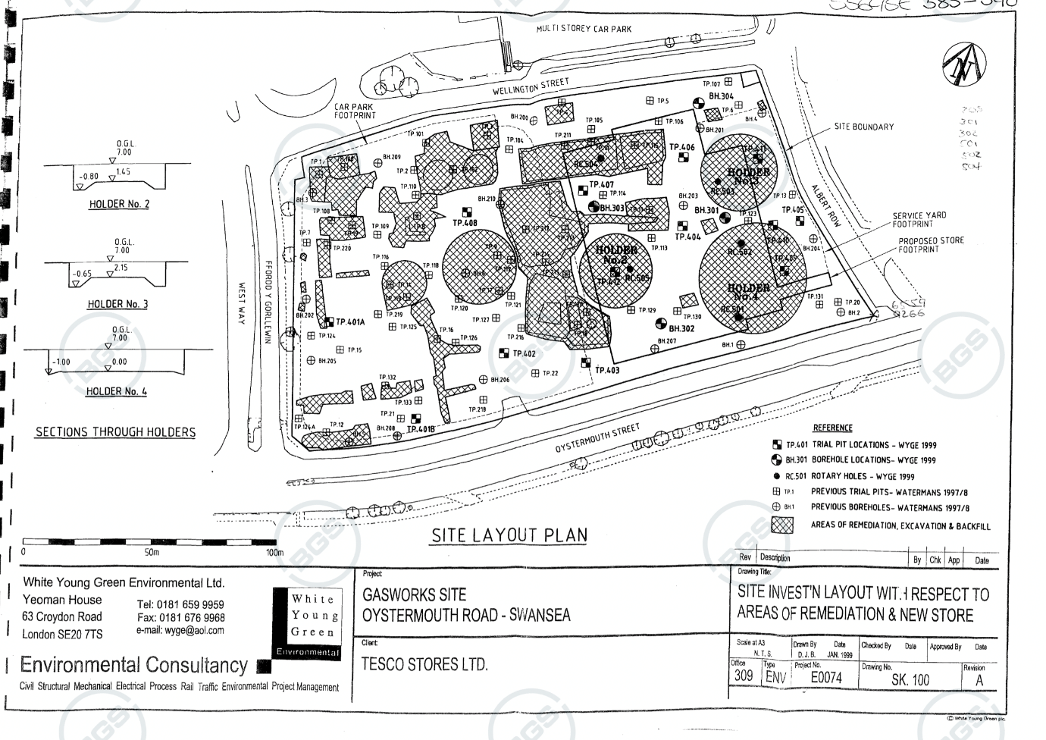

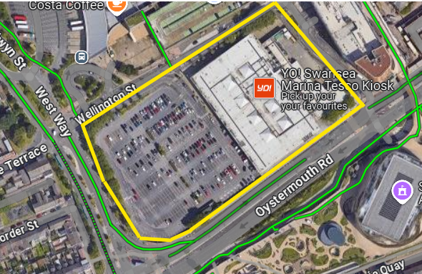
Page 4
Site details-

This preliminary desktop study, produced as a junior construction professional, has been produced to assess the feasibility of a newly proposed residential development at the Oystermouth Road, Swansea development. This study includes areas such as the site location, geology, planning constraints, and the historical landmarks held on this land. The current present site spans across 5.3 acres, which was a former gasworks site back in the 1900s. The gasworks here in Swansea were a massive landmark to the area where work first took place in 1840 before being sold by sales agent Cooke and Arkwright in 1998 for a large cost. To date, the site is currently occupied by a Tesco Extra, which was bought out in February 2000 for a sum of 13.5 million to build this retail development. This new five-story production will offer many features with the accommodation of four hundred rooms. The complex will have a new bar, restaurant, and conference centre, creating a very welcoming environment for all sorts of commotion. The site is situated right along Oystermouth Road, which is also near a busy city centre with tens of shops, potentially causing constraints to access and egress for heavy plant machinery and big deliveries. With the construction of high-rise architectural building developments on the rise, this project for Jarvis hotels will be a significant feature to the Swansea area and will, without a doubt, attract strong revenue to the local economy. The boundaries of the site, depicted in the photograph above, extend alongside the heavily trafficked main road. This may pose challenges when accessing the site for materials and other necessities. However, this issue can be readily addressed by widening the road, which would involve utilizing a section of the site, pending the closure of a footpath authorized by Swansea County Council. This will allow for easy access and egress for all types of vehicles and machines.

Swansea Gas Undertaking (reference – GB 216 D/D Ga/s) Created 1830-71 by Swansea Gas Undertaking
Accessed on the 3rd of January 2025

Page 5

Historical information-

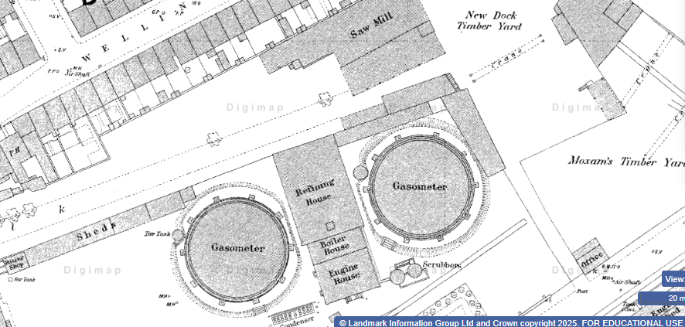
Due to the historical background in the area, the site could potentially pose many hazards that could preclude this development. Swansea gas works commenced as the Swansea Gas Light Company with the intent to supply local gas resources to the Swansea area. In the year 1949, the gas works expanded nationwide with the Wales Gas Board becoming the first public industry to supply gas to the whole of Wales. By means of the gasworks in action, the soil certainly will contain masses of excessive toxic waste buried within the boundary. With the land being undeveloped and many land changes over time, a borehole log will need to be completed to ensure all made-up ground is uncontaminated, and waste is removed from the premises safely. It is important to understand that before Oystermouth Road was established, there was a railway track running from West Cross, expanding all the way down to Blackpill, which had been in use from 1807 to 1960, spanning a prolonged duration in use. Risk assessments will need to be carried out to identify any risks to human or environmental lives, with the potential presence of gas, which is extremely important before any ground tests are carried out.
With the railway in place for over one hundred years, contaminants and archaeological findings are almost guaranteed here. Analysis of historic maps is observed to understand the changes in the evolved surrounding area.
As seen in the Aerial photograph, there are the surroundings of previous residential buildings located north of the site with a sawmill in touching distance of the site’s boundary. When the gasworks were dismantled to allow for the construction of Tesco in 1999, it was necessary to excavate the soil and either replace or cap any potentially contaminated materials. Ensuring proper compaction was crucial to prevent any settlement occurring beneath the building and the car park. The nearby ongoing development projects have included some serious digging (about 6 meters deep) for drainage improvements. This digging needed to be done carefully to ensure that Tesco’s foundations weren’t affected. To handle the ground and structural shifts, these ground works would have needed temporary supports or monitoring. The Tesco site is built on engineered soil instead of natural clay or sand. The redevelopment process required a lot of soil cleanup, compaction, and strong foundation systems to ensure everything is stable. With ongoing excavations and utility work happening nearby, careful geotechnical monitoring is essential to safeguard both the ground and the structure under this project.

Page 6

Just south of the site is the old railway track that was operated to Blackpill during the Swansea trade era. Gathering information from this photograph allows us to understand there were a lot of urban development trends which has polluted the area many years ago. As evidenced by the development of aerial photography is very unclear, leaving us with some uncertainty about what else could have been present in the surrounding area.

Environmental-

With the designation for redevelopment, it is important to know what type of ground is adjacent to the site. With regards to topography and site elevation, there should not be too many constraints as this site is built on a flat terrain on top of sand. Swansea is renowned for its location being so close to a long-stretched beach, meaning that hydrogeology shall

Page 7

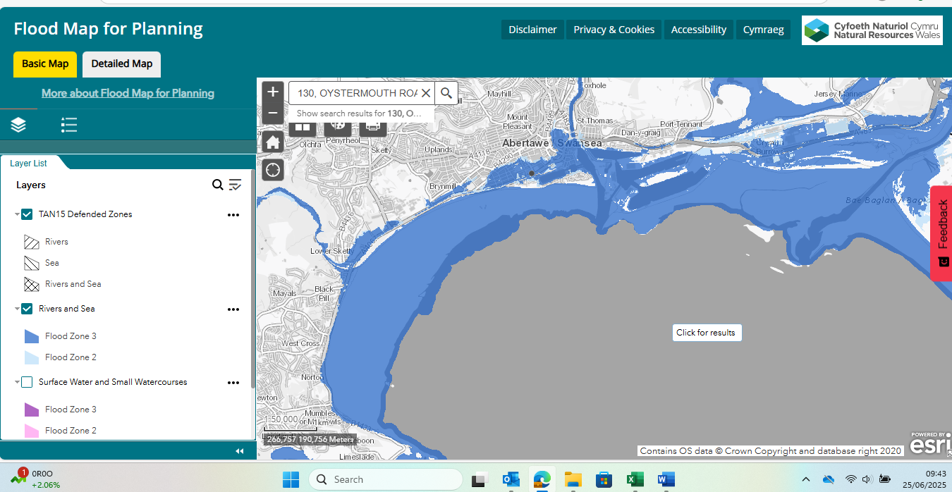
Be considered heavily with large probable chances of flood risks occurring/recurring, and the possibility of damage to the new structure when constructed. When studying the environment, it is also important to consider the surrounding protected areas. As Swansea is known for a lot of historical landmarks, there are many protected buildings that could be linked to the site boundary. Thorough ecologist monitoring will be needed on this site during peak endangered and invasive animal breeding times is compulsory due to the interruption it may cause to animals living in and around the area that are protected under the Wildlife and Countryside Act 1981. NRW's Flood Risk Assessment Wales maps indicate that regions near Swansea, including Oystermouth Road, are at risk of surface water, river, and tidal flooding, classified into high, medium, and low zones. The revised NRW flood-map-for-planning emphasizes that all three types of flood risks are taken into account in this area, implying that developments in the area must comply with stringent flood resilience standards. There have been some cases of flash flooding on Oystermouth Road—when firefighters had to save people from cars trapped in floodwater close to the project's land. In September 2024, heavy rain led to flash flooding on Oystermouth Road (in the Blackpill area), highlighting how susceptible the area is during intense storms.

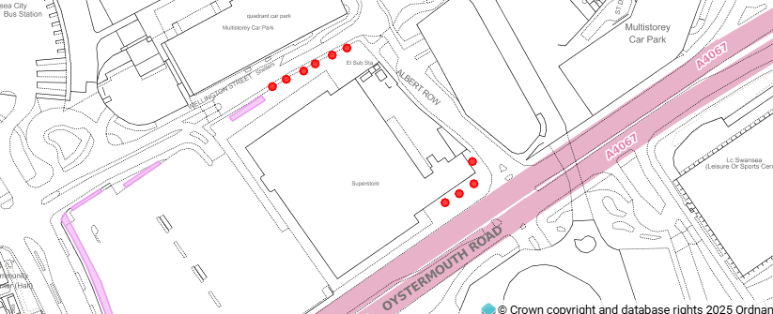

Here is a TPO map of the surrounding area. The red dots show protected trees, meaning extra precautions are needed when excavating in the section that needs digging. Planning will need to be applied for as TPOs are illegal to cut down.

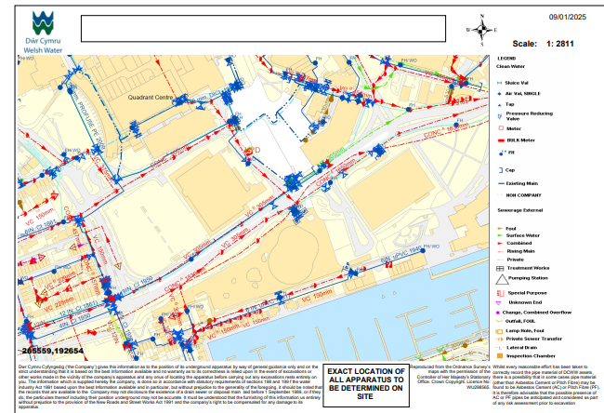
Photo of Welsh water map services within the area (Opened on the 4th of January 2025)
It is vital that an inspection is carried out to identify any spillages, leaks, or hazardous materials used, which could still be present below ground, left from previous land usage. There is a need to document whether any natural disasters, such as flooding or landslides, have taken place that could be impacting the new site.

Here is a photo containing all service locations in the area, which will be extremely useful to understand where all mains will be running to. There is a 33kV electric mains pipe running beside the site. It is convenient that the current mains to date are tapped in and functioning to the present Tesco extra on this new tender, allowing an easy structure connection upon construction. Although these services are all connected, it will be important to check that no dunes of blown sand have disrupted and restricted free drainage. Climate surveys in the area will need to be conducted due to Swansea being so close to the sea a lot of rainfall is seen, and wind direction can vary, usually flowing towards the east, threatening potential climate hazards. As there are no records of contamination, a phase 2 desktop study shall be carried out to ensure all present hazards are identified early for all developers to take precautions like soil remediation or the correct disposal of hazardous waste. Addressing these early allows the developer to factor in the potential cost change to the project's budget. Conducting this phase 2 study helps developers avoid unexpected costs and verify whether the project will have its financial resources. It will be great to consider sustainability and potentially install

Page 8

Borehole log of the Site in 1999 (Opened on the 4th of January 2025)

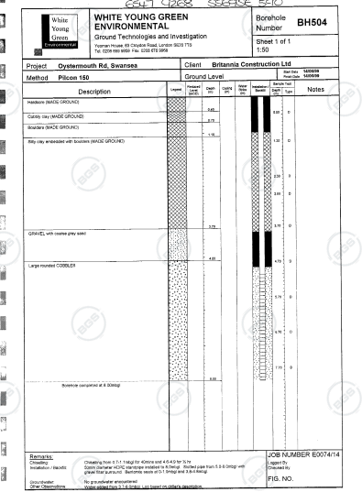

Geological

As seen in the geological photo below, the ground consists of sandstone, siltstone, and a lot of coal. The site also features a lot of blown sand from the sand dunes in the surrounding area, which is a threat to the construction of the site due to the moving particles weakening the airflow velocity and enhancing turbulence over the site. Blowing sand is also defined as an environmental variable action by the health and safety law.
From researching the site, it contradicts levels from 9 to 6m from the directions east to west.

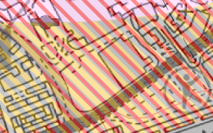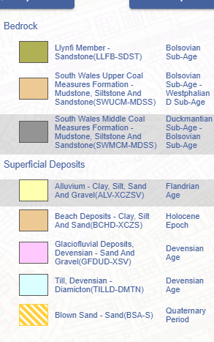
Page 9

Created by Digi Maps (Opened on the 4th of January 2025)
From researching the site, the geomorphology side of things contradicts levels from 9 to 6m from the directions east to west. By this, you can gather the understanding that ground levels will need to be altered and boosted in order for the site to be level. There is no evidence of previous geological constraints in the area, such as faults, folds, or sinkholes. Thus, meaning that given the past, there should not be any problems regarding future works or compatibility. The only damper to geohazards is the potential of flooding risks; therefore, it is important that this land is built up to ensure fewer problems.

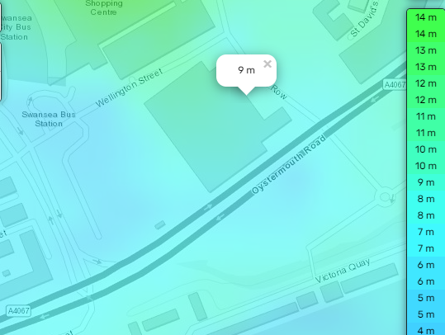
Photo of the ground levels of the site
Last updated 15 September 2024
(Opened on the 5th of January 2025) https://en-gb.topographic-map.com/map-733q/Swansea/?center=51.61736%2C-3.94398&zoom=17&base=4&popup=51.61624%2C-3.94562

Archaeology
Page 10
This study area, lying at the confluence of an old railway main source track and a city centre, holds a lot of history of industrial works. Sample tests should be conducted as a matter of finding objects that lie beneath ground level. The soil layer lower into the ground consists of three solid layers of gravel, siltstone, and coal. Due to the site being in touching distance from the sea, a remarkably high groundwater level will be present under the site, unequivocally holding a strong suspicion of contamination with coal and water mixing in its components. A comprehensive water check shall be performed to ensure no further threat lies within. Due to the potential history under the ground, an archaeologist shall be present on site with a watching brief in place during the excavation phase in case of any findings of any undisclosed infrastructures.

From an overview, there seems to be no vegetation due to the low carbon and fertility rates in the area, no listed buildings/structures that are posing constraints to construction on this site, which simplifies things from a constructor’s standpoint. This will help the programme flow in a streamlined manner and minimise any big delays and the need for temporary works. There is no evidence or traces of previous findings from the site; therefore, having an archaeologist write up on the site would be beneficial.

Created on the 21st of October 2024 by Piling experts.
Opened on the 4th of January 2025
https://www.pilingexperts.com.au/bored-piling-for-your-construction-project/

Conceptual ground model

There are many possible weight-bearing structures to use to construct a tall accommodation building, but from all the information gathered and research, the suggestion to use a bored pile foundation will be made. The use of a bored pile foundation, also known as a ‘drilled shaft’, is a type of reinforced concrete foundation with the ability to drill vertically and deep into the ground to create a borehole. Once the borehole is created, it is then filled with concrete, and the use of steel is used to enhance the structure's strength through its reinforcement to create a robust support for the future five-story hotel. These drilled shafts are a large diameter and deep foundation best suited for heavy structural loads such as high-rise buildings and bridges, and also suited for
Page 11
diverse types of soil conditions, including elevated levels of groundwater. When considering a foundation method, the noise and vibrations produced should be considered due to local residency, and also events taking place near the city centre. The bored pile foundation method produces lower noise and vibration levels compared to other types of foundation construction. Thus, allowing this procedure to be an environmentally friendly option, giving its urban area many noise restrictions in place. While the advantages are significant, this technique can be costly based on the given project specifications and location, with its access and egress points considered. Although cost can be a slight drawback, using the bored method outweighs the profiles of other foundations and allows for a guarantee of a less problematic future within its structure.
Due to a slight dip in the given land, it is best suited that this foundation should be built on a higher level. Once the correct ground material resource is used to add height to the land, things like less erosion beneath the surface level can be considered, and also more ground stability. It is vital that the ground is levelled out correctly, as these foundations require a lot of ground strength to support the weight and pressure of this newly imposed structure.

The structure will be a terrific addition to the area, given the numerous high-rise buildings in the surrounding area, and with the use of the given foundation, it allows more weighty features to be added to the structure to impose a fascinating look.

It is recommended that hand auger and dynamic sampling be used due to the possibility of previous historical objects once trial pits are dug. It is important to note that any unsuspected findings could lead to additional time added to the project programme therefore its important these sampling tests are done correctly to avoid any additional lead time to the construction phase within good convenience.

Site summary

To summarize the site I believe that the new addition of a 5-star hotel and all its additional features will be a great incorporation to not only the sights but economy. By all means its key that all tests and soil samples are done correctly to ensure no future constraints. A phase 2 desktop study is highly recommended by a higher inspection corporation. Climate shall be considered massively due a heavy rainfall across the year.
Page 12

And with the need to take the environmental risks into consideration during the construction phase.

A prior borehole has been conducted within the boundaries of the site. It reached a depth of 8 meters and included the following at various depths:
- 0 - 0 - 4 Meters of Hardcore Made Ground
- 0.4 - 0.7 Meters of Hardcore Cobbly Clay
- 0.7 - 1.1 Meters of Made Ground Boulders
- 1.1 - 3.7 Meters of Made Ground Silty Clay Embedded with Boulders
- 3.7 - 4.6 Meters of Gravel with Coarse Grey Sand
- 4.6 - 8.0 Meters or Large Rounded Cobbles
The borehole indicates that the subsurface consists of materials with a low level of durability until reaching a depth of 3.70 meters.
The bored pile method is best suited for this job due to its ability to withstand high winds and support heavy massed structures. The ground condition is most definitely suited to hold a large structure and remain strong for many years. The bore pile method also offers a muffled sound and vibration level, which will be substantial for the surrounding area given its activity. Engineering of the building will need to be precise to counteract the strong winds that come from the direction of the sea. When conducting the site investigation, it is crucial for the contractor to test various areas of the site. There is a significant amount of history associated with and present within the site, which could potentially lead to several issues for the client. With all surrounding services in place and being active, there should be no difficulty with the connections apart from the potential road closure with services running from the south. The site has the potential to contain historical and archaeological remains based on the previous land use and site surroundings. Due to the background buildings being high-rise, there should be no planning constraints. This project will be an impressive, grand extension to the city.

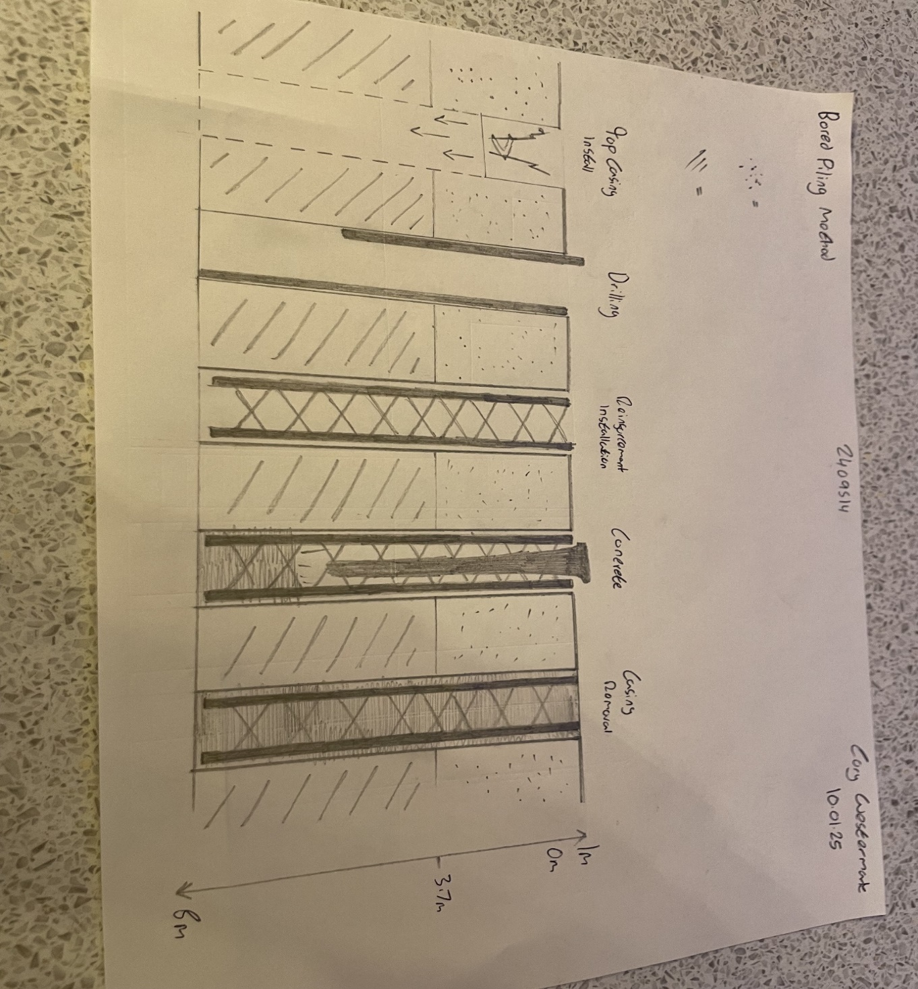
Page 13

Page 14

Reference list

Swansea Gas Undertaking (reference – GB 216 D/D Ga/s) Created 1830-71 by Swansea Gas Undertaking (Accessed on the 3rd of January 2025)

Photo of Welsh water map services within the area (Opened on the 4th of January 2025)

Borehole log of the Site in 1999 (Opened on the 4th of January 2025)

Created by Digi Maps (Opened on the 4th of January 2025)

topographic-map.com (2025). Swansea topographic map, elevation, terrain. [online] Topographic maps. Available at: https://en-gb.topographic-map.com/map-733q/Swansea/?center=51.61736%2C-3.94398&zoom=17&base=4&popup=51.61624%2C-3.94562 [Accessed 19 Jul. 2025].

PilingExp (2023). Bored Piling: The Key to Building a Solid Foundation. [online] Piling Experts. Available at: https://www.pilingexperts.com.au/bored-piling-for-your-construction-project/.

