

ASSIGNMENT 2

Report
Intercultural Competence Report of Switzerland

Foreign Languages and Cultural Awareness
BMIH5003

Student name: Stancheva Yanka
Student number: 2210661
Lecturer name: Giulia Chifari
Word count: 980

Summary

Switzerland is a federal republic known for its neutrality, linguistic diversity, and self-governing cantons. The country has one of Europe's highest immigration rates. The Swiss economy is characterized by a high proportion of small and medium-sized firms.
Switzerland's hospitality business is well-known for its high standards of quality and luxury. The Swiss culture values independence. Managers should create an environment in which employees are comfortable proposing and implementing changes.
A hotel General Manager in Switzerland should use a management style that is consistent with the country's cultural characteristics, which include minimal power distance and high uncertainty avoidance. This denotes a leadership style that values teamwork, open communication, and adaptability.

Table of content

- Introduction……………………………………………………………………..3
- Main Findings…………………………………………………………………..3
- Country overview…………….…………………………………………….3
- Immigration rates……….………………………………………………….4
- Cultural dimensions…………………………………………………….....4
- Globe project……………………………………………………………….5
- Conclusion………………………………………………………………….…..7
- Recommendations……………………………………………………………..7
- References……………………………………………………………………...8

- Introduction
This report will be useful for General Manager in UK looking to engage effectively with Switzerland's diverse and culturally rich surroundings. It will aid in the improvement of communication, collaboration, and relationships in professional settings. Creating a full intercultural competence assessment for Switzerland would necessitate a thorough examination of numerous factors, such as cultural characteristics, institutional collectivism, and business practices.
- Main findings
- Country overview
Switzerland is a federal republic with 23 cantons (states) and a high degree of autonomy. According to D’Amato (2010, p. 130) the nation's ability to govern its heterogeneous population through its federal institutions is the foundation for its stability. “Multilingualism is an essential part of Switzerland's identity” (Eda, 2023). The most common languages spoken in the workplace are Swiss German, standard German, Italian, Romansh, and French are the national languages of Switzerland, which is renowned for its neutrality, linguistic diversity, and autonomous cantonal governance. Moreover, two thirds of those over 15 frequently utilize more than one language.
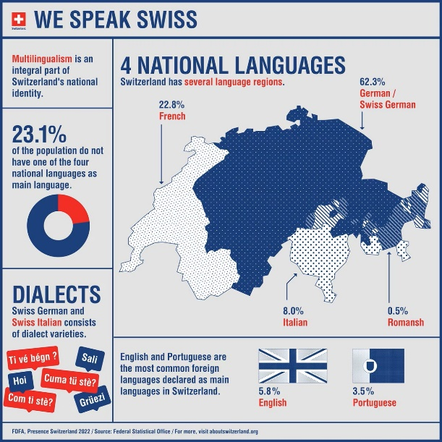
Source: The Federal Council
- Immigration rates
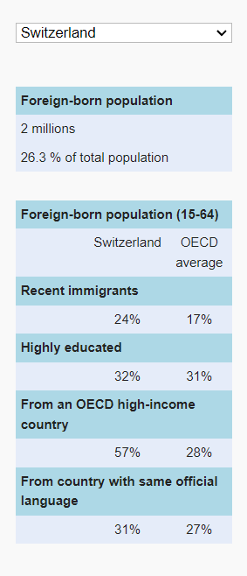
The nation has had the very high immigration rates in Europe. According to OECD (2012) in terms of the percentage of its population that is foreign-born, Switzerland ranks third, with 26% of the total population being foreign-born. Compared to the average of 22% across OECD (Organization for Economic Co-operation and Development) countries, 24% of them arrived in the last five years. 32% are highly educated and 31% are coming from country with same official language (Fig.1).

Fig. 1. Source: OECD, 2012

- Cultural dimensions
The Germanic Europe cluster of the Globe project is formed up of Austria, Germany, the Netherlands, and Switzerland. They have a common border. The Swiss confederation is a democratic republic. According to Riklin et al. (cited by Szabo et al., p. 58) “Switzerland is considered worldwide to be the country with the most extended, differentiated and traditional institutional structure of direct democracy.” Switzerland's economy is characterized primarily by a high percentage of small and medium-sized businesses that employ a sizable section of the workforce. Cooperative relationships between employers and employee representatives have a long history. There is no strike legislation. Switzerland joined the United Nations in 2002 (House, 2007), after perhaps a long commitment to the international community through institutions such as the World Bank, the International Monetary Fund, the World Trade Organization, and others. There were 375 banks in 2000, and it was regarded "overbanked," and it is a strong rival for foreign banks due to the bank secret - no information about accounts was provided. Switzerland's hospitality industry has always been a substantial contributor to the country's economy, owing to the country's strong reputation for luxury tourism and business meetings (Mordor intelligence, 2023).

- Globe project
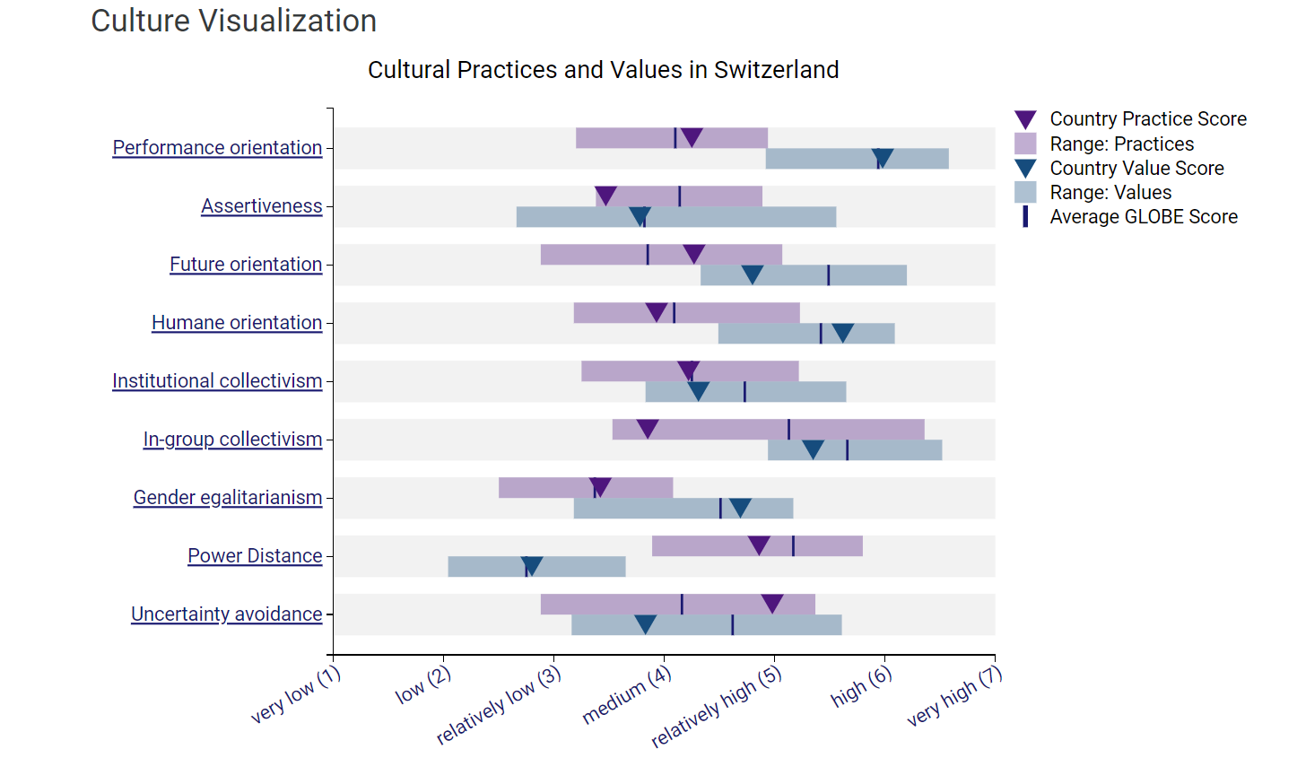
Fig. 2. Source: Globe Project
Performance orientation: Individuals in Switzerland strive to reach high standards and be recognized for their efforts, with a focus on hard work, precision, quality, efficiency, and meritocracy. Swiss goods and services are well-known for their accuracy and high quality.
Assertiveness: The Swiss communication style is often polite and diplomatic, which can be viewed as less assertive according to the Fig.2 and when compared to other cultures. In professional contexts, however, where clear, well-structured communication is anticipated and individuals are encouraged to express their viewpoints and contribute to decision-making processes, assertiveness is rewarded.
Future orientation: Switzerland is forward-thinking, emphasizing long-term planning, sustainability, and a commitment to investing in long-term solutions in business and in daily life.
Humane orientation: Switzerland exhibits a compassionate approach, demonstrating a strong commitment to social welfare, quality of life, and human rights, with a focus on balancing economic success with social well-being.
Institutional collectivism: is the extent to which individuals in society are encouraged and rewarded for communal resource distribution and collective action (Ollier-Melaterre at al., 2018). Switzerland's institutional collectivism is moderate because it promotes social cohesion and has well-established structures for collective decision-making, such as the consensus-driven parliamentary system and cooperative business practices.
In-group collectivism: On a societal level, Switzerland exhibits limited in-group collectivism. While social cohesion and communal bonds are valued, individualism and personal autonomy are also highly valued in Swiss society.
Gender egalitarianism: Switzerland encourages gender equality through laws and practices that strive to achieve gender equality in all spheres of society, including the workplace and education. Gender discrimination in the workplace and other spheres of public life is prohibited by the Gender Equality Act (GEA). Women's rights movements have a long history in Switzerland. Swiss women gained the right to vote in 1971, and there has been an ongoing movement for gender equality and women's rights since then (Kiani 2012).
Power distance: According to Fig 2 in both society and companies, Switzerland has a low power distance culture with score of 2.8, that emphasizes equality and a preference for flatter hierarchical structures.
Uncertainty Avoidance: Switzerland has the highest Uncertainty avoidance of 5.37 according to the Fig 3, which measures how much people want to avoid future volatility. As seen by their reputation for creativity and openness to change, the country demonstrates adaptability and the ability to manage ambiguity (Analyst, 2023).

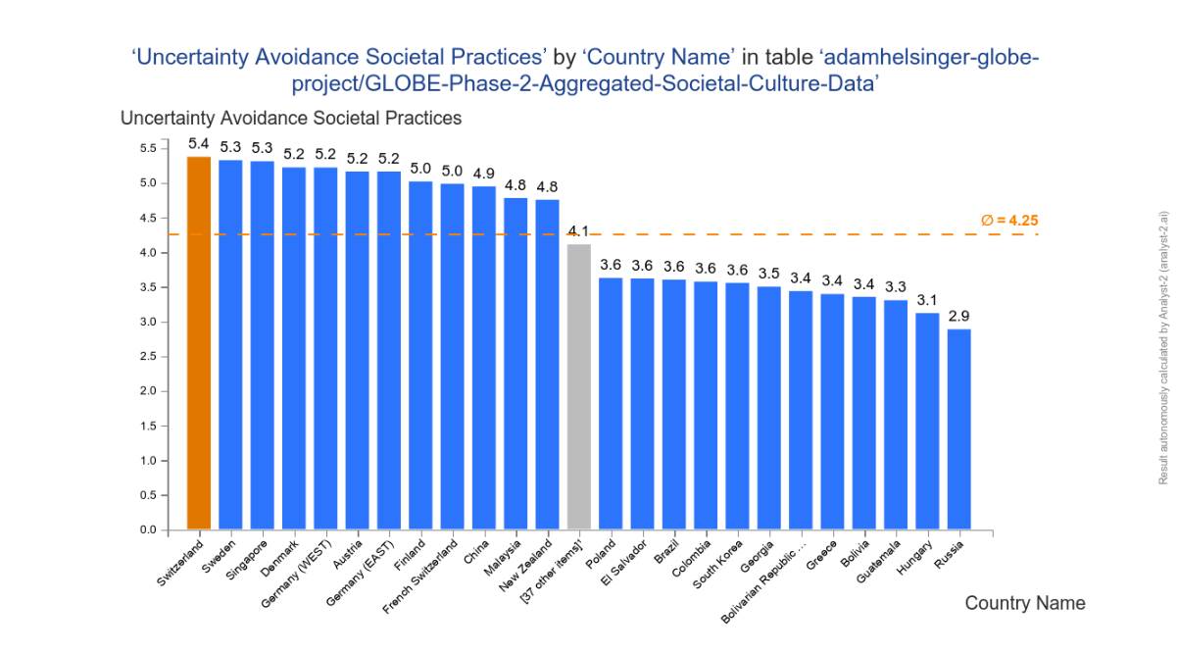
Fig. 3. Source: Analyst, 2023

- Conclusion
In summary, a General Manager of a hotel in Switzerland should have a management style that aligns with the country's cultural values, which encourage teamwork, open communication, adaptability, and employee empowerment. Understanding and adjusting to these cultural distinctions will be critical for successful human management in Switzerland vs the United Kingdom.
- Recommendations
Here are some specific tips for hotel personnel management in Switzerland that differ from those in the United Kingdom:
- Accept an organizational design that promotes more direct and open communication between management and employees.
- Allow staff some degree of autonomy and empowerment in their roles.
- Employees in Switzerland are generally open to new ideas and developments, owing to the country's high level of uncertainty avoidance.
- Highlight the hotel's long-term goal and provide prospects for professional development and growth within the organization.
References:
Analyst (2023) Globe project. Available at: https://analyst-2.ai/analysis/kaggle-globe-project-2dcf/0cf59b7b/ (Accessed 07 November 2023)
D’amato, G. (2010) Switzerland: a multicultural country without multicultural policies? In The Multiculturalism Backlash (pp. 140-161). Routledge.
EDA (2023) About Switzerland. Available at: https://www.eda.admin.ch/aboutswitzerland/en/home/gesellschaft/sprachen/die-sprachen---fakten-und-zahlen.html (Accessed 04 November 2023)
Globe project (2023) Switzerland. Available at: https://globeproject.com/results/countries/CHE?menu=list#country (Accessed 05 November 2023)
Kiani, S. (2012) Equal rights and strategies of the Swiss women’s movement (1975-1996). FEMINA POLITICA. Volume 21, Issue 2: Jg. 21, Nr. 2-2012: Recht als feministische Politikstrategie
Mordor Intelligence (2023) Switzerland Hospitality Market Size. Available at: https://www.mordorintelligence.com/industry-reports/hospitality-industry-in-switzerland (Accessed 06 November 2023)
Organisation for Economic Co-operation and Development (2023) Switzerland. Available at: https://www.oecd.org/migration/integration-indicators-2012/keyindicatorsbycountry/name,218348,en.htm#:~:text=Switzerland%20is%20in%203rd%20place,on%20average%20across%20OECD%20countries. (Accessed 04 November 2023)
Ollier-Malaterre, A. and Foucreault, A. (2018) GLOBE’s cultural dimensions: Implications for global work family research. The Cambridge handbook of the global work-family interface, pp.69-86. Cambridge University Press.
Szabo, E., et al. (2010) The Germanic Europe cluster: where employees have a voice. Journal of World Business. Volume 37, Issue 1, pages 55-68. https://doi.org/10.1016/S1090-9516(01)00074-8
Weibler, J. and Wunderer, R. (2007) Leadership and culture in Switzerland–theoretical and empirical findings. Culture and leadership across the world: The globe book of in-depth studies of, 25, p.251.

