University of Wales Trinity Saint David
BA(HONS) Business Management Level 4
Group 2, Weekend
Student name: Ionut Cernea
Student ID: 1917345
Lecturer: Tushara Balendran

Michelin

Table of Contents

Introduction 3
History and background of the company 4
Products of Michelin 5
Pricing of Michelin 6
Places 7
Promotion 8
Conclusion 9
References 10

Introduction
The following blog post has been prepared to represent the company to the customers at a single glance. The blog post will be defining about the history or background of Michelin along with the 4Ps of marketing mix.
History of company includes the establishment of the company in its early stage. Then it will be telling that how the company grew from a small rubber factory to the second largest tyre manufacturer of the world. Also the achievement of company along with the tie up with the other countries of the world will be made clear through the background of the company. Then the marketing mix of Michelin will be defined starting from the products of the company. The products of the company will be including about the different types of tyre for the different vehicle and other accessories being provided by the company. The product will also be defining about the quality and characteristics of these products. Moving to Pricing, it will be including the information about the pricing of the product of Michelin and the factors that causes the variation in the prices in different countries. Some of the factors can be taxes and global exchange market. Next term in the blog post is place which will be including the name of the countries having manufacturing units of Michelin. Last but not the least, various promotional strategies being used by Michelin will be included in the report.

History and background of the company
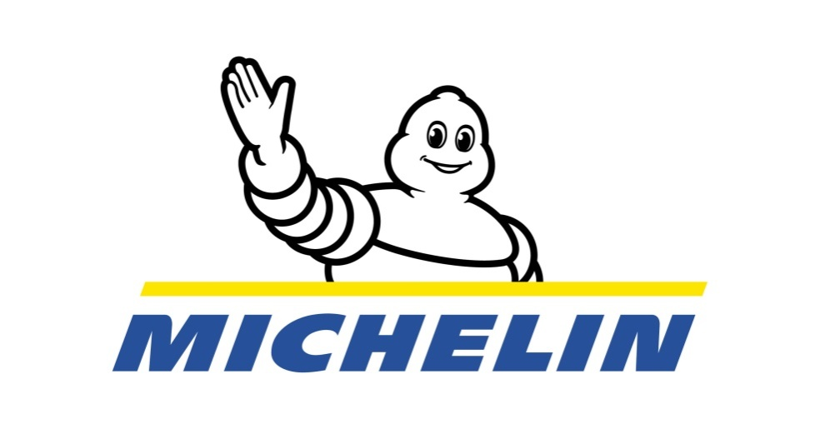
Full name of Michelin is Compagnie Générale des Établissements Michelin SCA. It is the French multinational tyre manufacturer company in Clermont-Ferrand in Auvergne-Rhone-Alpes region of France. The company is second largest tyre manufacturer in the whole world just after the Bridgestone. Other brands of Michelin includesKleber tyre company, Uniroyal-Goodrich Tire Company, SASCAR, Booktable and Camso brands. Along with the services, Michelin also share the other services like travel guides, roadmaps. The products of Michelin includes removable tyre, pneurail and radial tyres. The company manufactures the tyre for motorcycle, bikes, bicycle, cars as well as space shuttle, aircrafts, automobiles and other heavy equipment (Malik et al. 2019).
Edouard Michelin and Andre Michlin were two brothers who ran a rubber factory in Clermont-Ferrard, France in the year 1889. On a random day, a cyclist arrived on the store whose tyre needed to be repaired. As the tyre was glued to the rim, it took a lot of time and effort to repair. Then the tyre was left for the whole night in order to let it dry. On the next day when Edouard took the bicycle to the yard to test the tyre, the tyre didn’t run even of the hundred meters. Despite the failure, the two brothers decided to make the pneumatic tyre in the factory with correction. The brother made sure that the new tyre don’t need to be glued to the rim in order to run. By the hard work and effort of continuous 2 years, the brother were successful in making the removable pneumatic tyre. The same tyre was used by Charles Terront who won the world’s first longest cycle race in 1891 covering the distance between Paris-Brest-Paris.

In 1920-1930, Michelin established the large rubber plantation in Vietnam. In 1934, the brothers succeed in making a tyre that can run on a special lining foam after puncturing. The design now is known as run flat tyre. With the manufacturing of Radial Tyre in 1946, the company represented its technological innovation and became the world’s leading tyre manufacturer.
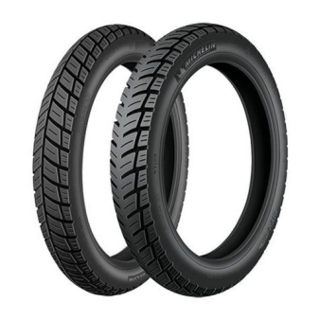
In 1966, company came in the partnership with Sears and produced the radial tyres with the brand name Allste which made the record in sale. In 1968, company opened its first sale office in North America. In 1989, Michelin acquired the B.F. Goodrich Company and Uniroyal, Inc. In December 2018, the company acquired Camso, the manufacturer of off-road-tyres (Baker et al. 2018).

Products of Michelin
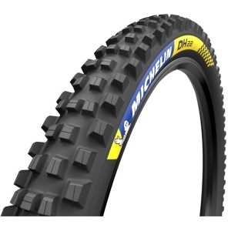
The tagline of Michelin is “Michelin: a better way forward”. Michelin pledge to achieve better, more environment friendly and more efficient mobility. Being the second largest tyre manufacturing company of the world, Michelin serves with the variety and wide range of products to its audience with quality. Michelin provide the best quality and variety of tyres for the followings:

- Motorcycles and scooters: Michelin provide with a vast range of sustainable tyres according to the journey. No matter whether the customer is going for long ride or off-roading, Michelin provide the customer with the best quality of tyre accordingly. Variety of tyres include cruiser, custom, MX, Sport, Roadster, Enduro tyres, trail, trials, scooters, rally, electric and super-moto.

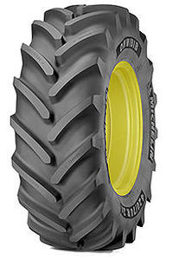
- Bicycles: Michelin make sure the safe and enjoyable journey of the customers on their bicycle. Michelin offers with the road range, mountain bike range and city trekking range of the tyres. The market growth of the tyre of bicycle by Michel has recorded an anuual growth of 25-30%. The range of bicycle tyre from Michelin includes The MICHELIN PRO4 Endurance, The MICHELIN PRO4 Comp Service Course, MICHELIN Lithion 2 and many more.


- Truck and Trailers: Michelin has also made a significance presence for providing the tyres for heavy transportation vehicles. Michelin provide the quality of tyres to the truck driver in completing the journey without thinking about the mileage. The tyre helps the truck owner to optimize the total cost with durability and longevity. Using the Michelin tyre, drivers don’t need to worry about the obstacles in the way of journey (Schober et al. 2018).

- Agriculture and Farming: Michelin even design the tyres handle heavy loads for the sustainability in field work. For the durability and keep working in farming and agriculture, Michelin manufactures the tyres for tractor and automobiles used in field work.

- Michelin Lifestyle:
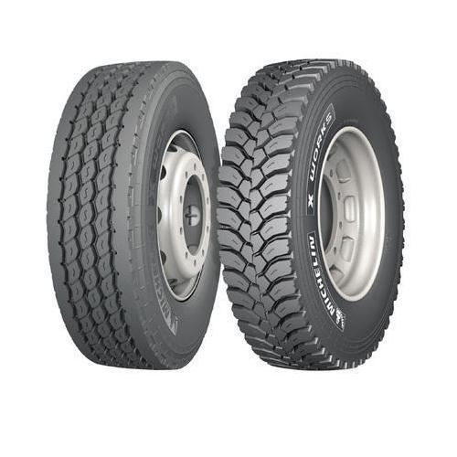
Along with providing the quality tires to the customer for their every type of vehicle, Michelin also make sure that the customers are using other accessories with best quality. So Michelin provide the quality products. The accessories includes the casual outdoors, boxing accessories, construction assistance and the products to explore the nature in a better way (Guerrini 2019).

Pricing of Michelin
Along with providing the quality, Michelin also make sure that the pricing of the product provided by the company are affordable for the customers. Company make sure that the products of Michelin are worth for the money of the consumers. Being the second largest manufacturer of the tyre in the world, it is the prime responsibility of the company to provide the customer with the products which are cost efficient and also don’t compromise with the quality of the product (Hanson et al. 2019).

Tyres: pricing of the tyres from Michelin varies according to the quality of the tyre or product. Although the taxes being imposed by the government of different countries makes the different in the cost of tyre in different nations. Also the global exchange market plays a vital role in defining the prices of the tyres. The price range of Michelin tyre in UK varies from 50 GBP- 100 GBP, according to the quality and type of vehicle (Chernysheva 2017).

Places:
Being the second largest tyre manufacturer of the world, Michelin has hundreds of store in various counties of the world. Along with the stores, Michelin operates with more than 69 manufacturing unit in 17 different countries. The distribution of manufacturing unit is as follow (Medrano-Bigas 2018):
France-10
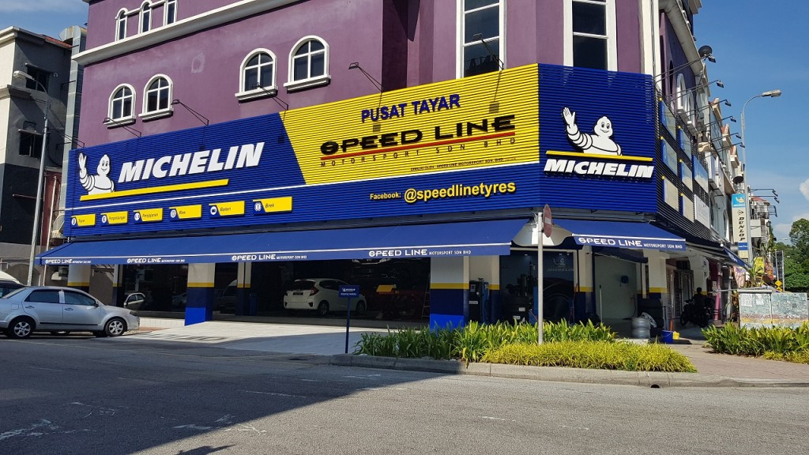
Germany-4
Spain-4
Italy-2
United kingdom-3
Hungary-2
Poland-1
Romania-2
Serbia-1
Russia-1
US-11
Canada-3
Mexico-2
Brazil-4
China-2
Thailand-3
India-1
Along with these, Michelin own 7 R&D centres in Europe, Japan, China, Thailand, India, Brazil and the United States.
Michelin occupies the 14% market share in the tyre market and have more than 5000 tyre distribution and service centres (Metodijeski et al. 2018).
Michelin even provide the tyre by online facilities through the link given below:
https://www.michelin.in/

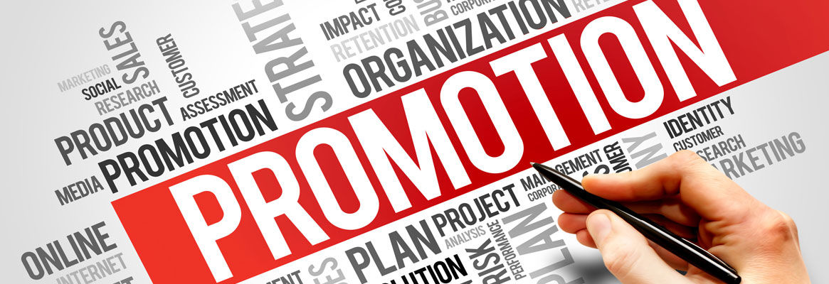
Promotion
Company has a high profile in the market of tyres so company preform the promotion of their product on the same standard.
Michelin keep promoting the products via newspaper, radio, hoarding, te
levision and internets.
Company focuses on the brand visibility of Michelin. Advertisement of Michelin has been seen in both MotoGP and Formula 1 as the top tyres of the world. Company also focuses on the CSR activities.
The main way of promoting the tyre of Michelin is the customer itself. As Michelin never compromise with the quality of their products, customer are highly satisfy with the product of the company and never forget to recommend its product to the friends and family.
Various online medium of promotion such as online ads, social media etc. are used by the company for promotion.
Also the company keep organising the events like cycling, endure racing and rally to prove the quality of product to the people (Chicu et al. 2020).

Conclusion
The blog post well explained about the background of the company and its historical development of the company in the France. Many achievements with their time has been included in the report. Full name of Michelin is CompagnieGénérale des Établissements Michelin SCA. Then the marketing mix of Michelin has been included in the report. In the products, blog post well defined about the tyres for different vehicle and other lifestyle accessories. Pricing defined about various strategies and factors that determine the price of different products in different countries. Places included about the different countries having manufacturing unit. In the last various strategies for the promotion of company and its product has been included in the blog post.

References
Baker, C.R., Cohanier, B. and Gibassier, D., 2018. Environmental Management Controls at Michelin–how do they link to sustainability?. Social and Environmental Accountability Journal, 38(1), pp.75-96.
Chernysheva, O.M., 2017. FOREIGN EXPERIENCE OF THE FORMATION THE ELEMENTS OF THE TIRE ENTERPRISES STRATEGY.
Chicu, N., Prioteasa, A.L. and Deaconu, A., 2020. Current Trends and Perspectives in Tyre Industry. StudiaUniversitatis „VasileGoldiş” Arad, SeriaŞtiinţeEconomice, 30(2), pp.36-56.
Hanson, A., Kemp, K., Mullet, J., Riemenschneider, H. and Webb, R., 2019. Secondary Research Report.
Malik, F., Malik, L., Aziz, S., Ahmed, J. and Tahir, F., 2019. Michelin Tire Baby Syndrome: A Rare Case with Review of Literature. Cureus, 11(9).
Medrano-Bigas, P., 2018.The Forgotten Years of Bibendum. Michelin’s American Period in Milltown: Design, Illustration and Advertising by Pioneer Tire Companies (1900-1930).
Metodijeski, D., Filiposki, O. and Micev, G., 2018. Perfection in service and cuisine: review of Michelin star restaurants in Europe.
Schober, B.D., Gramling, F.E. and Judd, D.A., CompagnieGenerale des Establissements Michelin etCie, 2018. Sensor device for tire inspection.U.S. Patent 10,060,832.

