Student name and number | Albena Dimitrova 1814002
Module title  Module code | Professional Career Development  BMSK4004
Lecturer name  Submission date | Anupam Mazumdar  13/01/2019

Contents

Introduction ……………………………………………………………………………………………….p.3
My profile……………………………………………………………………………………………………p.4
Lifeline…………………………………………………………………………………………………………p.5
Skills and Knowledge Contributing……………………………………………………………….p.6
Self-Motivation review…………………………………………………………………………………p.7
Learning styles……………………………………………………………………………………………..p.8
Kolb Learning style……………………………………………………………………………………….p.8
Honey and Mumford learning style………………………………………………………………p.9
VAK learning style…………………………………………………………………………………………p.9
Personal Development Plan………………………………………………………………………p.10
SWOT analysis……………………………………………………………………………………….p.10-11
Johari Model……………………………………………………………………………………………….p.11
SMART objectives ………………………………………………………………………………………p.12
Review of understanding and expectation of World of Employment………….p.12
Personal development plan………………………………………………………………………..p.13
Action plan………………………………………………………………………………………………….p.14
Conclusion………………………………………………………………………………………………….p.15
References ……………………………………………………………………………………………p.16-17

Introduction

This report aim is to produce a Personal Development Portfolio with evidence of skills and knowledge. With my profile and using of my lifeline I will show you how I approach here. My journey from birth until present days was fraught with difficulty, but I never give up. So, I arrived from Bulgaria before 8 years ago, because I wanted to live a better life. I had some experience from my work in Bulgaria, but not enough for good career. I realized that without education I can’t find better job, so I find course to help me to develop more skills. As a student I improved different skills and knowledge, and I am confident to apply for job. I will test myself with self-motivation quiz to see how motivate I am. I believe in pushing myself further and further in life, not only physically, but mentally as well. Also, I will use SWOT analyse to help me to identify my strength and weakness. However, I will use SMART objectives and will set action plan as well.
Moreover, employers looking for creative and honest people, people with self-motivation to work hard. Along with good understanding and knowledge, employers often outline set of skills they want from employee. However, after students graduate, employers recruit them to interact with customers, to work with different teams and be effective in their job(Cameron,2008).According to Doyle (2019) important skills as communication, teamwork, interpersonal skills, leadership skills, technical, problem solving, positive attitude, ability to work under pressure are most important to employers.

My profile

I will give a brief description of myself. I was born on the 22 of August 1989 in Pazardjik, Bulgaria. Bulgaria is a European country since 2007. Bulgaria’s economy is underdeveloped and there are no jobs, minimum payment and it is very difficult to live there. Present day I am citizen on England since 2012.
My family consists of my partner, my daughter, my mother in law and my brother. I am 30 years old now.
When I was 7 years old, I started my primary school. I was excited to learn how to read and write. This time was an adventure, but also was very difficult for me, because my mother and father divorced then. In this long gurney I become a teenager and started my secondary school. I felt sad in this moment, because I had to move to the other school. I had to leave all my friends. When I finished secondary school, I received my diploma and I started to work as sale assistant in perfume shop. In that moment, I needed to saved money for my degree. Also, I applied for driver license course. I spend two months to finish the course and to receive my driving license. This was amazing opportunity and experience for me, and a big advantage to have a licence.
I remember I had to broke up with my boyfriend, because I wanted to study. That year my granny brought me a car. Year after I was ready to study English philology. I was so happy and proud of myself. In my first term I was so excited, because I met new people and I was traveling to another city. However, after second semester I had to cancel my degree, because my mom was very ill, and I had to take care of her. The end of the story was very sad for me. It was the worst day of my life.
However, in 2011 I became a mother of a beautiful girl. It was the best day in my life. After my daughter first birthday, I had to leave her with her grandma, and I went to live in London. First of all, I started to work for an agency for domestic cleaning. It was very difficult for me, because I didn’t speak well English language. Also, I needed to travel around London and find addresses without phone with navigation system. I felt strange and scary to live in a country that is not mine. I met different people, people of different background and culture. This was one of the interesting things in London for me. The people who was my clients were amazing and kind with me. They were my friends not my employers. I saved money and I bring my daughter in London. In present days I feel more happy, confident and I am not scare anymore. After 8 years I love this country. She gives me amazing opportunities for my future and my family as well. After a year I decided to apply for personal trainer course. It was big step for me, but also was something that I loved to do. However, my hobby become my job. The course was month, full time so I was going every day. I learned and developed skills who helped me to change my career. To work as personal trainer was amazing, the feeling every time, when I helped to someone to rich their goal, I can’t describe it. Moreover, I had one more sad moment when my grandmother died. Then I had to return to my country for the funeral. After 2 years of work I realized I need more skills and knowledge. However, I become a student in University in London, and I started to study business management. My dream is after my graduation to build my own business.

My Lifeline
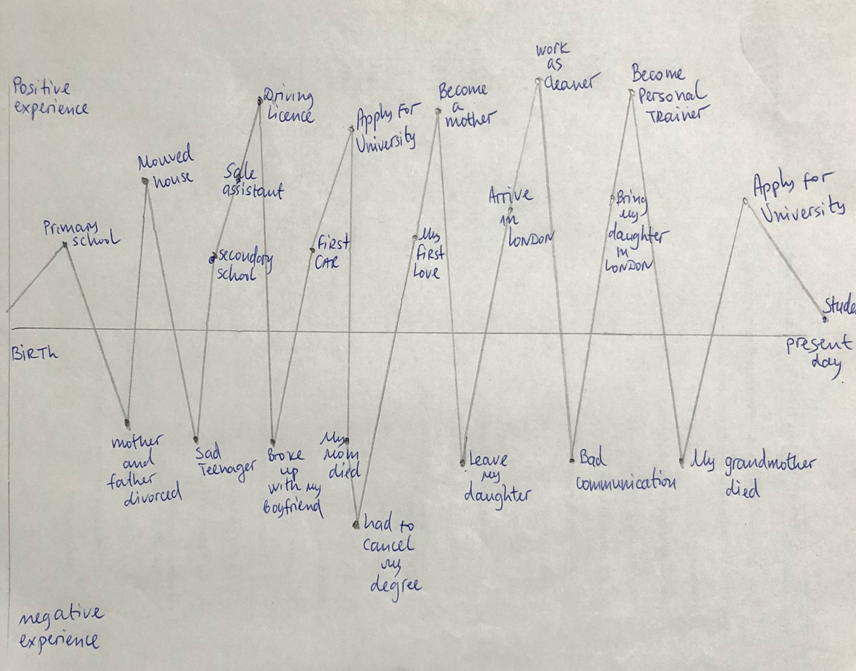

Knowledge and skills towards effective working

Communication is most important skill at workplace. According to Griffiths and Dunham (2005) communication is shared information between two or more people. Communication is verbal and non-verbal. Verbal communication is ability to use words. Non-verbal is ‘’body language’’ ability to use your behaviour and emotions (Griffiths and Dunham,2005). For example, written communication and ability to read. You can communicate by send an email or receive one, but that may not be effective (Morgn,2017). Face-to-face communication is most important, because others can understand correctly what you want to say, through your facial expression, and body language as well (Morgan,2017).
Another important part of communication is listening. According to Morgan (2017) listening is one of the most frequent skill and it is takes time and energy. Active listening is not the same as hearing, “is the active search for an accurate understanding of another’s message” (Morgan,2017).

Interpersonal skills you use to interact and connect with colleagues and customers (Cameron, 2008).
Positive attitude and ability to work under pressure.
To be effective at workplace you need to be creative and flexible as well.

Time management is important skill at workplace. It is our ability to manage our time effectively (Morgan,2017). “Good time management is the ability to ontrol our use of time to such an extent that we are able to plan and manage what we do without undue streess or tension”(Morgan,2017).

“Critical thinking is the development and use of information beyond memory and repetition”(Morgan,2017).
According to Cottrell(2005) critical thinking is a process which involve different skills including:identifying arguments,evaluation of evidence with defferent points of view,..”being able to read between the lines..” use reflection in a structured way to bring logic,convinces others with a clear and good point of view(Cottrell,2005).

However, according to Morgan(2017) team is a number of people working together to achieve a specific goals. ‘’All those in the team understand each other, practically support each other and encourage each other as the task progresses”(Morgan,2017).
“Problem solving is defined as the area of cognitive psychology which deals with the processes involved in solving problems” (Pal and Poyen,2017). The problem can arise from family, social agenda, healthy issue and work (Pal and Poyen,2017).
According to Adair(2004) decision-making is ability to choose the action ar course of action. It is about the what,how,when,where and why of course of action and to solve problems(Adair and Thomas,2004).

Research and investigtive skills also are important,because ypu need to be able to research,to identify business data and resolve management issues.Numeracy and quantative skills are good skills,because enable you to analyse data,interperet and use numbers(Cameron,2008).

Leadership is a complex skill, a series of skills and behaviors, and capabilities to be successful at motivating others,decision making,developing and implementing vision,manage relationship and demonstrating self-awareness(Morgan,2017).

Also, presentation skills are important part at the workplace. “Presentation is the oral delivery of information to achieve particular objective”(Morgan,2017). According to Morgan(2017) ability to make a good presentation is important part of business and employment life.

Another skill is self-awareness that enable you to be open to different people and be careful how others behave(Cameron,2008).

Self-motivation
The ability to motivate yourself is self-motivation and it is important skill.
There are four factors to improve your self-motivation:
Self-confidence, positive thinking, focus and strong goals, and a motivating environment.

Self-motivation quiz inspired by mindtools.com
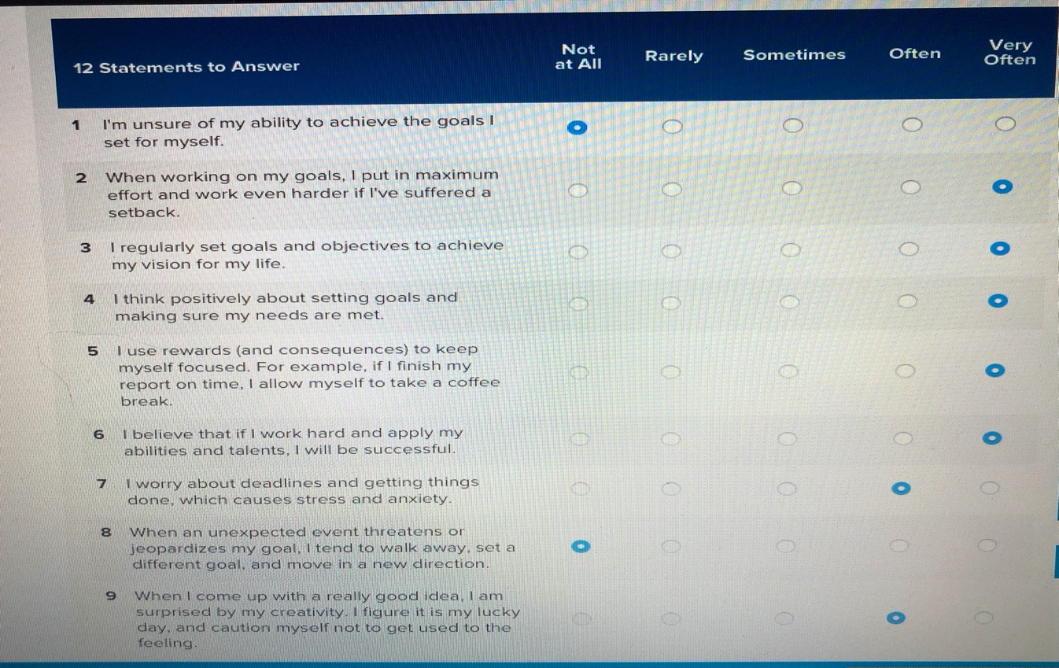

I tested myself and my score was 50. According to the questionnaire interpretation I am “wonderful” and I make everything possible to stay self-motivated. I set goals and acting to achieve them. I inspire others and I don’t let anything stand in my way, when something has to be done.
I believe in myself, always I set goals and I know if I work effective, I can achieve them.

Learning styles:

1.“Learning is the process whereby knowledge is created through the transformation of experience’’(Kolb,1984).

According to Kolb’s (1984) to be effective learner,you need four different kinds of abilities:
concrete experience,reflective observation, abstract conceptualisation,active experimentation. The process begins how experince is followed through reflection on concepts which guided to experimentation(Akella,2010).

Concete experience:”is the basis for observation and reflection”(Kolb,1984). Learnenrs are experinecing an activity(Akella,2010). ‘’The learner experiences, reflects, thinks and then acts again” (Akella,2010).

Reflective observation:people learn from their experience and they reflect and observe from all perspectives(Akella,2010).
Abstract conceptualization:relates on logic and ideas to understand problems(Akella,2010).
Active experimentation:students fist test the theories and then act.(Akella,2010)

Figure 1:Kolb’s learning style.

Experience
(Feeling)
(Doing)
Experimentation Reflection
(Watching)
Conceptualisation (Thinking)

According to McLeord (2017)Kolb’s in 1988 identified four styles of learning based on learning cycle:
- Accommodative- -it is the ability to adapt to changing immediate the circumstances(Mcleord,2017).
- Divergent- it is a style where people look at things from different perspectives(Akella,2010).
- Assimilative-prefers to swing between reflection and conceptualisation and will use inductive reasoning to develop new theory (Mcleord,2017).
- Convergent-This style gives abilities to people to experiment and to work with practical applications.Think and do(Mcleord,2017).

2.Honey and Mumford (1986)developed Kolb’s theory to produce their onw learning style. They are classified as pragmatist,reflector,theorist and activist(Rosewell,2005).
- Activists:learn best by active involvment in particular task,new experiences and opportunities(Rosewell,2005).
- Reflectors:observe and think from different perspectives,analyse before making a decision(Rosewell,2005).
- Theorists:they like to understand the theory and use facts and models in order to learn(Rosewell,2005).
- Pragmatists:they look for new ideas, see a link between new information and a current need,they can use an example(Rosewell,2005).

According to Honey and Mumford(1986) people follow one or two of these learning styles.They have produced a questionnaire to help people to recognise themselves with the prefered learning style(Honey and Mumford,1986).This questionnaire is created to individuals to think the way they learn from their experiences(Honey and Mumford,1986).

3.The VAK learning style is created in 1920 to provide different ways of learning and approching information to learners. According to the model some people learn in one of the three ways.

Visual learning- data and information are associated with image and technique.(Sreenidhi and Helena,2017)
Auditory learning-they depend of hearing,listening and speaking.(Sreenidhi and Helena,2017)
Kinesthetic learning- learners take practical activities and learn best in envoroment where they can be active(Sreenidhi and Helena,2017).

I have done two learning style test which is VAK learning questionaire and Honey and Mumford learning questionnaire. The results are ilustrate below:

Scores for VAK questionnaire:
Visual-16
Auditory-2
Kinesthetic-14

According to VAK questionnaire(HEF,2019) my score showed that I prefered to touching,feeling and holding things.I am kind of people who like to experimet. Also,the result showed that I observed things,pictures and diagrams.I work with written instruction as well(HEF,2019).

Scores for Honey and Mumford questionnair :
Pragmatist
This result showed that I am from people who tried new ideas and activities to seed if they work in practice(Farooq,2016). Also according to Honey and Mumford(1986) questionnaire I am practical and like to solve problems,and I see the problems as challenges(Farooq,2016).

Personal development plan is a process of self-analysis and personal reflection and is very important in enabling the tracking of developmental changes that are necessary for the achievement of set goals.

SWOT analyse is used to analyze business,but this tool can be used for nonprofits,governments and individuals(Grant,2019).The framework used to improve the company position and develop a strategic plan(Grant,2019).
Personal SWOT analysis is tool to improve yourself and to plan your career.
To understand my strengths and weaknesses,and opportunities and threats I am gone to use SWOT analysis.

Strengths Weaknesses
Communication skills  Time management  Planning  Decision making  Creative  Self-motivator  Teamwork skills  Hard worker  Ambitious | Bored easily  Emotional  Presentation and Public speaking  Adaptive  Talking too much  Argue with colleagues  Can be impatient  Leadership  Analytical
To find a way to be more focused and not emotional.  Good listener and presentation practice.  To receive training in service to improve my leadership skills.  To continue Level 5 and Level 6 Business and management.  To finish Master degree.  To become Manager  To build my own company. | I am not focused when I am bored.  I can’t think right if I am emotional.  I will not be effective without presentation skills.  Missunderstanding when I talk too much.  Time pressure can cause stress  Healthy issues  Don’t have too much friends  Money
Opportunities Threats

My strength are good communication skills, I am able to work underpreasure and can take quick decision. Also I am good in planning, it is better always to have a plan for everything.
I never leave job without finishing it. I manage my time well with my work and my family.
I am creative person, find different options for particular situation and asly gives ideas.
I work well with other people and I am able to listen them. I am good coordinator and can convince people easliy. I am ambisious when it is come to work. I am good self-motivator,because I push myself and motivate myself always.

My weaknesses are: I generally get bored easly with routine work. I am not good enouth for presentations. Always I am nervouse and stressed when it is time for presentation. Moreover, I am emotional in my personal life as well as my professional. When I have to change an organization I can’t adapt quickly, I need some time to work to the new place.
I can argue about an issue until the end if I am right , even when I am wrong.
Sometimes I talk too much and I can’t stop, that is a weakness, because I didn’t give a chance the other person to speak. I can be impatient if I need to explain twice. I need more experience with my leadership skills. Sometime is hard for me to take the leader role.Also, it is hard for me to be more analytical in some point.

My opportunities:
I always grab opportunities that can enhance my capabilities of learning something new. I will find way to be more focused and not so emotional.I will try to think first and then to act. Also,to receive training to improve my leadership skills.
If I turn my weaknesses in strenght I will had all skills needed to finish my degree and start working as manager. When I have enough experience and money, and the right connections I will build my company. I have opportunity to continue level 5 and level 6 in business management.

Johari Window

Two psychologists Jo Luft and Harry Ingham created Johari Window model and
this model is made to help you better to understand yourself and others(Bibi,2016).
The process of understanding your own feelings,believes,different approaches,strenght and inspirations and understanding of other people and how they perceive you,your attitude is called self-awareness (Bibi,2016).
There are four components in the model named as Open, Hidden,Blind and Unknown (Bibi,2016). As you can see in figure 1 are four quadrants. The open is information that you know and others as well(Bibi,2016). The hidden is information that you know,but for the other is hidden. On the other hand, information that you don’t know, but the others know is in blind quadrant(Bibi,2016). Also, four quadrant is information that you and the others is unknown (Bibi,2016).

Figure 1.Johari Window
Open | Blind
Hidden | Unknown

Smart objectives

S - Specific
M - Measurable
A - Achievable
R - Relevant
T - Time

To accomplish my goals I will use SMART objectives method.It will help me to set my goals. My specific goal is to complete my degree. I will know that this goal is accomplished by finishing all assignements. This goal is achievable, because I know I will give my best of me and I am inteligent, and I have desire to accoplish it. It is also realistic, because I have two years left of the degree. When i receive my degree I can work as manager.
In February 2022 I will accomplish this goal. This is the time when I will complete my degree.

Employment and understanding

Expectation of employers and employees

When you start a new job, you need to be sure that you understand clear what your employer expect of you. Also important is what you expect of him as well(Thompson,2018).Regardless of the job, people with strong communication skills are in high demand(Doyle,2019).Employees need to communicate with managers,customers by phone and online in writing as well(Doyle,2019).
According to Thompson(2018) your employer expect of you to be reliable. To arrive on time and to be there until your shif is over.new employer will expect you to be honest, to dress appropriately and to be a professional at workplace(Thompson,2018).You need to learn quickly and to respect your supervisor and your coolleagues(Thompson,2018).
You also expect thing of your employer. As employee you expect save working conditions,good payment,fair feedback and explanation of policies and responsibilities especialy of your job(Thompson,2018).
You and your employer will be in trouble, because of expectation for example you don’t get your payment on time or he expect loyalty from employees,but does not extand the same loyalty(Thompson,2018).
“Employees need to be able to confront a problem” and with analytical skills employers expected of employees to organize and prioritize effectively(Doyle,2019).
Employers want to hire people with positive attitude and to contribute extra effort to get the job done(Doyle,2019).

My Personal Development Plan

What do I need/want to learn? | What will I do to achieve this? | What resources or support will I need? | What will my success criteria be? | Target dates for review and completion
Public speaking  Analytical skills  Leadership skills  Management | Train in school  Practice with colleagues and friends  Brain games,to learn new things every day  Developing persuasion skills  Level 5 and level 6 business management degree | Theacher support  Video resourses  Analytical tools  Reading resources  Strategic tools  Advisor  Books, articals  Lectures internet | Able to speak confidently in front of people  Able to see the bigger picture  Able to lead effectively  Able to build team  Management experience  Qualification | 2020  2020  End of 2020  2022

Action plan

Short-term  What do I want to accomplish in the next three to six months? | Mid-term  What do I want to accomplish in the next six months to two years? | Long-term  What do I want to accomplish in the next two to three years?
I want to continue my degree. To reach level 5. | To achieve and improve new skills and knowledge.Complete level 5.  To reach level 6 and accomplish a Bachelor degree. | Manager  To build my own business.  To buy hotel in Thailand.

My short-term goal is to continue my course. After completing my assignemets and passing I will be able to continue my degree. My next goal is to reach level 5.

My mid-term goal is to complete leadership and management level 5 and level 6, and accomplish Bachelor degree.

My long-term goal is to become a manager. As manager I will have experience,knowledge,respect and opportunities in a company. Then I will have a chance to build my own business. My next goal is to buy a hotel inThailand. I will need skills, knowledges and strategies to accomplish this goal after three years.

Conclusion

Setting goals for yourself is something I consider very important.By going back to school and getting my degree I am opening lots of doors for myself in the future. This portfolio showed my life journey, my skills and knowledge.
However,to better understand my personality I undertake various tests such as Honey and Mumford questionaire and VAK qustionaire and self-motivation quiz. Also, using SWOT analysis to evaluate my strengh, my weaknesses,threats and opportunities, and to improve them. I was learning many things for myself during this portfolio. As I am pragmatist and I am well selfmotivator.
Now I have clear vision of myself and action plan to accomplish my goals.The employability depends on my knowledge, my skills and attitude, how I use those assets, and how I will present them to employers. This portfolio helped me to understand and identify qualities and skills, and to achieve my goals.
Employability skills are important if you want to change your career and your future.

References

Adair, J. and Thomas,N. (2004).The John Adair Handbook of Management and Leadership.London,Thorogood.

Akella, D. (2010).Learning together:Kolb’s experiential theory and its application. Journal of Management & Organization [online] available at: https://www.researchgate.net/publication/247920250_Learning_together_Kolb's_experiential_theory_and_its_application [Accessed:14 December 2019]

Bibi, S. (2016). Self Awareness,Journal of Pioneering Medical Sciences [online] Available at: https://www.researchgate.net/publication/317038169_Self_Awareness [Accessed:21 December 2019]

Cottrell, S. (2005). Critical Thinking Skills.1st Edition. Basingstoke: Palgrave Macmillan Ltd.

Cameron, S. (2008). The business student’s handbook: learning skills for study and employment. Fourth edition. Harlow, England

Doyle,A. (2019). Top Skills and Attributes Employers Look For [online] Available at: https://www.thebalancecareers.com/top-skills-employers-want-2062481 [Accessed: 4th of January 2020]

Farooq,S.(2016)Honey and Mumford Learner Types(1986) Online Quiz [online] Available at:
https://www.eln.io/blog/honey-mumford-learner-types-1986-questionnaire-online [Accessed:14 December 2019)

Grant, M. (2019).Strength, Weakness, Opportunity, and Threat (SWOT) Analysis[online] Available at: https://www.investopedia.com/terms/s/swot.asp [Accessed:2 January 2020]

Honey, P. and Mumford, A. (1986). The Manual of Learning Styles, London

HFE (2019).VAK Learning Style Questionnaire [online] Available at:
https://www.hfe.co.uk/learning-styles-questionnaire/ [Accessed : 14 December 2019]
McLeod, S. A. (2017). Kolb - learning styles [online] Available at: https://www.simplypsychology.org/simplypsychology.org-Kolb-Learning-Styles.pdf[Accessed:10th December 2019]
Morgan,P. (2017).The Business Student’s guide to Study and Employability,London,SAGE Publications Ltd.

Pal, A. and B.F.E., P. A. P.,(2017). Problem Solving Approach. International Journal of Advanced Engineering Research and Science, 4(5).

Rosewell, J.(2005).Learning styles,The Open University[online] Available at: https://www.open.edu/openlearn/ocw/pluginfile.php/629607/mod_resource/content/1/t175_4_3.pdf [Accessed:24 December 2019]

Sreenidhi S K, Tay C Helena(2017). Styles of Learning VAK based on the Research of Fernald,Keller,Orton,Gillingham,Stillmsn,Montessori and Neil D Fleming, International Journal for innovative research in multidiscplinary field. [online] Available at:https://www.researchgate.net/publication/317305325_Styles_of_Learning_VAK
[Accessed: 13 December 2019]

Thompson, S. (2018). The Expectations of Employers & Employees at a New job[online] Available at:https://work.chron.com/expectations-employers-employees-new-job-9494.html [Accessed:20 December 2019]

