A Report on an Entrepreneur
Lucy Miles

Contents Page

- Executive Summary Page 3
- Introduction Page 4
- Main Body Page 5-8
  - What is an entrepreneur?
  - Different types of entrepreneurs
3.3 Entrepreneur
3.4 Are entrepreneur’s heroes?
4. Conclusion Page 9
5. Appendixes Page 10
6. References Page 11

1 Executive Summary

“An entrepreneur sees an opportunity which others do not fully recognize” (Oakley, 1991). There are many different perceptions of entrepreneurs which cause a divide. The main three motivational factors appear to be psychological, social and economic. This also links to the nature v nurture argument as to whether an entrepreneur was born one or raised as one.

Sir Terry Matthews is one of the world’s wealthiest entrepreneur. His journey to financial success began when he moved to Canada and built a prosperous telecommunications business enterprise. During this time as an economic entrepreneur the main motivation was money. However, in his later life he turned into a more social entrepreneur by investing millions in building a hotel on the grounds where he was born. This shows how he turned from focusing on his wealth, to improving business opportunities for others.

A hero is “a person who, in the opinion of others, has special achievements, abilities, or qualities and is regarded as a role model or ideal (Dictionary, 2018).” There are many contrasting views as to whether an entrepreneur can be categorised as hero. An economic entrepreneur can be selfish, but even their motivation cannot not go unrecognised. A social entrepreneur is most definitely a hero who takes opportunities to benefit others.

Sir Terry Matthews can most definitely be classed as a hero along with other social entrepreneurs.

2 Introduction
This report will define the meaning of entrepreneur and will discuss the conflicting theories the definition provokes. It will reveal the different types of entrepreneurship apparent during the career of Sir Terry Matthews. To achieve a greater understanding as to how Sir Terry Matthews became an entrepreneur the report will discuss what initially encouraged him to become an entrepreneur and the factors which still motivate him in achieving what he does. To conclude the report, a discussion will be made as to whether an entrepreneur can be categorised as a hero, and in this instance if Sir Terry Matthews justifiably fits that role.

3 Main Body

3:1 What is an Entrepreneur?

“An entrepreneur sees an opportunity which others do not fully recognize” (Oakley, 1991). This statement implies that an entrepreneur is someone who takes risks. It also suggests that other people may have the same ideas but what defines an entrepreneur is that he or she grabs the opportunity by both hands and develops it to their advantage. Thomas Cochran holds a view that there are three key elements to an entrepreneur, namely culture values, role expectations and social sections. This theory suggests that becoming an entrepreneur is a result of ones’ personality (Cochran, 1971). It is evident that there is not one clear definition of what entrepreneurship truly means and such diverse thinking has led to a range of theories being discussed. McClelland’s (1961) theory on entrepreneurship, of need for achievement (N-ach) expresses how entrepreneurs have two major features. These include performing and executing better than others, and making decisions with vagueness. McClelland also expresses that entrepreneurs are highly motivated individuals, spurred on by achievement. Even though there is not one clear definition most entrepreneurs have similar traits such as passion, vision and flexibility. These are what motivates them and thus defines them as entrepreneurs (Robinson, 2014).

3:2 Different types of entrepreneurs

Along with the variations on entrepreneurship, there appear three different approaches. The first approach is social. A social entrepreneur focuses on the social environment around them. A social entrepreneur functions because of the environment around them. If the entrepreneur sees, and acts upon an opportunity to help the community they would be classed as a social entrepreneur. They do not focus on profit, they focus on how the people will benefit (Schwab, 2017).
The second approach is economic. This kind of entrepreneur is driven by money and all opportunity’s the entrepreneur take is motivated by monetary gain. Kirzner explains that economic entrepreneurship is the process of discovery for profit, therefore implying that an entrepreneur’s choices are influenced by the financial reward they and their business will receive. An example of an economic entrepreneur would be an individual renovating houses in a University city where enrollment is rising. The opportunity is taken due to the possibility of greater profit. (Sobel, 2005).
The final approach is psychological. Some people believe that an entrepreneur is born with this frame of mind, and is a direct result of their upbringing and early experiences. Their thirst for success could be down to family wealth and aspirations, which many see as an advantage to be an entrepreneur (Johanasson, 2018). Additionally, a further study was carried out showing that children who were well disciplined and had their questions answered when growing up have a greater likelihood of becoming an entrepreneur. An entrepreneur may emerge from a successful business family who share a passion for business and commerce. This provides them with a sense of ambition and the drive to take opportunities that may become available to them. It is important however to remember that entrepreneurship is not a gene, which is where the nature v nurture argument arises. Some argue that entrepreneurship is down to nature, arising from genetics and biological factors (McLeod, 2015).In contrast, others believe that entrepreneurship is down to nurture and the environment they live in (Therapy, 2018).As there are many different entrepreneurs one of the main questions asked is, were they born an entrepreneur or raised to be one? (Post, 2018).

3:3 Entrepreneur

Sir Terence (Terry) Matthews is a multi-billionaire whose net worth is around £1.2b, making him the third richest man in Wales and 101st in the world (Ruddick, 2016). Some people may suggest that an entrepreneur who is worth billions of pounds was born an entrepreneur. However, Sir Terry was not and thus other contributory factors must have been instrumental in his business successes. He was born in 1943 in Newport and lived in a terraced house with his family in the small town of Newbridge, in the Ebbw valley. As the family was not affluent, Sir Terry generated his own wealth and was not born to a family who were entrepreneurs (Forbes, 2018).

Initially, Sir Terry Matthews is portrayed an economic entrepreneur. He emigrated to Canada in 1964 to meet Michael Cowpland who is the CEO of a Canadian software company called Corel. By emigrating to Canada, it shows that Matthews is a risk taker, ambitious with a view to make a profit for himself and become an established entrepreneur (Waddell, 2009). A theory Mathews may have considered before emigrating is Piagets 1963 cognitive theory. This theory allows risks to be taken considering the three main factors, namely cognitive, behavior and environmental. When Sir Terry Matthews emigrated, he would have researched the different culture in Canada. His ideas may have an impact on the Canadian people who may or may not have the same opinions as him. Even having deliberated over this theory there still remains an element of a risk in the choices he made, as with any decision you cannot always predict what will happen (Piagets, 1963).

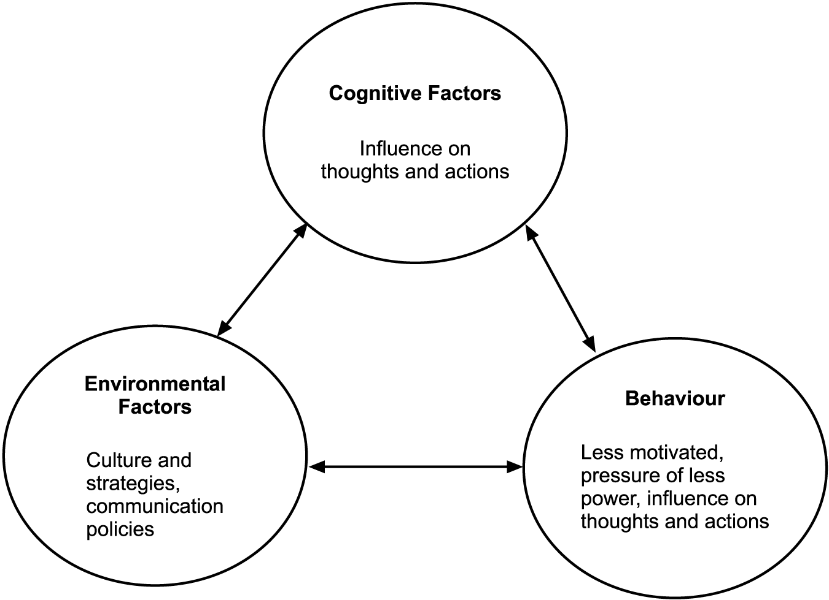
Fig 1 (Piagets, 1963)

In 1973 Matthews took that significant risk and become the CEO alongside Cowpland in their telecoms company Mitel. Their initial idea was to manufacture and sell cordless lawnmowers. However, after identifying a gap in the market they decided to produce telephone receivers. The change in product proved to be a huge success for Matthews as the wealth he accumulated through this enterprise allowed him to reach billionaire status. In 1985, British telecom bid to control Mitel. As with most economic entrepreneur’s, profit is the main goal for business enterprise. As Sir Terry’s first company was such a success he decided to create a data company in 2000 called Newbridge Network, named after his hometown. Matthews may have achieved success by taking opportunities that others had considered, but not risked. He was willing, and brave enough to take the opportunity that was made available to him. He set up Newbridge Network as it was the only company that understood European technical standards which gave Matthews company the edge on other similar businesses (Independent, 2000). After accumulating similar success from this company as with Mitel in 2001, he was knighted by the Queen to Sir Terry Matthews (Waddell, 2009). From such financial success, it is questionable as to whether his apparent continual motivation stems from the need to make money, or from an overwhelming passion he experiences from creating new businesses and grabbing every opportunity and challenge he is faced with.

It appears evident that through Sir Terry’s earlier career as an entrepreneur, money is the main driving force behind his investments. However, it appears that from being a billionaire it changed the way Sir Terry behaved in terms of achieving business success. He changed focus and started to invest in projects that would help the community in which he lived and not just increase his bank balance. In 1980 Matthews invested £100m into the Celtic Manor formerly known as Coldra House where he was born. The hotel now consists of over 300 rooms and hosted the 2010 Ryder Cup Golf tournament. This attracted millions, and heightened the profile of the hotel (Caradice, 2010). Matthews also became chairman of the Swansea Bay City region board. This allows him to help other businesses, of varying size, to develop and expand by offering his expertise of the business world. In support of Wales’ economic position, Matthews also spoke to the government on the impact of the delay of the Swansea and Cardiff rail network system. Sir Terry Matthews’ business attitude and aspirations have changed course. In his later career, he has become more of a social entrepreneur rather than that of an economic. In Wickham’s social development model (2006), he says that entrepreneurship is a “social phenomenon” and it occurs not because you are born with it but due to interactions with other people in social situations. Matthews could have had a change of mind-set about to entrepreneurship because of the changing environment he now lives in. His wealth has given him the opportunity to take even greater chances and make further changes. He may now in return want to give back to society, and help those who have helped him become the multi billionaire he has become (Ruddick, 2016).

3:4 Are entrepreneurs heroes?

‘The heroic myth begins with the hero's humble birth, his rapid rise to prominence and power, his conquest of the forces of evil….” (Vries, 2012).

According to the Oxford dictionary a hero is “a person who, in the opinion of others, has special achievements, abilities, or qualities and is regarded as a role model or ideal.” Many entrepreneurs including Sir Terry have achieved success during their lifetime. Some may view him as a hero when referring to the definition of one. His contribution to business was recognised when he was knighted by the Queen acknowledging his efforts in helping his community. However, at the start of this successful career he may not have been perceived as a hero. As Sir Terry created businesses solely to benefit himself, he could be seen as selfish. Arguably, this is not the characteristic of a hero and therefore he cannot be regarded as one. However even in this instance you cannot criticize him for his motivation, determination and work ethic. He strove for success and maybe ‘hero’ is well deserved when considering the time and effort, he put into their business ventures. Many entrepreneurs are economically driven however like Sir Terry opportunities may arise for them to become socially driven. Surely a social entrepreneur can be labelled a hero. Such individuals are there to improve opportunities for those in the communities they live. They are providing financial rewards not only for themselves but also for others who would not have access to such rewards if they were not there to intervene.

4 Conclusion

Sir Terry said, “never stand still, that’s my philosophy in life.” (Independent, 2000). He has most definitely adhered to his philosophy. From humble beginnings, he has created a multi -million business empire. It was by chance that he met his first business partner and from that time he has had the courage to take calculated risks and in doing so he has achieved significant wealth. Theories have revealed Sir Terry’s goals in achieving for himself and in his later career benefiting others also. His story has shown him to initially be perceived as an economic entrepreneur. He appears a risk taker, and the money he has accumulated has allowed him to return to his town of birth and become a social entrepreneur. He provided his community with business opportunities where local people too could prosper. Sir Terry Matthews was not born into an affluent lifestyle but maybe this only made him hungrier to make a success of his life. He is an opportunist who is willing to take chances. He has achieved international business success and has created numerous job opportunities for people both in Wales and abroad. He deservedly earns the recognition of being a hero.

5. Appendixes

(Piagets, 1963)

6. References

Caradice, P., 2010. The Celtic Manor. Blog, 14 December, p. 1.
Cochran, T., 1971. Theoretical Framework and Analysis, unknown: unknown .
Dictionary, O., 2018. dictionary.com. [Online]
Available at: http://www.dictionary.com/browse/hero
[Accessed 2 jan 2018].
Forbes, 2018. Sir Terenec Matthews. [Online]
Available at: https://www.forbes.com/profile/terence-terry-matthews/
[Accessed 2 January 2018].
Independent, 2000. The secret billionaire. Business Analysis and Features , 25 July, p. 1.
Johanasson, A., 2018. Is Successful Entrepreneurship Nature or Nurture? It's Both. But Not Really.. Entreprenu Mindset, 2 January, p. 1.
McClelland, D. C., 1961. The Achieving Society. 1 ed. London: Princeton, N.J .
McLeod, S., 2015. Nature vs. Nurture in Psychology. Simply Psychology.
Oakley, C., 1991. ukbusinessforum. [Online]
Available at: http://www.ukbusinessforums.co.uk/articles/what-is-an-entrepreneur-a-brilliant-definition.741/
Piagets, 1963. Cognitive Learning Theory. [Online]
Available at: https://explorable.com/cognitive-learning-theory
[Accessed 2 January 2018].
Post, F., 2018. is an entrepreneur born or raised?. [Online]
Available at: http://business.financialpost.com/entrepreneur/nature-versus-nurture-is-an-entrepreneur-born-or-raised
[Accessed 2 January 2018].
Robinson, J., 2014. The 7 Traits of Successful Entrepreneurs. Take it from the pros, 10 January, p. 1.
Ruddick, G., 2016. Sir Terry Matthews: south Wales's local boy done good. Wales, 20 April, p. 1.
Schwab, 2017. What is a social entreprenur?. Social entreprenur , 1 December, p. 1.
Sobel, R. S., 2005. Entreprenurship. The Concise Encyclopedia on Economics , 4 january .
Therapy, G., 2018. Nature vs. Nurture Debate. [Online]
Available at: https://www.goodtherapy.org/blog/psychpedia/nature-versus-nurture
[Accessed 2 january 2018].
Vries, K. D., 2012. Entrepreneurship. In: P. Macmillan, ed. Understanding Enterprise: Entrepreneurship and Small Business. london: s.n., p. Unknown.
Waddell, N., 2009. How did Sir Terry become a billionaire?. Cantech Letter , 29 December , p. 1 .
Wickham, P. A., 2006. The Entrepreneur as an individual . In: Pearson, ed. Strategic Entrepreneurship. 4 ed. Essex: Pearson Education , p. 15.

