PRINCIPLES OF HEALTH AND SOCIAL CARE PRACTICE
Module: LIVING WITH CARE THE ODLER PERSON
Module code: BMHP6009

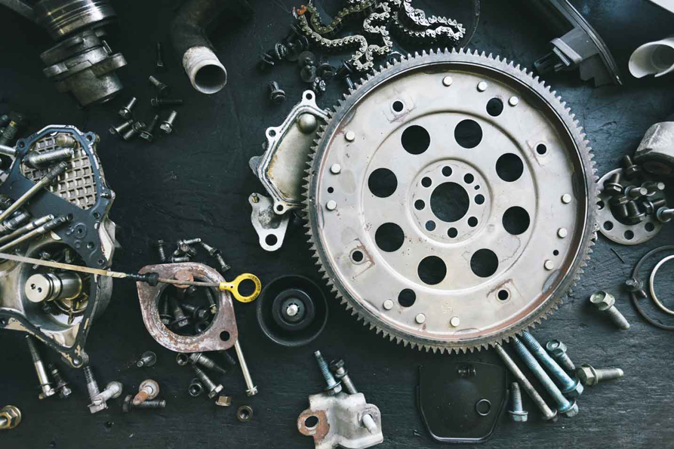
Name: Carlene Campbell
Student ID: 1908537
Date: 06/12/2021
Lecturer: Edward Goka

Table of Contents
Introduction 3
What is technology? 3
Standpoints: 3
Analysis 4
Evaluation 5
Recommendations 7
Conclusion 7
References 8
Appendix: 10

Introduction
This debate will answer the main question; is the use of technology necessary for the elderly UK population or an older person's life? The answer to the question from this side of the debate is ‘yes’. Based on the research conducted I will give evidence and discuss the technologies that are available on the market to help improve an older person’s life and the benefits that it provides for them. However, the opposing side insists that technology is not necessary for the older UK population and the disadvantages that it creates for older people. They argue that technology limits personal interaction, disconnects people and can cause health problems such as mental illness and loneliness (Goodman, 2021).

What is technology?
According to the Oxford English Dictionary, “it is the application of scientific knowledge for practical purposes, especially in industry”. Technology is also described as mechanism and apparatus developed from the request of technical information.
The Webster’s dictionary definition: “the use of science in industry, engineering, etc., to invent useful things or to solve problems”.

Standpoints:
- What was your standpoint in the debate? | - What were the other views on the debate?
Carlene Group | Osayamen Group
PC, Laptop & Tablets | Social Disconnect
Smart Phone | Gap Between Technology and the Elderly
Home Human Centre AI | Cost of Technology
Lifeline Personal Alarm Service | Technology Undermines Personal Centred -Care
GPS Tracker | Data Protection/Privacy Concerns
Home Security | Technology Could be Faulty and  Unreliable  Technology Could be Faulty and  Unreliable  Technology Could be Faulty and  Unreliable  Technology Could be Faulty and  Unreliable  Technology Could be Faulty and  Unreliable  Technology Could be Faulty and  Unreliable  Technology Could be Faulty and  Unreliable  Technology could be faulty and unreliable
Memory aids | Ongoing physical and mental health conditions
Communication aids – Hearing and Speaking
Visual Aids and Screen Readers
Case Study

Analysis
Laptops, PC, smart phones and tablets are some of the main devices used to carry out technological requests. Statistics shows that 65% of people aged sixty-five and older currently uses smartphones in the UK and as of 2016, approximately 26% more elderly people are using them. Most technology device can do things such as internet browsing, online banking, social media, games, online shopping, emails, and storing or sharing pictures and videos for special moments such as birthdays and other special events. Social media acts as a major benefit to the elderly as it allows them to stay connected to family members (AgingIn Place, 2021). These devices can also be used for relaxation such as watching movies, reading books or listening to music. The opposition argues that technology can be traumatic for the elderly as they can become victims of internet scam and have low self-esteem in using it (Age UK, 2015).
Most modern technology devices are fast, user friendly and easy to operate which makes it quite beneficial to the elderly and even the opposing side have made reference in agreement to this (Age UK, 2021). However, the opposition debates that there is a gap between technology and older people, they were not bought up having technology and that the use of technology can be intricate (Goodman, 2021). They also argue that it can be thought-provoking or impossible for the elderly to catch up unless they develop the habit of using it.
Technology has been using to support elderly people for a long time with Home Human Centre (AL), with things such as GPS tracker, Lifeline Personal Service alarms, Family Care and Care Predict. Some of these can be connected to smartphones namely Family Care and GPS, which provides a 24-hour safety for older people and will send alerts to the phone. There are also other aids and improvements that are available for the elderly such as visual aids, hearing aids, memory aids and communication aids. These answers the question of the opposition relating to ongoing physical and mental conditions such as vision and hearing loss, cognitive decline and physical impairment (Elefteria, V. Clausen, M.G. & Gow, A.J. 2017).
Compared to supervising done by human being, technologies are more cost effective (Rahal. S, 2020). For example, the cost of Home security ranges from £40 to £300 which is inexpensive if a comparison is made with paying salary for personal security. On the other hand, the opposition debates that technology is not cheap as maintenance cost can become a financial problem as well as time and patience needed to install and operate.

Evaluation
The UK government has set up the Longevity Council (LC), to assist in financial opportunities accessible by the elderly population. This council advises the government on how to encourage healthy living as well as studying how they can be in a position to pioneer the world in the increasing market for age-associated services and products. (Loughran, 2016). Gregg Clarke states that the longer people live, the government must ensure that they will be able to live independent, with decent quality of life and dignity by exploiting efficient technological invention and developments to assist.
Age UK has provided a technology learning program for older people by introducing digital buddies in communities who inspires the elderly to make good use of the internet and technology (Age UK, 2021). Open Age is a charity that supports people aged 50 and up in their local communities by providing an IT session which helps them to cultivate new and inspiring interest. They also offer hands-on guidance on how to use devices (Open Age, 2020).
Covid-19 has had an impact on people aged 60 years and older in that they were worried about future living and they were concerned about going on holidays and their health. During the pandemic, they were not able to have direct contact and interactions with family members but had to make contact via video calls using Skype, Zoom, WhatsApp and other social media platforms. As a result, it has helped to build their confidence in using technology and given some the experience of using technology. Many of them had to resort to shopping online so as to maintain isolation and social distancing. Older people were more stressed, worried, and concerned about everything returning to normal than younger people (ONS, 2020).

Recommendations
Advancements in technology presented notable opportunities to provide care and sustain connections despite the need to isolate. These discoveries can be incorporated into emergency communications, municipal health reactions and care plans in order to tackle loneliness among older people. On a broader spectrum, technology results and methodologies can make a change in tackling loneliness amongst the elderly (Conroy et al, 2020).

Conclusion
On this basis we conclude that technology may be considered a promising aspect of improving the wellbeing of the older population in the UK. Technology also performs a vital role in assisting the elderly to bond with people of the same interest and activity groups (NIHR, 2020). It is evident that with the correct guidance and training, older people will benefit from using technology for their own personal growth and self-confidence as well as their safety and security. With this said there are possibilities of risk factors and disadvantages (Hutchings. R, 2020).

References
Age UK, (2021) Crime Prevention [online] Available at: https://www.ageuk.org.uk/information-advice/care/housing-options/home-safety/crime-prevention/(Accessed:17 November 2021).
Age UK, (2015) Only the Tip of The Iceberg: Fraud against Older People’. Age UK. Available at: https://www.ageuk.org.uk/age-uk/documents/reports-and-publications/reports and briefing/safe-at-home/rb/(Accessed: 20 November 2021).
AgingIn Place, (2021) How to become Tech Savvy Seniors in 10 Days. Available at: https://aginginplace.org/how-to-become-tech-savvy-for-seniors-in-10-days/ (Accessed: 16 November 2021).
Conroy et al, (2020) Technology advancements to address elderly loneliness: Practical Considerations and Community resilience implications for Covid-19. Available at: https://www.emerald.com/(Accessed: 04 December 2021).
Elefteria.V., Clausen. M.G, & Gow A.J, 2017). ‘Older Adults Perceptions of technology and Barriers to interacting with Tablets Computers: Focus Group Study’. Frontiers in Psychology. 8, (1687) doi: 10.3389/fpsyg.2017.01687
E&T Magazine (2019) ‘UK Government endorses elderly tech to give people five more years of independent living’ | E&T Magazine. Available At: https://eandt.theiet.org/content/articles/(Accessed:04 December 2021).
Goodman, P. (2021) ’17 Disadvantages-of-digital-technology’. Turbo Future. [Blog]. Available at: https://www.turbofuture.com.Misc.Disadvantsges-of-digital-technology/(Accessed: 05 November 2021).
Hutchings, R. (2020) ‘The impact of Covid-19 on the use of digital technology in the NHS’. Available at: https://www.nuffieldtrust.org.uk/(Accessed: (04 December 2021).
Loughran. J, (2016) ‘CommunITy Support: helping older people use new technology’. Available at: http://dftdigital.blog.gov.uk/(Accessed: 05 December 2021).
NIHR, (2020) ‘Staying in touch’. Case Study 28. Available at: https://evidence.nihr.ac.uk/themedreview/help-at-home-use-of-assistive-tech/(Accessed: 20 November 2021).
ONS, (2020) ‘Coronavirus and the social impacts on older people in Great Brition’: Office Of national statistics. Available at: https://www.ons.gov.uk/peoplepopulationandcommunity/birthsdeathsandmarriages/ageing/articles/coronavirusandthesocialimpactsonolderpeopleingreatbritain/3ap/(Accessed: 04 December 2021).
Open Age (2020) ‘How to use Zoom’. Available at: https://www.openage.org.uk/(Accessed: 04 December 2021).
Oxford Dictionary, (2021) ‘Technology’ noun - Definition, pictures, pronunciation, and usage notes | Oxford Advanced Learner's Dictionary. Available at: https//:www. OxfordLearnersDictionaries.co/(Accessed: 20 Nov 2021).
Rahal, M. (2020) ‘Safety-in-dementia-door-alarms’. Available at: https://www.verywellhealth.com/safety-in-dementia-door-alarms-98172/ [Accessed on 16th Nov 2021).
Webster, M. (2021) Webster's dictionary. Essential Meaning of technology. Available at: www.webstersdictionaries.com/(Accessed/(20 November 2021).

1$!

υ
'#F44$"$!"GAge UK. 'H"%H@@///#)&#)&@'!!H6

υ
'#F5" %$"(!#HA)#5%%GAge UK. 'H
"%H@@///#)&#)&@#@#?)&@!)@%??%)!@%??<#@$??"@
I%II"I%I$I"I!#%$
'!!H6
υ
0$97):-D-/'C>) ‘5')!%$!"#.(!#/"
7%)HA!)-)%+)GFrontiers in Psychology8, (1687)doi:10.3389/fpsyg.2017.01687
υ
-F>,#?$?,#J !"#GTurbo Future. K#L'H
"%H@@)$))!@!@,#?$?,#? !"#'!!H6
υ
3 D3 F:!"H, !"#3%30%"?7
7MGThe Health Foundation Available at:
"%H@@///""#)&@/??!@!"??$#%"!@%??!"??!"#?"%??"
?%"
'!!H6
υ
:C >F3/3%+/" "7%)()$A'/GHu PostK#L,!
'H"%H@@///")N%!@@"/??"%??/"II'!!H>6
υ
+%"#%",%%"'H
"%H@@%%"!@E>E@!&?%"?$)????)#"'!!H6
υ
F3)###%%)H'#GHouse of Commons Library. 'H
"%H@@!%)&@!"?<#@!%?@'!!H6
υ
9%=0-7):-/'C>O5')!%$ !"#.
(!#/" !%)HA!)-)%+)PFrontiers in PsychologyEE>,5(H
E@$%#>E>"%H@@///!"#@%!@!@:7@

1$!

υ
'#F44$"$!"GAge UK. 'H"%H@@///#)&#)&@'!!H6

υ
'#F5" %$"(!#HA)#5%%GAge UK. 'H
"%H@@///#)&#)&@#@#?)&@!)@%??%)!@%??<#@$??"@
I%II"I%I$I"I!#%$
'!!H6
υ
0$97):-D-/'C>) ‘5')!%$!"#.(!#/"
7%)HA!)-)%+)GFrontiers in Psychology8, (1687)doi:10.3389/fpsyg.2017.01687
υ
-F>,#?$?,#J !"#GTurbo Future. K#L'H
"%H@@)$))!@!@,#?$?,#? !"#'!!H6
1$!

υ
'#F44$"$!"GAge UK. 'H"%H@@///#)&#)&@'!!H6

υ
'#F5" %$"(!#HA)#5%%GAge UK. 'H
"%H@@///#)&#)&@#@#?)&@!)@%??%)!@%??<#@$??"@
I%II"I%I$I"I!#%$
'!!H6
υ
0$97):-D-/'C>) ‘5')!%$!"#.(!#/"
7%)HA!)-)%+)GFrontiers in Psychology8, (1687)doi:10.3389/fpsyg.2017.01687
υ
-F>,#?$?,#J !"#GTurbo Future. K#L'H
"%H@@)$))!@!@,#?$?,#? !"#'!!H6
'#F44$"$!"GAge UK. 'H"%H@@///#)&#)&@'!!H6

υ
'#F5" %$"(!#HA)#5%%GAge UK. 'H
"%H@@///#)&#)&@#@#?)&@!)@%??%)!@%??<#@$??"@
I%II"I%I$I"I!#%$
'!!H6
υ
0$97):-D-/'C>) ‘5')!%$!"#.(!#/"
7%)HA!)-)%+)GFrontiers in Psychology8, (1687)doi:10.3389/fpsyg.2017.01687
υ
-F>,#?$?,#J !"#GTurbo Future. K#L'H
"%H@@)$))!@!@,#?$?,#? !"#'!!H6
'#F44$"$!"GAge UK. 'H"%H@@///#)&#)&@'!!H6

υ
'#F5" %$"(!#HA)#5%%GAge UK. 'H
"%H@@///#)&#)&@#@#?)&@!)@%??%)!@%??<#@$??"@
I%II"I%I$I"I!#%$
'!!H6
υ
0$97):-D-/'C>) ‘5')!%$!"#.(!#/"
7%)HA!)-)%+)GFrontiers in Psychology8, (1687)doi:10.3389/fpsyg.2017.01687
υ
-F>,#?$?,#J !"#GTurbo Future. K#L'H
"%H@@)$))!@!@,#?$?,#? !"#'!!H6
1$!

υ
'#F44$"$!"GAge UK. 'H"%H@@///#)&#)&@'!!H6

υ
'#F5" %$"(!#HA)#5%%GAge UK. 'H
"%H@@///#)&#)&@#@#?)&@!)@%??%)!@%??<#@$??"@
I%II"I%I$I"I!#%$
'!!H6
υ
0$97):-D-/'C>) ‘5')!%$!"#.(!#/"
7%)HA!)-)%+)GFrontiers in Psychology8, (1687)doi:10.3389/fpsyg.2017.01687
υ
-F>,#?$?,#J !"#GTurbo Future. K#L'H
"%H@@)$))!@!@,#?$?,#? !"#'!!H6

Appendix:




