Helpdesk Ticketing Support System
Based on Natural Language Processing
for a Government Organisation

by Abigail Lucy Davies

Supervisor: Seena Joseph

Project submitted as part of the requirements for
the award of BSc (Hons) Computing (Software Engineering)

July 2025

Declaration Form and Form of Consent

Declaration
I, Abigail Lucy Davies, declare that I am the sole author of this Project; that all references cited have been consulted; that I have conducted all work of which this is a record, and that the finished work lies within the prescribed word limits.
This work has not previously been accepted as part of any other degree submission.

Form of Consent
I, Abigail Lucy Davies, hereby consent that my Project, submitted in candidature for the B.Sc. (Hons) Computing (Software Engineering) degree, if successful, may be made available for inter-library loan or photocopying (subject to the law of copyright), and that the title and abstract may be made available to outside organisations.

Abstract

This study examines how machine learning algorithms can be exploited to assist in the decision-making process of assigning helpdesk tickets to the relevant departments. Currently this is a manual process, limiting the time employees can spend performing other important tasks. Additionally, as it is a manual process, meaning that human error can occur, increasing the overall resolution time of issues. This project aims to develop a helpdesk ticketing support system that uses natural language processing (NLP) to predict the department of a ticket. This has been achieved through critically examining existing literature to determine that support vector machines (SVM) were the most appropriate model. The SVM was designed and developed, using various NLP techniques to clean and prepare the data. The model was then evaluated, returning high performance levels, allowing it to be integrated into an API for human interaction. Despite the success of the SVM, other avenues such as evaluating the performance of the model when tested with an actual dataset, compared with a manufactured dataset, as well as introducing more data fields to the dataset, have been recommended.

Table of Contents
Declaration Form and Form of Consent 2
Abstract 3
Table of Contents 4
Chapter 1 – Introduction 6
1.1. Context of the Study 6
1.2. Natural Language Processing 6
1.3. Aim and Objectives 6
1.4. Document Details 7
Chapter 2 – Review of Literature 8
2.1. NLP Procedure 8
2.1.1. NLP Techniques 8
2.2. ML Algorithms for Text Classification 10
2.2.1. Support Vector Machines 12
2.3. Evaluation 14
2.4. Application Integration 14
2.5. Summary 15
Chapter 3 – Development Methodology 16
3.1. Method 16
3.1.1. SVM 16
3.1.2. API 17
3.2. Materials 17
3.2.1. Data 17
3.2.2. Evaluation 17
3.3. Workflow 19
3.4. Summary 20
Chapter 4 – Design and Implementation 21
4.1. Diagram of Design / Implementation 21
4.1.1. Stage 1: Data Preparation 21
4.1.2. Stage 2: Initialise and compile model 22
4.1.3. Stage 3: Train the model 22
4.1.4. Stage 4: Evaluate the model 23
4.1.5. Stage 5: Fine-tune model 23
4.1.6. Stage 6: Predict and deploy 23
4.2. Difficulties and their Solutions 23
4.3. Summary 24
Chapter 5 – Evaluation 25
5.1. SVM Experiments 25
5.1.1. Comparing the Results of Manual Division of dataset with use of train_test_split function 25
5.1.2. Understanding the impact on changing each kernel function 26
5.1.3. Understanding the Impact of Importing Stemming, Lemmatisation and Tokenisation to Assist in Cleaning Data 26
5.1.5. Understanding the impact on introducing C parameter 26
5.1.6. Investigation into High-Performance Levels 27
5.2. SVM Results 28
5.2.1. Classification Report Results 28
5.2.2. Confusion Matrix 28
5.2.3. PR Curve Graph 29
5.2.4. ROC and AUC-ROC Curve Graphs 30
5.3. Comparison with Literature 31
5.4. API Experiments 31
5.4.1. Testing CSS Render 31
5.4.2. Testing Response in Command Prompt 32
5.4.3. Testing Response in Application 33
5.4.4. Testing Validation – No Title 34
5.5. API Results 34
5.6. Summary 36
Chapter 6 – Conclusion and Recommendations 37
6.1. Conclusion 37
6.2. Recommendations 37
Chapter 7 – Reflection 39
Chapter 8 – References 41
Chapter 9 – Bibliography 47

Chapter 1 – Introduction

This project analyses, documents and develops a model that utilises natural language processing (NLP) for ticket classification in a helpdesk support system. Many large public organisations employ applications to record and document incident investigation and their solutions as it provides a central access for all employees. It has been said that these types of systems allow the process for both the customer and employees, to be well-organised, and allow the workload to be prioritised accordingly [1]. However, this is a manual process exploiting a lot of employee’s time, that could be used more effectively on other tasks.

1.1. Context of the Study
The study was conducted following the recognition, in the workplace, that the resolution time of incidents raised on a helpdesk ticketing system can be delayed when tickets are mistakenly assigned to the wrong departments. This happens from human error as it would be difficult for all employees within the department that distributes the tickets, to have in-depth knowledge of all incident types. Additionally, it can be extremely time-consuming due to the volume of possible tickets raised, leaving employees less time conducting other important tasks. This project proposes to overcome these difficulties by identifying and developing a model, that exploits machine learning (ML) techniques and a supervised learning algorithm. Reports where this issue has been previously analysed have been reviewed to assist in the decision making of the design of this study.

1.2. Natural Language Processing
Natural Language Processing (NLP) is a method of artificial intelligence (AI) that is intended to mimic human language [2]. This project will utilise both elements of this discipline, Natural Language Understanding (NLU) and Natural Language Generation (NLG). The focus is NLU as it is implemented to understand the data. However, an NLG application, readily available over the internet has been exploited to create different variations of the test and training data.
NLP continues to grow rapidly due to its ability to understand and generate various versions of dialect and general everyday conversations [3]. It is being analysed by various developers to investigate areas of concern where bias results are returned [2]. Nonetheless, engineers are taking these opportunities to develop applications utilising NLP that are becoming crucial in today’s society [2]. Moreover, AWS [3] states that companies are now utilising it for numerous tasks to automate day-to-day human tasks. As anticipated, AWS [3] confirm that this lowers costs by decreasing the time employees spent on redundant jobs and improves the overall customer experience.

1.3. Aim and Objectives
The aim of this project is to develop a helpdesk ticketing support system based on natural language processing for a public organisation. There are five main objectives to ensure that the requirements are met:
- To critically analyse the current literature to understand the use of natural language processing in customer service and helpdesk systems.
- To design and develop a model based on natural language processing for a helpdesk system to automate the redirection of tickets to the relevant departments.
- To evaluate and compare the performance of the developed model using well-known evaluation metrices such as F1 score, accuracy, precision and recall.
- To develop a web application that integrates the evaluated model for human interaction.

1.4. Document Details
The upcoming chapters will detail the following:
Chapter 2 – Review of Literature
Chapter 3 – Development Methodology
Chapter 4 – Design and Implementation
Chapter 5 – Evaluation
Chapter 6 – Conclusion and Recommendations
Chapter 7 – Reflection

Chapter 2 – Review of Literature

This section discovers researchers in the field that have experimented whether NLP techniques can be used affectively in environments such as a helpdesk ticketing support system or similar. In addition, it recognises the difference in results and limitations brought to their attention following the evaluation, based on the techniques and dataset used.

2.1. NLP Procedure
The NLP process involves a number of techniques used to convert the human language into meaningful language for computers to understanding and process by finding connections between the fundamental portions of a piece of text [2]. There are three main phases that a variety of techniques can fall into; data pre-processing, feature extraction and modelling [2].
Data pre-processing is the process of structuring text into a form that a computer can understand [2]. Some examples of techniques that can be used to achieve this are stemming, lemmatisation, stop word removal and tokenisation [2]. These can be implemented in conjunction with each other or individually. To provide a brief explanation of each:
- Stemming is a technique used to reduce words to their root, e.g. researching, researcher and researched would all be reduced to research [4].
- Lemmatisation makes collections of different variations of one word [5], through interpreting the context of each word [6].
- Stop word removal focuses on eliminating common words that do not provide much context [2], e.g. and, a, etc.
- Tokenisation separates the words in a sentence or piece of text by labelling each word a token [7].
The next stage of this process is called feature extraction. Examples of NLP techniques that can be exploited in this phase are bag-of-words or TF-IDF [2]. Bag-of-words measures the number of times a word appears within a piece of text to gather an understanding of the importance, without context [8]. TF-IDF stands for term frequency-inverse document frequency, and it calculates how important a word (term) is within a piece of text [9].
The final stage to be discussed is modelling, which is where the data that has been pre-processed, by the steps previously discussed, is passed into an NLP algorithm for interpretation [2].

2.1.1. NLP Techniques
M. Truss and S. Bohm [10] investigated whether non-traditional techniques such as built-in tools like Google VertexAI can be used in a customer support ticketing system to improve the quality of classification. They state that non-traditional methods do not require as much knowledge and skill, meaning that organisations could invest in this type of software if further research was developed to support the findings. The researchers used a number of dataset volumes for their work, ranging between 996 and 4,265 tickets, where they were tested against different models. The datasets were a combination of balanced and unbalanced data, although upon reflection is it clear to see that balanced datasets performed better. Pre-processing techniques such as converting all data to lowercase and removal of all content that was considered irrelevant, e.g. emails, name, special characters. In addition, the title and description fields were combined into one string and exported into a CSV file. The researchers documented the evaluation metrics recorded for each ML method to understand and compare the results. Thus, identifying that the quality of data, including the preparation methods used, is far more important that the size of the dataset.
Almarzooqi [11] published a paper where traditional NLP algorithms were analysed. The dataset consisted of 48,000 tickets, which were obtained, from an organisation called Kaggle, featuring fields such as “descriptions, categories, priorities, timestamps, and resolution times” [11]. Almarzooqi [11] prepared the data by ensuring the any fields with missing data were updated with a non-bias placeholder to prevent any invalid text errors. The researcher also used a number of data cleaning techniques such as transforming all text to lowercase, removing special characters. The pre-processing of data also involved a feature called term frequency-inverse document frequency (TF-IDF) [11], [9]. Almarzooqi [11] also implemented an additional step that recorded the cleansed data so that there was a backup of the original data. Upon completion of the project, the researcher [11] concluded that the quality, volume and number of variations within the dataset had a significant impact on the results.
As part of the research to investigate a model derived from stacked generalisation to increase the success rate of ticket classification in help desk systems, Moreno, Yushimito and Hughes [12], initially analysed 3,736 tickets which contained 12 fields. During the data cleaning stage, it was recognised that a number of tickets did not contain any text which concerned the researchers in case it impacted results. They decided the most appropriate decision would be to remove any variables and tickets which did not contain text. Additionally, analytical methods identifying the importance of a variable or field were also considered. Together, these cleansing methods resulted in the field count reduction from 12 to 4, as well as tickets from 3,736 to 1,051.
Gorbunova, Trunov and Voronov [13] are scientists who analysed a chatbot system that processes ticket data. The system is intended to understand the request, extract the relevant information and deal with the issue present. Due to the nature of this type of application, the dataset was relatively small as the main focus appears to be on the volume of data provided in the input message, rather than quantity of tests actioned. Despite these differences to other research projects, data pre-processing is still required. This project applies methods such as continuous bag of words (CBOW) and Skip-Gram Model [13]. Both are word embedding techniques used on unsupervised learning algorithms like Word2vec [14]. CBOW foresees the meaning of a word by analysing the words surrounding it [14].
Revina, Buza and Meister [15] published their second paper investigating ticket classification with the intention to develop and improve the limitation identified in their primary paper. The project was split into two datasets; dataset one contained 28,243 tickets and dataset two contained 4,684 tickets. Both were cleaned by removing punctuation, converting text to lowercase and stemming. The data was then exported into a CSV file. The text in the tickets differed from 5 to 150 words.
Pereira et al [16] used a dataset from an IT company, holding 2,229 tickets that had been previously categorised and updated to remove all sensitive data. The tickets were divided into 7 categories, although the dataset was imbalanced. The data in the tickets were free typed by the user raising the issue, suggesting that validation methods were not in place to control what the user entered.
U. Sanderink [17] documented a project that analysed a dataset containing complaints from customers. The dataset was in JSON format and the data was cleaned by converting text to lowercase, removing punctuation, lemmatization and POS filtering. Similarly to stemming, previously mentioned, it reduces text to a basic form [4].

2.2. ML Algorithms for Text Classification
There are several NLP techniques and methods that can be exploited to obtain different levels of success for text classification. Obina [18] focused on two methods; NB and SVM. A comparison of the two found that the SVM model performance was scored at an overall 87%, whereas NB resulted in 83% overall. The dataset that achieved these results was labelled and contained around 25,000 records. Although SVM resulted in a slightly higher accuracy score, it is important to note that significant training time was required when working with such a large dataset, in comparison to NB.
Al-Hawari and Barham [19] further support these statistics when they documented the experiment that they completed to compare a variety of ML algorithms. These developers created four models built upon on SVM, DT, NB and Rule-based. Figure 1 has been extracted from the case study, displaying the results of the experiment against each model.

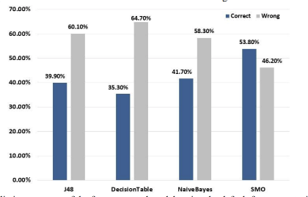
Figure 1 [19]
In contrast to the previous experiments noted, Moreno, Yushimito and Hughes [12] decided to analyse an ensembled model in a two-step process to avoid issues if unpredictability increased in any of the individual models. An ensemble model combines at least two ML methods to achieve greater success in the predictions [20]. LR, NB and Classification Tree where the chosen base algorithms [12]. Each algorithm made a prediction, and their results were combined to achieve a result. As a comparison, Moreno, Yushimito and Hughes [12] also studied individual ML techniques which allowed them to recognise that the ensemble models improved the results for accuracy and F1 score.
U. Sanderink [17] documented a small project called Automatic Ticket Classification NLP where a four supervised learning methods were implemented to compare the prediction of the delivery of which department a complaint needed to be sent to. Sanderink [17] states that the four supervised learning methods analysed were LR, random forest (RF), decision tree (DT) and NB, although LR scored the highest in accuracy with 95%.
I. McConnell [21] took a different angle to the classification of support tickets. The goal of the project was to use JIRA tickets to divide into two classes; easy and hard. This was investigated as the overall aim was to reduce the volume of admin work prior to sprints for those working in an agile framework. Unfortunately, this project appears to be a first stage attempt and therefore, unfortunately many tickets were incorrectly labelled as hard instead of easy and vice versa. McConnell [21] also states that the next steps would be to improve the model by adding more features and using a balanced dataset to investigate whether this would impact the results.
In January 2025, Mohamed Almarzooqi [11] analysed three ML techniques, investigating approaches to automate the prioritising and routing of support tickets. The classifiers that Almarzooqi [11] examined were SVM, RF and Gradient Boosting which predicated the urgency and category of each ticket. The results propose that predicating the urgency was marginally more successful that predicting the category. When calculating the success rate of both predictions, on average, the gradient boosting model resulted in 93% success rate, followed by RF at 92.1% and SVM at 90.5%. Despite the great success rates achieved from the experiments conducted, Almarzooqi [11] suggests that it would be a good idea to research into leveraging more advanced NLP techniques such as Bidirectional Encoder Representations from Transformers (BERT) [22]. Furthermore, a number of studies, including one written by Eduardo C. Garrido-Merchan, Roberto Gozalo-Brizuela and Santiago Gonzalez-Carvajal in 2023 [23] and another written by Filip Koukal et al in 2024 [24], support this statement by completing several experiments, comparing BERT against traditional methods for text classification. In both case studies, BERT outperformed the traditional methods. However, despite these positives, there are some limitations that come with this model including that it requires significant computer resources to train and deploy due to the size and complexity of the model [25]. As a consequence of this, it can be recognised as unfeasible for some projects [25].
As previously mentioned, it is clear that individuals in the field have similar viewpoints that transformer techniques like BERT have great potential in this environment. Contributing to this theory, Bonechi et al [26] created two models to compare the transformer's performance against a classical ML method. The two classification approaches were BERT and SVM which were chosen due to their recognisable effectiveness demonstrated when operating complex patterns in NLP. However, there was an expectation that BERT would surpass SVM. With that in mind, the SVM accuracy score in Bonechi et al’s [26] experiment was only 3.46% lower than BERT [21]. Moreover, Wahba, Madhavji and Steinbacher [27] also came to comparable results, where they saw similar performance between SVM’s and a Pre-trained Language Models (PLM) like BERT. This resulted in the researchers questioning whether SVM is a more realistic option due to the complexity of BERT [26].
To summarise these findings, figure 2 is a representation of the statistics produced by utilising readily available online tools like Chat GBT [28]. The online AI tool was asked to complete a search of research papers that are available online, identifying how often each traditional method was used for classification type tasks.
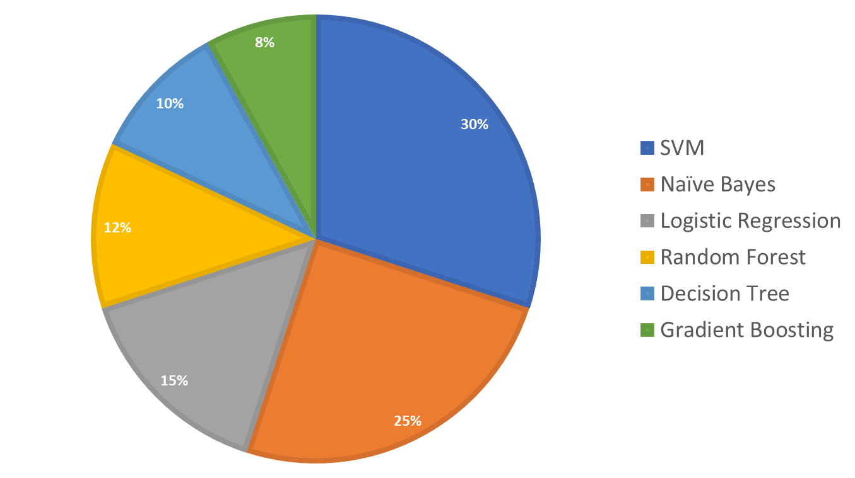
Figure 2

2.2.1. Support Vector Machines
Based on the research discovered in section 2.2, SVM stands out as the most appropriate model to take forward for this study. Boswell [29] states that Vladimir Vapnik established SVMs, first referenced in 1979, whilst the main discovery was in 1995. Moreover in 2002, when Boswell [29] composed this study, SVM’s were recognised as a “relatively new learning method”.
The aim of an SVM is to differentiate between classes, through identifying the best hyperplane [30]. This maximises the margin between the nearest data points of the different classes, enabling the algorithm to recognise the optimal decision boundary [30]. Figure 3 is a visual representation of this for a clearer understanding.
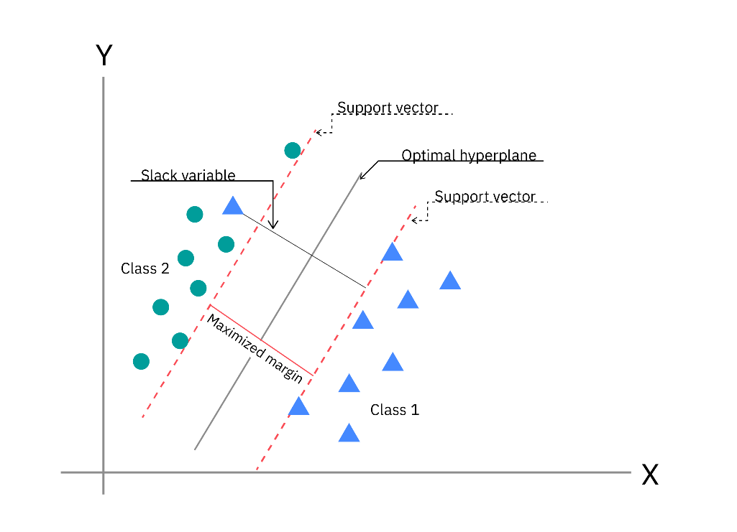

Figure 3 [30]

There are two types of classifiers that SVM implement; linear and nonlinear. Linear SVMs are generally used when the data can be directly separated, whilst nonlinear SVMs are used when there is not a clear separation [31]. The kernel parameter when implementing a linear SVM, should be set to linear [30]. Alternatively, there are various kernel functions for non-linear SVMs including, polynomial, radial basis function (RBF) and sigmoid [30]. The formulas for these functions are shown in figure 4.

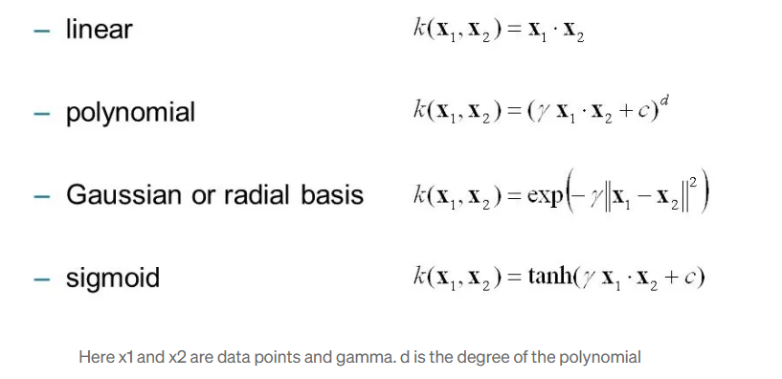
Figure 4 [32]

2.3. Evaluation
All sections of literature reviewed, describe the techniques used to measure the success of their project. This is a vital element of a project as it allows for areas of improvement to be identified. One way that has been highlighted in many case studies is a confusion matrix [10], [11], [16], [24]. A confusion matrix is table that evaluates four categories based on the predicted and actual results; true positive, true negative, false positive and false negative [33].
Other methods that various case studies have utilised is measuring metrics such as accuracy, precision, recall and F1 score [10], [11], [12]. All four metrics are calculated using the results of the confusion matrix [34]. Some evaluation stages use a combination of two or more and some have focused primarily on one. Where case studies have focused on one metric calculation, accuracy has appeared more often. It aims to calculate the frequency of correct results [33]. In regard to the other metric calculations that are available, precision assesses the quality of the results, whereas recall calculations provide a percentage of how many positives are true [33]. F1-score aims to give an understand of the overall performance and therefore, it is a combination of recall and precision calculations [33].
Cross validation is another style of evaluating the performance of the model created [16]. This method involves dividing the dataset into a training group and testing group [35]. The data is then further subdivided into subsets (folds) [35]. Pereira et al [16] decided utilised this technique, along with others, extracting 30% for test data and 10% of the training data for validation. The goal of cross validation is to understand how the model performs with new data [35].

2.4. Application Integration
Many developers have created these systems without integrating into an application where a visual representation is available. However, Pereira et al [16] agree that incorporating an application to display the findings is a useful way of creating a better understanding of the performance of the program. They developed an application programming interface (API) that worked with a Postgres database so that it could execute basic functions. The program was written in Python, and the API was created using the FastAPI framework.
Zemp [36] is another researcher that took on the task of reviewing different types of AI methods that could be used in different aspects of a ticketing system. Zemp [36] tested the functionality of the developed model before integrating into an existing ticketing system for a service desk team to evaluate and provide feedback. Unfortunately, the research paper does not explicitly state what the existing ticketing system is built using, although overall the feedback of the feature was positive and was shown to be more frequently used in individuals who are learning the role, as well as more senior employees recognising that it was predicting similar decisions.
As previously highlighted, there appeared to be limited findings on developers who had completed the investigation of utilising an AI method to automate classification, as well as the implementation of it in user friendly systems for there to be visibility of the system working. That being said, some developers included this in their recommendations for further research [11]. One developer stated that integrating such automated systems to an existing ticking system would be best achieved via APIs [11]. Although, others [37] suggested that other avenues such as chatbots and dashboards need further investigation, specifically when focusing on how AI tools can be utilised efficiently in ticketing systems.
To further enhance research into utilising APIs, Chi [38] documented a paper that was published in June 2024 that highlighted the benefits of integrating APIs with AI. To list a select few that stood out for this project, Chi [38] states that the integration process is easy, and API can handle data loads of different variations well, in hand creating a seamless integration.
Conversely, there has also been some discussions of the disadvantages of APIs in businesses. One blog written by a team at OPENVPN [39], states that the main concern is security related [30]. They state that they can be vulnerable and at risk due to them being internet based. This is a particular concern for a Government organisation due to the sensitivity of the data that would be transmitted via this network. That being said, there are many precaution techniques already in place that would need to be analysed and adapted to ensure full security measures are in place [39].

2.5. Summary
A number of datasets volumes, data cleaning techniques, data preparation and NLP methods, evaluation procedures and ways of integrating with new and existing user interfaces have been analysed. When excluding the few large datasets, the average volume of tickets in a data set is approximately 2,000 tickets. The pre-processing stage is vital, with each case study implying it has a substantial impact on the performance of the model. Additionally, a balanced dataset also appears to provide greater results. SVM is the most popular model exploited in such classification tasks, generally resulting in greater performance compared to other models. As for integration, some researchers have reported their findings, yet most have provided recommendations for future development. Harun, Huspi and Iahad [40] suggested that producing a dashboard to display the classification statistics would be beneficial, whilst McConnell [21] estimated the difficultly of the tickets and advised that introducing the length of time could be an avenue for investigation. Overall, the research demonstrates that the developers have shared views that there are many organisations and businesses that have manual procedures in place to perform these tasks, when there are various tools available to minimise the manual effort.

Chapter 3 – Development Methodology

3.1. Method
Following investigation into a number of case studies, the chosen methodology to predict the classification label of each ticket was SVM. The in-depth research has highlighted that SVMs are the most popular ML algorithm for supervised classification tasks due to their great performance levels, especially when evaluating and comparing with traditional methods only. There are also many advantages documented online including SVMs are very efficient in handling high-dimensional data and are more resistant to overfitting; both vital for classification tasks like this project [41]. Non-traditional methods demonstrated marginally higher levels; however, the disadvantages outweigh the positives for this study.
There are also some disadvantages to SVMs. One being that it cannot handle data that has missing values [41]. However, this has been avoided as the dataset has been synthesised. Going forward, validation has been implemented, ensuring this is not a problem with new data parsed into the model via the API.

3.1.1. SVM
To develop the SVM, a variety of Python libraries were imported, including pandas, re, and a number of modules from sklearn and nltk. Once the libraries were implemented, the dataset was parsed in and divided into a testing and training set. This was achieved via the train_test_split function, where an 80 (training) / 20 (testing) split was applied. Additionally, the stratify parameter was set to ‘Assignment Group’ to ensure that both new datasets had the same proportion of ‘Assignment Group’ labels as the original dataset [42].
The next stage was to action the pre-processing of data utilising the NLP techniques identified in the literature review. A detailed description of the implementation, including how the data collection was conducted, is included in the material section.
Following these steps, the features for the training and testing set were selected. As the title and description had been combined as part of the pre-processing stage, this left two options. The ‘Combined_Text’ was set to the feature (x axis) and the ‘Assignment Group’ was set to the target (y axis). A developer from Milvus Zilliz [43] confirms that, a feature can also be recognised as the input data, which is used to predict the outcome, whereas the target is the outcome that the model is expected to predict.
Once data formatting was actioned, the model was trained using the training dataset as the input and parameters tuned in an experimental environment, discovering the best combination for achieving greater performance. The tests were assessed by many evaluation metrics that will be reviewed in section 3.2.2.
Finally, once the SVM met the required performance levels, it was exported as a pkl file, also known as a python pickle file [44], for future use in API.

3.1.2. API
There are a few steps involved with the API development process. The first stage is to download FastAPI via the command prompt [45]. Once this is installed, a HTML file was developed containing a HTML form requesting the title and description of a new ticket. A python file was also developed which called the FastAPI framework, making a connection to the SVM pkl file. Once the connection was successfully tested, a CSS file was developed to correct the format of the web page.

3.2. Materials
There are a number of materials that have been exploited for the purpose of achieving the aim and objectives of this study. This section covers the data, evaluation and software used.

3.2.1. Data
The volume of the dataset varies from study to study, depending on the size of the project at hand. Some researchers have used existing datasets available online such as via Kaggle [46]. In this case, due to the sensitivity of the data from the workplace and due to the need to focus on the similarity of tickets in the workplace, the dataset was generated using online tools such as Chat GPT [28], Claude [47], Google Gemini [48] and Microsoft Copilot [49]. Furthermore, 2000 tickets were generated; 5 labels or assignment groups and 8 types of tickets for each label. This was agreed during the planning stages with the supervisor of the project, where Joseph [50] confirmed that these figures would be adequate for the training and testing of the project, providing results that could be evaluated and compared to understand the performance of the model.
The next stage to be discussed is the pre-processing stages for data preparation, which is vital to improving the quality of the data and enhancing the model’s performance [51]. To quote Novogroder [51], “Your data project will only be as successful as the input data you feed into your ML algorithm”. The emphasises they key role that the quality of the data plays in when evaluating the performance of the model. As discussed, when referring to many case studies in the literature review, most researchers invoke a number of pre-processing steps to achieve the better-quality data.
The dataset was initially stored in a CSV file, once collected from various AI tools online. A CSV file has been used in various research studies formerly discussed, due to the simplicity of the format. Additionally, Geeksforgeeks [52] recognises it as one of the most common formats used in python due to is accessibility.

3.2.2. Evaluation
The evaluation metrics used for assessing the model’s performance were accuracy, precision, recall and F1-score. Each provide an insight into the different areas that result in the understanding of the overall performance of the SVM.
Accuracy is the main evaluation metric used to calculate the performance [53]. It is often seen using the formula shown in figure 5.
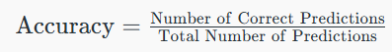

Figure 5 [53]

Precision and recall both base their calculations of true positive (TP) results, false positive (FP) results, and false negative (FN) results. In terms of this study and whilst focusing on one assignment group, TP is the number of tickets correctly matched to the ‘Service Desk’, where ‘Service Desk’ is their actual ‘Assignment Group. Conversely, True negative (TN) is the number of tickets correctly assigned to other ‘Assignment Group’, where the actual ticket is not for ‘Service Desk’. Conversely, FP is the number of tickets assigned to ‘Service Desk’ incorrectly, as their ‘Assignment Group’ should be one of the others. Finally, FN is the number of tickets the model has assigned to different a ‘Assignment Group’ but should have been assigned to ‘Service Desk’. The formulas for each are shown in figures 6 and 7.
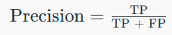

Figure 6 [53]
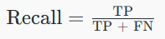

Figure 7 [53]

The final formula (figure 8) examined was the F1-score which uses a calculation that contains the results from the precision and recall. High F1-scores imply that the model is performing well [53].
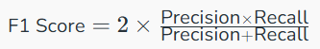

Figure 8 [53]

In addition to the evaluation calculations, a confusion matrix has been produced for a visual representation of the success of the model. A confusion matrix uses a table to plot the TP, TN, FP, FN results [54].
Finally, many graphs have been generated for further graphical representation. These are called the Precision-Recall (PR) curve, Receiver Operating Characteristic (ROC) curve and Area Under Curve – Receiver Operating Characteristic (AUC-ROC) curve. Steen [55] states that generally PR curves are useful for understanding imbalanced datasets. Although, the dataset is balanced for this study, Mirshekari [56] confirms that is valuable. Furthermore, a ROC curve illustrates the model’s ability to differentiate between classes [56]. Mirshekari [56] documents the importance of utilising both graphs due to the complimentary nature each has to each other. Collectively these graphs provide a complete view of the overall performance.

3.2.3. Software
The software and tools required for this project were evaluated based on personal experience and from further research. Whilst the case studies referenced in the literature review did not explicitly state which software was used in the research, they did specify that Python was used as the coding language. Python is often recognised as one of the most powerful tools in data science due to its ease of use, flexibility and the wide range of libraries available [57]. This leads onto the software required to run and compile the code. Jupyter Notebooks was used as it is commonly used when using a combination of code, text and data visualisations to have clear formatted results [58]. Previous learning environments have also touched on the usefulness of this software and language, including the libraries that are available to be imported to assist in expanding the functionality of the end product [59].
Lastly, once the SVM model was developed, the API was established using notepad++ and FastAPI. The API was run locally as it was only used as a visual representation to test how the model performs with new data. Notepad++ was chosen as the text editor as it is simple to use and has many features such as highlighting syntax for ease of use.

3.3. Workflow
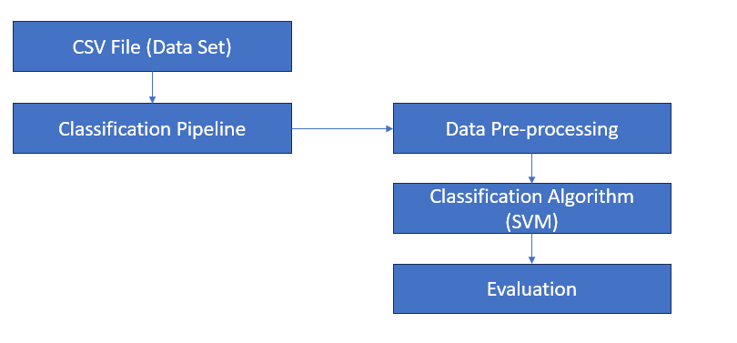
Figure 9 is a diagram of the initial design, containing the development and testing of the SVM only. To briefly explain the process, the tickets stored in the dataset CSV file, synthesised from various online AI tools, is read into the model to go through the pre-processing stages. A number of NLP techniques are then actioned to achieve the required quality of data. Once both the training and testing data were cleaned, they are parsed into the classification algorithm so that the model can learn and predict. The results are returned, in the form of a classification report, a confusion matrix and numerous curve graphs.
Figure 9
Figure 10 is a diagram of the end product. This diagram is a slightly amended version as it is once the API development has been integrated. The final development will allow users to enter details for a ticket that has been raised through the user interface and parsed into the classification pipeline via the API. The model then predicts the ‘Assignment Group’ and it is returned to the user via the API.
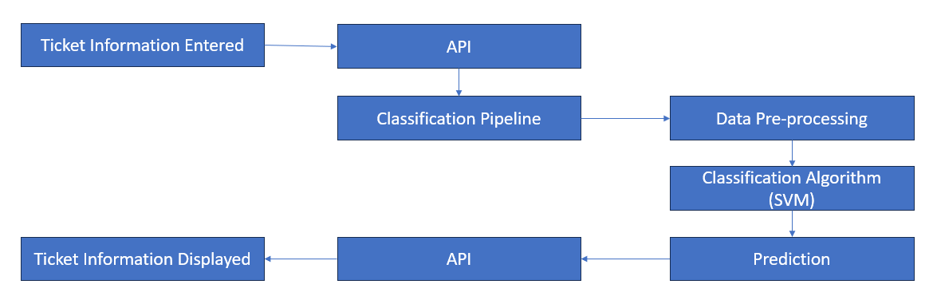
Figure 10

3.4. Summary
To summarise the development methodology, a 2000 balanced synthesised dataset has been generated and divided into a training and testing set where 1600 tickets assigned to the training set and 400 tickets assigned to the testing set. A number of NLP techniques have been applied to clean the data to ensure the model can handle the text parsed into it. The target label has been set to ‘Assignment Group’ as this is the column that the model is expected to predict. This data has then been used to train the SVM model that has been initialised with a variety of parameters which have been tested and evaluated during experimentation. Once the final SVM model was achieved, the model has been saved and used to connect to a FastAPI enquiry service which is used to input new data and understand how the system would work if connected to existing system that would then automate the routing of new tickets. The FastAPI enquiry service is a simple html form requesting the title and description of the ticket which must be present.

Chapter 4 – Design and Implementation

4.1. Diagram of Design / Implementation
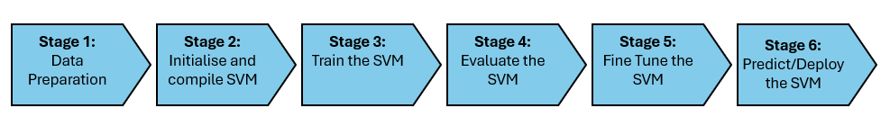
Figure 11 is a visual representation of the stages involved in the design and implementation of the SVM, which will be discussed in more detail below.
Figure 11

4.1.1. Stage 1: Data Preparation
This stage involved many different elements. Firstly, the synthetic dataset was generated using a number of AI tools readily available online. An example of this is shown in figure 12 and 13, where figure 12 was the example ticket inputted into ChatGPT and figure 13 is the output produced by ChatGPT [28].
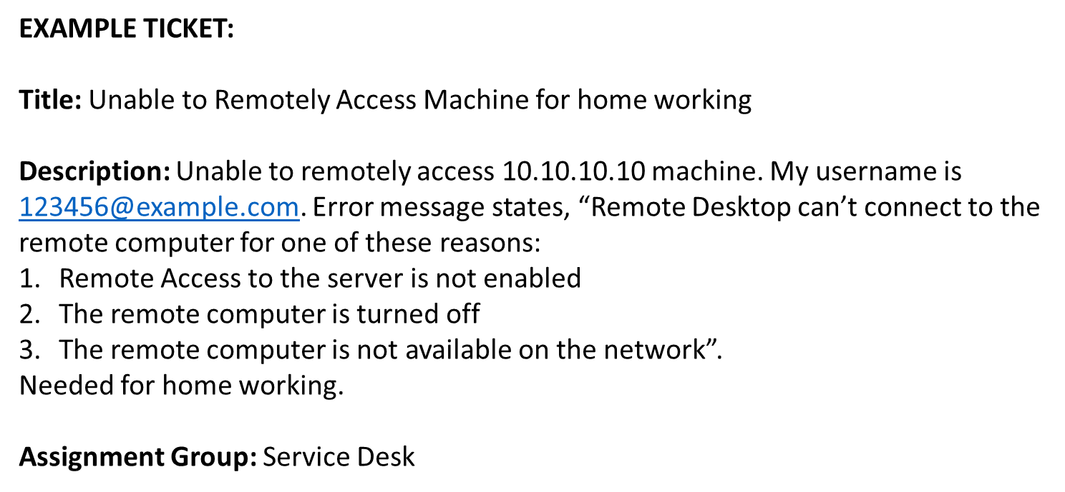

Figure 12

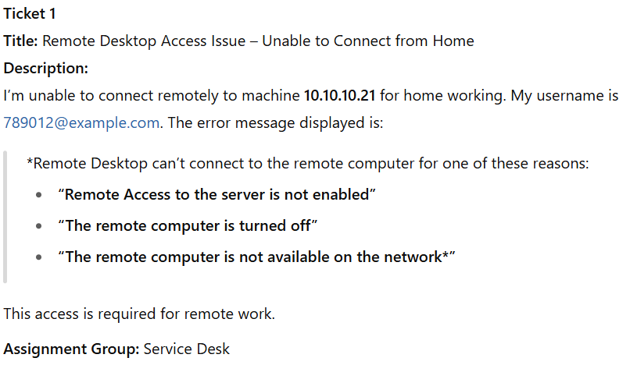

Figure 13
Once the dataset had been generated, containing 2000 tickets, it was manually split into two csv files, ensuring that a balanced dataset for testing and training was achieved. Additionally, the initial combined version of the dataset was also saved for use of comparing a manual data split to utilisation of the functions available from sklearn.model_selection to automate the split.
Progressing onto the coding elements of this stage, a number of libraries were imported for utilisation throughout the program. It is suggested that these are implemented to the top of a program for readability and to achieve best coding practice [60]. This was followed by reading in the dataset csv files, initially as two separated files and then later as one file. Focusing on the latter, this led onto the code that uses the stratify technique to automate the testing amd training split from sklearn.model_selection.
The final element of stage one involed cleaning the data so that the data can be handled appropriately by the model. As referenced in the literature review, there are many NLP techniques that can be used for this. The few focused on in this project are amending all text to lowercase, removing characters and whitespace. The data will then be pushed through tokenisation, stemming and lemmatisation functions for additional data preparation. Figure 14 is a screenshot of the code used to implement these.
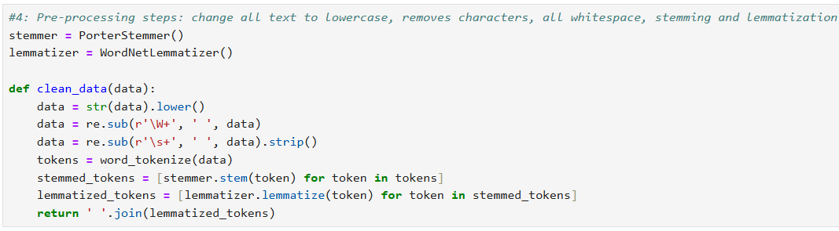
Figure 14

4.1.2. Stage 2: Initialise and compile model
The next stage of the implementation process was to initialise and compile the SVM. This is generally actioned in one stage. The initialisation allows parameters to be set which affect the results of the model. This will be discussed further into the report (5.1), where a variety of tests are actioned to monitor and track the performance. However, the end result parameters were kernel equal to linear and c equal to 1. The SVM was then compiled between stage 2 and 3, where the training data was parsed in.

4.1.3. Stage 3: Train the model
As already suggested, this stage works very closely with stage 2. The fit function was used from the sklearn.svm library to train the model. The training dataset was at 80% of original dataset, meaning that there were a total of 1600 tickets input for training purposes. This allowed the model to understand how to make the predictions. These predictions were then identified using the predict function from the same library, exploited in the next stage to understand how well the model has performed.

4.1.4. Stage 4: Evaluate the model
A number of evaluation methods are used to understand the performance levels of the model and how different parameters can affect the results. The three main methods that are exploited in this program are the classification reports, a confusion matrix and a variety of graphs such as PR curve and AUC-ROC curve. These three methods are applied through various functions imported from the sklearn.metrics library, whilst the Matplotlib.pyplot library has been exploited to plot the data in the tables and graphs.

4.1.5. Stage 5: Fine-tune model
Once the model was functioning and running without errors, it was important to experiment with different parameters to understand which parameters allowed the model to perform at its highest level. A number of tests were conducted as part of this stage, e.g. changing kernel functionality options. The experiment section of this report covers these changes in detail.

4.1.6. Stage 6: Predict and deploy
The stage has a few elements. The first section was to save the final version of the SVM code as a pkl file. This allowed the pipeline to be accessed via API, once developed and connected. Figures 15 is the section of code that executes this.
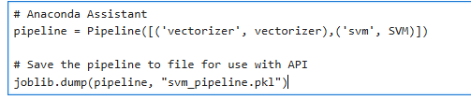
Figure 15
The next stage was to develop a simple HTML file to store the HTML form, requesting the title and description of a ticket and install FastAPI via the command line to allow the application to handle the form submissions. The python file was then developed to store the API code that opens a communication line between the SVM and HTML page. The application behaves like an enquiry service to show how the system would react with new data and how it could respond if connected to the existing system.
Once all code elements were developed, testing took place through submitting various title and descriptions of new tickets to analyse whether the classification algorithm returned the expected assignment group. Additionally, a CSV file was also developed to amend the format of the HTML page.

4.2. Difficulties and their Solutions
In order to introduce stemming, tokenisation and lemmatisation, a package called nltk needed to be installed and downloaded. Upon the initial attempt, the code was implemented to the Jupyter notebook file and appeared to be successfully installed. However, when attempting to use the functions from the nltk package further in the code, a number of errors returned. The main issue appeared to be that the nltk package could not be found. Following multiple attempts to run this cell, it was apparent that a refresh by uninstalling and removing all files would be the best option. Research using anaconda assistant [61], geeksforgeeks [62] and stackoverflow [63] resulted in the success of the download by implementing it in the anaconda command prompt, separately from the notebook.

4.3. Summary
To summarise, the design and implementation falls into a 6-stage workflow. The first stage consisted of generating the dataset, splitting it into a training and testing set, importing the necessary libraries and executing various NLP techniques to clean the data. The second and third stage worked closely together, where the SVM model is initialised, compiled and trained. This is followed by the 4th stage, where the model is evaluated using a number of evaluation matrices. Once the model was executing as anticipated, stage 5 allowed a number of experiments to take place for fine-tuning until the most effective results were achieved. Finally, the model is deployed through integration with a web application, where new data is pushed through the workflow and the model’s prediction is returned to the user.

Chapter 5 – Evaluation

5.1. SVM Experiments
The experiments are a mixture of independent and combined evaluations. The combined experiments are where positive experiments are taken forward to the next experiment for further development.

5.1.1. Comparing the Results of Manual Division of dataset with use of train_test_split function
Initially, the dataset was manually split into the 80% for training and 20% for testing. These were loaded into the project as two separate csv files. This was actioned to ensure the 80/20 split was performed as expected. The overall accuracy score is 98.50% and the results of each class for precision, recall and F1-score have been displayed in the table below.
Table 1: Classification Report where dataset has been manually balanced and divided into two separate csv files.
Assignment Group (Label) | Precision | Recall | F1-score
Drivers Department | 100.00% | 93.75% | 96.77%
Network Department | 98.75% | 98.75% | 98.75%
Private Registration Department | 100% | 100.00% | 100%
Service Desk Department | 98.77% | 100.00% | 99.38%
Vehicle Department | 95.24% | 100.00% | 97.56%
Average | 98.55% | 98.50% | 98.49%

Although the results initially achieved were very positive, other avenues were analysed to see how to improve the results further. The first step to test how the performance could be affected was to combine the dataset into one csv file and import train_test_split from sklearn.model_selection to use the stratify feature to allow the code to automate the balanced split. The overall accuracy score was 99.75% and the results from this test have been displayed in the table below. As you can see the precision and recall was improved for 2 assignment groups and F1-socre improved for 1 assignment group. However, the recall and F1-score did also decrease slightly for 2 assignment categories.
Table 2: Classification Report where dataset has been divided using train_test_split function.
Assignment Group (Label) | Precision | Recall | F1-score
Drivers Department | 100.00% | 100.00% | 100.00%
Network Department | 100.00% | 100.00% | 100.00%
Private Registration Department | 98.77% | 100.00% | 99.38%
Service Desk Department | 100.00% | 100.00% | 100.00%
Vehicle Department | 100.00% | 98.75% | 99.37%
Average | 99.75% | 99.75% | 99.75%

5.1.2. Understanding the impact on changing each kernel function
Now that the division of the dataset has been automated, the next experiment was to recognise which kernel resulted in the higher performance levels. The results from this experiment have been inserted into table 3. As shown, all perform well, but the Linear function has a slight edge.
Table 3: Average Accuracy, Precision, Recall and F1-Score for each Kernel Function.
Kernel Function | Accuracy (avg) | Precision (avg) | Recall (avg) | F1-score (avg)
Linear | 99.75% | 99.75% | 99.75% | 99.75%
RBF | 99.75% | 99.75% | 99.74% | 99.75%
Sigmoid | 99.00% | 99.03% | 99.00% | 99.00%
Poly | 99.01% | 99.00% | 99.00% | 99.00%

5.1.3. Understanding the Impact of Importing Stemming, Lemmatisation and Tokenisation to Assist in Cleaning Data
The next test was to investigate whether stemming, lemmatisation and tokenisation could improve the results. To allow this to be implemented, pip needed to be installed so that the required nltk packages could be downloaded and imported for use in the code. This was performed on the dataset that was divided using the train_test_split introduced in section 5.1.1 and the kernel set to Linear from section 5.1.2. The results have been inputted to the table below. In this case, the average results scored for each evaluation metric mirror the results from 5.1.2, suggesting that it has not significantly impacted the performance as it was suggested in the literature review.
Table 4: Classification Report where stemming, tokenisation and lemmatisation added to data cleaning function.
Assignment Group (Label) | Precision | Recall | F1-score
Drivers Department | 100.00% | 98.75% | 99.37%
Network Department | 100.00% | 100% | 100%
Private Registration Department | 100.00% | 100% | 100%
Service Desk Department | 100.00% | 100% | 100%
Vehicle Department | 98.77% | 100% | 99.38%
Average | 99.75% | 99.75% | 99.75%

5.1.5. Understanding the impact on introducing C parameter
As the best performing kernel function was linear, identified in 5.1.2, a vital parameter to investigate is known as C. This influences the decision boundary by controlling how the SVM should deal with misclassifications, e.g. a wider margin indicates a lower C value, a narrow margin indicates a higher C value [64].

Table 5: Average Accuracy, Precision, Recall and F1-Score for each value of C with linear function.
C Function | Accuracy (avg) | Precision (avg) | Recall (avg) | F1-score (avg)
0.0001 | 97.25% | 97.58% | 97.25% | 97.29%
0.001 | 98.50% | 98.54% | 98.50% | 95.50%
0.01 | 94.75% | 95.75% | 94.75% | 94.74%
0.1 | 99.50% | 99.51% | 99.50% | 99.50%
1 | 99.75% | 99.75% | 99.75% | 99.75%

5.1.6. Investigation into High-Performance Levels
Upon reflection of the significantly high scores, it was suggested by anaconda assistant [61] that there could be a data leakage between the testing and training set. Data leakage can cause accurate results in training, but it will not be a true reflection of how the program will perform once deployed [65]. One avenue that was reviewed for this was to check whether there were duplicated tickets within the dataset. The code in figure 16 was suggested [61] to identify these tickets.
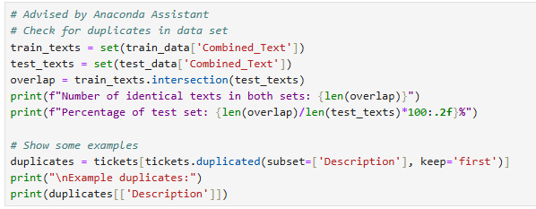
Figure 16

After execution of figure 16, it was returned that there was a 4.79% overlap between the testing and training set. To resolve this, investigation into the csv file was conducted, where conditioning formatting tools were exploited in excel to highlight the problematic records. They were swiftly amended and the code in figure 16 was executed again, returning the positive results shown in figure 17.
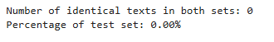

Figure 17

The experiments previously listed and documented were re-run with the updated dataset, to recognise whether this had an impact on each of the results. Although, upon investigation and execution of each test, it did not affect the results displayed in tables 1 – 5.

5.2. SVM Results
The following sections contain the final evaluation results produced for the SVM model.

5.2.1. Classification Report Results
The data from the classification report has been inserted into table 6. The model scored 99.75% across all evaluation metrics. This is a significantly high percentage which some online documents state that it can imply overfitting or data leakage, but measures have been taken and implemented which have been discussed in the experiments, ensuring that this is not the case. The final parameter chosen, based on the results of each experiment, have been included in the table.
Table 6: Classification Report for final SVM model
Model | Accuracy (avg) | Precision (avg) | Recall (avg) | F1-score (avg)
SVM (kernel='linear', class_weight='balanced', C=1, probability=True) | 99.75% | 99.75% | 99.75% | 99.75 %

5.2.2. Confusion Matrix
The confusion matrix (figure 18) shows the cross comparison of actual results, compared with predicted results. All Departments, except Drivers Department tickets, were predicted correctly. For the Drivers Department, 1 ticket’s Assignment Group was incorrectly predicted as a ticket for the Vehicle Department.
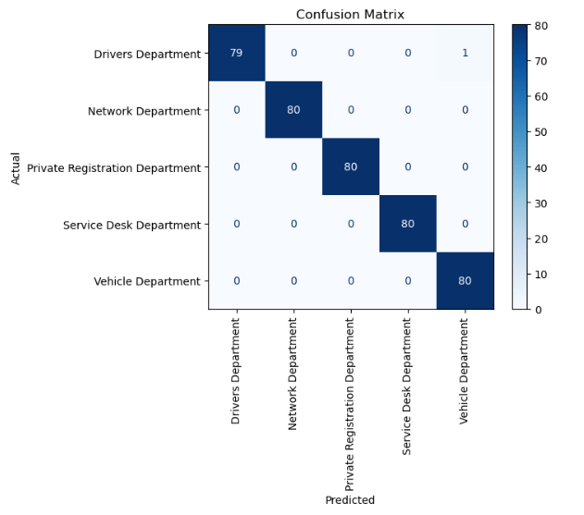
Figure 18

5.2.3. PR Curve Graph
Figure 19 is a PR curve graph, where AP stands for Average Precision. The graph also reflects the high-performance levels of the model, implying that there is a 100% success rate. This shows the importance of utilising a number of evaluation techniques as the average precision has been rounded up, suggesting it has better performance.
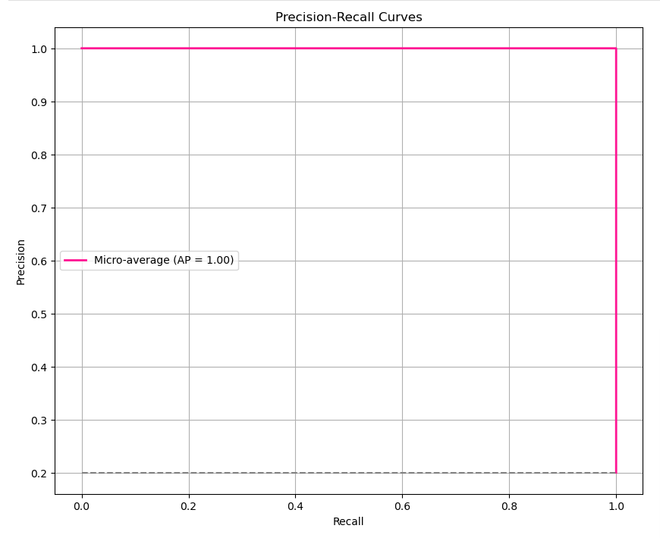
Figure 19

5.2.4. ROC and AUC-ROC Curve Graphs
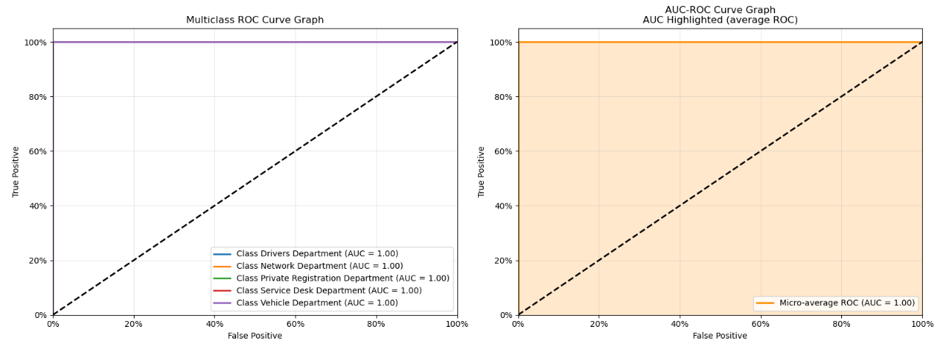
Similarly to the PR Curve, both the ROC and AUC-ROC curve graph suggest 100% prediction rates. Therefore, a combination of all evaluation in 5.2 provides better understanding of the full picture.
Figure 20

5.3. Comparison with Literature
In order to assess the performance of the model, the results of 4 studies conducted by various researchers have been inserted into table 7. In most studies, including this project, SVM has scored over 95% for accuracy, precision, recall and F1-score.
Table 7: Results comparison with other studies that explored SVM for Service Ticket Classification.
Studies | Accuracy | Precision | Recall | F1-Score
Arias-Barahona et al [66] | 98.97% | 98.95% | 98.97% | 98.95%
Revina, Buza, Meister (dataset 1) [15] | 96.70% | 97.60% | 97.00% | 97.30%
Revina, Buza, Meister (dataset 2) [15] | 98.30% | 95.80% | 97.00% | 96.20%
Almarzooqi [11] | 88.45% | 89.21% | 87.90% | 88.55%
Proposed Study | 99.75% | 99.75% | 99.75% | 99.75%

5.4. API Experiments
Once the SVM model was complete, the next step was to evaluate the API and its connection to the SVM to complete the workflow.

5.4.1. Testing CSS Render
The first experiment tested whether the CSS rendered as expected when served from the API framework (figure 22), opposed to running from the local directory (figure 21).
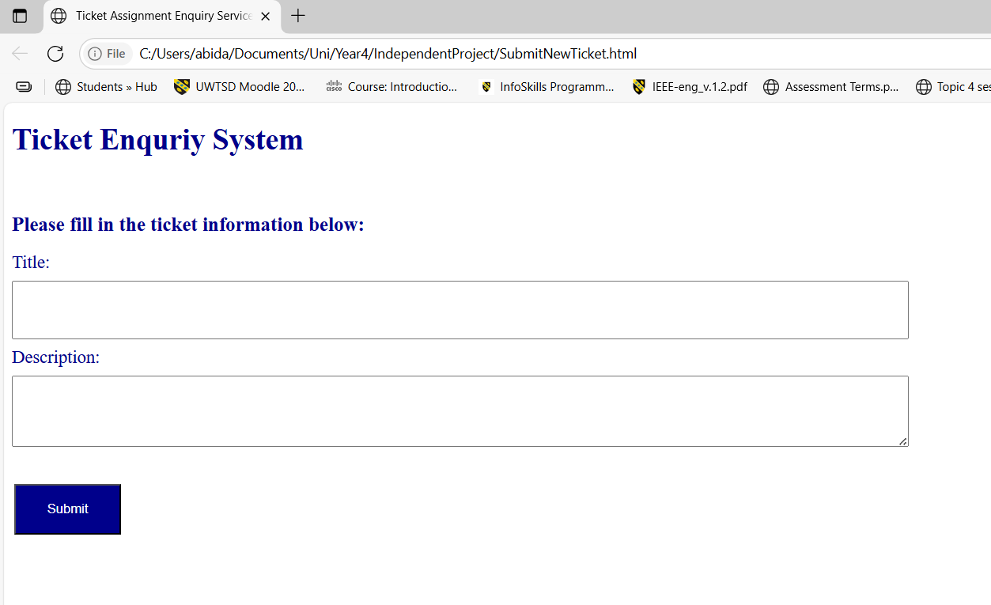
Figure 21
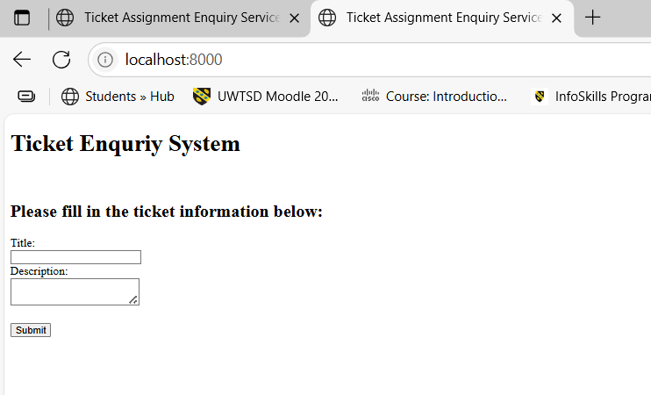
Figure 22
As demonstrated in figure 21 and 22, these pages to not mirror each other suggesting there was an issue loading the CSS file. This was resolved through adding the CSS code into html file within the style tags.

5.4.2. Testing Response in Command Prompt
The next test was to assess the connection to the SVM. Figure 23 is the python file created called testPipeline.py. This code was assisted by Chat GPT [28].
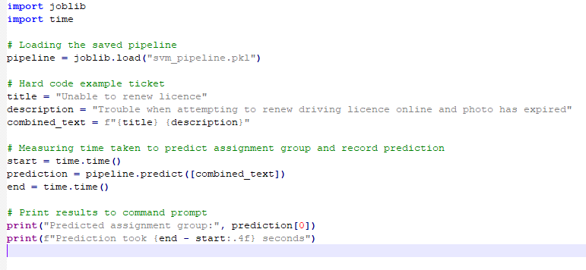
Figure 23
Python file (figure 23) was run in the command prompt, using command: python testPipeline.py. Figure 24 is the output to the console, showing a successful result and quick response time.
Figure 24

5.4.3. Testing Response in Application
The third test was to test whether the implementation of the SVM pipeline was successful, and the assignment group was displayed on screen as expected. Figure 25 is the data inputted into the form and figure 26 is the response. The response was accurately predicted.
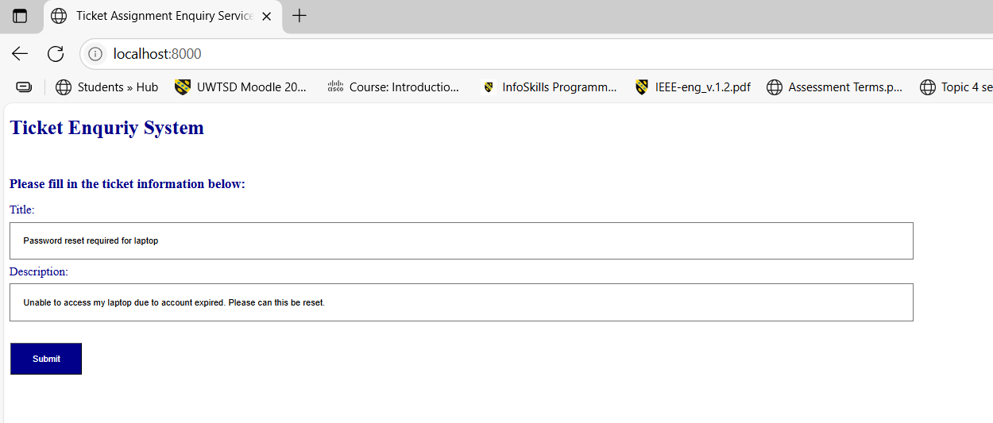
Figure 25
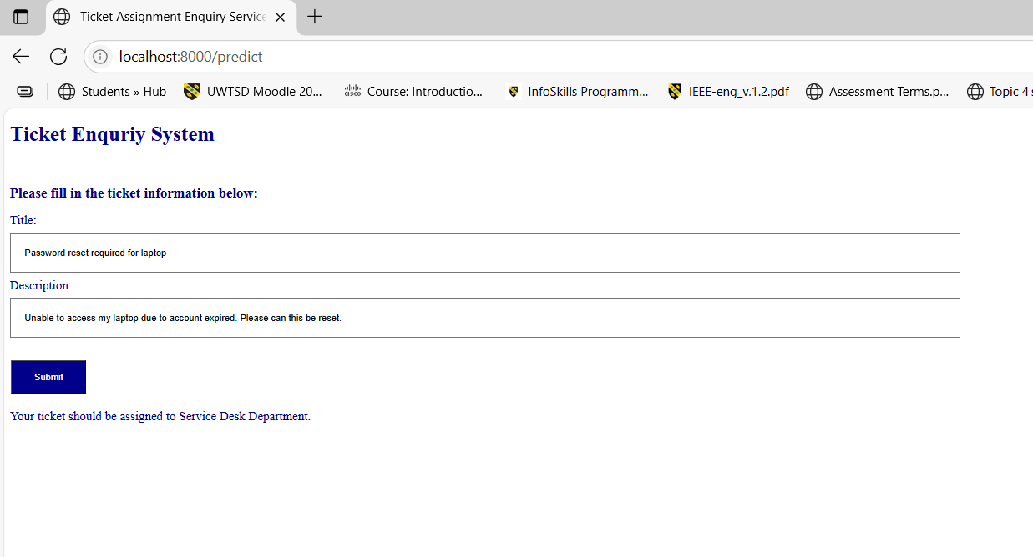
Figure 26

5.4.4. Testing Validation – No Title
Experiment 4 was introduced, to guarantee that empty values were not parsed into the SVM, as the model has not been set up to handle null values. This validation prevents null values from being entered into the HTML form by setting a required parameter. Figures 27 and 28 are screenshots showing both fields displaying error messages when the user attempts to leave one blank.
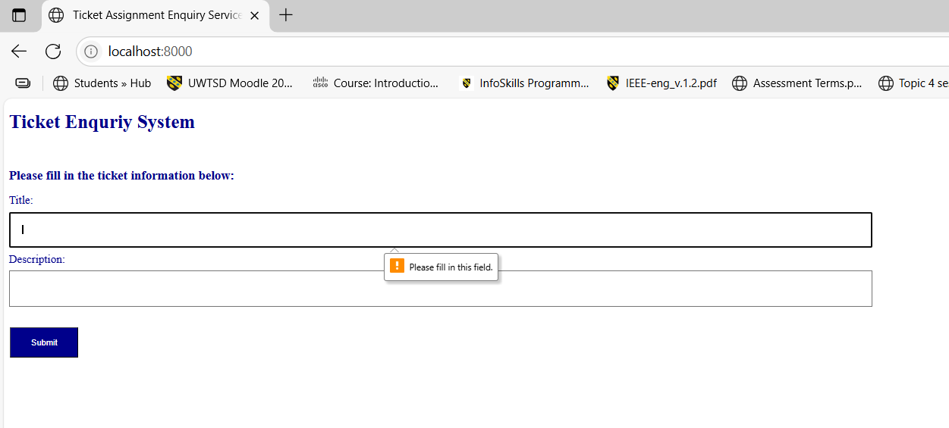
Figure 27
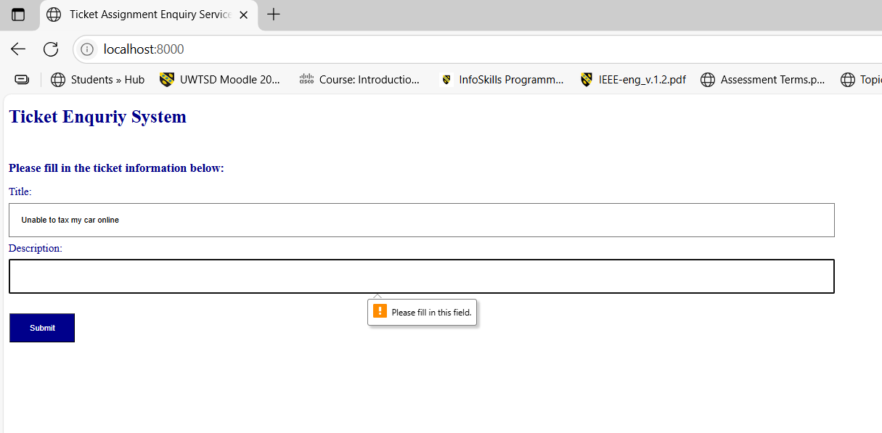
Figure 28

5.5. API Results
Once all testing was complete and successful, the final process was to start the program as follows. Firstly, the API is started via the command prompt, entering the following command into the command prompt: python -m uvicorn main:app –reload
Once the server has started in the command prompt, the application can be accessed through searching for localhost in a web browser. Figure 30 is an example of this process.
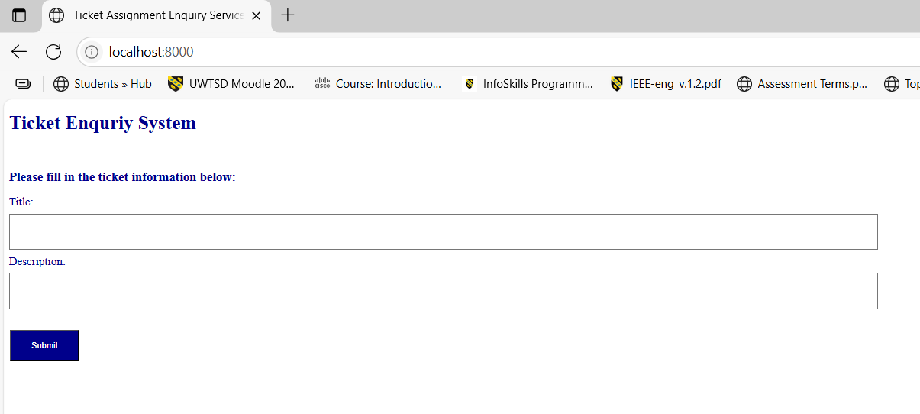
Figure 30

The next step is to enter the details of the ticket and click on the submit button. Figure 31 is an example of the application correctly predicting and returning the prediction to the user interface.
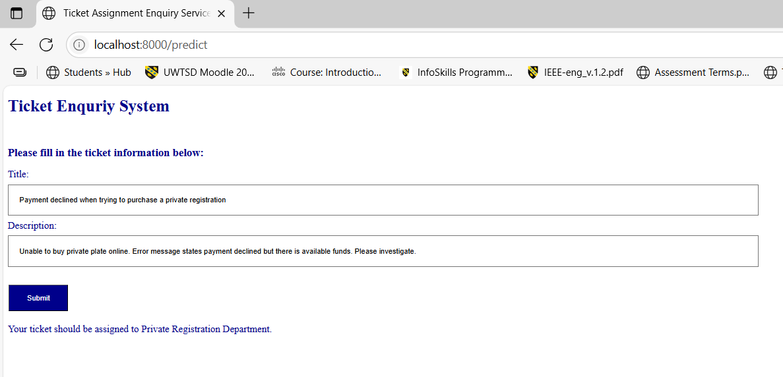
Figure 31

The user is able to continue entering new data until satisfied. Although, once complete, the web browser can be closed and crtl + C should be entered to the command prompt that is running in the background to successfully shutdown the FastAPI instance. An example of what can be seen in the command prompt is displayed in figure 32.
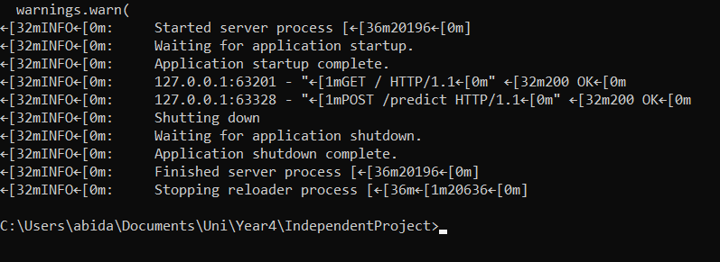
Figure 32

5.6. Summary
To review the evaluation stage, a number of experiments have been conducted to review the performance of the SVM model and the integrated API. The SVM has significantly high scores for all decision metrics which was initially a concern for overfitting and data leakage. Sections of code were implemented to review these concerns and addressed appropriately. Further research [67] has suggested that similar data within the testing and training set can trigger high-performance. Nonetheless, comparison with other studies that researched SVM models for ticket classification also achieved high scores, with this project only surpassing the highest score by 0.78%. Additionally, similar data is expected for these tickets, as it is unlikely that the terminology used will not be seen before.
In regard to the fine-tuning experiments, using hyperparameters as an alternative way to identify the best combination of results could have been reviewed to reduce the time spent evaluating each. However, previous experience recognised that this increased the processing time and therefore, a device with higher CPU would need to be utilised. That being said, if this was available then it could significantly reduce the runtime, and the length of time spent executing different experiments.

Chapter 6 – Conclusion and Recommendations

6.1. Conclusion
To conclude, this study aimed to develop a helpdesk ticketing support system based on natural language processing for a public organisation. The evaluation of results demonstrate that this was achieved with great success. Initially, the current literature was critically analysed to understand how NLP has been used in customer service and helpdesk systems. The knowledge learnt from this, influenced the decision-making process for the design and development of the NLP based model that predicted the relevant department of each tickets. Furthermore, a number of evaluation metrics such as accuracy, precision, recall and F1-score provided clarification on how well the model was executing the predictions. Once the greater results were achieved and documented via a number of experiments, the SVM model was successfully integrated into a web application for human interaction. The web application was a simple form, functioning as an enquiry service for an employee to enter ticket details to assist in the decision-making process. Alternatively, the web application could be seen as a testing prototype for understanding how the SVM could be integrated into the existing system.
In addition to achieving the studies aim and objectives, the evaluation results highlighted that the SVM performed slightly better than anticipated, when comparing other studies identified in the literature review. High quality data was a key finding in the research, which was achieved through manufacturing the dataset, likely suggesting to have had an impact on the results. This study provides a clear demonstration of how NLP methods, specifically SVMs, can be utilised in ticket classification tasks to reduce human error and free up employees time for other tasks such as learning new skills. Additionally, investigating further into this would have the potential to improve customer satisfaction through a decrease in resolution time.

6.2. Recommendations
Based on the successful results of this study, a further recommendation would be to investigate whether the model performs as well with a different dataset. For the purpose of this project, data from the workplace could not be implemented and tested due to data protection reasons, although it could possibly be explored in a controlled environment in work. Currently, the workplace requires security clearance to view and deal with this type of data so measures to ensure compliance would be vital. Investigating this avenue would provide valuable insights on how the system predicts classes where the information is not well constructed. Experience has led to the understanding that not all tickets are well written and can be missing important information that could assist in the prediction and decision. For this study, the synthetic dataset prevented any anomaly tickets like this so it would be fascinating to understand how it could deal with such tickets. Moreover, as the dataset was synthetic, steps were taken during the generation stage to make it balanced. For this reason, future research could be to explore and investigate whether the SVM model would maintain its high-performance levels, if utilising a real dataset where it is more likely to be imbalanced.
Additionally, the application that deployed the classification algorithm was a simple webpage to illustrate how the system could work. The current system that allows employees to raise tickets requests much more data which could be introduced to see if the classification algorithm still performs at the same level. That being said, no changes would be anticipated as the additional columns should not affect the decision due to them containing personal data on the individual raising the ticket. Nonetheless, this avenue should be reviewed for validation.

Chapter 7 – Reflection

Whilst completing this project, I have been required to develop and implement a number of skills that I have learnt over the course of my university degree which have only been enhanced since completing this project. This project has allowed me to develop my programming skills in Python, initially learnt in the Software Development modules. It has also allowed me to revisit some HTML and CSS code from earlier modules of the degree. Other courses that have contributed to the general knowledge required to complete this project would be the Learning in a Digital Era and Changemakers: Creativity and Value Creation modules due to the reporting, evaluating and investigative skills required for this study. Moreover, revisiting the use of the add-in software called RefWorks learnt in the early stages of the course has helped format references. Previously, I have manually written them due to initial configuration issues. This has been great for understanding how different modules can come together to achieve an end result.
This project has also improved my research and report writing skills by being the largest project that I have produced to date. The study required me to look at larger volumes of research, where I identified how AI can also be used in research elements of reports. For example, during the initial stages I utilised an AI website called ScisSpace [68] to help analyse reports and documents, withdrawing specific data columns that I set myself. This significantly reduce the time spent reading through documents that were not explicitly relevant to this project. I focused and read through the reports that were only specifically significant to the project and that would assist in the research and understanding. Although, as helpful as this tool was, it is important to note, that I cross examined the data output with the individual reports, ensuring the data was extracted successfully. Despite this, it helped analyse existing literature, and reduce the time spent on unrelated papers.
In relation to research work, this project has also allowed me to develop in my analytical skills. This works hand in hand with the critical thinking skills that I have learned, through reading various reports and studies. Furthermore, reviewing existing documentation and studies has broadened my understanding to other areas in the field.
Additionally, this project has also resulted in the development and improvement in many practical skills. One main skill that I have improved during this project is time management. A previous module was delayed due to extenuating circumstances which led to the need to complete another assignment during this time. Under normal circumstances, I would have only been required to focus on this project for the last few months of my university degree. However, due to the increased workload, I needed to monitor my progress in both ensuring I could actively and successfully reach the deadlines in both to achieve good results. Although this has been challenging, organisation in the earlier stages made it easier to manage. Moreover, the topic that was deferred to a later date was the AI and ML module, meaning that at the start of the project I did not have as much knowledge as I had hoped when I had chosen the project title. Nonetheless, fortunately, my assigned supervisor was also my lecturer which meant I could ask questions and gain a better understanding through their knowledge, over the months of completing the project and assignments.
Another practical skill that I have improved on during this project would be my confidence. Like many individuals, I am not comfortable in speaking or presenting in front of others and therefore, initially I was quite anxious at the thought of having to present my project and answer questions. My markers were very welcoming and encouraging which allowed me to relax. Although generally I found that having a clear understanding of the topic and aims and objectives made the process much easier to talk about in detail. Not to mention, this element also allowed me to improve my communication skills through the need to explain the research and project planning, in a relatively short period of time to an individual who had no prior knowledge of it. As well as improving my communication skills during this element, I also feel that it was improved through having regular meetings with my supervisor. These meetings were 20–30-minute weekly sessions, meaning that my questions and discussions required to be precise to prevent any blockers throughout the week. This allowed me to make consistent progression throughout the couple months and stay on track.
To conclude, these skills will be taken forward in future working life and for personal development. My place of work values these skills, and I believe that they will significantly benefit me during my career. I’m currently transitioning between roles and therefore, I also trust that the hard and soft skills developed throughout my time in university will also enhance how I learn my new role.

Chapter 8 – References

[1] S. Schick. 7 benefits of a help desk ticketing system. Available: https://www.verizon.com/business/resources/articles/s/seven-benefits-of-a-help-desk-ticketing-system/.
[2] deeplearning ai. (Jan 11). A Complete Guide to Natural Language Processing. Available: https://www.deeplearning.ai/resources/natural-language-processing/.
[3] AWS. What is Natural Language Processing (NLP)?. Available: https://aws.amazon.com/what-is/nlp/.
[4] J. Ph.D. Murel and E. Kavlakoglu. (Nov 29). What is stemming?. Available: https://www.ibm.com/think/topics/stemming.
[5] K. Yasar and A. S. Gillis. (Mar 5). What is lemmatization?. Available: https://www.techtarget.com/searchenterpriseai/definition/lemmatization.
[6] Geeksforgeeks. (Jul 17). Python | Lemmatization with NLTK. Available: https://www.geeksforgeeks.org/python/python-lemmatization-with-nltk/.
[7] Geeksforgeeks. (Jul 11). Tokenization in NLP. Available: https://www.geeksforgeeks.org/nlp/nlp-how-tokenizing-text-sentence-words-works/.
[8] J. Murel Ph.D. and E. Kavlakoglu. (Jan 19). What is bag of words?. Available: https://www.ibm.com/think/topics/bag-of-words.
[9] Y. Hamdaoui. Y. Hamdaoui. A guide to TF-IDF. A guide to TF-IDF. 2024. Available: https://builtin.com/articles/tf-idf.
[10] M. Truss and S. Böhm. M. Truss and S. Böhm. AI-Based Classification of Customer Support Tickets: State of the Art and Implementation with AutoML AI-Based Classification of Customer Support Tickets: State of the Art and Implementation with AutoML .
[11] M. Almarzooqi, D. Analytics, S. Modak and E. Warriach. M. Almarzooqi, D. Analytics, S. Modak and E. Warriach. Automated prioritization and routing of IT support tickets using machine learning. Automated prioritization and routing of IT support tickets using machine learning. 2025.
[12] S. Moreno, W. Yushimito and S. Hughes. S. Moreno, W. Yushimito and S. Hughes. A stacked generalization ensemble model for help desk ticket assignment. A stacked generalization ensemble model for help desk ticket assignment. 2022 41st International Conference of the Chilean Computer Science Society (SCCC) 2022 41st International Conference of the Chilean Computer Science Society (SCCC) pp. 1. pp. 1. 2022. DOI: 10.1109/sccc57464.2022.10000332.
[13] A. A. Gorbunova, A. S. Trunov and V. I. Voronov. A. A. Gorbunova, A. S. Trunov and V. I. Voronov. Intelligent analysis of technical support requests in service desk ticketing systems. Intelligent analysis of technical support requests in service desk ticketing systems.

[14] Geeksforgeeks. (Apr 3). Continuous bag of words (CBOW) in NLP. Available: https://www.geeksforgeeks.org/nlp/continuous-bag-of-words-cbow-in-nlp/.
[15] A. Revina, K. Buza and V. G. Meister. A. Revina, K. Buza and V. G. Meister. IT ticket classification: The simpler, the better. IT ticket classification: The simpler, the better. IEEE Access IEEE Access 88pp. 193380. pp. 193380. 2020. DOI: 10.1109/access.2020.3032840.
[16] L. S. B. Pereira, R. Pizzio, S. Bonho, L. M. F. De Souza and A. C. A. Junior. L. S. B. Pereira, R. Pizzio, S. Bonho, L. M. F. De Souza and A. C. A. Junior. Machine learning for classification of IT support tickets. Machine learning for classification of IT support tickets. 2023 International Conference on Cyber Management and Engineering (CyMaEn) 2023 International Conference on Cyber Management and Engineering (CyMaEn) pp. 210. pp. 210. 2023. DOI: 10.1109/cymaen57228.2023.10051041.
[17] U. Sanderink. Automatic_Ticket_Classification_NLP. Available: https://github.com/sinsasanderink/Automatic_Ticket_Classification_NLP.
[18] W. Obinna. (Dec 19). Comparing Naïve Bayes and SVM for Text Classification. Available: https://medium.com/@wisdom_obinna/comparing-na%C3%AFve-bayes-and-svm-for-text-classification-71874864d4d5.
[19] F. Al-Hawari and H. Barham. F. Al-Hawari and H. Barham. A machine learning based help desk system for IT service management. A machine learning based help desk system for IT service management. Journal of King Saud University - Computer and Information Sciences Journal of King Saud University - Computer and Information Sciences 3333(6), pp. 702. pp. 702. 2019. DOI: 10.1016/j.jksuci.2019.04.001.
[20] J. Ph.D. Murel and E. Kavlakoglu. (Mar 18). What is ensemble learning?. Available: https://www.ibm.com/think/topics/ensemble-learning.
[21] I. Mcconnell. (Feb 27). JIRA Ticket Effort Prediciton. Available: https://github.com/ilmcconnell/jira_ticket_effort_prediction.
[22] C. Hashemi-Pour. (Feb 15). BERT language model. Available: https://www.techtarget.com/searchenterpriseai/definition/BERT-language-model.
[23] E. C. Garrido-Merchan, R. Gozalo-Brizuela and S. Gonzalez-Carvajal. E. C. Garrido-Merchan, R. Gozalo-Brizuela and S. Gonzalez-Carvajal. Comparing BERT against traditional machine learning models in text classification. Comparing BERT against traditional machine learning models in text classification. JCCE JCCE 22(4), pp. 352. pp. 352. 2023. DOI: 10.47852/bonviewjcce3202838.
[24] F. Koukal, F. Dařena, R. Ježdík and J. Přichystal. F. Koukal, F. Dařena, R. Ježdík and J. Přichystal. Improving automated categorization of customer requests with recent advances in natural language processing. Improving automated categorization of customer requests with recent advances in natural language processing. EJOBSAT EJOBSAT 1010(2), pp. 173. pp. 173. 2024. DOI: 10.11118/ejobsat.2024.010.
[25] D. Bhatnagar. (Aug 24). Text Classification using BERT: A Comprehensive Guide (Part 1). Available: https://bhatnagar91.medium.com/text-classification-using-bert-a-comprehensive-guide-part-1-ae69a2f1505e.
[26] S. Bonechi, G. Palma, M. Caronna, M. Ugolini, A. Massaro and A. Rizzo. S. Bonechi, G. Palma, M. Caronna, M. Ugolini, A. Massaro and A. Rizzo. Enhancing customer support in banking: Leveraging AI for efficient ticket classification. Enhancing customer support in banking: Leveraging AI for efficient ticket classification. Procedia Computer Science Procedia Computer Science 246246pp. 128. pp. 128. 2024. DOI: 10.1016/j.procs.2024.09.235.
[27] Y. Wahba, N. Madhavji and J. Steinbacher. Y. Wahba, N. Madhavji and J. Steinbacher. A comparison of SVM against pre-trained language models (PLMs) for text classification tasks. A comparison of SVM against pre-trained language models (PLMs) for text classification tasks. Available: https://arxiv.org/pdf/2211.02563.
[28] ChatGPT. ChatGPT. ChatGPT. ChatGPT.
[29] D. Boswell. D. Boswell. Introduction to support vector machines. Introduction to support vector machines. 2002.
[30] IBM Experts. IBM Experts. What are support vector machines (SVMs)? What are support vector machines (SVMs)? 2023. Available: https://www.ibm.com/think/topics/support-vector-machine.
[31] Geeksforgeeks. (Jun 28). Linear vs. Non-linear Classification: Analyzing Differences Using the Kernel Trick. Available: https://www.geeksforgeeks.org/machine-learning/linear-vs-non-linear-classification-analyzing-differences-using-the-kernel-trick/.
[32] &. Jain and Abhishek. &. Jain and Abhishek. SVM kernels and its type. SVM kernels and its type. Medium Medium 2024. Available: https://medium.com/@abhishekjainindore24/svm-kernels-and-its-type-dfc3d5f2dcd8.
[33] Geeksforgeeks. Understanding the Confusion Matrix in Machine Learning. Available: https://www.geeksforgeeks.org/machine-learning/confusion-matrix-machine-learning/.
[34] D. Silwal. (Jan 5). Confusion Matrix, Accuracy, Precision, Recall & F1 Score: Interpretation of Performance Measures. Available: https://www.linkedin.com/pulse/confusion-matrix-accuracy-precision-recall-f1-score-measures-silwal/.
[35] Coursera Staff. Coursera Staff. What is cross-validation in machine learning? What is cross-validation in machine learning? 2025. Available: https://www.coursera.org/articles/what-is-cross-validation-in-machine-learning.
[36] M. Zemp. M. Zemp. Text classification of service desk tickets. Text classification of service desk tickets.
[37] A. Shanardi Wijaya and T. Oktavia. A. Shanardi Wijaya and T. Oktavia. Machine learning approaches for helpdesk ticketing system: A systematic literature review. Machine learning approaches for helpdesk ticketing system: A systematic literature review.
[38] Y. Chi. Y. Chi. Integrating APIs with AI revolutionizing modern applications. Integrating APIs with AI revolutionizing modern applications. 2024. Available: https://www.researchgate.net/publication/381548141_Integrating_APIs_with_AI_Revolutionizing_Modern_Applications.
[39] OpenVPN Team. OpenVPN Team. Advantages and disadvantages of API for business. Advantages and disadvantages of API for business. 2019. Available: https://blog.openvpn.net/advantages-and-disadvantages-of-api-for-business/.
[40] N. A. Harun, S. H. Huspi and N. A. Iahad. N. A. Harun, S. H. Huspi and N. A. Iahad. Question classification framework for helpdesk ticketing support system using machine learning. Question classification framework for helpdesk ticketing support system using machine learning. 2021 7th International Conference on Research and Innovation in Information Systems (ICRIIS) 2021 7th International Conference on Research and Innovation in Information Systems (ICRIIS) pp. 1. pp. 1. 2021. DOI: 10.1109/icriis53035.2021.9617077.
[41] Geeksforgeeks. (May 7). Support vector machine in Machine Learning. Available: https://www.geeksforgeeks.org/machine-learning/support-vector-machine-in-machine-learning/.
[42] aymuosmukherjee. aymuosmukherjee. Why do we use stratify in train_test_split. Why do we use stratify in train_test_split. Medium Medium 2025. Available: https://medium.com/@aymuosmukherjee/why-do-we-use-stratify-in-train-test-split-e3eb296a5494.
[43] Milvus Zilliz. How do I determine the features and labels in a dataset?. Available: https://milvus.io/ai-quick-reference/how-do-i-determine-the-features-and-labels-in-a-dataset.
[44] CMU School of Computer Science. Data Formats and Data Loading Options. Available: https://www.cs.cmu.edu/~ymiao/pdnntk/data.html.
[45] Geeksforgeeks. (Apr 28). Install Fastapi And Run Your First Fastapi Server On Windows. Available: https://www.geeksforgeeks.org/python/install-fastapi-and-run-your-first-fastapi-server-on-windows/.
[46] Suraj. Customer Support Ticket Dataset. Available: https://www.kaggle.com/datasets/suraj520/customer-support-ticket-dataset.
[47] Claude AI. Claude AI. Claude AI. Claude AI.
[48] Google Gemini. Google Gemini. Google gemini. Google gemini.
[49] Microsoft Copilot. Microsoft Copilot. Microsoft copilot. Microsoft copilot.
[50] S. Joseph. S. Joseph. Project meetings. Project meetings.
[51] I. Novogroder. I. Novogroder. Data pre-processing in machine learning: Steps & best practices. Data pre-processing in machine learning: Steps & best practices. 2025. Available: https://lakefs.io/blog/data-pre-processing-in-machine-learning/.
[52] Geeksforgeeks. Working with csv files in Python. Available: https://www.geeksforgeeks.org/python/working-csv-files-python/.
[53] Geeksforgeeks. (Jul 15). Evaluation Metrics in Machine Learning. Available: https://www.geeksforgeeks.org/machine-learning/metrics-for-machine-learning-model/.
[54] Super Data Science. Super Data Science. Confusion matrix and accuracy ratios. Confusion matrix and accuracy ratios. Super Data ScienceSuper Data Science2023.
[55] D. Steen. D. Steen. Precision-recall curves. Precision-recall curves. Medium Medium 2020. Available: https://medium.com/@douglaspsteen/precision-recall-curves-d32e5b290248.
[56] S. Mirshekari. S. Mirshekari. ROC curve vs. PR curve: Why you need both for effective model evaluation. ROC curve vs. PR curve: Why you need both for effective model evaluation. 2024. Available: https://saeedmirshekari.com/blog/roc-curve-vs-pr-curve-why-you-need-both-for-effective-model-evaluation/.
[57] Geeksforgeeks. Python for Machine Learning. Available: https://www.geeksforgeeks.org/machine-learning/python-for-machine-learning/.
[58] E. Kavlakoglu and K. Kervin. (Mar 7). Classifying data using the SVM algorithm using Python. Available: https://developer.ibm.com/tutorials/awb-classifying-data-svm-algorithm-python/.
[59] Open Class Rooms. Import Python Libraries. Available: https://openclassrooms.com/en/courses/6902811-learn-python-basics/7091081-import-python-libraries.
[60] M. Nzomo. M. Nzomo. Absolute vs relative imports in python. Absolute vs relative imports in python. 2018. Available: https://realpython.com/absolute-vs-relative-python-imports/.
[61] Anaconda Assistant. Anaconda Assistant. Anaconda. Anaconda. Available: https://www.anaconda.com/docs/tools/anaconda-notebooks/anaconda-toolbox/anaconda-assistant.
[62] Geeksforgeeks. (Dec 16). How to Download & Install NLTK on Windows?. Available: https://www.geeksforgeeks.org/installation-guide/how-to-download-install-nltk-on-windows/.
[63] Stackoverflow. Stackoverflow. Nltk package not found despite downloading it. Nltk package not found despite downloading it. 2023. Available: https://stackoverflow.com/questions/76411589/nltk-package-not-found-despite-downloading-it.
[64] Geeksforgeeks. (Jul 23). What is the influence of C in SVMs with linear kernel?. Available: https://www.geeksforgeeks.org/machine-learning/what-is-the-influence-of-c-in-svms-with-linear-kernel/.
[65] T. Mucci. (Sep 30). What is data leakage in machine learning?. Available: https://www.ibm.com/think/topics/data-leakage-machine-learning.
[66] M. X. Arias-Barahona, H. B. Arteaga-Arteaga, S. Orozco-Arias, J. C. Flórez-Ruíz, M. A. Valencia-Díaz and R. Tabares-Soto. M. X. Arias-Barahona, H. B. Arteaga-Arteaga, S. Orozco-Arias, J. C. Flórez-Ruíz, M. A. Valencia-Díaz and R. Tabares-Soto. Requests classification in the customer service area for software companies using machine learning and natural language processing. Requests classification in the customer service area for software companies using machine learning and natural language processing. 2023. DOI: 10.7717/peerj-cs.1016.
[67] C. Nguyen, T. Do and G. Carneiro. C. Nguyen, T. Do and G. Carneiro. Similarity of classification tasks. Similarity of classification tasks. 2021.
[68] S. Chandha. SciSpace. Available: https://scispace.com/search.

Chapter 9 – Bibliography
D. Tipe-Palomino and W. Auccahuasi. D. Tipe-Palomino and W. Auccahuasi. Development of helpdesk chatbot for incident classification and resolution using NPL and deep learning. Development of helpdesk chatbot for incident classification and resolution using NPL and deep learning. 2024 3rd International Conference on Automation, Computing and Renewable Systems (ICACRS) 2024 3rd International Conference on Automation, Computing and Renewable Systems (ICACRS) pp. 785. pp. 785. 2024. . DOI: 10.1109/icacrs62842.2024.10841729.
Y. Wahba, N. H. Madhavji and J. 2. Steinbacher. Y. Wahba, N. H. Madhavji and J. 2. Steinbacher. Evaluating the effectiveness of static word embeddings on the classification of IT support tickets. Evaluating the effectiveness of static word embeddings on the classification of IT support tickets. .
A. Taha, D. Mabrouk, A. Tamer, M. Tarek, F. Alaa, M. El-Fateh and F. Romany. A. Taha, D. Mabrouk, A. Tamer, M. Tarek, F. Alaa, M. El-Fateh and F. Romany. AI web-based smart ticketing system. AI web-based smart ticketing system. Advanced Sciences and Technology Journal Advanced Sciences and Technology Journal 22(1), pp. 1. pp. 1. 2025. . DOI: 10.21608/astj.2025.345106.1027.

