Eve Churchward.
Research project.
Student no. 2318064.

How would the standardisation of Police Community Support Officers’ designated powers benefit from a consistent training and assessment strategy nationally for all forces in England and Wales?

Introduction.
The purpose of this research project is to determine how the standardisation of Police Community Support Officer Powers would benefit from a consistent training and assessment strategy nationally for all police forces in England and Wales. The current training and assessment for PCSO’s provided by the College of Policing is complex and varies between forces resulting in confusion of the role.
The rationale for standardising PCSO powers in England and Wales:
- To ensure fairness and consistency for PCSO’s in training delivery and assessment decisions.
- The role and responsibilities would be clearly defined.
- Each police force would be compliant with the relevant codes of practice.
- Upholding the credibility of the process and practice.
- Sharing good practice and confirmation of own practice.
- Quality assurance.
- Enables PCSO’s to have the same transfer capabilities between police forces as Police Constables so would not have to re-train.
Literature Review
The topic of this research is very specific to Policing in England and Wales therefore I have found that there are very little publications and contributions to research in this area.
- O'Neill, M. (2014). PCSOs as the paraprofessionals of policing: findings and recommendations from a research project. University of Dundee.
This research was conducted to make recommendations to enhance the role of the PCSO. The research discusses the role over time, the positives and negatives and what can be developed to increase the perception of the role as a specialism in Neighbourhood Policing.
The research represents many of the current situations regarding PCSO’s in terms of the challenges with the difference in powers, the frustration within the role as there are no promotional opportunities, recruitment is aimed at younger people who want to move to the PC role therefore difficult to retain staff but also how valuable the role is to build trust and confidence with communities.
There are disadvantages with this research as it is now 11 years old and was conducted in Scotland which is not covered by the College of Policing.
- Strong, J. (2019) Research and policy support briefing paper. Policing Education Qualification Framework Implementation.
This research is more of a policy document that answers frequently asked questions about the implementation of the Police Education Qualification Framework which relates to my research on the police training and assessment of all officers including PCSO’s. Whilst it explains the reason for the introduction of a qualification framework for all officers, it only touches on the training and assessment for PCSO’s.
Background.
The Police Community Support Officer (PCSO) role was created by Section 38(2) of the Police Reform Act 2002 which was given Royal Assent by Queen Elizabeth ll on 24th July 2002. During the late 1990’s antisocial behaviour and minor crime had increased drastically which put pressure on the Labour Government who created the PCSO role which aimed to reduce antisocial behaviour and provide a visible presence in communities. ‘Police community support officers (PCSOs) are critical to the government’s commitment of sustaining visible and available frontline policing’ Home Office, 2012.
PCSO’s have a set of 20 national standard powers in England and Wales, and Chief Constables have the authority to designate additional powers to the PCSO’s in their force which are reviewed internally every five years to ensure they are still appropriate to the role.
PCSO’s are not warranted officers however they conduct high visibility patrols in police uniform which is slightly different to that of Police Constables. PCSO’s wear blue shirts, they have different hat bands and must wear signage on their uniform to display their role title. The difference in uniforms is, however, only slight and can cause some confusion to members of the public who do not realise what the difference means in terms of powers and policies. ‘One of the key aspects of PCSOs is that their focus will vary from one area to another, and this will affect many decisions about their powers, training, equipment etc.’ ACPO guidance for Police Community Support Officers, (2007, p.3).
PCSO’s have been a part of society for twenty-three years which has meant that over time their powers have increased to make more efficient use of police resources. As previously mentioned, Chief Constables can decide on what powers to designate to their officers which has led to inconsistency of the role throughout England and Wales. This also has a significant impact on the training and assessment of PCSO’s nationally and caused confusion with the role to both police and members of the public.
Methodology
I gathered information by conducting a benchmarking activity with all forces in England and Wales for both quantitative and qualitative data research. I also contacted the College of Policing to provide information and collected qualitative data though a collaborative visit to Sussex Police and their PCSO’s. I also interviewed PCSO’s in Gwent Police about their powers, the training and assessment practices. The PCSO’s interviewed have wished to remain anonymous for the purpose of this research.
Findings and results.
PCSO powers differ significantly from force to force for example, Gwent Police PCSO’s have the standard 20 powers but have been designated an additional 20 since being introduced in 2003. Their powers include detention of persons, but the neighbouring South Wales Police force does not designate that power to their PCSO’s. This causes confusion to Sergeants, Police officers and Control Room staff that are not aware of the PCSO powers ‘PCSOs were regularly given tasks to do which were beyond their remit due to uncertainty in their supervisors as to what the role was about and poor training on the role for communication staff’. O’Neill, M. (2014). This could have a consequential effect on the safety of the PCSO’s if their powers are not understood as they could be deployed to dangerous situations for which they are not equipped to deal with.
‘The result of periodic changes to PCSO powers and the range of ‘optional’ powers is that PCSOs have a degree of confusion about what they can and cannot do, as do their police officer colleagues and the public in general. This ever-present uncertainty about the extent of their powers, and inconsistency between police forces, can undermine their claims to authority in certain situations. It can, however, also have the opposite effect in that PCSOs can imply, or let members of the public assume, that they have more power and authority than they actually do.’ Dr Megan O’Neill, PCSO project findings.2016.

‘The result of periodic changes to PCSO powers and the range of ‘optional’ powers is that PCSOs have

Dyfed Powys Police for example, has designated the power to use handcuffs for using force to detain but none of the other forces in Wales has this power which can mislead the public into thinking that they are Police Officers and expect them to act outside of their powers. Having handcuffs has a significant impact on training and assessment as there are safety aspects and techniques to consider with this power which extends the training schedule by 2 weeks.
The College of Policing originally stipulated that PCSO’s were trained by their force to ensure the training covered the powers and policies that PCSO’s were to use and to reflect local policing priorities. That changed over time by the College of Policing so that PCSO’s were offered Level 3 training in Community Policing practice then more recently in 2019 the qualification was changed to accommodate different entry route options.

‘The College of Policing presented a national curriculum for the professional education of entrants into policing via national apprenticeships as well as a non-apprenticeship entry route. These entry routes into policing constitute an essential component of the College of Policing’s Policing Education Qualifications Framework (PEQF). College of Policing, 2023.

The development of the PEQF for PCSO’s was to align the role more towards the Police Constable entry routes and for their training and assessments and would consider Recognised Prior Learning for those PCSO’s who wished to progress into the Police Constable role.
The PCSO Level 4 apprenticeships in Community and Policing practice routes are, however, voluntary for forces to implement as the College of policing has not mandated them as a formal entry route. ‘PCSO initial learning under the PEQF can be delivered as an apprenticeship or as a stand-alone programme’ College of Policing PCSO Handbook, (2022).
I have conducted a recent benchmarking activity with all 43 police forces in England and Wales and received responses from the below forces which show that most are following the Level 4 curriculum but are not implementing it as a qualification as the graph below shows:

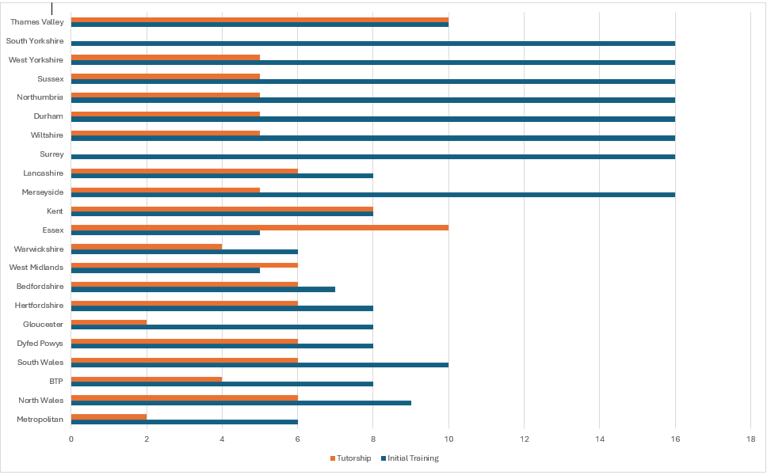
*Only the police forces that have 16 weeks initial training implement the Level 4 Community Policing Practice qualification.
The graph also shows the disparity between training schedules ranging from 5 weeks initial training to 16 weeks for the Level 4 Diploma in Community Policing Practice and the difference in the time spent with experienced tutors to complete a competency-based portfolio. The research also found that only the English police forces have implemented the qualification, which could be affected by the differences in funding by the Home Office.
‘For Welsh forces, although policing responsibility rests with the Home Office, skills policy is devolved to the Welsh Government, who do not have to spend the revenue received from the levy on Welsh apprenticeships.’ Police Federation, 2019.

The funding was approved in 2019, and accreditation was provided by Skills for Justice “The PCSO Apprenticeship Framework for Police Community Support Officers in Wales was also recently published on the AFO and is now available for forces recruiting to this role”. Skills for Justice, 2019.
The reasons why police forces in Wales don’t implement the PCSO apprenticeship are wide ranging and include the size of the force-not having the resources to implement a 12-month qualification to the value gained by the organisation as the attrition rate is relatively high for PCSO’s.
One of the PCSO’s in Gwent explained in a qualitative interview that he was leaving after 15 months to further his career as Police Constable as he felt that there was no progression in the role of a PCSO. He further explained that he felt frustrated with the lack of powers in some situations and originally entered the role to use it as a stepping stone to become a PC. PCSO Luca.
Discussion
The Police Education Qualification Framework (PEQF) academic route has recently been evaluated by the College of Policing as the attrition rate of police officers was deemed to be too high, as many of the trainees were leaving the role imminently after completion of the classroom-based training. The PEQF route required every officer to obtain a degree in Policing Practice which took 3 years to complete. The operational demands on the trainee officer became so great that it caused stress, anxiety and affected the quality of life of the trainees having to work a demanding role full time and study during their rest days.

Hefty cost implications were caused by those trainees leaving the force as each officer in training costs roughly £60,000 therefore from March this year the College of Policing has introduced the Police Constable Entry Programme (PCEP) which has seen an increase in the number of applicants applying for the role. The PCEP entry route focusses on more knowledge gained through practical application and is a shorter term at Level 5. This has proven that many adults entering this profession were deterred from joining due to academic learning and preferred to learn ‘on the job’ through experience, therefore it is vital to consider the theory of Malcolm Knowles and the six assumptions of andragogy: motivation to learn, orientation to learn, readiness to learn, experience, self-concept and the need to know.

The new PCEP course provides more of a learner centred practical approach through role play, scenario’s simulations and applying their own experience which they can then reflect and learn through new experiences as Kolb (1984) suggests in the experiential learning cycle. Dr Serhat Kurt, (2022) also believes that ‘Kolb’s Theory focused on learning styles, or the cognitive processes that occurred in order for acquire knowledge’.

Although the PCSO PEQF Level 4 apprenticeship routes are over a 12-month period, the learning is at a lower level so may not be such a barrier for those who struggle with academic learning.
Creating a standard curriculum will as Avis Fisher and Thompson, 2019, p.114 suggest that ‘a curriculum encapsulates the teaching and learning methods used’. The planning and design of curriculums also consider content, assessment strategies, resources and evaluation therefore allowing for clear objectives for the learning outcomes. Furthermore, standardisation creates a ‘process which ensures that all staff, for example: teachers; trainers; assessors; and quality assurers interpret and follow the requirements of the programme or qualification in the same way’. Gravells, Ann.
If powers were to be standardised, then all learners of the PCSO entry route will be trained with the same content in the same way as Police Constables currently are.
Having consistency of powers would enable a national standard of operational training that is required for the learners to build the knowledge and skills for their ‘day to day’ tasks.

The Level 4 Diploma in Community Policing Practice provides an element of a national training standard for PCSO’s and the College of Policing (2023) states that ‘it is essential that the underpinning knowledge and understanding associated with performance of the PCSO be intrinsically connected to application in the workplace’. This is true to a certain extent with the general topics covered within the training programme for example, national decision model, equality, diversity and inclusion, professional standards, communication, vulnerability and risk, team-working and problem solving, however the training does not consider the variances of powers between forces that have a drastic effect on the training and assessment timescales.
A PCSO interviewed in Gwent was previously a PCSO in South Wales police stated, “we received 10 weeks training which included learning definitions of burglary and theft which has no relevance to the PCSO role” PCSO Damon.
When creating a national programme, it is important to include the relevant knowledge but also to meet the needs of the learner. Maslow’s hierarchy of needs suggests that human motivation for learning includes esteem and self-actualisation and should be considered to ensure the learner can have achievement, self-fulfilment, personal growth and respect in the workplace.
Another PCSO interviewed in Gwent Police suggested that they “would like to have a recognised qualification as it shows achievement and professionalism for the role” PCSO Toby.
Therefore, having a recognised Level 4 qualification that incorporates PCSO standard powers meets the needs of the organisation and that of the trainee.
Assessment strategies are essential when considering learner achievement and currently they vary drastically between forces depending on whether the training is accredited or provided internally by each force. The previous chart showed the length of tutorship varies greatly between forces and again this is affected by the number of designated powers as the criteria is different for each police force who do not follow the PEQF programme. The assessment criteria also differ with the Level 4 apprenticeships as the diagram below shows:
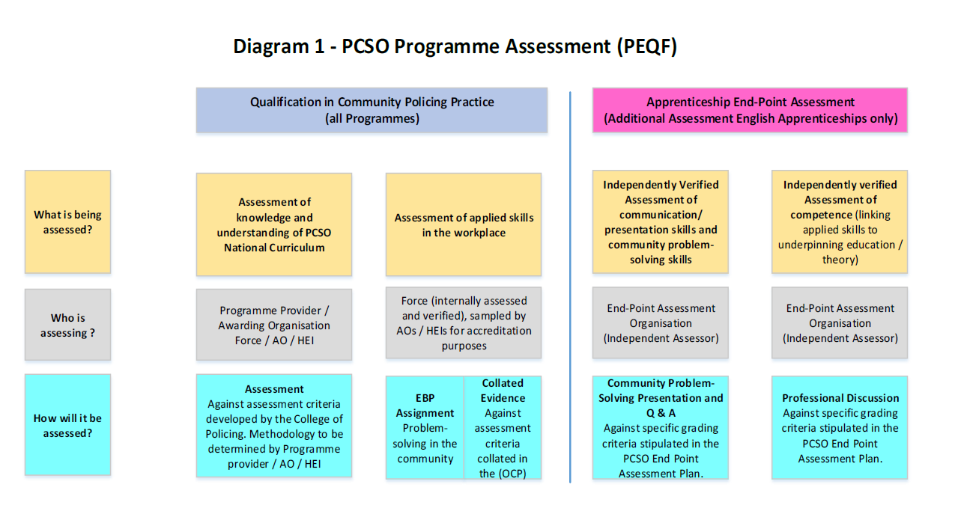
College of Policing PEQF: Curriculum, Qualification and Assessment: PCSO (2023)
The assessment practices detailed above do not specify methods of assessment which can be determined by the programme providers which can vary between forces. I attended Sussex Police last year for collaboration on PCSO training and assessment as they deliver the Level 4 Diploma in Community Policing Practice and found that most of the assessments took the form of written assignments apart from managing conflict that was practical based assessed scenarios. After speaking to some of the trainees to gather qualitative data, the overall opinion was that they were enjoying the training as they were gaining the wider knowledge of the role but that it lacked the day-to-day skills training that they believed were crucial to carry out the role.
Many of the forces that responded to my benchmarking request showed that there is a variety of assessment methods being used for their PCSO training which can affect learning outcomes. Duckworth, V. (2014, p.128) believes that ‘assessment should take place at every stage of the learning process, and it should be fairly frequent’ therefore a mixture of assessment methods to include formative, summative and ipsative would be preferred to both suit learner styles but also to best meet the learning objectives as per Blooms Taxonomy and learning domains – cognitive, affective and psychomotor.
Technology.
The assessment methods currently used by police forces include, knowledge checks, role plays, simulation, summative tests, written assignments and criterion-referenced assessments. Many of the forces reported only using minimal technology within their assessment strategy which includes Microsoft Forms, Virtual Reality kits, e-learning packages and the use of Hydra facilities (simulation) with 2 forces stating that they don’t use any technology for assessment purposes.
It is understandable that police as public sector organisations are constrained with funding, however using technology has many benefits and can make more efficient use of time and resources for trainers. It will also enable a more inclusive learning experience for trainees whilst adhering to the Equality Act 2010 to support those with additional learning needs.
‘This shift towards technology-supported assessment practices offers numerous benefits, including instant feedback, diverse data collection, and the capacity to tailor assessments to individual learning styles and needs.’ Learning Mole, (2024)

There are many ways that police forces can improve their use of technology, for example,
- using ChatGPT can assist with creating quizzes,
- Mote can be used for assessing and improving the learners’ communication,
- Kahoot can be used for formative assessments,
- Duolingo for Welsh language,
- Prezi AI for project work.
New and emerging technology can improve the assessment experience for both trainer and learner and digital skills are essential for the role of a trainer and assessor. The College of Policing (2024) state that ‘The use of I.T. is a core skill’ and lists 5 levels for the use of I.T. for policing professionals, also as a police force in Wales we are required to maintain digital standards as the Welsh Government state:
‘Our National Mission for education in Wales is to raise standards and ensure that learners of all ages, abilities and backgrounds are equipped with the skills they need to succeed in their work and throughout their lives. Digital skills, and the confidence to use them appropriately, are already established as part of the suite of essential skills.’ Welsh Government (2019).

Creating a national training and assessment strategy with standardised powers would align the learning outcomes and allow for creativity of trainers to use technology in set areas to standardise the assessment practices for fairness and consistency across England and Wales.
Conclusion.
The decision to incorporate all designated powers nationally would generate more suitable trained PCSO’s to their forces and provide clarity to the public. This can be integrated into one Level 4 programme to allow professional development of the role and that PCSO’s would achieve a better outcome from the learning that would enhance their skills, knowledge and understanding of the complexities of modern front-line policing and community support.
The research has shown that PCSO’s benefit from both educational qualifications and from operational learning therefore standardising powers would enable both elements to be amalgamated into one national training and assessment programme that clarifies the role and responsibilities for England and Wales.
Word count: 3251.

References.
Avis, J. Fisher, R. and Thompson, R. (2019) Teaching in Lifelong Learning. A Guide to Theory and Practice. 3rd Edition. Open University Press.
Digital 2030. A strategic framework for post 16 digital learning in Wales. Welsh Government (2019) Available at: www.gov.wales/sites/default/files/publications/2019-06/digital-2030-a-strategic-framework-for-post-16-digital-learning-in-wales.pdf Accessed 21/05/25).
Duckworth, V. (2014) How to be a Brilliant FE Teacher. A Practical Guide to Being Effective and Innovative. Routledge.
Gravells, Ann. (No date) Available at: www.anngravells.com/information/standardisation (Accessed 11/05/25).
Guidance on Police Community Support Officers. (1st September 2007) Association of Chief of Police Officer of England, Wales and Northern Ireland. Available at: www.assets.publishing.service.gov.uk/media/5a7b0087ed915d429748c169/ACPO_guidance.pdf (Accessed 16/05/2025).
Kurt, S. (28th December 2020- updated 25th September 2022. Kolb’s Experiential learning theory & Learning styles. Educational Technology.). Available at: www.educationaltechnology.net/kolbs-experiential-learning-theory-learning-styles/ (Accessed: 21/05/2025).
New Police Apprenticeships in Wales. Skills for Justice. (Published 26/04/19) Available at: www.skillsforjustice.org.uk/news-insights/new-police-apprenticeship-frameworks-in-wales-published (Accessed: 21/05/25)
O’Neill, M. (2014) PCSOs as the Paraprofessionals of Policing: findings and recommendations from a research project. Available at: www.discovery.dundee.ac.uk/ws/portalfiles/portal/5723855/PCSO_project_report_final2b.pdf (Accessed 13/05/25).
PEQF; Police Community Support Officer (PCSO) Entry Routes. (2023). College of Policing Unpublished (Accessed: 20/05/2025).
PCSO Powers. (27 June 2012). Home Office UK Government, Available at: www.gov.uk/government/publications/police-community-support-officer-powers (Accessed 16/05/25).
Strong, J. (February 2019). Police Education Qualification Framework (PEQF) Implementation Research and briefing policy support document. Police Federation. Available at: www.polfed.org/Wilts/media/1580/policing-eductation-qualifications-framework-faqs.pdf (Accessed: 16/05/25)
Use of I.T. College of Policing (2024) Available at: www.college.police.uk/career-learning/support-for-career-development/core-skills/use-of-it#a8d8439c-be22-44a9-8553-2116cb72cf27 Accessed: 21/05/25.
Using Technology for Efficient Assessment Practices: Streamlining Student Evaluations. Learning Mole. (9th November 2024). Available at: www.learningmole.com/technology-for-efficient-assessment-practices/ (Accessed: 21/05/25).

