Eren Kulahlioglu
2513628
Name: Eren Kulahlioglu
Student No: 2513628
Course Name: Computing Skills for the Workplace (CertHE)
Module Name: Computer Architecture and Operating Systems
Date: 28.04.2026
Computer Architecture and Operating Systems (ACCA4022_LON)
Assessment 2 - FEB 2026
Table of Contents
1. Introduction 2
2. Key Functions of General Operating Systems 2
3. Use of macOS (Unix) CLI Commands 4
Process Management 5
File & Directory Management 5
Network Testing/Monitoring 6
User Management 8
Task Scheduling 8
4. Use of Linux OS CLI Commands 9
Process Management 10
File & Directory Management 11
Network Testing/Monitoring 12
User Management 12
Task Scheduling 13
5. Use of macOS (Shell) Scripts 14
Script 1: User Age Calculator and Access Checker 14
Script 2: Automated Countdown Timer 15
6. Use of Linux OS Scripts 16
Script 1: Multiplication Table Generator 17
Script 2: Even or Odd Number Checker 17
7. Conclusion 17
8. Reference List 18
9. Appendices 18

Introduction
Operating systems are the most important software layer in modern computer architecture. They are the link between hardware resources and user applications [1]. The main job of an operating system is to make it possible to run programs in a safe, reliable, and efficient way while hiding the complexities of the hardware. This report looks at the main features of general-purpose operating systems and shows how to use them in real life. This report will focus on command-line administration and scripting in macOS (Unix), windows,s and Linux environments because more and more people are using Unix based systems these days. This assesment shows how to make administrative tasks, resource monitoring, and system automation more efficient by looking at these systems.

Key Functions of General Operating Systems
General-purpose operating systems, like macOS, Microsoft Windows, and Linux distributions, are made to meet a variety of user needs, personal computing and running servers for business. These systems are able to do many things because they have a number of core functions that work together. Silberschatz et al. [2] say that the main jobs of an OS are managing processes, memory, the file system, and device input/output.
Managing processes: The OS is in charge of making, scheduling, and ending processes. A process is basically a program that is running. The OS uses scheduling algorithms to give these processes CPU time so that the user doesn't notice any interruptions when they're doing multiple things at once. In macOS, the Activity Monitor lets administrators see active threads, process IDs (PIDs), and CPU usage per application [3].
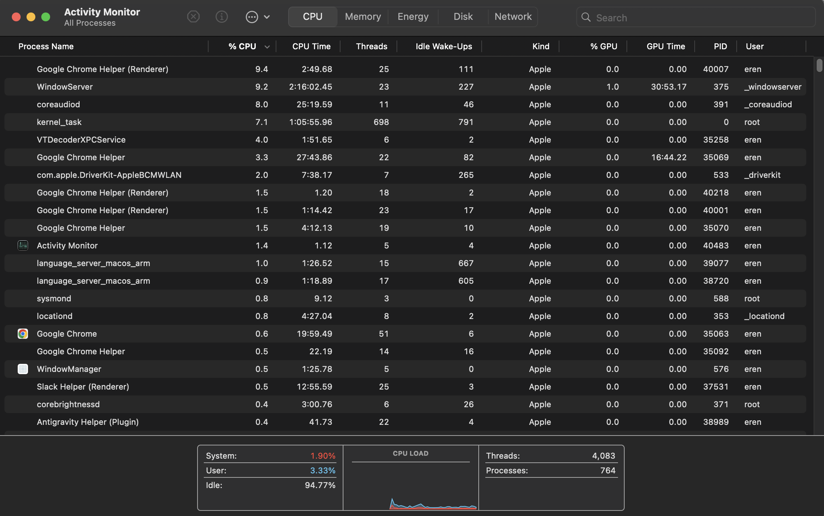

Memory Management: RAM, or main memory, is a volatile resource that needs to be carefully shared among processes that are running. The operating system keeps track of which parts of memory are being used, gives memory to a process when it asks for it, and takes memory back when the process ends. Virtual memory and swap files are two ways that systems can run programs that are bigger than the physical RAM they have available [2].
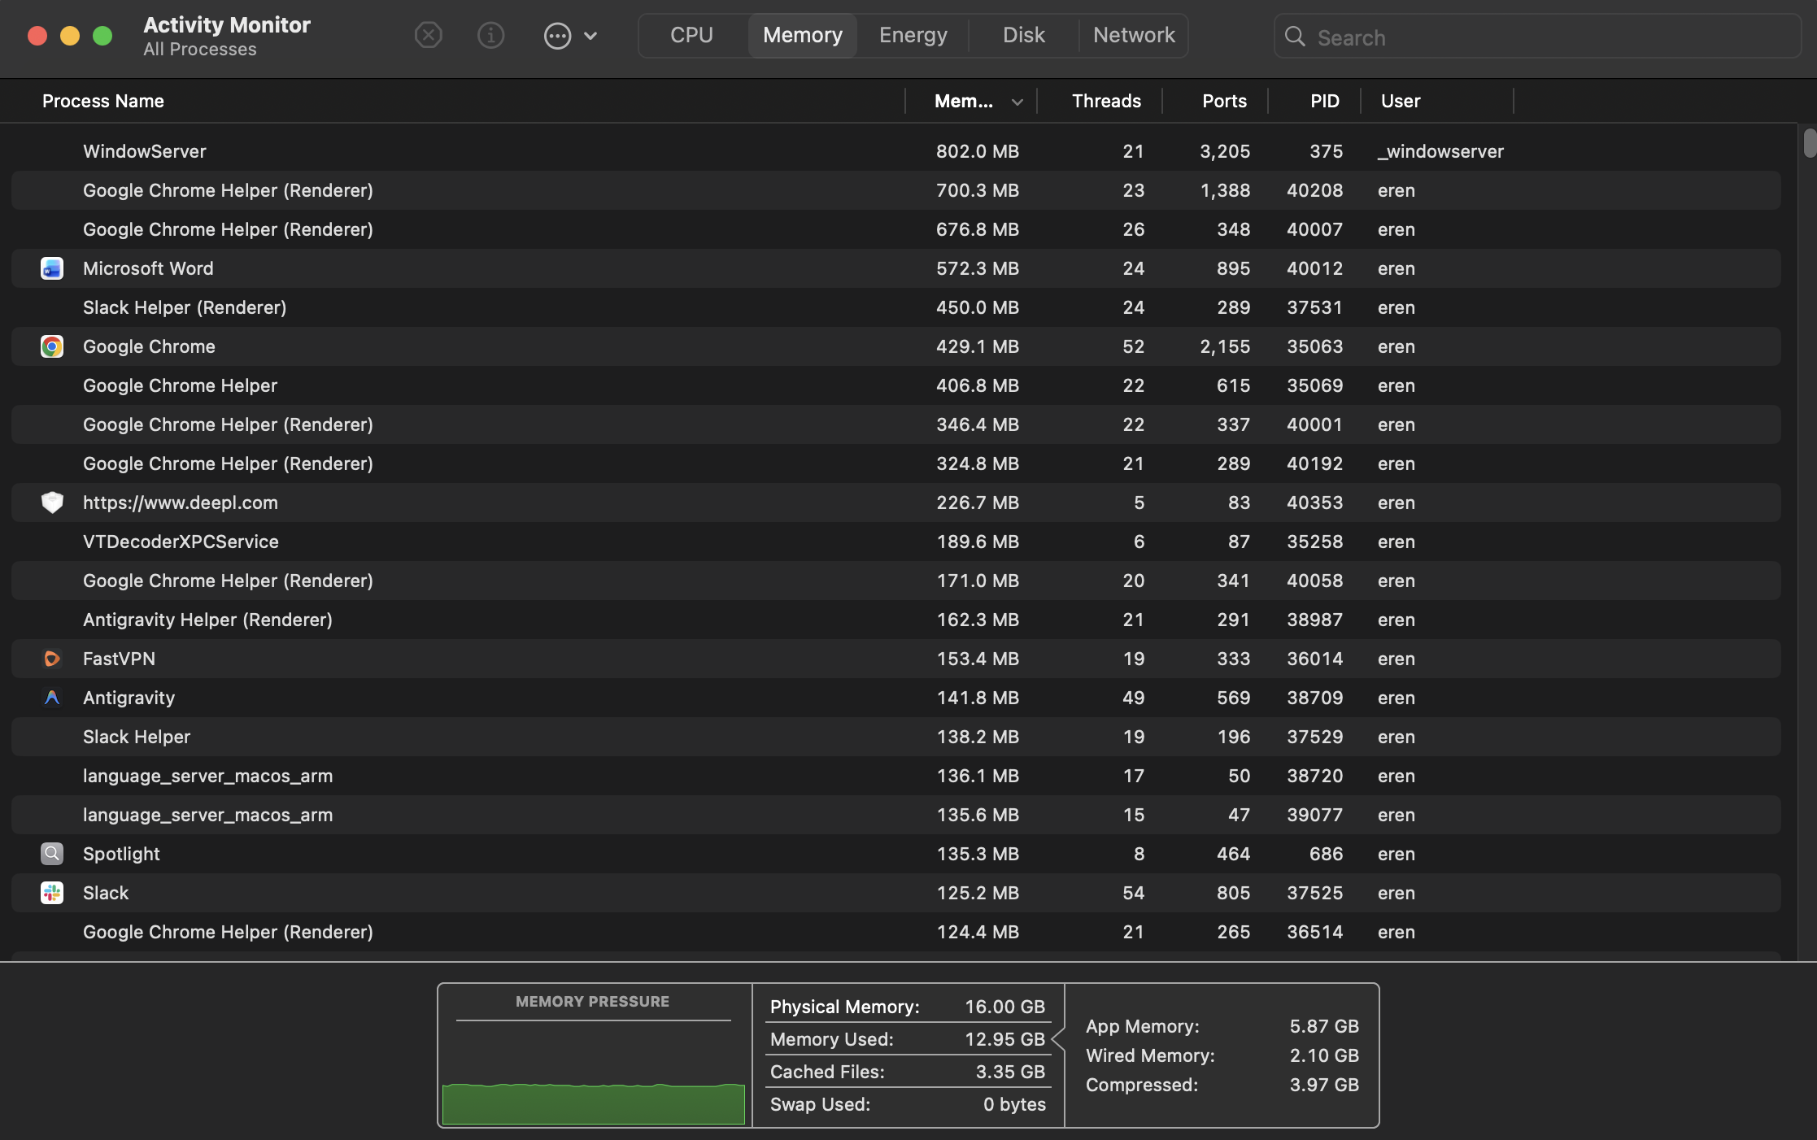

File and Directory Management: An OS turns physical storage devices into a logical view of files and directories. It makes, deletes, reads, writes, and organises files. It also enforces strict access control and POSIX permissions to keep data safe and users separate [1].
Device Management (I/O Control): Operating systems use device drivers to talk to hardware peripherals. The OS uses buffers, caches, and spooling to deal with the speed differences between the fast CPU and the slower Input output devices, like external drives or network cards.
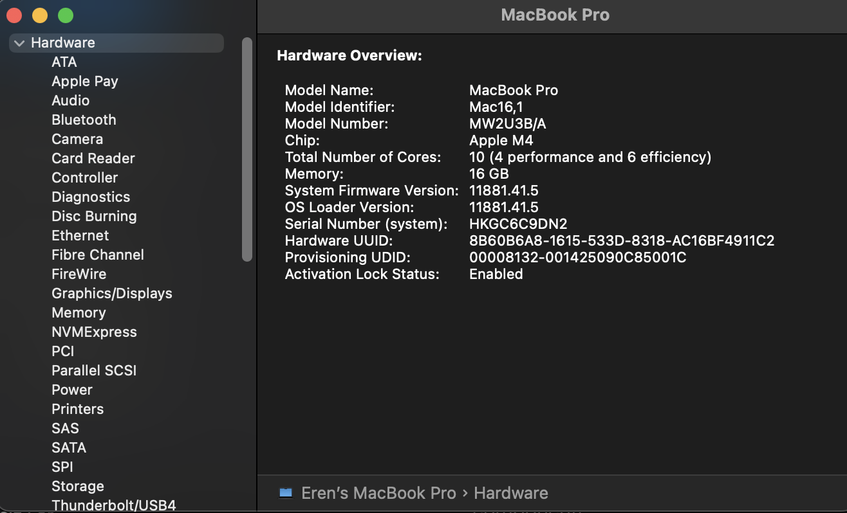
All of these functions work together to make sure that system resources are used well. This stops rogue apps from taking over the CPU and unauthorised users from getting to system files that are off-limits.

3. Use of macOS (Unix) CLI Commands
Command Line Interfaces give system administrators exact control over system resources. macOS runs in a Unix based environment, which is mostly the zsh shell on newer versions. This environment is similar to Linux but has its own set of administrative tools [4].
Here is a list of 12 different macOS terminal commands.

Process Management
- top: Displays sorted information about processes.
  - Command: top -o cpu -n 5
  - Displays the top 5 active processes, dynamically sorted by their CPU usage, allowing administrators to identify resource bottlenecks.
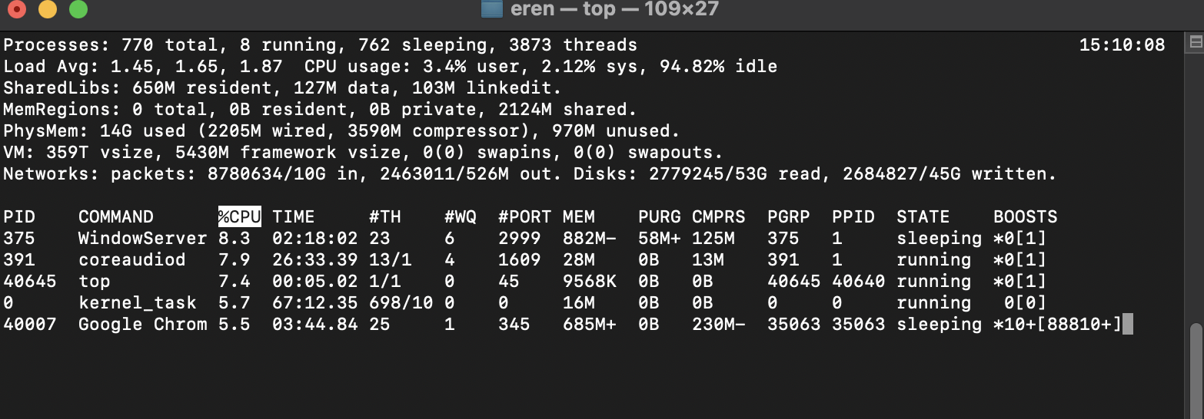
- killall: Terminates all processes associated with a specific name.
  - Command: killall Safari
  - Forcibly quits all running instances of the Safari browser without needing to know the specific Process ID (PID).

File & Directory Management
- ls: Lists directory contents.
  - Command: ls -laO ~/Documents
  - Lists all files in the user's Documents folder, including hidden files (-a), in a long format (-l), and shows file flags (-O) which are specific to macOS file metadata.
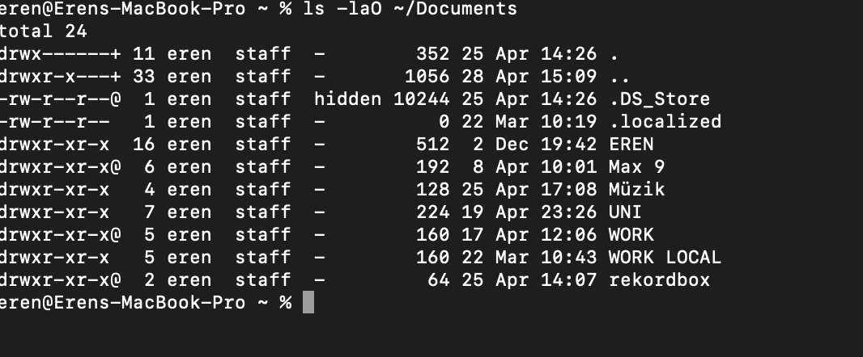
- mkdir & touch: Creates directories and empty files.
  - Command: mkdir -p ~/TestFolder && touch ~/TestFolder/system_log.txt
  - Creates a new folder and instantly creates an empty text file named system_log.txt inside it using the logical AND operator.
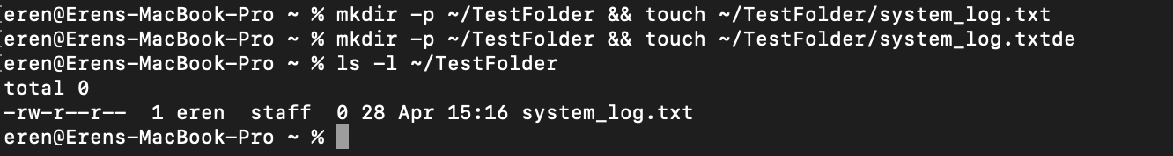
- cp: Copies files and directories.
  - Command: cp -R ~/TestFolder ~/BackupFolder
  - Recursively (-R) copies the entire folder and its contents to a new backup location.
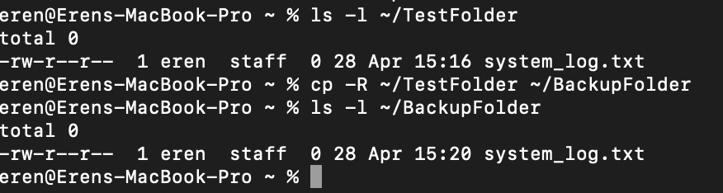

Network Testing/Monitoring
- ping: Tests reachability of a host on an IP network.
  - Command: ping -c 4 apple.com
  - Sends exactly 4 ICMP echo requests to Apple's servers to test network connectivity and measure latency.
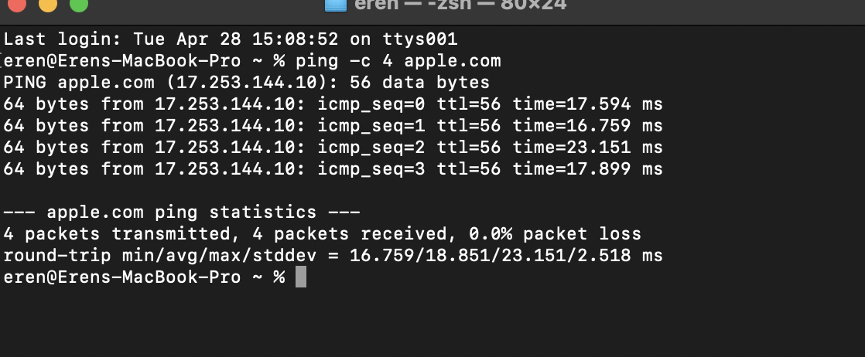

- traceroute: Prints the route packets trace to a network host.
  - Command: traceroute -q 1 google.com
  - Traces the network path to Google, sending only 1 probe per hop (-q 1) to speed up the terminal output.
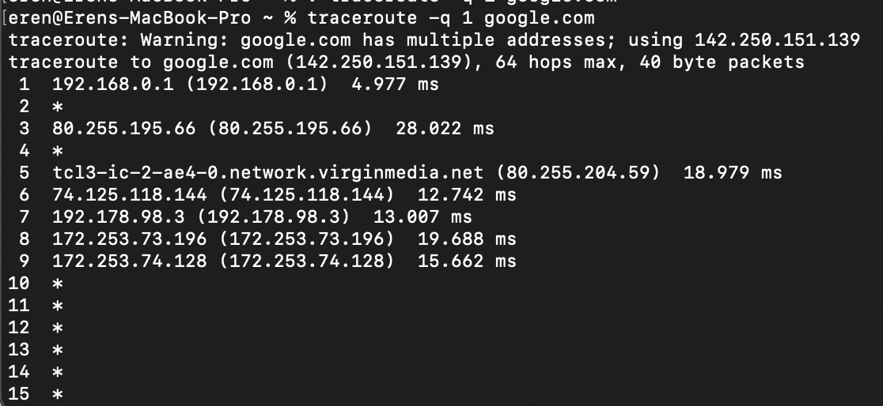
- lsof: Lists open files and network connections.
  - Command: lsof -i -P -n | grep LISTEN
  - A powerful macOS alternative to Linux's netstat that lists all currently open network ports actively listening for incoming connections.
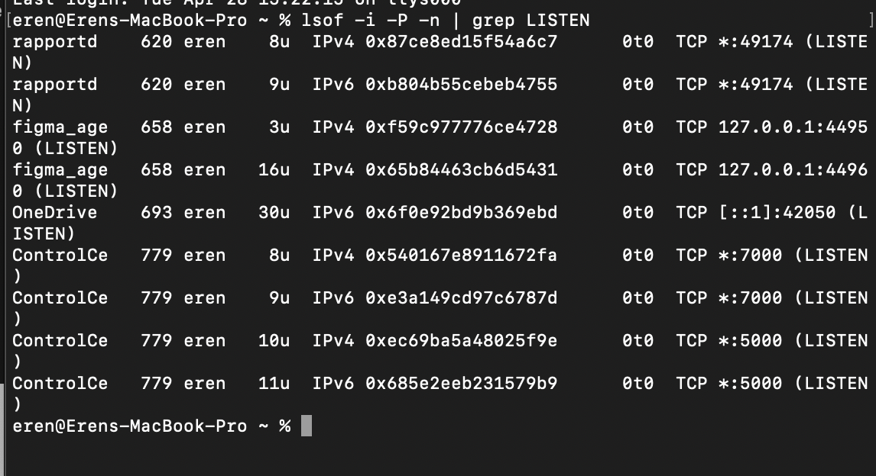

User Management
- dscl: Directory Service command line utility.
  - Command: dscl . -list /Users | grep -v '^_'
  - Lists all human user accounts on the Mac, filtering out (grep -v) hidden system service accounts that start with an underscore.
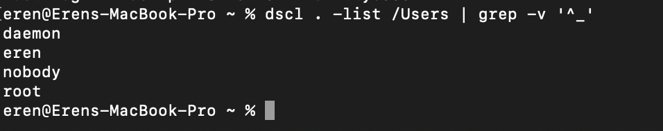
- sysadminctl: macOS specific tool for managing system accounts.
  - Command: sudo sysadminctl -addUser testuser -fullName "Test Account" -password "Pass123"
  - Creates a new local user account directly from the terminal (requires administrator privileges via sudo).
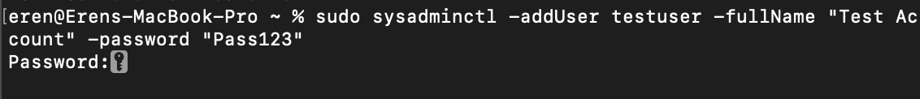

Task Scheduling
- crontab: Schedules periodic background jobs.
  - Command: crontab -l
  - Lists the current user's scheduled cron jobs for basic automation.
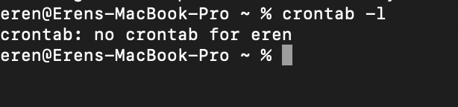
- launchctl: Interfaces with launchd, the macOS service management framework.
  - Command: launchctl list | grep com.apple
  - Lists background services and daemons currently loaded by the macOS system, filtering for Apple's built-in services.
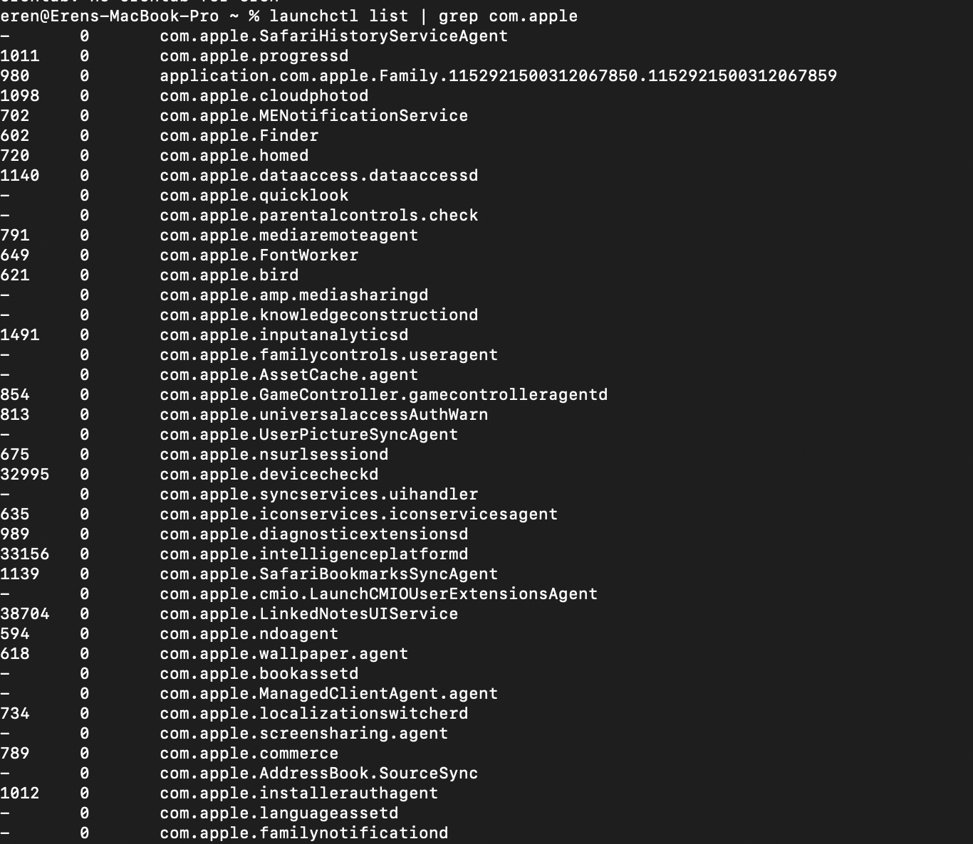

4. Use of Linux OS CLI Commands
Linux servers are the most common type of server in businesses, while macOS gives users a Unix-like experience [5].
The next 12 commands show how to manage a system in a normal Linux Bash environment. (Note: I used the TutorialsPoint Online Linux Terminal environment at https://www.tutorialspoint.com/compilers/online-linux-terminal.htm to run, test, and document the following Linux specific commands. My main computer runs macOS.

Process Management
- top: Provides a dynamic real-time view of a running system.
  - Command: top -b -n 1
  - Uses batch mode (-b) for exactly one iteration (-n 1) to instantly print the current CPU and RAM usage of active processes directly to the screen.
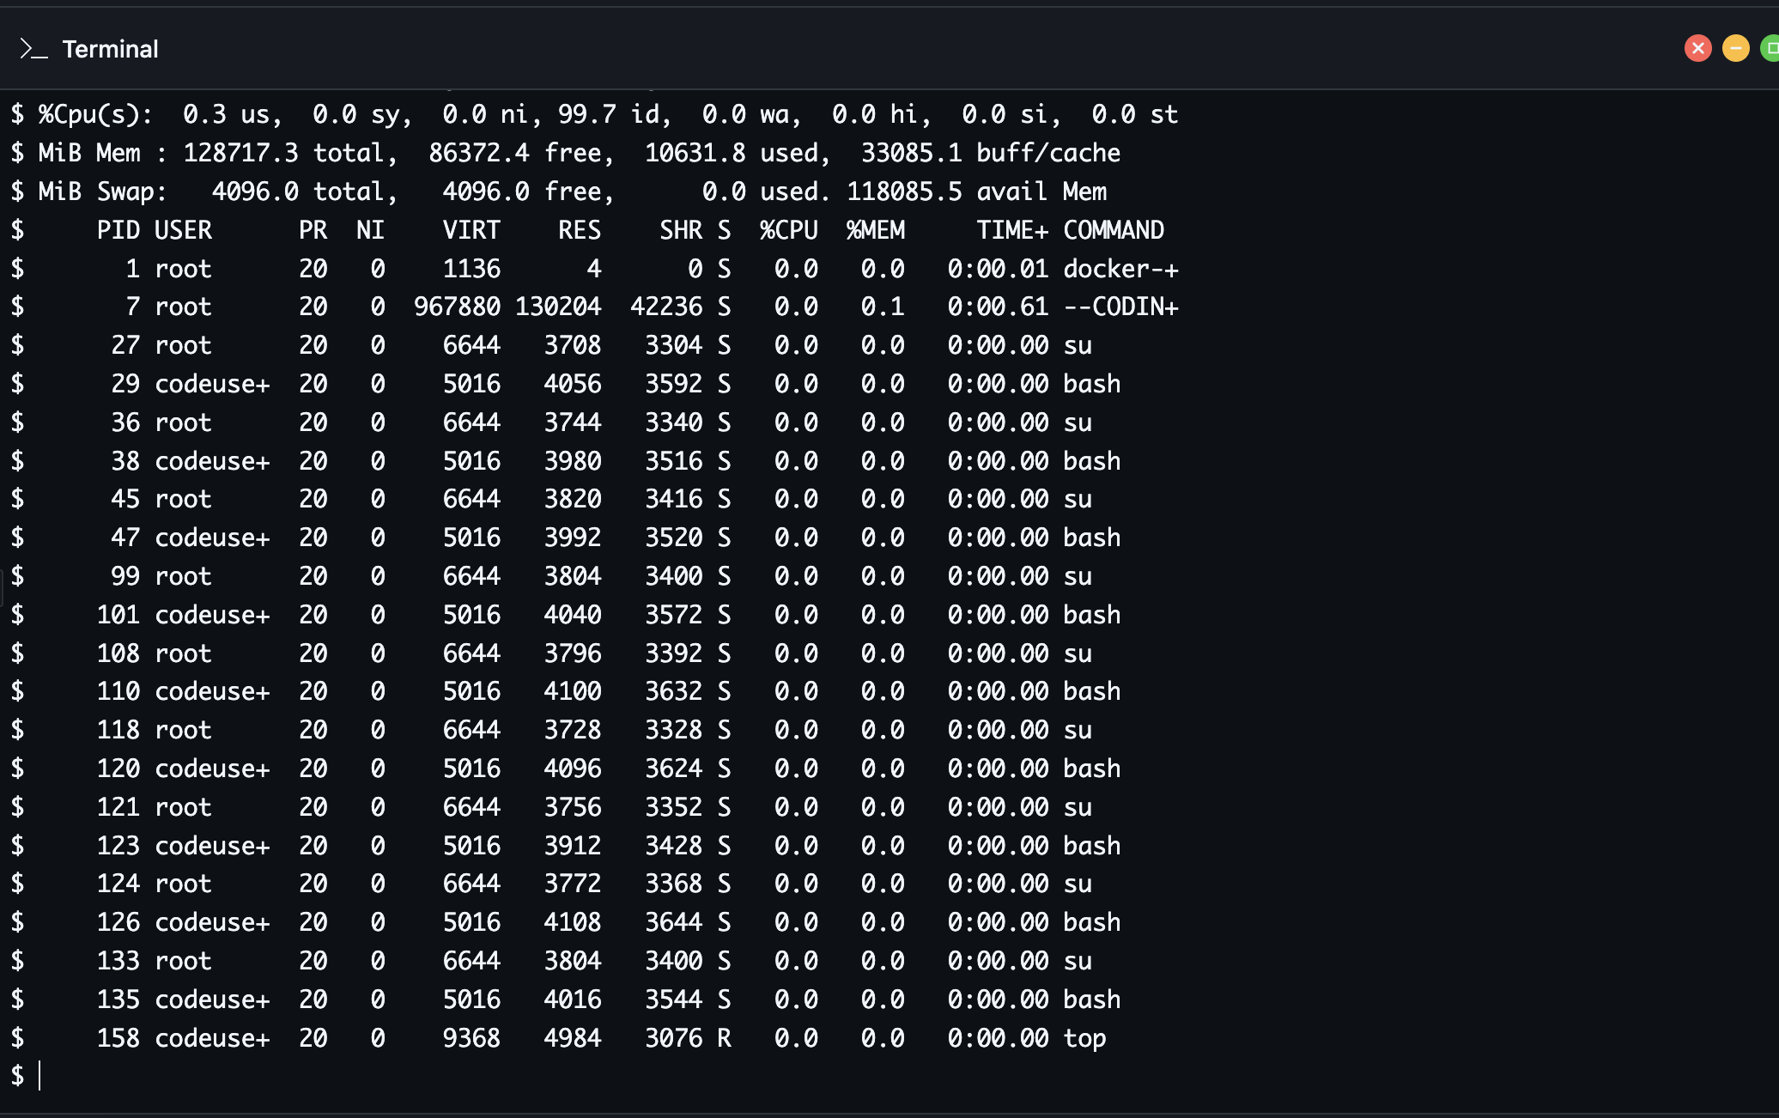
- ps: Reports a snapshot of current processes.
  - Command: ps -ef | head -n 5
  - Lists detailed standard formatting (-ef) of processes, piped to head to display only the top 5 lines for a clean overview.
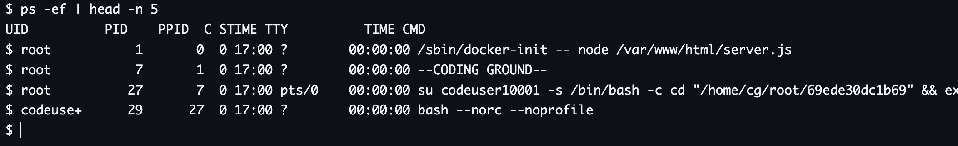

- uptime: Tells how long the system has been running.
  - Command: uptime -p
  - Shows the system's active running time in a pretty (-p), human-readable format, which is crucial for monitoring server health.
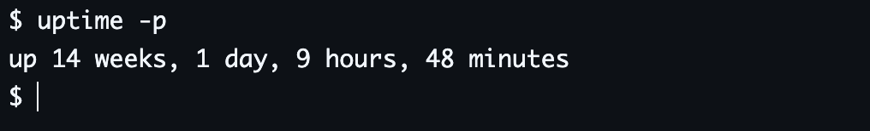

File & Directory Management
- ls: Lists directory contents.
  - Command: ls -lah /etc/ | head -n 6
  - Lists files in the /etc directory with human-readable sizes (-h), showing all files (-a) in long format (-l), limited to the first 6 entries.
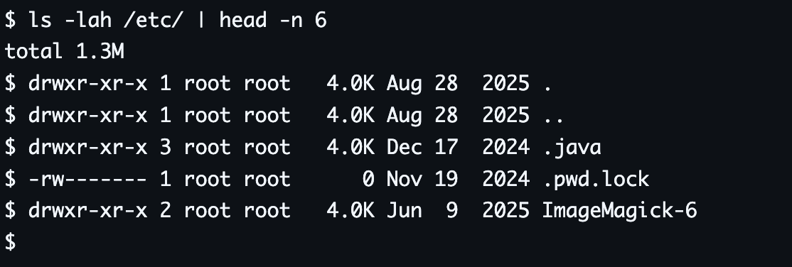
- mkdir: Makes directories.
  - Command: mkdir -v -p /tmp/my_new_project
  - Creates a new directory path. The verbose switch (-v) forces the terminal to print a visual confirmation message that the directory was successfully created.
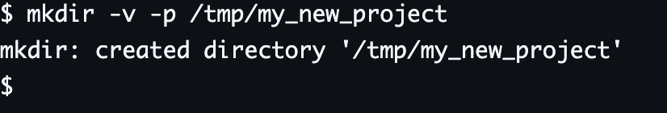
- pwd: Print name of current/working directory.
  - Command: pwd -P
  - Prints the absolute physical path (-P) of the current working directory, avoiding any symlinks.
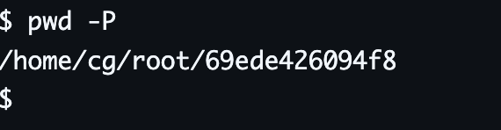

Network Testing/Monitoring
- ping: Sends ICMP ECHO_REQUEST to network hosts.
  - Command: ping -c 3 google.com
  - Tests network connectivity by sending exactly 3 packets (-c 3) to Google, displaying the response time and packet loss statistics on screen.
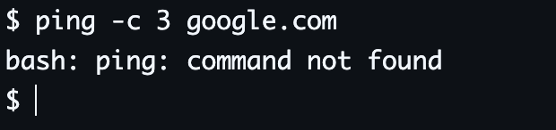
- ip: Show / manipulate routing, network devices, interfaces.
  - Command: ip -4 addr show
  - A modern replacement for ifconfig. It visually displays the IPv4 (-4) network addresses assigned to the system's network interfaces.
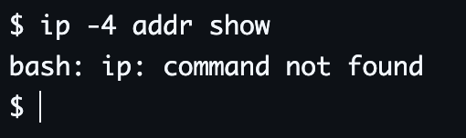

User Management
- whoami: Print effective userid.
  - Command: whoami --version
  - Prints the current active username to the screen, verifying the user context currently operating the shell.
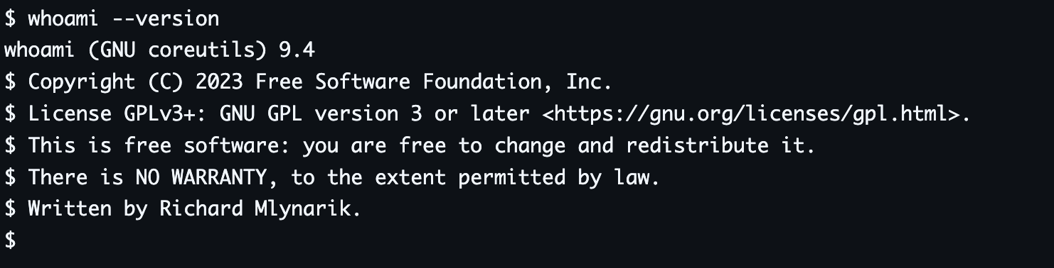
- cat (Viewing User Files): Concatenate files and print on the standard output.
  - Command: cat /etc/passwd | tail -n 4
  - Reads the system's central user database file (/etc/passwd) and displays only the last 4 user accounts (tail -n 4) created on the system.
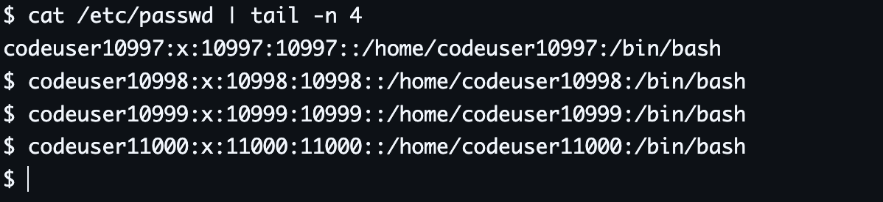

Task Scheduling
- crontab: Maintains crontab files for individual users.
  - Command: crontab -l
  - Lists (-l) the currently scheduled cron background jobs, visually confirming whether tasks are pending or if the schedule is empty.
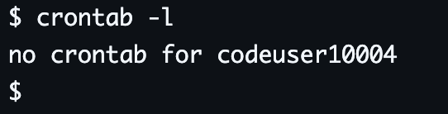
- sleep: Delay for a specified amount of time (used for basic job scheduling).
  - Command: sleep 10 &
  - Schedules a task to wait for 10 seconds. The ampersand (&) sends the task to the background, immediately printing the scheduled background Job ID and Process ID to the screen.
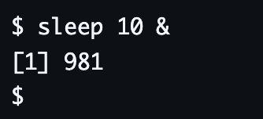

5. Use of macOS (Shell) Scripts
Administrators can use scripting to combine CLI commands with logic to automate boring tasks. Here are two working macOS shell scripts (in zsh) that show how automation can be useful.

Script 1: User Age Calculator and Access Checker
This simple script shows how to get user input, save it in variables, do a simple math problem to figure out the user's age, and use an if/else statement to figure out who can access the system.

#!/bin/zsh

echo "--- Welcome to the System Checker ---"

echo -n "Please enter your name: "
read USER_NAME

echo -n "Enter your birth year (e.g., 2000): "
read BIRTH_YEAR

CURRENT_YEAR=2026
AGE=$((CURRENT_YEAR - BIRTH_YEAR))

# 3. Output and Conditional statement
echo "Hello, $USER_NAME! You are $AGE years old."

if [ $AGE -ge 18 ]; then
echo "Status: You are an adult. System access granted."
else
echo "Status: You are a minor. System access restricted."
fi

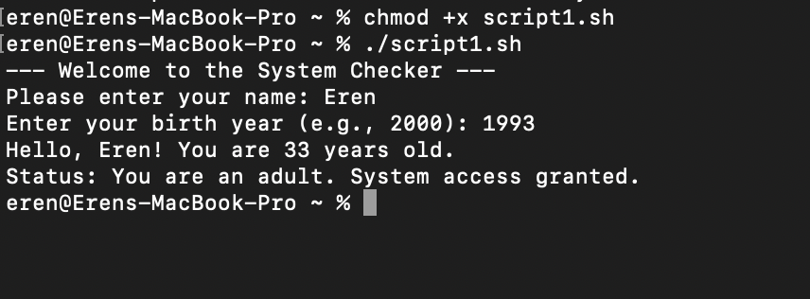

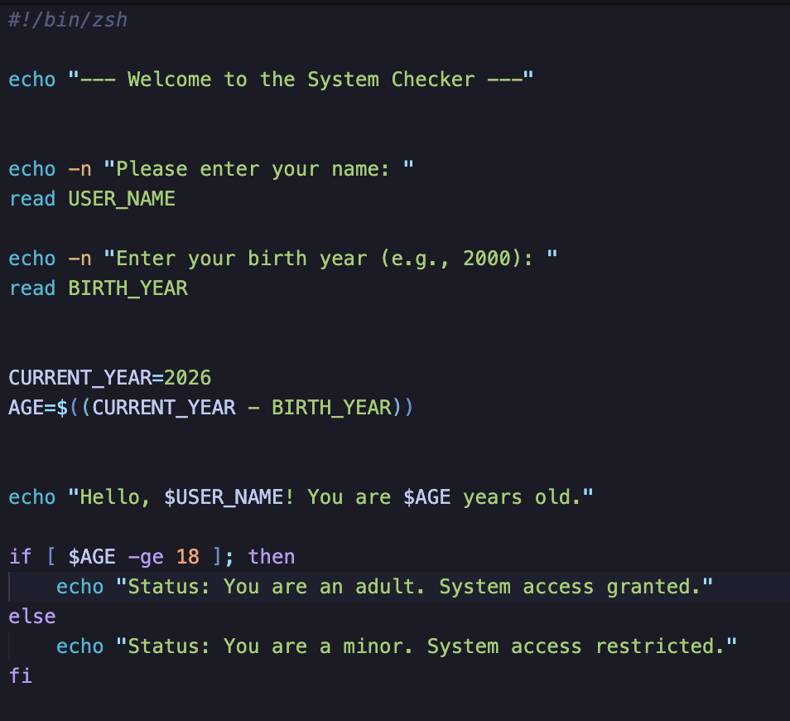

Script 2: Automated Countdown Timer
This script shows how to make a working countdown timer by taking numbers from the user and using a while loop with arithmetic subtraction.
echo "--- System Countdown Initiated ---"

echo -n "Enter a number to start the countdown (e.g., 5): "
read COUNT

echo "Starting countdown..."

while [ $COUNT -gt 0 ]; do
echo "Time remaining: $COUNT seconds"
# Arithmetic subtraction
COUNT=$((COUNT - 1))
# Pause for 1 second
sleep 1
done

echo "Countdown complete! System tasks can now proceed."

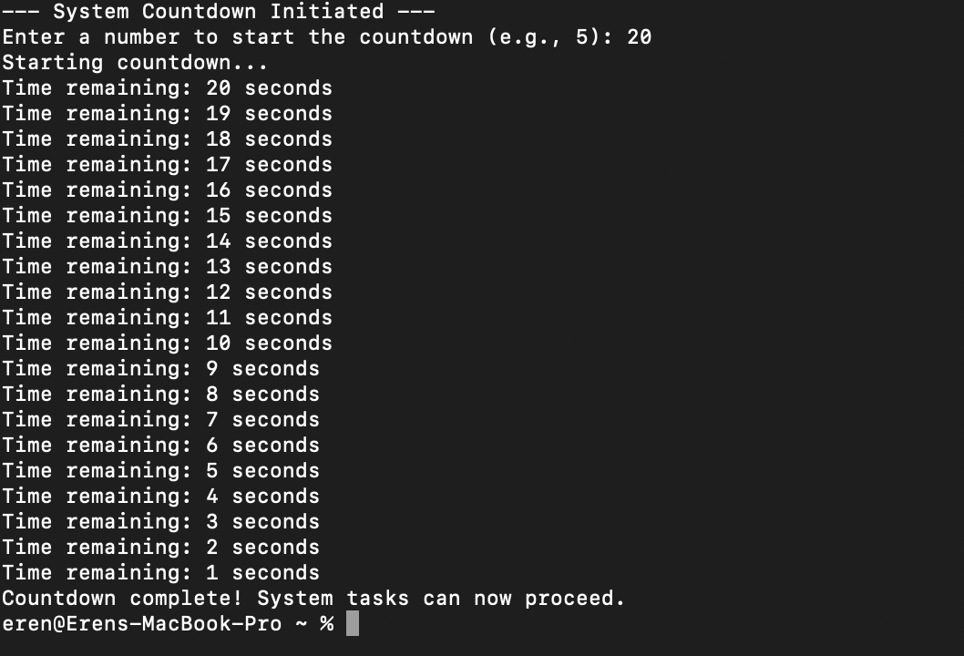

6. Use of Linux OS Scripts
We can use loops, conditionals, and standard Linux utilities to automate complicated tasks with Linux Bash scripting. The next two Bash scripts show basic automation logic that works in a Linux environment. (These scripts were tested and written down using the TutorialsPoint Online Linux Terminal.)

Script 1: Multiplication Table Generator
This script logic shows how to use variables, simulated user input, a for loop, and math operations to make a math table automatically.
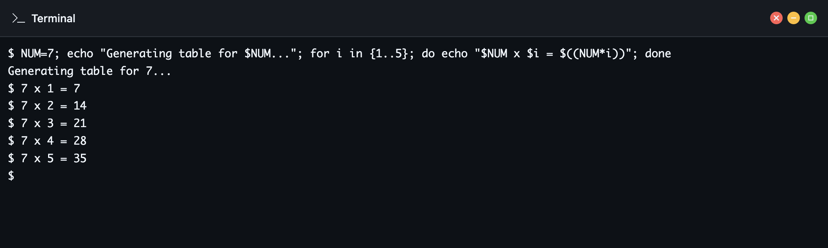

Script 2: Even or Odd Number Checker
This script logic demonstrates the use of variables, simulated user input, the modulo arithmetic operator, and an if/else conditional statement to determine if a number is even or odd.
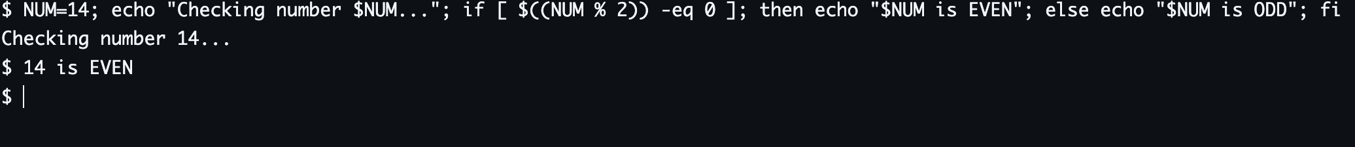

7. Conclusion
This assessment has thoroughly the fundamental principles and operational management of contemporary general-purpose operating systems. We can see that the OS is very important for hardware abstraction and resource allocation by looking at its core functions, which include process, memory, and file management. The hands-on exercises using Unix-based environments (macOS zsh and Linux Bash) showed that command-line interfaces are much more efficient and precise than standard Graphical User Interfaces for system diagnostics, user management, and network monitoring.

The creation of automation scripts also showed how important scripting is for modern system administration. By using variables, logical conditionals, mathematical operations, and loops, administrators can automate routine maintenance tasks like making reports, doing math, and checking the state of the system. This not only lowers the chance of human error, but it also greatly improves the efficiency of operations. To be good at managing IT infrastructure, you need to know how to use these CLI environments and scripting methods.

8. Reference List

[1] W. Stallings, Operating Systems: Internals and Design Principles, 9th ed. Pearson, 2017.
[2] A. Silberschatz, P. B. Galvin, and G. Gagne, Operating System Concepts, 10th ed. Wiley, 2018.
[3] Apple Inc., "View CPU activity in Activity Monitor on Mac," Apple Support, 2024. [Online]. Available: https://support.apple.com/guide/activity-monitor/view-cpu-activity-actmntr1004/mac. [Accessed: April 28, 2026].
[4] Apple Inc., "Use zsh as the default shell on your Mac," Apple Support, 2023. [Online]. Available: https://support.apple.com/en-us/HT208050. [Accessed: April 28, 2026].
[5] W. E. Shotts Jr., The Linux Command Line: A Complete Introduction, 2nd ed. No Starch Press, 2019.

9. Appendices
Tutorial Activity
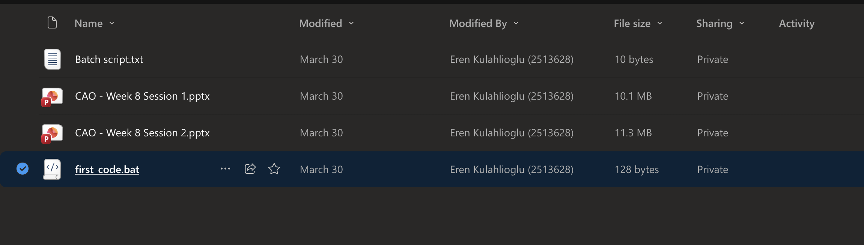
@echo off
set /A a = 6
set /A b = 6
echo a = %a%
echo b = %b%
set /A sum = a * b
echo sum=%sum%
Pause

Engagement with Google online certified course




