University of Wales Trinity Saint David (UWTSD)
Birmingham campus

Software Solutions for Business
Module Code: ACCA4026

Component 1 – Coursework: Portfolio
Contribution to Overall Module Assessment: 100%

Programme of Study: CertHE Computing Skills for Workplace

Student Name: Malik Imran Javaid
Student ID Number: 2538963

Lecturers: Osman Elgawi | Mohd Syafiq Bin Zolkeply
Internal Verifier: Sadhana Jha

Date of Submission: 15/07/2026

Table of Contents
Table of Contents 1
1. Introduction 1
2. Task 1: e-Commerce Website Builders / Software Solutions 1
2.1 Shopify 1
2.2 Wix 1
3. Task 2: Mind Map of Contemporary Software Applications 1
3.1 What is Mind Mapping and its Benefits in Business 1
3.2 Mind Map of Contemporary Business Software Applications 1
4. Task 3: Office Applications for Creating, Storing, Presenting and Analysing Information 1
4.1 Microsoft Word 1
4.2 Microsoft PowerPoint 1
4.3 Microsoft Excel 1
4.4 Microsoft Access 1
4.5 Practical Testing of Two Microsoft Excel Features 1
4.5.1 Feature 1 – VLOOKUP Function 1
4.5.2 Feature 2 – PivotTable 1
5. Task 4: Communication and Collaboration Applications 1
5.1 Communication Application: Slack 1
5.2 Online Collaboration Application: Trello 1
5.3 Practical Testing of a Communication and a Collaboration Feature 1
5.3.1 Communication Feature – Creating a Channel and Posting a Message in Slack 1
5.3.2 Collaboration Feature – Creating a Kanban Board in Trello 1
6. Conclusion 1
7. References 1

1. Introduction
It would be hard to find a business today that does not depend on software in some way. Whether it is taking card payments, scheduling staff, or simply keeping a team in contact while working remotely, the tools a company uses quietly shape how well things actually run. This portfolio covers several of the main types of business software and tries to show not just what they do, but how and why they are used. I start with a comparison of two e-commerce website builders, Shopify and Wix. From there, I move on to mind mapping, what it is and how it helps, along with a mind map covering the main software categories businesses use. The portfolio then looks at four Microsoft Office applications with a practical test of two Excel features, before finishing with a communication tool (Slack) and a collaboration tool (Trello), each tested hands-on. All sources are recent and referenced throughout in IEEE format.

2. Task 1: e-Commerce Website Builders / Software Solutions
An e-commerce website builder is a platform that lets a business create and run an online shop without writing code. Most bundle their services together: a visual editor, secure payment processing, stock and order management, and some marketing tools into a single monthly subscription. Shopify and Wix are two of the best-known options, and I have looked at both below.

2.1 Shopify
Shopify is one of the bigger names in e-commerce. It launched in 2006 and has grown considerably since, and it now powers millions of active stores while holding just over twelve per cent of the US e-commerce market [1]. It runs as a hosted “software as a service” platform, which means Shopify manages the servers, security patches and SSL certificates, so the person running the store does not have to. Payment card compliance is handled, too; the platform meets Level 1 PCI DSS standards [2].
In terms of features, there is quite a lot on offer regardless of the size of the business:
- a drag-and-drop store builder with a wide selection of mobile-ready themes to choose from [2];
- built-in payments through Shopify Payments and a one-click checkout called Shop Pay, which has a good track record for reducing abandoned carts [1];
- stock and order management, multi-channel selling across Instagram, Facebook and Amazon, in-person selling via Shopify POS, and basic SEO and marketing tools [2];
- an App Store with thousands of third-party add-ons, plus newer AI features, Shopify Magic for generating content and a Sidekick assistant for sales analysis, added more recently [1], [2].
What Shopify does particularly well is scalability. A business can start on the cheapest plan and stay on the same platform through significant growth without ever needing to migrate, and around-the-clock support is available if something breaks [2]. That said, the pricing can catch people out. Choosing a payment provider other than Shopify Payments triggers an extra transaction fee on every order; the monthly subscription and paid apps stack up as the business grows, and going beyond the standard themes means learning Liquid, Shopify’s own template language, which is not particularly beginner-friendly [2].

2.2 Wix
Wix takes a different approach. It started as a general website builder and added e-commerce later, which shows in how it feels more design-focused and beginner-friendly than Shopify, even if it was not built exclusively around selling. Hundreds of thousands of online shops now run on it [3], and to access the e-commerce features, a business needs one of the paid plans, starting at around twenty-nine US dollars a month for the Core plan [3].
As for what it actually includes, Wix has a reasonable amount on offer. The feature that stands out most is the combination of a flexible drag-and-drop editor and an AI builder that can generate a complete store from a short setup questionnaire [3]. Beyond that:
- over five hundred templates and support for up to fifty thousand products, covering physical, digital and subscription formats [4];
- more than seventy payment options alongside a secure checkout, abandoned-cart recovery and automatic sales-tax calculation [3], [4];
- selling through Amazon, eBay and social channels, storefronts in over ninety languages, and a Printful integration for print-on-demand products [4];
- built-in SEO tools, which Wix claims can meaningfully increase a store’s monthly revenue, though that kind of self-reported figure is worth treating with some scepticism [3].
For a small or first-time seller, Wix is genuinely good value. Hosting, a blog, booking tools and email marketing all come bundled in the same package, and unlike Shopify, Wix does not add its own transaction fee on top of the payment processor’s standard charge [3], [4]. The limitations become more apparent at scale, though. It does not handle very high sales volumes as well as a platform built purely around e-commerce, changing your template once the site is live is not possible, and loading times can suffer if the site carries a lot of heavy content [3]. On balance, Wix suits smaller businesses and beginners who prioritise design and ease of use, while Shopify is the stronger fit for anyone planning serious growth.

3. Task 2: Mind Map of Contemporary Software Applications

3.1 What is Mind Mapping and its Benefits in Business
A mind map is a diagram built around a single central topic, with branches spreading outwards to related ideas using short labels, colour and occasionally images. The technique is most associated with Tony Buzan, who popularised it as a way of working with the brain’s natural tendency to connect ideas rather than process them in a straight line [5]. In practice, you start with the main concept in the middle, add primary branches for the big themes, and extend those with secondary branches for the supporting detail, which gives you a visual overview of how everything fits together at a glance [5].
In a business setting, mind maps are probably used most for brainstorming. The open, branching structure does not push people towards any single conclusion, so it tends to generate a wider range of ideas more quickly than a traditional list [6]. There is some evidence they help with productivity too. A survey by mind-mapping researcher Chuck Frey found that users believed the technique improved their productivity by around twenty-five per cent, though it is worth keeping in mind that self-reported estimates of this kind are not always reliable [7]. Mind maps are also used for planning: setting out project stages, task lists and responsibilities in a format that is easy to share and refer back to [6].
They also work well for communication and teamwork. Because everyone is working from the same visual, it is easier for each person to see how their part connects to everyone else’s, and online tools let teams in different locations edit the same map simultaneously [8]. For decision-making and problem-solving, the branching structure helps break a complex issue into manageable pieces, making it easier to spot gaps, bottlenecks and priorities [8]. The visual format also tends to be more memorable than written notes [5]. One limitation worth flagging is that a mind map can become cluttered on very large or complex projects and does not track the level of detail that dedicated project-management software can, so it tends to work best alongside other tools rather than as a complete replacement for them [8].

3.2 Mind Map of Contemporary Business Software Applications
The mind map in Figure 1 brings together a range of software that a typical business might draw on day to day. The central concept branches into eight categories: office productivity, communication, online collaboration, cloud storage, e-commerce, accounting and finance, customer relationship management (CRM), and design and creative tools. Under each category I have listed a selection of common applications.
Figure 1: Mind map of contemporary software applications supporting business operations.

4. Task 3: Office Applications for Creating, Storing, Presenting and Analysing Information
Microsoft Office, now sold as the cloud-based Microsoft 365 subscription [9], remains the most widely used office software suite in the workplace, with over three hundred and forty-five million paying users worldwide [10]. Moving to Microsoft 365 means the familiar desktop applications now sit alongside cloud services, including OneDrive storage and live co-authoring, so staff can access and edit their files from almost any device [10]. This section covers four of the main programs, Word, PowerPoint, Excel and Access, looking at what each does well and where it falls short, before moving on to a practical test of two Excel features in Section 4.5.

4.1 Microsoft Word
Word is the word processor in the suite, used for reports, letters, proposals, CVs and most other text-based documents [11]. The formatting options are extensive: styles, fonts, headings, tables, templates for common document types, and there are automatic tools for things like generating a table of contents or formatting references. For collaborative work, Track Changes and comments allow multiple reviewers to mark up a document; live co-authoring lets several people edit the same file simultaneously, and an AI-powered Editor checks spelling, grammar and writing style [10]. Finished documents can also be exported to PDF directly without any additional software.
Word’s biggest practical advantage is that it is the standard. Documents created in Word look professional and open correctly on almost any system, and integration with the rest of the Microsoft 365 suite is seamless [12]. The downsides are the ongoing subscription cost, the fact that formatting in long or complex documents can become inconsistent and difficult to fix, and the occasional layout issue that appears when a file is opened in a non-Microsoft application [12].

4.2 Microsoft PowerPoint
PowerPoint is the presentation application, used for building slideshows for meetings, pitches, training sessions and lectures [11]. Slides can carry text, images, video and audio, and the software provides templates, transitions, animations, charts and SmartArt diagrams, speaker notes, and a Presenter View for delivery. A more recent addition is the AI Designer, which suggests clean layout options automatically as you work [10]. Presentations can be exported as video or PDF files and, like other Microsoft 365 applications, can be co-edited in real time through the cloud.
The main strength of PowerPoint is accessibility; it is relatively quick to learn, and the visual format makes it straightforward to structure a message for an audience. The multimedia features help with engagement too. Its weaknesses are well-documented: it is easy to overload slides with text and animations, producing what is sometimes called “death by PowerPoint”, the slide-by-slide format can feel rigid for complex subjects, and presentations with a lot of embedded media can grow to very large file sizes [12].

4.3 Microsoft Excel
Excel is the spreadsheet application, used across businesses for financial models, budgets, stock tracking, data analysis and reporting [11]. It includes a large library of built-in functions, SUM, IF, VLOOKUP and many more, along with PivotTables for summarising large datasets, a wide range of chart types, conditional formatting, data validation and what-if tools like Goal Seek. For more advanced requirements, Power Query handles data reshaping and macros written in VBA can automate repetitive processes [11].
What makes Excel genuinely useful is the combination of power and flexibility. It can handle complex calculations, automate large volumes of work and turn raw figures into readable charts, and almost every business already has access to it as part of Microsoft 365. The downsides are real, though. The more advanced features take time to learn properly, manual data entry is prone to errors, and Excel is not actually a database: it struggles with very large or highly relational datasets and shared files can quickly become inconsistent when multiple people are editing at once [12]. My practical test of two Excel features follows in Section 4.5.

4.4 Microsoft Access
Access is Microsoft’s desktop database application, technically a relational database management system (RDBMS) used for storing and managing structured information such as customer records, product catalogues or order histories [11]. It works through linked tables, queries built either visually or in SQL, data entry forms, and printed or exported reports. It connects to Excel, SharePoint and SQL Server, and includes templates and macros that make it possible to assemble small database applications without writing a great deal of code.
The advantage Access has over a spreadsheet is that it handles larger, more structured data and avoids duplication through the relational table structure, making it practical for small-business database needs [12]. That said, its limitations have become more noticeable as more work has moved to the cloud. It is primarily a Windows desktop application with limited web access, there are ceilings on database size and concurrent users, and Microsoft is now actively steering customers towards cloud alternatives like Dataverse and Power Apps. As a result, Access is only included in certain Windows-based business plans [12]. Table 1 below summarises all four applications.
Application | Primary Use | Key Strength | Main Limitation
Word | Creating and formatting text documents | Professional, standardised document creation | Formatting can become inconsistent in long files
PowerPoint | Designing and delivering presentations | Easy, multimedia visual communication | Slides easily overloaded (“death by PowerPoint”)
Excel | Organising, calculating and analysing data | Powerful data analysis and automation | Not a true database; error-prone manual entry
Access | Managing structured relational data | Handles larger, structured datasets | Desktop/Windows-only; limited cloud and scale
Table 1: Summary of four core Microsoft Office applications.

4.5 Practical Testing of Two Microsoft Excel Features
To demonstrate how these features work in practice, I tested VLOOKUP and PivotTable on a small set of made-up business data, a product price list and a matching sales record. No real or private information was involved at any point. The screenshots below show what I did and what the results looked like.

4.5.1 Feature 1 – VLOOKUP Function
VLOOKUP, short for vertical lookup, searches the first column of a table for a specific value and returns whatever is in the matching row from a different column. In practical terms, if you give it a product code, it can pull back the corresponding price from a reference table elsewhere in the workbook. I set up a product reference table with columns for product code, name and unit price, then moved to a separate sales sheet and entered the formula =VLOOKUP(B4, Products!$A$4:$C$12, 3, FALSE) into the Unit Price column. As Figure 2 shows, the formula correctly returned the right price for every product code in the list, which I then multiplied by quantity to get each line total. The main point of the exercise was to show how VLOOKUP links two separate sheets and removes the need to retype prices in multiple places, which also reduces the chance of a keying error [11].
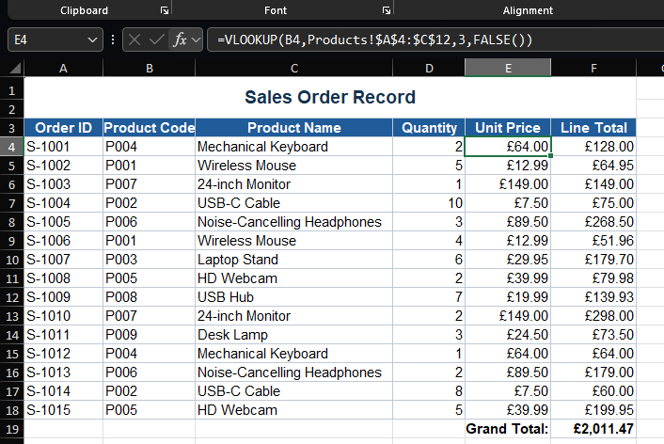
Figure 2: VLOOKUP function retrieving unit prices from a product reference table.

4.5.2 Feature 2 – PivotTable
A PivotTable summarises large amounts of data quickly and without complex formulas. Working from the same sales record, I selected the data range, inserted a PivotTable, then dragged the product name field into the Rows area and the line total field into the Values area, with the aggregation set to Sum. As Figure 3 shows, the result was a total sales figure broken down by product, which can easily be sorted to see the best and worst performers. It is a straightforward example of how a PivotTable can take a long, unwieldy list of raw order data and turn it into something a manager can actually use to make decisions [11].
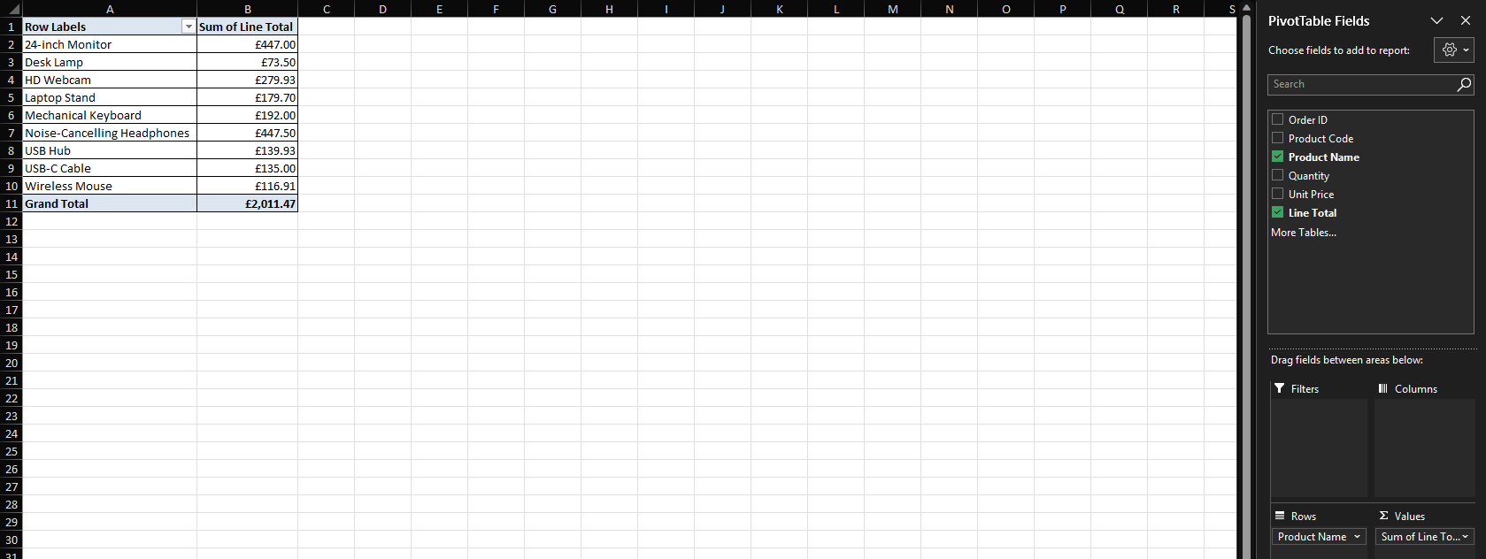
Figure 3: PivotTable summarising total sales revenue by product.

5. Task 4: Communication and Collaboration Applications
Remote and hybrid working has made communication and collaboration tools considerably more important than they used to be. This section covers one of each: Slack as the communication application and Trello as the collaboration tool. A hands-on test of one key feature of each follows.

5.1 Communication Application: Slack
Slack is a cloud-based team messaging platform owned by Salesforce, built around the idea of moving internal communication out of email and into searchable channels organised by team, project or topic [13]. Alongside channels, there are direct messages for one-to-one conversations and a feature called Huddles that lets you start an audio or video call with screen sharing without leaving the app [14]. The platform also includes a marketplace of over two thousand six hundred integrations with other tools, a Workflow Builder for automating repetitive tasks, a powerful search covering every message and file, Slack Connect for communicating securely with people outside the organisation, and Slack AI, which can summarise threads or conversations missed while away [13], [14].
The most frequently cited benefit is the reduction in internal email: some companies have reportedly seen drops of thirty to forty per cent after switching to Slack [15]. It also works asynchronously, which is valuable for teams spread across different time zones who cannot be expected to reply in real time. And because everything is searchable and stored, the platform accumulates into a running record of the company’s decisions and conversations over time [15]. On the other hand, constant notifications can be genuinely distracting if channels are not actively managed. The free plan is also fairly restrictive: message history is capped, Huddles are limited to two participants for thirty minutes, and a number of the more useful features sit behind the paid plans [14].

5.2 Online Collaboration Application: Trello
Trello is a web-based project-management and collaboration tool from Atlassian, built on the Kanban method [16]. The structure is boards (one per project), lists (representing the stages of a workflow), and cards (individual tasks), and work advances simply by dragging a card from one list to the next [16]. Each card can hold checklists, due dates, colour-coded labels, file attachments and comments with @mentions, so discussions about a task stay on the card itself rather than in a separate thread. Beyond the basics, Power-Ups add integrations with outside tools, the paid plans unlock extra views such as calendar, timeline and dashboard, the built-in Butler tool handles routine automation, and a library of templates covers common workflow types [16].
What most people like about Trello is how immediately understandable it is. Someone who has never used it can look at a board and grasp what is happening without any training, and real-time updates mean the board always reflects the current state of the project [17], [18]. The free plan is also reasonably generous, covering unlimited cards and up to ten boards per workspace. Where Trello struggles is on larger or more complex projects: there are no built-in Gantt charts, no way to create task dependencies, and the time, cost and resource-tracking features are limited. There is also no internal chat, so teams that need to discuss things in real time have to use a separate tool or rely on card comments, and some of the more useful views and integrations require a paid plan [16], [17].

5.3 Practical Testing of a Communication and a Collaboration Feature
For the practical tests, I tried one feature of each application: creating a channel and posting a message in Slack, and setting up a Kanban board in Trello. Made-up information was used throughout, and the screenshots are shown below.

5.3.1 Communication Feature – Creating a Channel and Posting a Message in Slack
Using the free plan, I created a new channel called #project-launch to keep all the communication for a sample project in one place. I then posted a welcome message to start the conversation. As Figure 4 shows, the message immediately becomes part of the channel’s shared, searchable history, which is the key way Slack keeps project communication organised rather than scattered across individual inboxes [15].
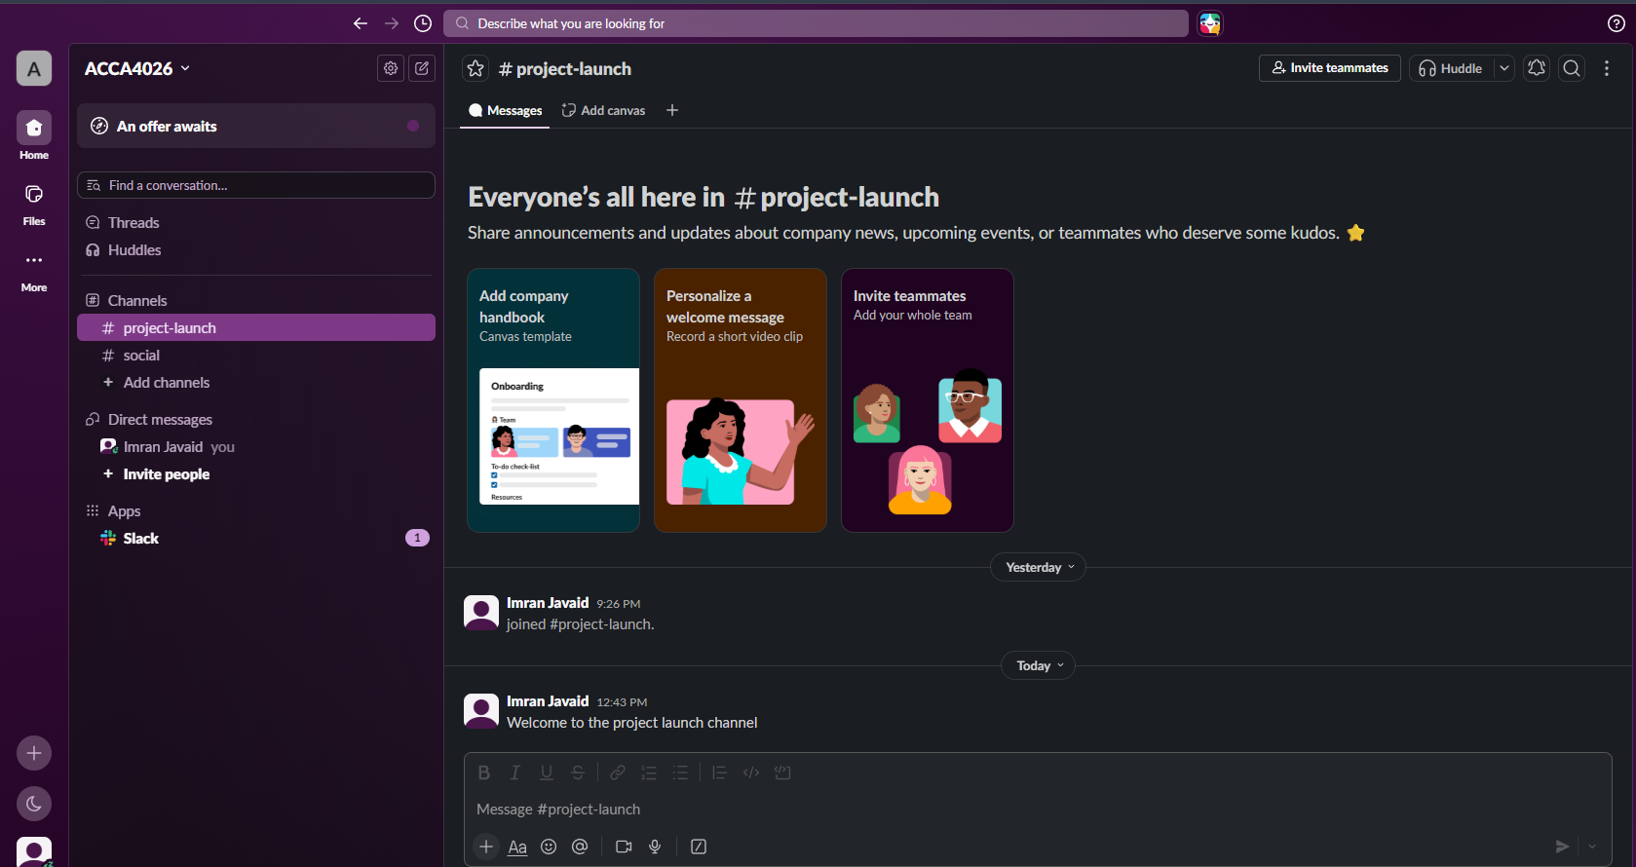
Figure 4: Posting a message in a Slack channel.

5.3.2 Collaboration Feature – Creating a Kanban Board in Trello
Using the free version of Trello, I set up a board called “Marketing Campaign” with three lists “To Do”, “In Progress” and “Done” to represent a simple workflow. I added several task cards to the “To Do” list and then dragged one across into “In Progress” to show how progress is tracked visually. As Figure 5 shows, the board gives an at-a-glance view of where every task is up to, which is how Trello keeps a team’s work organised and easy to follow without a status meeting [16].
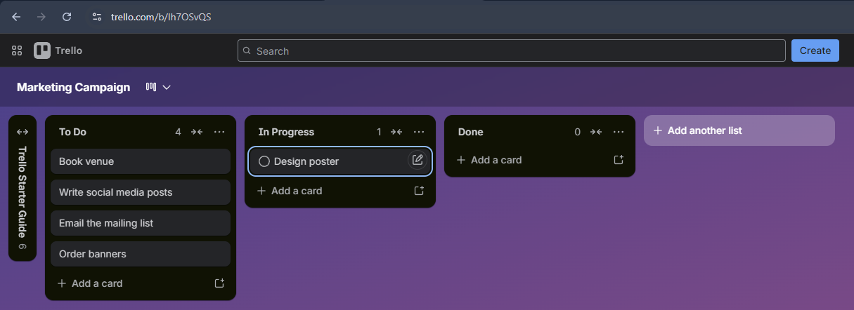
Figure 5: Creating and managing a Kanban board in Trello.

6. Conclusion
Looking back at what this portfolio has covered, there is a clear common thread: the right software does not just speed things up; it changes what a business can realistically do.
E-commerce builders like Shopify and Wix have made it possible for small businesses to start selling online without any real technical expertise, while mind mapping provides a practical way to organise thinking for brainstorming, planning and teamwork. The Microsoft Office suite and Excel in particular, as the practical test demonstrated, remains central to how most organisations create, store, present and analyse information. And tools like Slack and Trello have made it more achievable for teams to collaborate effectively without being in the same building. None of these tools is perfect on its own. What matters is choosing the right combination for the situation. A business that makes those choices thoughtfully will generally communicate better, make faster decisions and get more done, and that increasingly seems to be one of the things that separates organisations that do well from those that do not.

7. References
[1] M. Smith, “Why 2025 was Shopify’s best year yet,” Modern Retail, Jan. 5, 2026. [Online]. Available: https://www.modernretail.co/technology/why-2025-was-shopifys-best-year-yet/. [Accessed: Jun. 26, 2026].
[2] Praella, “Shopify review 2025: The ultimate e-commerce solution for businesses of all sizes,” Praella, 2025. [Online]. Available: https://praella.com/blogs/shopify-news/shopify-review-2025-the-ultimate-e-commerce-solution-for-businesses-of-all-sizes. [Accessed: Jun. 26, 2026].
[3] Website Builder Expert, “Wix ecommerce review,” Website Builder Expert, Jan. 30, 2026. [Online]. Available: https://www.websitebuilderexpert.com/ecommerce-website-builders/wix-ecommerce-review/. [Accessed: Jun. 26, 2026].
[4] Wix, “eCommerce features that help you sell more online,” Wix.com. [Online]. Available: https://www.wix.com/ecommerce/features. [Accessed: Jun. 26, 2026].
[5] Grammarly, “How to use mind mapping: Benefits, techniques and examples,” Grammarly, Nov. 10, 2025. [Online]. Available: https://www.grammarly.com/blog/writing-process/mind-mapping/. [Accessed: Jun. 26, 2026].
[6] Business.com, “How mind mapping helps professionals succeed,” Business.com, Jan. 12, 2026. [Online]. Available: https://www.business.com/articles/benefits-of-mind-mapping-for-professionals/. [Accessed: Jun. 26, 2026].
[7] MindMapping.com, “Mind mapping in the workplace – business use,” MindMapping.com. [Online]. Available: https://www.mindmapping.com/mind-mapping-in-business. [Accessed: Jun. 26, 2026].
[8] Atlassian, “What is mind mapping? How to organise your ideas,” Atlassian, Mar. 10, 2026. [Online]. Available: https://www.atlassian.com/work-management/project-management/mind-mapping. [Accessed: Jun. 26, 2026].
[9] Microsoft, “Which Microsoft 365 plan is right for your business?,” Microsoft Support. [Online]. Available: https://support.microsoft.com/en-us/office/which-microsoft-365-plan-is-right-for-your-business-4b140c05-d02d-4086-bebb-4638b1691305. [Accessed: Jun. 26, 2026].
[10] Microbyte, “Benefits of Microsoft 365 for your business,” Microbyte, Jan. 24, 2026. [Online]. Available: https://www.microbyte.com/blog/benefits-of-microsoft-365-for-your-business/. [Accessed: Jun. 26, 2026].
[11] The Knowledge Academy, “Microsoft Office 365 features and benefits: Explained,” The Knowledge Academy, Apr. 8, 2026. [Online]. Available: https://www.theknowledgeacademy.com/blog/microsoft-office-features-and-benefits/. [Accessed: Jun. 26, 2026].
[12] Ramsac, “The pros and cons of Microsoft 365,” Ramsac, May 22, 2025. [Online]. Available: https://www.ramsac.com/it-resources/microsoft-365/pros-cons-microsoft-365/. [Accessed: Jun. 26, 2026].
[13] Slack, “Slack features: Team collaboration tools,” Slack. [Online]. Available: https://slack.com/features. [Accessed: Jun. 26, 2026].
[14] Siit, “Slack review: Features, pricing, pros and cons (2025),” Siit. [Online]. Available: https://www.siit.io/tools/trending/slack-software-review. [Accessed: Jun. 26, 2026].
[15] David Tries, “Slack in 2025: The ultimate business communication hub,” DavidTries.com, May 18, 2025. [Online]. Available: https://davidtries.com/slack-business-communication-hub/. [Accessed: Jun. 26, 2026].
[16] The Digital Project Manager, “Trello Kanban software review,” The Digital Project Manager, 2026. [Online]. Available: https://thedigitalprojectmanager.com/tools/trello-software-review/. [Accessed: Jun. 26, 2026].
[17] DataCose, “Trello – modern Kanban project management,” DataCose. [Online]. Available: https://www.datacose.com/blog/trello-overview. [Accessed: Jun. 26, 2026].
[18] UC Today, “Trello review: The ultimate Kanban project management app?,” UC Today, Nov. 25, 2025. [Online]. Available: https://www.uctoday.com/collaboration/trello-review-the-ultimate-kanban-project-management-app/. [Accessed: Jun. 26, 2026].

