Managing projects in the workplace

"Discuss how you would plan and design a project management process for the workplace"
Proceeding “Discuss and critically evaluate project management process and assess the suitability in the context of the workplace.”

Adam Shelton

15/09/2023

Contents
Introduction 3
Understanding the university department context 3
Step 1: Needs Assessment & Goal definition 4
Primary issues 4
Objectives 5
Step 2: Stake holder Identification and engagement 6
Customising Agile for the Art & Design department: Planning & Designing a process. 7
Agile 7
Tools and process design documentation 8
The Process 9
Step 1: Project Initiation 9
Step 2: Project Progression 10
Step 3: Project Conclusion 11
Training and implementation 11
Continuous improvement and evaluation 12
Conclusion 12
Appendices 13
References 17
Online Resources 17
Figures Table 17

Introduction

In the last paper titled “Discuss and critically evaluate project management process and assess the suitability in the context of the workplace.”
we explored 3 different types of project management methods and critically analysed them with the help of case studies in terms of suitability to the workplace – of which was a universities’ Science, engineering and art department.
The conclusion was that the Agile project management method was the most suitable due to its adaptability and short term scope, with its on the move meeting methods and goal setting.
However, not only were some aspects of the other 2 methods also applicable, agile would also require some minor adaptations to itself in order for the method to work within this workplace context.
Therefore, within this paper we will look forward and plan how we will adapt the agile method to include the aspects of other methods that will bring benefits in which the way the department works, whilst also designing how to introduce and structure the implementation through use of explanations, meetings and templated digital resource.

Understanding the university department context

The department this plan is being applied to initially is the Art Design section of a wider science engineering & art department. It will then be instated across the other two legs of the department if proved successful. Spread across 2 campus’ and 9 courses each with their independent staff usually consisting of a programme manager/senior lecturer and supporting lecturer.
Due to the workplace in question being a creative environment; tasks, goals, outcomes and subjects are forever changing.
A very seasonal demand from the students due to deadlines and exhibitions means that everyone requires staff at once, mixed with the very hands on and physical nature of the subjects, whilst maintaining background projects, this makes staff/resource efficiency paramount.
Multitasking student demands, mixed with a small work force, a receding demand for creative degrees and ever higher expectations from the highly competitive art world, this creates an intense, stressful and sometimes confusing/overwhelming feeling amongst staff which exacerbates the lack of clear direction towards a cohesive target/ objective.

Step 1: Needs Assessment & Goal definition

The primary reason for introducing a project management method is to increase efficiency by way of providing pragmatic structure, clear goal setting and a way of providing a pathway to achieve these goals. To do this, we must first understand the issues we are trying to overcome.

Primary issues

Firstly by stating the key issues within the department:
- Minimal staff communication across disciplines resulting in a lack of support and student access to facilities.

Due to the spread out locations of the staff, communication can be difficult, or not as continuous as it should be, relying heavily on digital means.

- Lack of project structure & staff accountability.

It is currently mainly down to technical demonstrators prerogative to initiate and drive projects. Lack of record means that projects lose their focus and often end up incomplete.

- Lack of student processing guidance & structure.

- It is currently mainly down to technical demonstrators prerogative to initiate and drive inductions and development – this means many different timelines and methods are used which can result in differing quality of delivery which be unsettling for the student experience.

- Lack of cohesion in budget spending direction.

It is currently mainly down to the technical demonstrators to figure out what equipment and resource is needed to progress the courses. An increase in cross discipline communication could find commonality in desirable equipment, bringing improvements to multiple courses for the same amount of money.

- Lack of projects actually being initiated to push new technologies and techniques.

Due to the low staffing levels and high demand, whether its through the lack of support, or just lack of drive – there is a lack of new projects being initiated. This gives a lack of marketing opportunity and loses potential student desire.

- Severe Lack of marketing.

A lack of marketing is currently observed due to a number of reasons, but the main ones being lack of projects and therefore content, and lack of time and support.

- Resistance to change.

Due to an older generation of experienced staff, and a distinct lack of free time, it is predicted that new ideas, structures and processes would be met with resistance.

Objectives

We have clear issues to design our structures around in order to solve them. Therefore by default, the objectives we need to address in order to succeed, echo the above issues:

- Increased communication to improve staff cohesion and support across disciplines.

- Increased structure, to not only to help guide projects along but to hold stake holders accountable in order to prevent projects from going stale.

- Common-ising processes such as workshop inductions and module/project timings and practices.

- Increased control/Informed budget decision making.

- Cross discipline collaboration to push new technologies and techniques.

- Improved marketing: Content, planning and interaction.

- A project template that assists rather than hinders, mixed with an incremental introduction in order to demonstrate the benefits of following new processes to be created.

Step 2: Stake holder Identification and engagement

Stake holder analysis is vital to any successful project. The importance of understanding Who, what where and when people should and can be involved, what they require and what they can bring to the table can be detrimental to the project outcome.
2 of our key objectives are to increase cross discipline collaboration and communication. Therefore it is important to understand key stakeholders, key contacts and the resource they can provide to a project, but also the resource they would also require from a project, in order to maximise the result of the project by using everything within our access such as; technology, equipment and staff.

Below, figure 1 shows a summary table of the course and stakeholders involved.

Course | Building | Programme manager | Supporting lecturer | Tech Dem | # of Students
Swansea
Automotive & Transport Design | I | 1 | 1 | 1 | ~60-70
Surface Pattern & Textiles | D | 1 | 1 | 2 | ~30
Product design | A | 1 | 1 | 2 | ~20
Design Crafts | A | 1 | 2 | 1 | ~30
Carmarthen
Set Design & Production | - | 2 | 1 | 1 | ~30
Film making | - | 1 | - | 1 | ~40
Applied Drama | - | 1 | 2 | - | ~40
Figure 1 - Stake holder identification table

Understanding details like building location, staff and student levels allow us to clearly see important information to consider at the very early stages of a project to gather insights, align expectations and secure buy in into the project.

This also highlights just the lack of information university staff actually have about its key stake holders and their courses. When considering a project proposal, more information such as budget holders, budget amounts, key skills, equipment access, past project involvement and down time periods would significantly improve a project initiators ability to choose who to involve and who to not.

Customising Agile for the Art & Design department: Planning & Designing a process.

Agile

Agile project management is an iterative and collaborative approach that promotes adaptability and responsiveness to changing project requirements. It emphasizes continuous feedback, short development cycles, and customer involvement to deliver valuable results incrementally.
(Kerzner, 2017)

“In this case, The University Science, Engineering & Art department draws parallels with the case study in how its dynamic, fast paced, trend based demands from the customer base, drives its developments – of which need to be achieved within a swift time period in order to stay relevant and competitive within the market.

The agile project management style has proven itself to cater for situations where companies need to be highly adaptable, it encourages iterative development through short, resource intense “sprints” allowing for fast effective communication (within suitable conditions) and response to new customer based demands, in turn, encouraging creativity and collaboration within the business which proves a vital requirement within a Science, Engineering & Art department.

Where agile falls short in terms of communication and documentation management for the case study, the negative effect should be far less when applied to our workplace example, due to it only being based within 1 time zone, and the application of the agile structure would be applied through the use of documentation rather than using documentation as a record.”
(A.Shelton, 2023)

As stated above the agile methodology lends itself to the departments fast paced, dynamic needs. I intend to use this to bring more structure in the way we drive projects, through short meetings and improved communication means.
However, if it were easy, it would be done already – therefore careful consideration of all partakers have to be considered in order to design a way in which improvements through implementation are seen as helpful and not hindrance.

Tools and process design documentation

Figure 2 - Process structure chart
PROJECT INITIATION LOG (VISIBILITY & CONTROL)
- PROJECT NUMBER - INITIATOR - PROPOSAL DATE - AREA - PROJECT
- DESCRIPTION - KEY EQUIPMENT - KEY WORDS - TARGET DATE

- WHO
- WHAT
- WHERE
- WHEN
- WHY
- HOW
- Benefits
- Concerns/risk
- State interest
- Faculty contact sheet

- TITLE
- Description
- Key information
- Outcomes
- Key Contacts/Stakeholders
- Goal breakdowns (In steps)
- SUMMARY
- LOG OF OUTCOMES
- LIST OF BENEFITS
- REFLECTION

PROJECT CONCLUSION DOCUMENT (OPTIONAL)
PROJECT PROGRESSION DOCUMENT
PROJECT INITIATION DOCUMENT

Therefore, this planned method of introducing the agile concept will be introduced through the guidance of a template structure. (As seen in figure 2) Due to the sporadic nature of the tasks set, staff locations and workload; it would be suspected that agile without the guidance of a template may be carried out, however not built up on or maybe intermittently carried out depending on how busy the staff are. Due to the lack of accountability and record keeping of the results of each meeting it is feared that momentum would not carry through projects and many projects would be forgotten about or left incomplete even when the majority of the work had been done or funds have been invested.

The Process

All files within this system will be accessible at all times as live documents through one drive, allowing anyone to access/write the Project Initiation Log, with only the Project initiator having write access to the Project Initiation, Progression and Conclusion documents. However all will be readable documents.

Step 1: Project Initiation

Project Initiation Log (PIL)

The project initiation log seen in figure 3 of the appendices is used as the control document and the go to for overseeing a summary of a project.
This allows all staff within the university seeking certain pieces of equipment, skill sets and techniques to see who, where and when any projects may have involved said searches. The Project Initiation Log also allows managers to oversee resource allocation and project progression within the touch of a button.
Although this log is the most important part of the system, this document is designed for the majority of the fields to mimic the Project Initiation Document, so it isn’t seen as too time consuming, as the Initiator can copy and paste the relevant fields.

Project Initiation Document (PID)

The project initiation document as seen in figure 4 of the appendices coincides with the filling out of the Project Initiation Log.
“2. Initiate the Project
During this process, you’ll need to define the project aspects that we mentioned above; scope, costs, timescales, risk, quality and benefits. A project initiation document template can help.”
(Projectmanager.com, extracted 08.2023)

This document and associated meeting is a hybrid of PRINCE 2’s initiation process and AGILES sprint meeting process. This is by far the most intense document of the three part series, as it intends to provide as much information as possible in order for the managers and proposed key stake holders to be able to fully understand the demands, desires, timelines and benefits/outcomes of the project.
This Document is to be filled out and then emailed to all involved, who of which then sign if they wish to partake. Once the Line manager OK’s the project, a sprint meeting is then organised with the key stake holders to discuss, state what they can provide, and then begin the process of filling out the PPD.
Another very important part of this document is the contact sheet at the bottom. This enables the initiator to quickly see who’s in their department, what influence they have, what building they’re in, what skillset they have and the best way to contact them.

Step 2: Project Progression

Project Progression Document (PPD)

The PPD as seen in figure 4 of the appendices, is the live pro-active record of the project.
This Document is a hybrid of AGILES team review process and PRINCE 2’s “direct the project” & “control stages” process’.
“3. Direct the Project
This process is to help the project board be accountable to the project through their decision-making. They have the authority on initiating the project, deliver its product and close the project. They also offer direction and control during the project. Additionally, they work with corporate entities or program management and review post-project benefits. Activities related to this process include authorizing the initiation, the project itself and the stages of the project. Another direction is offered as needed until project closure is authorized.

4. Control Stages
This is where the project manager assigns tasks, monitors that work deals with whatever issues arise and reports on its progress to the project board. Activities in this process include authorizing a work package with the team, reviewing its status and progress, and checking on its quality when complete. One must also review and compare progress to the project plan, capture any issues and risks and act to resolve them.”
(11 - Projectmanager.com, extracted 08.2023)

Through providing regular updates/meetings and clear desired outcomes broken down into manageable assigned goals with designations and deadlines, this document is designed to be filled out before the project task in order to drive the project and not be seen as “extra paper work”.
This document should be instrumental in driving projects forward as it enables staff to be supported in breaking down big tasks and asking for help when its needed. It also allows the project initiator to keep a close eye on whether goals are being met and whether to re allocate resource in order to improve the project outcome without pestering or asking directly for updates which could be seen as undermining or micromanaging, keeping project morale high.

Step 3: Project Conclusion

Project Conclusion Document

The PCD although is optional, is also an important part of the structure.
This document will be based off of a hybrid of AGILES team review and retrospective meeting process’.
“Team review (Show and tell)
The team review is a regular meeting which gives team members the opportunity to demonstrate their work. It can also be called a sprint review or a show and tell.”

Retrospective meetings
Retrospectives, sometimes called ‘retros’, are regular meetings where your whole team talks about what’s going well and what is not.” (Gov.uk, extracted 08.2023)

It will drive a conclusion meeting preferably with the budget holder/manager in order to show the positive outcomes and allow all stakeholders to show individually their contribution to the project.
This document will allow the project initiator to really show the positive outcomes of the project and display the benefits and return that the fund, resource and time investments have made. In turn this will allow the project initiator to not only have a record of their achievements, but also prove instrumental to providing evidence of past success to budget holders and managers when proposing new projects.
Due to the live nature of the implementation of this project management system, this section of the process and therefore document hasn’t actually been reach yet. Therefore I have chosen to wait until projects do conclude, to shape and design this document so that it clearly portrays the results of a vast range of dynamic project outcomes.

Training and implementation

Due to the very busy nature of the workplace this is being applied to, mixed with a large number of very experienced staff, it is feared that a resistance to implementation will be observed, as experienced in the case study “Project management within a healthcare environment” referenced in the preceding paper.
Therefore the implementation of this management method will be introduced in a fragmental/expanding method.
The method has been firstly trialled by myself across numerous different types of projects in order to iron out initial creases and oversights, it will now be demonstrated to a group of enthusiastic staff of which are just about to take on projects. Once the method has been trialled and tested by this focus group, the process will be then shown to larger groups across the department, with analogies and results to back up its effectiveness in order to encourage the more resistant staff members.
This is designed to be a very effective way of introducing the new method due to an almost domino effect allowing staff members to teach each other and not just relying on one staff member to explain the process in a non personal way.

Continuous improvement and evaluation

The introduction of this method management process will actually be trialled using its own structure. The introduction to staff will follow the template structure allowing for feedback and improvement.
The process is initially being trialled with a handful of the universities most enthusiastic an pro active staff. This will enable the focus group to feedback any general alterations before being introduced on still a small, but wider more diverse scale. This then enable the process to be altered again will challenges from multiple circumstances and disciplines, in order for the process to become more generic and all inclusive so that it can be common-ised across multiple departments. This will help to improve cross departmental collaborations on a larger university wide scale.

Conclusion

In conclusion its felt that Through critical analysation of the three process SIX SIGMA, AGILE and PRINCE 2 in application of case studies allowed a best fit to be selected in context of this particular workplace.
The foundations of an effective tailored approach to introducing AGILE to the art and design department has been created and is now in its preliminary stages of implementation.
The process outline and templates were shown to the Dean who of which was very optimistic and tasked my line manager with trailing and developing the process along side me.
With careful consideration and thought it is felt that this project management method will increase productivity, communication and therefore collaboration, enthusiasm, allow for better resource allocation and will make staff feel more appreciated and supported. In turn this will therefore reap rewards such as more creativity, a better and more productive workplace all round and therefore a better quality student experience resulting in much more higher quality marketing content, achieving all of the aforementioned outcomes.

Appendices

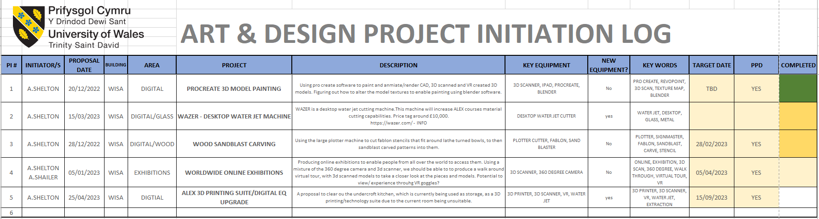
Figure 3 - Project Initiation Log (PIL)

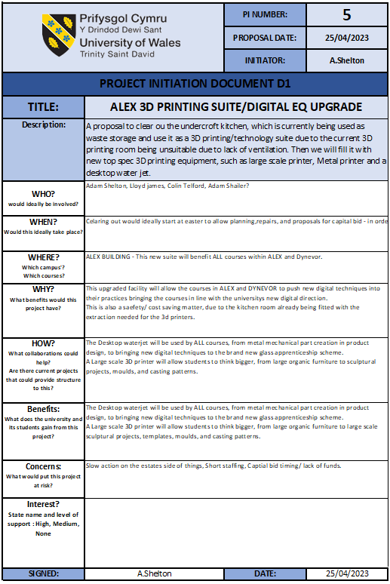
Figure 4 - Project Initiation Document (PID)
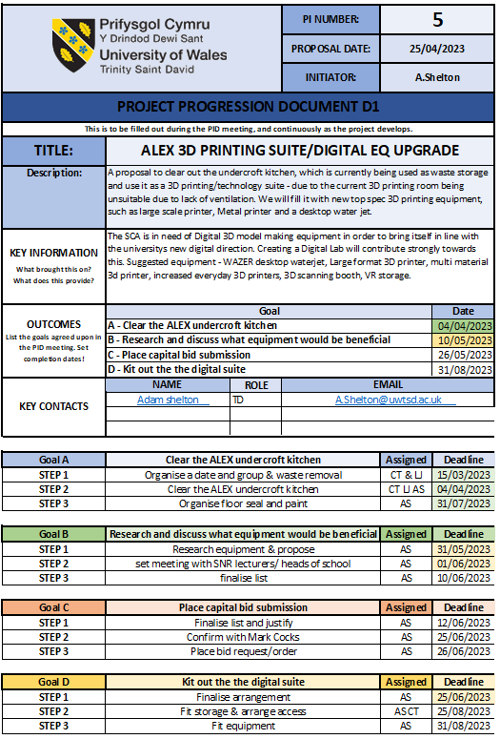
Figure 5 - Project Progression Document (PPD)

References

Shelton. A., (2023) “Discuss and critically evaluate project management process and assess the suitability in the context of the workplace.”
Kerzner, H., & Kerzner, H.R. (2017). – Project management: A systems approach to planning, scheduling and controlling. : John Wiley & Sons.

Online Resources

Malsam, W., (2021) https://www.projectmanager.com/blog/prince2-methodology

UK Goverment., (2023) https://www.gov.uk/service-manual/agile-delivery/agile-tools-techniques

Figures Table

Figure 1 - Stake holder identification table 6
Figure 2 - Process structure chart 8
Figure 3 - Project Initiation Log (PIL) 13
Figure 4 - Project Initiation Document (PID) 14
Figure 5 - Project Progression Document (PPD) 15

