University of Wales Trinity Saint David
Certificate of Higher Education in Skills for the Workplace
Module Title: Problem Solving and Decision Making
Module Code: BMSW4004
Assignment Title: Problem Solving and Decision Making
Lecturer’s Name: Dr Anupam Mazumdar
Student Name: Tanmay Vyas
Student ID: 1914103

Table of Contents
Table of Contents 1
Introduction 2
Employee dissatisfaction- a big problem in Trunki 2
Analysing the problem of employee dissatisfaction 3
Solutions for the dissatisfaction problem 4
Choosing a plan 9
Implementation of the selected solution 10
Communication of the solution implementation 12
Review Techniques 13
Conclusion 14
References 15

Introduction
Whenever a company falls into a problem, that company needs to find out the sources of the problem and prepare more than one solution for the problem in case the first solution is unattainable. Here in this assignment at first a problem that the bag making company Trunki is facing is described and then different solutions and their implementation strategy is discussed briefly.

Employee dissatisfaction- a big problem in Trunki
Trunki is a travel bag manufacturer for kids based in the UK. The company has been performing very good in recent years. and the company got some awards also (Abidal, 2020). But now the company is facing a problem in its manufacturing and marketing section of the company. In the company, the employees of those sections are seemed to be dissatisfied and it is affecting the performance of the company. The sales of the company have fallen due to the performance drop in the company (Alam, 2015).
As a manufacturing company, the company needs to make sure their production department is working. Without the production department, the company will not have any products to sell in the market. So the company should always need to keep the employees in the production department to get products to sell. Like the manufacturing department, it is also important to keep the employees in the marketing department. The employees in the marketing shape out the ways of sales and reach to the customers and sell the products of the company (Bravestone, 2019). So to remain profitable, the company needs to keep the employees happy. But for Trunki, both departments’ employees are unhappy and unsatisfied.
Here the unsatisfied employees will bring many problems. Firstly, the company will have problems in their production department. The production will be slow. And the product quality may fall also. In the case of the marketing department, the company will face a fall in sales due to a lack of trying from dissatisfied employees (Snell and Hart, 2014). And other departments like accounting and inventory control will also be affected as due to lower sales it will be hard for the accounting department to adjust the prepared budget. For inventory control, as the sales are falling and making a target profit will be tough. And as the production has slowed, it will slow down the inventory turnover and will be a problem for the inventory management department (Zhen, 2020).

Analysing the problem of employee dissatisfaction
Employee dissatisfaction in a company can be defined as employees’ having negative thoughts regarding their job, their seniors and their job environment. It is very bad for a company to have employee dissatisfaction as it hampers the performance of the company. Here Trunki is facing the same problem.
Every year Trunki gives their employee a little increase in their salaries. Usually, the rate ranges from .50%-1%. but in some consecutive years, the inflation rate has been over 1%. Even it went over 2.5% in 2018. So in this situation, even with the increased salaries, the employees can't maintain their lifestyles (김유경, 2016). So it is a major fall-back for the company.
Besides, in Trunki, Seniors always provide juniors with commands. There is a straight chain of command in the company. Here there are some cases where the seniors disregard the junior employees. But because of the straight-chain command system, the junior employees cannot do anything about their abuse from seniors. It can be another reason behind the problem.
Another problem that is fuelling this dissatisfaction is the work allocation process in the company. Here the best performers always get more and more work to do. Where below-average performers are not getting such a tremendous load of work. But the effort from the best performers is not getting any recognition. And it is making the best performers have negative feelings regarding their job.
Figure 1: Causes of employee dissatisfaction in Trunki (author)

Solutions for the dissatisfaction problem
Solution 1: Increasing the salary
Here the company’s employees are getting an increase in salary which is insufficient. And the employees are unsatisfied and it is harmful to the company. So to make the employees satisfied and motivated to work hard, the company can increase the salary of the employees by a higher percentage compared to the previous years. here the company should provide a salary increase over the inflation rate so that the employees’ lifestyle can be improved (Alam, 2015).
A SWOT analysis of the solution will help to understand the solution better with withs positive and negative sides.
Strengths  - Increased employee satisfaction in the company.  - Enhanced performance of the company. | Weakness  - May become a problem for the company.  - Increased cost may decrease profit.
Threats  - May need to increase the price of the products to manage the extra expenses.  - May lose customers.  - Employees’ effort may be reduced. | Opportunity  - Can get skilled employees  - Signal regarding the company’s sound financial health
Figure 2: SWOT for salary increase (author)
Now a PESTEL analysis will show the impact of the solution over the elements of the environment.

Environment | Description
Political environment | The company will need to pay fewer taxes as salary is a tax-deductible item.
Economic environment | In case of a cash shortage, the company will need to take a loan and loan is an element of the economic environment.
Social environment | The pay rise will increase the life-style of the employees who are part of the social environment.
Technological environment | The employees may use the pay rise to upgrade their technological tools.
Environmental environment | No effect.
Legal environment | The company will have a reduced risk of lawsuits from employees.
Figure 3: PESTEL analysis for salary increase (author)

Now a Fishbone analysis will show how all the department will gather together its efforts and can achieve employees’ satisfaction. In a fishbone analysis, how different efforts end up getting a uniformed result. In other words, it shows the cause and effect of a matter.

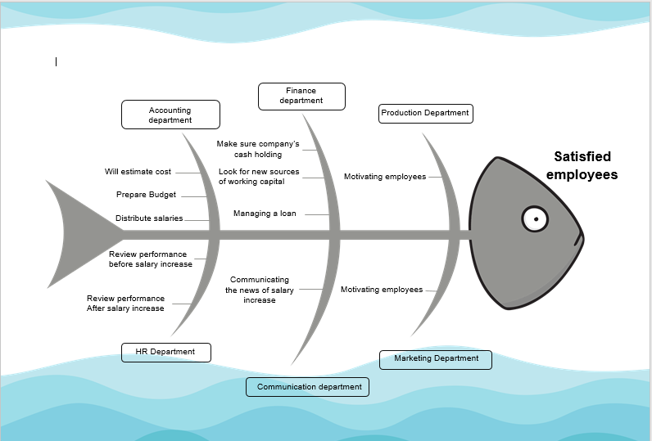
Figure 4: Fishbone analysis for salary increase (author)
Here it can be seen that different activities from the different departments are helping in achieving the goal of employee satisfaction.
Solution 2: Managers’ training and recognition to employees
Here providing training to managers will help to stop senior managers’ unprofessional behaviour with the employees. And recognising the effort of an employee will motivate them. And these will surely satisfy the employees. Now a SWOT analysis will show the positive and negative sides of the solution.

Strengths  - Less costly for the firm  - Easy review of the performance  - Easy to implement | Weakness  - Managers may not change their behaviour.  - The recognition may not be sufficient for the employees
Threats  - A wrong training method may be chosen.  - Recognition may allure the employees to show-off. | Opportunity  - Some new ideas may come to the company  - Signal regarding the company’s good HR policy
Figure 5: SWOT for training and recognition (author)
Now a PESTEL analysis will show the effect of solution over different elements in the environment.
Environment | Description
Political environment | The company will need to pay fewer taxes as training cost is a tax-deductible item.
Economic environment | No effect
Social environment | Recognition and good behaviour will relax the employees who are part of the social environment. And it will boost performance.
Technological environment | No effect
Environmental environment | No effect.
Legal environment | The company will have a reduced risk of lawsuits from employees.
Figure 6: PESTEL for solution 2 (author)
Now a Fishbone analysis will show how the solution can be attained using the effort of different departments in the company.
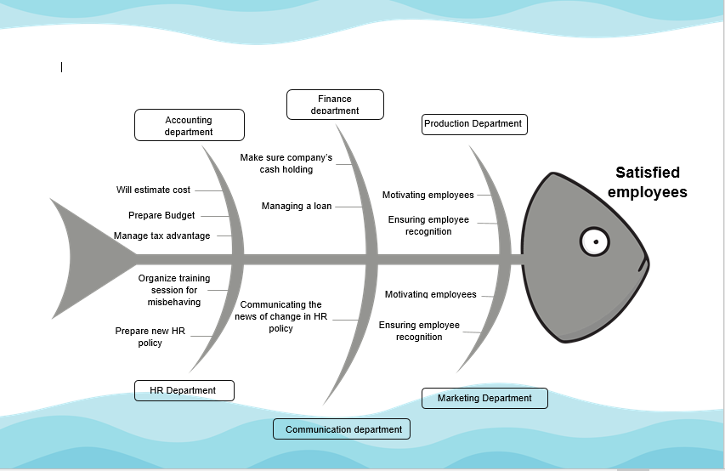
Figure 7: Fishbone analysis for 2nd solution (author)
Here the HR department and communication department needs to perform a lot more tasks than other departments to make sure that the employees are satisfied.

Choosing a plan
Here to choose a plan, first, the cost of the two solutions must be determined.
Cost for the 1st solution
Particulars | Amount
Current salary expense | £686,768.00
Increase by 3.80% | £26097.00
Cost of communication and others | £1000.00
Total cost | £27,097.00
Figure 8: Estimated cost for 1st solution (author)
Cost for the 2nd solution
Particulars | Amount
Cost for training | £20,000.00
Cost for policy realignment | £1,500.00
Cost for providing recognition | £3,000.00
Communication and other costs | £500.00
Total cost | £25,000.00
Figure 9: Estimated cost for 2nd option (author)
So here it can be seen that the cost of implementing the 2nd solution is lesser than the 1st ones. And as an economic depression is going on due to the Coronavirus outbreak, so it will be better for the company to cut the costs as much as it can (Abidal, 2020). Now if the 1st solution is chosen, it will solve the problem for an insufficient salary increase problem. But the rest of the three problems are unsolved. But when the second solution is chosen 3 problems are solved except the salary increase. So here the 2nd solution will satisfy the employees more and it will be an efficient solution for the company as well.

Implementation of the selected solution
Now as the 2nd solution has been selected to be implemented, now its time for the company to manage different resources to implement the solution. To see how the solution will be implemented, the ADKAR model can be used. In the section, an ADKAR model is prepared for the solution.
Table 1: ADKAR model for the problem (author)
Abbreviation | Full form | Way of implementation
A | Awareness | Here the HR department will announce implementing the solution and describe how it will satisfy the employees. Any queries from the employees need to be answered.
D | Desire | Here the reaction from the employees regarding the solution will be recorded and analysed. In the case of a negative or resistant reaction, the company need to provide employees with further information to make them accept the solution (Abidal, 2020).
K | Knowledge | Here the company need to gather knowledge regarding different training programs and their advantages. Besides, the company should also learn different techniques for recognising employees’ performances.
A | Ability | Here the company has to invest in their money and logistics support to implement the training program and new recognition related rules in the company.
R | Reinforcement | After the implementation, the company will oversee the positive changes that came to the company. And positive feedback and recognition will be continued towards employees to keep them satisfied and motivated (Buckland, 2020).

Communication of the solution implementation
The plan for communicating the solution to different stakeholders are shown below:
Table 2: Communication plan for the solution (author)
Communication medium | Stakeholders
Communication medium | Employees | Managers | Customers | Suppliers | Tax authority | Potential customers | Investors
Formal letter |  | x |  | x | x
Announcement | x |  | x |  |  | x | x
E-mail | x | x | x |  |  | x | x
Telephone | x |  | x |  |  |  | x
Text message | x |  | x |  |  | x
Social media posts and blogs |  |  | x |  |  | x

Here,
The green boxes indicate the need for immediate communication
The yellow boxes indicate a later communication compared to immediate

x
x

Review Techniques
Here the solution 2 is being implemented. It will ensure proper treatment of the employees. Besides, they will also get their jobs allocated fairly and their efforts will be recognised. But the company needs to review whether the implementation has been perfect or not. That is why it should do a periodic interview with the employees to know whether they are satisfied. Besides a place for recommendation must be set where employees can provide recommendations to make the implementation a success. In this way, the company can make sure that the implementation of the solution has been fruitful.

Conclusion
Here in this assignment, Trunki’s problem of employee dissatisfaction has been described. At first, the problem is described. Then different solutions are explained and the optimal solution is found. Then the process of implementation and communicating with stakeholders are discussed in brief. Finally, the process of review ids discussed to ensure the effectiveness of the solution’s implementation.

References
Abidal, T., 2020. Made In The UK. [online] Trunki. Available at: <https://www.trunki.co.uk/pages/made-in-uk> [Accessed 29 November 2020].
Alam, S., 2015. Employee Turnover in MFIs: Reasons & Remedies. SSRN Electronic Journal.
Arthur, M., 2019. Trunki As Carry-On On Icelandair - Iceland Forum - Tripadvisor. [online] Tripadvisor.com. Available at: <https://www.tripadvisor.com/ShowTopic-g189952-i223-k12345818-Trunki_as_carry_on_on_Icelandair-Iceland.html> [Accessed 29 November 2020].
Bravestone, J., 2019. Trunki. [online] Trunki Australia. Available at: <https://www.trunki.com.au/collections/trunki> [Accessed 29 November 2020].
Buckland, R., 2020. Rob’S Trunki Call Brings Manufacturing Back From China To The UK | Bristol Business News. [online] Bristol-business.net. Available at: <http://www.bristol-business.net/robs-trunki-call-brings-manufacturing-back-from-china-to-the-uk/> [Accessed 29 November 2020].
Connell, s., 2018. Trunki Suitcase Ruling Clarifies Design Law, Say Patent Attorneys | Chartered Institute Of Patent Attorneys. [online] Cipa.org.uk. Available at: <https://cipa.org.uk/policy-and-news/latest-news/trunki-suitcase-ruling-clarifies-design-law-say-patent-attorney/> [Accessed 29 November 2020].
Snell, D. and Hart, A., 2014. Reasons For Non-completion And Dissatisfaction Among Apprentices And Trainees: A Regional Case Study. International Journal of Training Research, 6(1), pp.44-73.
Zhen, Y., 2020. A Review on Employees’ Voluntary Turnover from the Psychological Perspective. International Journal of Psychosocial Rehabilitation, 24(3), pp.2304-2309.
김유경, 2016. Employees’ Humor Style, Emotional Labor, Job Satisfaction, and Turnover Intention among High-Contact Service Employees. Journal of Distribution Science, 12(10), pp.109-121.

