Digital Skills and Research Methods

Code: BMSW4003
Student Module ID: Fazlee Zahid
Student Id: 2012168
Date of submission: 2nd January 2021

Table of Contents
Title 3
Rational 3
Objectives 3
Literature review 3
Methodology 5
Primary data analysis 6
Secondary data analysis 11
Conclusion and recommendation 12
References 13

Title
The title of this study is to investigate the impact of the Virtual Learning Environment (VLE) on the learning experience of the student.

Rationale
This research is conducted about the investigation of the impact of Virtual Learning Environment on different academic activities including learning, classroom activities, virtual learning as well as experience of students. In the time of present pandemic situation, safety and security are more important than traditional learning, and in this concern, virtual learning is an opportunity for students to flourish in a deadlock situation. A virtual learning environment is an artificial learning environment that is created by using different communication media through the internet. Research shows that virtual learning is more effective and easy than traditional learning in some cases such as saving time, increasing reach area, ensuring safety and security, etc. Virtual learning has great popularity in distance learning which enables a learner to reach a huge amount of resources through the internet (Belloc, 1967). Though virtual learning has some difficulties with the support of both experienced teachers and authority, it can be overcome as it has more benefits than difficulties. The wide use of the internet and digital media such as smartphone, laptop, etc. make it easy to foster rapid change. So, it can be said that this research project will enlighten the area of research in the present pandemic and deadlock situation.

Objectives
- To investigate the importance of virtual learning environment in academic learning of the present pandemic situation.
- To assess the literacy and usability of virtual learning tools of both learners and teachers.
- To design an effective methodology of the research for conducting this study.

Literature review
According to Jain, (2002) the world of business, as well as the lifestyle of people, is changing rapidly because of the rapid advancement of digital technology. The wide use of the internet and communication technology makes things easy to comprise the whole world in hand. Ismail, (2019) stated that the uses of digital technology become popular in academic and professional learning also. In the time of present pandemic situation, safety and security are more important than traditional learning, and in this concern, virtual learning is an opportunity for students to flourish in a deadlock situation. According to Dommett, (2019) a virtual learning environment is an artificial learning environment that is created by using different communication media through the internet. Research shows that virtual learning is more effective and easy than traditional learning in some cases such as saving time, increasing reach area, ensuring safety and security, etc. Virtual learning has great popularity in distance learning which enables a learner to reach a huge amount of resources through the internet. Balint and Allbeck, (2017) stated that though virtual learning has some difficulties with the support of both experienced teachers and authority, it can be overcome as it has more benefits than difficulties. The wide use of the internet and digital media such as smartphones, laptops, etc. makes it easy to foster rapid change. As most people have a digital presence at present, it is easy to implement a virtual learning environment. It is also found that implementation of VLE has some difficulties including providing necessary support to the students or teachers who are new with this term, hiring executive and technical staff, etc.

Methodology
Research philosophy
To conduct successful research, the researcher has to select an appropriate research philosophy at first which depicts the nature of the whole research and helps to select an appropriate research method, approach, and format. Interpretivism is a thought that portrays that realities that are detectable should be joined into the investigation. Then again, positivism's way of thinking underscores adherence to goals and contends that the truth is consistently relative never total; the perception makes us near-reality to comprehend. Analysts accept that the positivism theory can infer the genuine epistemological musings in the exploration (Welman, Kruger and Mitchell, 2005). In positivism epistemology, the scientist can apply measurable applications. In this study, the researcher intends to use positivism philosophy which is a sub-section of epistemology. This philosophy will be effective as the researcher uses statistical tools and techniques to analise the research data and this positivism philosophy allows the statistical technique to analyze data.
Research approach
The approach of the research is another important tool of research methodology which depicts who research is conducted to fulfil the aim and objectives of the research. The deductive methodology is the examination cycle where the analyst from the start audit distributed writing, discoveries, and speculations to build up another theory concerning the relationship of the exploration theme and afterward research the theory to test the relationship of the examination subject. Interestingly, the inductive methodology is the exploration cycle where the analyst utilizes individual perceptions on the examination theme to build up conditional speculation and investigate to fabricate another hypothesis on the exploration subject (Jha, 2008). In this study, the researcher intends to use the deductive approach as the researcher uses market data to test the developed hypothesis rather than develop a new theory about this topic.
Research method
Research method generally helps to select types of data used in research. Two methods are popular in research methodology such as deductive and inductive methods. the quantitative strategy is the technique to fuse just the realities expressible in numeric figures were, the subjective technique grants to fuse confounded human conduct into study not expressible in numeric scales. Then again, the subjective technique is followed when the analyst plans to investigate a case or depicts any hypothetical issue (Goddard and Melville, 2011). In this study, the researcher intends to use the quantitative method as quantitative data are analysed to find out the research result.
Source and method of data collection
Research data are collected from two sources the primary and secondary sources. In this study, the researcher uses both primary and secondary sources of data to find out the accurate result of the research. a primary source is the first-hand data source which is more accurate and authentic as this data are used only for specific research purposes with an intended methodology where the secondary source is used and published data source which is collected from website, journal, articles, etc. (Welman, Kruger and Mitchell, 2005). In this research, an online survey questionnaire is used for collecting primary data and different well-known journal and articles are used for collecting secondary data.

Primary data analysis
Q-1 & 2: How often you use the platform of virtual learning with your lecturer and your colleagues?
In an online survey questionnaire, the researcher wants to know the frequency of using VLE at first. The outcome of the first two questions shows that almost 70% of responders out of 20 responders are aware and regular users of VLE for academic purposes. Other 30% have an idea but rarely use VLE which can be improved by the effective consultancy.
Question | Very Frequently | Frequently | Rarely | Not at all
Question 1 | 8 | 6 | 6 | 0
Question 2 | 8 | 9 | 3 | 0

Q-3: Is it heard to use virtual learning platform?
The survey is conducted online for which 20 responders are selected by using a convenience sampling technique. The following graph shows that 70% of responders have sufficient literacy about using VLE as they respond that it is easy to use VLE and only 10% think that uses of VLE is difficult where 20% are not sure about the problem of using VLE.
Q-4: Do you prefer to use VLE until you complete this course?
The following graph shows that 70% of responders have sufficient literacy about using VLE as they want to use VLE until completing this course but 25% of responders disagree with the statement and another 25% cannot make a decision about this statement. So, it is difficult to implement and effective consultancy is required.
Question | Yes | No | Not Sure
Question 3 | 2 | 14 | 4
Question 4 | 10 | 5 | 5

Q-5: Virtual Learning platform is the best learning platform for higher studies.
The survey is conducted online for which 20 responders are selected by using a convenience sampling technique. The following graph shows that 60% of responders think VLE is the best learning platform for higher studies where 40% disagree. This result is satisfactory but difficult to implement.

Q-6: Effectiveness of the VLE is more than classroom teaching.
It is important to know about the effectiveness of VLE. The following graph shows that only 35% of respondents think that VLE is more effective than classroom teaching and the rest 65% of respondents have a negative attitude about the effectiveness of VLE.
Question | Strongly Agree | Agree | Disagree | Strongly Disagree
Question 5 | 1 | 11 | 8 | 0
Question 6 | 2 | 5 | 13 | 0

Q-7: How confident are you in terms of using VLE for your studies?
The level of respondents' confidence is assessed in this section. The following output of the data analysis shows that 85% of respondents are satisfied and more confident to use VLE in their higher studies where only 15% are not satisfied and unknown about the VLE. The survey is conducted online for which 20 responders are selected by using a convenience sampling technique.

Q-8: How satisfied are you in terms of the services provided by the lecturers and the admin via VLE?
The level of respondents’ satisfaction is assessed in this section. The following output of the data analysis shows that 80% of respondents are satisfied and more confident to use VLE in their higher studies where only 20% are not satisfied and unknown about the VLE. The result is excellent about respondent’s satisfaction level.
Question | 1 (Less Confident/Extremely Dissatisfied | 2 | 3 | 4 | 5 (More Confident/Extremely Satisfied)
Question 7 | 0 | 1 | 2 | 9 | 8
Question 8 | 0 | 1 | 3 | 8 | 8

Q-9: Which platform you prefer to use for VLE?
There are different VLE platform which is supported by different level of security and performance. The preference of respondents is important to know about the uses of the VLE platform. Analysis of data shows that 75% of respondents prefer to use Microsoft Team which is easy to use and effective for VLE and only 25% prefer to use Zoom.
Question | Zoom | Microsoft Team | Google Classroom | Other
Question 9 | 5 | 15 | 0 | 0

\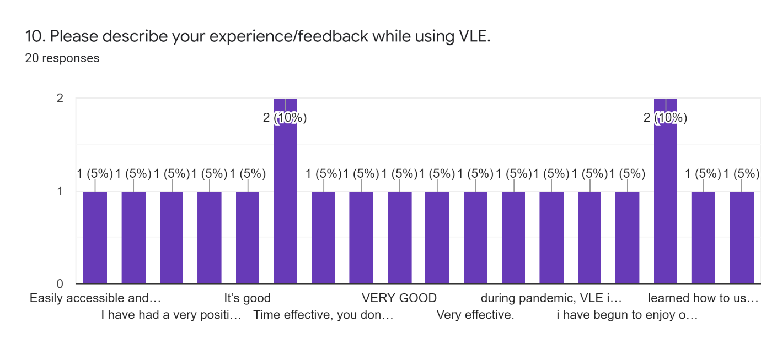

Secondary data analysis
A virtual learning environment is an artificial learning environment that is created by using different communication media through the internet. Virtual Learning has both pros and cons as it is almost a new term in the present learning environment but it has great popularity as well as acceptance in the present pandemic situation. Some important advantages of VLE are flexibility, affordability, accessibility, engagement, and simple management support (KALAYCI, 2015). In contrast, VLE has some potential disadvantages including lack of motivation, limitation of cooperation, lack of practice, delays in communication, etc. To get maximum benefits from the VLE some guidelines should be followed by both student-teachers and authority. Understudy to-educator and understudy to-understudy correspondence stays life, consequently, more successful and including. The learning cycle is enabled with intuitive online exercises and extra materials to develop information. In the time of present pandemic situation, safety and security are more important than traditional learning, and in this concern, virtual learning is an opportunity for students to flourish in a deadlock situation (Thomas, 2012).

Conclusion and recommendation
It can be concluded that the authority should analyse the pros and cons of the virtual learning environment in the academic setting of the University of Wales. Empirical analysis shows both positive and negative sites of implementing VLE in university education which has limited potentiality in terms of both learners and academic authority.
Recommendations
- Empirical analysis shows that more than two third of the respondents have sufficient knowledge about VLE and almost two third of total respondents think that VLE is the best learning platform for higher studies. So, authority should motivate learners to comprise more respondents.
- Empirical analysis shows that almost two third of total respondents have a negative attitude about the effectiveness of VLE. It is difficult to convince respondents to implement VLE in academic study. So, for implementing VLE, management should reduce potential disadvantages of VLE through effective and efficient management.

References
Balint, J. and Allbeck, J., 2017. ALET: Agents Learning their Environment through Text. Computer Animation and Virtual Worlds, 28(3-4), p.e1759.
Belloc, H., 1967. On. Freeport, N.Y.: Books for Libraries Press.
Dommett, E., 2019. Understanding the Use of Online Tools Embedded Within a Virtual Learning Environment. International Journal of Virtual and Personal Learning Environments, 9(1), pp.39-55.
Ismail, S., 2019. Using a Virtual Learning Environment for Problem Based Learning (P.B.L). SSRN Electronic Journal.
Goddard, W. and Melville, S., 2011. Research Methodology. Kenwyn, South Africa: Juta & Co.
Jha, N., 2008. Research Methodology. Chandigarh: Abhishek Publications.
Jain, L., 2002. Virtual Environments for Teaching & Learning. Singapore: World Scientific.
KALAYCI, S., 2015. Students’ Attitudes Towards Collaborative Tools in A Virtual Learning Environment. EDUCATIONAL PROCESS: INTERNATIONAL JOURNAL, 4(1-2), pp.71-86.
Keppell, M., Souter, K., Riddle, M. and Tynan, B., 2014. Physical and Virtual Learning Spaces in Higher Education. Hershey: IGI Global.
Thomas, M., 2012. Design, Implementation, and Evaluation of Virtual Learning Environments. Hershey, PA: Information Science Reference.
Welman, J., Kruger, F. and Mitchell, B., 2005. Research Methodology. Cape Town: Oxford University Press.

Appendix – Survey Form


