θωερτψυιοπασδφγηϕκλζξχϖβνμθωερτψυιοπασδφγηϕκλζξχϖβνμθωερτψυιοπασδφγηϕκλζξχϖβνμθωερτψυιοπασδφγηϕκλζξχϖβνμθωερτψυιοπασδφγηϕκλζξχϖβνμθωερτψυιοπασδφγηϕκλζξχϖβνμθωερτψυιοπασδφγηϕκτψυιοπασδφγηϕκλζξχϖβνμθωερτψυιοπασδφγηϕκλζξχϖβνμθωερτψυιοπασδφγηϕκλζξχϖβνμθωερτψυιοπασδφγηϕκλζξχϖβνμθωερτψυιοπασδφγηϕκλζξχϖβνμθωερτψυιοπασδφγηϕκλζξχϖβνμθωερτψυιοπασδφγηϕκλζξχϖβνμθωερτψυιοπασδφγηϕκλζξχϖβνμθωερτψυιοπασδφγηϕκλζξχϖβνμθωερτψυιοπασδφγηϕκλζξχϖβνμρτψυιοπασδφγηϕκλζξχϖβνμθωερτψυιοπασδφγηϕκλζξχϖβνμθωερτψυιοπασδφγηϕκλζξχϖβνμθωερτψυιοπασδφγηϕκλζξχϖβνμθωερτψυιοπασδφγηϕκλζξχϖβνμθωερτψυιοπασδφγηϕκλζξχϖβνμθωερτψυιοπασδφγηϕκλζξχϖβνμθωερτψυιοπασδφγηϕκλζξχϖβνμθωερτψυιοπασδφγηϕκλζξχϖβνμθωερτψυιοπασδφγηϕκλζξχϖβνμθωερτψυιοπασδφγηϕκλζξχϖβνμθωερτψυιοπασδφγηϕκλζξχϖβνμθωερτψυιοπασδφγηϕκλζξχϖβνμρτψυιοπασδφγηϕκλζξχϖβνμθωερτψυιοπασδφγηϕκλζξχϖβνμθωερτψυιοπασδφγηϕκλζξχϖβνμθωερτψυιοπασδφγηϕκλζξχϖβνμθωερτψυιοπασδφγηϕκλζξχϖβνμθωερτψυιοπασδφγηϕκλζξχϖβνμθωερτψυιοπασδφγηϕκλζξχϖβνμθωερτψυιοπασδφγηϕκλζξχϖβνμθωερτψυιοπασδφγηϕκλζξχϖβνμθωερτψυιοπασδφγηϕκλζξχϖβνμθωερτψυιοπασδφγηϕκλζξχϖβνμθωερτψυιοπασδφγηϕκλζξχϖβνμθωερτψυιοπασδφγηϕκλζξχϖβνμρτψυιοπασδφγηϕκλζξχϖβνμθωερτψυιοπασδφγηϕκλζξχϖβνμθωερτψυιοπασδφγηϕκλζξχϖβνμθωερτψυιοπασδφγηϕκλζξχϖβνμθωερτψυιοπασδφγηϕκλζξχϖβνμθωερτψυιοπασδφγηϕκλζξχϖβνμθωερτψυιοπασδφγηϕκλζξχϖβνμθωερτψυιοπασδφγηϕκλζξχϖβνμθωερτψυιοπασδφγηϕκλζξχϖβνμθωερτψυιοπασδφγηϕκλζξχϖβνμθωερτψυιοπασδφγηϕκλζξχϖβνμθωερτψυιοπασδφγηϕκλζξχϖβνμθωερτψυιοπασδφγηϕκλζξχϖβνμρτψυιοπασδφγηϕκλζξχϖβνμθωερτψυιοπασδφγηϕκλζξχϖβνμθωερτψυιοπασδφγηϕκλζξχϖβνμθωερτψυιοπασδφγηϕκλζξχϖβνμθωερτψυιοπασδφγηϕκλζξχϖβνμθωερτψυιοπασδφγηϕκλζξχϖβνμθωερτψυιοπασδφγηϕκλζξχϖβνμθωερτψυιοπασδφγηϕκλζξχϖβνμθωερτψυιοπασδφγηϕκλζξχϖβνμθωερτψυιοπασδφγηϕκλζξχϖβνμθωερτψυιοπασδφγηϕκλζξχϖβνμθωερτψυιοπασδφγηϕκλζξχϖβνμθωερτψυιοπασδφγηϕκλζξχϖβνμρτψυιοπασδφγηϕκλζξχϖβνμθωερτψυιοπασδφγηϕκλζξχϖβνμθωερτψυιοπασδφγηϕκλζξχϖβνμθωερτψυιοπασδφγηϕκλζξχϖβνμθωερτψυιοπασδφγηϕκλζξχϖβνμθωερτψυιοπασδφγηϕκλζξχϖβνμθωερτψυιοπασδφγηϕκλζξχϖβνμθωερτψυιοπασδφγηϕκλζξχϖβνμθωερτψυιοπασδφγηϕκλζξχϖβνμθωερτψυιοπασδφγηϕκλζξχϖβνμθωερτψυιοπασδφγηϕκλζξχϖβνμθωερτψυιοπασδφγηϕκλζξχϖβνμθωερτψυιοπασδφγηϕκλζξχϖβνμρτψυιοπασδφγηϕκλζξχϖβνμθωερτψυιοπασδφγηϕκλζξχϖβνμθωερτψυιοπασδφγηϕκλζξχϖβνμθωερτψυιοπασδφγηϕκλζξχϖβνμθωερτψυιοπασδφγηϕκλζξχϖβνμθωερτψυιοπασδφγηϕκλζξχϖβνμθωερτψυιοπασδφγηϕκλζξχϖβνμθωερτψυιοπασδφγηϕκλζξχϖβνμθωερτψυιοπασδφγηϕκλζξχϖβνμθωερτψυιοπασδφγηϕκλζξχϖβνμθωερτψυιοπασδφγηϕκλζξχϖβνμθωερτψυιοπασδφγηϕκλζξχϖβνμθωερτψυιοπασδφγηϕκλζξχϖβνμρτψυιοπασδφγηϕκλζξχϖβνμθωερτψυιοπασδφγηϕκλζξχϖβνμθωερτψυιοπασδφγηϕκλζξχϖβνμθωερτψυιοπασδφγηϕκλζξχϖβνμθωερτψυιοπασδφγηϕκλζξχϖβνμθωερτψυιοπασδφγηϕκλζξχϖβνμθωερτψυιοπασδφγηϕκλζξχϖβνμθωερτψυιοπασδφγηϕκλζξχϖβνμθωερτψυιοπασδφγηϕκλζξχϖβνμθωερτψυιοπασδφγηϕκλζξχϖβνμθωερτψυιοπασδφγηϕκλζξχϖβνμθωερτψυιοπασδφγηϕκλζξχϖβνμθωερτψυιοπασδφγηϕκλζξχϖβνμθωωερτψυιοπασδφγηϕκλζξχϖβνμθωερτψυιοπασδφγηϕκλζξχϖβνμθωερτψυιοπασδφγηϕκλζξχϖβνμθωερτψυιοπασδφγηϕκλζξχϖβνμ
Digital Marketing
Questionnaire assignment
By Grace Kindembe

1. Names of the team members: Genevieve, Grace, Abul and Carl.

2. Questionnaire Link: https://docs.google.com/forms/d/1MoZ3MgvZSsKnDk4H_cUZqZ-gn-K6CoLtFR9rQRvQtZU/edit?ts=5d1941a3

3. Screenshots of the graphs of your responses. (Included in the text below)

4. Student email: 1809717student@gmail.com

Student password: dob28.02.86

About the business:

The company:

Pontcanna Bed and breakfast is located in the centre of Cardiff, capital of Wales. It is close to Sophia gardens and a short walk from the University, castle and SWALEC, the principality and Cardiff city stadium. The Building was originally built in 1783 and is believed to be haunted in the past. The Bed and breakfast has been in operation for the last seven years and is equally owned by four friends, all from different background.

Services:

The Bed and breakfast offers seven beautiful en-suite bedrooms on the upper floors each with its own antique theme. Each room is equipped with a large TV, and free WI-FI. There is a welcoming bar and conference lounge for events on the main floor and free parking outside the building. There is also a children play area for families. The B&B offers full complementary breakfast served to the guests each morning.

Targeting strategy:

Pontcanna Bed and breakfast targeting market strategy is based on becoming a destination of choice for families, students, holidaymakers and business travellers.

Mission:

Pontcanna mission is to provide an outstanding experience, deliver reliable, genuine and caring service for the guests from arrival to departure. Each guest will be treated with respect and meet their needs. Pontcanna also offers snacks.

Questionnaires

1.Question :

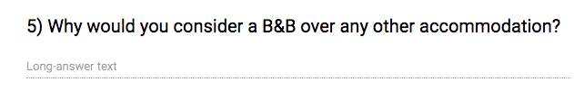

Answer:

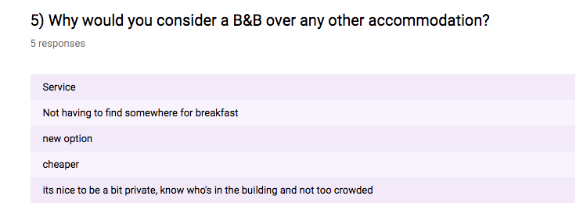

Service:
Many Bed and breakfast offer many facilities and breakfast compare to hotels, which are built for commercial purpose.(suheta P 2017). At Pontcanna, we offer free breakfast, free parking and children area.

Breakfast included
Bed and breakfasts are known for delicious food and breakfast that comes as a package. From generous buffets to multi course menus. (Tony s 2014) Breakfast is included in our B&B.

New option:
Bed and breakfast makes you feel like home. Hosts are always there available for help Compare to hotels. (Tony s 2014) For instance, guests can choose themes for their bedrooms.

Cheaper:
Many breakfast are known to be cheaper compare to hotels and offer free breakfast.

Privacy and not too crowded:
Most Bed and breakfast has fewer rooms compare to hotels. Many people prefer Bed and breakfast because it is less crowded and tranquil.

2.Question 10:

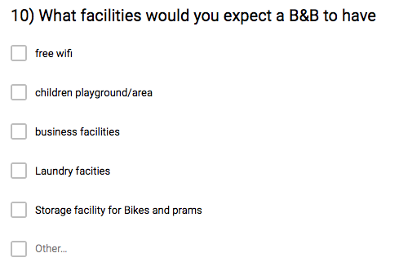

Answer:

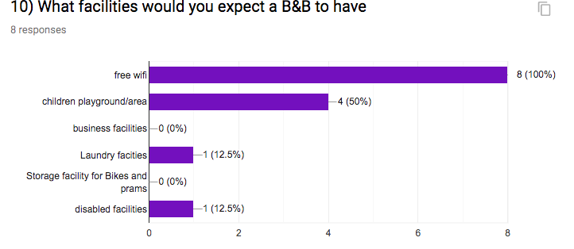

One of the reasons why many people prefer Bed and breakfast compare to hotels is because of the different facilities B&B offer to guests. As shown above 100% of people expect to have WIFI. 50% expect children play area, 12 % opted for laundry facilities and further 12.5% for disables facilities. At Pontcanna, We provide all these facilities for our guests and hope to improve in the future.

REFERENCE LIST

Tony S (2014) available at: https://www.arizona-leisure.com/bed-breakfast-benefits-advantages.html (accessed on the 27/07/2019)

Dc Inn blog 2008 Available at: https://www.dcinns.com/5-reasons-to-choose-a-bed-and-breakfast-vs-a-hotel/ (accessed on the 27/07/2019)

Suheta P 2017 available at: https://vacayholics.com/bed-breakfast-vs-hotel (accessed on the 27/07/2019)

https://www.pontcannainn.com/ (Accessed on the 27/07/2019)

