

Student Name: Onyemaechi Christian Meregini
Student ID: 2413001

Module Name: Changemakers Building Your Personal Brand
Module Code : BMHP5015LON
Lecturer Name : Caroline Salami

Topic:
Brand You

Date Submitted:
Friday 31st July 2026

Introduction
Personal branding is increasingly recognised as an essential aspect of professional development, enabling individuals to communicate their values, strengths, and unique qualities in a competitive employment market. This assessment reflects on the key concepts explored in the” Brand You” module and examine how these have influenced my personal development and career ambitions. It explores how self-awareness, authenticity, and personal branding have enhanced my understanding of the importance of presenting a professional identity that is credible and align with my values, self-awareness, authenticity, cultural identity and emotional intelligence etc.

Unit 1: Brand You
Brand You, enhanced my understanding of personal branding as more than self-promotion; it is about communicating an authentic professional identity.
One key concept was self-awareness, which highlighted the importance of recognising my strengths, values, and areas for development. Goleman (1998) identifies self-awareness as a fundamental aspect of emotional intelligence, enabling individuals to understand how their behaviour influences others. This encouraged me to reflect on my professional values of compassion, integrity, and person-centred practice.
A second concept was authenticity. The lectures emphasised that a strong personal brand should reflect genuine values rather than an idealised image. Shepherd (2005) argues that authentic personal branding builds trust and credibility, reinforcing the importance of consistency between personal values and professional behaviour.
Finally, the concept of digital presence demonstrated how online platforms contribute to professional reputation. Labrecque, Markos and Milne (2011) explain that social media allows individuals to shape and communicate their personal brand. This prompted me to review my online profile and consider how it reflects my skills and career aspirations.
A central focus of this assessment is the notion of authentic choice and freedom. Authentic choice refers to making decisions that reflect an individual's personal values, beliefs, and aspirations rather than being influenced solely by external expectations or social pressures (Ryan and Deci, 2000). Freedom, in this context, is the ability to pursue meaningful goals while remaining true to one's identity. Through reflecting on these concepts, I have become more aware of the importance of making career decisions that are consistent with my commitment to compassion, integrity, and person-centred practice. This is further explained in Figures 1 – Autonomy to make personal choices in line with my values and culture.

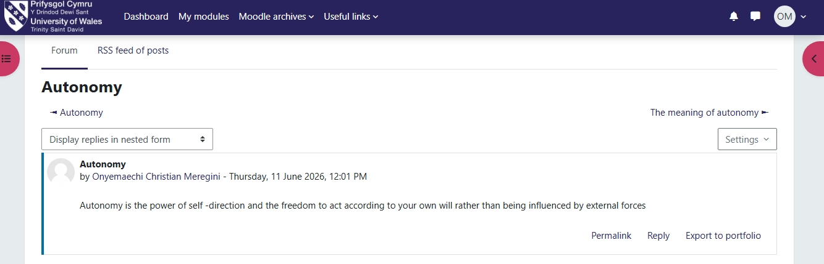
Figure 1: Freedom To Choose Our Career.

Figure 2. equally buttressed the freedom to make my career choices without limitation

Figure 2. Choosing Our Career
As an aspiring leader within health and social care, I recognise that developing an authentic personal brand requires continuous reflection, lifelong learning, and professional growth. This assessment will critically examine how the theories and concepts introduced in Unit 1 have shaped my understanding of personal branding and how they will support my future career aspirations while enabling me to make authentic and value-driven professional choices.

Unit 2: It's a Small World (Reflection)
It's a Small World, expanded my understanding of how globalisation influences health and social care practice and reinforced the importance of recognising our interconnected world. The lectures explored several key topics, including global health inequalities, cultural diversity, collaborative working, sustainability, and the importance of having a clear sense of purpose. These themes encouraged me to consider how international events, policies, and social changes affect local practice and the delivery of person-centred care. It's a Small World, broadened my understanding of the importance of networks and global connections in personal and professional development.
One of the most significant concepts I learned was the impact of global interconnectedness on health and social care. The COVID-19 pandemic demonstrated that health challenges are not confined by national borders and require international collaboration. The World Health Organization (2023) highlights that global cooperation is essential for improving health outcomes and reducing inequalities. This understanding has made me more aware that, as a health and social care professional, I must consider wider social, economic, and environmental factors that influence people's health and wellbeing, not just their immediate care needs. See figure 3, below explaining the concept of networking.
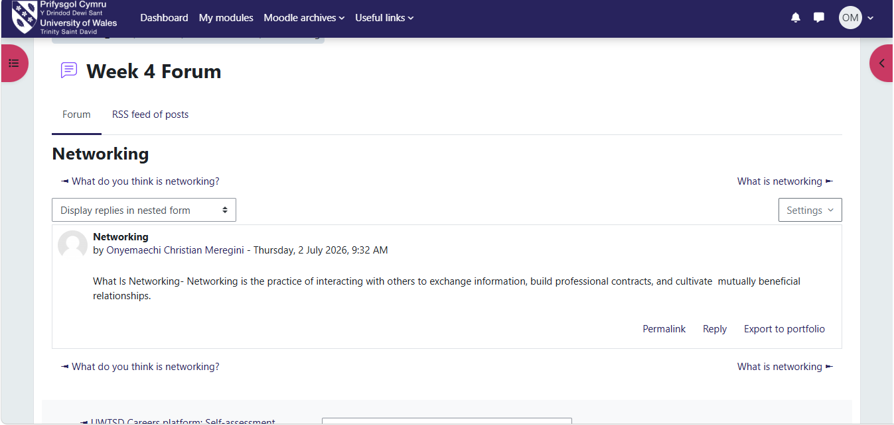
Figure 3: Networking
.
It highlighted the importance of professional networks and the role that both human and non-human elements play in supporting development. I learned that effective practice relies on collaboration with colleagues, multidisciplinary teams, organisations, digital technologies, and professional resources. Latour (2005) explains through Actor-Network Theory that both people and systems influence how knowledge is created and shared. This encouraged me to value supervision, professional guidance, legislation, and digital systems as important contributors to my learning and decision-making.
The unit also strengthened my appreciation of cultural competence. Working in diverse communities requires professionals to respect different beliefs, traditions, and values while delivering equitable care. Campinha-Bacote (2002) argues that cultural competence is an ongoing process of developing awareness, knowledge, and skills to work effectively with people from different backgrounds. Reflecting on my own practice, I recognise the importance of listening without judgement, adapting communication to individual needs, and promoting inclusion. These approaches enable me to build trusting relationships and provide person-centred support that respects each individual's identity.
Another key learning point was the importance of purpose in both study and professional practice. The lectures encouraged me to reflect on why I chose a career in health and social care and how a clear sense of purpose supports resilience, motivation, and continuous improvement. Sinek (2009) suggests that individuals who understand their "why" are more likely to remain committed to their goals and inspire others. This concept resonated with me because my purpose is to improve the wellbeing of vulnerable adults by promoting dignity, independence, and choice. Remembering this purpose helps me remain focused when managing complex situations and motivates me to continue developing my knowledge and skills.
The unit also influenced how I approach my studies and professional development. I have become more proactive in engaging with current research, reflecting on my practice, and learning from different perspectives. I now appreciate that lifelong learning is essential in responding to changing health needs, emerging global challenges, and evolving legislation.

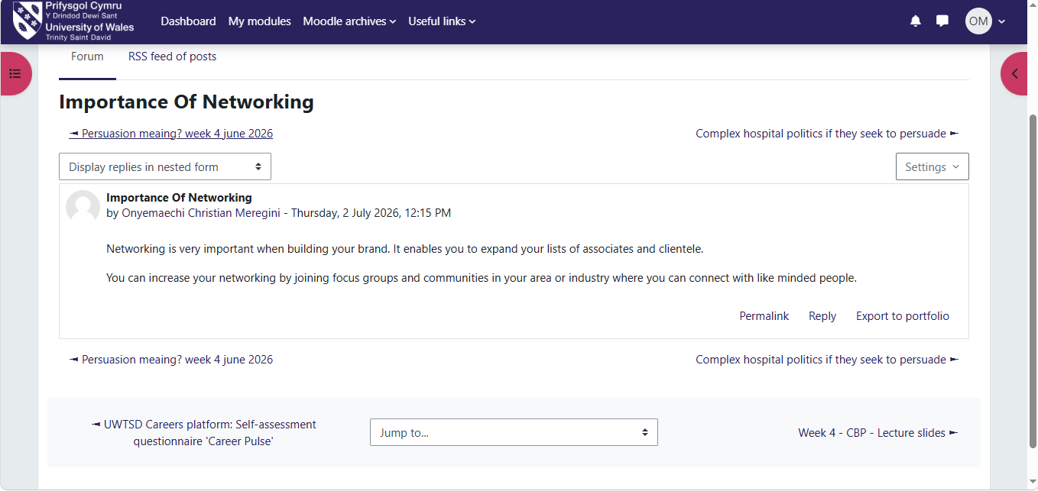
Figure 4: Importance of Networking

This unit emphasised the benefits of developing large and diverse professional e networks. Figure 4, highlights the importance of networking. tGranovetter (1973) argues that weak social ties often provide access to new information and opportunities that close networks cannot offer. Reflecting on this concept, I recognised the importance of engaging with professionals from different disciplines, cultures, and organisations. As a social worker, working alongside healthcare professionals, voluntary organisations, and community services enables me to provide holistic, person-centred care while continually expanding my knowledge and perspectives.
Overall, Unit 2 has increased my awareness that effective health and social care practice extends beyond local services. It requires cultural sensitivity, global awareness, collaboration, and a strong sense of purpose. These insights will help me become a reflective practitioner who is better equipped to contribute positively to individuals, communities, and the wider health and social care system.

Reflection on Unit 3: Opportunity Knocks
Opportunity Knocks, broadened my understanding of career development by introducing the concepts of boundaryless careers, protean careers, and the gig/open talent economy. Before studying this unit, I viewed career progression as following a traditional pathway within a single organisation. However, the lectures challenged this perspective by demonstrating that modern careers are increasingly flexible, self-directed, and shaped by continuous learning rather than organisational structures. This has influenced how I view my own professional development and future career opportunities within health and social care.

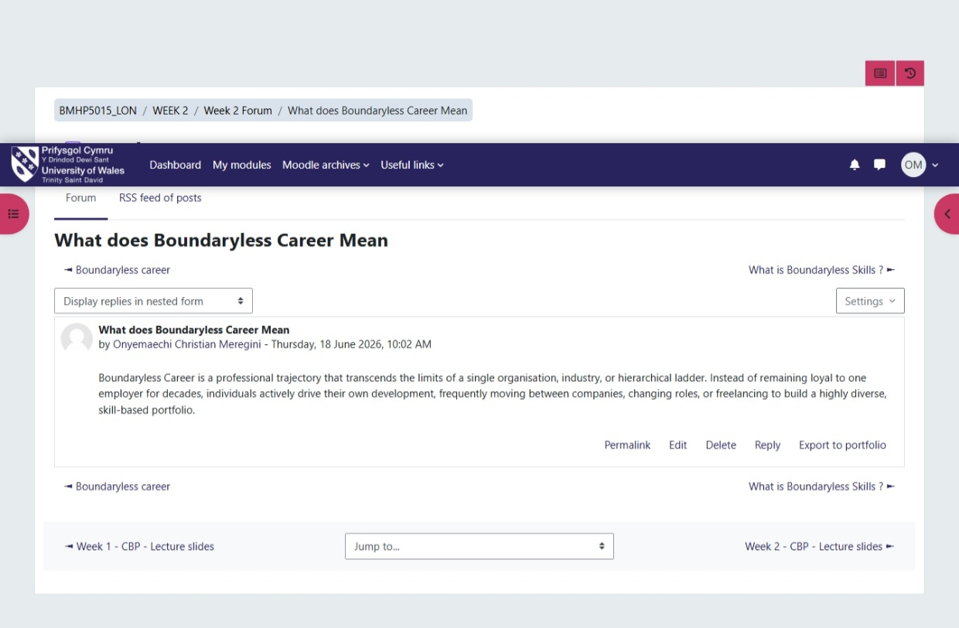
Figure 5. Boundaryless Career

One of the key concepts explored was the boundaryless career, see figure 5, which refers to careers that extend beyond the boundaries of a single employer and involve movement across organisations, sectors, and professional roles (Arthur and Rousseau, 1996). This concept helped me recognise that career success is no longer defined solely by promotion within one organisation but by developing transferable skills, professional networks, and diverse experiences. Reflecting on my own career, I realise that gaining experience in safeguarding, mental capacity assessments, multidisciplinary working, and leadership has equipped me with skills that are valuable across different health and social care settings. This understanding has encouraged me to remain open to new opportunities that support both personal growth and improved outcomes for the people I support.
The unit also introduced the concept of the protean career, where individuals take responsibility for managing their own careers based on personal values, continuous learning, and psychological success rather than external rewards (Hall, 2004). This theory resonated with me because it aligns with my ambition to develop as a compassionate and effective Registered Manager (CQC). I have realised that achieving career satisfaction is not only about obtaining senior positions but also about remaining committed to lifelong learning, reflective practice, and maintaining professional integrity. This perspective has motivated me to actively seek training, supervision, and professional development opportunities that enhance my knowledge and confidence.
Another important topic was the gig and open talent economy, which highlighted how technology has created more flexible ways of working and learning. Although health care work remains a regulated profession, the increasing availability of online learning, consultancy, project work, and digital collaboration provides opportunities to broaden professional expertise beyond traditional employment. This encouraged me to appreciate the importance of adaptability, digital skills, and networking in maintaining career resilience within an evolving workforce.
Overall, Unit 3 has changed my perspective on career development by demonstrating that opportunities often arise through being proactive, adaptable, and willing to embrace change. Rather than waiting for opportunities to appear, I now recognise the importance of actively creating them through continuous professional development, networking, and reflective practice.
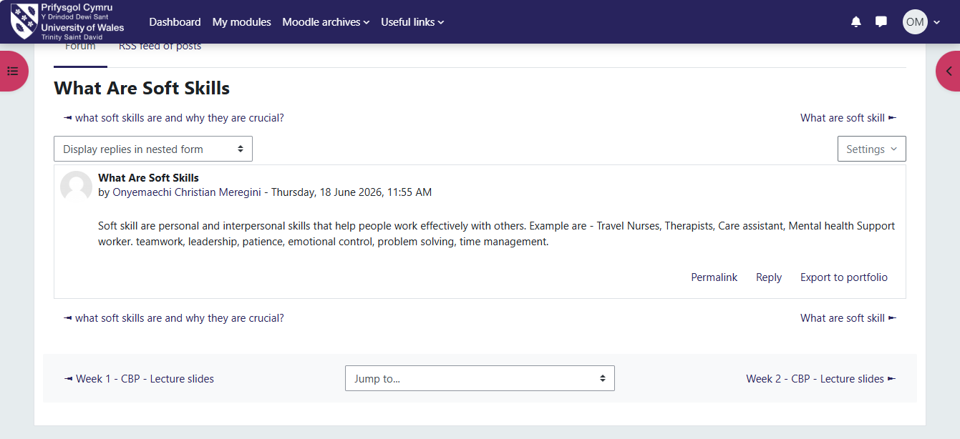
Figure 6: What are Soft Skills
The topic network has increased my awareness of how networks respond to complex situations and create positive change within society. Castells (2010) suggests that modern society is shaped by interconnected networks that influence communication, decision-making, and social change. This helped me understand the importance of partnership working within health and social care, where effective collaboration between agencies is essential to safeguarding vulnerable adults, coordinating care, and improving outcomes.
As I progress in my career within health and social care, I intend to adopt a boundaryless and protean mindset by remaining open to new experiences, strengthening my transferable skills, and pursuing opportunities that align with my values and long-term career aspirations. See figure 6, that explains the importance of acquiring essential and transferable soft skill for added value.

Reflection on Unit 4: The Pursuit of Happiness and Conclusion
Unit 4, The Pursuit of Happiness, deepened my understanding of how personal wellbeing, self-awareness, and emotional intelligence contribute to professional success. The unit emphasised that career satisfaction is not measured solely by promotion or financial rewards but by finding purpose, maintaining wellbeing, and continually developing the skills needed to adapt to changing professional environments. This learning encouraged me to reflect on how I can build a meaningful and sustainable career in health and social care.
One of the key topics explored was the importance of self-management. Self-management involves effectively managing time, emotions, resilience, and professional responsibilities to achieve personal and career goals. Covey (1989) argues that effective self-management begins with understanding personal priorities and acting proactively. Reflecting on my own practice, I recognise that managing a complex caseload as a health care worker requires organisation, adaptability, and resilience. Developing these skills enables me to maintain high standards of practice while supporting my own wellbeing and preventing burnout. You can not over-emphasise the importance of maintaining emotional balance in order to manage both our life and the lives other people we are responsible to manage. Figure 7, below, explains all that.

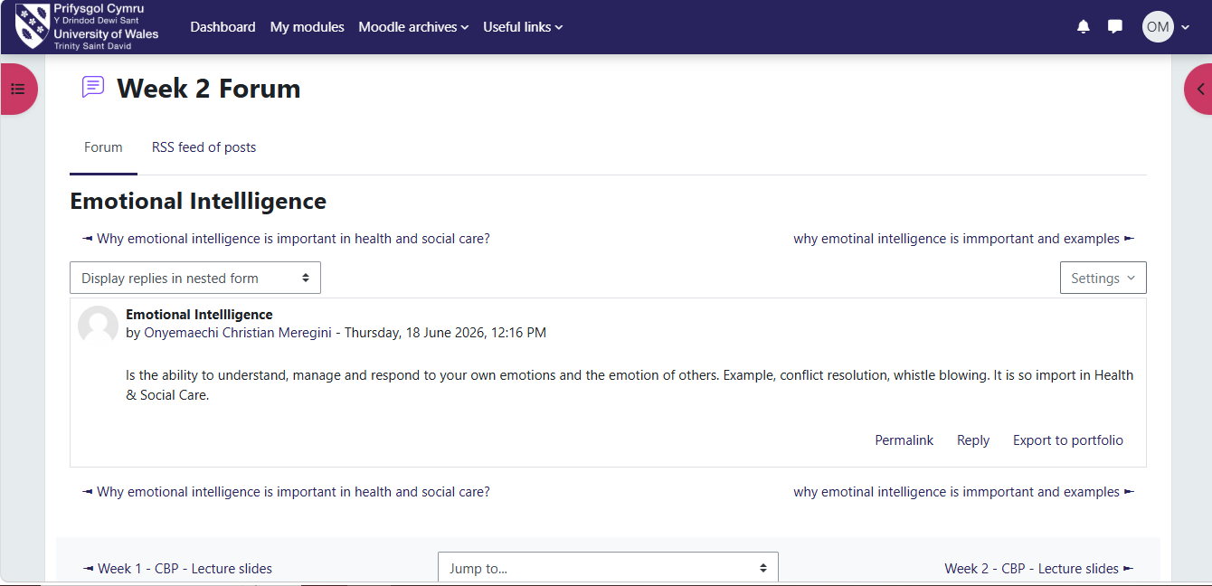
Figure 7: Emotional Intelligence

The unit also reinforced the value of self-awareness and emotional intelligence. Goleman (1998) describes emotional intelligence as the ability to recognise and manage one's emotions while understanding and responding appropriately to the emotions of others. I have realised that emotional intelligence is essential in health and social care, where professionals regularly work with individuals experiencing distress, loss, or significant life changes. By strengthening my self-awareness, empathy, and communication skills, I can build trusting relationships, make balanced decisions, and work more effectively within multidisciplinary teams.
Another valuable concept introduced was curiosity intelligence, which encourages individuals to remain open to learning, questioning existing practice, and seeking innovative solutions. Curiosity promotes lifelong learning and supports continuous professional development in rapidly changing healthcare environments. Maxwell (2005) suggests that individuals who remain committed to learning are better equipped to adapt to change and achieve long-term success. This has encouraged me to actively seek feedback, engage with research, and embrace new opportunities to enhance my knowledge and practice.
The unit also highlighted the importance of developing boundaryless skills, including adaptability, communication, collaboration, digital literacy, and lifelong learning. These transferable skills enable professionals to work effectively across organisations and respond to the changing demands of health and social care. I now recognise that maintaining these skills will strengthen my career resilience and prepare me for future leadership opportunities.
Finally, making connections reinforced the value of building meaningful professional relationships based on trust, communication, and shared learning. Developing strong networks supports career progression, enhances problem-solving, and encourages lifelong learning. This topic also reminded me that networking is not only about creating career opportunities but also about improving the quality of care provided to individuals and communities. This is particularly supported by the network of professionals that we engage in our circle of influence. See figure 8. One adage says, show me your friends and I will tell you who you are – Influence of Authentic Networking.

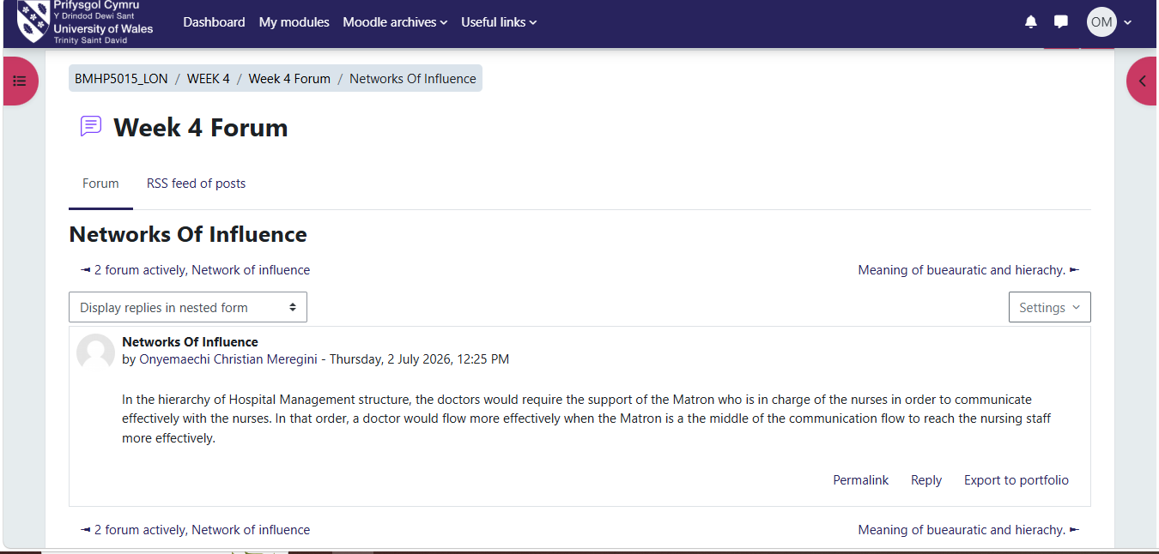
Figure 8: Network of Influence
Conclusion
In conclusion, this module has significantly enhanced my understanding of personal branding, global awareness, career development, and professional wellbeing. Across all four units, I have developed greater self-awareness, confidence, and a clearer sense of purpose. I have learned that successful careers are built through authenticity, continuous learning, emotional intelligence, and the ability to recognise and create opportunities. These insights will support my future practice as a health and social care professional by enabling me to deliver compassionate, person-centred care while continuing to grow as a reflective practitioner and future leader.

References
Goleman, D. (1998) Working with Emotional Intelligence. London: Bloomsbury.
Labrecque, L.I., Markos, E. and Milne, G.R. (2011) 'Online personal branding: Processes, challenges, and implications', Journal of Interactive Marketing, 25(1), pp. 37–50.
Ryan, R.M. and Deci, E.L. (2000) 'Self-determination theory and the facilitation of intrinsic motivation, social development, and well-being', American Psychologist, 55(1), pp. 68–78
Shepherd, I.D.H. (2005) 'From cattle and coke to Charlie: Meeting the challenge of self-marketing and personal branding', Journal of Marketing Management, 21(5–6), pp. 589–606.
Campinha-Bacote, J. (2002) 'The process of cultural competence in the delivery of healthcare services: A model of care', Journal of Transcultural Nursing, 13(3), pp. 181–184.
Castells, M. (2010) The Rise of the Network Society. 2nd edn. Oxford: Wiley-Blackwell.
Granovetter, M.S. (1973) 'The strength of weak ties', American Journal of Sociology, 78(6), pp. 1360–1380.
Latour, B. (2005) Reassembling the Social: An Introduction to Actor-Network-Theory. Oxford: Oxford University Press.
Sinek, S. (2009) Start With Why: How Great Leaders Inspire Everyone to Take Action. New York: Portfolio.
World Health Organization (2023) World Health Statistics 2023: Monitoring Health for the SDGs. Geneva: World Health Organization.
Arthur, M.B. and Rousseau, D.M. (1996) The Boundaryless Career: A New Employment Principle for a New Organizational Era. New York: Oxford University Press.
Castells, M. (2010) The Rise of the Network Society. 2nd edn. Oxford: Wiley-Blackwell.
Hall, D.T. (2004) 'The protean career: A quarter-century journey', Journal of Vocational Behavior, 65(1), pp. 1–13
Covey, S.R. (1989) The 7 Habits of Highly Effective People. New York: Simon & Schuster.
Goleman, D. (1998) Working with Emotional Intelligence. London: Bloomsbury.
Maxwell, J.C. (2005) Thinking for a Change. Nashville: Thomas Nelson.

