How did Elvis influence film and animation?
In recent times films have used celebrities as symbols to strengthen the films morals, Blade Runner has used various past time celebrities to help create a scene which happened in an auditorium. In this scene there was a specific part which paid homage to Elvis Presley. Elvis was a very influential man which his character has showed through in many films and animations alike. In this paper I will deconstruct characters and scenes which are influenced by Elvis Presley.
Elvis was born January 1935 in the city of Tupelo, Mississippi. When it came to his career in singing which began in 1954, Where he birthed a new genre of music, Rock and Roll. His first hit single ‘Heart Break Hotel’ came about the same year he had his first number one album and signed a movie contract with paramount pictures. He was a big hit, he was also very popular guest on several variety shows even though his sexy dancing sparked uproar and he became the big sex symbol of that era. You could spot Elvis a mile away due to his slick combed back hair and his flared white jumpsuits. Following suit with his extraordinary career, his death in 1977 was also a very famous one. He died from a heart attack, due to overdosing in his home in Graceland.
Johnny Bravo was an animated series from the mid 90’s, with the character thinking all woman wanted him due to his look and ‘Hunky body’ along with a strong output of a confident man with no shame of putting himself out there.
My theory about Johnny Bravo is that he is a man in his mid-thirties who is all into working out and looking after his appearance as well as his attempt to get ladies. He also comes across as a strong character with a outgoing personality, but when I deconstructed his personality he is very lonely and his way to deal with this is to speak to women. Along with using a voice as common as Elvis. I also feel that’s the deeper you investigate the tv program the more things you realize that Elvis is a huge part of the tv show. The fact that the named their town after Elvis middle name to create Aron town is not a suspicion of adding more of the king to the show.
Blade runner is a film based in the future from a past sequel from 1982, which mainly took place in Budapest, Hungary. It’s based around a character who works for the police in Los Angele police department known as (LSPD). The main character discovers a lead that takes him to a former blade runner who had been missing for three decades.
My Theory of blade runner 2049 with the visual scene of Elvis is very eerie and the space laid out to focus your attention on the holographic image. The lighting also accentuates this by having a dark misty surrounding to the hologram which makes it stand out. I believe the purpose of this scene was to show that Elvis among others would still be relevant in the year 2049. The director Denis Villeneuve had a vison that once holographic technology was invented (in the world of blade runner) that they would re show some of the greats in a Las Vegas auditorium. ‘Suspicious Minds’ was also the favourite song of the character Rick Deckard who was played by Harrison Ford.
Amongst my personal theories there are people who would think otherwise. There is one theory in particular that has me intrigued, which is that Johnny Bravo is a child with the character on screen displaying the imagined perfect characteristic that a child would like. (BuzzFeed Community, 2018) says, ‘He has exaggerated expressions and behaviors just as a kid. He appears to have no real job, like a child would. His body seems out of

proportion like a kid's idealized version of his adult body compared to others. He has the basic idea of dating women, but the full concept of going into a full relationship.’

As the generation continues forward there may be a lot more Genre metas around, therefore Elvis may become more obsolete within the generation change, there will be a chance of outdated entertainment, with time changing Elvis will become more nostalgic. There will end with a certain generation when they would have experienced Elvis will likely be either passing or close to the next generation will not appreciate Elvis as much. Based on a movie for the future 2049. (CINEMABLEND, 2018) Describes ‘Evidently his fame hasn't declined in the Blade Runner world either, because he was briefly spotted as a hologram in one of the Blade Runner 2049 trailers.’

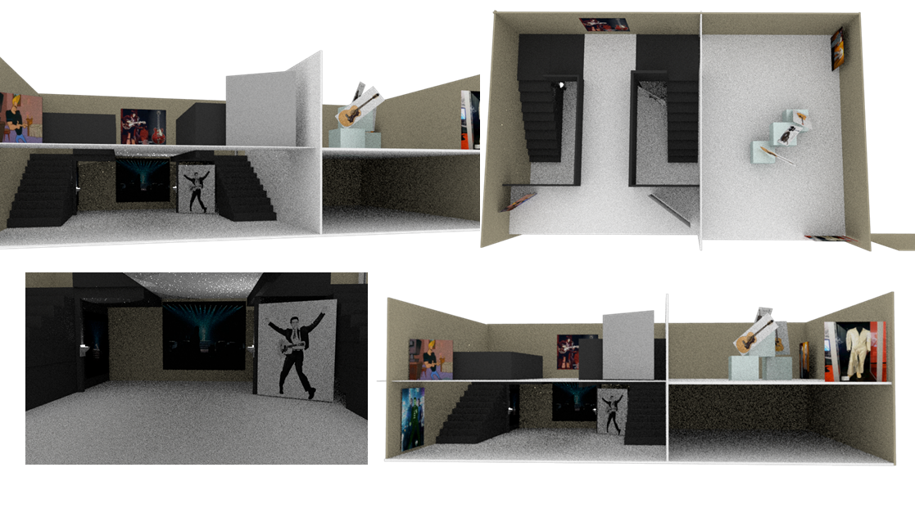
When designing this exhibition, I wanted to make it known to my audience that Elvis was the focus for my exhibition. I placed it in such way where It commands the space, I wanted to take the audience back in time starting from the newest tributes to Elvis and filter it back to the oldest.
I wanted to start with blade runner next to the Elvis display as this was the most recent tribute to the king of rock and roll. On the blade runner display I wanted to have the scene in the auditorium where Elvis glitches in and out of the scene using a projector, this was to imitate the holographic effect created in blade runner.
If you were to follow the stairs to the first floor you will be joined by a display of the tv series, Johnny Bravo. This is an animated show dedicated to creating a voice like character using a voice like Elvis. ‘’When Partible told the eventual voice of Johnny Bravo, Jeff Bennett, that he wanted the character to sound like Elvis, Bennett only had one question: Old or young? Bennett explained that they’re basically two unique voices, with a younger Elvis sounding much faster and more energetic, while the elder Presley would require Bennett to deepen and “slow it down.” (Mentalfloss.com, 2018)
When walking into the following room you will be amidst all the guitars and outfits Elvis ever wore, and to see a visual image of him presented in his costumes. The reason in choosing this is because I wanted to connect the past and the present. When Johnny Bravo was first released, animated tv programs were very simple and as the time has gone on the progression of visual effects is outstanding as shown in blade runner where there is a very well created holographic figure of Elvis.

Bibliography

BuzzFeed Community. (2018). 17 Mind-Blowing Fan Theories That Will Completely Ruin Your Childhood. [online] Available at: https://www.buzzfeed.com/readcommentbackwards/17-mind-blowing-fan-theories-that-will-completely-dmjk?utm_term=.med17b34Z#.ug4wzK7Dm [Accessed 7 May 2018].

CINEMABLEND. (2018). Apparently Elvis Presley Is In Blade Runner 2049. [online] Available at: https://www.cinemablend.com/news/1692980/apparently-elvis-presley-is-in-blade-runner-2049 [Accessed 7 May 2018].

Lefebvre, H. (2016). The production of space. Malden, Mass.: Blackwell.

Mentalfloss.com. (2018). 10 Fun Facts About <em>Johnny Bravo</em>. [online] Available at: http://mentalfloss.com/article/502673/10-fun-facts-about-johnny-bravo [Accessed 6 May 2018].

