Daniel Awuku Acheampong - 2217832

Learning in the Digital Era – BMPL4007/BMPS4009
Part 1 - Reflection Using Gibb's Reflective Model

The first part of this assignment demands the use of Gibbs’ reflective model to reflect on how the transferable skills l have developed over the course of Learning in the Digital Era module will help my future aspirations, and whether there are any gaps in my skills which needs to be addressed.
Gibbs’ reflective model consist of six stages which provides the description of a situation, feelings, evaluation and analysis to make sense of the experience to examine what you would do if the situation arose again each of which will be discussed in this assignment, Gibbs G. (1988).

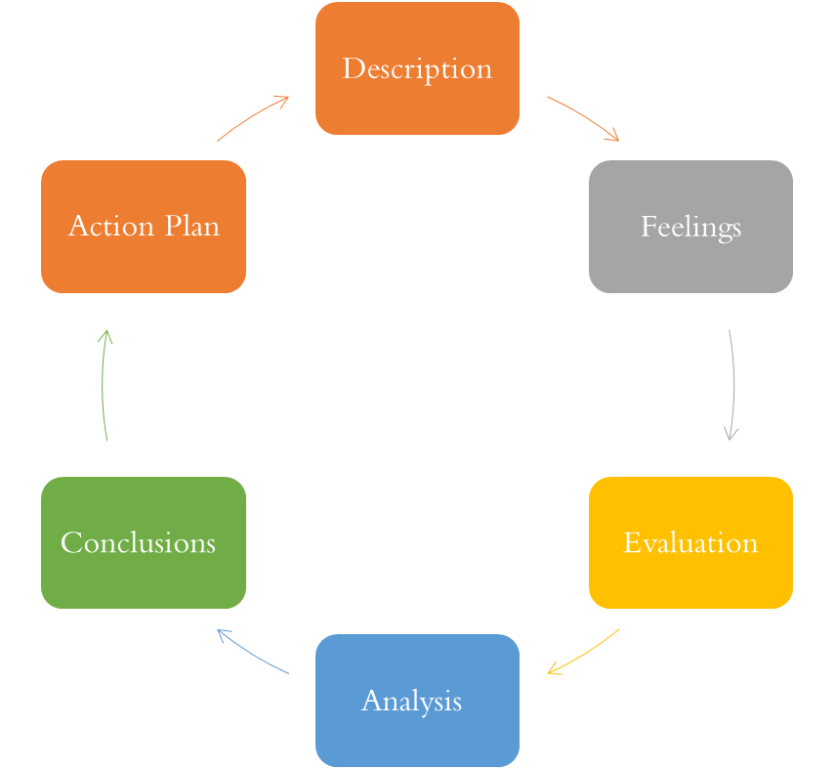

Description
In January 2023, l wrote my assignment in “Learning in the Digital Era module” at home in London. I wrote it using the transferable skills l have acquired over the course of Learning in the Digital Era module including how to be a resilient and healthy independent learner, how to practise the principles of learning agility as well as how to use suitable technology to support my work. These includes using technology such as Microsoft word, PowerPoint, excel, Teams and outlook. Conducting research using databases, library catalogue and other tools for research. Effective communication and Teamwork as well as other unhelpful habits like procrastination and perfectionism, uwtsd moodle (2023).
I would say that writing the assignment coincided with series of circumstances, and it became apparent that my focus and concentration was inadequate, therefore, l was unable to achieve the expected outcome.
Feelings:
Initially I felt apprehensive, thinking l will achieve an excellent result. However, as mentioned above, writing of the assignment coincided with series of circumstances causing constant panicking and nervousness. These challenges and lack of understanding of the question contributed to my poor assignment results, l felt disappointed and felt that my lecturer will be disappointed in me.

Evaluation
Some elements of the assignment did go well because l was able to create the right study environment which in this case my home, ensured it was conducive in terms of having the right furniture lighting and temperature. Also considered was reducing the levels of distraction by turn off your phone. I was able to plan and prioritised tasks by using Eisenhower’s principle to create a study plan.
However, some elements of the assignment did not go well because l was unable to organise my study time with other commitment such as my job, my family, social life and hobbies, Cottrel, (2019). Also, l was unable to accurately estimate the full amount of time, effort and resources required to complete the assignment. Having no clear plans resulted in falling behind in reading and research leading to poor writing of the assignment.
Analysis
On reflection, one thing that went well was that I was able to locate information and services, evaluate the information and find credible academic resources. I was also able to identify fake news as well as credible academic information CyberWise, (no date). Recognise strategies to effectively use online resources and the library catalogue.
Furthermore, l was able to use appropriate technology such as Microsoft word and Microsoft PowerPoint to make high quality written assessments and presentation to support my work.
Other elements which did not go well were procrastination and perfectionist behaviour on my part. Procrastination is the avoidance of starting certain task, Moore et al (2010). I waited until the deadline and I found myself rushing to complete the assignment and was disorganised and unable to produce good work.

There are other elements which l felt contributed to my failure including my inability to identify where l needed to reference to avoid plagiarism “UWTSD’s Academic Misconduct Policy (2020-21 p.2) defines plagiarism as presenting someone else’s work as the student’s own”. This is an Academic Misconduct where there are penalties.
Other contributing elements are lack of realistic plan, unclear objectives, being perfectionist and not able to seek for help when needed, however, I feel I still need to improve on my digital learning skills as there still some gaps that need to be filled to be a successful individual in future.

Conclusion

In conclusion, I learnt that I need to practise how to overcome procrastination in order avoid writing my assignment in a rush and leave more time to be able to do a good work. There could have been a more positive approach by having a realistic plan in carrying out research and planning ahead of writing the assignment. In future, I need to develop my organisational skills to ensure that I am able to plan and prioritised tasks by using Eisenhower’s principle to create a study plan.

There are several things that I could have done, including to referencing my work properly to avoid plagiarism “UWTSD’s Academic Misconduct Policy (2020-21 p.2). To have a clear objective, avoid being perfectionist and to seek for help when needed.

Action Plan
In order to improve my digital literacy skills, I have planned to take online courses to make efforts to use technology to complete my assignments, and keep myself updated with latest technological and digital information.
I also have planned to take online courses to improve the foundational skills required to be a resilient and healthy independent learner and to practise the principles of learning agility to support and enhance my learning experience to be a successful individual in future.

Part 2 - Personal Development Plan

It is reasonable to think that taking time to learn new things will improve my life and the fact that l am studying with UWTSD shows that l am committed to this. I have realised that the future workplace is unlikely to value a qualification unless one can demonstrate the skill of learning.
It is argued that agile learners will be the kind of people valued in future work environments, as they are able to embrace the risk of embarrassment by placing themselves in new situations where the risk of success or failure is finely balanced, Schon D (1983).

My Personal Development Plan is mainly focused on developing my Digital skills, improve the foundational skills required to be a resilient and healthy independent learner and practise the principles of learning agility to support and enhance my learning experience to be a successful individual in future.

In this section I will develop a personal development plan concerning these skills for my personal and professional development.

Student Name |  | Student Number |  | Module |  | Code
Daniel Awuku Acheampong |  | 2217832 |  | Learning in the Digital Era |  | BMPL4007  BMPS4009
What goals do I want to achieve? | How will I measure my progress? |  | What resources or support will I need? |  | How is the objective relevant to my personal aspirations? | What is the timeframe for the achievement of my goals?
Specific | Measurable |  | Achievable |  | Relevant | Timebound
My Personal Development Plan is mainly focused on developing my Digital skills, improve the foundational skills required to be a resilient and healthy independent learner and practise the principles of learning agility to support and enhance my learning experience to be a successful individual in future.  These will be done alongside with traditional communication skills, involving speaking, writing, and reading clearly, | Being able to use technology such as Microsoft word, PowerPoint, excel, Teams and outlook.  Being able to conduct research using databases, library catalogue and other tools for research.  Being able to communication effectively, collaboration and a reliable Team player..  Being able to overcome other unhelpful habits like procrastination and perfectionism uwtsd moodle (2023). |  | I have planned to take online courses to improve the foundational skills required to be a resilient and healthy independent learner and to practise the principles of learning agility to support and enhance my learning experience to be a successful individual in future.  I will need to save money to pay for the fees, buy books and laptop. |  | In conclusion, my main focused on developing my Digital skills, improve the foundational skills required to be a resilient and healthy independent learner and practise the principles of learning agility to support and enhance my learning experience to be a successful individual in future. | September 2023 – June 2024

References

C. Cooper, J. Flint-Taylor, M. Pearn (2013) Buildings Resilience for success: A resource for managers and organisations Published by: Palgrave Macmillan UK , 9 Jul 2013 - Business & Economics - 233 pages. date accessed 23/11/2023

Cottrell, S (2019) The study Skills handbook-5th edition .London: Macmillan Education.

Gibbs, G. (1988). Learning by Doing: A Guide to Teaching and Learning Methods. Oxford: Oxford Further Education Unit

Flood A, (2019), Nora Roberts files multi-plagiarism lawsuit alleging writer copied more than 40 Authors; The Guardian, 25th April. Available at https://www.the guardian.com/books/2019/25/nora-roberts-files-multi-plagiarism-lawsuit-alleging-writer-copied-more-than-40-authors

Moore, S. et al (2010) The Ultimate study Skills handbook. Maidenhead, England: Open University Press.

Mind Tools (no date), Eisenhower's Urgent/Important Principle Using Time Effectively, Not Just Efficiently, (Article), https://www.mindtools.com/al1e0k5/eisenhowers-urgentimportant-principle

Uwtsd moddle (2023) – Reflection and Reflexivity, Learning through experience -
https://moodle.uwtsd.ac.uk/course/view.php?id=8618&section=15&singlesec=15

UWTSD’s Academic Misconduct Policy (2020-21 p.2)

Donald Schon (1983), What is reflection-in-action (article) https://content.iriss.org.uk/reflectivepractice/practitioner.html

