REFLECTION ON STUDY SKILLS

William Noakes – 2019255
L4 Ordnance Munitions & Explosives
Abstract
This purpose of this report is to reflect on the implementation and application of techniques and skills acquired through the ACDA4010 Study Skills module from the perspective of the author. Key transferable skills were identified in a review of literature; and the findings of a skills self-evaluation presented, and used to set goals and create a S.M.A.R.T action plan. Evidence demonstrating successful implementation of the action plan is provided and used to show how the module can facilitate meaningful change and improvement in skills and understanding of personality in the author, whilst identifying areas for further improvement and research.

Contents
Abstract (2)
Introduction (4)
1. PRESENTATION (5)
- 1.1 Synopsis of Presentation (5)
- 1.2 Key Learning Points from Completing Presentation (7)
- 1.3 Evaluation of Presentation (7)
2. SKILLS EVALUATION (9)
- 2.1 Transferrable Skills and Skills for Higher Education (9)
- 2.2 Data from Self-Evaluation (10)
- 2.2.1. Skills Strengths and Weaknesses (10)
- 2.2.2. Personality Type (12)
- 2.2.3. Suitable Careers Suggestions (14)
- 2.3. Analysis of Self-Evaluation Results (15)
- 2.3.1 Analysis of Skills Evaluation Results (15)
- 2.3.2. Analysis of Personality Type Results (16)
- 2.3.3. Analysis of Suitable Careers Suggestions (17)
- 2.4. Identification of academic and personal goals (17)
- 2.5. Creation of S.M.A.R.T Action Plan (19)
3. APPLICATION (20)
- 3.1. Managing Data (20)
- 3.1.1. Creating an organised filing system (20)
- 3.1.2 Creating a Data Backup Plan (20)
- 3.2. Time-Management, Organisation and Realising Action Plan Objectives (21)
- 3.2.1. Time Management and Organisation (21)
- 3.2.2 Realising Other Action Plan and Goals Objectives (23)
4. CONCLUSION AND EVALUATION (23)
5. APPENDICES (27)
- 5.1. Appendix A – Self Evaluation of Academic Skills (27)
- 5.2. Appendix B – Big-five Personality Test Factor Descriptors (28)
- 5.3. Appendix C – INTP Personality Type Descriptor (28)
- 5.4. Appendix D – ISFP Personality Type Descriptor (29)
- 5.5. Appendix E – Quiet Revolution Test Parameters (30)
- 5.6. Appendix F – CryptoWall Trojan Report (31)
Introduction
The purpose of this report is to reflect upon the implementation and application of techniques and skills acquired through the ACDA4010 Study Skills module. The first section, ‘Presentation’, consists of a basic character profile, which gives a personal introduction and demonstrates the level and basis of self-understanding of personality and skills prior to completing the module. The second section, ‘Skills Evaluation’ provides a synthesis of background research on the importance and priority of various skills for both personal development and for progression in higher education and employment. Following this, a variety of skills and personality assessments are presented, and the findings derived from these analysed and used to set long and short-term goals, and create a S.M.A.R.T action plan. Section 3 then covers the application of the findings and the action plan, presenting evidence of its completion.

1. PRESENTATION
1.1 Synopsis of Presentation
The first section of the Study Skills module entailed the preparation and delivery of a 5-minute autobiographical presentation, using Microsoft PowerPoint to display visuals whilst speaking directly to the audience. The following brief synthesis provides a synopsis of the author’s presentation, including some screenshots from the presentation itself.
The author is William Noakes, born 22nd November 1997, in East Dulwich London. After moving to Horsmonden, in the Weald of Kent, he grew up and went to school there, living with his two parents and younger brother and sister. His main hobbies and interests include the environment and ecology, photography, politics, playing the drums, music and geography. As can be seen in Image 1, one of his passions in particular is macro photography of insects, with a main focus on butterflies and moths.

Image 1: A screenshot from the author’s presentation showing some examples of his wildlife photography

The author has amassed a collection of items based around his interest of playing the drums, including an acoustic 8-piece drum kit, an 11-piece Alesis Strike Pro electric kit, and a self-made cajón (see image 2). This hobby fits well with his interest in music, and his passion for both alternative rock and drum and bass has inspired much of his creativity when playing the drums. In the presentation the author regards their personality as being somewhat introverted, and very much an ‘over-thinker’ (see image 3). He attended the University of Southampton, completing a BSc in Geography, with a focus on physical geography and the biogeography of environments and landscapes. Following this, the author gives details of his current employment at Illusion Pyrotechnics, listing the work which the company carries out and the roles he is responsible for. As shown in image 4, these include research and development projects, conceptualising and designing products and manufacturing of commercial pyrotechnics, technical authoring and complying with and formulating plans for health and safety regulations. The author describes working at Illusion Pyrotechnics as being challenging and having lots of responsibilities, but within a friendly and close work environment. The author ends the presentation by stating some of his personal goals, ranging from short to long term. Listed in particular are: challenging himself by progressing a career in OME, creating and following a fitness routine based around mountain biking and gym work-outs, progressing at skiing, his favourite sport, and designing a custom-built ecohome.
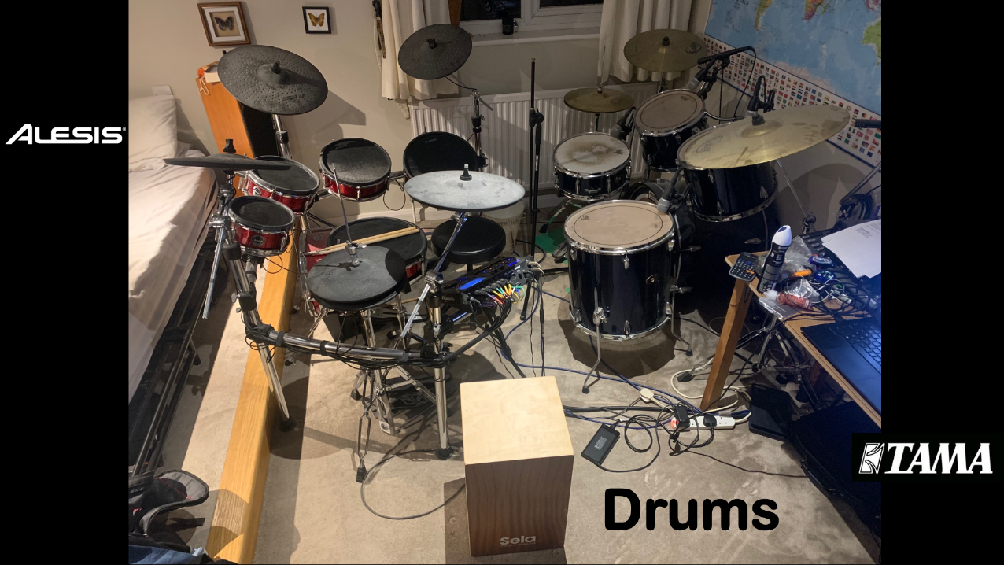
Image 2: A screenshot from the author’s presentation showing his drum kit set-up, featuring the acoustic and electric kits as well as the cajon.

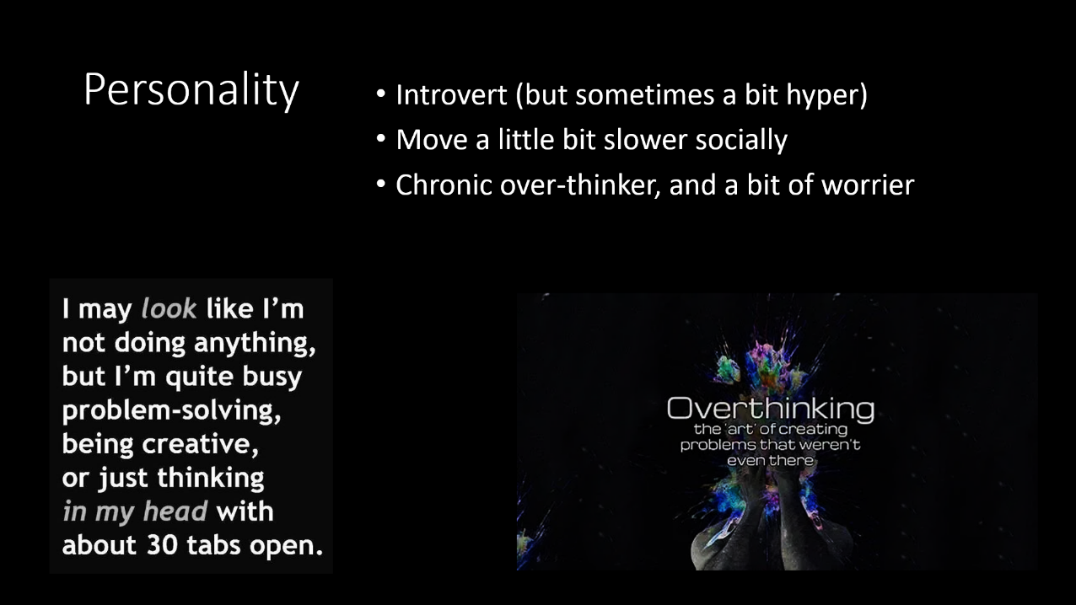
Image 3: A slide from the author’s presentation on his personality.
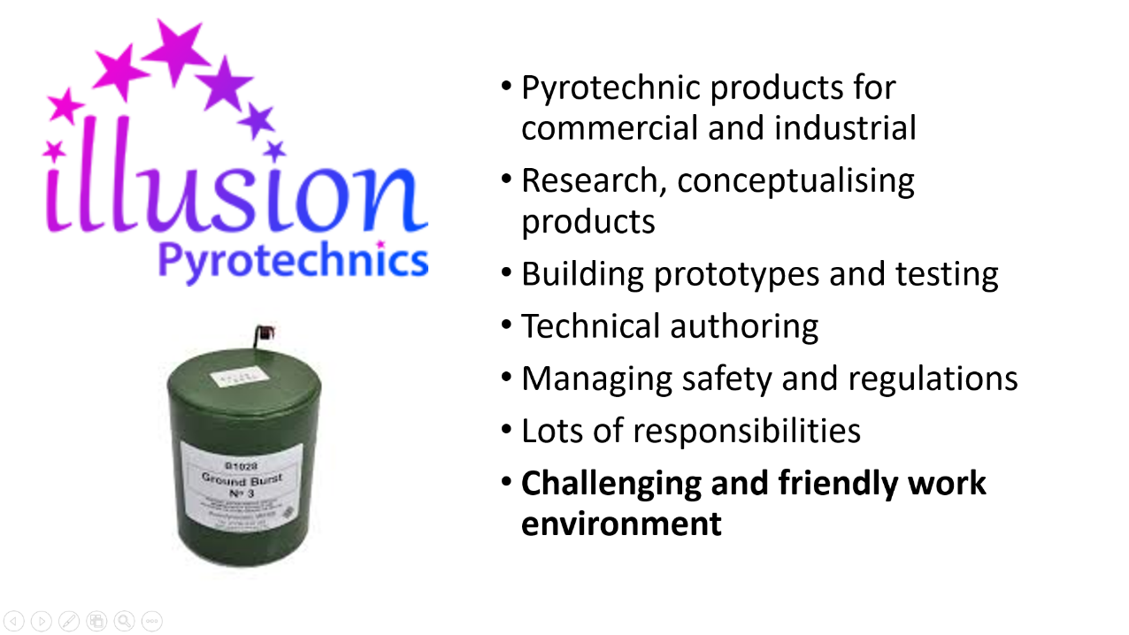
Image 4: A screenshot from the author’s presentation describing his work at Illusion Pyrotechnics
1.2 Key Learning Points from Completing Presentation
The author lists some of the key learning points that he identified from producing and delivering the presentation. These are as follows:
- The importance of being concise when the duration of the presentation is time-limited, such that enough different topics and points can be covered to give a good coverage and overview of the whole subject being presented.
- The need to prioritise topics and information - particularly where the relative importance of the information is subjective - so that the key areas and points are covered in sufficient and/or the most detail.
- The necessity of speaking clearly, both in terms of volume and pace, so that a balance can be found whereby the audience has enough time and is able to acknowledge and understand the information being presented, whilst the pace of the presentation is fast enough to keep their interest and to cover all the topics included.
1.3 Evaluation of Presentation
The presentation was marked by the module coordinator, who provided a feedback sheet scoring the presentation on a variety of criteria grouped into two categories: practical application and deployment and skills for professional practice. This feedback was received by the author, and used, along with their own thoughts, to create a self-evaluation of their presentation. A screenshot of the feedback provided by the module coordinator is shown in image 5.
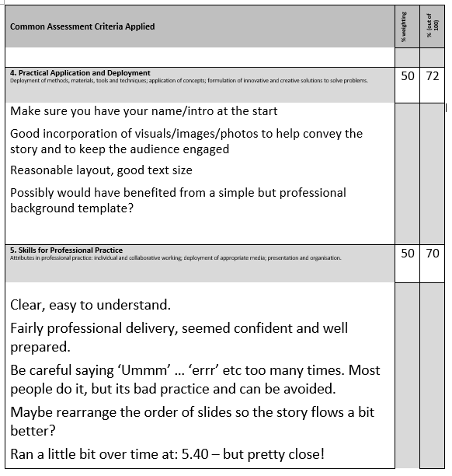
Image 5: A screenshot of the feedback provided by module coordinator on the author’s presentation
In self-evaluation, the main areas which the author feels they could have improved are as follows…
- Ensuring that any basic and administrative information, such as name, date and a general introduction, are properly covered at the beginning of the presentation.
- Balancing the use of different graphics and styles with a layout that feels clean and consistent for the audience, therefore enhancing the readability of the presentation and making it more visually pleasing.
- Better limiting the number of different topics and subjects included, such that the presentation follows a more natural flow of information, as opposed to simply covering as many different topics as possible within the time limit, or exceeding the specified duration.
- Avoiding the use of filler or hesitation words which don’t actually convey any information, so that a greater number of natural pauses can be used to break up blocks of speech and to aid in being as concise as possible.
The author suggests that these improvements, particularly the latter three of the aforementioned points, could be achieved by carrying out more practice deliveries of the presentation. This would provide more chance for self-reflection of the work, and therefore improve the author’s ability to adapt and adjust the content included and the presentation style prior to the final delivery to an audience. Similarly, running through practice presentations with a greater number of different people present would allow for a better range of samples of feedback prior to final delivery, potentially enabling improvements that make the presentation more palatable to a wider or more diverse range of audience members.
2. SKILLS EVALUATION
2.1. Transferrable Skills and Skills for Higher Education
Transferrable skills have been loosely defined as skills developed and applied in one area which are integral to or can be used in another area; for example: skills which are useful in higher education which have uses in employment. In order to develop transferrable skills one must consider what is needed in one scenario and apply it to and within the other scenario [1] [2]. Fallows and Steven describe this as “reverse transfer” [2]. There has been a strong focus on ensuring that skills required and learned in higher education are transferable to the workplace, in order to ensure to efficient graduate employment and allow graduates to provide immediate value to businesses [3]. Transferrable skills are an integral part of enhancing efficiency and productivity in the workplace, as well as improving communication and working relationships with colleagues [4]. Furthermore, it is being increasingly recognised that, due to modern employment patterns and the fact that many people now have multiple differing careers during their lifetime, transferrable skills which promote adaptability and flexibility in a variety of roles are necessary [1] [2] [3].
It’s widely acknowledged that no official or singular definition of transferrable skills exists, and there is much debate and variance in bounding and classifying skills and skill types [5] [1]. However, literature on this topic does tend to provide some consensus on examples of transferrable skills which are both important to employers and consequently for completing higher education courses [3] [6] [4]. The following list of transferrable skills required by employers was created by grouping several examples synthesised from the literature [3] [6] [4]…
- Interpersonal relations and communication skills
- Teamwork
- Problem solving
- Data analysis
- Effective use of information technology
- Emotional intelligence and empathy
- Understanding personality and character
- Leadership
- Time management and organisational skills
- Initiative and creativity
- Self-motivation
- Numeracy
- Critical thinking
Being skilled in human relations has been identified through employer surveys as one of the most important or frequently sought-after skills, and similarly the London Development Partnership lists ‘tolerance of diversity’ as one of its top 10 attributes [3]. This would suggest that these transferrable skills require an underlying focus on understanding interpersonal relations and emotions, personality and character [7] [3].
Literature on evaluating and diagnosing transferable skills has identified that, in recent times, psychometric tests and other similar tools have proved an increasingly utilised and reliable resource, potentially providing a better assessment of prospective employees’ skillsets than direct questioning [8] [9] [7]. Nevertheless, skills assessments based on direct questioning still play a significant role, tend to allow for a straightforward methodology and can more easily be designed to be as widely representative as possible [8].
2.2 Data from Self-Evaluation
An extensive self-evaluation has been carried out by the author in order to identify their skills strengths and weaknesses, to define personality type and furthering this, to find suggestions of suitable careers. This consisted of completing a variety of psychometric tests assessments and also some more direct, questionnaire-based assessments, which focus on different area of the aforementioned topics. The assessments completed are described, and the resultant findings presented.
2.2.1. Skills Strengths and Weaknesses
‘Self-evaluation of skills’ sheet
- This document was provided as a resource within in the module. It consists of a direct questionnaire which asks participants to rank their ability from 5 (high) to 1 (low) in a series of questions relating to academic skills.
- Based on the author’s answers, they tend to be strong in skills relating to reading and writing, using IT and also delivering presentations. Areas of weakness identified were generally in skills relating to organisation and time management, and perseverance with difficult tasks.
- The full document, showing answers for each questions asked, is attached in Section 5.1: Appendix A.
Honey and Mumford Learning Style
- The Honey and Mumford learning styles were developed in 1986s, furthering previous research on the differences in how people learn. Their questionnaire inquires of the participant’s behavioural traits and tendencies in order to assign or score them on a four-way continuum of learning types [10].
- The results from this assessment revealed that the author doesn’t have a particularly strong affiliation to any one learning type, being ranked from 1-3 out of 10 for all four axes (see image 6).
- The author has the closest affiliation to the activist and theorist learning types, scoring 3 out of 10 for both of these.
- According to the descriptions provided in the questionnaire which characterise the four learning types, the author is likely to learn best from student-centred teaching methods such as group tasks, role play and activities which allow them to take the lead, as well as logically-sequenced lectures, demonstrations and precision coaching.
- Conversely, the results suggest that the author will learn the least from solely passive learning situations such as reading alone and observing procedures, and from unstructured activities and activities which explore emotions and feelings.

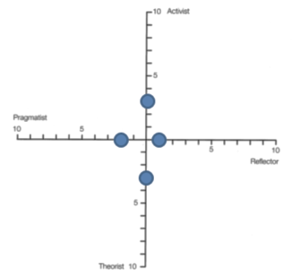
Image 6: A screenshot of a graph plotting the author’s affiliation to the 4 learning types, according to the Honey and Mumford learning types questionnaire.

Skills You Need Interpersonal Skills Assessment
- This test was sourced from Skills You Need, a company providing information and resources for developing a range of everyday and employability skills. It follows a semi-direct questioning method in four core areas relating to interpersonal skills: listening skills, emotional intelligence, verbal communication and communicating in groups [11].
Results from this test were as follows:
- Listening Skills: 50% (average)
- Emotional intelligence: 62% (average)
- Verbal communication: 55% (average)
- Communicating in groups: 47% (average)
- An overall score of 54% for interpersonal skills was derived from the individual results above, showing that the author has average interpersonal skills, with strengths lying in emotional intelligence and understanding behaviour of others and verbal communication and effective conveyance of information. Listening and general communication in groups were identified as the weaker skills.
2.2.2. Personality Type
Big-five personality test
- The big-five personality test provided by openpsychometrics.org is based on the big-five factor markers used by psychologist Lewis Goldberg when creating the international personality item pool (IPIP), the first psychometric test. It scores participants based on five main personality factors [12] (see image 7). This test has been utilised by many organisations and companies to better understand their employees or members [13].
- Full descriptors of the five variables are included for reference in Section 5.2: Appendix B.
- Results showed that the author scores highly on personality traits relating to intellect and imagination, falling within the 91st percentile. Scores for agreeableness and extroversion are also moderately high and moderate respectively, and are around average when compared to other participant’s results in terms of percentile ranking.
- Scores for conscientiousness and emotional stability were fairly low, with the emotional stability score falling in the 19th percentile, showing that the author is less emotionally stable than a very significant proportion of the other test participants.
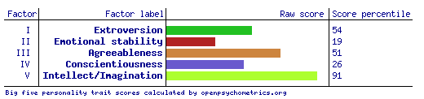

Image 7: A screenshot of a table scoring the author for each of the big-five personality factors.

Open Extended Jungian Type test
- This test is based on the Myers-Briggs Type Indicator, an extension to Carl Jung’s theory of psychological types. The test categorises participants into one of 16 personality types by assessing them on four variables [14]. Despite therefore presenting results differently, it is regarded as being based on the same principles of personality shaped by environmental adaptation as the five factor model, used to create the big-five personality test [15].
- Results from the test showed the author doesn’t conform strongly to either end of any of the four variable spectrums, having a generally balanced or average affiliation to each group of personality traits (see image 8)
- Results suggested that the author tends very slightly towards introversion rather than extroversion, and very slightly towards perceiving rather than judging.
- The result for thinking vs. feeling was very balanced, whilst there is a significant tendency, however, towards intuition rather than sensing in terms of preferences for receiving information.
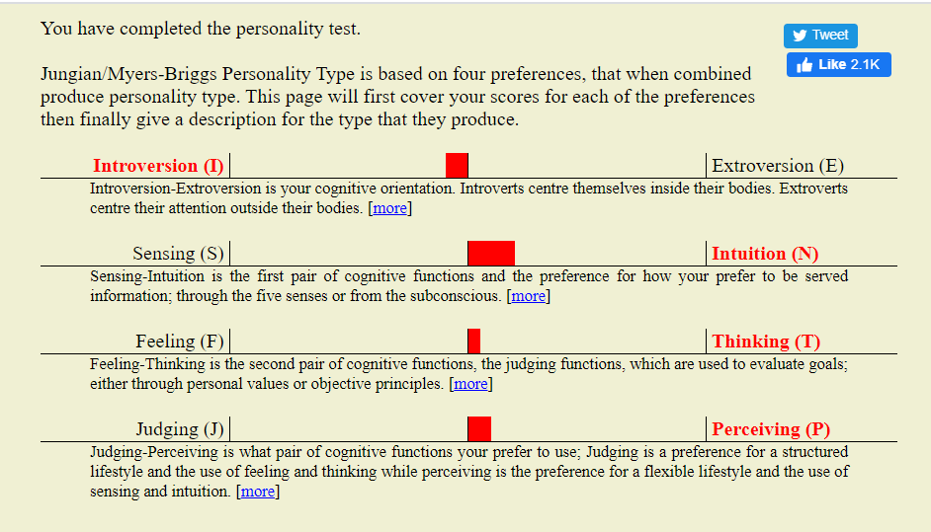
Image 8: Results of the Open Extended Jungian Type test, displaying the author’s location on each of the four variable spectrums.

- Overall these results classified the author as having a weak conformity with the INTP personality type. The results page described this as meaning they are generally analytical and appreciating of theoretical constructs, have a tendency to accept ideas based on merit rather than tradition or authority. For a full description taken from the results page see Section 5.3: Appendix C.
Jung personality test
- This test was provided by 123test.com and uses a set of psychometric questions to assign one of the 16 personality types developed by Jung in 1921 [16]. This is very similar to the above Open Extended Jungian Test, but works from a differing set of questions and parameters.
- The Jung personality test categorised the author as an ISFP (introvert-sensor-feeler-perceiver) type personality (see image 9).
Key points from the results descriptor for ISFP personality type were as follows…
- A pragmatic and realistic, but spontaneous person, who is also somewhat artistically gifted and prefers non-repetitious work.
- Likely to have a smaller group of friends, and a need to know people well in order to feel comfortable
- Brings precise information and common sense solutions to group work tasks.
- For a full descriptor of the ISFP personality type see Section 5.4: Appendix D.
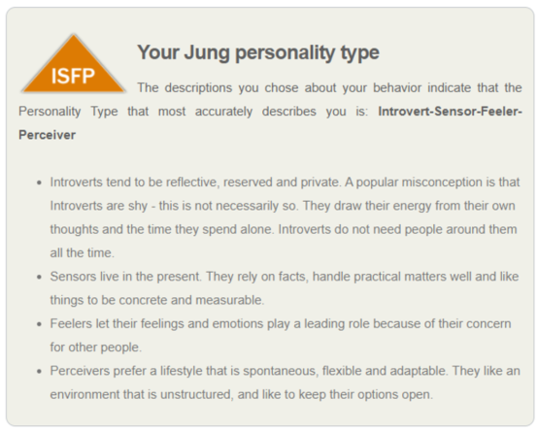
Image 9: Results of the Jung personality type test

Quiet Revolution Introvert-Extrovert Test
- This test, consisting of a semi-direct questionnaire was designed to assess the participant’s location on the spectrum of introversion to extroversion [17]
- The results classified the author as an ambivert, falling in the middle of the extroversion/introversion spectrum, suggesting that they can draw on strengths of both introversion and extroversion.
- For a description on how the test parameterised these extremes of the spectrum see Section 5.5: Appendix E.
2.2.3. Suitable Careers Suggestions
123 career test
- 123 Test’s ‘Career Aptitude Test’ asks a series of questions in order to categorise the participant based on the Holland Code personality types, used to identify their ‘career personality’. This is then matched with specific employment roles and sectors in order to recommend suitable career options [18].
- The results showed that the author has a preference for investigative and enterprising work in particular, and to a lesser extent, artistic work (see image 10)
The top 5 career suggestions derived from the test were as follows…
- Land planner (96% match)
- Urban planner (96% match)
- Business intelligence manager (86% match)
- Marketeer (86% match)
- Business analyst (86% match)
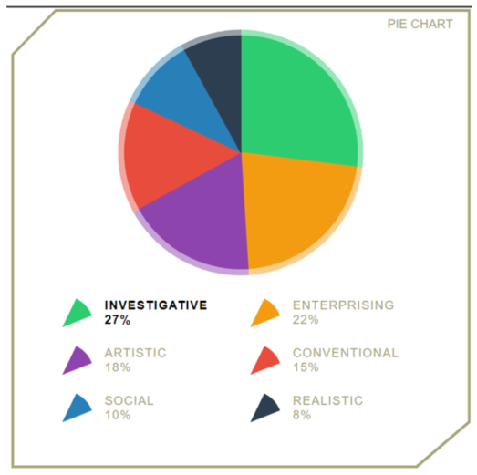
Image 10: Pie chart showing results of Career Aptitude Test, by Holland Code personality type

2.3. Analysis of Self-Evaluation Results
2.3.1 Analysis of Skills Evaluation Results
Overall the results of the three skills evaluation test taken have each identified differing strengths and weaknesses in skills pertaining to the author, due to the fact that they have each analysed different skill areas.
The outcome of the self-evaluation of skills sheet clearly identifies that whilst reading, writing and presenting are strengths, organisation and time management are weaknesses. Since this was a direct questionnaire these findings are based on the author’s own perception, and highlight areas with a perceived need for improvement.
In terms of learning style, the results derived from the Honey and Mumford learning style questionnaire, would suggest that the author should benefit from a variety and wide range of teaching/learning tasks and activities, given that they conformed weakly to each of the four learning types. The slight tendency towards activist and theorist learning types demonstrate that, when learning things they find difficult, falling back on logically-sequenced theoretical information gathering, and working as part of a group activity are likely the best strategies. This preference for theory was already noted by the author, however the need to learn in as many varied ways as possible served as a learning point in itself for how to approach future gathering and understanding of knowledge.
The author’s original perceptions of their interpersonal skills supported by the findings of the interpersonal skills test. Relative strengths of emotional intelligence and verbal communication fit with their perceived tendency to be good at adjusting explanations of theories and ideas to best convey information to the listener, and are concomitant with their aforementioned perception of being good at presenting. Likewise the relative weaknesses of listening skills and communication within a group fit very well with the author’s anxiety of conversing interchangeably within larger groups of people.
2.3.2. Analysis of Personality Type Results
Of the five tests taken which assessed the author’s personality, some traits and preferences were similarly described by all tests, whilst reading other traits the results of each individual test did not conform to each other.
On the subject of introversion/extroversion, the author’s own perception of falling somewhere within the middle of the spectrum, described as ambiversion, was well supported, with no assessment placing the author near either end of the spectrum. Both the Open Extended Jungian Type test and Jung Personality Type test listed the author as introverted, however in the case of the former this was only a slight tendency. The findings of the Quiet Revolution test further back this result, but conversely the score percentile of 54 from the Big-five Personality Test suggests the author is more extroverted than a slim majority of the population. This score percentile result could however be somewhat unrealistic in comparison to the wider population because the sample of people taking the test may be skewed towards introverts. Similarly this theory could be applied to the other score percentiles shown in the results from the Big-five personality test.
On the topics of sensing vs. intuition and similarly for thinking vs. feeling, the author had no well-developed preconceptions. The contrasting results of the Open Extended Jungian Type test and Jung Personality type test for these axes/spectrums, alongside the fact that the former showed no strong correlation with either extreme for both axes, suggests that these traits are relatively balanced in the author. It may also reflect the similar nature, but somewhat differing sequence of questions and parameterisations that both tests apply. This could be perceived as suggesting that, in terms of these traits, there is no one particularly strong area of focus for improvement.
On perception vs. judging, the findings of the two quad-variable personality type tests show a slight preference for perception, which according to these test’s descriptors is generally a feature of someone who prefers flexibility and spontaneity as opposed to following a rigid principle or tradition. This certainly conforms to the author’s own perceptions on these matters and to their disdain for daily routine, and need for wide variability in learning style. Taking into account the aforementioned need for better organisation and time management as well, this may play into the suggestion that the author could benefit somewhat from developing and attempting to appreciate features and practices which bring a sense of structure and continuity to their life.
One strong point of weakness identified is a lack of emotional stability, with both the raw score and score percentile being low for this trait according to the Big-five personality test. The author’s preconceptions on this topic strongly supported the findings of the test, and further confirmed their perception that this an area they need to improve on. The author noted, from previous experience, that problems with emotional stability and changeable mood can hinder their ability to be productive and communicate well with others. This suggests that improvement in this immediate area may be beneficial in consequently improving their interpersonal skills and also their ability to meet deadlines and better apply plans for organisation and time management too.
2.3.3. Analysis of Suitable Careers Suggestions
The tendency towards an enterprising, and particularly towards and investigate, career personality type, as identified by the 123 career test, appeared to fit the author’s perception that they have a tendency to be inquisitive and ask complex questions. It also supports the categorisation as an INTP personality type derived from personality tests (see Section 5.3: Appendix C). The author noted an extremely strong correlation between their preconceived ideas of suitable career options and the two best-matched listings derived from the test results, as these are both careers they have not only considered, but applied for roles within, in the past. Despite these not conforming or relating strongly to the author’s current employment, the author feels their present job role fits well with their general personality, and preference for spontaneity and needing to be flexible and adaptable. This is because their current employment is in a small company and encompasses several roles and opportunity to work in many areas. Furthermore, it is also a very good fit for their tendency towards being investigative according to the Holland Code personality, given that it features complex research and development projects.
2.4. Identification of academic and personal goals
Short-term goals identified by the author are as follows…
- Prioritise working on basic organisational skills and time management, particularly with regard to completing difficult and/or time-limited tasks
- Commence a regular routine for fitness and physical health, consisting of mountain biking and working out
- To improve my ability to learn more advanced numeracy and mathematical skills
Long and medium term goals the author is aspiring to are…
- To continue to improve general emotional stability, for the dual purposes of enhancing life satisfaction and improving productivity and interpersonal relations in work
- To progress with their career in OME, such that they are able to improve their usefulness in research and development roles
- To design and build a low-cost ecohome

LEFT INTENTIONALLY BLANK

2.5. Creation of S.M.A.R.T Action Plan
In order to realise some of the goals identified in the above section, the author created an action plan, following the ‘S.M.A.R.T’ guidelines, as developed by Doran in 1981 [19], shown below.
Strengths, skills and qualities
1. Finding a variety of resources for research tasks
2. Reading and analysing texts
3. Prioritising relevance of texts and critical evaluation
4. Writing in my own words and adapting to relevant style

What I need to work on, develop or improve
1. Time management (particularly of tasks with inflexible deadlines)
2. Persevering immediately with difficult tasks (rather than delaying them)
3. Organisation in general (including a particular focus on digital data)
4. Improving emotional stability

My Priorities: What I am going to do, When and How
What? | When? | How?
1. Use an intelligent calendar | ASAP; review objective in 2 weeks | Try using Google Calendar
2. Allot time to specific difficult tasks so I’m not tempted to delay them | When a difficult task arises; next assignment for OME course? | Use calendar/task list system
3. Improving the way I store/sort documents digitally | ASAP; review objective in 2 weeks | Reshuffling/categorising my filing system and storage of data, and maintaining a good level of organisation
4. Learn how to better understand/process emotions | From the present and into the future in the mid-term | Use a self-help book to record and reflect on emotions

How will I measure if I have improved?
1. Reviewing in two weeks whether I’m successfully allotting majority of my time to specific tasks in calendar
2. Noting, from the present day onwards, whether I’m sticking to planned timescales for difficult tasks
3. Assessing the ease of navigation of my data two weeks’ time, to ensure files are stored logically and can be found quickly
4. Reviewing, each month, whether my emotional stability is improving

3. APPLICATION
This section of the report demonstrates how some of the goals and aims set out in Section 2, and in particular within the S.M.A.R.T action plan developed, were applied and completed, and how the author improved their general organisation.
3.1. Managing Data
3.1.1. Creating an organised filing system
The author created a filing system for data based on a hierarchal structure of folders. A main documents folder was segmenting into Personal, OME Course Work, and Work folders. Within these, different areas and projects were assigned different folders. Data relating to finance, for example, and to the author’s ecology project were created within the personal folder, and within folders for the different modules of the OME course were created in the OME Course Work folder (see image 11).
Two weeks after creating this filing system, the author reviewed the objective of improving digital storage of files and documents, as stated in the action plan (see Section 2.5). The review found that the filing system had led to better organisation of data, allowing documents to be found easily and that the author had maintained the sorting of documents into logical folders/areas.
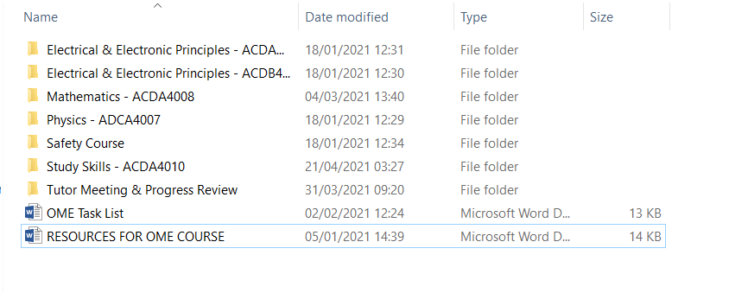
Image 11: Screenshot showing filing system within OME Course Work folder created by the author

3.1.2 Creating a Data Backup Plan
The author created a data backup system. This is based on ensuring that all documents created on their personal laptop were copied on to a NAS (Network Access Storage) device on a regular basis, at least once a day. This NAS device contained a RAID system, featuring two hard disks operating as copies of each other. This significantly reduces the risk of data loss due to disk failure. Furthermore this NAS device was programmed to automatically back-up on a bi-daily basis to a secondary storage device. The secondary storage device is located in an outbuilding, situated 50 metres from the building where the primary NAS device is kept. This therefore prevents loss of data in the case of an event such as a fire in the author’s house or burglary in which electronic goods are stolen. This system is illustrated in the flow diagram shown below (see image 12).
Should an incident happen in which data is lost from any one device, the short duration between the copying or automatic backing-up of data should minimise the value of any losses, in terms of restoring data. Any one of the three storage locations can be used to manually (or in the case of transferring data from the primary NAS to the secondary storage device, automatically) restore the data to the other device.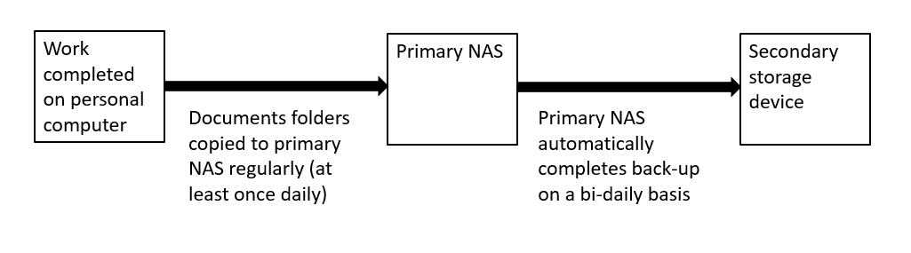
Image 12: Flow diagram showing the data back-up plan created by the author
Steps were also taken to ensure safety of data in case of infection by malware, for example, ransomware such as the CryptoWall Trojan (see Section 5.6: Appendix F for CryptoWall Ransomware Report), which constitutes one of the biggest digital threats in the present day. This included not having the primary NAS visible as a mapped network drive, such that CryptoWall or another similar ransomware would be unable to find and encrypt the files stored on it, and renewing a subscription to Norton Anti-virus software in order to try and prevent infection of the computer in the first place.
3.2. Time-Management, Organisation and Realising Action Plan Objectives
3.2.1. Time Management and Organisation
As stated in the S.M.A.R.T action plan (see Section 2.5), the author commenced using Google Calendar in order to better organise time. Google Calendar was chosen because it is a web-service, meaning it is accessible to the author in any location with internet access. To date, the author has used the calendar to allot time to completing the fitness and work-out goals stated in the action plan, marked time spent at work, and created events for planning potential sessions of completing OME course work and going out. A further reason for the use of Google Calendar was the intelligent layout, which makes it easy to see tasks and events by month, week or day view (see images 13 & 14).
Two weeks after first utilising Google Calendar, the author reviewed the objectives of whether they were allotting a majority of their time to specific tasks and following planned timescales for difficult tasks, as per the action plan. They found that the calendar had allowed them to manage their time, but that a majority of their time was still not assigned to a specific task on the calendar. Using the calendar did, however, provide a better visualisation to the author of time remaining to complete time-limited tasks, therefore reducing stress, and ensuring they met deadlines.
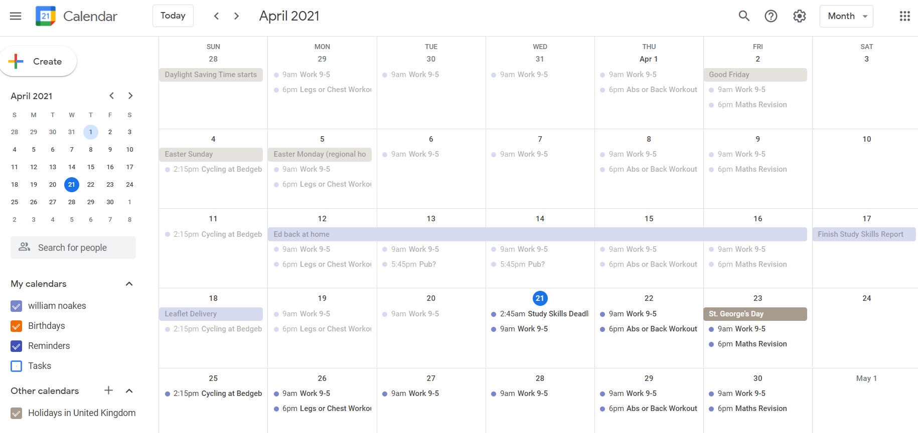
Image 13: Screenshot showing a month overview of the Google Calendar utilised by the author

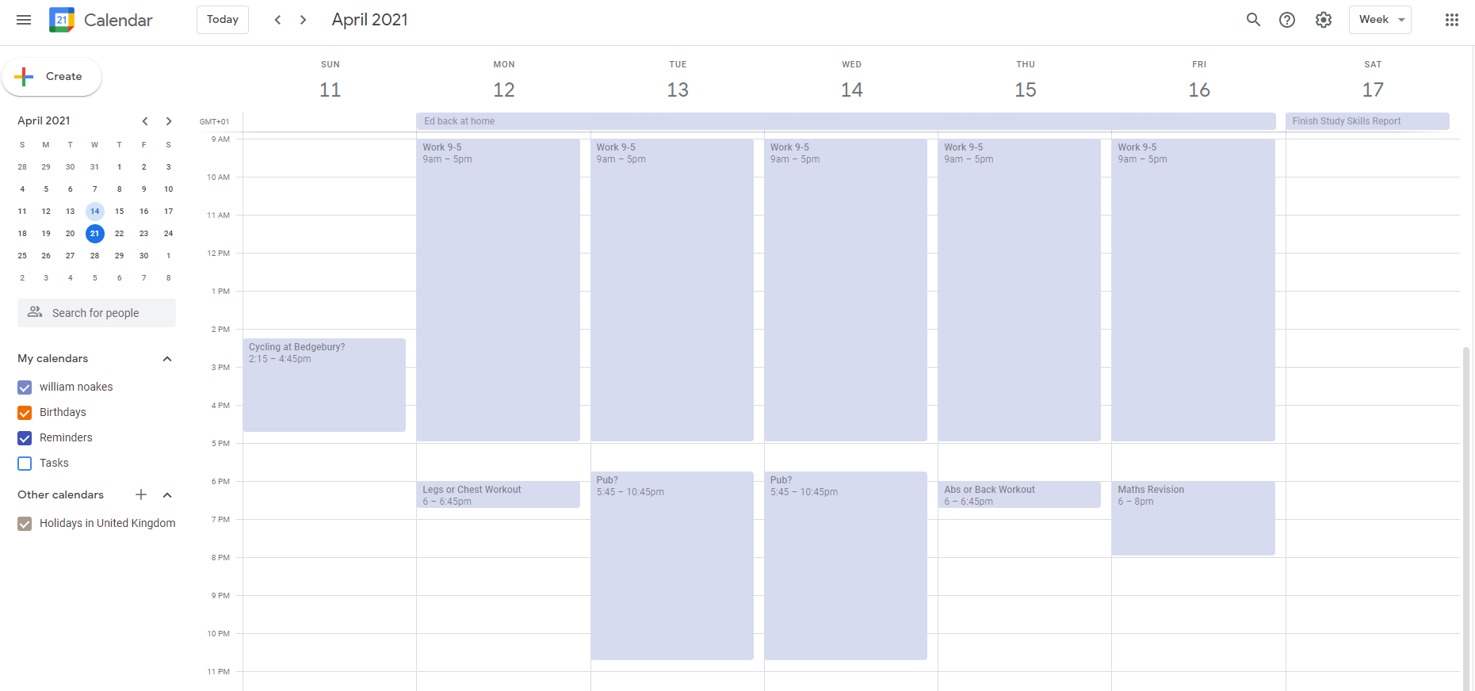
Image 14: Screenshot showing an hour-by-hour week view of the Google Calendar utilised by the author

3.2.2 Realising Other Action Plan and Goals Objectives
In order to realise the fourth objective stated in the action plan (see Section 2.5), the author purchased and began filling out a self-help book; ‘Get out of your mind and into your life’ by Stephen C Hayes, PH.D. The purpose of the book is to use mindfulness and acceptance techniques in order to learn better ways to manage emotions [20]. The author chose this method of fulfilling the action plan goal because the book is interactive in the sense that the reader/user is prompted to fill-in information. This means that they could set aside a small amount of time on a weekly basis in order to complete the book, and progress in achieving the goal of improving emotional stability in the medium term, with the ability to review whether it is having a positive impact on a monthly basis, as stated in the action plan.
Reviewing the use of the self-help book a month after beginning to use it, the author found that it had had some positive impact in processing and understanding emotions, which would likely factor in to improving their emotional stability in the longer term.

Image 15: Photo of the author’s copy of ‘Get Out of Your Mind and Into Your Life
The author has also progressed the short-term goal of commencing a regular fitness routine, as outlined in Section 2.4. They have three planned sessions on a weekly basis, as marked on their Google Calendar (see Section 3.2.1), for completing either legs or chest, abs or back workouts, and going mountain biking.
4. CONCLUSION AND EVALUATION
The completion of the skills evaluation utilised and compared and contrasted the results of, multiple tests, ranging from psychometric assessments to direct questionnaires, and allowed the author to identify areas of strength and weakness in academic and transferable skills. Key learning points derived from this were that they could make improvements in time management and organisation, with progress in these areas being successfully facilitated through the S.M.A.R.T implementation of a calendar and organised data filing system as per the action plan. Application. Listening skills and group communication were also identified as areas for improvement, and provide a topic for further research.
Analysis using the various personality tests in Section 2.2.2. derived generally similar, but somewhat contrasting, findings, whilst demonstrating that the author’s preconceptions on their personality were mostly supported by the results. The key weakness of low emotional stability was identified, and subsequently featured in the action plan; the successful application of which has commenced a strategy of self-improvement in this area.
The evidence provided in Section 3. Application shows that the implementation of the action plan has been mostly successful, with priorities 2, 3 having been fully achieved, and significant progress made on priorities 1 and 4.
Overall the module has facilitated a better understanding of the author’s skills and personality and where improvements can be made, proven how the assessments carried out can be used to set goals and formulate an action plan, and demonstrated how the mostly successful implementation of a S.M.A.R.T action plan can bring about meaningful change.

Bibliography

[1] | S. Muhamad, "Graduate employability and transferable skills: A review," Advances in Natural and Applied Sciences, vol. 6, no. 6, pp. 882-885, 2012.
[2] | S. Fallows and C. Steven, The Skills Agenda, London: Routledge, 2000.
[3] | R. Bennett, "Employers' Demands for Personal Transferable Skills in Graduates: a content analysis of 1000 job advertisements and an associated empirical study," Journal of Vocational Education and Training, vol. 54, no. 4, pp. 457-476, 2002.
[4] | Indeed, "Transferable Skills: Definitions and Examples," 12 02 2021. [Online]. Available: https://uk.indeed.com/career-advice/career-development/transferable-skills. [Accessed 17 04 2021].
[5] | S. Gash and D. F. Reardon, "Personal transferable skills for the modern information professional: a discussion paper," Journal of Information Science, vol. 14, no. 5, pp. 285-292, 1988.
[6] | Universities UK, "HIGHER EDUCATION IN ENGLAND: PROVISION, SKILLS AND GRADUATES," Universities UK, London, 2016.
[7] | Skills You Need, "Transferable Skills," [Online]. Available: https://www.skillsyouneed.com/general/transferable-skills.html. [Accessed 17 04 2021].
[8] | A. Jenkins, "Companies use of psychometric testing and the changing demand for skills: A review of the literature," in CEE Discussion Papers 0012, Centre for the Economics of Education, LSE, 2001.
[9] | J. Bimrose, S.-A. Barnes, A. Brown, C. Hasluck and H. Behle, Skills diagnostics and screening tools: A literature review, Leeds: Corporate Document Service, 2007.
[10] | R. Rumson, "Honey and Mumford Learning Styles," 17 09 2017. [Online]. Available: https://www.eln.io/blog/honey-and-mumford-learning-styles#:~:text=Honey%20and%20Mumford%20learning%20styles%20were%20developed%20by%20Peter%20Honey,model%20(Leaver%2C%202005).&text=And%20to%20be%20an%20effective,to%20learn%20using%20those%20methods.. [Accessed 17 04 2021].
[11] | Skills You Need, "Interpersonal Skills," [Online]. Available: https://www.skillsyouneed.com/interpersonal-skills.html. [Accessed 17 04 2021].
[12] | L. R. Goldberg, "The development of markers for the Big-Five factor structure.," Psychological Assessment, vol. 4, no. 1, pp. 26-42, 1992.
[13] | E. T, "History of the Big 5: Why This Online Psychometric Test Packs a Punch," 10 01 2020. [Online]. Available: https://www.retorio.com/blog/big-5-history-psychometric-test#:~:text=Robert%20McCrae%20and%20Paul%20Costa,)%2C%20the%20first%20psychometric%20test.. [Accessed 17 04 2021].
[14] | E. Jorgenson, "Development of the Open Extended Jungian Type Scales," 2014. [Online]. Available: https://openpsychometrics.org/tests/OJTS/development/. [Accessed 17 04 2021].
[15] | J. H. Reynierse, "Toward an Empirically Sound and Radically Revised Type Theory," Journal of Pyschological Type, vol. 72, no. 1, pp. 1-25, 2012.
[16] | 123 Test, "Jung personality test," [Online]. Available: https://www.123test.com/jung-personality-test/. [Accessed 17 04 2021].
[17] | Quiet Revolution, "The Quiet Personality Test," [Online]. Available: https://www.quietrev.com/the-introvert-test/?from=takethequiz. [Accessed 17 04 2021].
[18] | 123 Test, "Career aptitude test," [Online]. Available: https://www.123test.com/career-test/. [Accessed 17 04 2021].
[19] | G. T. Doran, "There's a S.M.A.R.T Way to Write Management Goals and Objectives," Management Review, vol. 70, pp. 35-36, 1981.
[20] | S. C. Hayes, Get Out of Your Mind and Into Your Life, Oakland, CA: Harbinger Publications, 2015.

5. APPENDICES
5.1. Appendix A
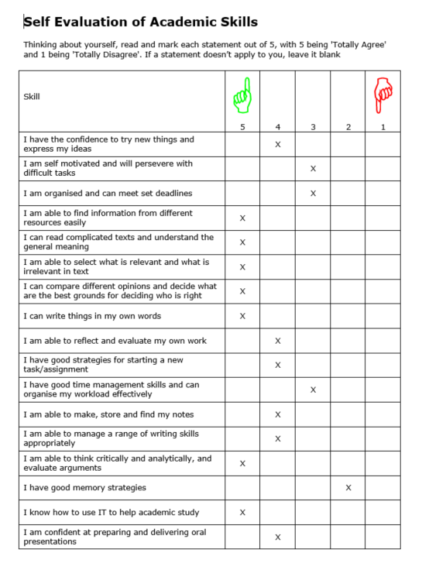

5.2. Appendix B
Descriptors for the five variables analysed by the Open Psychometrics big-five personality test, taken from the results.
Factor I
Labelled as Extroversion by the developers of the IPIP-BFFM. Factor I is sometimes given other names, such as Surgency or Positive Emotionality. Individuals who score high on Factor I one are outgoing and social. Individuals who score low tend to be shut-ins.
Factor II
Labelled as Emotional Stability. Factor II is often referred to by other names, such as Neuroticism or Negative Emotionality (in these two cases interpretations are inverted, as Neuroticism and Negative Emotionality can be thought of as the opposite of Emotional Stability).
Factor III
Labelled as Agreeableness. A person high in agreeableness is friendly and optimistic. Low scorers are critical and aggressive.
Factor IV
Labelled as Conscientiousness. Individuals who score high on this factor are careful and diligent. Low scorers are impulsive and disorganized.
Factor V
Labelled as Intellect/Imagination. This factor is also often called Openness to Experience. People who score low tend to be traditional and conventional.
5.3. Appendix C
Description of INTP personality type, taken from the results presented by the Open Extended Jungian Test, at URL: https://openpsychometrics.org/tests/OJTS/development/
INTP Descriptor
INTPs are quiet, thoughtful, analytical individuals who tend to spend long periods of time on their own, working through problems and forming solutions. They are curious about systems and how things work. Consequently, they are frequently found in careers such as science, philosophy, law, and architecture. INTPs tend to be less at ease in social situations or in the "caring professions", although they enjoy the company of those who share their interests. They prize autonomy in themselves and others. They generally balk at attempts by others to convince them to change. They also tend to be impatient with the bureaucracy, rigid hierarchies, and the politics prevalent in many professions. INTPs have little regard for titles and badges, which they often consider to be unjustified. INTPs usually come to distrust authority as hindering the uptake of novel ideas and the search for knowledge. INTPs accept ideas based on merit, rather than tradition or authority. They have little patience for social customs that seem illogical or that serve as obstacles for pursuing ideas and knowledge. This may place them at odds with people who have an SJ preference, since SJs tend to defer to authority, tradition, and what the rest of the group is doing. INTPs prefer to work informally with others as equals.
INTPs organize their understanding of any topic by articulating principles, and they are especially drawn to theoretical constructs. Having articulated these principles for themselves, they can demonstrate remarkable skill in explaining complex ideas to others in simple terms, especially in writing. On the other hand, their ability to grasp complexity may also lead them to provide overly detailed explanations of simple ideas, and listeners may judge that the INTP makes things more difficult than they need to be. To the INTPs' mind, they are presenting all the relevant information or trying to crystallize the concept as clearly as possible.
Given their independent nature, INTPs may prefer working alone to leading or following in a group. During interactions with others, if INTPs are focused on gathering information, they may seem oblivious, aloof, or even rebellious—when in fact they are concentrating on listening and understanding. However, INTPs' extraverted intuition often gives them a quick wit, especially with language. They may defuse tension through comical observations and references. They can be charming, even in their quiet reserve, and are sometimes surprised by the high esteem in which their friends and colleagues hold them.
INTPs are driven to fully understand a discussion from all relevant angles. Their impatience with seemingly indefensible ideas can make them particularly devastating at debate. When INTPs feel insulted, they may respond with sudden, cutting criticism. After such an incident, INTPs are likely to be as bewildered as the recipient. They have broken the rules of debate and exposed their raw emotions. To INTPs, this is the crux of the problem: improperly handled emotions, INTPs believe, can only harm. While INTPs experience emotions as an important part of their internal lives, and sometimes share their emotions with others, INTPs nevertheless believe that emotions must not play a role in logical discussions, or be expressed in a way that would put themselves at disadvantage.
According to Keirsey, based on behavioural characteristics, notable Architects might include Albert Einstein, Charles Darwin, and Thomas Jefferson.
5.4. Appendix D
Description of ISFP personality type, taken from the results presented by the Jung personality type test, at URL: https://www.123test.com/jung-personality-test/
ISFP at a glance

Out of all of the different personality types, you are typically one of the most down-to-earth types.
Actions speak louder than words could be your motto or your philosophy of life.
Your personality traits combine to create a pragmatic, realistic, spontaneous and amiable person. Someone who knows how to have fun and enjoy life. You are happiest taking each day as it comes. You feel confined by schedules, rules, regulations and people with limited imagination.
As an ISFPs, you are keenly in tune with the way things look, taste, sound, feel and smell. You appreciate and have a keen interest in the arts and beauty in all its forms. Many ISFP personality types are also artistically gifted.
Compared to people who are more extraverted, you are likely to have a smaller circle of friends. In order for you to feel comfortable opening up to others, and exposing your sensitivity, you need to know people well. Once you do establish a relationship, your trust in that person runs deep and maintaining the relationship is very important to you. Every Jung Personality type has one or two specific nicknames that concisely describe your Jung personality type, e.g. Inventor, Strategist, Protector and others.

Probable contributions to an organisation

Each Personality Type has a different set of skills, talents and attributes that they bring to an organization, group or relationship. Here is a list of those most commonly associated with Personality Types like you - ISFP.
Likes challenge, variety and non-repetitious work.
Goes about their work with a quiet feeling of joy.
Is optimistic in their attitude and outlook. Enjoys private space and the freedom to work.
Desires to make an impact with his/her solutions and results.
Focuses on the human side of work and on the well-being of others.

On a team

Some people work well on teams, others work best on their own. Understanding the personality types of team members provides information about how individuals are likely to carry out their work and interact with each other. Given your personality preferences, the following are the strengths (and possible weaknesses!) you will most likely bring to a team:
Brings a quiet humour to the team, along with precise information.
Is dedicated to accomplishing whatever tasks are present.
Brings attentiveness and an appreciation for team members' viewpoints.
Gets others to work together, collaborate and cooperate.
Brings a strong dose of common sense to projects and solutions.

5.5. Appendix E
Given the choice, introverts will devote their social energy to a small group of people they care about most, preferring a glass of wine with a close friend to a party full of strangers. Introverts think before they speak, have a more deliberate approach to risk, and enjoy solitude. They feel energized when focusing deeply on a subject or activity that really interests them. When they’re in overly stimulating environments (too loud, too crowded, etc.), they tend to feel overwhelmed. They seek out environments of peace, sanctuary, and beauty; they have an active inner life and are at their best when they tap into its riches.
Extroverts relish social life and are energized by interacting with friends and strangers alike. They’re typically assertive, go-getting, and able to seize the day. Extroverts are great at thinking on their feet; they’re relatively comfortable with conflict. Given the choice, extroverts usually prefer more stimulating environments that give them frequent opportunities to see and speak with others. When they’re in quiet environments, they’re prone to feeling bored and restless. They are actively engaged in the world around them and at their best when tapping into its energy.
5.6. Appendix F
CryptoWall Trojan Report
1. Introduction
This report covers the threats to the personal data and proper functioning of computer systems, in particular to home or personal devices and small companies’ IT systems, from trojans and viruses, with a detailed focus on the recently much-noted CryptoWall Trojan. The aim is to provide a brief but comprehensive and informative guide, including the specifics on areas such as methods of infection, avoiding infection, the effects of the malware, the means of eradication and restoring or backing-up data.
2. Trojans and Viruses
2.1. Viruses & Worms vs Trojans
Malware (or malicious software) is defined as being any software program ‘designed to damage or do other unwanted actions on a computer system’ [1]. Viruses, worms and trojans are all forms of malware and are generally defined specifically by how they infect a system. Worms follow a basic method of infection, constituting a standalone program which can reproduce itself to spread between systems, whist viruses are segments of code that embed themselves within the code of a different legitimate program, forcing it carry out malicious actions which spread it [2]. Contrastingly, trojans (or trojan horses) do not reproduce themselves but infect systems individually by disguising themselves as legitimate or wanted software, and therefore require activation by the user/victim [3] [2].
2.2. Malware by function
These malware come in many forms, and with varying capabilities, and as such some are considered a more severe threat than others. Therefore, malware is also often categorised by purpose and/or technique, with a large number of different classes or categorisations recognised by digital security organisations [3][2]. Popular malware functions and features include: spyware, designed to covertly relay the users’ data to another entity; ransomware, designed to encrypt a user’s access to their data or system and demand a ransom payment to restore access; adware, which illegitimately generates monetised online advertisements within the user interface of software; and bots, automated process that communicate through network services to allow a central server to manage a network of infected computers. Botnets are often responsible for carrying out cybercrime, such as DDOS (distributed denial of service) attacks against important targets. Additionally features such as bootkits and rootkits allow malware to embed itself within the OS (operating system) [3].
2.3. Malware Infection Vectors
There are four main methods through which malware can infect a system [3]. One is through downloads, either through ‘piggybacking’ where desired download files are spiked with malicious code, or through ‘drive-by downloads’ where a malicious website or advert attacks the browser and forces installation of code [4] [3]. Another method is through unsolicited email or message, where attachments and embedded links constitute a similar risk. Self-propagation, as aforementioned in the case of viruses and worms, relies on the malware itself reproducing, allowing spread between computers and/or networks. Lastly, physical media, such as USB drives and CDs, are also another significant infection vector [3]. A vastly more extensive and comprehensive guide to methods and techniques of infection and compromise is provided by Mitre Attack [5] at attack.mitre.org.
3. Ransomware
Ransomware is a malware capable of encrypting either the victims’ data and files or the ability to access to their device/system. The general purpose of this is to demand a payment in order for the files to be un-encrypted and for the user to regain access, such that they are held to ransom [6] [7].
3.1. General Overview and Evolution
A multitude of variants and specific ransomwares have been developed since 1989, when the original, floppy-disk spread, ‘AIDS Trojan’ malware was created. Generally these have evolved to feature increasingly sophisticated encryption keys, in an effort to maintain a situation where breaking the encryption is impossible or unviable for the victim [7] [6].
One of the key drivers of growth in ransomware has been the rise of anonymous payment services online, particularly following a boom in use of these services after 2011. Anonymous payment is key to the attackers, preventing traceability of money derived from ransom payments as well as playing an essential part in disguising their own digital and personal identities [8] [7].
Evolution and adaptation of ransomware by attackers means that targets are wide ranging, from personal or small business users, affected through home PCs or Android phones, to large professional or governmental organisations, from whom attackers often anticipate large ransom payments for un-encryption of complex and critically important IT systems. Furthermore, these malware are able to encrypt a high number of different file types, with CryptoLocker – a notably successful example developed in 2013 – known to affect 67, including Microsoft Office files [7].
It has been noted that products known as ‘ransomware as a service’ became available in 2015. This concept provides an anonymous TOR (The Onion Router) user with customisable, pre-written Ransomware for a commission or fee paid to the suppliers’ website, and has led to the mass availability of this form of malware. As of the same year ‘CryptoWall’ became the leading ransomware used, and along with its sequential versions and other newly-written creations, has helped create a huge global ransomware market, which analysts estimate generated over 1bn USD in 2016 [7].
3.2. Identifying ransomware and dealing with infection
If a system is infected with ransomware several steps can be taken to try to rectify the issue. An initial recommendation is to run a scan using an anti-virus or anti-malware software, in an effort to identify the specific malware present. This is helpful because differing ransomwares require different next-steps in order to facilitate the best outcome. Some contain flaws - or, as in the past, weak encryptions – which enable the user to recover files without paying the ransom, often by copying them to an uninfected computer and utilising specialist tools developed by PC security companies. Other, more sophisticated ransomware may present no option other than to pay the ransom in good faith that the attacker will restore the files. In either case however, these options are only necessary where there is no recent backup of the encrypted files available. Removal of the ransomware is best conducted by reformatting of the hard-drive and reinstallation of the operating system, since using most sophisticated forms are difficult to remove whilst using Safe Mode. Prior to this, copying the encrypted files to a USB drive is also recommended for good measure and in the case that they may be able to be unencrypted [6] [7].
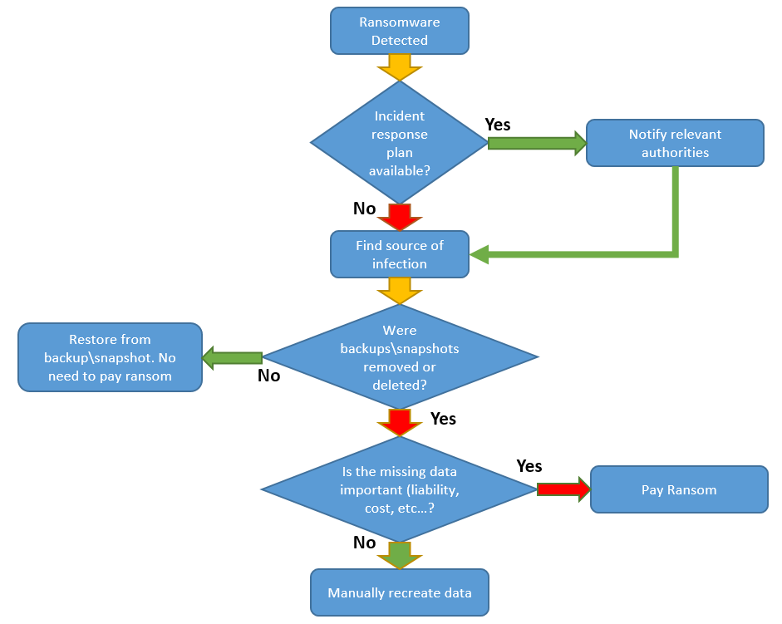
Image 1: Flow-diagram taken directly from the ‘What to do if you get hit by a ransomware attack’ article by Darragh Delaney at netfort.com [5].
4. The CryptoWall Trojan
4.1. CryptoWall Operation and Evolution
CryptoWall, released in the latter part of April 2014, was a notable ransomware program which used public RSA encryption to prevent a user accessing their files, before demanding a ransom in order to facilitate restoration of the files using a private RSA key. It has since evolved, with several sequential versions created and significant improvements in encryption methods and evading detection [9] [10]. As of February 2021, the various iterations of CryptoWall were listed by the CIS (Centre for Internet Security) as part of their ‘top 10 malware’ list which covered variants responsible for 76% of reported malware globally that month [11].
Although subsequent versions of CryptoWall have utilised differing encryption facilities and modified methods of operation, they still all function on the same principles. Following infection on Windows systems, the malware distributes itself within folders on the C:Drive and explorer.exe is hijacked through insertion of malicious code, to allow encryption operations. Additionally, CryptoWall inserts itself into the registry and Startup folders, meaning that unless the user manages the difficult task of removing every piece of malicious code while in Safe Mode, the malware cannot be easily removed and re-launches whenever the PC is restarted [10] [9].
The malware scans the system for any of the many compatible data files on all accessible drives and processes them. This entails encrypting the file, deleting the shadow volume copy – from which the file could potentially otherwise be restored, adding a path to the file within a registry key and writing a decryption file, which contains the instructions on facilitating ransom payment and restoring access [9] [10].
After encryption is complete, the infection files are generally removed from the system. The user generally first notices the infection after the above processes are complete, and the decryption instructions pop-up on the system interface via a .txt file, generally opened in Notepad. In the form of various wordings, this presents a ransom demand – sometimes time limited, and instructs the user to utilise a Web-to-TOR gateway as a proxy server in order to pay a ransom – normally in Bitcoin – to a unique Bitcoin wallet within a TOR hidden web service [9] [10].
Notable extra threats added in versions 3 and 4 respectively are: a ransom value which increases with time, leaving the user less time to find potential solutions or having to pay more; and encryption of filenames as well as contents, in order to make it difficult for users to check whether backups are available for the encrypted files [10] [9].
4.2. Infection vectors
Infection with CryptoWall is facilitated through a limited number of routes. One of the most common is through ZIP or RAR files attached to phishing emails. These purport to be legitimate emails containing PDFs for invoices or bills which the user thinks are important and therefore downloads. Unpacking or extracting these reveals a CHM file, which when opened downloads and embeds the CryptoWall binary into the %appdata%, %temp% folders. This often contains a range of useless instructions and anti-emulation procedures which fool anti-virus software into categorising the code as non-malicious [12] [10]. Other notable, but less common vectors are exploit kits – which utilise security vulnerabilities in legitimate software and applications or websites, and malicious adverts, often featured on legitimate websites, which attempt to deliver the malware through running JavaScript within a web browser [9].
4.3. Affected File Types
CryptoWall can encrypt a large range of file types, generally targeting those most frequently used by the victims. Varonis provides a list of 48 known compatible file types [9], whilst Secureworks lists over 80. Notable listings include the file extensions used by the Microsoft Office suite, and .pdf, .txt, .gif, .js, .raw, .png, .jpeg, .avi and .mp3 files. One key feature is that .exe and .dll files are not impacted, with this being a deliberate tactic used to ensure that the affected system does not become corrupted and therefore unusable to the user [13].
4.4. Restoring Files
Most simply, if the infected system has been fully backed-up recently enough to minimise the value of any data losses, then restoring the system to the last unaffected back-up provides a simple means of regaining access to the files, as well as restoring the system to a state before when it became infected [14]. Should such a back-up not be available, restoring files can be tricky. The ‘ListCwall’ tool, developed by bleepingcomputer.com, can be used to identify which files have been encrypted, providing a useful start point to the victim in deciding how to progress once the infection is confirmed to be CryptoWall. At present, no decryption tools have been produced which are known to be powerful enough to counter encryption facilities utilised by CryptoWall, and the developers appear to have fixed all flaws which allow traceability of the private decryption key. R-Studio and Photorec are two file recovery software suggested by bleepingcomputer.com, but success in using these is not guaranteed. Occasionally, CryptoWall may fail to execute deletion of the shadow volume copy of files. In this case, ShadowExplorer or other file recovery software can be used to restore the files. In many cases, however, victims must choose between manually recreating their data and paying the ransom. Even then, sending the ransom payment does not provide certainty the files will be successfully restored [10].
4.5. Removing CryptoWall
It is possible to remove CryptoWall from an infected system, with specialist anti-malware tools having been developed which are proven to be effective against it. However it is important to consider that these tools cannot unencrypt the affected files and facilitate restoration of data. Once the user has chosen a strategy for recovering files (covered in the next section), a strategy for removal of the malware can be commenced [15]. Equally however, it’s worth noting that restoring files on a system is pointless if CryptoWall is still present, as they may simply be encrypted over again. According to the Malwaretips website, running the popular Malwarebytes anti-malware software should clean the infection from a system. Running another alternative antimalware application, such as HitmanPro afterwards can then provide confirmation that CryptoWall has been removed, or potentially facilitate any further cleaning-up that is required [15]. Other sources, however, suggest a more cautious approach whereby, following a ransom payment or copying of the encrypted files to another uninfected system, the hard drive of the infected system is reformatted and the operating system (and subsequently the restored files) are reinstalled from scratch [7].
4.6. Ransom Payments
There are several instances in which payment of the ransom may not be necessary in order to restore the encrypted files. As mentioned above, where an infected system can be restored to a previous state from a back-up, the CryptoWall infection no longer poses a problem to data or the system. Outside this scenario however, restoring data is more difficult.
6. References

Bibliography

[1] | TechTerms, "Malware," [Online]. Available: https://techterms.com/definition/malware#:~:text=Short%20for%20%22malicious%20software%2C%22,you're%20not%20Spanish).. [Accessed 17 04 2021].
[2] | J. Fruhlinger, "Malware explained: How to prevent, detect and recover from it," 17 05 2019. [Online]. Available: https://www.csoonline.com/article/3295877/what-is-malware-viruses-worms-trojans-and-beyond.html. [Accessed 17 04 2021].
[3] | Cisco, "What is the difference: Viruses, Worms, Trojans and Bots?," [Online]. Available: https://tools.cisco.com/security/center/resources/virus_differences#2. [Accessed 17 04 2021].
[4] | Bullguard, "Routes of Computer Infection," 2021. [Online]. Available: https://www.bullguard.com/bullguard-security-center/internet-security/security-tips/routes-of-computer-infection.aspx. [Accessed 17 04 2021].
[5] | MITRE ATT&CK, "ATT&CK Matrix for Enterprise," 2021. [Online]. Available: https://attack.mitre.org/. [Accessed 17 04 2021].
[6] | A. K. Maurya, N. Kumar, A. Agrawal and R. A. Khan, "Ransomware: Evolution, Target and Safety Measures," International Journal of Computer Sciences and Engineering, vol. 6, no. 1, pp. 80-85, 2018.
[7] | M. North and R. Richardson, "Ransomware: Evolution, Mitigation and Prevention," International Management Review, vol. 13, no. 1, pp. 10-21, 2017.
[8] | M. Rosenberg, "A Q&A about the malicious software known as ransomware," 2015.
[9] | J. Petters, "The State of Cryptowall in 2018," 17 04 2020. [Online]. Available: https://www.varonis.com/blog/cryptowall/. [Accessed 17 04 2021].
[10] | Bleepingcomputer.com, "CryptoWall and HELP_DECRYPT Ransomware Information Guide and FAQ," 10 07 2014. [Online]. Available: https://www.bleepingcomputer.com/virus-removal/cryptowall-ransomware-information. [Accessed 17 04 2021].
[11] | CIS (Center for Internet Security), "Top 10 Malware February 2021," 2021. [Online]. Available: https://www.cisecurity.org/blog/top-10-malware-february-2021/. [Accessed 17 04 2021].
[12] | Sophos, "The current state of ransomware: CryptoWall," 17 12 2015. [Online]. Available: https://news.sophos.com/en-us/2015/12/17/the-current-state-of-ransomware-cryptowall/. [Accessed 17 04 2021].
[13] | Dell Secureworks Counter Threat Unit Threat Intelligence, "CryptoWall Ransomware Threat Analysis," 27 08 2014. [Online]. Available: https://www.secureworks.com/research/cryptowall-ransomware. [Accessed 17 04 2021].
[14] | D. Delaney, "What to do if you get hit by a ransomware attack?," 19 06 2016. [Online]. Available: https://www.netfort.com/blog/get-hit-ransomware-attack/. [Accessed 17 04 2021].
[15] | S. Pilici, "How to remove CryptoWall 4.0 ransomware (Free Guide)," 13 11 2015. [Online]. Available: https://malwaretips.com/blogs/remove-cryptowall-4-0-virus/. [Accessed 17 04 2021].
[16] | Kaspersky, "What is a Trojan Virus?," 2021. [Online]. Available: 17.

