  - BMSW4003 – Digital Skills and Research Methods

Impact of Virtual Learning Environment (VLE) – Moodle on students’

learning experience.
  - CertHE Skills for the Workplace

Tutor: Suneth Fernando
Student name: Raluca Elena Caruntu
Student ID: 2010421

Table of Contents
Introduction 2
Aim of the Research 3
Objectives of the Research 3
Rationale of Research 3
Literature Review 4
Research Methodologies 5
Qualitative Research 5
Quantitative Research 5
Sample and Sample Size 5
Data collection tools 5
Ethical considerations. 6
Analysis and Discussion 7
Design Questionnaire 7
Graphical Visualisation and Findings 8
Limitations of this Research 12
Recommendations for Future Research 13
Conclusion 14
References 15

Introduction
VLE, which stands for Virtual Learning Environment, refers to a specific educational technology based around a web platform with the goal of digital aspects of courses of study, generally in the educational institutions’ context. Here, activities, resources and interactions are presented inside the structure of a course. In other words, VLE is an online platform that enables the students and teachers to enhance their learning experience through the use of digital solutions, this system is mainly aimed at creating interactive, active learning environments through digital-based solutions ("VLE (Virtual Learning Environment) Definition", 2017). This research report will focus on the impact of the Virtual Learning Environment (VLE).

Figure 01: UWTSD Logo; Source: ("UWTSD London", 2021)
The University of Wales is a confederal university, which was founded in 1893. UWTSD or University of Wales Trinity Saint David London Campus was founded on 18 November 2010 and is located at Winchester House, 11 Cranmer Rd, Vassal, London SW9 6EJ, United Kingdom (Hughes, 2020).

Aim of the Research
This research aims to find out the impact of Virtual Learning Environment (VLE) – Moodle on students’ learning experience at the University of Wales Trinity Saint David London Campus.

Objectives of the Research
Objectives of this research are-
- Improving the digital skills of the students.
- Developing awareness of effective information analysis and information-to-knowledge translation.
- Evaluating the usage of contemporary techniques to improve employability and workplace efficiency.
- Identifying and evaluating works of literature on VLE.
- Illustrating data handling capability in the workplace.

Rationale of Research
VLE enables the teachers, as well as the support staff, managing and delivering various regular tasks, such as creating lesson plans with the help of existing resource, regular class administration, as well as, monitoring the students from the remote ("Knowledge Anywhere: The Advantages and Disadvantages of a Virtual Learning Environment", 2013). Understanding the VLE in-depth will help teachers and students to enhance the overall learning experience, which can be accelerated through this research.

Literature Review
(Waheed et al., 2020): In this paper named ‘Predicting the academic performance of students from VLE big data using deep learning models’, Salem Alelyani, Saeed-Ul Hassan, Hajra Waheed, Naif Radi Aljohani, Julie Hardman, and Raheel Nawaz proposed the use of big data in the prediction of academic performance. They have concluded the facts listed down below. Data generated from the VLE makes it possible to take a sustainable data-driven decision. Students at-risk can be intervened early with the prediction from clickstream data acquired through VLE. According to this report, this AI system also outperforms current prediction models to predict students at risk. This report also states that including VLE data, assessment-related data, as well as legacy data enhances the networks’ prediction capacity.
(Carvalho, Areal, and Silva, 2011): In another research named ‘Students' perceptions of Blackboard and Moodle in a Portuguese university, Nelson Areal, Ana Carvalho, and Joaquim Silva explores the perception of students’ about a certain LMS or Learning Management System named Blackboard and Moodle. They have assessed the usage of these two LMSs, and in the result, they have found that 46.5% preferred Blackboard over Moodle, when 34.7% of them stated that they prefer Moodle, and about 20% showed no specific preferences. This research also explored the rationales behind those preferences.
(Pagani et al., 2016): In this research named ‘The impact of digital skills on educational outcomes: evidence from performance tests’, conducted by Pagani, Argentin, Gui, and Stanca, in the year 2016, the influence of digital skills has been explored. The findings from this report illustrate that Internet skills impact academic achievement positively, as well as, this impact is more significant in the case of a student with low academic performance otherwise a student with low family background. Students in technical or vocational schools are also impacted by it strongly.

Research Methodologies

Qualitative Research
Qualitative research refers to a specific research approach, where the research relies upon data collected by the researcher himself from interviews, questionnaires, first-hand observation, focus groups, participant-observation, documents, and artefacts. The raw data collected in qualitative research is normally nonnumerical (Silverman, 2020). Qualitative research has its special use cases such as identifying customer needs, understanding underlying values, feelings and perceptions which impacts the behaviour, developing hypotheses to test further and to develop the quantitative questionnaire, and capturing the language and imagery of the customers used for describing a service or a product (Flick, 2018). To evaluate the usage of contemporary techniques, this research requires qualitative research.

Quantitative Research
Quantitative research refers to a specific research approach that focuses on quantifying the collection and analysis of data (Vogt, 2011). To do a statistical and mathematical analysis of the data collected from the mass, the quantitative research approach is adopted. It helps the researcher to quantify opinions, attitudes, behaviours, and other selected variables. To illustrate data handling capability, this research needs to make use of Quantitative research.

Sample and Sample Size
A sample is a specific methodology in the field of statistics and quantitative research, which refers to a set of individuals or objects selected from a statistical population through a defined method. Some of the well-known sampling techniques are Snowball sampling, Quota sampling, Clustered sampling, Systematic sampling, and simple random sampling (Alvi, 2016). This research will use Simple random sampling, where each individual will be selected randomly and entirely by chance (Maziero, 2015). The sample size for this research will be 100.

Data collection tools
There are various data collection techniques used by the researchers, such as documents and records, interviews, focus groups, questionnaires and surveys, observations, and oral histories. This research will make use of questionnaires and surveys as the data collection technique, as they are more cost-friendly, practical, and scalable.
For the survey, different survey services can be used, such as Google Forms, QuestionPro, Qualtrics, SurveySparrow, Typeform, SurveyMonkey, SurveyGizmo (Now Alchemer), and Zoho Survey. As the preferred data collection tool, this research will make use of SurveyMonkey, as it has some advantages over other survey tools, such as easier access, less data coding and input errors, more smooth faster distribution system and time and cost-efficiency.

Ethical considerations
Ethical considerations are a very important part of the research, and for research that deals with confidential personal information, this is much truer. The students that will participate in this research should not be put into any kind of harm. The dignity of the students’ needs also to prioritize as well. And before the study, the full consent of the students is necessary.

Analysis and Discussion

Design Questionnaire
The questionnaire for this research is below.
- Who are you?
  - Student user
  - Staff
- Were you trained on VLE as part of your lesson?
  - Yes
  - No
- Are you encouraged to use the Virtual Learning Environment?
  - Yes
  - No
  - Sometimes
- Did you find any obstacles while using VLE?
  - Yes
  - No

- Why did you start using VLE?
  - Your teacher encouraged you.
  - Your classmates encouraged you to do so.
- Would you like additional services through VLE?
  - Yes
  - No

Graphical Visualisation and Findings
Question 1:
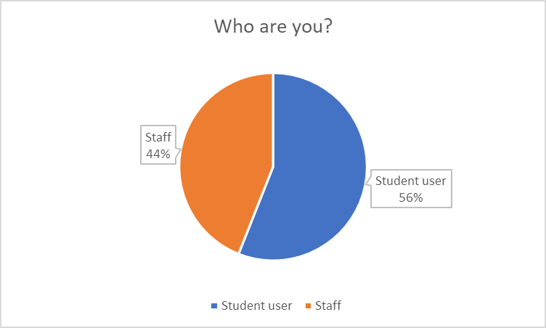
With the answer of the question, who the respondent was, 44% of them addressed them as the staff, such as university staff, teacher, tutor and such, while 56% of the respondents addressed them as the student or the end-user of VLE. While assessing and analysing the other answers, this is something, the researcher and the reader have to keep in mind.
Question 2:
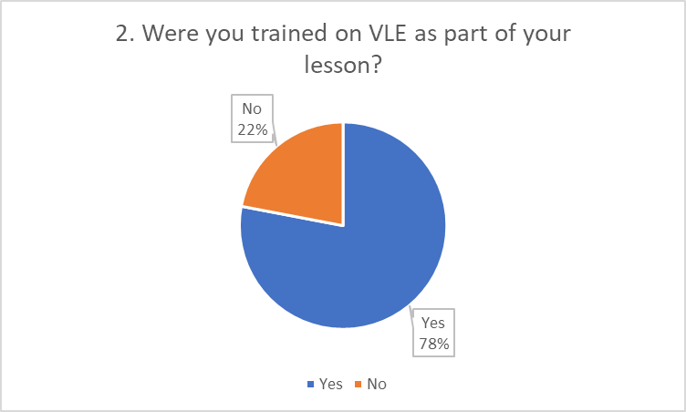
The second question was about if the respondents were trained on VLE as a part of their lesson, and the answer was largely positive. In the answer to this question, 78% of them agreed that they were trained on VLE as a part of their lesson, while 22% didn’t get any pieces of training as a lesson part. VLE is relatively new for some students and they are not aware of the usage. Training would help these students to effectively learn in VLE. A majority of students and teacher doesn’t take any training as a lesson part; they will largely be in disadvantage while using VLE.
Question 3:
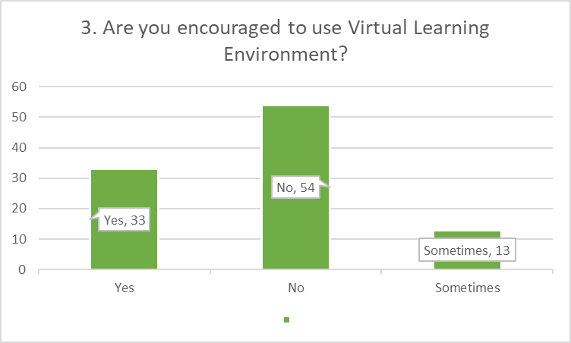
The third question was about if the students or teachers were encouraged by others, such as the management or tutors to use VLE, and the answer was largely negative. 33% of the respondents were encouraged to use VLE regularly and 13% of them were encouraged on an irregular basis, but 54%, which is larger than the combination of the other both, weren’t encouraged to use VLE. As most of the students are not encouraged to use VLE, it is not a very positive sign.
Question 4:
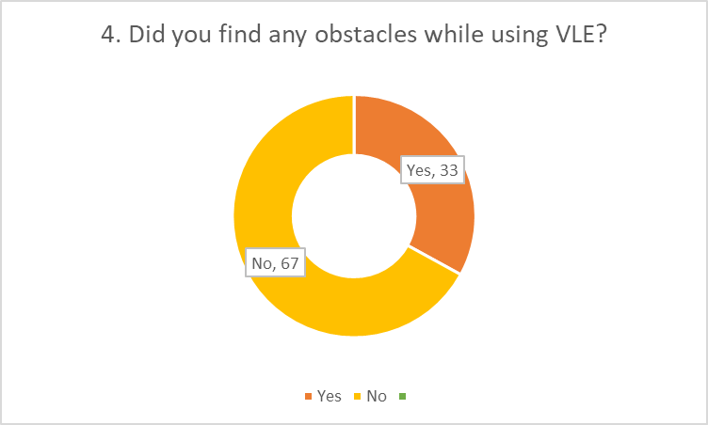
The fourth question was if the respondents faced any obstacles while they were using VLE, and the answer was largely negative, that most of them didn’t face any obstacles while they were using VLE. In the answer, 67% of the respondents didn’t find any obstacles when using VLE and 33% of the respondents found obstacles when using VLE. This means that less and fewer students are facing obstacles.
Question 6:
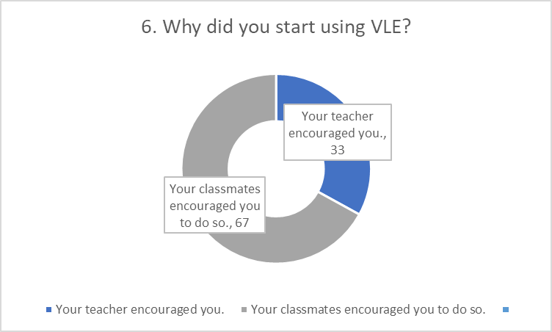
The sixth question was to find the reasons the respondents chose VLE. The options were the classmates and the tutor. And in answer, 67% of the respondents thanked their classmates or colleagues for their introduction to VLE, while 33% of the respondents thanked their teacher or superior for that.
Question 7:
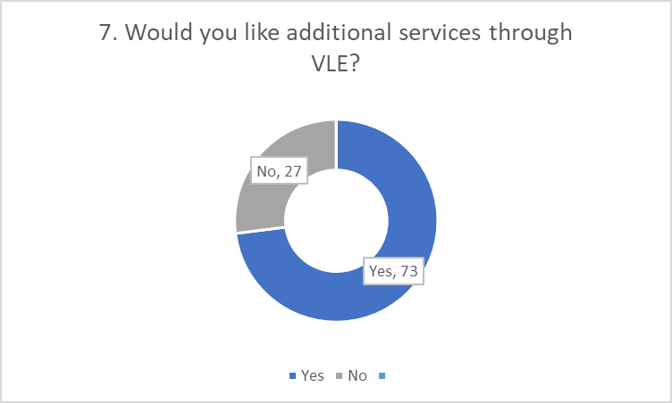
And in the answer of if the students want additional services through VLE, 73% of them wanted additional services, while 27% of them didn’t. By the preference of the majority, VLE needs a more sophisticated feature set.

Limitations of this Research
Research limitations refer to the characteristics of design or methodology which influenced the interpretation of the findings from this research. The limitations of this research will be discussed in this portion of this research report.
- Sample and Selection issues: The research used simple random sampling, for its simplicity. But this selection technique is prone to bias.
- Insufficient sample size: At the same time, 100 sample sizes is not representative of the school population, as the preferred sample size is 10% of the total population and 100 is not 10% of the UTWSD’s student size.
- Lack of works of literature: After searching through some of the well-known places to find research work, such as Google Books, science.gov, Refseek, Microsoft Academic, Google Scholar, Wolfram Alpha, ERIC or Educational Resource Information Centre, I have found little to no specific work on VLE, as VLE is a relatively new idea and this field was less explored by the researchers.
- Limited access to data: COVID-19 was a major obstacle in the way of this research. As it was less possible to reach the students directly, the response rate was very low. This limited access to data infected the findings significantly and the findings don’t represent the overall population.
- Time constraints: The research had a very limited time, which was 2 months at large. These constraints put this research in a constant rush and may reduce its quality.

Recommendations for Future Research
Based on the limitations discussed earlier, below are some recommendations for future research.
- In the case of future such research, the research needs to use a clustered sampling technique, as the respondents are divided into teachers and students. By dividing students and teacher into different cluster, the sample should give both parties the equal chance.
- The sample size should be increased based on the population. 10% of the population will be the size of the sample. For instance, if the student size is 3,000, the sample size will be 300.
- The help of research professionals and specialists should be taken before carrying out the primary research.
- New survey methods should be used, as well as, third-party survey services should be used to have the highest respondent rate.
These are recommendations for UWTSD for their future research.

Conclusion
This research report has focused on the impact of VLE: Moodle and it has used a quantitative research approach on the UWTSD to find the answer. The research has discovered that the VLE: Moodle has a significant impact on the students, but the teachers and the management of the school are not taking the necessary steps to use the full potential of the VLE, though the students are interested. These research findings will help the teaching professionals to better understand the importance of VLE, the current state of its progress and the students’ perception about it, as well as, their needs around it.

References
Alvi, M., 2016. A manual for selecting sampling techniques in research.
Carvalho, A., Areal, N. and Silva, J., 2011. Students' perceptions of Blackboard and Moodle in a Portuguese university. British Journal of Educational Technology, 42(5), pp.824-841.
Flick, U., 2018. An introduction to qualitative research. sage.
Hughes, S. (2020). University of Wales & University of Wales Trinity Saint David. Retrieved 3 March 2021, from https://university.wales/.
Knowledge Anywhere:: The Advantages and Disadvantages of a Virtual Learning Environment. Knowledge Anywhere. (2013). Retrieved 4 March 2021, from https://www.knowledgeanywhere.com/resources/article-detail/the-advantages-and-disadvantages-of-a-virtual-learning-environment.
Maziero, J., 2015. A random sampling of quantum states a survey of methods. Brazilian Journal of Physics, 45(6), pp.575-583.
Pagani, L., Argentin, G., Gui, M. and Stanca, L., 2016. The impact of digital skills on educational outcomes: Evidence from performance tests. Educational Studies, 42(2), pp.137-162.
Silverman, D. ed., 2020. Qualitative research. Sage Publications Limited.
UWTSD London. uwtsdlondon.ac.uk. (2021). Retrieved 3 March 2021, from https://www.uwtsdlondon.ac.uk/.
Vogt, W.P. ed., 2011. SAGE quantitative research methods. Sage.
VLE (Virtual Learning Environment) Definition. techterms.com. (2017). Retrieved 4 March 2021, from https://techterms.com/definition/vle.
Waheed, H., Hassan, S.U., Aljohani, N.R., Hardman, J., Alelyani, S. and Nawaz, R., 2020. Predicting the academic performance of students from VLE big data using deep learning models. Computers in Human Behaviour, 104, p.106189.

