

Methods and Search Strategy Academic Poster

Student name: Mehwish Arshad
Student ID: 2312904

Module name: Independent Project
Module code: (BMHP6020_BIRM)

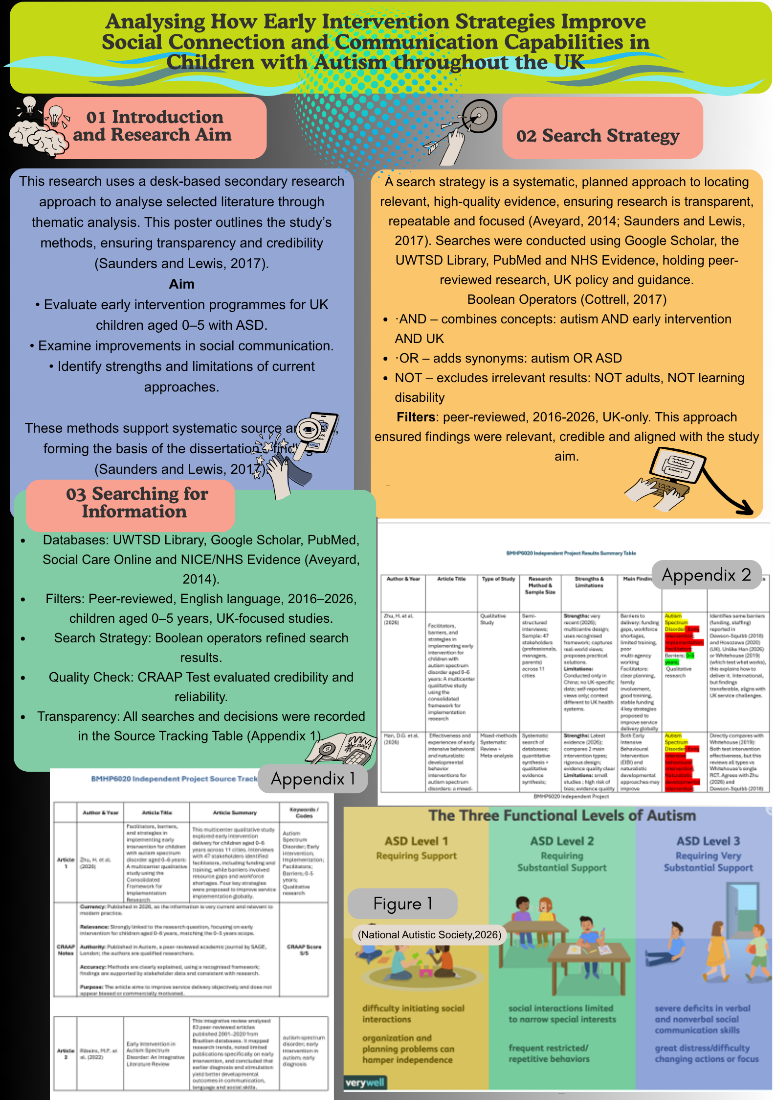

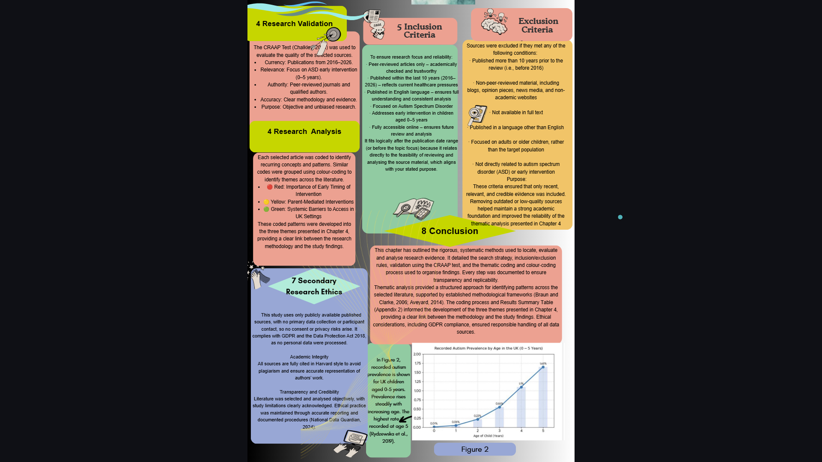

References

Aveyard, H. (2014) Doing a literature review in health and social care: a practical guide. Maidenhead: Open University Press, pp. 143–156.
Braun, V. and Clarke, V. (2006) 'Using thematic analysis in psychology', Qualitative Research in Psychology, 3(2), pp. 77–101. Available at: https://doi.org/10.1191/1478088706qp063oa (Accessed: 9 June 2026).
Chalkley, A. (2024) ‘Making the most of libraries, part 5: evaluating information using the CRAAP Test’, British Journal of Healthcare Assistants, 18(7), pp. 284–286. Available at: https://www.magonlinelibrary.com/doi/abs/10.12968/bjha.2024.18.7.284 (Accessed: 9 June 2026).

Cottrell, S. (2017) Critical thinking skills: effective analysis, argument and reflection. 3rd edn. London: Bloomsbury. Available at: https://ebookcentral.proquest.com/lib/trinity/detail.action?docID=6234915 (Accessed: 9 June 2026).
Data Protection Act 2018, c. 12. London: The Stationery Office. Available at: https://www.legislation.gov.uk/ukpga/2018/12/contents (Accessed: 9 June 2026).
National Autistic Society (2026) What is autism? Available at: https://www.autism.org.uk/advice-and-guidance/what-is-autism (Accessed: 18 June 2026).
National Data Guardian (2024) National Data Guardian 2023-2024 report. London: GOV.UK. Available at: https://www.gov.uk/government/publications/national-data-guardian-2023-2024-report/national-data-guardian-2023-2024-report (Accessed: 9 June 2026).
Rydzewska, E., Hughes-McCormack, L.A., Gillberg, C., Henderson, A., MacIntyre, C., Rintoul, J. and Cooper, S.A. (2019) ‘Age at identification, prevalence and general health of children with autism: observational study of a whole country population’, BMJ Open, 9(7), e025904. Available at: https://doi.org/10.1136/bmjopen-2018-025904 (Accessed: 9 June 2026).
Saunders, M. and Lewis, P. (2017) Doing research in business and management. 2nd edn. Harlow: Pearson.

