Author laurance cutforth P146632
Lecturer Dr Carlene Campbell

Construction and Research of Network & Data Centre Management Systems

Abstract: - this document contains a logical topology for a centralised network, this has been done on the behest of the UWTSD. This document also contains a research paper on the Network and Data Centre Management field of Big Data Storage and Processing. That will discuss what Big Data is and the issues and solutions in storage and possessing such data.

Contents
Table of Figures 1
Introduction 2
Design Implementation 2
Assumptions 2
University Network 2
London Network 2
London data centre 3
London Extranet 3
Swansea Network 3
Swansea intranet 3
Swansea data Storage backup 4
Swansea Email, HTTP, management servers 4
Email 4
HTTP 4
ISP 4
Backup ISP 5
Problems 5
Improvements 5
Big Data Storage and Processing 5
Introduction 6
Big data 6
Storage 6
Processing 6
Relations with design 7
Conclusion 7
References 7

Table of Figures
Figure 1 UWTSD Network 2
Figure 2 London UWTSD network 3
Figure 3 simulated data centre for London UWTSD 3
Figure 4 UWTSD Extranet based in London 3
Figure 5 Swansea UWTSD Network 3
Figure 6 UWTSD intranet based in Swansea 4
Figure 7 Simulated Remote Data storage 4
Figure 8 Simulated Emails between two users on the UWTSD Intranet 4
Figure 9 Simulated Web site that can be accessed by UWTSD Students 4
Figure 10 Simulation of an Internet Service Providers Network 5
Figure 11 Basic simulation of an ISP, used for Backup 5
Figure 12 Shows the APIPA error Preventing DHCP 5

Introduction
University of Wales Trinity St David (UWTSD), are working towards the goal of centralising the UWTSD’s IT operations, equipment and management to support the day to day operations[1]. The UWTSD has tasked the author with designing a logical topology for the UWTSD network, this will include the Swansea, Carmarthen, Lampeter, London and Malaysia campuses. The author will also include data storage and backups into this design. To make the design the author has used the simulation software Cisco Packet Tracer[2], this software allowed the author to design the network topology.
UWTSD has also tasked the author with providing a comprehensive research paper in the Network and Data Centre Management Field[1]. The research the author has decided to conduct is based on Big Data Storage and Processing, this research will provide UWTSD with information on how to store and process the large amounts of data the University will generate.

Design Implementation

Assumptions
During the design of the network, the author had to make assumptions on what the university needs in the network.
- Direct links to an Internet Service Provider (ISP).
- Back up ISP.
- On site Data centre on each campus
- Extranet based in the London campus.
- Intranet based in Swansea campus.
- Offsite data backup direct connection to Swansea campus.
- Bring Your Own Device (BYOD) infrastructure.
- Extranet and Intranet Email and Website capabilities.
- Redundancy between the campuses.

University Network
The UWTSD network, is a Wide Area Network (WAN), in figure 1 it can be seen that the design symbolically shows the distance between Malaysia campus and the other campuses.
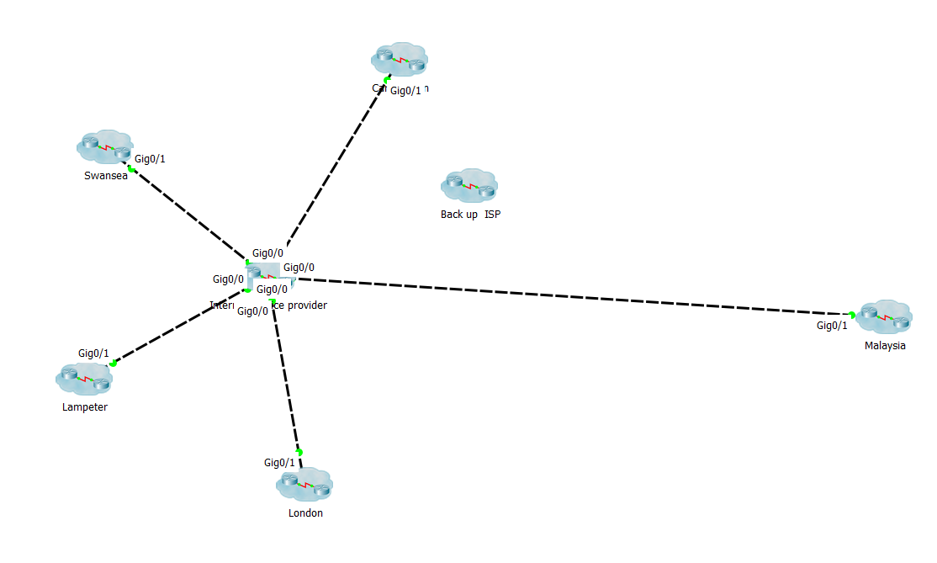
Figure 1 UWTSD Network

London Network
The London campus network, is the base design of the other campuses. This allows a consistency with the other campuses that would benefit the management of a centralised network, by allowing the IT managers to understand the logical topology of any campus with little difficulty. Within figure 2 the basic network configuration shows core, distribution and access layers, and a data centre. The unique area in this network is that the Extranet is setup in London to be accessed by the other campuses.
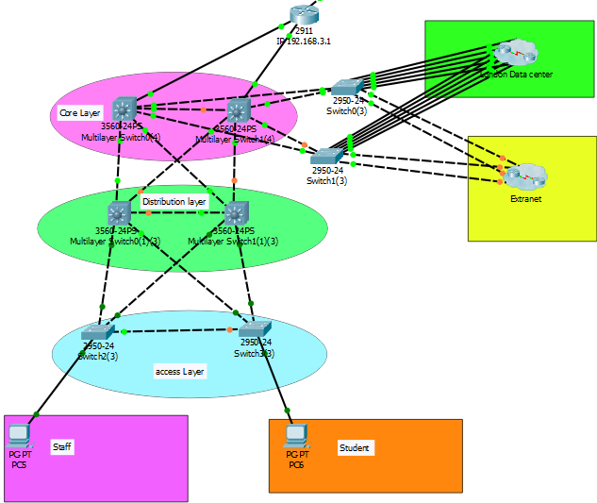
Figure 2 London UWTSD network

London data centre
Figure 3 shows the basic setup for a campus data centre, within the data centre there are groups if servers used for the campuses DNS and DHCP, data storage and file transfer. This load out is the same for all the campuses and allows each one to function independently. By the logical topology of each data centre similar the IT staff will be able to use images of the servers for one data centre to start up the others.

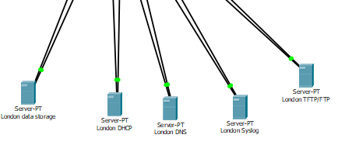
Figure 3 simulated data centre for London UWTSD

London Extranet
Figure 4 shows the setup the UWTSD’s Extranet, this was designed to provide interconnectivity between the campuses and partners of the university such as Turnitin[3]. An Extranet would provide the management staff of a centralised network, to be able to remote access the network to manage any issues the network is having from a home computer.
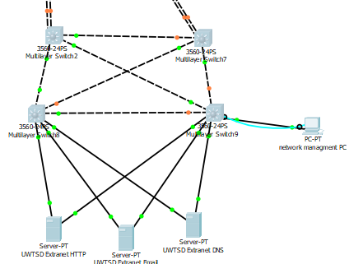
Figure 4 UWTSD Extranet based in London

Swansea Network
Figure 5 shows the Swansea campus network, it is very similar to the London network topology except there is a BYOD infrastructure and this is where the UWTSD intranet is setup. The BYOD infrastructure, allows the university staff and students to connect to the campuses network, using their own devices such as laptops and phone.[4]
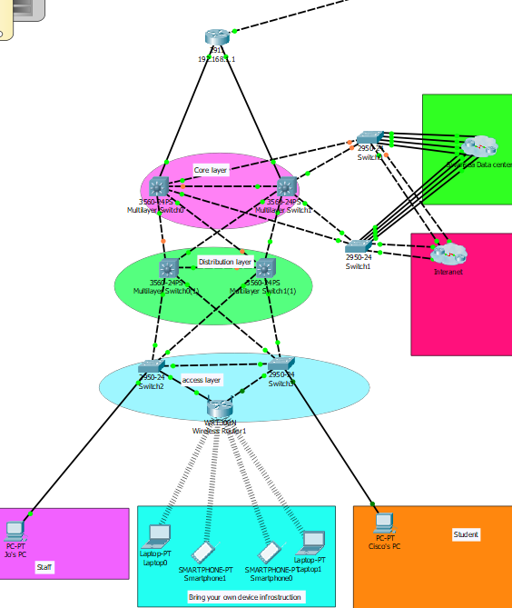
Figure 5 Swansea UWTSD Network

Swansea intranet
Figure 6 shows the UWTSD’s intranet setup, while similar to the extranet, this network cannot be accessed by non UWTSD accounts. The backup data storage for the UWTSD is directly linked to the intranet.
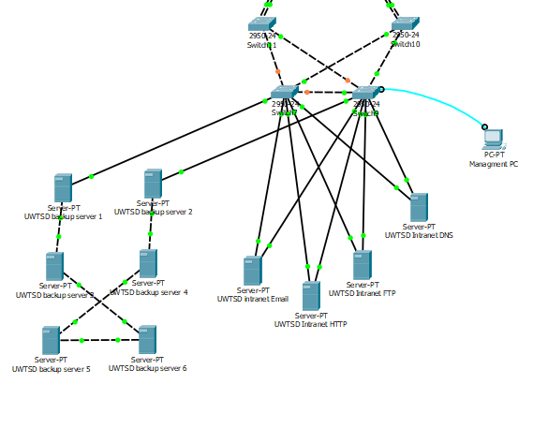
Figure 6 UWTSD intranet based in Swansea

Swansea data Storage backup
Figure 7 shows a simulation of a data backup, this is used to back up all the data that the UWTSD generates. The backup storage is used to provide a failsafe in the event that the onsite data centres brake down. In a centralised network having a backup is a critical point, without a backup if the data centres went down then all the university’s data would be lost.
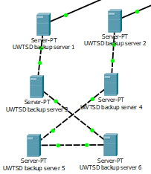
Figure 7 Simulated Remote Data storage

Swansea Email, HTTP, management servers
The need for Email and HTTP access in a centralised network, is that it would allow the IT staff to manage the UWTSD’s website and user access rights

Email
Figure 8 is a simulated Email between two network users, this shows that the intranet functionality is capable of allowing users to communicate over the network.
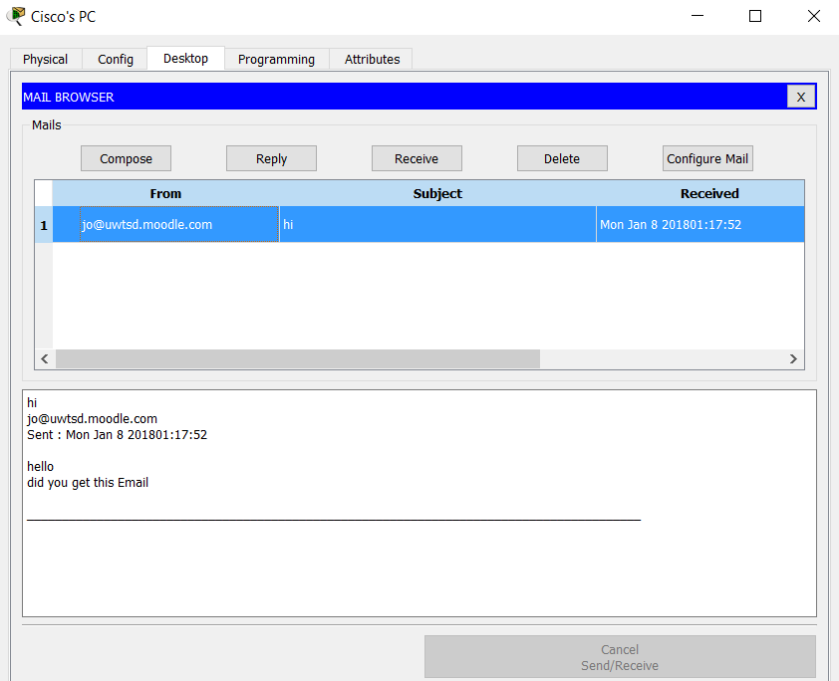
Figure 8 Simulated Emails between two users on the UWTSD Intranet

HTTP
Figure 9 shows a basic university website that is accessible through the intranet. This allows students and staff to have access to UWSTD news and information.
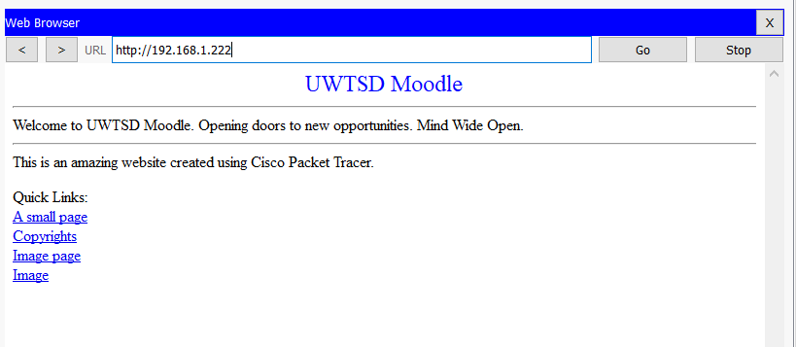
Figure 9 Simulated Web site that can be accessed by UWTSD Students

ISP
Figure 10 shows a simulation of an active Internet Service Provider (ISP), this was made to symbolically show the interconnectivity the university will need with an ISP.
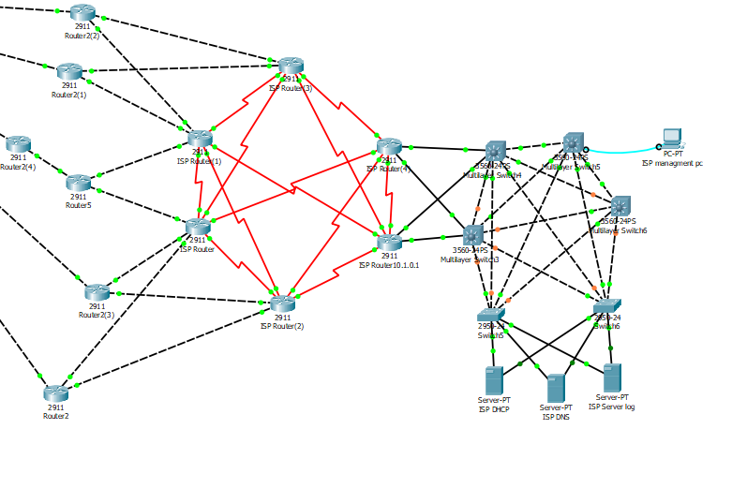
Figure 10 Simulation of an Internet Service Providers Network

Backup ISP
Figure 11 shows a basic simulation of a backup ISP, these are used in the event that the main ISP goes down.
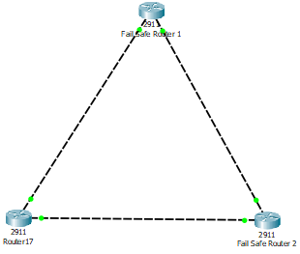
Figure 11 Basic simulation of an ISP, used for Backup

Problems
While creating the UWTSD network design the author discovered problems with the design. The problem the author had problems with the Automatic Private IP Addressing (APIPA) already running error, this error caused problems with DHCP and IP addressing.
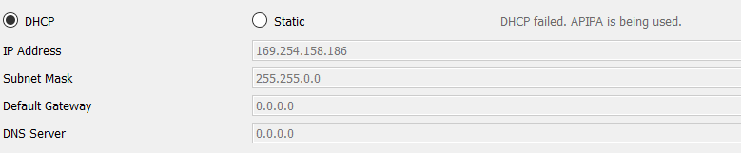
Figure 12 Shows the APIPA error Preventing DHCP
The author was unable to fix the error shown in figure 12, this caused the intranet, extranet, Email and HTTP servers to lose connectivity. Another problem the author had was being unable to connect to each campus network, the author believes that this is also caused by the APIPA error but was unable to confirm this.

Improvements
There are many improvements that can be made to this design, the main improvement that can be made is to add firewalls. Firewalls are physical and software based security devices that allow management to protect the network[5].
An improvement in the design would have been to add more offsite data storage centres, one campus in perticuler sould of had its own offsite storage is the Malaysian campus. The reason for this improvement is that the Malaysian campus of UWTSD in within a different country than the others, so in the event of system down time it would be very difficult to repair the system.
Another improvement that could be made to the design, could also be to provide a visual representation of the possible future growth of the UWTSD’s network. Currently the design show what a centralised network could look like, what it does not show it the potential for growth such a network has. For example, with the uses of BYOT it is possible to have a WLAN set up to double the number of users on a campus, it is also possible to show expansion through the uses of dark sites and back up locations for when a catastrophic shut down of the system happens there are ways to recover within the same day.

Big Data Storage and Processing

Introduction
Big data is the term used when discussing extremely large data sets, that are analysed to discover patterns and trends[6]. This research report focuses on the Storage and processing of big data, this research will be linked to the authors design for the UWTSD network and will show the university how to handle their big data.

Big data
As the name suggests Big Data is a large amount of data, but that’s not all it is, Big Data is the situation where the velocity, variety and volume of the data surpasses an organizations ability to store and process the data in a accurate and timely way[7]. When discussing Big Data the big “V” (as described by D. Laney)[8]are often mentioned, the Vs are: -
- Volume - the amount of the ever-increasing data that is available to an organization.
- Velocity - the speed that data is crated, received, stored and processed.
- Variety - the incompatibility of data formats, including structured, semi-structured and non-structured data[9].
Big Data has caused a new need for the research and development new storage and processing techniques, and software such as Apache Hadoop[10]. This research has led to the emergence “heterogeneous and hybrid storage systems that employ different types of storage devices” as stated in K.R. Krish’s research paper On Efficient Hierarchical Storage for Big Data Processing[11], in this paper it K.R. Krish states that the Hadoop Distributed File System (HDFS) main function is to protect the system form data loss due to failure and to provide tasks with the needed data.

Storage
The storage of Big Data is a challenging prospect, the sheer volume of data that an organization like the UWTSD generates on a daily it become very difficult to uses traditional storage methods, because the amount of data cannot be guaranteed to be keep its integrity[12]. To answer this problem many organizations, hire or operate their own off site storage centre (The Cloud)[13]. This allows organizations to guaranty the security and integrity of their user’s data, in the case of a university this data would be the students and staff work and personal data.
There are problems with this though, these problems where inherited from the time when companies only needed to worry about dealing with small amounts of data. The problems with storage are the cost of constructing a data storage area capable of storing Big Data, the cost of energy waste due to the poor utilization of storage, the management and maintenance costs that come with running such a site[14].

Processing
In the IT industry the ability to process the massive datasets of Big Data, is an integral part of a range of scientific disciplines[15]. There are challenges with the data mining of Big Data such as: -
- Accessing data – Big Data is often stored in different locations, this causes problems with traditional data mining algorithms that require the data to be stored in one location.
- Domain of Knowledge – this challenge involves where the Big Data was generated, for example the difference between analysing and sharing data generated by a sensor network for applications such as air quality in a city and analysing and sharing medical data generated a country’s hospitals about their patients.
- Algorithm design – Big Data, datasets are large and complex, this means that the algorithm needs to be able to process the data efficiently. Also a system for Big Data mining needs an information exchange with the other storage site to allow for a global optimization of then analysis of the data[16].
To overcome these challenges new methods of data analysis have been developed. For example, to overcome the lager scale of data and the need for multiple storage areas, the method of having the storage communicate with each other to share information allows for the reduction in the time it takes for analysis of the data.

Relations with design
In relation to the author’s UWTSD centralized network design, Big Data will play a big role. The reason for this is that by being a multi campus university hundreds of thousands of staff and students will be generating data every day, this data can be will range from simple attendance data to more complex equipment (food, drink, day trip etc.) procurement data. To store this data the university is going need storage on each of these sites which is shown in figures 2,3,5 known as the data centres. The vast amount of data the university will be generating will mean that the data might not be large enough, that’s why the author designed a offsite data storage centre on the Swansea campus, as shown in figure 7, another site that should have had an offsite storage area was the Malaysian Campus.
The processing of Big Data will be difficult for the university network, because of the data being stored in many different locations. To mitigate this the author suggest using a private intranet setup between each of the data centres and offsite storage, this would allow each site to share data and information while analysis of the data takes place, both reducing the time it take and the increasing the integrity of the analysed data.

Conclusion
In conclusion although the author had problems with the APIPA error, they where able to design an approximation on what a centralised UWTSD network could look like as shown in figure 1. Although not shown in the diagram, the UWTSD is a growing university and will need to expand their network, this will allow for the ever-growing student population and the members of staff required to keep such an industry running. this means that there is no real future proofing that the UWTSD can achieve to handle the growth of their data, so they will have to expand the network to accommodate the growth.
Big Data is an ever-growing aspect of IT and the volume of data and the complexity of it will continue to increase with the advancement of technology, this will continue to cause problems with storage and integrity but the solutions that are currently being developed for the analysis of Big Data, such as Apache Hadoop are increasing the seed in which we can analyse data.

References

[1] ‘ACCA6001_sem1_CW1_2017_18_Network Data Centre Management (1)’. UWTSD, Seansea.
[2] Cisco, ‘Packet Tracer | Cisco NetAcad’, netacad.com, 2017. [Online]. Available: https://www.netacad.com/courses/intro-packet-tracer/.
[3] U. August, ‘Turnitin Moodle Direct Integration Instructor User Manual’, Integration The Vlsi Journal. pp. 1–20, 2010.
[4] L. C. P146632, ‘Internet {S}ecurity’. UWTSD, Swansea, pp. 1–9, 2003.
[5] ‘Internet Firewalls for Trusted Systems’, in Wireless Mobile Internet Security, Chichester, UK: John Wiley & Sons, Ltd, 2013, pp. 387–414.
[6] M. Gheisari, G. Wang, and M. Z. A. Bhuiyan, ‘A Survey on Deep Learning in Big Data’, in 22017 IEEE International Conference on Computational Science and Engineering (CSE) and IEEE International Conference on Embedded and Ubiquitous Computing (EUC), 2017, pp. 173–180.
[7] E. Sivaraman and R. Manickachezian, ‘High Performance and Fault Tolerant Distributed File System for Big Data Storage and Processing Using Hadoop’, in 2014 International Conference on Intelligent Computing Applications, 2014, pp. 32–36.
[8] D. Laney, ‘META Delta’, Appl. Deliv. Strateg., vol. 949, no. February 2001, p. 4, 2001.
[9] R. Patgiri and A. Ahmed, ‘Big Data: The V’s of the Game Changer Paradigm’, in Proceedings - 18th IEEE International Conference on High Performance Computing and Communications, 14th IEEE International Conference on Smart City and 2nd IEEE International Conference on Data Science and Systems, HPCC/SmartCity/DSS 2016, 2017, pp. 17–24.
[10] Apache.org, ‘Welcome to Apache TM Hadoop ® !’, Http://Hadoop.Apache.Org/, no. November 2008, pp. 2010–2013, 2013.
[11] K. R. Krish, B. Wadhwa, M. S. Iqbal, M. M. Rafique, and A. R. Butt, ‘On Efficient Hierarchical Storage for Big Data Processing’, in 2016 16th IEEE/ACM International Symposium on Cluster, Cloud and Grid Computing (CCGrid), 2016, pp. 403–408.
[12] X. Chen, T. Shang, I. Kim, and J. Liu, ‘A Remote Data Integrity Checking Scheme for Big Data Storage’, in 2017 IEEE Second International Conference on Data Science in Cyberspace (DSC), 2017, pp. 53–59.
[13] R. N. Karthika, C. Valliyammai, and D. Abisha, ‘Perlustration on techno level classification of deduplication techniques in cloud for big data storage’, in 2016 Eighth International Conference on Advanced Computing (ICoAC), 2017, pp. 206–211.
[14] Y. Xiaoshan, Z. Ligu, Z. Qicong, and F. Dongyu, ‘Research on Evaluation Method of Big Data Storage Utilization’, in 2016 4th Intl Conf on Applied Computing and Information Technology/3rd Intl Conf on Computational Science/Intelligence and Applied Informatics/1st Intl Conf on Big Data, Cloud Computing, Data Science & Engineering (ACIT-CSII-BCD), 2016, pp. 368–372.
[15] Sowmya R and Suneetha K R, ‘Data Mining with Big Data’, in 2017 11th International Conference on Intelligent Systems and Control (ISCO), 2017, pp. 246–250.
[16] X. Wu, X. Zhu, G.-Q. Wu, and W. Ding, ‘Data Mining with Big Data’, Knowl. Data Eng. IEEE Trans., vol. 26, no. 1, pp. 97–107, 2014.

