Abstract
This assignment presents a complete redesign proposal for the MealSwift website and mobile platform. The project focuses on improving user experience, visual appeal, navigation, and ordering efficiency through a structured design process. Key elements include usability analysis, responsive design implementation, and the development of wireframes and visual prototypes for five main pages: Home, Menu, Services, About Us, and Contact Us. The redesign aims to increase customer satisfaction, improve mobile accessibility, and support business growth by creating a modern, user-centred digital experience that strengthens brand trust and encourages repeat orders
business and Web management
Component 1 – Website Redesign for Online Business Presence ACCA5019
Lecturer: Dr Mobolanle Bello
Mekonnen Tessema
2333138@student.uwtsd.ac.uk

Contents
1. Introduction 2
2. MealSwift Website Redesign 2
Confusing Navigation 2
Outdated Visual Design 3
Ordering and Checkout Process 3
3. Responsive Design Implementation 4
3.1 Implications of Responsive Design for Improving User Experience 4
3.2 Implications of Responsive Design for Increasing Sales 5
4.0 IMPLEMENTATION SECTION 5
Moodboard Screenshot 5
Wireframe Pages Screenshots: 5
Page 1. Home page wireframe 5
Page 2. Menu page wireframe 5
Page 3. Services page wireframe 6
Page 4. About Us page wireframe 6
Page 5. Contact Us page wireframe 6
Web Design Prototype 6
Home Page Web Design Screenshots 6
Menu Page Web Design Screenshots 6
Services Page Web Design Screenshots 6
About Us Page Web Design Screenshots 6
Contact Us Page Web Design Screenshots 6
4.1 Moodboard and Wireframe Design 6
5. Conclusion 7
REFERENCES 8

1. Introduction
This report presents the redesign proposal for MealSwift, a fast-growing food delivery platform that connects customers with local restaurants through online ordering and delivery services. The purpose of this project is to improve MealSwift’s website and mobile experience by addressing usability problems, enhancing visual appeal, and creating a smoother ordering journey for users. The scope of the report covers an evaluation of the current website, the proposed redesign solutions, responsive design implementation, and the use of mood boards and wireframes during the design process.
The methodology involved reviewing the existing platform, identifying key user experience issues, and developing a prototype guided by user-centred design principles. This included analysing navigation flow, layout structure, accessibility needs, and customer engagement features. Mood boards were used to establish the visual direction, while wireframes helped plan page layouts and functionality before moving into detailed design.
The significance of this project lies in its focus on improving customer satisfaction and supporting MealSwift’s business growth. A well-designed website [3] plays a major role in encouraging repeat orders, building trust, and strengthening brand loyalty. By redesigning the platform with users in mind, MealSwift can create a more engaging digital experience that supports both customer needs and commercial goals.

2. MealSwift Website Redesign
The current MealSwift website presents several challenges that affect user satisfaction and conversion rates.

Confusing Navigation
One of the main issues is confusing navigation [4]. Users struggle to quickly find restaurants, menus, or their account information, which creates frustration and increases the likelihood of abandoned sessions. To resolve this, the redesign introduces a simplified navigation bar with clearly labelled categories such as “Restaurants,” “Offers,” “My Orders,” and “Profile.” A prominent search bar allows users to find food or restaurants instantly, reducing the time needed to place an order.

Outdated Visual Design
Another major concern is the outdated visual design. The existing interface lacks consistency in colours, fonts, and spacing, giving the platform an unprofessional appearance. The redesign adopts a modern visual style with a consistent colour palette, clean typography [5], and improved spacing to create a more welcoming and trustworthy feel. High-quality food imagery replaces low-resolution photos, helping users better visualise meals and encouraging purchases.
Poor Mobile Responsiveness
Poor mobile responsiveness is also a significant issue. Many users access food delivery services through their phones, yet the current site does not adapt well to smaller screens. The redesigned platform uses flexible layouts that automatically adjust to different devices, ensuring buttons, images, and text remain readable and easy to interact with. This creates a seamless experience across desktops, tablets, and smartphones.
Limited Restaurant and Menu Information
Limited restaurant and menu information further reduces user confidence. In the redesign, each restaurant page includes clear menu descriptions, pricing, estimated delivery times, dietary labels, and customer ratings. Adding reviews helps users make informed decisions while increasing trust in the platform. Personalised recommendations based on previous orders and browsing behaviour are also introduced to improve engagement and encourage repeat purchases.

Ordering and Checkout Process
The ordering and checkout process was another area requiring improvement. Previously, too many steps and unclear progress indicators caused users to abandon carts. The new design simplifies checkout into a clear, step-by-step flow with visible progress markers. Users can easily edit their cart, select delivery options, and confirm payment without unnecessary distractions. Saved addresses and payment details speed up future orders, making the process more convenient.
Accessibility
Accessibility [6] was also addressed in the redesign. Text contrast was improved for readability, buttons were enlarged for easier tapping, and descriptive labels were added to forms. These changes ensure the website is usable for people with different abilities and browsing needs.

Call-to-action Elements
Call-to-action elements such as “Order Now” and “Reorder Favourite” are now visually distinct and strategically placed to guide users naturally through the ordering journey. In addition, real-time order tracking was added so customers can monitor their delivery status, reduce uncertainty and improve overall satisfaction.
Performance Optimisation
Finally, performance optimisation was considered. Compressed images and cleaner page layouts help reduce loading times, ensuring users do not leave the site due to slow responses. Together, these redesign improvements aim to create a smoother, more engaging experience that increases customer loyalty and supports MealSwift’s growth.

3. Responsive Design Implementation
Responsive design is an approach that allows a website to automatically adapt its layout and content to fit different screen sizes and devices [1]. It ensures users receive a consistent experience whether they access the site on a desktop, tablet, or smartphone [2].
In e-commerce platforms such as MealSwift, responsive design is essential for meeting modern user expectations and supporting mobile purchasing behaviour.

3.1 Implications of Responsive Design for Improving User Experience
Responsive design greatly enhances user experience by providing clear layouts, readable text, and touch-friendly buttons on all devices. When users can easily browse menus, view images, and complete orders on their phones, they are more likely to stay engaged. A responsive interface also reduces the need for zooming or horizontal scrolling, making interactions feel natural and effortless.
Consistency across devices builds trust and familiarity. Users who begin browsing on one device can continue on another without confusion. Faster loading times on mobile-friendly layouts further improve satisfaction, while simplified navigation ensures users reach their goals quickly. Overall, responsive design supports comfort, accessibility, and ease of use [7].

3.2 Implications of Responsive Design for Increasing Sales
From a business perspective, responsive design directly supports higher conversion rates. Since many customers place food orders on mobile devices, a smooth mobile experience removes barriers to purchasing. Clear product displays, simple checkout processes, and accessible payment options encourage users to complete transactions.
Responsive platforms also support impulse buying by making it easier to place quick orders. Personalised content and recommendations display effectively on smaller screens, increasing opportunities for upselling. By reducing friction in the buying process, responsive design helps transform casual visitors into loyal customers, leading to increased order volume and revenue.

4.0 IMPLEMENTATION SECTION

Moodboard Screenshot
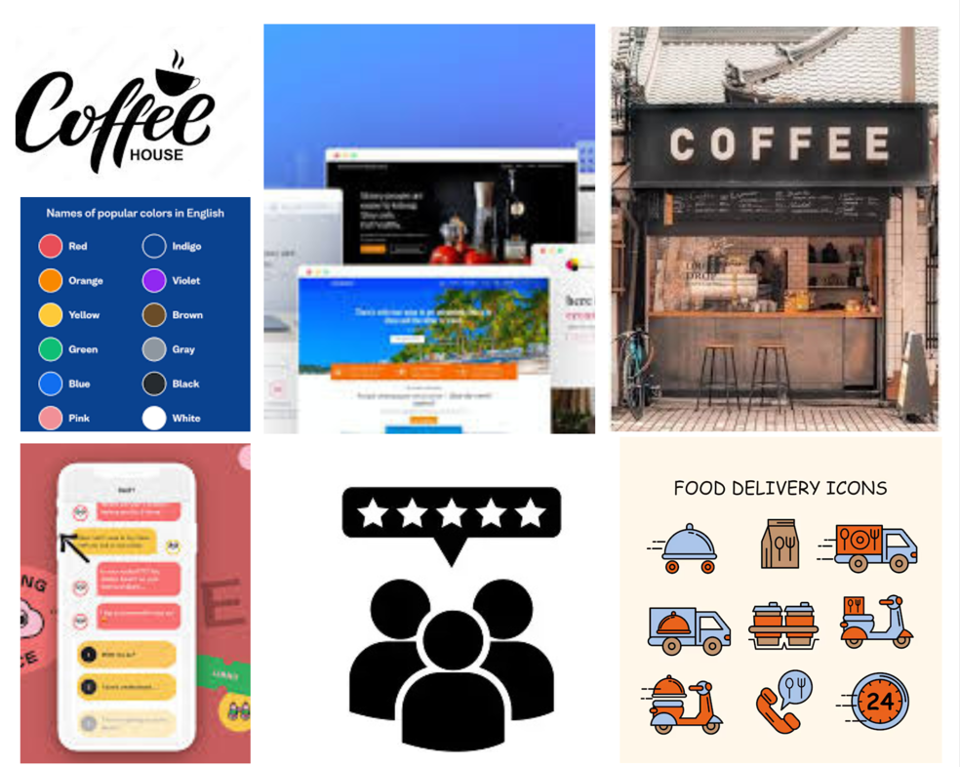

Wireframe Hand sketch
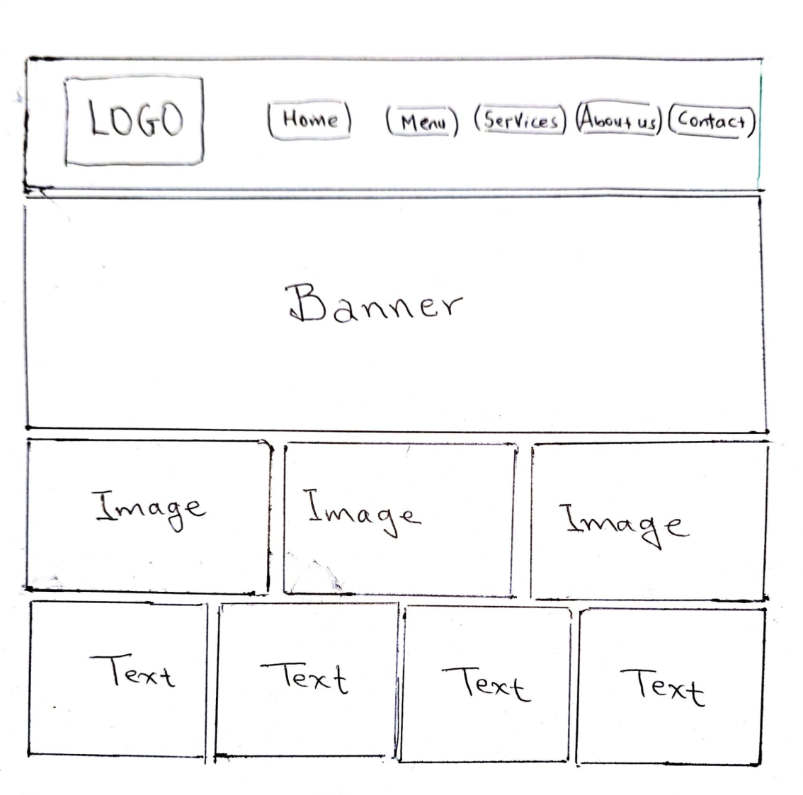

Wireframe Pages Screenshots:

Page 1. Home page wireframe

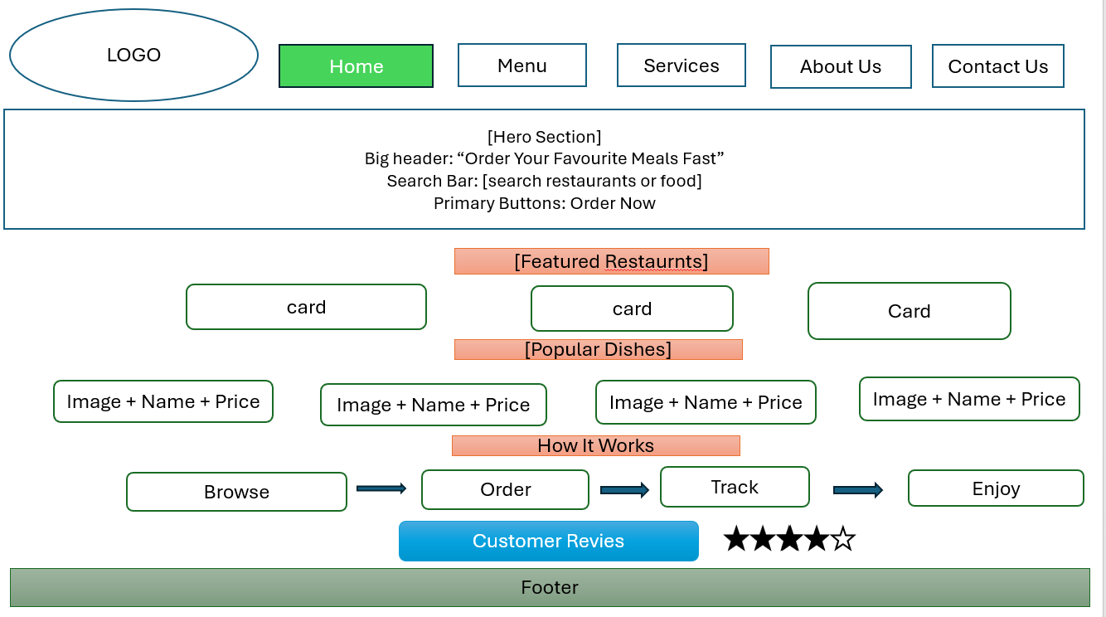

Page 2. Menu page wireframe
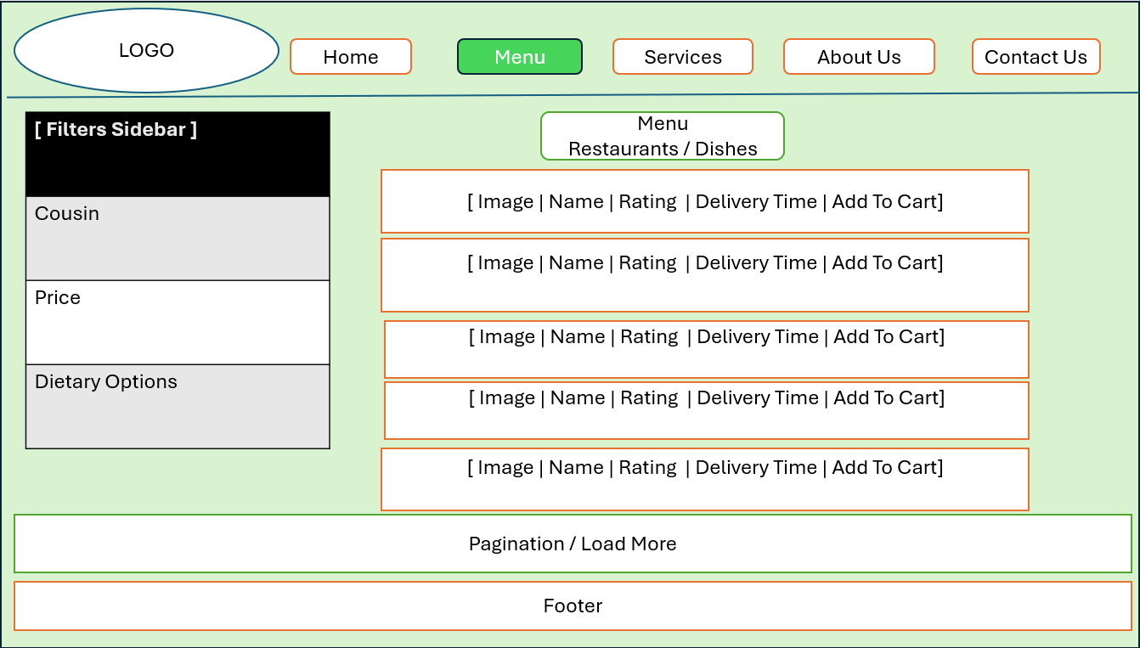

Page 3. Services page wireframe
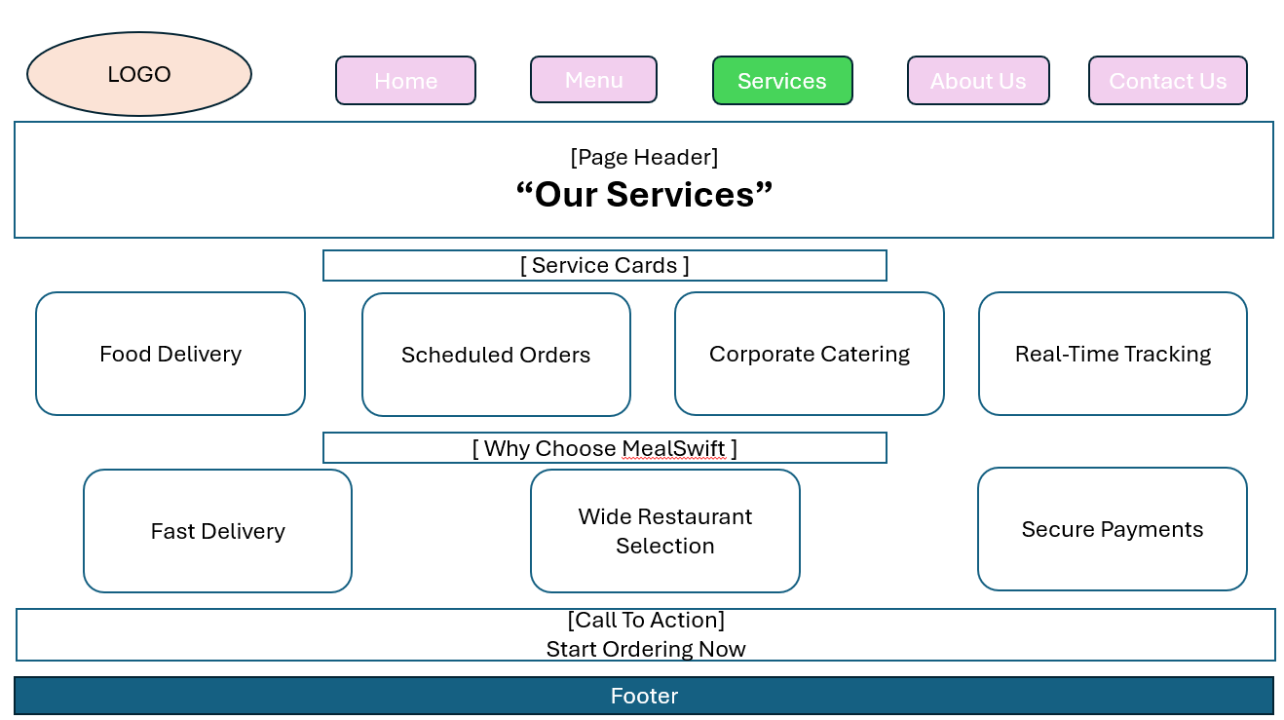

Page 4. About Us page wireframe
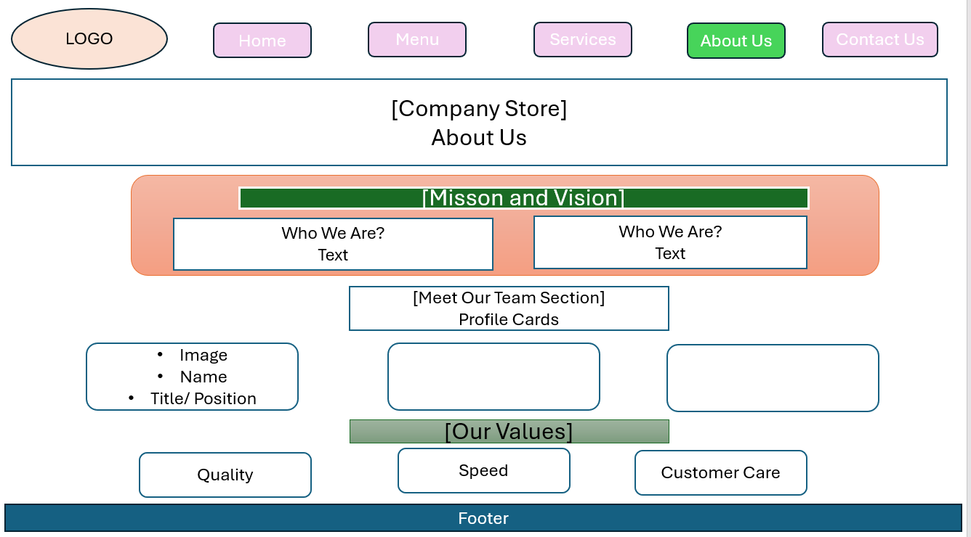

Page 5. Contact Us page wireframe
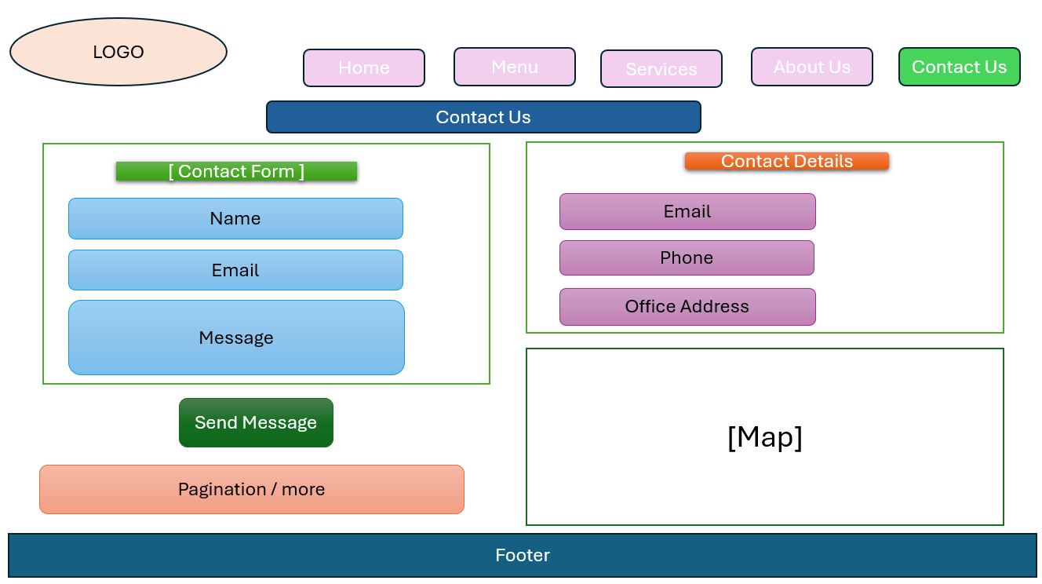

Web Design Prototype

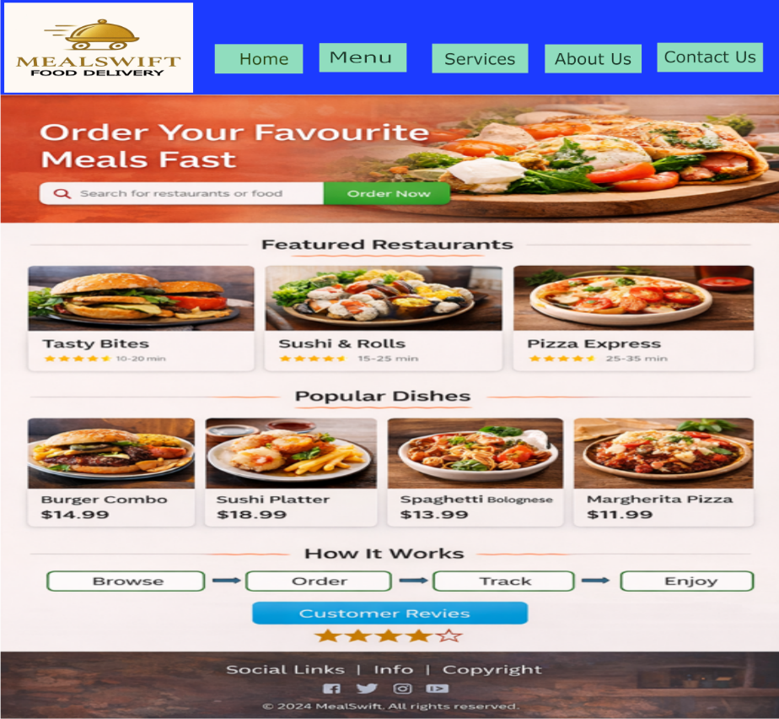
Home Page Web Design Screenshots

Menu Page Web Design Screenshots
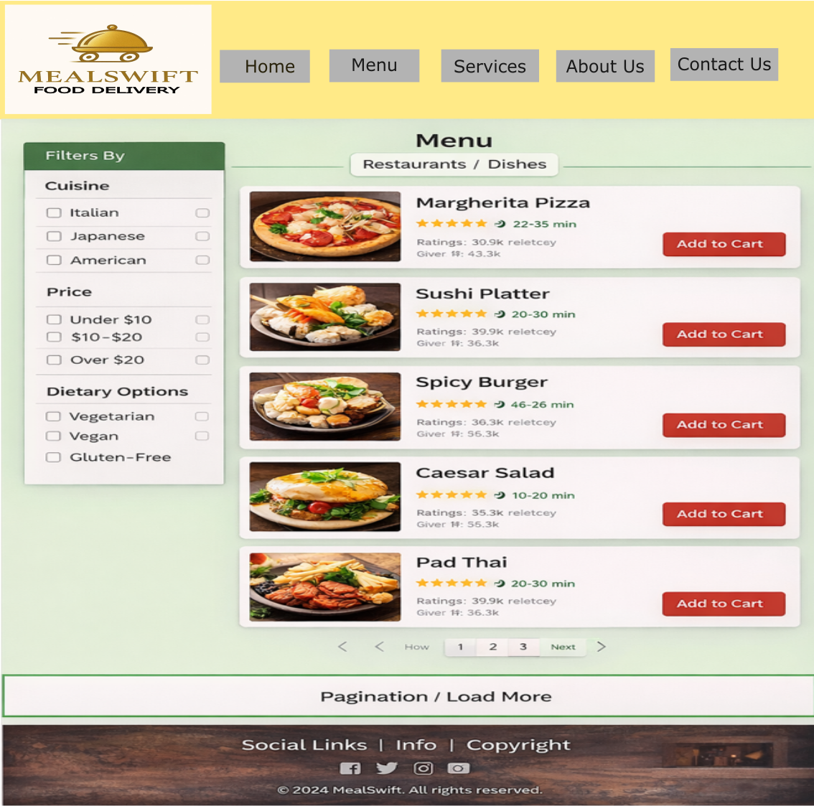

Services Page Web Design Screenshots
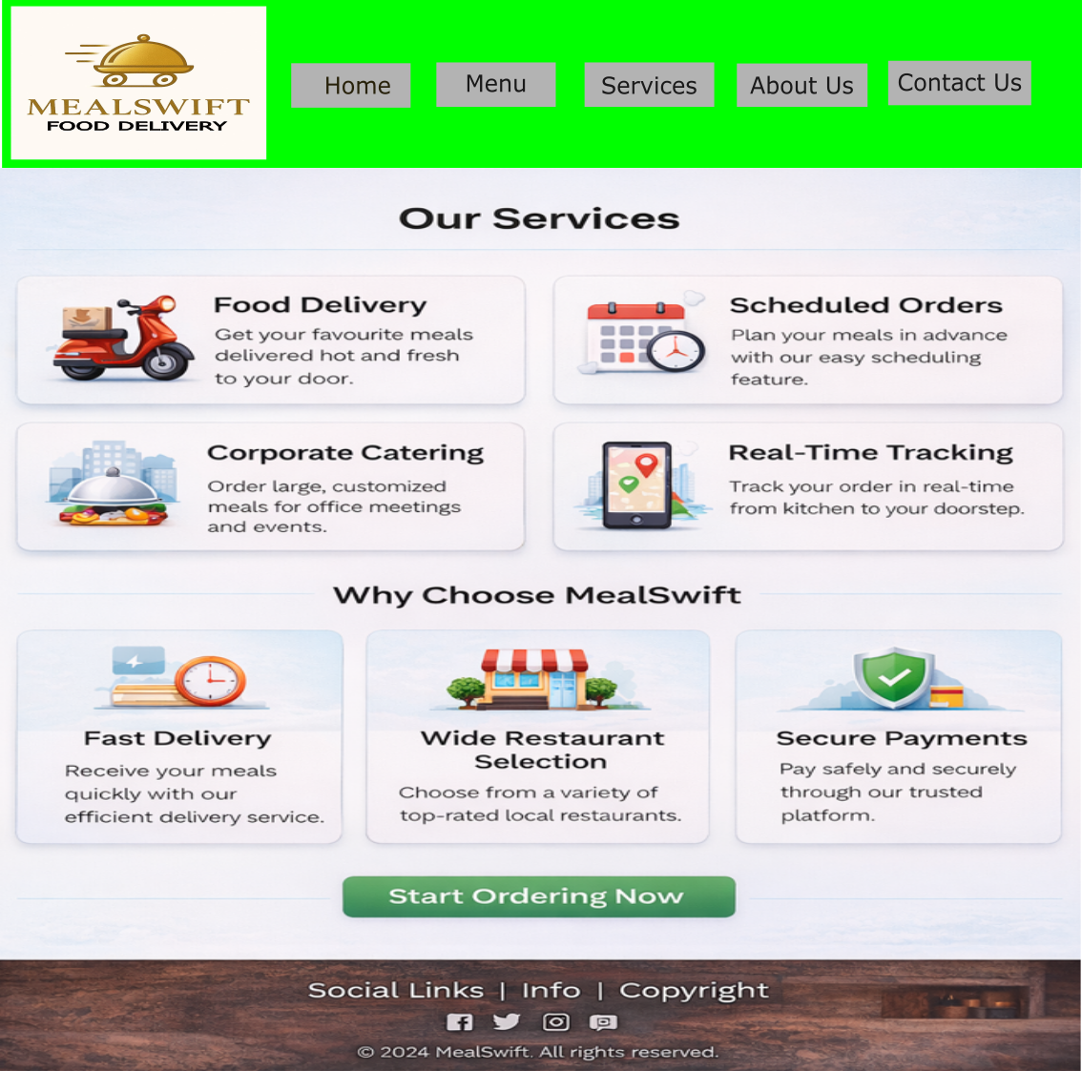

About Us Page Web Design Screenshots
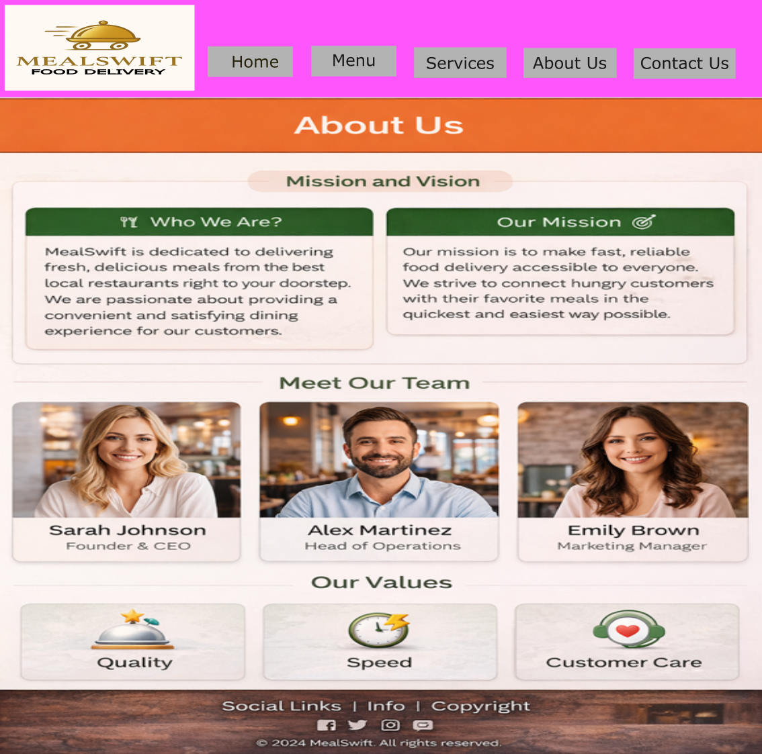

Contact Us Page Web Design Screenshots
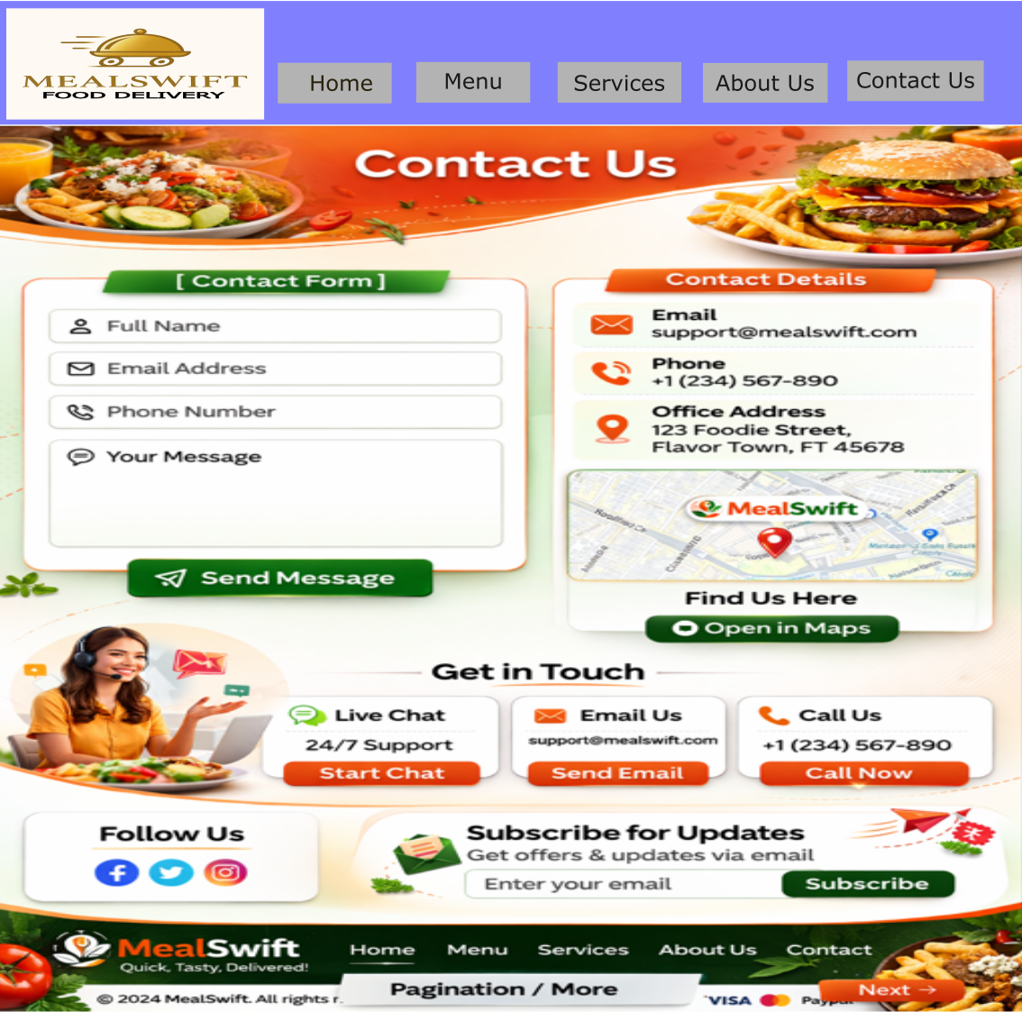

4.1 Moodboard and Wireframe Design
A mood board [8] is a visual collection of colours, fonts, images, and design references that communicates the overall look and feel of a project. It helps designers align on style direction before detailed design begins.
For MealSwift, the mood board focused on warm colours, clean typography, and appetising food imagery to create a friendly and energetic brand atmosphere. This visual guide influenced choices such as button colours, background tones, and photography style, ensuring consistency across the platform. The mood board also helped reflect MealSwift’s identity as a fast, reliable, and customer-focused service.
A wireframe is a basic visual layout [9] that outlines the structure of a webpage without detailed graphics or colours. It shows where key elements such as menus, buttons, images, and text will appear.
Wireframes played a crucial role in shaping MealSwift’s redesign. They helped map out user journeys, ensuring important features like search, restaurant listings, and checkout were placed logically. By testing layouts early, usability issues were identified before visual design began. Wireframing also supported collaboration between designers and developers by providing a clear blueprint for implementation, reducing misunderstandings and saving development time.
Together, mood boards and wireframes ensured that both visual style and functionality were carefully planned, resulting in a balanced design that meets user needs while supporting business goals.

5. Conclusion
This project demonstrated the importance of a structured design process in creating a successful digital product. By carefully analysing MealSwift’s existing challenges and applying user-centred design principles, the redesign delivers a more intuitive, visually appealing, and accessible platform.
The combination of improved navigation, responsive layouts, streamlined checkout, personalised features, and real-time order tracking significantly enhances the user experience. These changes not only make ordering food easier but also build trust and encourage customer loyalty. Mood boards and wireframes proved valuable in guiding creative direction and layout planning [10], ensuring consistency and usability throughout the project.
Overall, the redesign supports MealSwift’s goal of increasing orders while strengthening customer relationships. This experience highlights how thoughtful design decisions can directly impact business success. A well-planned website is more than just visually attractive it plays a key role in meeting user expectations, adapting to technology trends, and helping companies grow in competitive digital markets.

REFERENCES

[1]. M. Ayaz, A. Alqurashi, T. Essa Alharbi, and F. Abdul Rasheed, “Design and Implementation of a Magnetostatic-Responsive Stub-Loaded Phase Shifter With Stepwise Precise Phase Control for X-Band Wireless and Radar Applications,” IEEE access, vol. 13, pp. 209091–209107, 2025, doi: 10.1109/ACCESS.2025.3640540.
[2]. P. Ahrweiler, Participatory Artificial Intelligence in Public Social Services : From Bias to Fairness in Assessing Beneficiaries, 1st ed. 2025. Cham: Springer Nature Switzerland, 2025. doi: 10.1007/978-3-031-71678-2.
[3]. W. Guan, P. Chen, Y. Xie, and P. Lu, “PL-EVIO: Robust Monocular Event-Based Visual Inertial Odometry With Point and Line Features,” IEEE transactions on automation science and engineering, vol. 21, no. 4, pp. 6277–6293, 2024, doi: 10.1109/TASE.2023.3324365.
[4]. E. Y. Daraghmi, Chih-Tien Fan, Wei-Jun Lin, Zih-You Peng, and Shyan Ming Yuan, “Eye-Tracking Assisted Self-Directed Learning System,” in Proceedings (IEEE International Conference on Advanced Learning Technologies), IEEE, 2015, pp. 52–54. doi: 10.1109/ICALT.2015.33.
[5]. W. Mao, S. Yang, H. Shi, J. Liu, and Z. Wang, “Intelligent Typography: Artistic Text Style Transfer for Complex Texture and Structure,” IEEE transactions on multimedia, vol. 25, pp. 1–15, 2023, doi: 10.1109/TMM.2022.3209870.
[6]. R. Ismailova and Y. Inal, “Comparison of Online Accessibility Evaluation Tools: An Analysis of Tool Effectiveness,” IEEE access, vol. 10, pp. 58233–58239, 2022, doi: 10.1109/ACCESS.2022.3179375.
[7]. E. Perakakis and G. Ghinea, “Smart Enough for the Web? A Responsive Web Design Approach to Enhancing the User Web Browsing Experience on Smart TVs,” IEEE transactions on human-machine systems, vol. 47, no. 6, pp. 860–872, 2017, doi: 10.1109/THMS.2017.2726821.
[8]. H. Liu et al., “Angel’s Girl for Blind Painters: An Efficient Painting Navigation System Validated by Multimodal Evaluation Approach,” IEEE transactions on multimedia, vol. 25, pp. 2415–2429, 2023, doi: 10.1109/TMM.2022.3146767.
[9]. D. Raj and R. C. Tripathi, “Method for generating 3-Dimensional wireframe model from different 2-Dimensional Drawings 2-Dimensional to 3-Dimensional Conversion,” in 2010 4th International Conference on New Trends in Information Science and Service Science, IEEE, 2010, pp. 313–318.
[10]. X. Cui, X. Feng, and S. Sun, “Learning to Generate Urban Design Images From the Conditional Latent Diffusion Model,” IEEE access, vol. 12, pp. 89135–89143, 2024, doi: 10.1109/ACCESS.2024.3419159.

